**Requirements**

**Database name: WanderersVGopalakrishnan**

This database is created to use by a front-end web application. Each user will have a different login page. There may be other individual users like business analysts, architect, developer, tester and user. Another user of the database will be the administrators who does performance tuning, check the sessions that are slow, data profiling, scheduling jobs and more. All these users will have an ID to access the database. Each group of users are given an appropriate role and access based on their role. The application will have read and write access to production. The developers will have only read access to production. If they need to update the database, they must get a special access for the same. The administrators will have full access to the database. The developers and testers will use the same database in the development and staging server for their work. The user ID to access the database should be their own active directory ID and password. The access is provided by the database administrator.

The web application can be used by 3 user groups below;

1. **Trekkers:** Trekkers are a group of people who use the database to search for trekking events. They have their own login details. The trekkers use details like current trip, which state, from and to date, category of trip, commute, lodging, food and more trip details.
2. **Guides:** Guides are the event organizers. They guide the people through the trekking tour. They provide the event details. They also provide a form where the trekkers can register for the event. The guides use the archived trip and current trip table. They insert new trip details and move the cancelled and completed trip details from current trip to archived table.
3. **Admins:** Admins are the super users who make any modification in the database, check and fix any issues in the data. The admins use all the main tables to insert details, delete certain details which cannot be deleted from front end, maintains login details, other profiling and performance improvement.

The login ID and password is required for all the users. The login ID can be a maximum of 10 characters or 10 numbers. The password can be a maximum of 20 characters. All the users will have an ID auto generated by the system in the master table and it will be used as foreign key in other tables. There are relations created below to represent the various data required by various user groups. Each attribute has a datatype and size. Some attributes have constraints and domains. Some primary keys are used as foreign keys in other tables. Indices are created in tables to search the record faster.

**Relations:** Relation consist of attributes and tuples. I have created some tables that will be used by these user groups to access data. “MT” before the table names refers that the table is main table. “Tran” refers to a transaction table in which transactions like update, delete and insert takes place often.

MT_Trekker will contain the basic details of trekkers who have registered in the site. The details are name, phone, email, state, trek card number. The trekkers will enter their basic details for sign up. A unique id is generated for the trekker and it is referenced every time they login.

|  |  |  |  |  |
| --- | --- | --- | --- | --- |
| **MT_Trekker** | | | | |
| **Attribute Name** | **Data Type** | **Size** | **Constraints/Domains** | **Cascading Problems** |
| LoginID | Varchar | 10 | Login ID of the user |  |
| T_ID | varchar | 10 | Auto Generated. Not null. 2 alphabets with the state postal code and numbers from 1. | Cascade delete |
| T_FirstName | varchar | 20 | First name of the trekker |  |
| T_LastName | varchar | 20 | Last name of the trekker |  |
| T_DOB | Date |  | Not null. |  |
| T_Phone | numeric | 12 | Not null. 10 digits. |  |
| T_Email | varchar | 25 - n | Valid only if it contains @ and a dot. |  |
| T_State | varchar | 2 | State with state postal code with 2 characters like NJ. |  |
| T_IsActive | Bool |  | Not null. Active(T/1), Inactive(F/0). |  |
| T_Pet | Bool |  | Not null. Yes(T/1), No(F/0). |  |
| T_TrekCard | Bool |  | Not null. Available(T/1), Not available(F/0) |  |
| T_CardNum | Varchar | 10 | Not null. Alphabets, Numbers. |  |

**Primary Key(s):** T_ID

**Foreign Key(s):**

**Indices:** T_LastName

MT_Guide will contain the basic details about the event organizer like name, email, phone, which category of camp he works for, his trek card details. It is mandated to have a trek card for all the guides. The types of camps include Forest camp, farm camp, beach camp, mountain camp, school college camp, get together camp, corporate company camp.

|  |  |  |  |  |
| --- | --- | --- | --- | --- |
| **MT_Guide** | | | | |
| **Attribute Name** | **Data Type** | **Size** | **Constraints/Domains** | **Cascading Problems** |
| LoginID | Varchar | 10 | Login ID of the user |  |
| G_ID | Int | 5 | Auto generated by the system. Not null. | Cascade delete |
| G_Name | Varchar | 50 | Not null. First and Last Name |  |
| G_DOB | Date |  | Not null. |  |
| G_Phone | Numeric | 12 | Not null. 10 digits. |  |
| G_Email | Varchar | 25 | Not null. Valid only if it contains @ and a dot |  |
| G_Category | Varchar | 25 | Not null. Types of camps |  |
| G_IsActive | Bool |  | Not null. Active(T/1), Inactive(F/0). |  |
| G_CardNum | Varchar | 10 | Not null. Alphabets, Numbers. |  |

**Primary Key(s):** G_ID

**Foreign Key(s):** G_Category(CategoryName from MT_Category)

**Indices:** G_Name.

MT_Admin consists of the administrator details who manages the database. This table is for login and administrative purpose.

|  |  |  |  |  |
| --- | --- | --- | --- | --- |
| **MT_Admin** | | | | |
| **Attribute Name** | **Data Type** | **Size** | **Constraints/Domains** | **Cascading Problems** |
| LoginID | Varchar | 10 | Login ID of the user | LoginID |
| A_ID | Int | 5 | Auto generated. Not null. | Cascade delete(MT_Login) |
| A_Name | Varchar | 100 | First and last name. Not null. |  |
| A_DOB | Date |  | Not null. |  |
| A_Phone | Numeric | 12 | 10 digits. Not null. |  |
| A_Email | Varchar | 25 | Not null. Valid only if it contains a regular expression of “…….@....dot….” |  |
| A_IsActive | Bool |  | Not null. Active(T/1), Inactive(F/0). |  |

**Primary Key(s):** A_ID

**Foreign Key(s):**

**Indices:**

Tran_Login relation contains the login details of all the users. The LastLogin attribute is overwritten with the CurrentLogin value and CurrentLogin is overwritten with the current login date.

|  |  |  |  |  |
| --- | --- | --- | --- | --- |
| **Tran_Login** | | | | |
| **Attribute Name** | **Data Type** | **Size** | **Constraints/Domains** | **Cascading Problems** |
| LoginID | Varchar | 10 | Login ID of the user. Not null. |  |
| Password | Varchar | 20 | Password of the user. Not null. |  |
| U_ID | Varchar | 10 | Unique ID created by the system. Not null. |  |
| LastLogin | Date |  | Date the user last logged in. Not null. |  |
| CurrentLogin | Date |  | Current date user logged in. |  |

**Primary Key(s):** LoginID

**Foreign Key(s):** U_ID(T_ID from MT_Trekker, G_ID from MT_Guide, A_ID from MT_Admin)

**Indices:**

MT_Category is used to define the various categories of trekking camps like forest, mountain, farm, beach, corporate camps and more. The category name is referenced in other tables as foreign key.

|  |  |  |  |  |
| --- | --- | --- | --- | --- |
| **MT_Category** | | | | |
| **Attribute Name** | **Data Type** | **Size** | **Constraints/Domains** | **Cascading Problems** |
| Category_ID | Varchar | 10 | First 2/3 letters with state code. Not null. | Cascade delete, update |
| CategoryName | Varchar | 25 | Category of trekking event. Not null. |  |
| StateCode | Varchar | 2 | State postal code. |  |
| Cat_IsActive | Bool |  | Active(T/1), Inactive(F/0). |  |

**Primary Key(s):** Category_ID

**Foreign Key(s):**

**Indices:**

MT_Activity contains the event details for the camp like rock climbing, scuba diving, snorkeling.

|  |  |  |  |  |
| --- | --- | --- | --- | --- |
| **MT_Event** | | | | |
| **Attribute Name** | **Data Type** | **Size** | **Constraints/Domains** | **Cascading Problems** |
| EventID | Varchar | 10 | First 2/3 letters with state code. Not null. |  |
| EventName | Varchar | 25 | Kinds of activities involved. Not null |  |
| Event_IsActive | Bool |  | Not null. Active(T/1), Inactive(F/0). |  |
| Event_MaxCount | Int | 3 | Number of people involved for the activity at a time. Not null. |  |

**Primary Key(s):** EventID

**Foreign Key(s):**

**Indices:**

Tran_CurrentTrip contains the trip details of current month.

|  |  |  |  |  |
| --- | --- | --- | --- | --- |
| **Tran_CurrentTrip** | | | | |
| **Attribute Name** | **Data Type** | **Size** | **Constraints/Domains** | **Cascading Problems** |
| Trip_ID | Int | 5 | Not null. Auto generated. |  |
| Trip_Name | Varchar | 25 | Not null. |  |
| Trip_CategoryID | Varchar | 5 | Not null. |  |
| Trip_IsActive | Bool |  | Not null. Active(T/1), Inactive(F/0) |  |
| Trip_From | Date |  | Not null. |  |
| Trip_To | Date |  | Not null. |  |
| Trip_StateCode | Varchar | 2 | Not null. |  |
| Trip_CommuteID | varchar | 5 | Not null. |  |
| Trip_Pet | Bool |  | Yes(T/1), no(F/0). |  |
| Trip_MediSupp | Bool |  | Yes(T/1), no(F/0). |  |
| Trip_Bonfire | Bool |  | Yes(T/1), no(F/0). |  |
| Trip_Insurance | Bool |  | Yes(T/1), no(F/0) |  |
| Trip_Toileteries | Bool |  | Yes(T/1), no(F/0) |  |
| Trip_Rate | Currency |  | Not null. |  |
| Trip_GuideID | Varchar | 5 | Not null. |  |

**Primary Key(s):** Trip_ID

**Foreign Key(s):** Trip_CategoryID(Category_ID from MT_Category), Trip_Commute(TrainID from MT_Train, BusID from MT_Bus), Trip_GuideID(GuideID from MT_Guide)

**Indices:** Trip_ID, Trip_StateCode

Tran_ArchivedTrip will contain the completed trips and cancelled trip details. It maintains the audit trail of old trips.

|  |  |  |  |  |
| --- | --- | --- | --- | --- |
| **Tran_ArchivedTrip** | | | | |
| **Attribute Name** | **Data Type** | **Size** | **Constraints/Domains** | **Cascading Problems** |
| ATrip_ID | Int | 5 | Not null. |  |
| ATrip_Status | Varchar | 10 | Completed, Cancelled |  |

**Primary Key(s):** ATrip_ID

**Foreign Key(s):** Atrip_ID(Trip_ID from Tran_CurrentTrip)

**Indices:**

MT_Lodging contains the lodging details available in each state.

|  |  |  |  |  |
| --- | --- | --- | --- | --- |
| **MT_Lodging** | | | | |
| **Attribute Name** | **Data Type** | **Size** | **Constraints/Domains** | **Cascading Problems** |
| Lodge_ID | Int | 5 | Not null. Auto generated. |  |
| Lodge_Name | Varchar | 25 | Not null. |  |
| Lodge_StateCode | Varchar | 2 | Not null. |  |
| Lodge_Budget | Currency |  | Not null. |  |
| Lodge_Count | Int | 3 | Not null. Total count in the lodge. |  |

**Primary Key(s):** Lodge_ID

**Foreign Key(s):**

**Indices:**

MT_Bus contains the buses details for each state and its camp.

|  |  |  |  |  |
| --- | --- | --- | --- | --- |
| **MT_Bus** | | | | |
| **Attribute Name** | **Data Type** | **Size** | **Constraints/Domains** | **Cascading Problems** |
| BusID | Int | 5 | Not null. Auto generated. Starts with letter “B” |  |
| Bus_Name | Varchar |  | Not null. |  |
| Bus_Budget | Currency |  | Not null. |  |
| Bus_StateCode | Varchar | 2 | Not null. |  |
| Bus_CategoryID | Varchar | 5 | Not null. |  |
| Bus_MaxCount | Int | 3 | Not null. |  |

**Primary Key(s):** BusID

**Foreign Key(s)**

**Indices:**

MT_Train contains the train details for each state. TrainID is referred in other tables.

|  |  |  |  |  |
| --- | --- | --- | --- | --- |
| **MT_Train** | | | | |
| **Attribute Name** | **Data Type** | **Size** | **Constraints/Domains** | **Cascading Problems** |
| TrainID | int | 5 | Not null. Auto generated. |  |
| Train_Name | Varchar | 25 | Not null. |  |
| Train_Budget | Currency |  | Not null. |  |
| Train_State | varchar | 2 | Not null. |  |

**Primary Key(s):** TrainID

**Foreign Key(s)**

**Indices:**

MT_Food contains the types of food available.

|  |  |  |  |  |
| --- | --- | --- | --- | --- |
| **MT_Food** | | | | |
| **Attribute Name** | **Data Type** | **Size** | **Constraints/Domains** | **Cascading Problems** |
| FoodID | int | 5 | Not null. Auto generated. |  |
| Food_Name | Varchar | 15 | Types of food available through the trip. Not null. |  |
| Food_Budget | Currency |  | Not null. |  |
| Food_IsActive | Bool |  | Active(T/1), Inactive(F/0). Not null. |  |

**Primary Key(s):** TrainID

**Foreign Key(s)**

**Indices:**

Tran_Trekkers contains the details of trekkers who are registered for the trip.

|  |  |  |  |  |
| --- | --- | --- | --- | --- |
| **Tran_Trekkers** | | | | |
| **Attribute Name** | **Data Type** | **Size** | **Constraints/Domains** | **Cascading Problems** | |
| Trip_ID | Int | 5 | Not null. |  | |
| Trekker_ID | Varchar | 5 | Not null. |  | |
| Trip_CategoryID | Varchar | 5 | Not null. |  | |
| Trip_FoodID | Varchar | 5 | Not null. |  | |
| Trip_Paid | Bool |  | Yes(T/1), No(F/0). Not null. |  | |

**Primary Key(s):** Trip_ID

**Foreign Key(s):** Trip_ID(Trip_ID from Tran_CurrentTrip), Trekker_ID(T_ID from MT_Trekker), Trip_Category(CategoryName from MT_Category), Trip_Food(Food_ID from MT_Food).

**Indices:**

**UNF: Trekkers**

The relation contains the major attributes required for the application. There are 3 users in the table with their basic details, trek card details and the trips taken by them.

UserName, FirstName, LastName, DoB, Phone, Email, State, TrekCard, CardNum are non-atomic attributes.

StateCode is a derived attribute.

CategoryID, CategoryName, EventName, GuideName are multivalued attributes.

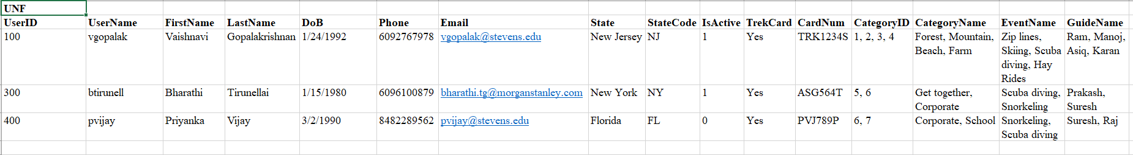

**First NF: Trekkers**

Any table in first normal form should have

* no duplicate rows or tuples in the relation.
* Only one value in each data field.
* entries in a column (attribute) of the same kind (type).

The table contains 8 tuples with no multivalued attributes.

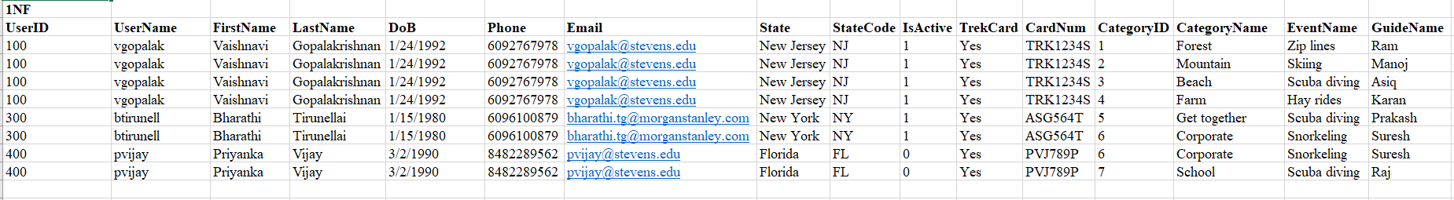

**Second NF:**

* Should be in 1NF.
* Non key attribute is fully dependent on each candidate key.
* Only one primary key.

Functional Dependency  
(UserID, CategoryID) → (UserName, FirstName, LastName, DoB, Phone, Email, State, StateCode, IsActive, TrekCard, CardNum, CategoryName, EventName, GuideName)

Partial Dependency  
UserID → (UserName, FirstName, LastName, DoB, Phone, Email, State, StateCode, IsActive)   
CategoryID → (TrekCard, CardNum, CategoryName, EventName, GuideName)

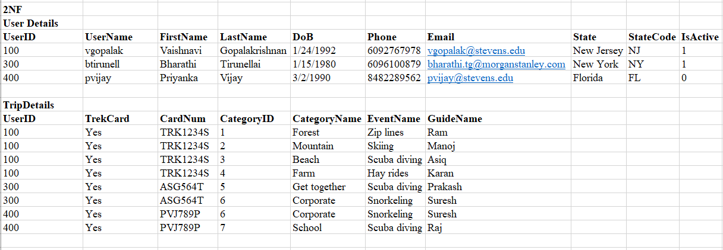

**Third NF:**

* Should be in 2NF.
* Non key attributes are non-transitively dependent on each candidate key.

Transitive Dependency   
StateCode → State

