CHAPTER 1
INTRODUCTION

  - OVERVIEW

The Internet occupies an important role in our routine life. Besides doing many risk-free activities, we also perform net banking, checking mails and so on which lead us to trouble. In these activities, the users are asked to login with their user ID and password for authentication. These passwords are easily stolen by the adversaries as it is just an alpha numeric password, which lead to a disaster for the victim. This type of authentication is still vulnerable to following attacks: phishing, key loggers and shoulder-surfing.

- Phishing: Phishers attempt to acquire sensitive information by masquerading as a trustworthy person.
- Key loggers: It is done by installing malicious codes.
- Shoulder-surfing: Steals sensitive information by capturing users’ inputs using video cameras.
- Replay attack: It occurs when an attacker copies a stream of messages between two parties.

Network Security

The overall goal of the network security is to protect users’ passwords from being stolen by the adversaries. Network security has become increasingly critical. Many schemes, protocols and software have been designed to protect users from some specified attacks.
Various techniques are used to remove the vulnerability. But still the traditional alpha numeric passwords are used by the victim which affects the security.
  - OBJECTIVE

We introduce the virtual password mechanism which provides more security for the users’ passwords in the internet. To the best of our knowledge, this is the only technique that defends against all the three attacks simultaneously. In this mechanism, we use two constants, a password for the user, a range for the random number and a user-defined or system generated function during registration.

Our objective is to create a function that would be unsolvable and unobservable by the adversaries. The function should have some random input provided by the server and it should be easy for the users but a secure one. Due to the generation of random numbers by using code books, we are able to overcome the disadvantages faced in network security. We also use secret little functions generated by the system or defined by the user that consists of values to be substituted by the user to calculate the virtual password. Once the password entered is correct, the user is allowed to login to their account. Here, we explain the account creation and maintaining the users’ passport. We can get the passport through the internet itself. All the information entered by the user is maintained confidentially by the admin. It is difficult for the adversaries to capture sensitive information from such a secure website. As more organizations are heavily filtering or limiting employee email and Internet access to prevent phishing and other web-based attacks, attackers are identifying other ways to fool their victims into visiting malware-laden websites. Hence virtual password can be used.
CHAPTER 2
LITERATURE REVIEW

2.1 GENERATING UNIQUE PASSWORDS

In this paper, Abadi.M, Bharat.L and Marais.A proposed a computerized method is provided for generating passwords for password controlled access points. It provides a master password, an access password and a user name. The master password, the service name, and the user name are combined using an irreversible function to generate a unique password. The function can be a one-way hash function. The combining can be performed by a browser of a client computer. A similar combining can also be used to generate a user name from the master password and the user's real name. A computer usable medium having computer readable code embodied therein for causing the generation of a unique password, the computer program product including: Computer readable program code devices configured to cause a local computer to effect the reception of a master password, a service name and a user name, a password for the user, a range for the random number and a user-defined or system generated function during registration.

This invention relates generally to computer systems, and more particularly to passwords used to gain access to computer system services and data records stored by computer systems. As an advantage the technique is easy to use, and the service name does not need to be kept secret. In addition, the method provides for a way to automatically generating unique user names. This is useful in the case of users with common "real" names [1].
2.2 SOURCE AUTHENTICATION SCHEME
In this paper [4], Fathy.A, ElBatt.T and Youssef.M explore the security merits of network coding and potential trade-offs with the widely accepted throughput beneﬁts, especially in multicast scenarios. In particular, we propose a novel Source Authentication using Network Coding (SANC) scheme that can either complement state of-the-art application-layer authentication schemes proposed in the literature or be used as a stand-alone scheme in network coding-based networks. Towards this objective, we propose a general framework for embedding the authentication information within the network coding Global Encoding Vector. This is attained using a mapping function that enforces a structure on the Global Encoding Vector to facilitate authentication at the destination. First, we illustrate the proposed concept using a simple mapping function, namely a parity bit within each network coding co-efﬁcient. Second, we present a detailed security analysis that reveals the security merits of the proposed scheme, contrasted against two baseline schemes that solely adopt application-layer authentication. Finally, we present simulation results pertaining to the network coding performance. Simulation results show that, for plausible scenarios, SANC achieves the same throughput as regular network coding. Furthermore, the results reveal that, for the same packet header, stronger security can be attained. This is conﬁrmed for small as well as scalable networks encountered in practice.
2.3 SECURED BROWSING
Gaber.E, Gobbons.P, Mattias.Y and Mayer.A suggested that an increasing number of web sites require users to establish an account before they can access the information stored on that site personalized web browsing.
Typically the user is required to provide at least a unique username, a secret password and an email address. Establishing accounts at multiple websites is a tedious task. A security and privacy aware user may have to invent a distinct username and a secure password in which both unrelated to his/her identity for each website. The user may also desire mechanisms for anonymous email. Besides the information that the user supplies voluntarily to the website, additional information about the user may owe involuntarily from the users’ site to the website due to the nature of the HTTP protocol and the cookie [5].
2.4 LOGING FROM INTERNET CAFE

Herley.C and Florencio.D, says that roaming users who use untrusted machines to access password protected accounts have few good options. An internet cafe machine can easily be running a keylogger. The roaming user has no reliable way of determining whether it is safe, and has no alternative to typing the password. We describe a simple trick the user can employ that is entirely effective in concealing the password. We verify its efficacy against the most popular keylogging programs [7].
2.5 SELF ENCRYPTION AUTHENTICATION
Jiang.Y and Shen.X [8] proposed a novel authentication protocol for teleconference service. The main features of the proposed protocol include identity anonymity, one-time Pseudonym Identity (PID) renewal and location intracability. Identity anonymity is achieved by concealing the real identity of a mobile conferee in a prearranged PID. It is shown that the security has been significantly enhanced, while the computation complexity is similar to the existing ones appeared in the literature.
2.6 VIRTUAL PASSWORD FOR ATM
Lei.M, Xiao.Y and Li.C [9] said that People enjoy the convenience of on-line services, Automated Teller Machines (ATMs), and pervasive computing, but online environments, ATMs, and pervasive computing may bring many risks. We propose a virtual password concept involving a small amount of human computing to secure users’ passwords in on-line environments, ATMs, and pervasive computing. We adopt user-determined randomized linear generation functions to secure users’ passwords based on the fact that a server has more information than any adversary does. We analyze how the proposed schemes defend against phishing, key logger, and shoulder-surfing attacks.
2.7 PIN-ENTRY METHOD
Roth.V, Ritcher.K and Freidinger.R [11] mentioned that magnetic stripe cards are in common use for electronic payments and cash withdrawal. Reported incidents document that criminals easily pickpocket cards or skim them by swiping them through additional card readers. Personal identification numbers (PINs) are obtained by shoulder surfing, through the use of mirrors or concealed miniature cameras. Both elements, the PIN and the card, are generally sufficient to give the criminal full access to the victim’s account. In this paper, we present alternative PIN entry methods to which we refer as cognitive trapdoor games. These methods make it significantly harder for a criminal to obtain PINs even if he fully observes the entire input and output of a PIN entry procedure. We also introduce the idea of probabilistic cognitive trapdoor games, which offer resilience to shoulder surfing even if the criminal records a PIN entry procedure with a camera.
Each time a user withdraws money from an ATM or unlocks his cell phone, he types the identical four-digit PIN number sequence. Anyone who observes this procedure e.g., by looking over the shoulder of a user, can easily memorize the PIN. In conjunction with stolen or skimmed material such as magnetic stripe cards, account numbers printed on receipts, or mobile devices, criminals easily gain access e.g., to a victimized user’s bank account [4, 33] or telecommunication services.
2.8 MULTICAST AUTHENTICATION
Wang.H states that [12] broadcast transmission enables a sender to distribute data to many receivers via a public communication channel such as the Internet. Applications cover a large scope of areas such as software updates, sensor networks and GPS signals for instance. Nevertheless, existing Internet IP protocols only provide a best-effort delivery process and the large number of receivers prevents lost content from being redistributed. Furthermore, malicious users having access to the network can perform harmful actions on the data stream. Thus, the security relies on two aspects: the network properties and opponents’ computational power. In this paper, we will consider the computationally secure model for broadcast authentication. That is, the opponents have bounded computational abilities.
2.8 SHOULDER-SURFING RESISTANT

Wiedenbeck.A, Waters.J, Sobrado.L, and Birget.J, states when users input their passwords in a public place, they may be at risk of attackers stealing their password. An attacker can capture a password by direct observation or by recording the individual’s authentication session.
This is referred to as shoulder-surfing and is a known risk, of special concern when authenticating in public places. Until recently, the only defense against shoulder-surfing has been vigilance on the part of the user. This paper reports on the design and evaluation of a game-like graphical method of authentication that is resistant to shoulder-surfing. The Convex Hull Click (CHC) scheme allows a user to prove knowledge of the graphical password safely in an insecure location because users never have to click directly on their password images. Usability testing of the CHC scheme showed that novice users were able to enter their graphical password accurately and to remember it over time. However, the protection against shoulder-surfing comes at the price of longer time to carry out the authentication [14].
2.10 SECRET LITTLE FUNCTIONS

In this paper, Xiao.Y and Lei.M discuss how to prevent users’ passwords from being stolen by adversaries. They propose differentiated security mechanisms in which a user has the freedom to choose a virtual password scheme ranging from weak security to strong security. The tradeoff is that the stronger the scheme, the more complex the scheme may be. Among the schemes, we have a default method (i.e., traditional password scheme), system recommended function, user-specified function, user-specified program, etc. A function/program is used to implement the virtual password concept with a tradeoff of security for complexity requiring a small amount of human computing. We further propose codebook approach to serve as system recommended functions and provide a security analysis. For user-specified functions, we adopt secret little functions, in which security is enhanced by hiding secret functions/algorithms [15].
CHAPTER 3
SYSTEM ANALYSIS

3.1 EXISTING SYSTEM

The Internet has entered into our daily lives as more and more services have been moved online. While we enjoy its convenience, we are putting ourselves at risk. Most current commercial websites will ask their users to input their user identifications (IDs) and corresponding passwords for authentication. Once a user’s ID and the corresponding password are stolen by an adversary, the adversary can do anything with the victim’s account, which can lead to a disaster for the victim. As a consequence of increasing concerns over such risks, protecting users’ passwords on the web has become increasingly critical.

Users with important accounts on the Internet face many kinds of attacks, e.g., a user ID and password can be stolen and misused. The secure protocol SSL/TLS for transmitting private data over the web is well-known in academic research, but most current commercial websites still rely on the relatively weak protection mechanism of user authentications via a plaintext password and user ID. Meanwhile, even though a password can be transferred via a secure channel, this authentication approach is still vulnerable to attacks as follows: Phishing, Password Stealing Trojans and Shoulder-Surfing. Many schemes, protocols, and software have been designed to prevent users from some specified attacks. However, to the best of our knowledge, so far, there is not a scheme which can defend against all the types of attacks listed above at the same time.

3.2 PROPOSED SYSTEM

We present a password protection scheme that involves a small amount of human computing in an Internet based environment, which will be resistant to a phishing scam, a Trojan horse, and shoulder-surfing attacks. We propose a virtual password concept that requires a small amount of human computing to secure users’ passwords in on-line environments. We adopt user-determined randomized linear generation functions to secure users’ passwords based on the fact that a server has more information than any adversary does. We analyze how the proposed scheme defends against phishing, Trojan horses, such as key loggers, and shoulder surfing attacks. To the best of our knowledge, our virtual password mechanism is the first one which is able to defend against all three attacks together.

To authenticate a user, a system (S) needs to verify a user (U) via the user’s password (P) which the user provides. In this procedure, S authenticates U by using U and P, which is denoted as: S (U): U, P. All of S, U, and P are fixed. It is very reasonable that a password should be constant for the purpose of easily remembering it. However, the price of easy to remember is that the password can be stolen by others and then used to access the victim’s account. At the same time, we cannot put P in a randomly variant form, which will make it impossible for a user to remember the password. To confront such a challenge, we propose a scheme using a new concept of virtual password.

A virtual password is a password which cannot be applied directly but instead generates a dynamic password which is submitted to the server for authentication.
A virtual password P is composed of two parts, a fixed alphanumeric F and a function B from the domain ψ to ψ, where the ψ is the letter space which can be used as passwords.
Table 3.1 Differences between existing and proposed system
S. No. | Existing System | Proposed System
1 | Usage of alphanumeric passwords. | Usage of virtual passwords.
2 | Problems like phishing, trojans and shoulder surfing. | It overcomes all the problems.
3 | Constant password. | Random password.
4 | Less secured compared to proposed system. | More secured than other mechanisms.

We have P=(F, B) and B(F, R) = Pd, where R is a random number provided by the server (called the random salt and prompted in the login screen by the server) and Pd is a dynamic password used for authentication. Since we call P=(F, B) a virtual password, we call B a virtual function. The user input includes (ID, Pd), where ID is a user ID. On the server side, the server can also calculate Pd in the same way to compare it with the submitted password.

CHAPTER 4
SYSTEM SPECIFICATION

4.1 HARDWARE REQUIREMENTS
- PROCESSOR : PENTIUM® Dual Core
- HARD DISK CAPACITY : 360 GB
- MONITOR : 14“DELL MONITOR
- RAM : 3.00 GB
- INTERNAL MEMORY CAPACITY : 128 MB
- CPU CLOCK : 1.08 GHz

4.2SOFTWARE REQUIREMENTS
- LANGUAGE : PHP
- SYSTEM TYPE : 64-bit OS
- DATABASE : MYSQL

CHAPTER 5
SOFTWARE DESCRIPTION

5.1 PHP

PHP stands for Hypertext Preprocessor. PHP scripts run inside Apache server or Microsoft IIS. PHP and Apache server are free. PHP code is very easy. PHP is the most used server side scripting language. PHP files contain PHP scripts and HTML. PHP files have the extension “php”, “php3”, “php4” or “phtml”.

Using PHP

- Generate dynamic web pages. PHP can display different content to different user or display different content at different times of the day.
- Process the contents of HTML forms. We can use a PHP to retrieve and respond to the data entered into an HTML form.
- Can create database-driven web pages. A PHP can insert new data or retrieve existing data from a database such a MySQL.
Working of PHP

PHP is a standard HTML file that is extended with additional features. Like a standard HTML file, PHP contains HTML tag that can be interpreted and displayed by a web browser. Anything we could normally place in an HTML file like Java applets, blinking text, server side scripts can be placed in PHP. However, PHP has important features that make it unique.

- PHP contains server side scripts.
- PHP provides several built-in objects.
5.2 HTML

HTML is an application of the Standard Generalized Markup Language (SGML), which was approved as an international standard in the year 1986. SGML provides a way to encode hyper documents so they can be interchanged. SGML is also a Meta language for formally describing document markup system. In fact HTML uses SGML to define a language that describes a WWW hyper document’s structure and inter connectivity. Following the rigors of SGML, TBL bore HTML to the world in 1990. Since then, many of us have it to be easy to use but sometimes quite limiting. These limiting factors are being addressed but the World Wide Web Consortium (W3C) at MIT. But HTML had to start somewhere, and its success argues that it didn’t start out too badly.
5.3 DATABASE

A database is simply a collection of used data just like phone book. MySQL database include such objects as tables, queries, forms, and more. These tables are stored in the same database file because they are often used together to create reports to help to fill out on screen forms.
Properties
Properties are the specification we assigned to parts of our database design. We can define properties for fields, forms, controls and most other access objects. These objects help us to know more information about the fields present in the data base.

5.4 MYSQL
MySQL Server is a powerful database management system and the user can create application that requires little or no programming. It supports GUI features and an entire programming language, phpmyadmin which can be used to develop richer and more developed application.

The MySQL database can act as a back end database for PHP as a front end. MySQL supports the user with its powerful database management functions. A beginner can create his/her own database very simply by some mouse clicks. Another good reason to use MySQL as backend tool is that it is a component of the overwhelmingly popular Open source software which can perform the following;
- Design the structure of the tables and how they relate to one another.
- Add, edit and delete data.
- Sort and manipulate data.
- Query the database.

MySQL was developed by a consulting firm in Sweden. They were in need of a database system that was extremely fast and flexible. So they created MySQL, which is loosely based on another database management system called SQL. It is not a form of database, but a database system that uses SQL to create, manipulate and show data. These files can store tons of information that can be manipulated and called on when needed. SQL is a programming language that is used by MySQL to accomplish tasks within a database, just as Excel uses VBA to handle tasks with spreadsheets and workbooks.

CHAPTER 6
PROJECT DESCRIPTION

6.1 OVERVIEW OF THE PROJECT

This mechanism is with an eye toward how it can be used to protect user from adversaries who steal the sensitive information. We describe the mechanism of virtual password for user interaction in the most challenging on-line environment. We accept a range of random salt, a constant number, a matrix value and a password for user. Those values are substituted in the secret functions.
Problem Description
The Internet occupies an important role in our routine life. Besides doing many risk-free activities, we also perform net banking, checking mails and so on which lead us to trouble. In these activities, the users are asked to login with their user ID and password for authentication. These passwords are easily stolen by the adversaries as it is just an alpha numeric password, which lead to a disaster for the victim. The overall goal of the network security is to protect users’ passwords from being stolen by the adversaries. Various techniques are used to remove the vulnerability. But still the traditional alpha numeric passwords are used by the victims which affect the security. Network security has become increasingly critical. Many schemes, protocols and software have been designed to protect users from some specified attacks. Phishing attacks are relatively new but very effective. There are two typical types of phishing. First is to prevent phishing emails. Second is to defend against phishing websites.

6.2 ENTITY-RELATIONSHIP DIAGRAM
Qualification
Address
Name

Apply
View
Name
Address
Passport No
Address
Passport
Qualification
Name
User Name
Name
Users
View
Manage
Passport
Admin
Passport

Fig 6.1 E-R diagram for applying passport

6.3 MODULES DESCRIPTION
Modules List:
- User registration
- Login
- Passport application
- View passport status
- Admin login
- View registered users
- Update passport status

    - User Registration:
First of all the user has to register their details like user id, password. This registration is used to avoid anonymous users. User has to select the constant factor, a range for the random salt generation and a matrix value. For every user a unique random salt will be generated during every login. The user has to select the random function available for him during registration phase. The function may be user defined or system generated. The random salt number is generated using code books. The password must be a 4 digit positive integer. The user must click the register button. The user details are registered in the database. The registration phase is the first module through which, the number of user are maintained with a unique password for each. The virtual password helps us to secure their password and sensitive information. However, we do not use Secured Socket Layer or Transport Layer Security. The password can also be encrypted for more security. Any encryption mechanism can be used. This includes the cryptographic analysis.

6.3.2 Login:
In this module, user must enter his user name. Once he entered, a random number appears. Then the user enters the constant value a, select a particular digit from his password and this is the value of the variable b, enter the random salt value in x and the matrix value in y. Finally apply the values of x, y, b and constant values against the selected function. The system also calculates the result against the entered values. If user gives the same value as of the system, the system authenticates the user to login.
Apply Passport
Login Name
User
passport
address
View passport
Name
passport
Passport No
Print Passport
Name
passport
Photo

Fig 6.2 DFD for User login
6.3.3 Passport Application
This system can be used for various applications. For example, this is developed for applying passport application and to view the passport status securely by the registered user. He/she can also get the passport dispatched via online. After logging into the system the user register for the new passport application by giving the details like first name, last name, gender, date of birth, qualification, marital status, father name, mother name, address, email, and phone number. Captcha concept is implemented for recognizing human. This is a type of challenge response test used in computing as an attempt to ensure that the response is generated by a human being.
The process usually involves a computer asking a user to complete a simple test which the computer is able to grade. These tests are designed to be easy for a computer to generate but difficult for a computer to solve, but again easy for a human. If a correct solution is received, it can be presumed to have been entered by a human. It is known as completely automated public turning test to tell computers and human apart.
6.3.4 Admin login
Here administrator login by using their unique username and password. Administrator is the only authorized person to access admin module for security purpose. So other users don’t get rights to access this module. The admin can view the registered user, check for other details and update their passport status.
View User
Login Name
Admin
passport

Name
passport
Approve Passport

Fig 6.3 DFD for admin login
6.3.5 View Registered User
In this module, admin view the users who have applied for passport. He views the user information like User’s location, first name, last name, gender, date of birth, qualification, marital status, father name, mother name, address, email, and phone number, whether the amount is paid or not. If paid, whether it is cash or DD. The bank details are verified. He verifies the ration card details and the photo uploaded by the user. Usually, admin verifies the user with his/her file. And check-on for it.
6.3.6 Update Passport Status
In this module admin update the status of user who has applied for passport. Admin can hold the passport or dispatch the passport of the user according to the specified details. If the admin is satisfied with the details entered by the user, the passport is dispatched to the specified address on date. Or else, the user can also take the print out of the passport from the website with his unique ID or password. If the admin find something wrong or not satisfied with the information provided or if it is invalid, admin holds the passport of the particular user. Once the passport is dispatched, it is updated in the database.

Login Name
User
Apply Passport

passport
Address

Login Name
Admin
Approve
passport

Passport No

Fig 6.4 DFD for passport approval
6.3.7 View Passport Status
In this module, user view the passport status, whether the passport has be dispatched or under service. If the passport has been dispatched the user can view his passport and take printout of the passport. His photo, personal information like DOB, address, father name will be printed. Suppose, the status is on hold, the user must proceed with the same process again.

  - SYSTEM DESIGN
System design is a “how to” approach to creation of a new system. System design goes through 2 phases. They are
- Logical design
- Physical design
Logical design reviews the present physical system, prepares input and output specifications, makes edit security and control specifications. Physical design maps out the details of the physical system, plans, system implementation, device a test and implementation plan.
Fig 6.5 Password authentication
6.4.1 Design process
6.4.1.1 Input design

Input design is the process of converting the user-oriented. Input to a computer based format. The goal of the input design is to make the data entry easier, logical and free error. Errors in the input data are controlled by the input design. The quality of the input determines the quality of the system output. All the data entry screens are interactive in nature, so that the user can directly enter into data according to the prompted messages. The users can directly enter into data according to the prompted messages. The users are also provided with option of selecting an appropriate input from a list of values.
Table 6.1 Breaking password by phishing attack
Symbol size 10
Input design features can ensure the reliability of the system and produce result from accurate data or they can result in the production of erroneous information.

This will reduce the number of error, which are otherwise likely to arise if they were to be entered by the user itself. Input design is one of the most important phases of the system design. Input design is the process where the input received in the system are planned and designed, so as to get necessary information from the user, eliminating the information that is not required. The aim of the input design is to ensure the maximum possible levels of accuracy and also ensures that the input is accessible that understood by the user. The input design is the part of overall system design, which requires very careful attention. If the data going into the system is incorrect then the processing and output will magnify the errors.
The objectives considered during input design are:
- Nature of input processing.
- Flexibility and thoroughness of validation rules.
- Handling of properties within the input documents.
- Screen design to ensure accuracy and efficiency of the input relationship with files.
- Careful design of the input also involves attention to error handling, controls, batching and validation procedures.
6.4.1.2 Output design
The output form of the system is either by screen or by hard copies. Output design aims at communicating the results of the processing. The reports are generated to suit the needs of the users .The reports have to be generated with appropriate levels. In our project outputs are generated by asp as html pages. As its web application output is designed in a very user-friendly this will be through screen most of the time.
6.4.1.3 Code design
The main purpose of code design is to simplify the coding and to achieve better performance and quality with free of errors. The coding is prepared in such a way that the internal procedures are more meaningful validation manager is displayed for each column. The coding of the variables is done in such a way that one other than person who developed the packages can understand its purpose. To reduce the server load, the project is designed in a way that most of the Validation of fields is done as client side validation, which will be more effective.
6.4.1.4 Database design
The database design involves creation of tables that are represented in physical database as stored files. They have their own existence. Each table constitute of rows and columns where each row can be viewed as record that consists of related information and column can be viewed as field of data of same type. The table is also designed with some position can have a null value. The database design of project is designed in such a way values are kept without redundancy and with normalized format.
Data Store
A data store is a holding place for information within the system: It is represented by an open ended narrow rectangle. Data stores may be long-term files such as sales ledgers, or may be short-term accumulations: for example batches of documents that are waiting to be processed. Each data store should be given a reference followed by an arbitrary number. A data flow shows the flow of information from its source to its destination.
A data flow is represented by a line, with arrowheads showing the direction of flow. Information always flows to or from a process. . A DFD consists of series of bubbles join by the data flows in the system. The purpose of data flow diagrams is to provide a semantic bridge between users and systems developers.
Table 6.2 Attribute of the table “Passport”
Table name : passport
Primary key : id
Field name | Data type | Description
Id | int(10) | Auto increment id
Uid | varchar(100) | User id to login
Poffice | varchar(100) | Passport office area
Dist | varchar(100) | District of passport area
Fname | varchar(100) | First name of the user
Lname | varchar(100) | Last name of the user
Gender | varchar(100) | Gender of the user
Dob | varchar(100) | Date of birth of user
Qualification | varchar(100) | Education qualification of user
present_addr | varchar(500) | Present address of the user
Mobile | varchar(100) | Mobile no of the user
permanent_addr | varchar(500) | Permanent address of the user
Email | varchar(100) | Email id of the user
Marital | varchar(100) | Marital status of the user
Father | varchar(100) | Father name of the user
Mother | varchar(100) | Mother name of the user
Profession | varchar(100) | Profession of the user
Spouse | varchar(100) | Spouse name of the user
National | varchar(100) | Nationality of the user
Height | varchar(100) | Height of the user
Weight | varchar(100) | Weight of the user
Hair | varchar(100) | Hair color of the user
City | varchar(100) | City of the user
State | varchar(100) | State of the user
Pin | varchar(100) | Pin code of the user city
Photo | varchar(100) | Photo of the user
prev_apply | varchar(100) | Previous of the user
Payment | varchar(100) | Payment type for passport apply
Amount | varchar(100) | Payment amount for passport apply
Status | varchar(100) | Status of the passport

Table 6.3 Attribute of table “register”
Table name : register
Primary key : id
Field name | Data type | Description
Id | int(5) | Auto increment insertion id
Uid | varchar(100) | User id to login
start_limit | varchar(100) | Random salt starting number
end_limit | varchar(100) | Random salt ending number
Pass | varchar(100) | User password
Func | varchar(100) | Password function
A | varchar(10) | ‘A’ value of the password
random_num | varchar(10) | Random salt number
6.4.2 DFD
The first step is to draw a data flow diagram (DFD). A DFD also known as a “bubble chart” has the purpose of clarifying system requirements and identifying major transformations that will become programs in system design
The diagrams are:
- Graphical, eliminating thousands of words;
- Logical representations, modeling WHAT a system does, rather than physical models showing HOW it does it;
- Hierarchical, showing systems at any level of detail; and
- Jargon less, allowing user understanding and reviewing.

    - Codebook

We first assume that our server has sufficient computing power to run a cryptographically secure random number generator. This requirement is necessary to protect the whole system; in case a user loses their codebook, the system will not be compromised and the user can easily ask for a new codebook without changing the parameters of the random number. Note that linear congruential generators is not as cryptographically
secure as codebook. Our first codebook is rather straightforward. In the setup session, the user decides the length of the password, n. For security analysis, we consider the phishing attack because it is the most aggressive attack in which the adversary can control the random number R. For each attack, the phisher will provide a fake random number R to the victim. If successful, the adversary will get four corresponding digits in the codebook.
To maximize the information gained, the adversary will ask different positions in each phishing..
    - Security Analysis for Secret Little Functions
User specified functions can be infinite. Since attackers do not know the function forms (i.e., secret encryption algorithms), These simple functions are very secure. Therefore, secret little functions can easily prevent phishing, shoulder-surfing, key-logger, and even multiple attacks. How many successful phishing attacks can be tolerated by secret little functions? The answer is infinite. For key-logger/shoulder-suffer, the secret little functions can remain secure after the adversary obtains many virtual passwords. Next, we prove that the proposed scheme can prevent the following attacks;
- Phishing: Since each time, each time the user inputs a virtual password, the phishing attacker could get the virtual password, but cannot obtain the real password. The virtual password is different each time.
- Shoulder-surfing: Since each time, each time the user inputs a virtual password, the shoulder-surfing attacker could get the virtual password, but cannot obtain the real password. The virtual password is different each time.
- Key-logger: Since each time, each time the user inputs a virtual password, the Key-logger attacker could get the virtual password, but cannot obtain the real password. The virtual password is different each time.
- Replay attack: The virtual password does not suffer the replay attack since each time the server generated a different random number.

Under the brute-force attack, secret little function is much more secret than any other symmetric cipher. For an attacker to try to use the brute-force attack, the number of alternative keys
    - Security Analysis for Codebook
The codebook approaches can prevent shoulder-surfing and key-logger since a human is not likely to tolerate more than two or three phishing attacks without being able to get into the system. Random salt is much stronger than the codebook approach since the function using a codebook cannot survive ten successful phishing attacks while the random salt can survive an arbitrary number of successful phishing attacks. Thus, with the strength and weakness of the three possible real-world attacks in mind, we do not have to examine our schemes with theoretical cryptographic standards that may lead us to an impossible task under the computational constraints of designing a virtual password scheme; instead, we look for an economic method that can protect passwords against the three methods under some reasonable assumptions. The user and the server (for example, the banker) may have different prospects. A user may feel relatively protected if the key space is dropped to a few hundred, as long as the login process will be locked after a few wrong tries. On the other hand, the server may not agree if the determining adversary can have a few hundred victims over a short period, because that means the adversary has a very good change of compromising at least one or two accounts.
6.4.6 Quantitative Analysis for attacks
Quantitative analysis is always necessary in security analysis. We differentiate the three common methods of stealing passwords according to the degree of damage they are able to cause. It may be difficult to clearly say that one attack is more powerful than the other, but they do have different properties that may affect design principles for password protection against them. Phishing is the most aggressive method, since the adversary can choose fake random numbers to help him/her figure out the hidden part of the password.
The possible key-space dramatically drops after a few successful phishing attacks. But the adversary cannot conduct successful attacks on the same victim too many times because the victim will eventually become suspicious. Shoulder-surfing attack is less aggressive due to its physical constraints. The adversary may just randomly pick up a victim and obtain some limited data over the victim’s shoulder. Even if a camera is well installed at a certain spot, the victims still arrive on a random basis. The adversary has no control over them. On the other hand, we may assume that the adversary can also observe the random numbers provided by the system. In other words, if the virtual password function is not complicated enough, the key-space will significantly drop after a few shoulder-surfing attacks. Key-logger is the least aggressive attack among the three because the adversary cannot control and observe the random number. It may be safe to assume that the adversary cannot observe the random number provided by the system because the random numbers are shown on the screen and user key/mouse actions usually do not react directly to the numbers. However, the victim may not be able to know that he/she is under attack. We also note that a small amount of human-computing is involved in the authentication process. We have to choose a VPF to make the calculation as simple as possible if the helper-application is not used. A user has to remember both the hidden password and the function (i.e., VPF), and as a result more effort is required to remember them. However, the virtual password will be resistant to a dictionary attack, mostly because users like to create a password which is either related to their own name, date of birth, other simple words, and so on. In a traditional password scheme, users can change their password. This is also true in our virtual password scheme. Unlike the traditional scheme, users can change the hidden password, the VPF, or both.
CHAPTER 7
SOFTWARE TESTING

7.1 SYSTEM TESTING
It is the process of exercising software with the intent of finding and ultimately correcting errors. This fundamental philosophy does not change for web applications, because web based system and applications reside on network and inter-operate with many different operating systems, browsers, hardware platforms and communication protocols. Thus searching for errors is significant challenge for web applications.
Testing issues:
- Client GUI should be considered.
- Target environment and platform considerations
- Distributed database considerations
- Distributed processing consideration

7.2 TESTING AND METHODLOGIES
System testing is the state of implementation, which is aimed at ensuring that the system works accurately and efficiently as expect before live operation, commences. It certifies that the whole set of programs hang together System testing requires a test plan that consists of several key activities and steps for run program, string, system and acceptance testing.
The implementation of newly design package is important in adopting a successful new system.
Testing is important stage in software development. System test is implementation should be a confirmation that all is correct and an opportunity to show the users that the system works as they expected. It accounts the largest percentage of technical effort in software development process.
Unit testing
Here each program is tested individually so any error apply unit is debugged. The sample data are given for the unit testing. The unit test results are recorded for further references. During unit testing the functions of the program unit validation and the limitations are tested.
The situation is illustrated as follows:
Coding-> Debugging ->Unit testing -> Integration testing
The four categories of test that a programmer will typically perform on a program unit;
- Functional test
- Performance test
- Stress Test
- Structure test
Validation testing
Software validation is achieved through a serious of testes that demonstrate conformity with requirements. Thus the proposed system under consideration has been tested by validation & found to be working satisfactory.
Output testing
Asking the user about the format required by them tests the output generated by the system under consideration
.It can be done in two ways, one on screen and other on printer format. The output format on the screen is found to be correct as the format designed n system test.

System testing
In the system testing the whole system is tested for interface between each module and program units are tested and recorded.
It involves two kinds of activities namely
- Integrated testing
- Acceptance testing
Integrated testing
Integrated testing is a systematic technique for constructing tests to uncover errors associated with interface. Objective is to take unit tested modules and build a program structure that has been dictated by design.
Acceptance testing
Acceptance testing involves planning an execution of a functional test, performance test and stress test to verify that the implemented system satisfies the requirement. The acceptance testing is the final stage of the user the various possibilities of the data are entered and the results are tested. All the tests should be traceable to customer requirements the focus of testing will shift progressively from programs. Acceptance testing is a test conducted to determine if the requirements of a specifications or contract are met. It may involve chemical tests, physical tests, or performance tests. In systems engineering, it may involve black-box testing performed on a system
Risks
Risk analysis should be performed as part of the risk management process for each project. The data of which would be based on risk discussion workshops to identify potential issues and risks ahead of time before these were to pose cost and/ or schedule negative impacts
- Project Risks
It identifies a potential budgetary, schedule, personnel like staffing, organizing, resource, customer requirement, problems and their impact on a software project.
- Technical risks
Technical risks identify potential design implementation interface, verification, and maintenance problems.

7.3 SECURITY TECHNOLOGIES AND POLICIES
Any system developed should be secured & protected against possible hazards. Security measures are provided to prevent unauthorized access to database at various levels. Password protection & simple procedures to change the unauthorized access are provided to the users. The user will have to enter the user name and password and if it is validated he can participate in auction. Otherwise if he/she is a new user he should get registered and then he can place an order. When he/she registered they should provide authentication through jpg files (like ration card Xerox, voter identity card Xerox). A multi layer security architecture comprising firewalls filtering routers encryption & digital certification must be assured in this project in real time that order details are protected from unauthorized access.
CHAPTER 8
SYSTEM IMPLEMENTATION

8.1 IMPLEMENTATION
Implementation is the stage in the project where the theoretical design is turned into a working system. The most crucial stage is achieving a successful new system and giving a user confidence in that the new system will work efficiently and effectively in the implementation stage.
8.2 IMPLEMENTATION PROCEDURES
The implementation phase is less creative than system design. A system design may be dropped at any time prior to implementation, although it becomes more difficult when it goes to the design phase. The final report of the implementation phase includes procedural flowcharts, record layouts, and a workable plan for implementing the candidate system design into a operational design.
8.3 OPERATIONAL DOCUMENTATION
Documentation means of communication; it establishes the design and performance criteria of the project. Documentation is descriptive information that portrays the use and /or operation of the system. The user will have to enter the user name and password if it is valid he participate in auction. Otherwise if it is new user he needs to register. The system is business critical and must be fully re-documented. Even in this case, an intelligent approach is to pare documentation to an essential minimum.
Documentation means of communication; it establishes design & performance criteria for phases of the project. Documentations are descriptive information that portrays he use &/or operation of the system. Documentation tools improve the productivity. Creating document is time consuming. Documentation must be updated often. The changes which are currently undergoing are fully documented.
8.4 MAINTENANCE
Maintenance is actually implementation of the review plan as important as it is programmers and analyst is to perform or identify with him or herself with the maintenance. It is sometimes quite inefficient. There are psychological personalities and professional reasons for this. Analyst and programmers spend fair more time maintaining programmer then they do writing them. Maintenances account for 50-80% of total system development. Maintenance is expensive .One way to reduce the maintenance costs are through maintenance management and software modification audits.
Types of maintenance are
- Perfective maintenance
- Preventive maintenance

Perfective maintenance:
Changes made to the system to add features or to improve the performance.
Preventive maintenance:
Changes made to the system to avoid future problems. Any changes can be made in the future and our project can adopt the changes.

CONCLUSION & FUTURE ENHANCEMENT

CONCLUSION
We discussed the challenges of protecting users’ passwords on the internet and presented some related work in this field. We discussed how to prevent users’ passwords from being stolen by adversaries. We proposed a virtual password concept involving a small amount of human computing to secure users’ passwords in online environments. The function/program is used to implement the virtual password concept with a tradeoff between security and complexity and requires small amount of human computing. However, since simplicity and security conflict with each other, it is difficult to achieve both. In user-specified functions, we adopted secret little functions in which security is enhanced by hiding secret functions/algorithms. In conclusion, user-defined functions (secret little functions) are better. It’s more secure, especially in an insure environment such as the Internet cafe.
FUTURE ENHANCEMENT
In the future, we plan to study how to design smarter functions to alleviate the computation-burden of the user. We would also like to develop some small applications with building virtual passwords, which will be able to run at a customer’s wireless device, such as a cellular phone or a PDA. With such an application, the user only needs to input the system random digits which the system provides and then the virtual password is automatically calculated for the user.

APPENDIX
- SOURCE CODE
Registration
<?php
include "config.php";
?>
<!DOCTYPE html PUBLIC "-//W3C//DTD XHTML 1.0 Transitional//EN" "http://www.w3.org/TR/xhtml1/DTD/xhtml1-transitional.dtd">
<html xmlns="http://www.w3.org/1999/xhtml">
<head>
<meta http-equiv="Content-Type" content="text/html; charset=utf-8" />
<title>Virtual Password Authentication Scheme To Protect Password</title>
<link rel="stylesheet" href="style.css" type="text/css" />
<script type="text/javascript">
function rand(str)
{
document.getElementById('common').value=str;
}
</script>
</head>
<body>
<div id="header">
<div id="header_background">
<div id="total">
<?php
}
onClick="return rand(this.value);">&nbsp;&nbsp;<input type="button" name="6" value="6" onClick="return rand(this.value);"></td></tr>
<tr><td><input type="button" name="7" value="7" onClick="return rand(this.value);">&nbsp;&nbsp;<input type="button" name="8" value="8" onClick="return rand(this.value);">&nbsp;&nbsp;<input type="button" name="9" value="9" onClick="return rand(this.value);"></td></tr>
<tr><td><input type="hidden" name="common" id="common" value=""></td></tr>
</table>
</form>
</td>
</tr>
</table>
<?php
}
}
?>
</div>
<div id="footer">
All rights reserved @2012
</div>
</div>
</div>
</div>
</body>
</html>
<?php
if(isset($_POST['submit']))
{
$uid=$_POST['uid'];
$random_salt=$_POST['random_salt'];
$pass=$_POST['pass'];
$common=$_POST['common'];
$func=$_POST['func'];
$uid=$_GET['uid'];
if(empty($uid))
{
mysql_query("insert into register(uid,rand,pass,common,func)values('$uid','$random_salt','$pass','$common','$func')")or die(mysql_error());
}
else if(!empty($uid))
{
mysql_query("update register set pass='$pass',common='$common',func='$func' where uid='$uid'")or die(mysql_error());
}
}
?>
<!DOCTYPE html PUBLIC "-//W3C//DTD XHTML 1.0 Transitional//EN" "http://www.w3.org/TR/xhtml1/DTD/xhtml1-transitional.dtd">
<html xmlns="http://www.w3.org/1999/xhtml">
<head>
<meta http-equiv="Content-Type" content="text/html; charset=utf-8" />
<title>Virtual Password Authentication Scheme To Protect Password</title>
<link rel="stylesheet" href="style.css" type="text/css" />
</head>
<body>
<div id="header">
<div id="header_background">
<div id="total">
<div id="menu">
<?php require "menu.php"; ?>
</div>
<div id="title">
Virtual Password Authentication Scheme To Protect Password
</div>
<div id="content">
<div id="normal_content">
</div>
<div id="footer">
All rights reserved @2012
</div>
</div>
</div>
</div>
</div>
</body>
</html>

2. SCREEN SHOTS
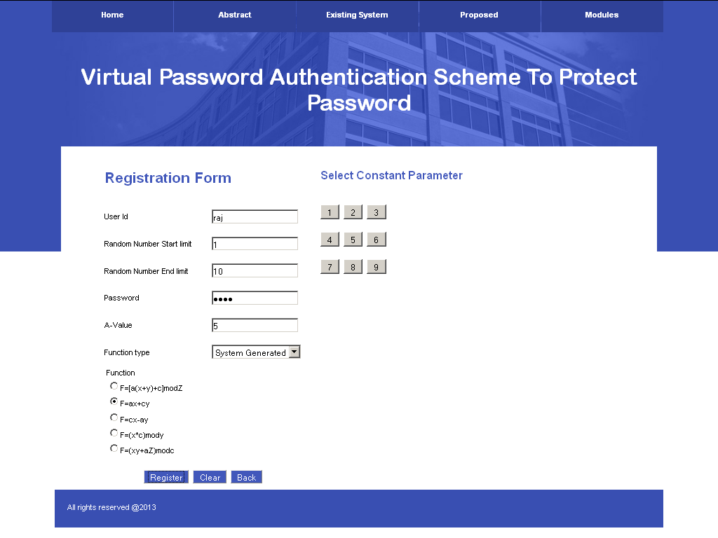
REGISTRATION PAGE

Fig 1 User registration

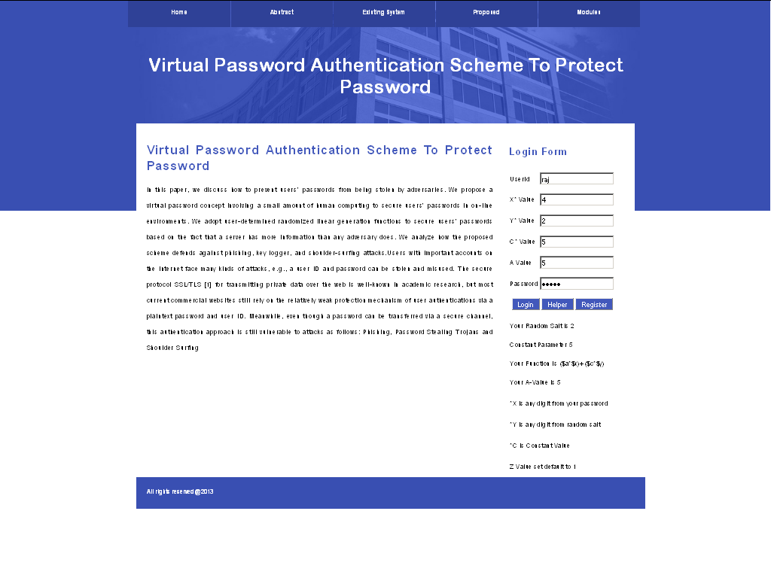
LOGIN PAGE

Fig 2 User login

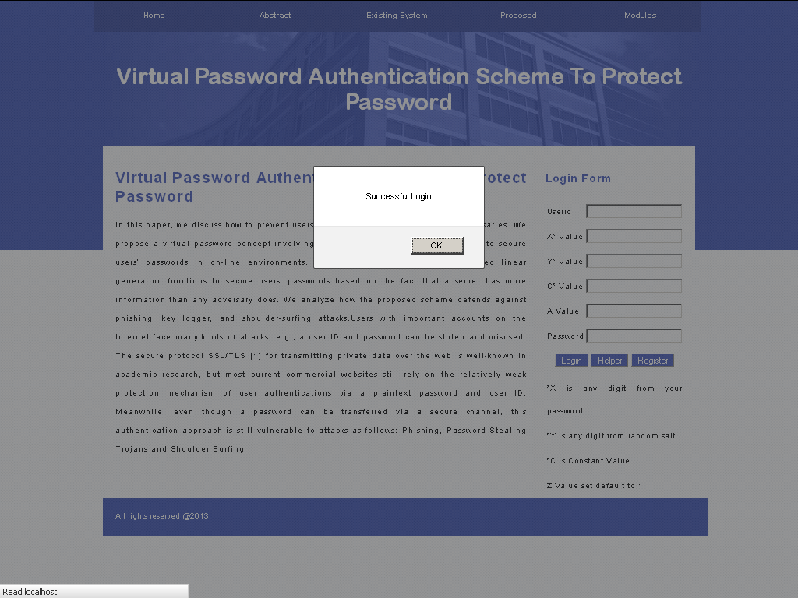
VALID LOGIN

Fig3 Password is valid

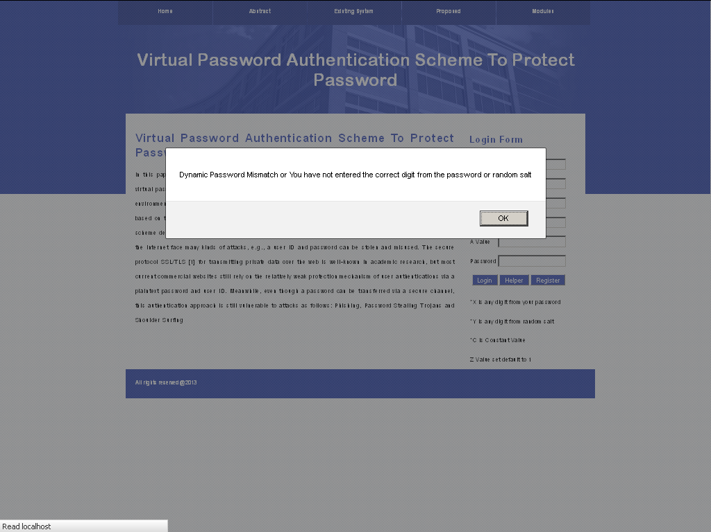
INVALID PASSWORD

Fig 4 Password doesn’t match

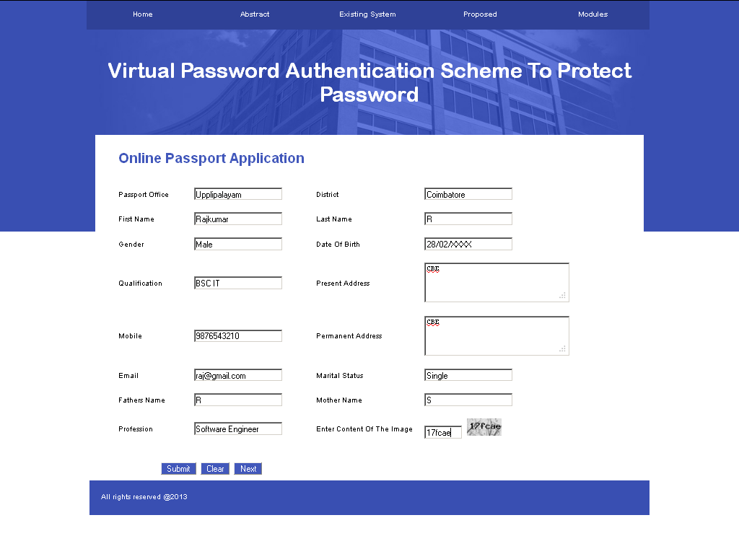
PASSPORT APPLICATION
Fig 4 Enter details of user

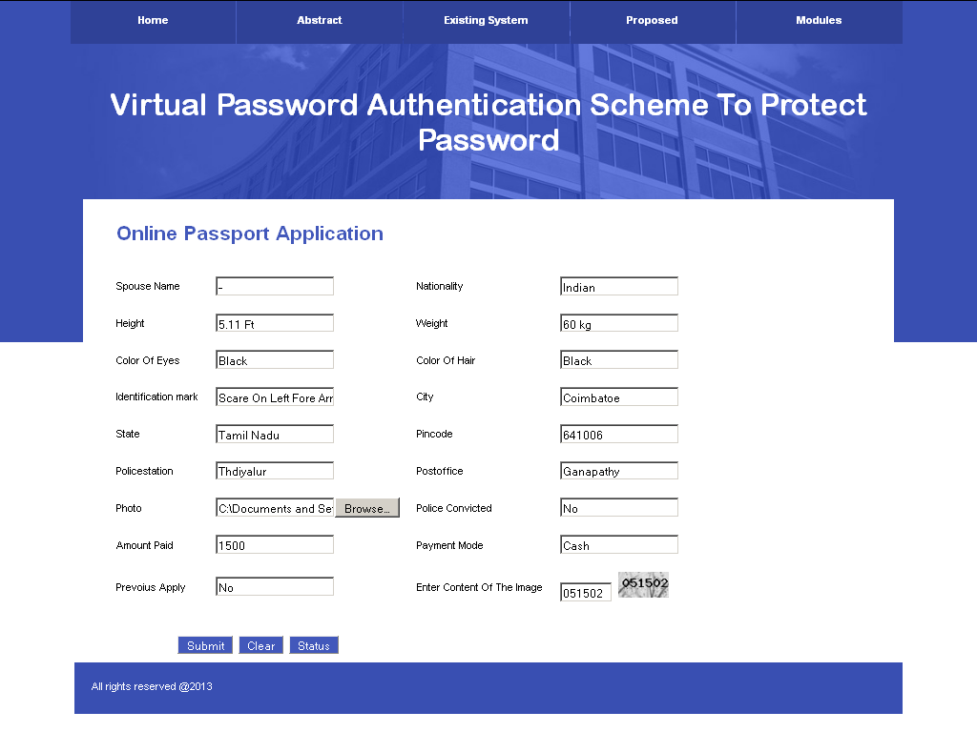
PASSPORT APPLICATION SUBMISSION

Fig 5 Enter details in 2nd page
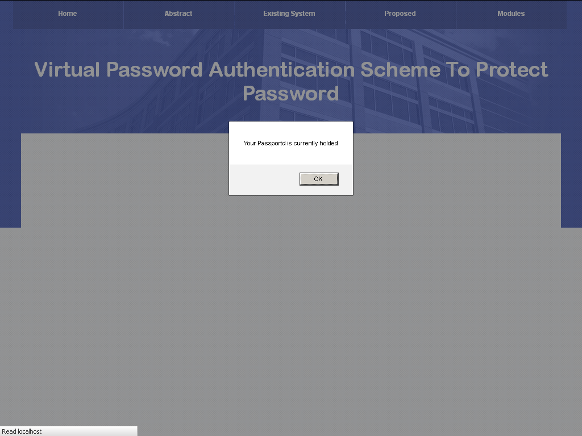
UPDATE PASSPORT STATUS

Fig 6 Status update by the admin

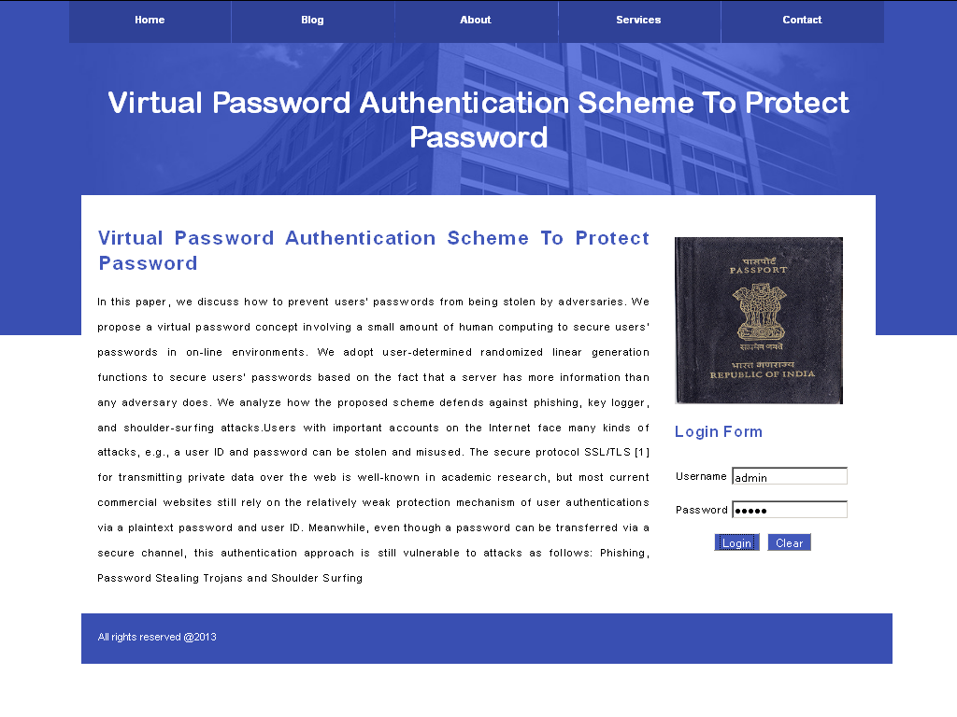
ADMIN LOGIN
Fig 7 Admin authentication

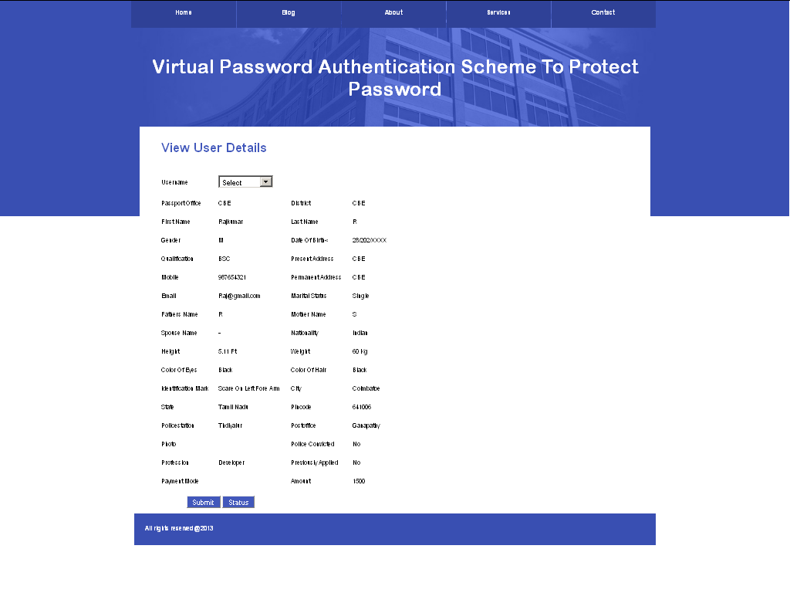
VIEW REGISTERED USER
Fig 8 User details

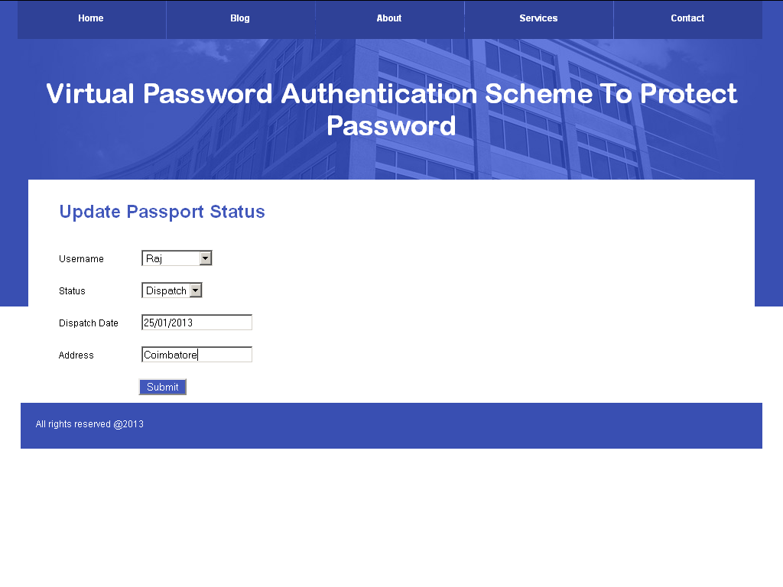
UPDATE STATUS

Fig 9 Updating status of user

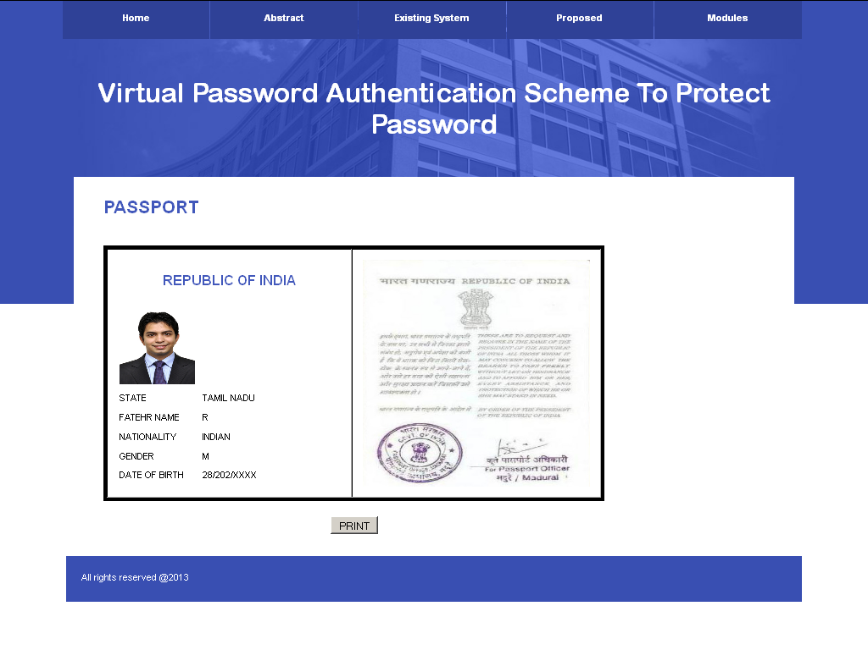
VIEW PASSPORT STATUS
Fig 8 User view his passport

REFERENCES

- Abadi.M, Bharat.L and Marais.A, (1997) “System and method for generating unique passwords” U.S. Patent 6 141 760.

- Ateniese.G, Fu.K, Green.M and Hohenberger.S, (2005) “Improved proxy re-encryption schemes with applications to secure distributed storage” In Proc. 12th Annu. Netw. Distributed Syst. Security Symp.

- Damiani.E, S.D.C.di Vimercati, Paraboschi.S, Samarati.P, Tironi.A and Zaniboni.L, (2004) “Spam attacks: P2P to the rescue” In Proc. 13th Int. World Wide Web Conf. pp. 358–359.

- Fathy.A, ElBatt.T and Youssef.M, (2011) “A source authentication scheme using network coding” Int. J. Security Netw., vol. 6, nos. 2–3, pp. 112–122.

- Gabber.E, Gobbons.P, Mattias.Y and Mayer.A, (1997) “How to make personalized web browsing simple, secure and anonymous” In Proc. Financial Crypto, LNCS 1318.

- Gabber.E, Gibbons.P, Kristol.P, Matias.A, and A.Mayer, (1997) “On
secure and pseudonymous user-relationships with multiple servers,”
ACM Trans. Inform. Syst. Security, vol. 2, no. 4, pp. 390–415.

- Herley.C and Florencio.D, (2006) “How to login from an Internet cafe without worrying about keyloggers,” In Proc.
- Herzberg.A and Gbara.A (2004), “Trustbar: Protecting (Even Naive) Web Users from Spoofing and Phishing Attacks, Cryptology ePrint Archive”, Rep. 2004/155 [Online].

- Jiang.Y, Lin.C, Shi.M and Shen.X, (2005) “A self-encryption authentication protocol for teleconference services,” Int. J. Security Netw., vol. 1, nos.3–4, pp. 198–205.

- Lei.M, Xiao.Y, Vrbsky.S.V and C.Li, (2008) “Virtual password
using random linear functions for on-line services, ATMs and pervasive computing” Comput. Commun. J. Elsevier, vol. 31, no. 18, pp. 4367–4375, Dec.

- Ross.B, Jackson.C, Miyake.N, Boneh.D, and Mitchell, “Stronger password authentication using browser extensions,” In Proc. 14th USENIX Security Symp.

- Roth.V, Richter.K and Freidinger.R, (2004) “A PIN-entry method resistant against shoulder-surfing,” In Proc. 11th ACM Conf. Comput. Commun. Security, pp. 236–245.

- Tartary.C, and Wang.H (2007) “Efficient multicast stream authentication for the fully adversarial network model,” Int. J. Security Netw., vol. 2, nos. 3–4, pp. 175–191.

- Teo.J, Tan.C and Ng.J (2006) “Low power authenticated group
key agreement for heterogeneous wireless networks,” Int. J. Security Netw., vol.1, nos. 3–4, pp. 226–236.

- Wiedenbeck.A, Waters.J, Sobrado.L, and Birget.J, “Design and evaluation of a shoulder-surfing resistant graphical password scheme,” In Proc. Working Conf. Adv. Vis. Interfaces.

- Xiao.Y, Lei.M, and Vrbsky.S.V,(2008) “Secret little functions and
codebook for protecting users from password theft,” In Proc. IEEEICC, pp. 1525–1529.

