**Title of the Project Report**

**(Detection and Indication of Pot Holes On Road For Safety Of an Automobile)**

**Contents**

|  |  |  |  |
| --- | --- | --- | --- |
| **Sr. No.** | **Topic** | | **Page No.** |
| 1 | **Introduction** | | 1-3 |
| 1.0 | Introduction to ______ | 6 |
| 1.1 | Problem Statement | 7 |
| 1.2 | Objectives | 7 |
| 1.3 | Scope | 7 |
| 1.4 | Methodology | 8 |
| 1.5 | Organization of Dissertation |  |
| 2 | **Literature Review** | | 9-12 |
| 3 | **Design Work**  (Expected CAD Model/ Drawing and their description) | |  |
| 3.1 | Construction |  |
| 3.2 | Working of System |  |
| 3.3 | Experimental Setup |  |
| 4 | **Simulation (Analytical/Numerical/FEM/CFD**) | | 13-15 |
|  | 4.1 |  |  |
|  | 4.2 |  |  |
| 5 | **Possible Outcomes** | | 16 |
| 6 | **Concluding Remarks and Scope for the Future Work** | | 16 |
| 6.1 | Concluding Remarks |  |
| 6.2 | Scope for the Future Work |  |
|  | **References** | | 17 |

**Abstract**

(One of the major problems in developing countries is maintenance of roads. Well maintained roads contribute a major portion to the country’s economy. Identification of pavement distress such as potholes and humps not only helps drivers to avoid accidents or vehicle damages, but also helps authorities to maintain roads. alerts to drivers to avoid accidents or vehicle damages. Ultrasonic sensors are used to identify the potholes and humps and also to measure their depth and height, respectively. The sensed-data includes pothole depth, height of hump. which is stored in the database. This serves as a valuable source of information to the government authorities and vehicle drivers. A Buzzer is used to alert drivers so that precautionary measures can be taken to evade accidents. Alerts are given in the form of an audio beep.)

**Chapter - 1**

**Introduction**

Millions of dollars are spent in maintaining and repairing to a shallow pit on a road’s surface, caused by activities like erosion, weather, traffic and some other factors. These anomalies when accumulated in the transportation system, constitutes to major problems. These problems, even though they appear to be less significant at an individual level, constitute to major problems when taken in cumulative, collective and large scale manner. The problems constituted by these potholes result in low fuel economy, accidents, traffic coagulations etc, which have an adverse impact on the economy of a country and day to day life of citizens. It can be proved that the traffic system can be bettered to a greater extent when these problems are checked and taken care of. Detecting Potholes on roads with the help of intelligent systems is a very well-studied problem. Detecting and hence avoiding potholes may reduce the fuel consumption, wear-tear and maintenance cost of a vehicle. Also, avoiding potholes increases road safety and indirectly decreases the total travel time in some cases.

Potholes, formed due to heavy rains and movement of heavy vehicles, also become a major reason for traumatic accidents and loss of human lives.

**1.1 Problem Statement**

Also, avoiding potholes increases road safety and indirectly decreases the total travel time in some cases. The existing systems of pothole detection uses a centralized database approach. Road conditions are a matter of public concern that have engendered a number of responses from local organizations dissatisfied with the state of their roads. Some of the solutions include: establishing pothole hot-lines, holding contests to report particularly bad potholes, and asking readers to contribute pictures of potholes. We seek a more systematic approach to the problem, but hope that this public interest may cause volunteers to carry hardware in their cars.

**1.2. Objectives**

1. To built a device which is a universal system that can be installed on any passenger vehicle

2. To detect the presence of potholes and report those potholes to the driver with the help of buzzer

**1.3. Scope**

In future we can use this system widely for safety and maintenance of roads. Potholes can be auto detected using acceleration data collected using vehicle mounted wireless sensors.. The proposed system can be further improved to display alerts such as 'Bad road ahead' in order to help the driver be more alert while driving/riding on such roads.

**1.4 Methodology**

**Flow Chart**

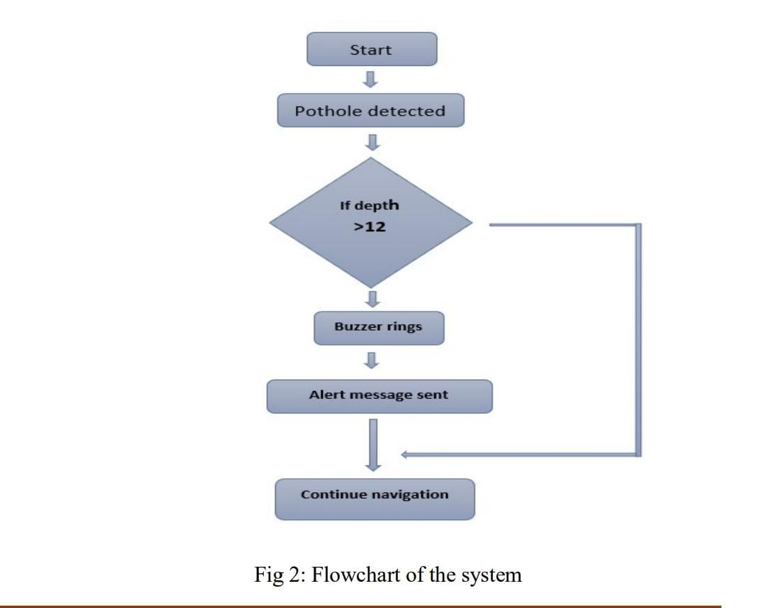

**Chapter - 2**

**Literature Review (2-4 pages)**

|  |  |  |  |  |  |
| --- | --- | --- | --- | --- | --- |
| **SR.**  **NO.** | **Name of Author/s** | **Title of the paper** | **Name of the journal (vol. no. year)** | **Relevant findings** | **Literature gap** |
| **1.** | **R. Madli,**  **S. Hebber ,**  **P. Pattar ,**  **V. Golla** | **Automatic Detection and Notification of Potholes on road** | **4313-4318,**  **2015** | **In this they used laser system to detect the potholes on roads with the help of GPS and from this they send notifications on mobile.** | **In this they can also do the research on automatic detection of potholes and humps and alerting vehicle drivers to evade potential accidents.** |
| **2.** | **Sandeep Venkatesh, Abhiram E ,Rajarajeswari S, Sunil Kumar K M , Shreyas Balakuntalay.** | **“An Intelligent System to Detect, Avoid and Maintain Potholes: A Graph Theoretic Approach”** | **2014** | **In this they used laser system to detect the potholes on roads with the help of quick wifi and navigation from which they can send location of potholes to the nearby vechiles and also update in the maps.** | **They can also send the data to municipal corporation on immediate basis so that they can repair potholes.** |
| **3.** | **Youngtae Jo and Seungki Ryu** | **“Pothole detection system using a Black-box Camera”** | **29316-29331** | **In this research they used black box cameras and GPS location to capture the photos of potholes.** | **And apart from this they can also give the signal immediately to driver so that he can be alert from that potholes and drive safely.** |
| **4.** | **J Bridgers** | **“Mobile pothole detection system and method”** | **US 20140355839 A1, Dec 4, 2014.** | **This research relates to a surface imaging system such as a surface imaging system configured to detect abnormalities in the surface.** | **In this they can use sensors to detect potholes and give signal to driver to stop the car.** |
| **5.** | **J. Cronin** | **"System and method for sensing and managing pothole location and pothole characteristi cs,"** | **US 20140196529 A1, Jul 17, 2014** | **Embodiments of the present invention are generally related to road way maintenance and repair, and, In particular to a system and method for sensing and**  **managing potholes locations and**  **potholes characteristics.** | **In this research they can also find economic solution for detection of dreadful potholes and uneven humps, as it uses low cost ultrasonic sensors.** |

**Chapter – 4**

**CODE FOR PROJECT**

**Simulation (Analytical/Numerical/FEM/CFD)**

**#define TRIGGER_PIN  12  // Arduino pin tied to trigger pin on the ultrasonic sensor.  
#define ECHO_PIN     11  // Arduino pin tied to echo pin on the ultrasonic sensor.  
#define MAX_DISTANCE 200 // Maximum distance we want to ping for (in centimeters). Maximum sensor distance is rated at 400-500cm. [this is an arbitrary number]  
#define buzzer1  2  
#define RELAY_LINE1_PIN 8  
  
// defines variables  
long duration;  
int distance;  
int safetyDistance;  
  
#include"NewPing.h"  
NewPing sonar(TRIGGER_PIN, ECHO_PIN, MAX_DISTANCE); // NewPing setup of pins and maximum distance.  
  
  
unsigned int critical_distance_cms = 25.5;  // Cutoff distance at which the light will switch [this is an arbitrary number]  
bool state = 0;  
  
void setup() {  
  Serial.begin(9600); // Open serial monitor at 115200 baud to see ping results.  
  pinMode(RELAY_LINE1_PIN, OUTPUT);  
  pinMode(buzzer1, OUTPUT);  
  digitalWrite(RELAY_LINE1_PIN, HIGH);  // Turn the light off  
}  
  
void loop() {  
  delay(50);                     // Wait 50ms between pings (about 20 pings/sec). 29ms should be the shortest delay between pings.  
  unsigned int distance = readDistance(); // Current distance of any object facing the ultrasonic sensor**

**#define TRIGGER_PIN  12  // Arduino pin tied to trigger pin on the ultrasonic sensor.  
#define ECHO_PIN     11  // Arduino pin tied to echo pin on the ultrasonic sensor.  
#define MAX_DISTANCE 200 // Maximum distance we want to ping for (in centimeters). Maximum sensor distance is rated at 400-500cm. [this is an arbitrary number]  
#define buzzer1  2  
#define RELAY_LINE1_PIN 8  
  
// defines variables  
long duration;  
int distance;  
int safetyDistance;  
  
#include "NewPing.h"  
NewPing sonar(TRIGGER_PIN, ECHO_PIN, MAX_DISTANCE); // NewPing setup of pins and maximum distance.  
  
  
unsigned int critical_distance_cms = 25.5;  // Cutoff distance at which the light will switch [this is an arbitrary number]  
bool state = 0;  
  
void setup() {  
  Serial.begin(9600); // Open serial monitor at 115200 baud to see ping results.  
  pinMode(RELAY_LINE1_PIN, OUTPUT);  
  pinMode(buzzer1, OUTPUT);  
  digitalWrite(RELAY_LINE1_PIN, HIGH);  // Turn the light off  
}  
  
void loop() {  
  delay(50);                     // Wait 50ms between pings (about 20 pings/sec). 29ms should be the shortest delay between pings.  
  unsigned int distance = readDistance(); // Current distance of any object facing the ultrasonic sensor**

**if (state)  
    {  
      Serial.println("Door Open!");  
      digitalWrite(RELAY_LINE1_PIN, LOW); // Turn the light on  
      digitalWrite(buzzer1, HIGH);  
    }  
     
    else  
    {  
      Serial.println("Door Closed!");  
      digitalWrite(RELAY_LINE1_PIN, HIGH);  // Turn the light off  
      digitalWrite(buzzer1, LOW);  
    }  
  }}  
  
// Updates the value of the Ultrasonic reading  
unsigned int readDistance()  
{  
  // Read 7 values from the ultrasonic and get the median value ( median filter )  
  // Gets rid of noisy reading  
  unsigned int distance = sonar.convert_cm(sonar.ping_median(7));  
  
  // The value 0 indicates that the ultrasonic sensor is reading nothing in front of it  
  // Set this distance to max distance so the light doesn't switch unnecessarily  
  if (distance == 0)  
  {  
    distance = MAX_DISTANCE;  
  }  
  // Prints the distance on the Serial Monitor  
Serial.print("Distance: ");  
Serial.println(distance);  
   
  return distance;  
}**

**Chapter - 5**

**Possible Outcomes**

The outcome of our project is, we are going to make a device with the help of ultrasonic sensors & Arduino. The ultrasonic sensors are used to detect potholes & that data will be send to control unit through Arduino, so the LED will be blink and alarm will be sound & the driver will know that there is a pothole ahead. He can pay attention on that. So this project is will going to be safety features in vehicle in future.

**Chapter - 6**

**Concluding Remarks and Scope for the Future Work**

**6.1. Concluding Remarks**

**6.2. Scope for the Future Work**

In future we can use this system widely for safety and main tenance of roads. Potholes can be auto detected using accel eration data collected using vehicle mounted wireless sensors. We can use sensor network deployed over a public transport system to monitor environmental pollution and road surface condition. The proposed system can be further im proved to display alerts such as 'Bad road ahead' in order to help the driver be more alert while driving/riding on such roads.

**References**

***[1] A. Wibowo, “Analisa Kecelakaan Lalu Lintas Pada***

***Ruas Jalan Utama di Wilayah Kabupaten Sragen***

***Tahun 2002-2006”, Universitas Muhammadiyah Surakarta, 2010.***

***[2] Saputra, D, “Studi Tingkat Kecelakaan Lalu Lintas Jalan di***

***Indonesia Berdasarkan Data KNKT (Komite Nasional Keselamatan***

***Transportasi) Dari Tahun 2007-2016”. Jakarta:KNKT, 2017***

***[3] J. Lin and Y. Liu, “Potholes Detection Based on SVM in the Pavement***

***Distress Image,” 2010 Ninth International Symposium on Distributed***

***Computing and Applications to Business, Engineering and Science, 2010.***

***[4] S. Joseph, “ROLE OF ULTRASONIC SENSOR IN AUTOMATIC***

***POTHOLE AND HUMP DETECTION SYSTEM,” International***

***Journal of Scientific & Engineering Research, 8, 260–265, 2017.***

***[5] R. Madli, S. Hebbar, P. Pattar, and V. Golla “Automatic Detection and***

***Notification of Potholes and Humps on Roads to Aid Drivers” in IEEE***

***sensors journal, 4313-4318, 2015***