**SEO Keyword Tracker and Analyzer**

**Group Project 3: Advanced Algorithm Section 4 Fall 2023**



**Date of Submission - 27th October 2023**

|  |  |
| --- | --- |
| **Team Members** | |
| Keshav Daga | [kd81@csu.fullerton.edu](mailto:kd81@csu.fullerton.edu) |
| Vedita Deshpande | [vedita@csu.fullerton.edu](mailto:vedita@csu.fullerton.edu) |
| Akash Avinash Butala | [akbutala@csu.fullerton.edu](mailto:akbutala@csu.fullerton.edu) |
| Vaishnavi More | [vaishnavimore@csu.fullerton.edu](mailto:vaishnavimore@csu.fullerton.edu) |
| Sri Sai Navya Manchikalapudi | [srisainavya@csu.fullerton.edu](mailto:srisainavya@csu.fullerton.edu) |
| Chathrapathi Nikhil Kandagatla | [chathrapathinikhil@csu.fullerton.edu](mailto:chathrapathinikhil@csu.fullerton.edu) |
| Hari Preetham Reddy Takuru | [haripreetham@csu.fullerton.edu](mailto:haripreetham@csu.fullerton.edu) |
| Mourya Velampati | [velampatimourya@csu.fullerton.edu](mailto:velampatimourya@csu.fullerton.edu) |

Table of Contents

|  |  |
| --- | --- |
| Introduction | 3 |
| Roles and Responsibilities | 4 |
| Methodology | 5 |
| Code Repository | 9 |
| Challenges Faced | 10 |
| Future Work | 10 |
| Conclusion | 11 |
| References | 12 |

**Introduction**

In the fast-evolving digital ecosystem, Search Engine Optimization (SEO) stands as the cornerstone of online success. Our mission is to embark on a coding odyssey, crafting the "SEO Keyword Tracker and Analyzer," a dynamic tool geared towards both tracking and meticulously analyzing SEO keywords for a specific website. As computer science students amid our algorithms class, we endeavor to showcase our prowess in applying intricate algorithms, including the Rabin-Karp, Suffix Tree, Suffix Array, Naive String Matching, and the KMP algorithm, to elevate the tool's capabilities.

The foundation of this project is rooted in a fusion of innovative technology and well-established algorithmic methods. The "SEO Keyword Tracker and Analyzer" harnesses Python scripts along find front end framework like React that encompass the power of these algorithms, for their computational efficiency and precision. These algorithmic powerhouses serve as the backbone of our tool, providing the essential edge required for top-tier SEO analysis.

Our primary aim is straightforward: to empower website owners, digital marketers, and SEO enthusiasts with an invaluable instrument. Our tool goes beyond mere keyword tracking; it conducts an intricate examination of the data, providing actionable insights that can significantly boost a website's online visibility. Through our algorithmic wizardry, we aim to unveil opportunities for optimization, spotlight areas necessitating enhancement, and guide users in their SEO journey.

The "SEO Keyword Tracker and Analyzer" isn't merely software; it's a manifestation of our commitment to mastering the art of algorithms and their practical applications in the real world. In a realm where each click and every keyword carries profound significance, this project epitomizes our dedication to innovation, data-driven decision-making, and the relentless pursuit of digital excellence. Our project isn't just a technical endeavor; it's a transformative experience, a chance to hone our algorithmic skills, and ultimately empower website owners and marketers to navigate the intricate landscape of SEO for online success.

ROLES AND RESPONSIBILITIES

# Front End developer & Full Stack Developer

* Conceptualize and craft the visual layout and design elements of the tool.
* Create an interactive user interface that simplifies data input and selection of sorting algorithms.
* Combine front-end and back-end development to ensure a seamless user experience.

# Back End Developer

* Optimize algorithms to address intricate problems or fulfill project-specific needs.
* Conduct rigorous testing and validation of algorithms to ensure the generation of accurate and dependable results, making necessary modifications as necessary.

# UI/ UX Designer

* User-Centered Design: Prioritize user needs and behaviors to create intuitive and satisfying interfaces.
* Visual Design Expertise: Create engaging and on-brand designs that enhance usability and user satisfaction.

# Data Engineer

* Data Pipeline Development: Create and maintain efficient data pipelines for collecting, processing, and storing data.
* Infrastructure Optimization: Enhance data infrastructure for scalability, security, and better data utilization.

METHODOLOGY

In the development of our SEO application, we have harnessed the power of Python's Flask framework to create robust backend APIs. These APIs play a pivotal role in conducting comprehensive keyword analysis and subsequently furnish the analyzed keyword data to the frontend. For the frontend, we've opted for a combination of HTML, CSS, and JavaScript, with React providing the foundation for an interactive and user-friendly user interface.

Within the framework of our project, known as the "SEO Keyword Tracker and Analyzer," we've meticulously followed a systematic and well-organized development approach. Each team member has been assigned specific roles and responsibilities to ensure the successful execution of our project. Here's a breakdown of our methodology and the technologies we've employed:

Technologies Used:

1. Python Flask for Backend

2. HTML, CSS, and JavaScript for Frontend

3. React for Interactive UI

Project Development Steps:

A. Data Collection

For the foundational data collection phase, essential for creating our SEO tool, we've relied on a structured approach. Here's a brief overview of how we collected and organized the data:

1. Keyword Selection: To define the keywords for analysis, we've carefully curated a list of target keywords relevant to SEO. These keywords are the building blocks of our analysis.

2. Data Gathering: We've collected data related to the chosen keywords from various sources, including search engines, websites, and online repositories. This data provides the basis for our keyword analysis.

3. Data Preprocessing: We've applied data preprocessing techniques to clean and organize the collected data, ensuring it is ready for in-depth analysis.

4. Algorithm Integration: Leveraging algorithms like Rabin-Karp, Suffix Tree, Suffix Array, Naive String Matching, and the KMP algorithm, we've developed the core analytical engine of our SEO tool.

5. API Development: Our backend APIs have been crafted using Python's Flask framework, enabling efficient data analysis and retrieval for the frontend.

By adopting a systematic approach and employing these cutting-edge technologies, we've strived to create a comprehensive SEO tool that empowers website owners, digital marketers, and SEO enthusiasts to make data-driven decisions and enhance their online visibility.

B. UI Design and User Interaction -

In crafting the user interface (UI) for our SEO tool, we've employed React.js as our framework of choice, leveraging its unique capabilities to enhance the user experience. Our UI design seamlessly integrates various components, allowing users to input data, access the backend for keyword analysis, and view the results in the form of an interactive word cloud.

Here's an overview of our UI design approach:

React.js: The component-based architecture of React.js empowers us to efficiently manage and update UI elements. This results in a user-friendly and interactive experience, enabling users to interact with the tool effortlessly.

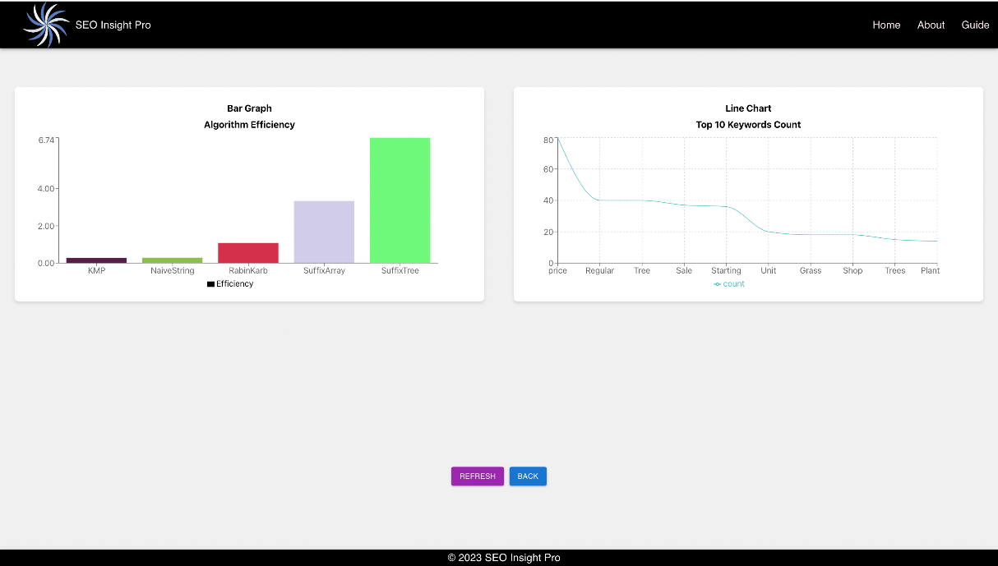

**CODE REPOSITORY**

 <https://github.com/akashbu/AdavAlgoProject3>

* https://youtu.be/nQUrkYdWeWs

**CHALLENGES FACED**

1. Algorithm Optimization: Implementing complex algorithms for keyword analysis posed a challenge. Ensuring efficiency and performance, especially with large datasets, required meticulous optimization.

2.Data Variety and Quality: Maintaining data accuracy and integrity from diverse sources proved challenging. Ensuring consistent and reliable results required rigorous data preprocessing.

3. Real-Time Processing: Achieving real-time keyword analysis and response time management under increasing user load was a significant challenge.

4. Integration Complexity: Seamlessly integrating the Python-based Flask backend with the React frontend and ensuring smooth communication was complex and required meticulous planning.

5. Usability and User Experience: Designing a user-friendly interface that caters to the diverse needs of website owners, marketers, and SEO enthusiasts was challenging. Continuously gathering user feedback and enhancing the user experience remained crucial.

**FUTURE WORK**

1. Algorithmic Enhancements: Continuous research and updates to algorithms are essential to stay at the forefront of the dynamic SEO landscape and adapt to evolving search engine algorithms.

2. Enhanced Scalability: Future work includes further enhancing the system's scalability to accommodate growing user bases and expanding datasets.

3. Data Security and Privacy: Strengthening data security measures and addressing privacy concerns to ensure compliance with regulations and user trust is a priority.

4. Usability Refinement: Ongoing improvements in the user interface and user experience based on user feedback will be a central focus.

5. Comprehensive Documentation: Maintaining and expanding project documentation for both development and end-users to support ease of use and future enhancements.

**CONCLUSION**

In the development of the "SEO Keyword Tracker and Analyzer," we undertook an ambitious journey to blend state-of-the-art technology with the precision of established algorithmic methods. Our primary goal was clear: to provide website owners, digital marketers, and SEO enthusiasts with an indispensable tool that goes beyond the realm of simple keyword tracking. Through intricate keyword analysis and actionable insights, our project aspires to elevate online visibility and guide users on their SEO path.

This project is more than just a technical endeavor; it reflects our dedication to mastering the art of algorithms and their practical application in the real digital world. In a landscape where each keyword and click carries significant weight, our tool embodies our commitment to data-driven decision-making and the unrelenting pursuit of digital excellence. As we reflect on our journey, we recognize the challenges we've conquered, from optimizing complex algorithms to ensuring data accuracy and achieving real-time processing. These challenges, while demanding, have propelled our growth and learning. We embraced comprehensive testing to validate the reliability and performance of our tool, acknowledging the importance of user-centric design and continuous enhancement. Our mission is not a one-time effort but a continuous commitment to improvement, algorithmic updates, and enhanced user experiences. We aim to remain at the forefront of the dynamic SEO landscape, offering a powerful tool to help users navigate the complexities of online success.

In summary, the "SEO Keyword Tracker and Analyzer" is a testament to our dedication to innovation, data-driven decision-making, and the relentless pursuit of digital excellence. It signifies our commitment to mastering the art of algorithms and applying them practically to empower website owners and marketers in their SEO journey.

**REFERENCES**

1. <https://legacy.reactjs.org/>
2. <https://flask.palletsprojects.com/en/3.0.x/>
3. <https://dataforseo.com/>
4. <https://mailchimp.com/marketing-glossary/seo/#:~:text=Search%20engine%20optimization%20(SEO)%20is,most%20to%20your%20target%20audience>.