Postgress admin password: root

How to start
- Powershell
cd D:/VITChennai/Ecommerce_Project/fabbrix_project/FABBRIX
cd server
npm run dev

- New terminal powershell
cd D:\VITChennai\Ecommerce_Project\fabbrix_project\FABBRIX
cd client
npm start
- PostgressSQL – login with host and do what you want

Open: http://localhost:3000/

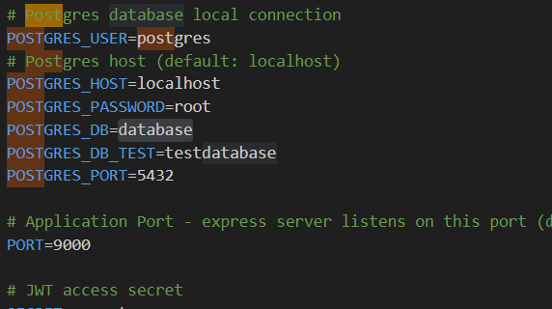

Nav.jxs to remove top navigation bar

To do:

Read db from python
Product discount: populate the discount
Write to db

Same db to read from python
Read from pgadmin
Load python code as well.

