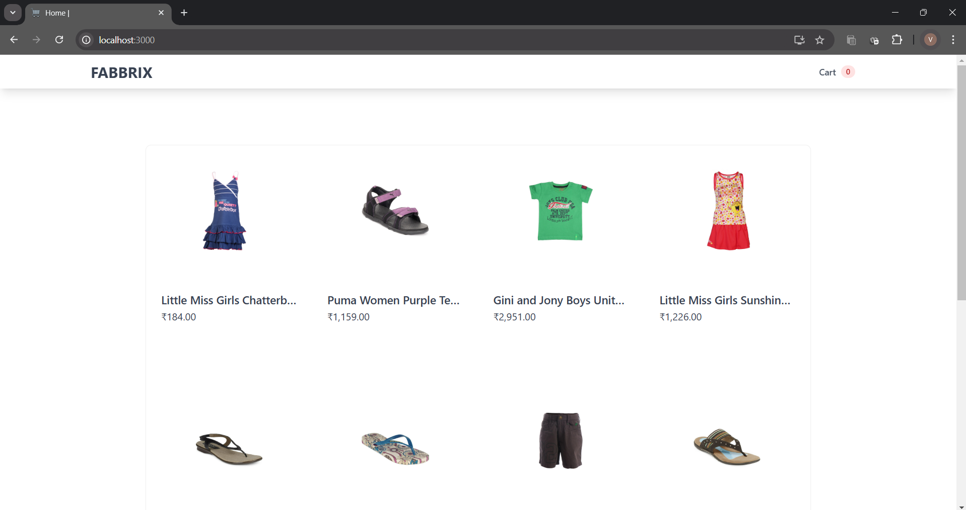
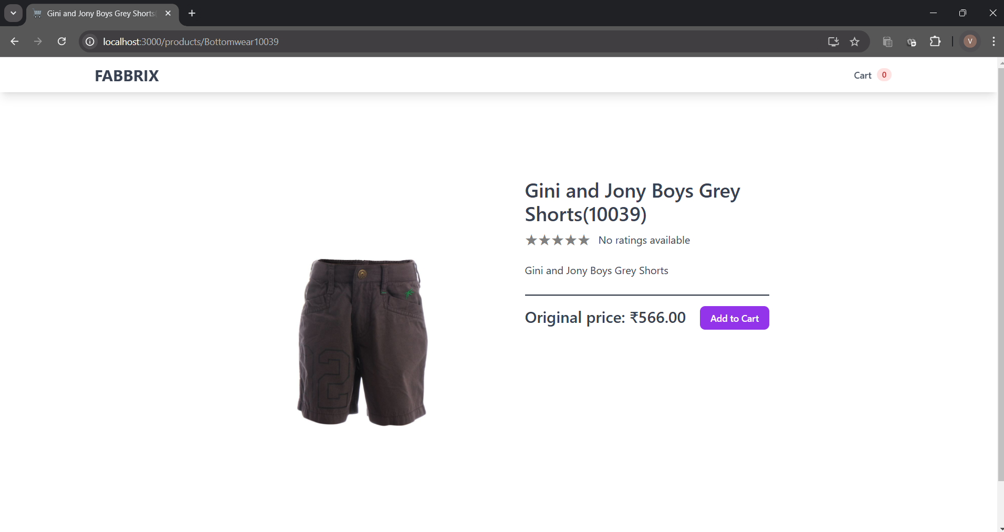
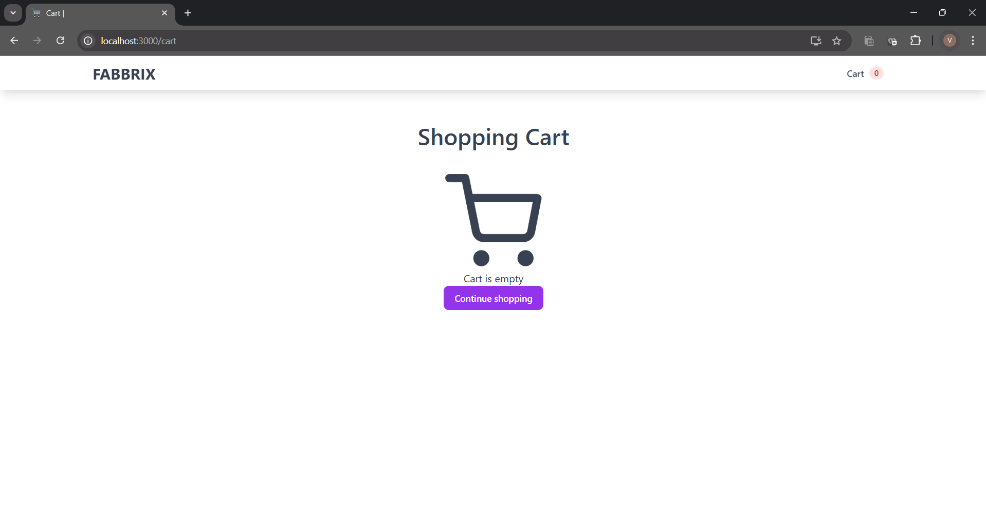

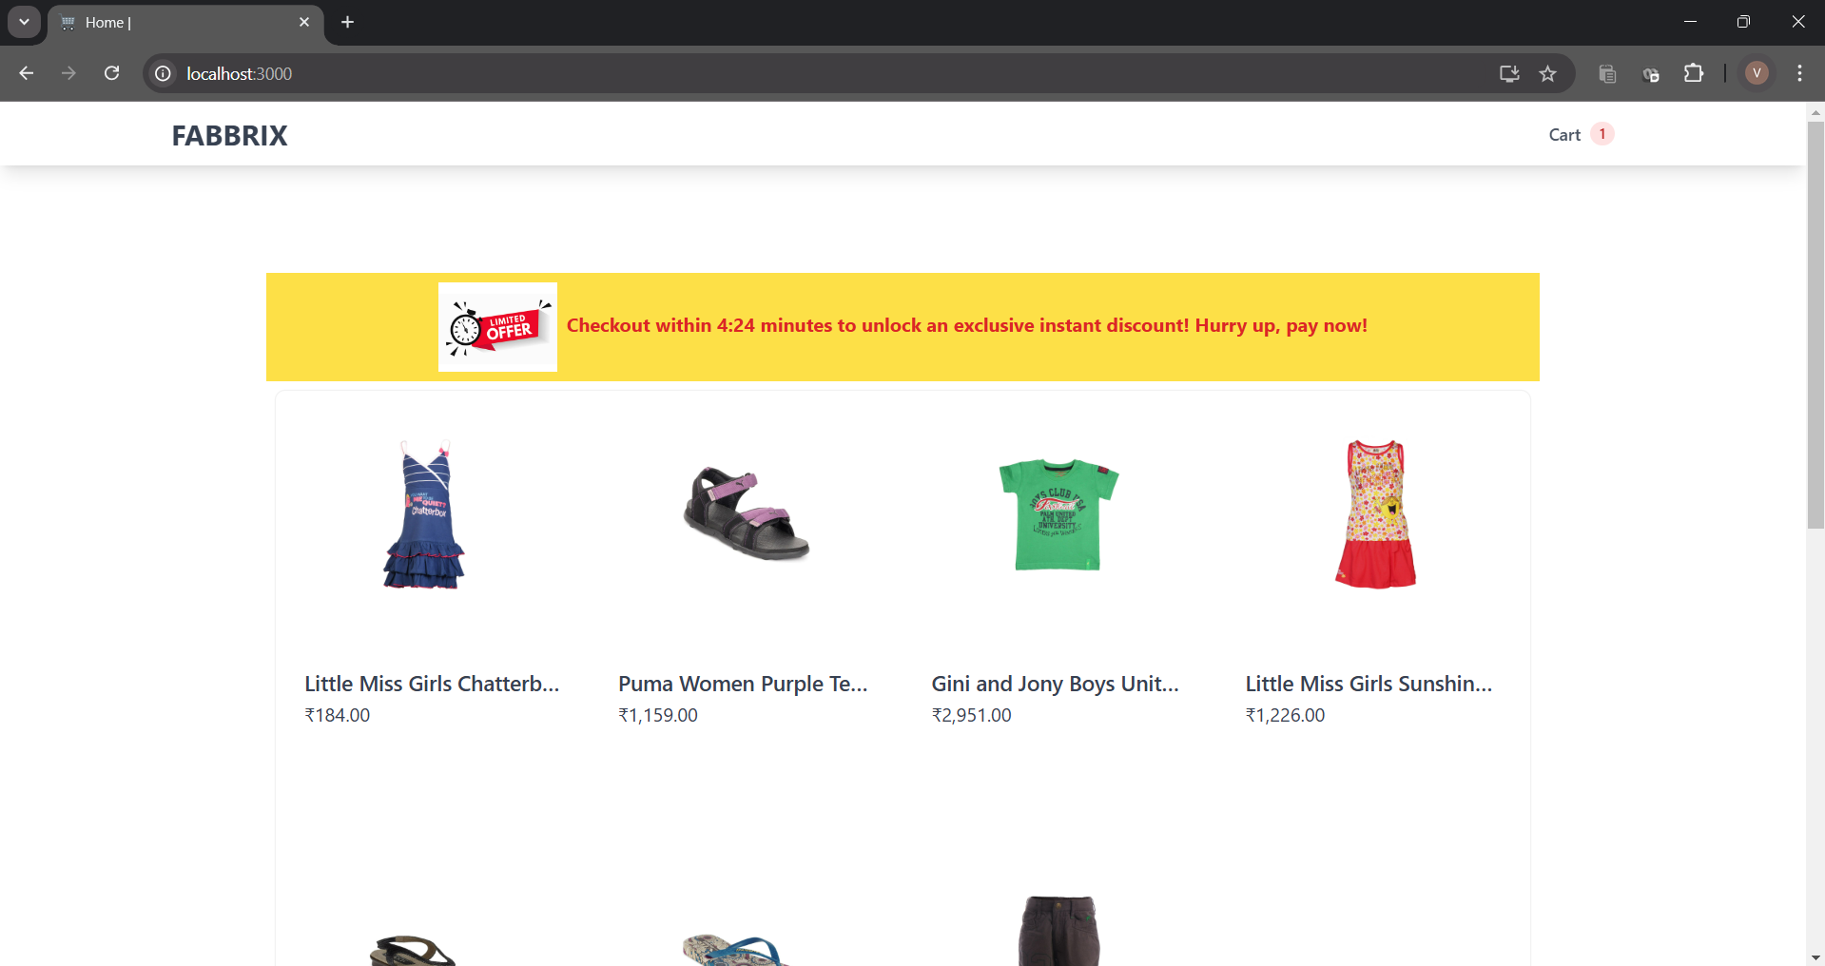
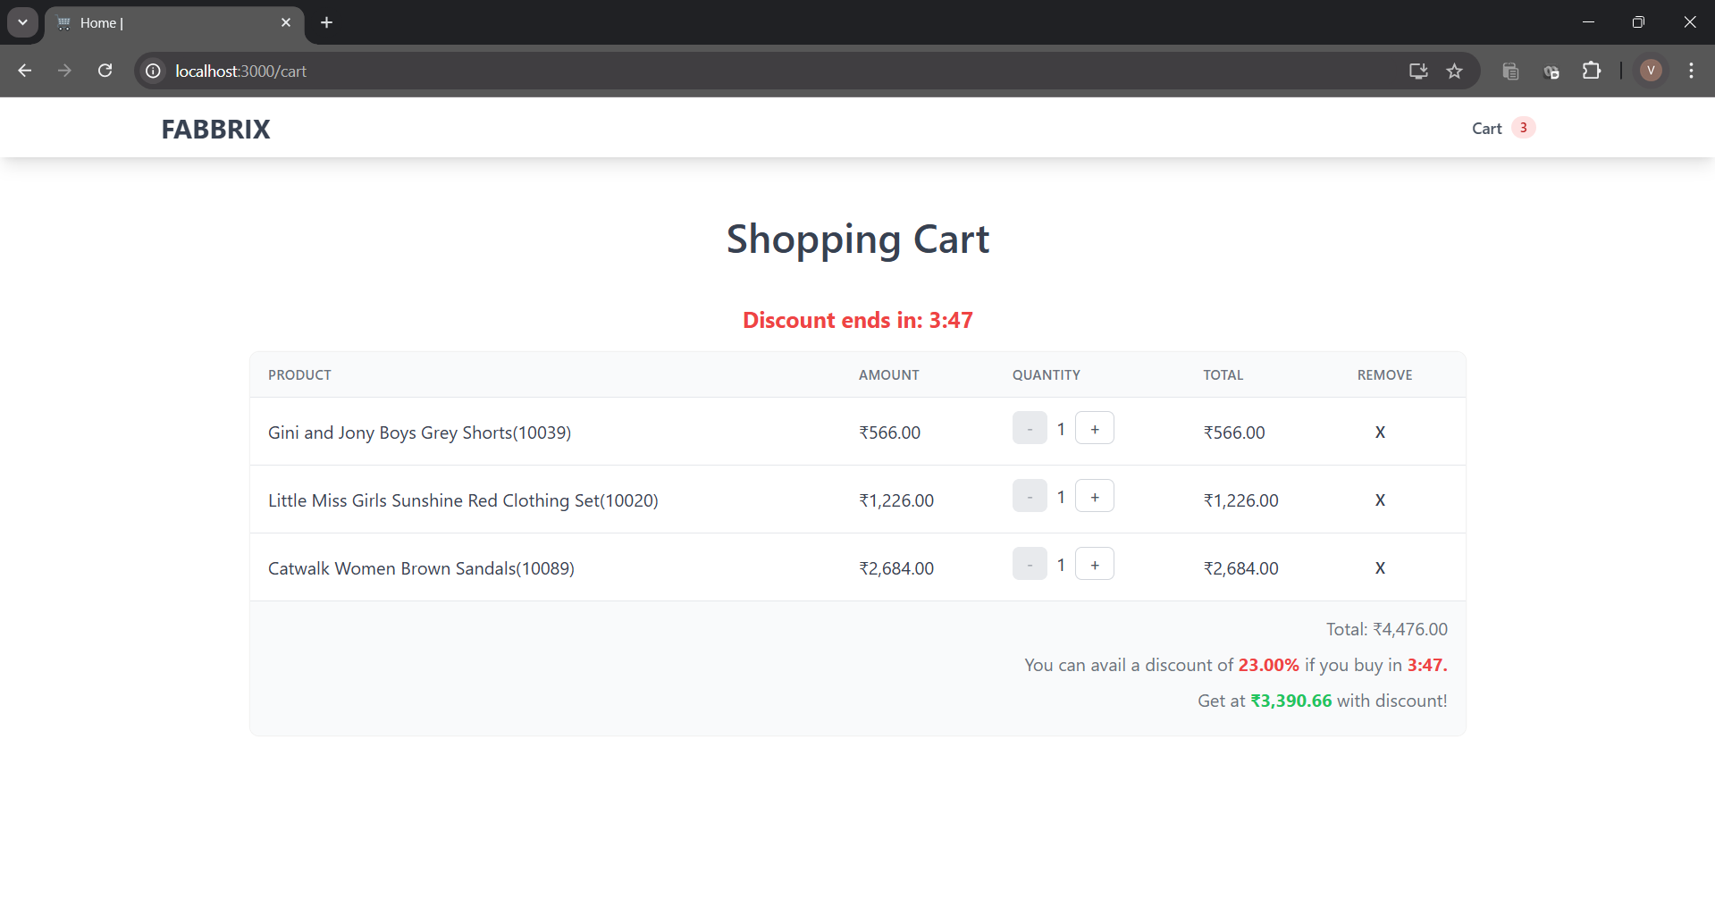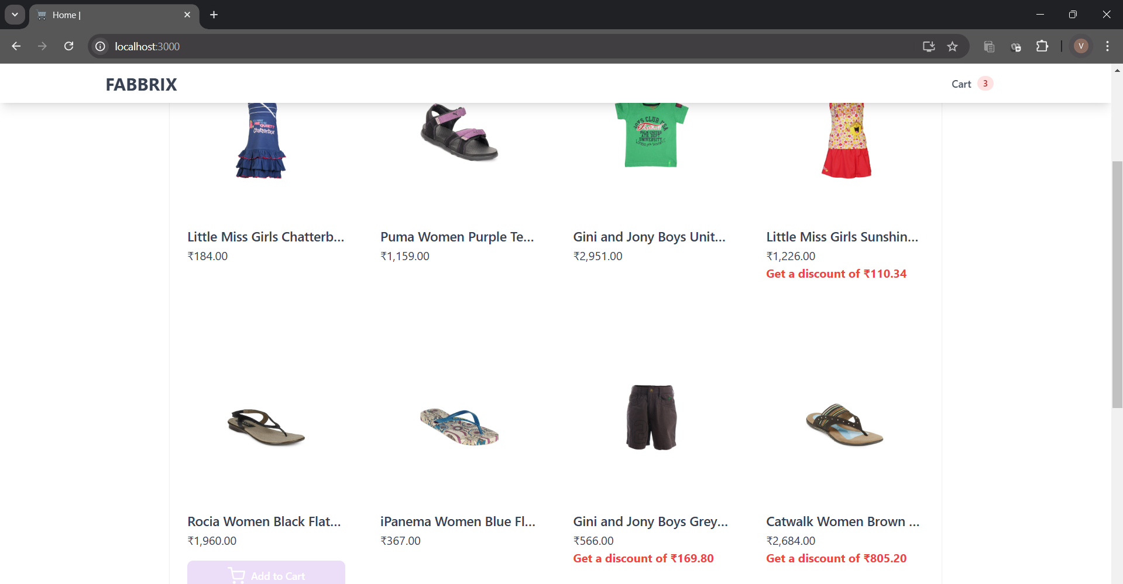

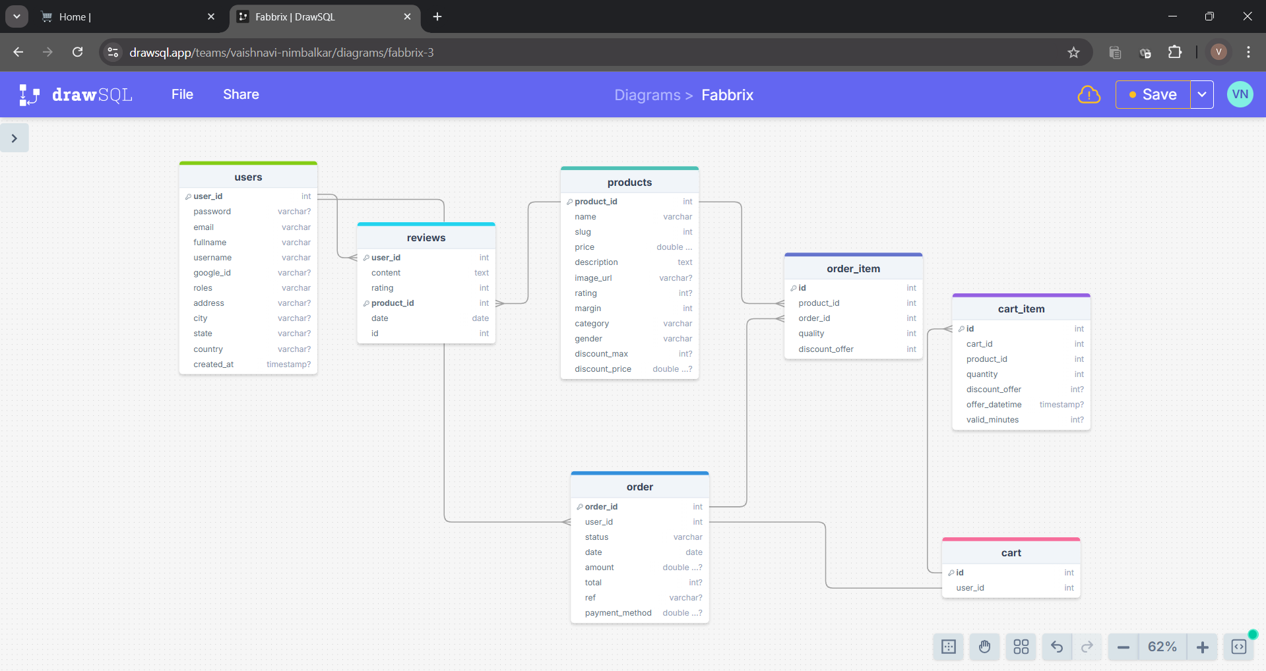

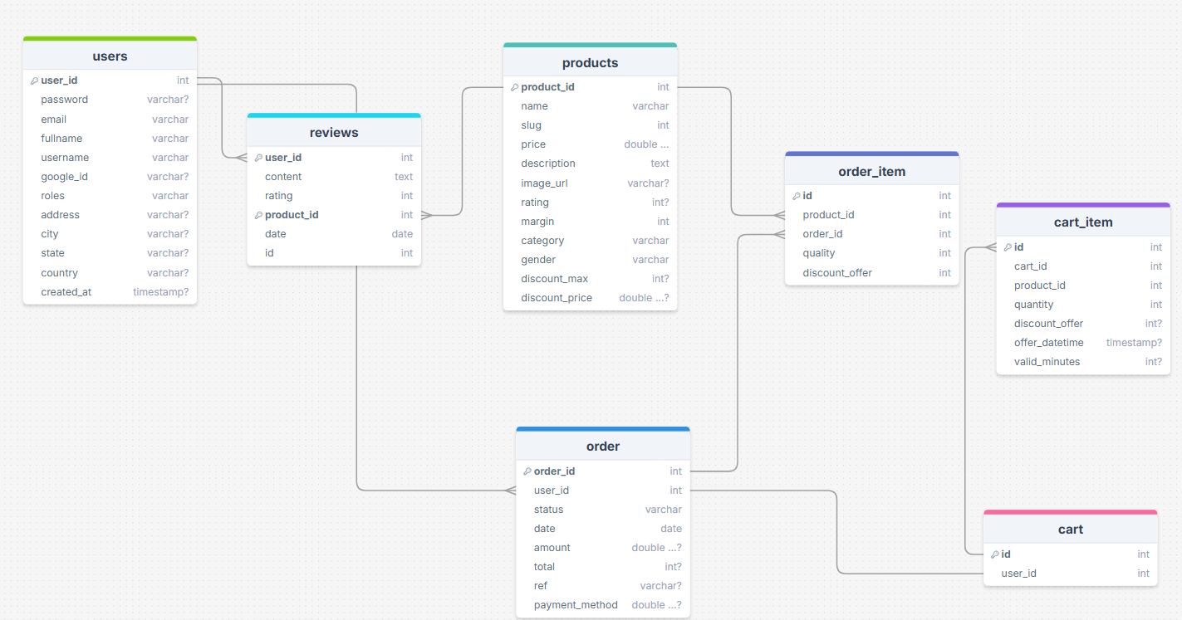

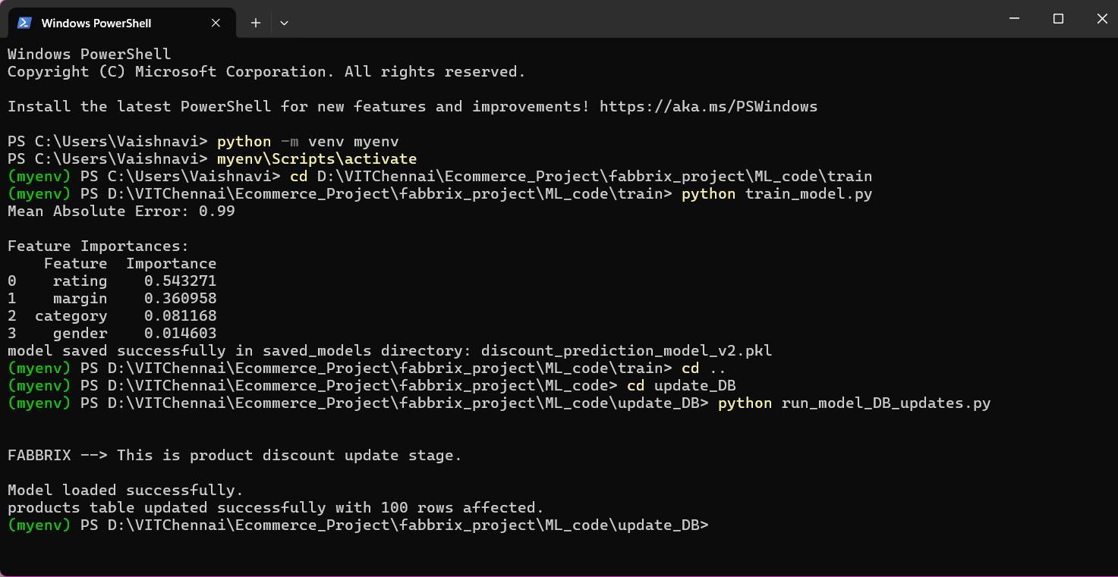

Activate environment
Open Power Shell
python -m venv myenv
myenv\Scripts\activate

OR if using another laptop:
Create environment and install all requirements (requirements.txt)
Pip install requirements.txt

Train ML model (Model will be saved in saved_models.)
cd D:\VITChennai\Ecommerce_Project\fabbrix_project\ML_code\train
python train_model.py

How to predict discount and update DB?
cd ..
cd update_DB
python run_model_DB_updates.py

Now discount_max (discount %) and discount_price columns are updated in products table in DB.

