**Exercise 1: Configuring a Basic Spring Application**

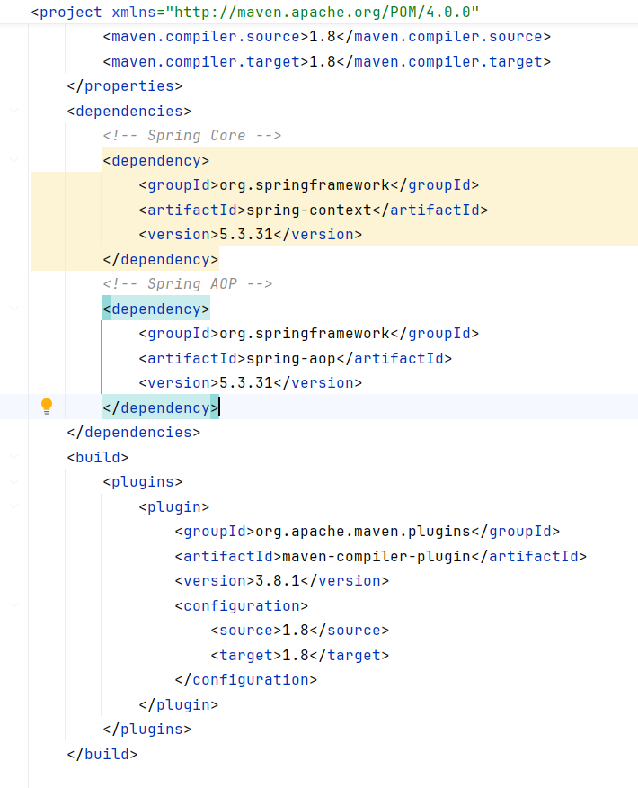

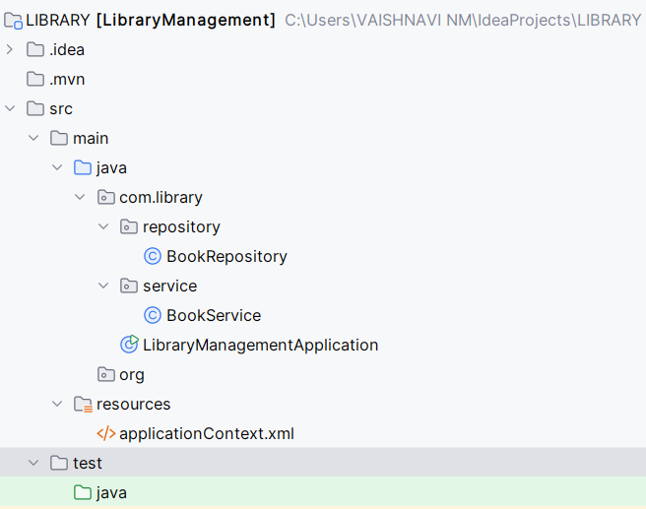

2. applicationContext.xml (src/main/resources):

*<?*xml version="1.0" encoding="UTF-8"*?>*<beans xmlns="http://www.springframework.org/schema/beans"  
 xmlns:xsi="http://www.w3.org/2001/XMLSchema-instance"  
 xsi:schemaLocation="  
 http://www.springframework.org/schema/beans  
 http://www.springframework.org/schema/beans/spring-beans.xsd">  
  
 *<!-- Bean Definitions -->* <bean id="bookRepository" class="com.library.repository.BookRepository"/>  
  
 *<!-- Constructor + Setter Injection -->* <bean id="bookService" class="com.library.service.BookService">  
 <constructor-arg ref="bookRepository"/>  
 <property name="bookRepository" ref="bookRepository"/>  
 </bean></bean>  
  
3. Java Classes:

package com.library.repository;  
public class BookRepository {  
 public void saveBook(String title) {  
 System.out.println("Saving book: " + title);  
 }  
}  
  
package com.library.service;  
import com.library.repository.BookRepository;  
public class BookService {  
 private BookRepository bookRepository;  
 public void setBookRepository(BookRepository bookRepository) {  
 this.bookRepository = bookRepository;  
 }  
 public void addBook(String title) {  
 bookRepository.saveBook(title);  
 }  
}  
  
Main Class:  
ApplicationContext context = new ClassPathXmlApplicationContext("applicationContext.xml");  
BookService service = context.getBean(BookService.class);  
service.addBook("Spring Framework Guide");

**Exercise 2: Implementing Dependency Injection**

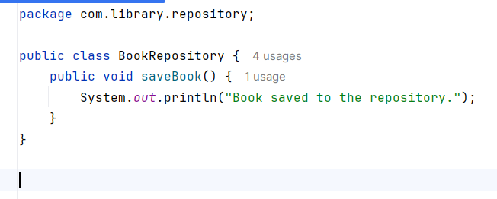

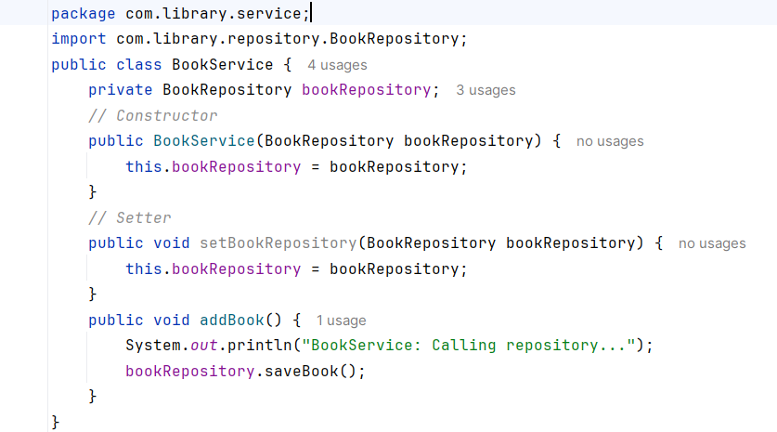

**Test the Configuration:**

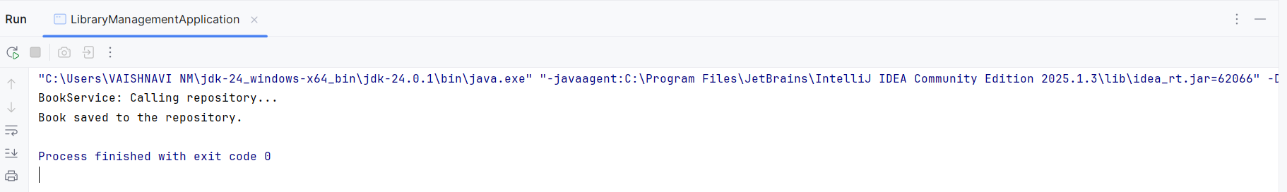

**Exercise 3: Implementing Logging with Spring AOP**

1. **Add Spring AOP Dependency:**

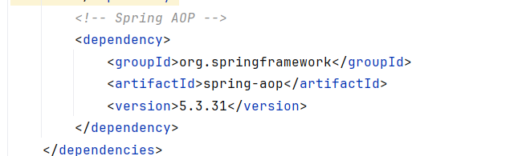

1. **Create an Aspect for Logging:**

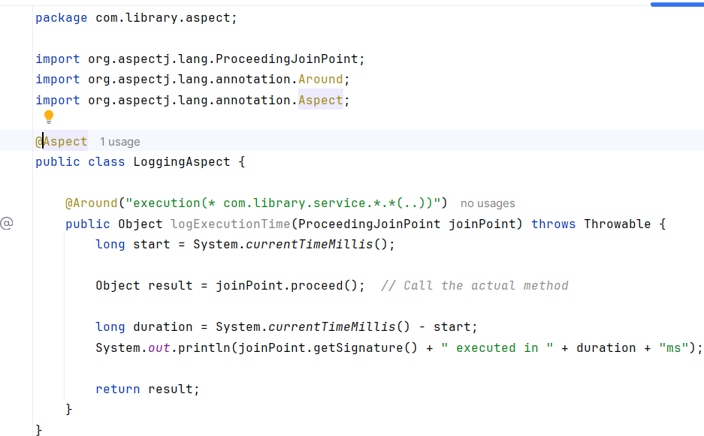

1. **Enable AspectJ Support:**

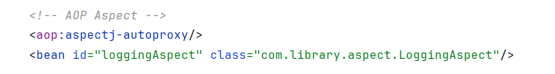

1. **Test the Aspect**

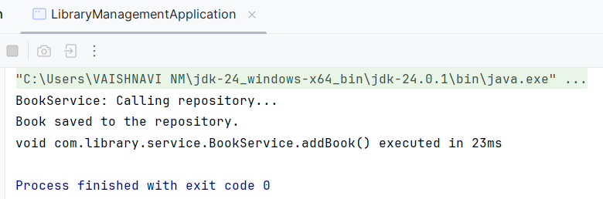

**Exercise 4: Creating and Configuring a Maven Project**

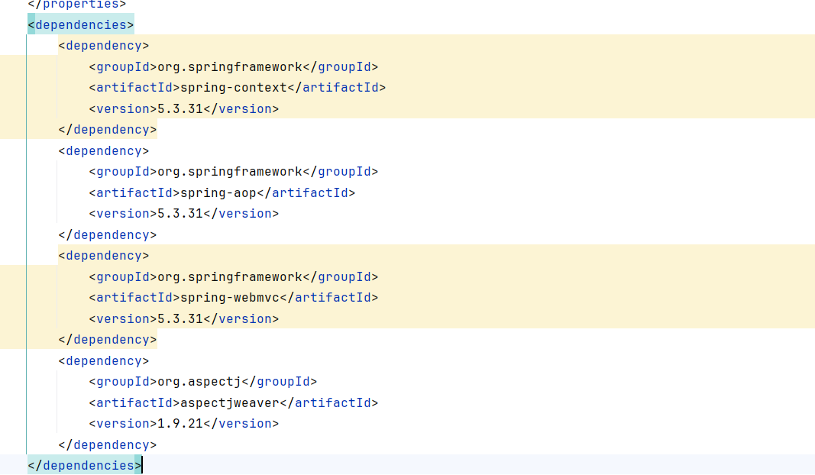

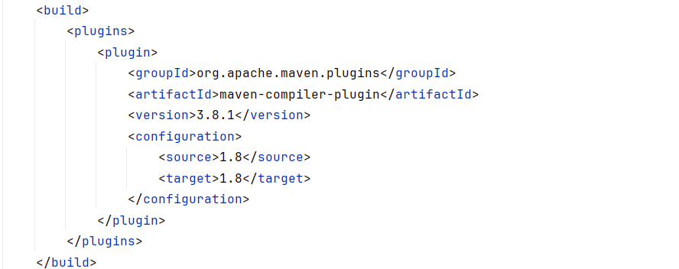

**Exercise 5: Configuring the Spring IoC Container**

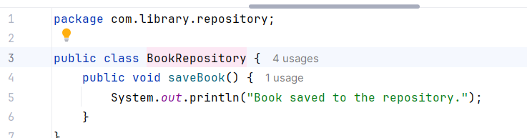

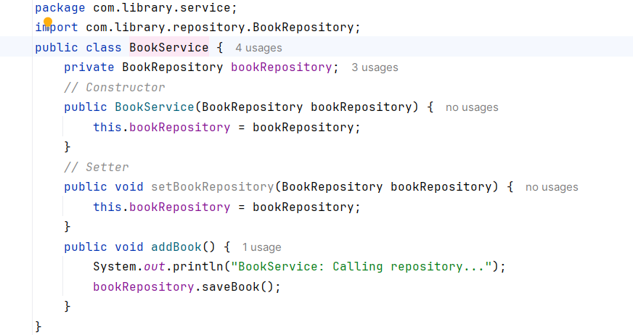



**Exercise 6: Configuring Beans with Annotations**

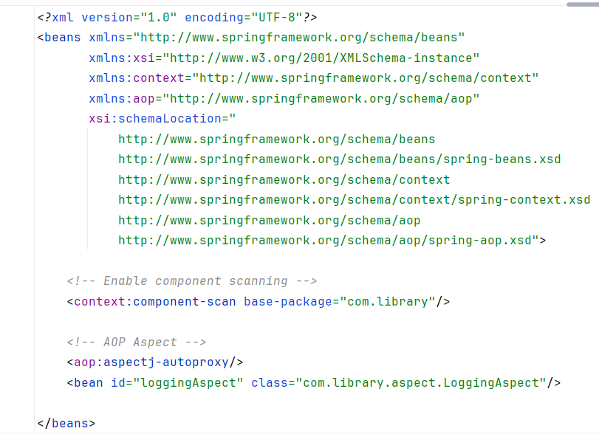

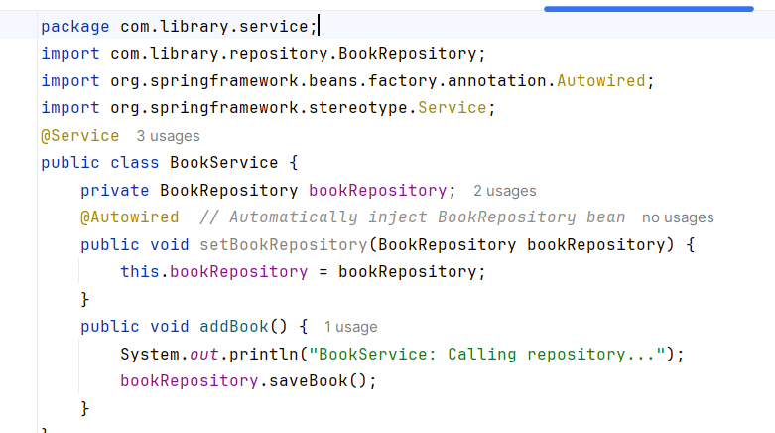

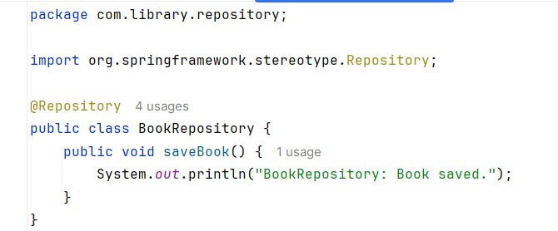

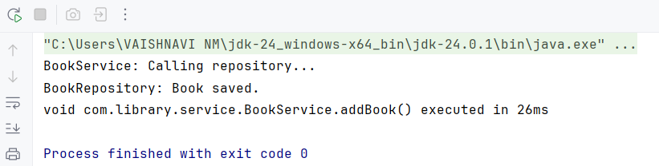

**Exercise 7: Implementing Constructor and Setter Injection**

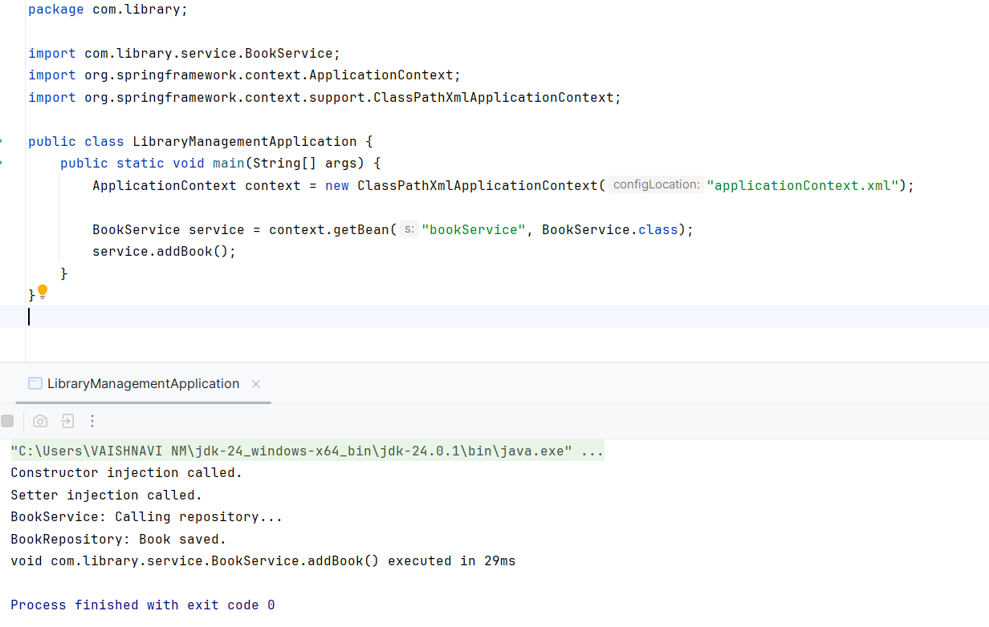

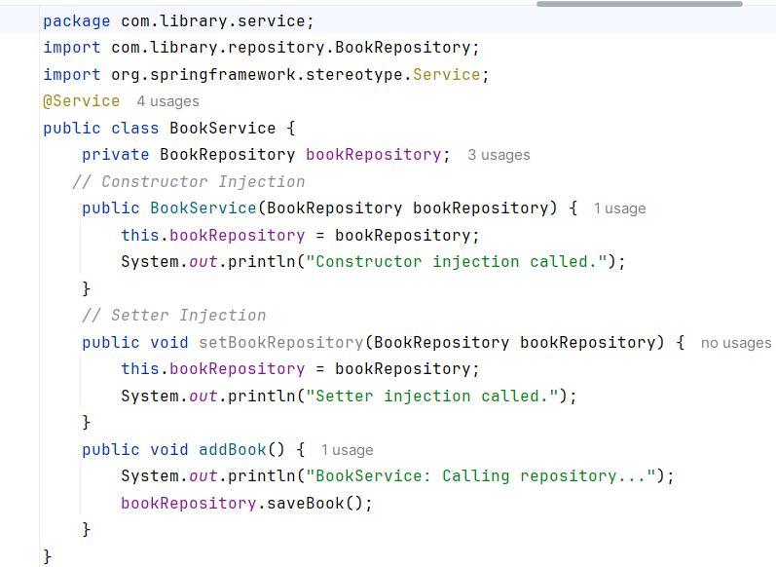

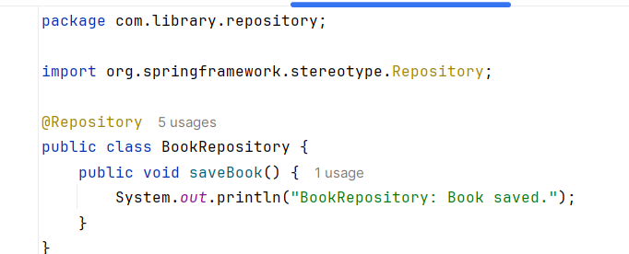

**Exercise 8: Implementing Basic AOP with Spring**

