WEEK 4
INTERNSHIP REPORT
Exploratory Data Analysis
and Feature Engineering

Internship | Data Science with Python Analyst Internship
Domain | Beauty and Wellness
Research Topic | Analysis of Customer Purchase Trends in the Beauty and Wellness Industry
Student Name | Vaishnavi Vijaykumar Patil
Week | 4

1. Introduction
Exploratory Data Analysis (EDA) is an important step in data analytics. It helps us understand a dataset by examining its structure, identifying patterns, finding missing values and studying relationships between variables.
Feature engineering is the process of creating new useful features from existing data. These features can help improve data analysis and future machine learning models.
In this week, I performed EDA and feature engineering using Python libraries such as Pandas, NumPy, Matplotlib, Seaborn and SciPy.

2. Objectives
- To understand the structure of the dataset.
- To perform statistical analysis.
- To identify patterns using graphs and visualizations.
- To create new features from existing columns.
- To perform data normalization and encoding.
- To study customer purchasing behaviour.
- To save the final processed dataset and analysis results.

3. Tools and Technologies Used
Tool / Library | Purpose
Python | Programming language
Jupyter Notebook | Writing and executing code
Pandas | Data handling and analysis
NumPy | Numerical operations
Matplotlib | Data visualization
Seaborn | Statistical graphs
SciPy | Statistical analysis
Scikit-learn | Data normalization

4. Dataset Description
The dataset used for this task was a cleaned retail transaction dataset. It contained the following important columns:
- InvoiceNo – Transaction identification number.
- StockCode – Product identification code.
- Description – Product description.
- Quantity – Number of products purchased.
- InvoiceDate – Date and time of transaction.
- UnitPrice – Price of one product.
- CustomerID – Customer identification number.
- Country – Customer's country.
- SalesAmount – Total amount for a product line.
SalesAmount = Quantity × UnitPrice
Dataset note: The practical dataset is based on general retail transactions. It is useful for demonstrating purchase and customer analysis methods, but its findings should not be treated as beauty-and-wellness-specific market findings.

5. Step 1 – Dataset Loading and Understanding
First, the cleaned dataset was imported into Jupyter Notebook using Pandas. The following operations were performed:
- Imported the required Python libraries.
- Loaded the CSV file.
- Displayed the first five records.
- Checked the dataset information.
- Calculated descriptive statistics.
- Checked missing values.
This step helped understand the dataset structure, column names, data types and missing values.
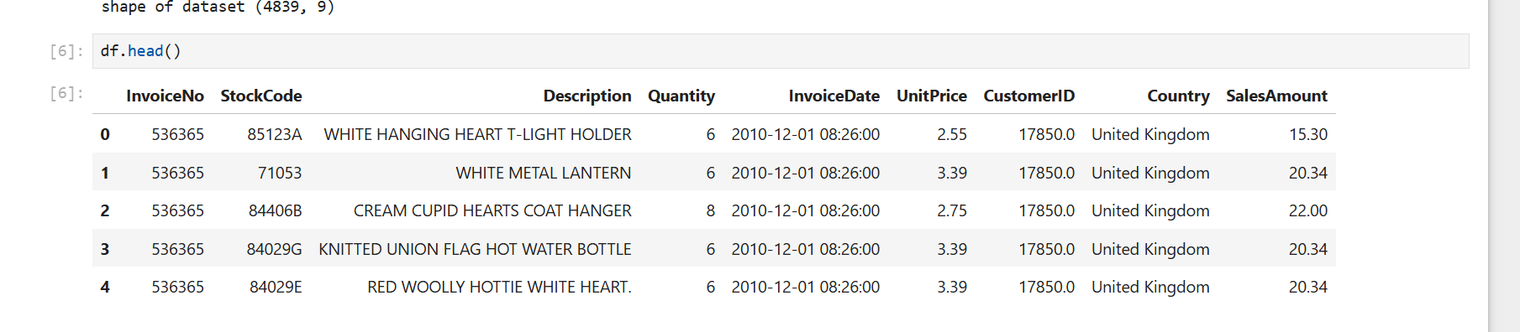
Figure 1: Dataset shape and first five records

6. Step 2 – Statistical Analysis
Statistical analysis was performed to understand numerical data.
Mean: Calculates the average value.
Median: Finds the middle value.
Mode: Identifies the most frequently occurring value.
Standard Deviation: Measures the spread of data.
Skewness: Helps understand the distribution of numerical values.
Correlation: Identifies relationships between numerical variables.
A correlation matrix and heatmap were created to study relationships between Quantity, UnitPrice and SalesAmount.
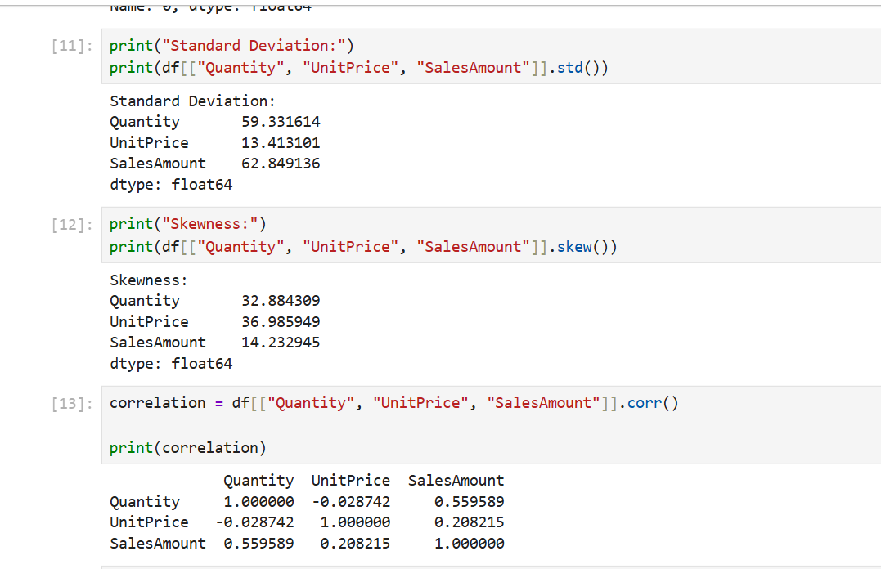
Figure 2: Standard deviation, skewness and correlation results
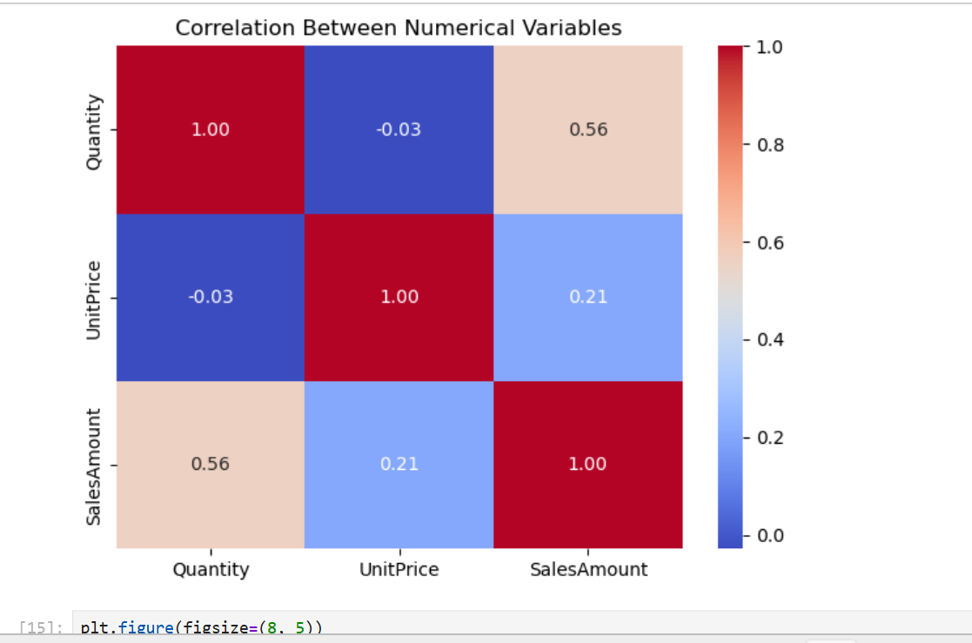
Figure 3: Correlation heatmap of numerical variables

7. Step 3 – Data Visualization
Different graphs were created using Matplotlib and Seaborn:
- Sales Amount Histogram: Shows the distribution of sales amounts.
- Quantity Boxplot: Helps identify unusually high or low quantities.
- Unit Price Histogram: Shows the distribution of product prices.
- Top 10 Products Bar Chart: Displays products with the highest total purchase quantities.
- Monthly Sales Trend: Shows how sales amounts change across months.
These graphs make the dataset easier to understand and help identify important patterns.
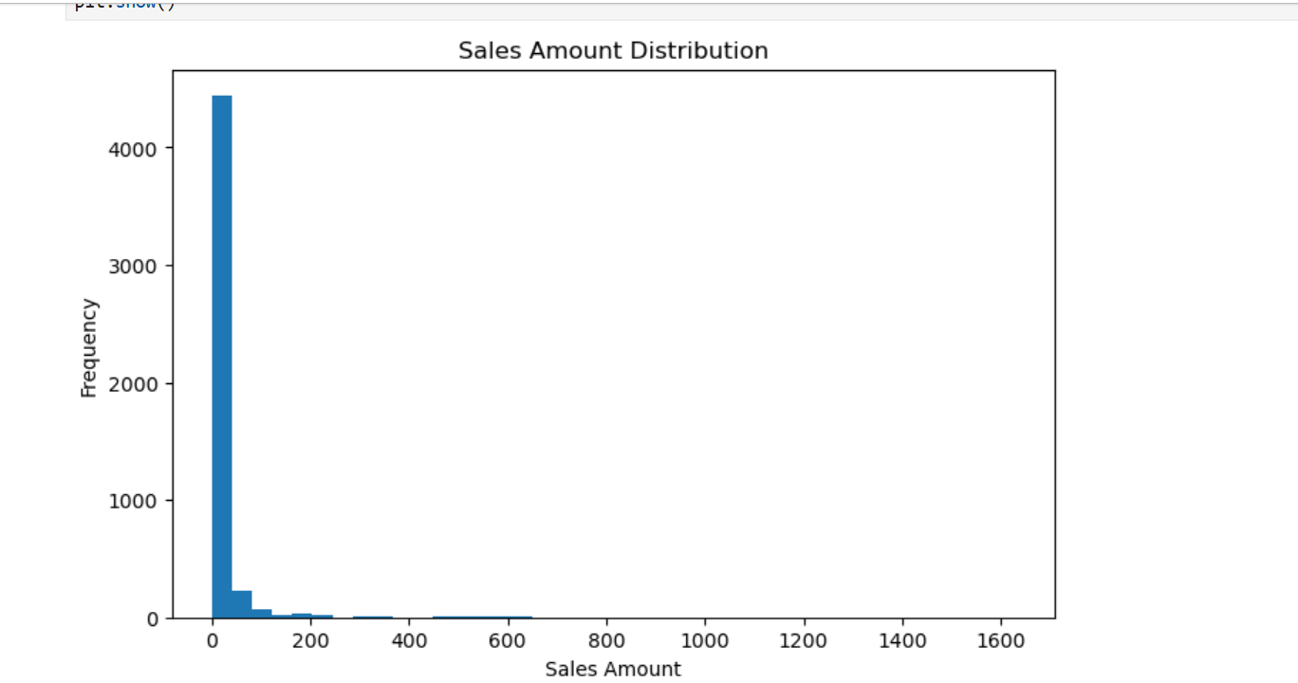
Figure 4: Sales Amount distribution histogram

8. Step 4 – Feature Engineering
New features were created using existing columns.

Date and Time Features
The following features were extracted from InvoiceDate: Year, Month, Day, DayOfWeek, Hour and IsWeekend.

Transaction Features
InvoiceTotal: Calculates the total sales amount for each invoice.
BasketQuantity: Calculates the total quantity of products in each invoice.

Customer Features
PurchaseFrequency: Number of unique invoices for each customer.
CustomerSpend: Total spending by each customer.
AverageOrderValue: Average invoice value.
ProductDiversity: Number of unique products purchased.
RecencyDays: Number of days since the customer's last purchase.
These features help study customer purchasing behaviour.

9. Step 5 – Data Normalization and Encoding
Data normalization and encoding were performed to prepare numerical and categorical data for further analysis.

Min-Max Normalization
The Min-Max Scaler from Scikit-learn was used to convert numerical values into a range between 0 and 1. The following columns were normalized: Quantity, UnitPrice and SalesAmount.

Categorical Encoding
The Country column was converted into numerical codes using category encoding. The IsWeekend column was also converted into numerical values: True = 1 and False = 0.
This process helps prepare data for machine learning algorithms that require numerical inputs.

10. Step 6 – Final Analysis and Interpretation
The final analysis included:
- Total sales calculation.
- Average sales calculation.
- Maximum and minimum sales calculation.
- Identification of the top five countries by sales.
- Identification of the top five customers by spending.
- Correlation analysis.
- Final dataset quality checks.
These operations helped summarize transaction performance and customer purchasing patterns. The results can support business decisions such as identifying high-spending customers, understanding purchase frequency and comparing sales across countries.

11. Step 7 – Saving Results
The final outputs were saved in CSV format for future use:
- Week4_Final_EDA_Dataset.csv
- Week4_Customer_Analysis.csv
- Week4_Statistical_Summary.csv
- Week4_Correlation_Results.csv
Saving these files helps maintain the results and makes them available for further analysis.

12. Business Applications
The techniques used in this task can be applied in the beauty and wellness industry. For example:
- Customer spending analysis can help identify valuable customers.
- Purchase frequency can help understand repeat customers.
- Monthly sales analysis can support promotional planning.
- Product quantity analysis can help with inventory planning.
- Product popularity analysis can help businesses understand customer demand.
These are potential applications of the methods, not confirmed findings about beauty and wellness products from the general retail dataset.

13. Limitations
- The dataset represents general retail transactions rather than only beauty and wellness purchases.
- Some CustomerID values are missing.
- The analysis depends on the available dataset columns.
- Correlation does not prove a cause-and-effect relationship.
- The results may not represent the entire beauty and wellness industry.

14. Learning Outcomes
Through this task, I learned:
- How to perform Exploratory Data Analysis using Python.
- How to calculate statistical measures.
- How to create graphs using Matplotlib and Seaborn.
- How to create new features from existing data.
- How to apply normalization and encoding.
- How to analyze customer and transaction data.
- How to save analysis results in CSV files.

15. Conclusion
In Week 4, I successfully carried out Exploratory Data Analysis and Feature Engineering using Python. I studied the dataset, performed statistical analysis, created visualizations, generated new customer and transaction features, applied normalization and encoding, and saved the final results.
This task improved my understanding of data analysis and preprocessing techniques. The knowledge gained will be useful for future data analytics and machine learning projects in the beauty and wellness domain.

16. References
- UCI Machine Learning Repository – Online Retail Dataset.
- Pandas Documentation – https://pandas.pydata.org/docs/
- NumPy Documentation – https://numpy.org/doc/
- Matplotlib Documentation – https://matplotlib.org/
- Seaborn Documentation – https://seaborn.pydata.org/
- Scikit-learn Documentation – https://scikit-learn.org/

Screenshot Evidence – To Be Added
The screenshots currently included in this report cover the dataset preview, statistical analysis, correlation heatmap and Sales Amount histogram. Additional screenshots can be added for the Quantity boxplot, Unit Price histogram, Top 10 Products chart, Monthly Sales Trend, customer feature analysis, normalization and encoding, final analysis, and saved CSV files.

