**cluster1_16TB_20240115_data-00010-of-00100:**

Number of traces: 168591

Number of distinct files: 14422

IO Zone Distribution:

WARM: 160079 (94.95%)

COLD: 8477 (5.03%)

UNKNOWN: 35 (0.02%)

Operation Type Distribution:

WRITE: 85880 (50.94%)

READ: 82711 (49.06%)

Service Class Distribution:

THROUGHPUT_ORIENTED: 126758 (75.19%)

LATENCY_SENSITIVE: 38883 (23.06%)

OTHER: 2950 (1.75%)

From Flash Cache Distribution:

0: 159358 (94.52%)

1: 9233 (5.48%)

Cache Hit Distribution:

-1: 85880 (50.94%)

0: 45105 (26.75%)

1: 37606 (22.31%)

Request I/O Size Analysis:

Distinct sizes: 33468

Lowest size: 0 bytes (0.00 KB)

Highest size: 8404992 bytes (8.02 MB)

Top 10 sizes (most frequent):

0 bytes (0.00 KB): 24948 (14.80%)

1050624 bytes (1.00 MB): 13012 (7.72%)

1048576 bytes (1.00 MB): 9033 (5.36%)

32832 bytes (32.06 KB): 6914 (4.10%)

262144 bytes (256.00 KB): 6732 (3.99%)

262656 bytes (256.50 KB): 6429 (3.81%)

279072 bytes (272.53 KB): 4577 (2.71%)

49248 bytes (48.09 KB): 3050 (1.81%)

36864 bytes (36.00 KB): 2969 (1.76%)

16416 bytes (16.03 KB): 2252 (1.34%)

Response I/O Size Analysis:

Distinct sizes: 1418

Lowest size: 0 bytes (0.00 KB)

Highest size: 8404992 bytes (8.02 MB)

Top 10 sizes (most frequent):

0 bytes (0.00 KB): 103792 (61.56%)

262144 bytes (256.00 KB): 6729 (3.99%)

1048576 bytes (1.00 MB): 5826 (3.46%)

262656 bytes (256.50 KB): 4300 (2.55%)

32832 bytes (32.06 KB): 3603 (2.14%)

1050624 bytes (1.00 MB): 3440 (2.04%)

36864 bytes (36.00 KB): 2898 (1.72%)

279072 bytes (272.53 KB): 2033 (1.21%)

16416 bytes (16.03 KB): 1795 (1.06%)

55296 bytes (54.00 KB): 1584 (0.94%)

Disk I/O Size Analysis:

Distinct sizes: 32908

Lowest size: 0 bytes (0.00 KB)

Highest size: 8417280 bytes (8.03 MB)

Top 10 sizes (most frequent):

0 bytes (0.00 KB): 62554 (37.10%)

1050624 bytes (1.00 MB): 9124 (5.41%)

1048576 bytes (1.00 MB): 7689 (4.56%)

1052672 bytes (1.00 MB): 5700 (3.38%)

262144 bytes (256.00 KB): 3068 (1.82%)

266240 bytes (260.00 KB): 2708 (1.61%)

36864 bytes (36.00 KB): 2641 (1.57%)

40960 bytes (40.00 KB): 1167 (0.69%)

53248 bytes (52.00 KB): 1081 (0.64%)

32768 bytes (32.00 KB): 968 (0.57%)

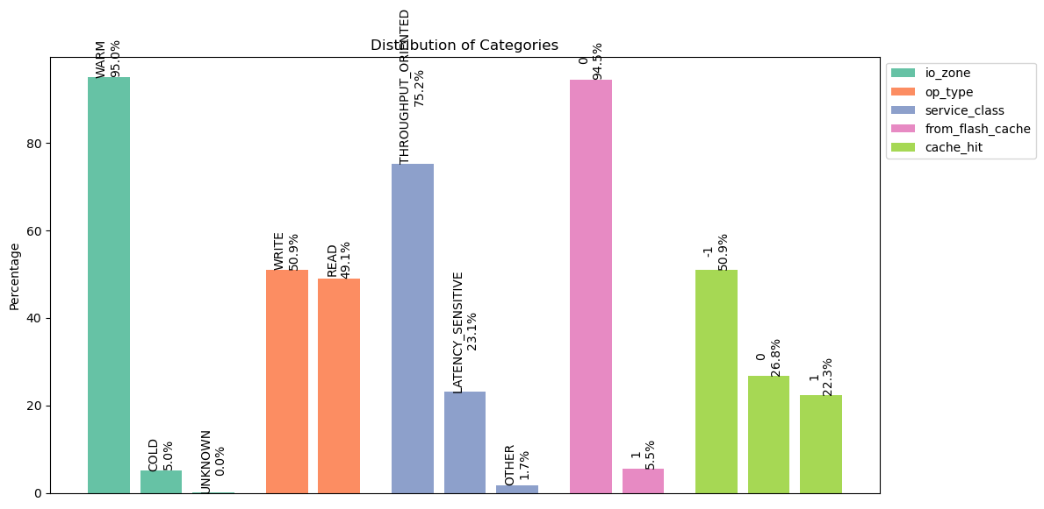

**cluster1_16TB_20240115_data-00022-of-00100:**

Number of traces: 168591

Number of distinct files: 13704

IO Zone Distribution:

WARM: 162175 (96.19%)

COLD: 6369 (3.78%)

UNKNOWN: 47 (0.03%)

Operation Type Distribution:

WRITE: 87938 (52.16%)

READ: 80653 (47.84%)

Service Class Distribution:

THROUGHPUT_ORIENTED: 123872 (73.47%)

LATENCY_SENSITIVE: 41418 (24.57%)

OTHER: 3301 (1.96%)

From Flash Cache Distribution:

0: 156363 (92.75%)

1: 12228 (7.25%)

Cache Hit Distribution:

-1: 87938 (52.16%)

1: 40454 (24.00%)

0: 40199 (23.84%)

Request I/O Size Analysis:

Distinct sizes: 30879

Lowest size: 0 bytes (0.00 KB)

Highest size: 8404992 bytes (8.02 MB)

Top 10 sizes (most frequent):

0 bytes (0.00 KB): 25216 (14.96%)

1050624 bytes (1.00 MB): 14433 (8.56%)

262144 bytes (256.00 KB): 8503 (5.04%)

262656 bytes (256.50 KB): 7397 (4.39%)

1048576 bytes (1.00 MB): 7251 (4.30%)

32832 bytes (32.06 KB): 6384 (3.79%)

279072 bytes (272.53 KB): 3930 (2.33%)

36864 bytes (36.00 KB): 3082 (1.83%)

49248 bytes (48.09 KB): 2710 (1.61%)

16416 bytes (16.03 KB): 2334 (1.38%)

Response I/O Size Analysis:

Distinct sizes: 1456

Lowest size: 0 bytes (0.00 KB)

Highest size: 8404992 bytes (8.02 MB)

Top 10 sizes (most frequent):

0 bytes (0.00 KB): 104854 (62.19%)

262144 bytes (256.00 KB): 8490 (5.04%)

262656 bytes (256.50 KB): 5335 (3.16%)

1048576 bytes (1.00 MB): 4123 (2.45%)

32832 bytes (32.06 KB): 3563 (2.11%)

1050624 bytes (1.00 MB): 3430 (2.03%)

36864 bytes (36.00 KB): 3031 (1.80%)

16416 bytes (16.03 KB): 1966 (1.17%)

279072 bytes (272.53 KB): 1837 (1.09%)

32768 bytes (32.00 KB): 1832 (1.09%)

Disk I/O Size Analysis:

Distinct sizes: 30284

Lowest size: 0 bytes (0.00 KB)

Highest size: 8417280 bytes (8.03 MB)

Top 10 sizes (most frequent):

0 bytes (0.00 KB): 65670 (38.95%)

1050624 bytes (1.00 MB): 9587 (5.69%)

1048576 bytes (1.00 MB): 6290 (3.73%)

1052672 bytes (1.00 MB): 4680 (2.78%)

262144 bytes (256.00 KB): 2888 (1.71%)

266240 bytes (260.00 KB): 2735 (1.62%)

36864 bytes (36.00 KB): 2303 (1.37%)

32768 bytes (32.00 KB): 1221 (0.72%)

53248 bytes (52.00 KB): 1069 (0.63%)

40960 bytes (40.00 KB): 1022 (0.61%)

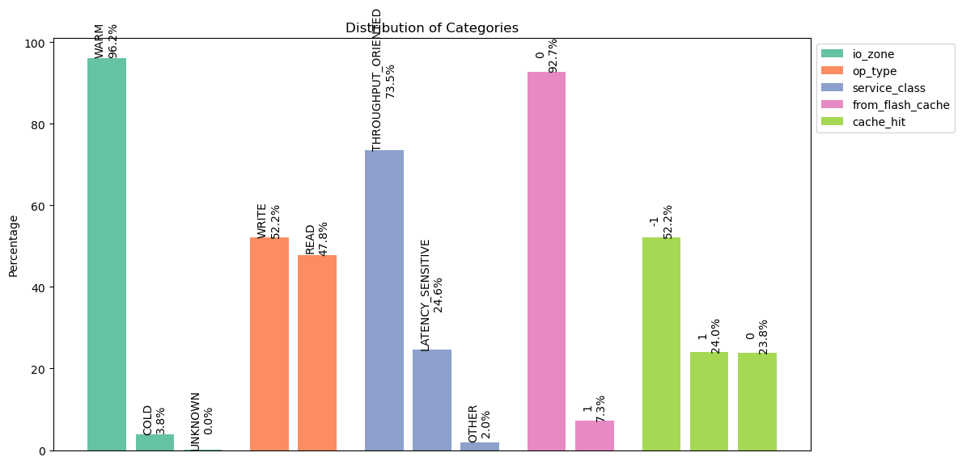

**cluster1_16TB_20240115_data-00030-of-00100:**

Number of traces: 168591

Number of distinct files: 14146

IO Zone Distribution:

WARM: 164156 (97.37%)

COLD: 4391 (2.60%)

UNKNOWN: 44 (0.03%)

Operation Type Distribution:

READ: 84750 (50.27%)

WRITE: 83841 (49.73%)

Service Class Distribution:

THROUGHPUT_ORIENTED: 127695 (75.74%)

LATENCY_SENSITIVE: 38183 (22.65%)

OTHER: 2713 (1.61%)

From Flash Cache Distribution:

0: 157979 (93.71%)

1: 10612 (6.29%)

Cache Hit Distribution:

-1: 83841 (49.73%)

1: 44009 (26.10%)

0: 40741 (24.17%)

Request I/O Size Analysis:

Distinct sizes: 33048

Lowest size: 0 bytes (0.00 KB)

Highest size: 8404992 bytes (8.02 MB)

Top 10 sizes (most frequent):

0 bytes (0.00 KB): 26866 (15.94%)

1050624 bytes (1.00 MB): 14059 (8.34%)

32832 bytes (32.06 KB): 8957 (5.31%)

262144 bytes (256.00 KB): 7494 (4.45%)

262656 bytes (256.50 KB): 7017 (4.16%)

1048576 bytes (1.00 MB): 5932 (3.52%)

279072 bytes (272.53 KB): 4522 (2.68%)

16416 bytes (16.03 KB): 4012 (2.38%)

49248 bytes (48.09 KB): 3201 (1.90%)

36864 bytes (36.00 KB): 2826 (1.68%)

Response I/O Size Analysis:

Distinct sizes: 1455

Lowest size: 0 bytes (0.00 KB)

Highest size: 8404992 bytes (8.02 MB)

Top 10 sizes (most frequent):

0 bytes (0.00 KB): 102086 (60.55%)

262144 bytes (256.00 KB): 7491 (4.44%)

32832 bytes (32.06 KB): 5491 (3.26%)

262656 bytes (256.50 KB): 4875 (2.89%)

1050624 bytes (1.00 MB): 3806 (2.26%)

16416 bytes (16.03 KB): 3467 (2.06%)

36864 bytes (36.00 KB): 2787 (1.65%)

1048576 bytes (1.00 MB): 2524 (1.50%)

279072 bytes (272.53 KB): 2061 (1.22%)

32768 bytes (32.00 KB): 1767 (1.05%)

Disk I/O Size Analysis:

Distinct sizes: 32456

Lowest size: 0 bytes (0.00 KB)

Highest size: 8417280 bytes (8.03 MB)

Top 10 sizes (most frequent):

0 bytes (0.00 KB): 70875 (42.04%)

1050624 bytes (1.00 MB): 8858 (5.25%)

1048576 bytes (1.00 MB): 5314 (3.15%)

1052672 bytes (1.00 MB): 4256 (2.52%)

262144 bytes (256.00 KB): 3160 (1.87%)

266240 bytes (260.00 KB): 2924 (1.73%)

36864 bytes (36.00 KB): 2750 (1.63%)

53248 bytes (52.00 KB): 1271 (0.75%)

40960 bytes (40.00 KB): 1158 (0.69%)

32768 bytes (32.00 KB): 1054 (0.63%)

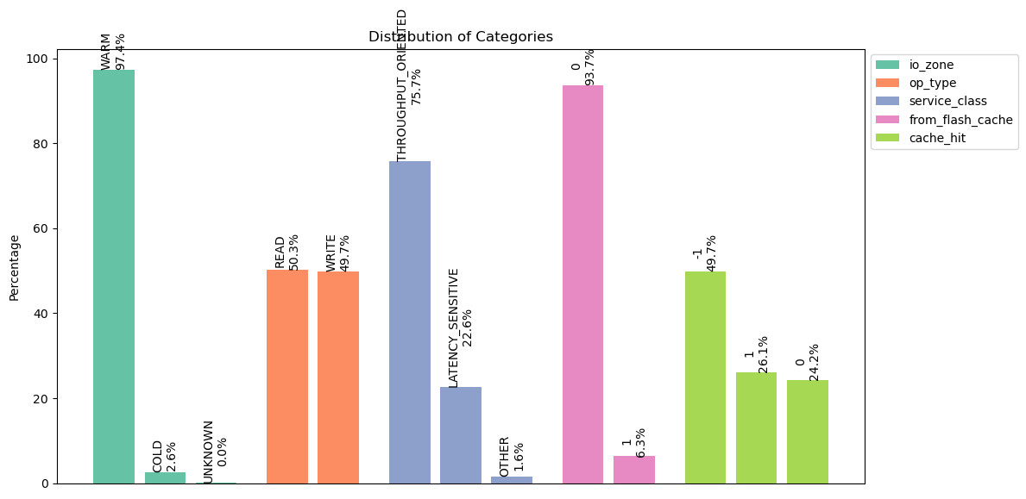

**cluster1_16TB_20240115_data-00052-of-00100:**

Number of traces: 168591

Number of distinct files: 13527

IO Zone Distribution:

WARM: 163782 (97.15%)

COLD: 4772 (2.83%)

UNKNOWN: 37 (0.02%)

Operation Type Distribution:

WRITE: 89583 (53.14%)

READ: 79008 (46.86%)

Service Class Distribution:

THROUGHPUT_ORIENTED: 128007 (75.93%)

LATENCY_SENSITIVE: 38023 (22.55%)

OTHER: 2561 (1.52%)

From Flash Cache Distribution:

0: 159286 (94.48%)

1: 9305 (5.52%)

Cache Hit Distribution:

-1: 89583 (53.14%)

0: 40678 (24.13%)

1: 38330 (22.74%)

Request I/O Size Analysis:

Distinct sizes: 32437

Lowest size: 0 bytes (0.00 KB)

Highest size: 8404992 bytes (8.02 MB)

Top 10 sizes (most frequent):

0 bytes (0.00 KB): 24066 (14.27%)

1050624 bytes (1.00 MB): 11750 (6.97%)

32832 bytes (32.06 KB): 8386 (4.97%)

1048576 bytes (1.00 MB): 6924 (4.11%)

262656 bytes (256.50 KB): 6704 (3.98%)

262144 bytes (256.00 KB): 6536 (3.88%)

279072 bytes (272.53 KB): 5112 (3.03%)

49248 bytes (48.09 KB): 3588 (2.13%)

16416 bytes (16.03 KB): 3022 (1.79%)

36864 bytes (36.00 KB): 2575 (1.53%)

Response I/O Size Analysis:

Distinct sizes: 1508

Lowest size: 0 bytes (0.00 KB)

Highest size: 8404992 bytes (8.02 MB)

Top 10 sizes (most frequent):

0 bytes (0.00 KB): 108467 (64.34%)

262144 bytes (256.00 KB): 6527 (3.87%)

262656 bytes (256.50 KB): 4586 (2.72%)

32832 bytes (32.06 KB): 4515 (2.68%)

1048576 bytes (1.00 MB): 3415 (2.03%)

1050624 bytes (1.00 MB): 3199 (1.90%)

36864 bytes (36.00 KB): 2511 (1.49%)

279072 bytes (272.53 KB): 2358 (1.40%)

16416 bytes (16.03 KB): 2255 (1.34%)

32768 bytes (32.00 KB): 1624 (0.96%)

Disk I/O Size Analysis:

Distinct sizes: 31863

Lowest size: 0 bytes (0.00 KB)

Highest size: 8417280 bytes (8.03 MB)

Top 10 sizes (most frequent):

0 bytes (0.00 KB): 62396 (37.01%)

1050624 bytes (1.00 MB): 7980 (4.73%)

1048576 bytes (1.00 MB): 6197 (3.68%)

1052672 bytes (1.00 MB): 4218 (2.50%)

262144 bytes (256.00 KB): 3345 (1.98%)

36864 bytes (36.00 KB): 2815 (1.67%)

266240 bytes (260.00 KB): 2809 (1.67%)

53248 bytes (52.00 KB): 1286 (0.76%)

40960 bytes (40.00 KB): 1203 (0.71%)

433 bytes (0.42 KB): 1129 (0.67%)

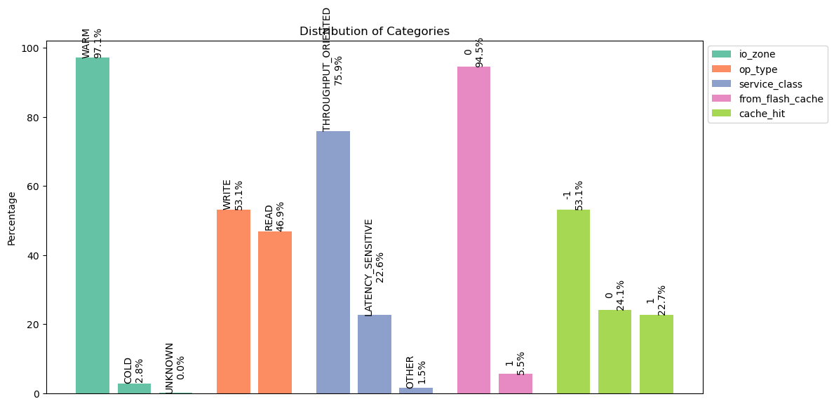

**cluster1_16TB_20240115_data-00066-of-00100:**

Number of traces: 168591

Number of distinct files: 13370

IO Zone Distribution:

WARM: 164262 (97.43%)

COLD: 4300 (2.55%)

UNKNOWN: 29 (0.02%)

Operation Type Distribution:

WRITE: 93239 (55.30%)

READ: 75352 (44.70%)

Service Class Distribution:

THROUGHPUT_ORIENTED: 117349 (69.61%)

LATENCY_SENSITIVE: 48250 (28.62%)

OTHER: 2992 (1.77%)

From Flash Cache Distribution:

0: 157342 (93.33%)

1: 11249 (6.67%)

Cache Hit Distribution:

-1: 93239 (55.30%)

0: 39258 (23.29%)

1: 36094 (21.41%)

Request I/O Size Analysis:

Distinct sizes: 34014

Lowest size: 0 bytes (0.00 KB)

Highest size: 8404992 bytes (8.02 MB)

Top 10 sizes (most frequent):

0 bytes (0.00 KB): 24533 (14.55%)

1050624 bytes (1.00 MB): 10582 (6.28%)

262656 bytes (256.50 KB): 8992 (5.33%)

262144 bytes (256.00 KB): 7206 (4.27%)

32832 bytes (32.06 KB): 6154 (3.65%)

1048576 bytes (1.00 MB): 5889 (3.49%)

279072 bytes (272.53 KB): 4813 (2.85%)

49248 bytes (48.09 KB): 2955 (1.75%)

36864 bytes (36.00 KB): 2557 (1.52%)

16416 bytes (16.03 KB): 1779 (1.06%)

Response I/O Size Analysis:

Distinct sizes: 1355

Lowest size: 0 bytes (0.00 KB)

Highest size: 8404992 bytes (8.02 MB)

Top 10 sizes (most frequent):

0 bytes (0.00 KB): 110765 (65.70%)

262144 bytes (256.00 KB): 7199 (4.27%)

262656 bytes (256.50 KB): 6527 (3.87%)

32832 bytes (32.06 KB): 3202 (1.90%)

1048576 bytes (1.00 MB): 2686 (1.59%)

36864 bytes (36.00 KB): 2508 (1.49%)

279072 bytes (272.53 KB): 2206 (1.31%)

16416 bytes (16.03 KB): 1420 (0.84%)

1050624 bytes (1.00 MB): 1382 (0.82%)

32768 bytes (32.00 KB): 1325 (0.79%)

Disk I/O Size Analysis:

Distinct sizes: 33552

Lowest size: 0 bytes (0.00 KB)

Highest size: 8417280 bytes (8.03 MB)

Top 10 sizes (most frequent):

0 bytes (0.00 KB): 60627 (35.96%)

1050624 bytes (1.00 MB): 8707 (5.16%)

1048576 bytes (1.00 MB): 4927 (2.92%)

262144 bytes (256.00 KB): 3847 (2.28%)

266240 bytes (260.00 KB): 2890 (1.71%)

1052672 bytes (1.00 MB): 2533 (1.50%)

36864 bytes (36.00 KB): 2405 (1.43%)

40960 bytes (40.00 KB): 1266 (0.75%)

53248 bytes (52.00 KB): 1078 (0.64%)

32768 bytes (32.00 KB): 885 (0.52%)

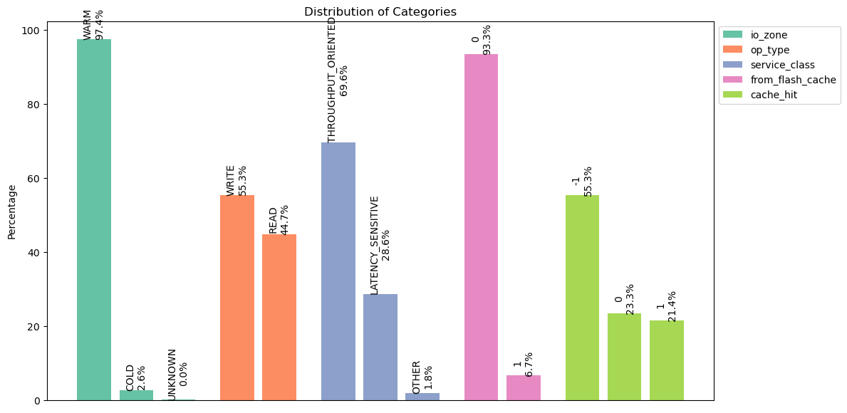

**cluster1_16TB_20240115_data-00085-of-00100:**

Number of traces: 168591

Number of distinct files: 13452

IO Zone Distribution:

WARM: 162279 (96.26%)

COLD: 6276 (3.72%)

UNKNOWN: 36 (0.02%)

Operation Type Distribution:

READ: 85031 (50.44%)

WRITE: 83560 (49.56%)

Service Class Distribution:

THROUGHPUT_ORIENTED: 123677 (73.36%)

LATENCY_SENSITIVE: 41846 (24.82%)

OTHER: 3068 (1.82%)

From Flash Cache Distribution:

0: 156872 (93.05%)

1: 11719 (6.95%)

Cache Hit Distribution:

-1: 83560 (49.56%)

1: 45194 (26.81%)

0: 39837 (23.63%)

Request I/O Size Analysis:

Distinct sizes: 32516

Lowest size: 0 bytes (0.00 KB)

Highest size: 8404992 bytes (8.02 MB)

Top 10 sizes (most frequent):

0 bytes (0.00 KB): 24159 (14.33%)

1050624 bytes (1.00 MB): 11328 (6.72%)

32832 bytes (32.06 KB): 11193 (6.64%)

1048576 bytes (1.00 MB): 7120 (4.22%)

262144 bytes (256.00 KB): 6678 (3.96%)

262656 bytes (256.50 KB): 6179 (3.67%)

16416 bytes (16.03 KB): 5111 (3.03%)

279072 bytes (272.53 KB): 4848 (2.88%)

49248 bytes (48.09 KB): 4297 (2.55%)

36864 bytes (36.00 KB): 2998 (1.78%)

Response I/O Size Analysis:

Distinct sizes: 1357

Lowest size: 0 bytes (0.00 KB)

Highest size: 8404992 bytes (8.02 MB)

Top 10 sizes (most frequent):

0 bytes (0.00 KB): 103885 (61.62%)

262144 bytes (256.00 KB): 6671 (3.96%)

32832 bytes (32.06 KB): 6282 (3.73%)

262656 bytes (256.50 KB): 5100 (3.03%)

16416 bytes (16.03 KB): 3784 (2.24%)

1048576 bytes (1.00 MB): 3677 (2.18%)

1050624 bytes (1.00 MB): 2944 (1.75%)

36864 bytes (36.00 KB): 2936 (1.74%)

279072 bytes (272.53 KB): 2091 (1.24%)

49248 bytes (48.09 KB): 1707 (1.01%)

Disk I/O Size Analysis:

Distinct sizes: 31983

Lowest size: 0 bytes (0.00 KB)

Highest size: 8417280 bytes (8.03 MB)

Top 10 sizes (most frequent):

0 bytes (0.00 KB): 69353 (41.14%)

1050624 bytes (1.00 MB): 7972 (4.73%)

1048576 bytes (1.00 MB): 6203 (3.68%)

1052672 bytes (1.00 MB): 4158 (2.47%)

36864 bytes (36.00 KB): 3103 (1.84%)

266240 bytes (260.00 KB): 2552 (1.51%)

262144 bytes (256.00 KB): 2526 (1.50%)

53248 bytes (52.00 KB): 1479 (0.88%)

40960 bytes (40.00 KB): 1077 (0.64%)

32768 bytes (32.00 KB): 966 (0.57%)

**cluster1_16TB_20240116_data-00000-of-00100:**

Number of traces: 152890

Number of distinct files: 11961

IO Zone Distribution:

WARM: 148644 (97.22%)

COLD: 4204 (2.75%)

UNKNOWN: 42 (0.03%)

Operation Type Distribution:

WRITE: 85912 (56.19%)

READ: 66978 (43.81%)

Service Class Distribution:

THROUGHPUT_ORIENTED: 114216 (74.70%)

LATENCY_SENSITIVE: 34965 (22.87%)

OTHER: 3709 (2.43%)

From Flash Cache Distribution:

0: 143003 (93.53%)

1: 9887 (6.47%)

Cache Hit Distribution:

-1: 85912 (56.19%)

0: 34618 (22.64%)

1: 32360 (21.17%)

Request I/O Size Analysis:

Distinct sizes: 30092

Lowest size: 0 bytes (0.00 KB)

Highest size: 8404992 bytes (8.02 MB)

Top 10 sizes (most frequent):

0 bytes (0.00 KB): 22144 (14.48%)

1050624 bytes (1.00 MB): 9471 (6.19%)

262144 bytes (256.00 KB): 6115 (4.00%)

1048576 bytes (1.00 MB): 5283 (3.46%)

262656 bytes (256.50 KB): 4656 (3.05%)

36864 bytes (36.00 KB): 4126 (2.70%)

32832 bytes (32.06 KB): 2945 (1.93%)

55296 bytes (54.00 KB): 2153 (1.41%)

433 bytes (0.42 KB): 2114 (1.38%)

24576 bytes (24.00 KB): 2010 (1.31%)

Response I/O Size Analysis:

Distinct sizes: 1480

Lowest size: 0 bytes (0.00 KB)

Highest size: 8404992 bytes (8.02 MB)

Top 10 sizes (most frequent):

0 bytes (0.00 KB): 94348 (61.71%)

262144 bytes (256.00 KB): 6113 (4.00%)

36864 bytes (36.00 KB): 4047 (2.65%)

262656 bytes (256.50 KB): 4042 (2.64%)

1048576 bytes (1.00 MB): 2159 (1.41%)

55296 bytes (54.00 KB): 2129 (1.39%)

24576 bytes (24.00 KB): 1980 (1.30%)

1050624 bytes (1.00 MB): 1758 (1.15%)

32832 bytes (32.06 KB): 1721 (1.13%)

32768 bytes (32.00 KB): 1443 (0.94%)

Disk I/O Size Analysis:

Distinct sizes: 29552

Lowest size: 0 bytes (0.00 KB)

Highest size: 8417280 bytes (8.03 MB)

Top 10 sizes (most frequent):

0 bytes (0.00 KB): 54504 (35.65%)

1050624 bytes (1.00 MB): 7194 (4.71%)

1048576 bytes (1.00 MB): 4574 (2.99%)

1052672 bytes (1.00 MB): 2449 (1.60%)

266240 bytes (260.00 KB): 2278 (1.49%)

433 bytes (0.42 KB): 2108 (1.38%)

262144 bytes (256.00 KB): 1757 (1.15%)

36864 bytes (36.00 KB): 1546 (1.01%)

40960 bytes (40.00 KB): 1409 (0.92%)

16384 bytes (16.00 KB): 965 (0.63%)

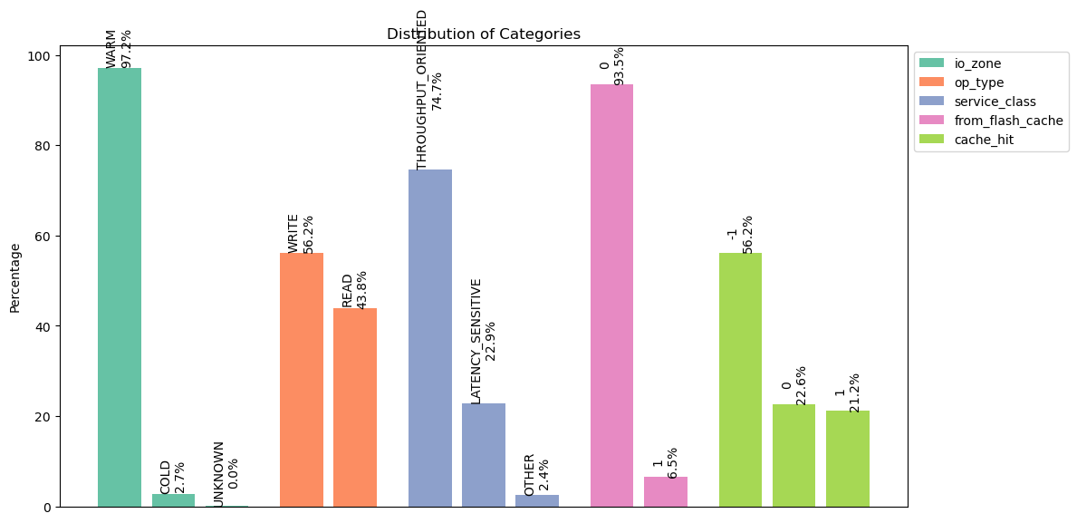

**cluster1_16TB_20240116_data-00057-of-00100:**

Number of traces: 152891

Number of distinct files: 12378

IO Zone Distribution:

WARM: 149021 (97.47%)

COLD: 3846 (2.52%)

UNKNOWN: 24 (0.02%)

Operation Type Distribution:

WRITE: 93933 (61.44%)

READ: 58958 (38.56%)

Service Class Distribution:

THROUGHPUT_ORIENTED: 99219 (64.90%)

LATENCY_SENSITIVE: 49106 (32.12%)

OTHER: 4566 (2.99%)

From Flash Cache Distribution:

0: 142274 (93.06%)

1: 10617 (6.94%)

Cache Hit Distribution:

-1: 93933 (61.44%)

0: 33333 (21.80%)

1: 25625 (16.76%)

Request I/O Size Analysis:

Distinct sizes: 33069

Lowest size: 0 bytes (0.00 KB)

Highest size: 8404992 bytes (8.02 MB)

Top 10 sizes (most frequent):

0 bytes (0.00 KB): 24203 (15.83%)

1050624 bytes (1.00 MB): 10694 (6.99%)

262144 bytes (256.00 KB): 8464 (5.54%)

1048576 bytes (1.00 MB): 5813 (3.80%)

262656 bytes (256.50 KB): 3264 (2.13%)

36864 bytes (36.00 KB): 2840 (1.86%)

2101248 bytes (2.00 MB): 2232 (1.46%)

32768 bytes (32.00 KB): 1703 (1.11%)

24576 bytes (24.00 KB): 1373 (0.90%)

55296 bytes (54.00 KB): 1241 (0.81%)

Response I/O Size Analysis:

Distinct sizes: 1507

Lowest size: 0 bytes (0.00 KB)

Highest size: 8404992 bytes (8.02 MB)

Top 10 sizes (most frequent):

0 bytes (0.00 KB): 101269 (66.24%)

262144 bytes (256.00 KB): 8454 (5.53%)

36864 bytes (36.00 KB): 2797 (1.83%)

262656 bytes (256.50 KB): 2561 (1.68%)

1048576 bytes (1.00 MB): 2404 (1.57%)

1050624 bytes (1.00 MB): 2219 (1.45%)

32768 bytes (32.00 KB): 1533 (1.00%)

24576 bytes (24.00 KB): 1356 (0.89%)

55296 bytes (54.00 KB): 1236 (0.81%)

28672 bytes (28.00 KB): 988 (0.65%)

Disk I/O Size Analysis:

Distinct sizes: 32593

Lowest size: 0 bytes (0.00 KB)

Highest size: 8417280 bytes (8.03 MB)

Top 10 sizes (most frequent):

0 bytes (0.00 KB): 49828 (32.59%)

1050624 bytes (1.00 MB): 7948 (5.20%)

1048576 bytes (1.00 MB): 5112 (3.34%)

1052672 bytes (1.00 MB): 3033 (1.98%)

266240 bytes (260.00 KB): 2512 (1.64%)

262144 bytes (256.00 KB): 1728 (1.13%)

40960 bytes (40.00 KB): 1141 (0.75%)

36864 bytes (36.00 KB): 987 (0.65%)

32768 bytes (32.00 KB): 966 (0.63%)

20480 bytes (20.00 KB): 647 (0.42%)

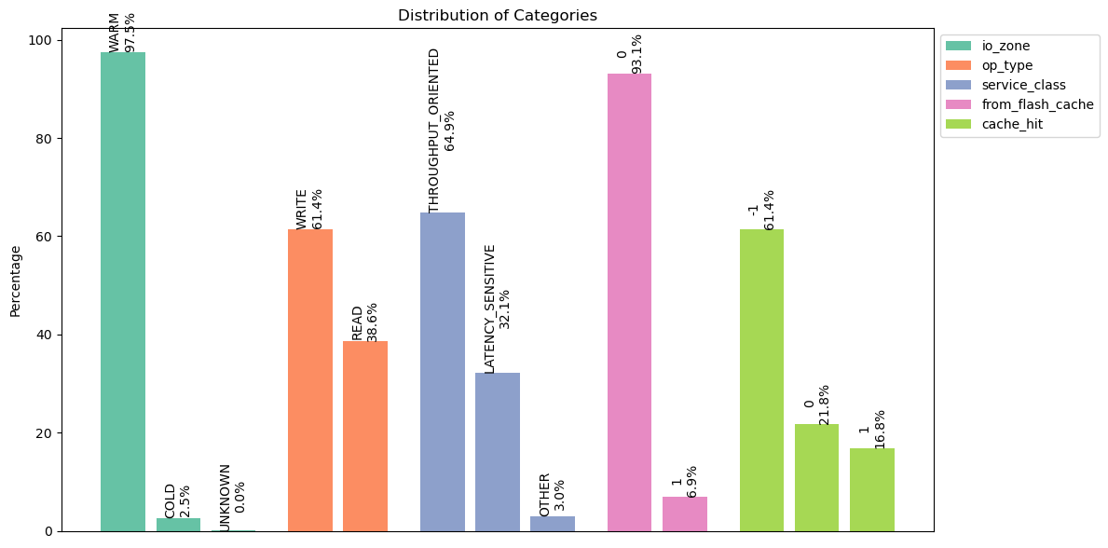

**cluster1_16TB_20240116_data-00099-of-00100:**

Number of traces: 152836

Number of distinct files: 13967

IO Zone Distribution:

WARM: 143967 (94.20%)

COLD: 8844 (5.79%)

UNKNOWN: 25 (0.02%)

Operation Type Distribution:

WRITE: 86062 (56.31%)

READ: 66774 (43.69%)

Service Class Distribution:

THROUGHPUT_ORIENTED: 105001 (68.70%)

LATENCY_SENSITIVE: 43042 (28.16%)

OTHER: 4793 (3.14%)

From Flash Cache Distribution:

0: 141400 (92.52%)

1: 11436 (7.48%)

Cache Hit Distribution:

-1: 86062 (56.31%)

0: 40590 (26.56%)

1: 26184 (17.13%)

Request I/O Size Analysis:

Distinct sizes: 36235

Lowest size: 0 bytes (0.00 KB)

Highest size: 8404992 bytes (8.02 MB)

Top 10 sizes (most frequent):

0 bytes (0.00 KB): 25958 (16.98%)

1050624 bytes (1.00 MB): 12200 (7.98%)

1048576 bytes (1.00 MB): 9520 (6.23%)

262144 bytes (256.00 KB): 8364 (5.47%)

262656 bytes (256.50 KB): 4355 (2.85%)

36864 bytes (36.00 KB): 3770 (2.47%)

32768 bytes (32.00 KB): 1651 (1.08%)

55296 bytes (54.00 KB): 1554 (1.02%)

282624 bytes (276.00 KB): 1496 (0.98%)

2101248 bytes (2.00 MB): 1450 (0.95%)

Response I/O Size Analysis:

Distinct sizes: 1483

Lowest size: 0 bytes (0.00 KB)

Highest size: 8404992 bytes (8.02 MB)

Top 10 sizes (most frequent):

0 bytes (0.00 KB): 93950 (61.47%)

262144 bytes (256.00 KB): 8357 (5.47%)

1048576 bytes (1.00 MB): 6367 (4.17%)

1050624 bytes (1.00 MB): 4118 (2.69%)

36864 bytes (36.00 KB): 3665 (2.40%)

262656 bytes (256.50 KB): 3594 (2.35%)

32768 bytes (32.00 KB): 1592 (1.04%)

55296 bytes (54.00 KB): 1527 (1.00%)

282624 bytes (276.00 KB): 1466 (0.96%)

24576 bytes (24.00 KB): 1318 (0.86%)

Disk I/O Size Analysis:

Distinct sizes: 35674

Lowest size: 0 bytes (0.00 KB)

Highest size: 8417280 bytes (8.03 MB)

Top 10 sizes (most frequent):

0 bytes (0.00 KB): 52142 (34.12%)

1048576 bytes (1.00 MB): 8092 (5.29%)

1050624 bytes (1.00 MB): 7697 (5.04%)

1052672 bytes (1.00 MB): 6135 (4.01%)

266240 bytes (260.00 KB): 3120 (2.04%)

262144 bytes (256.00 KB): 2223 (1.45%)

40960 bytes (40.00 KB): 1780 (1.16%)

36864 bytes (36.00 KB): 1303 (0.85%)

1056768 bytes (1.01 MB): 799 (0.52%)

258048 bytes (252.00 KB): 767 (0.50%)

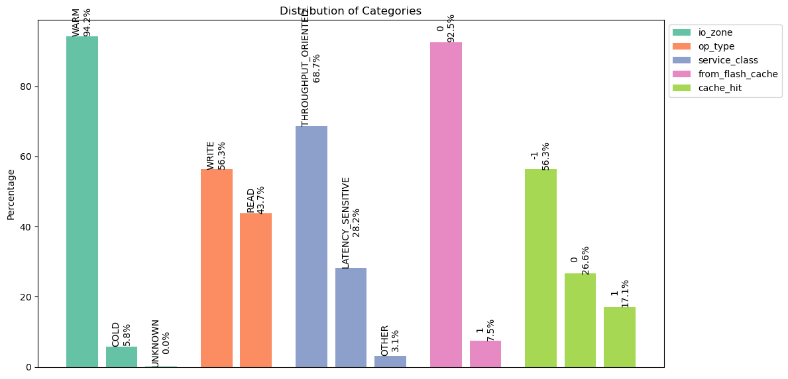

**cluster1_16TB_20240129_data-00016-of-00100**:

Number of traces: 143586

Number of distinct files: 10890

IO Zone Distribution:

WARM: 141200 (98.34%)

COLD: 2347 (1.63%)

UNKNOWN: 39 (0.03%)

Operation Type Distribution:

WRITE: 85684 (59.67%)

READ: 57902 (40.33%)

Service Class Distribution:

THROUGHPUT_ORIENTED: 98895 (68.88%)

LATENCY_SENSITIVE: 36639 (25.52%)

OTHER: 8052 (5.61%)

From Flash Cache Distribution:

0: 132787 (92.48%)

1: 10799 (7.52%)

Cache Hit Distribution:

-1: 85684 (59.67%)

0: 32845 (22.87%)

1: 25057 (17.45%)

Request I/O Size Analysis:

Distinct sizes: 33609

Lowest size: 0 bytes (0.00 KB)

Highest size: 8404992 bytes (8.02 MB)

Top 10 sizes (most frequent):

0 bytes (0.00 KB): 24751 (17.24%)

1050624 bytes (1.00 MB): 12499 (8.70%)

262144 bytes (256.00 KB): 7500 (5.22%)

1048576 bytes (1.00 MB): 4447 (3.10%)

262656 bytes (256.50 KB): 4096 (2.85%)

36864 bytes (36.00 KB): 3683 (2.57%)

2101248 bytes (2.00 MB): 1885 (1.31%)

55296 bytes (54.00 KB): 1682 (1.17%)

24576 bytes (24.00 KB): 1638 (1.14%)

282624 bytes (276.00 KB): 1537 (1.07%)

Response I/O Size Analysis:

Distinct sizes: 1556

Lowest size: 0 bytes (0.00 KB)

Highest size: 8404992 bytes (8.02 MB)

Top 10 sizes (most frequent):

0 bytes (0.00 KB): 90441 (62.99%)

262144 bytes (256.00 KB): 7497 (5.22%)

36864 bytes (36.00 KB): 3638 (2.53%)

262656 bytes (256.50 KB): 3598 (2.51%)

1050624 bytes (1.00 MB): 3396 (2.37%)

55296 bytes (54.00 KB): 1672 (1.16%)

24576 bytes (24.00 KB): 1610 (1.12%)

1048576 bytes (1.00 MB): 1594 (1.11%)

282624 bytes (276.00 KB): 1531 (1.07%)

43008 bytes (42.00 KB): 1500 (1.04%)

Disk I/O Size Analysis:

Distinct sizes: 33013

Lowest size: 0 bytes (0.00 KB)

Highest size: 8417280 bytes (8.03 MB)

Top 10 sizes (most frequent):

0 bytes (0.00 KB): 49808 (34.69%)

1050624 bytes (1.00 MB): 8532 (5.94%)

1048576 bytes (1.00 MB): 4192 (2.92%)

1052672 bytes (1.00 MB): 3800 (2.65%)

266240 bytes (260.00 KB): 2455 (1.71%)

262144 bytes (256.00 KB): 1957 (1.36%)

40960 bytes (40.00 KB): 1356 (0.94%)

258048 bytes (252.00 KB): 899 (0.63%)

32768 bytes (32.00 KB): 690 (0.48%)

61440 bytes (60.00 KB): 655 (0.46%)

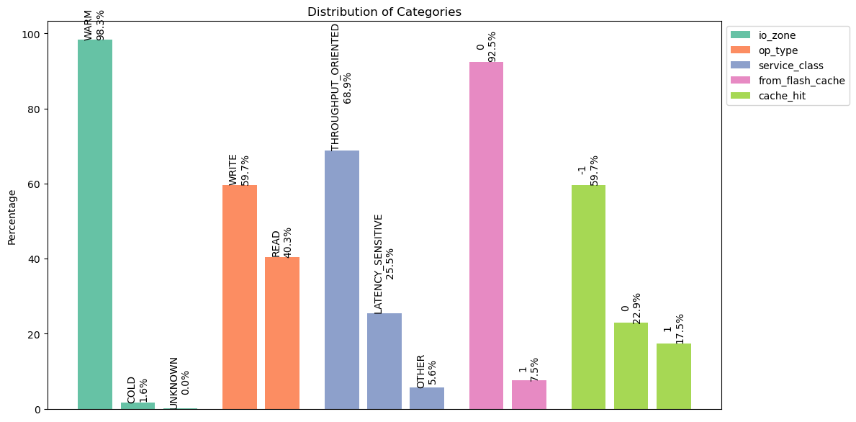

**cluster1_16TB_20240129_data-00071-of-00100:**

Number of traces: 143586

Number of distinct files: 10574

IO Zone Distribution:

WARM: 140175 (97.62%)

COLD: 3384 (2.36%)

UNKNOWN: 27 (0.02%)

Operation Type Distribution:

WRITE: 84559 (58.89%)

READ: 59027 (41.11%)

Service Class Distribution:

THROUGHPUT_ORIENTED: 94747 (65.99%)

LATENCY_SENSITIVE: 43910 (30.58%)

OTHER: 4929 (3.43%)

From Flash Cache Distribution:

0: 132316 (92.15%)

1: 11270 (7.85%)

Cache Hit Distribution:

-1: 84559 (58.89%)

0: 35049 (24.41%)

1: 23978 (16.70%)

Request I/O Size Analysis:

Distinct sizes: 31660

Lowest size: 0 bytes (0.00 KB)

Highest size: 8404992 bytes (8.02 MB)

Top 10 sizes (most frequent):

0 bytes (0.00 KB): 24677 (17.19%)

1050624 bytes (1.00 MB): 10456 (7.28%)

262144 bytes (256.00 KB): 7286 (5.07%)

1048576 bytes (1.00 MB): 5263 (3.67%)

262656 bytes (256.50 KB): 4878 (3.40%)

36864 bytes (36.00 KB): 3373 (2.35%)

55296 bytes (54.00 KB): 1686 (1.17%)

282624 bytes (276.00 KB): 1524 (1.06%)

2101248 bytes (2.00 MB): 1353 (0.94%)

32768 bytes (32.00 KB): 1305 (0.91%)

Response I/O Size Analysis:

Distinct sizes: 1457

Lowest size: 0 bytes (0.00 KB)

Highest size: 8404992 bytes (8.02 MB)

Top 10 sizes (most frequent):

0 bytes (0.00 KB): 89876 (62.59%)

262144 bytes (256.00 KB): 7280 (5.07%)

262656 bytes (256.50 KB): 4303 (3.00%)

36864 bytes (36.00 KB): 3300 (2.30%)

1048576 bytes (1.00 MB): 2348 (1.64%)

55296 bytes (54.00 KB): 1676 (1.17%)

282624 bytes (276.00 KB): 1520 (1.06%)

1050624 bytes (1.00 MB): 1516 (1.06%)

32768 bytes (32.00 KB): 1232 (0.86%)

43008 bytes (42.00 KB): 1223 (0.85%)

Disk I/O Size Analysis:

Distinct sizes: 31135

Lowest size: 0 bytes (0.00 KB)

Highest size: 8417280 bytes (8.03 MB)

Top 10 sizes (most frequent):

0 bytes (0.00 KB): 48655 (33.89%)

1050624 bytes (1.00 MB): 8549 (5.95%)

1048576 bytes (1.00 MB): 4510 (3.14%)

1052672 bytes (1.00 MB): 2656 (1.85%)

266240 bytes (260.00 KB): 2463 (1.72%)

262144 bytes (256.00 KB): 1921 (1.34%)

40960 bytes (40.00 KB): 1441 (1.00%)

32768 bytes (32.00 KB): 869 (0.61%)

258048 bytes (252.00 KB): 859 (0.60%)

49152 bytes (48.00 KB): 666 (0.46%)

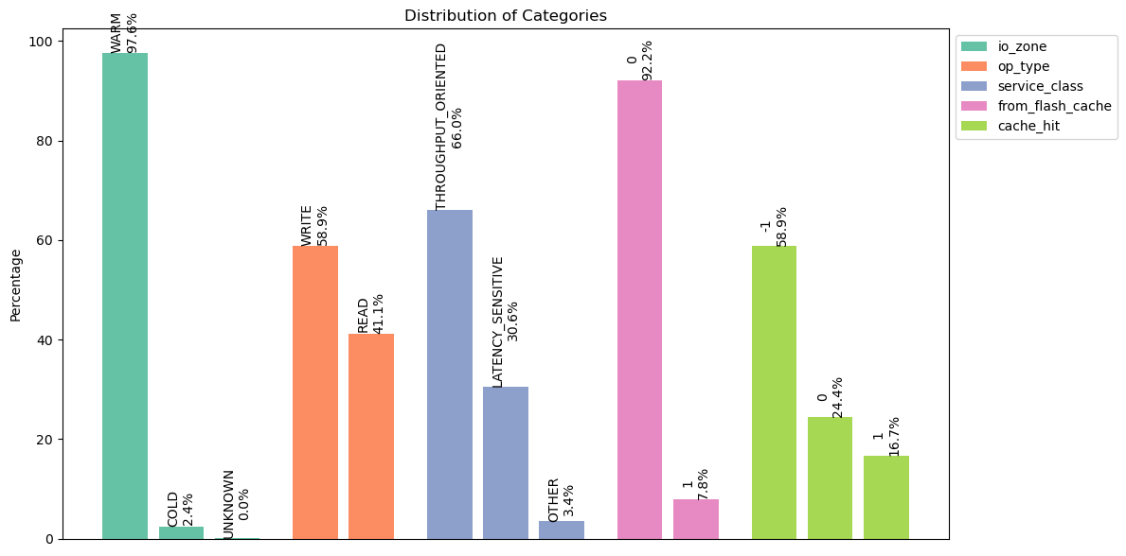

**cluster1_16TB_20240215_data-00021-of-00100:**

Number of traces: 144149

Number of distinct files: 11511

IO Zone Distribution:

WARM: 133089 (92.33%)

COLD: 11008 (7.64%)

UNKNOWN: 52 (0.04%)

Operation Type Distribution:

WRITE: 84066 (58.32%)

READ: 60083 (41.68%)

Service Class Distribution:

THROUGHPUT_ORIENTED: 102917 (71.40%)

LATENCY_SENSITIVE: 37490 (26.01%)

OTHER: 3742 (2.60%)

From Flash Cache Distribution:

0: 134336 (93.19%)

1: 9813 (6.81%)

Cache Hit Distribution:

-1: 84066 (58.32%)

0: 39586 (27.46%)

1: 20497 (14.22%)

Request I/O Size Analysis:

Distinct sizes: 32384

Lowest size: 0 bytes (0.00 KB)

Highest size: 8404992 bytes (8.02 MB)

Top 10 sizes (most frequent):

0 bytes (0.00 KB): 21257 (14.75%)

1050624 bytes (1.00 MB): 11921 (8.27%)

1048576 bytes (1.00 MB): 9779 (6.78%)

262144 bytes (256.00 KB): 6033 (4.19%)

262656 bytes (256.50 KB): 4521 (3.14%)

36864 bytes (36.00 KB): 3070 (2.13%)

32768 bytes (32.00 KB): 1637 (1.14%)

55296 bytes (54.00 KB): 1631 (1.13%)

282624 bytes (276.00 KB): 1576 (1.09%)

264192 bytes (258.00 KB): 1125 (0.78%)

Response I/O Size Analysis:

Distinct sizes: 1501

Lowest size: 0 bytes (0.00 KB)

Highest size: 8404992 bytes (8.02 MB)

Top 10 sizes (most frequent):

0 bytes (0.00 KB): 88437 (61.35%)

1048576 bytes (1.00 MB): 7239 (5.02%)

262144 bytes (256.00 KB): 6014 (4.17%)

1050624 bytes (1.00 MB): 4896 (3.40%)

262656 bytes (256.50 KB): 4004 (2.78%)

36864 bytes (36.00 KB): 2991 (2.07%)

55296 bytes (54.00 KB): 1620 (1.12%)

32768 bytes (32.00 KB): 1572 (1.09%)

282624 bytes (276.00 KB): 1553 (1.08%)

264192 bytes (258.00 KB): 1114 (0.77%)

Disk I/O Size Analysis:

Distinct sizes: 31819

Lowest size: 0 bytes (0.00 KB)

Highest size: 8417280 bytes (8.03 MB)

Top 10 sizes (most frequent):

0 bytes (0.00 KB): 41754 (28.97%)

1048576 bytes (1.00 MB): 8296 (5.76%)

1052672 bytes (1.00 MB): 7397 (5.13%)

1050624 bytes (1.00 MB): 6939 (4.81%)

266240 bytes (260.00 KB): 2788 (1.93%)

262144 bytes (256.00 KB): 1958 (1.36%)

40960 bytes (40.00 KB): 1458 (1.01%)

258048 bytes (252.00 KB): 950 (0.66%)

32768 bytes (32.00 KB): 937 (0.65%)

1056768 bytes (1.01 MB): 729 (0.51%)

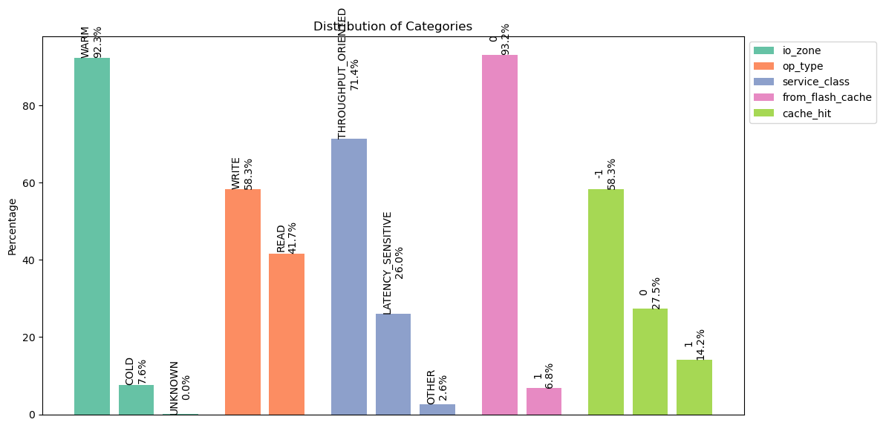

**cluster1_16TB_20240215_data-00085-of-00100:**

Number of traces: 144149

Number of distinct files: 11480

IO Zone Distribution:

WARM: 132949 (92.23%)

COLD: 11163 (7.74%)

UNKNOWN: 37 (0.03%)

Operation Type Distribution:

WRITE: 83513 (57.94%)

READ: 60636 (42.06%)

Service Class Distribution:

THROUGHPUT_ORIENTED: 99176 (68.80%)

LATENCY_SENSITIVE: 42125 (29.22%)

OTHER: 2848 (1.98%)

From Flash Cache Distribution:

0: 134864 (93.56%)

1: 9285 (6.44%)

Cache Hit Distribution:

-1: 83513 (57.94%)

0: 39222 (27.21%)

1: 21414 (14.86%)

Request I/O Size Analysis:

Distinct sizes: 31759

Lowest size: 0 bytes (0.00 KB)

Highest size: 8404992 bytes (8.02 MB)

Top 10 sizes (most frequent):

0 bytes (0.00 KB): 20399 (14.15%)

1050624 bytes (1.00 MB): 11594 (8.04%)

1048576 bytes (1.00 MB): 11099 (7.70%)

262144 bytes (256.00 KB): 6161 (4.27%)

262656 bytes (256.50 KB): 3973 (2.76%)

36864 bytes (36.00 KB): 2945 (2.04%)

55296 bytes (54.00 KB): 1806 (1.25%)

282624 bytes (276.00 KB): 1706 (1.18%)

32768 bytes (32.00 KB): 1696 (1.18%)

2101248 bytes (2.00 MB): 1533 (1.06%)

Response I/O Size Analysis:

Distinct sizes: 1298

Lowest size: 0 bytes (0.00 KB)

Highest size: 8404992 bytes (8.02 MB)

Top 10 sizes (most frequent):

0 bytes (0.00 KB): 89281 (61.94%)

1048576 bytes (1.00 MB): 8999 (6.24%)

262144 bytes (256.00 KB): 6147 (4.26%)

1050624 bytes (1.00 MB): 4253 (2.95%)

262656 bytes (256.50 KB): 3435 (2.38%)

36864 bytes (36.00 KB): 2866 (1.99%)

55296 bytes (54.00 KB): 1762 (1.22%)

282624 bytes (276.00 KB): 1655 (1.15%)

32768 bytes (32.00 KB): 1573 (1.09%)

264192 bytes (258.00 KB): 1300 (0.90%)

Disk I/O Size Analysis:

Distinct sizes: 31313

Lowest size: 0 bytes (0.00 KB)

Highest size: 8417280 bytes (8.03 MB)

Top 10 sizes (most frequent):

0 bytes (0.00 KB): 41813 (29.01%)

1048576 bytes (1.00 MB): 8955 (6.21%)

1052672 bytes (1.00 MB): 7512 (5.21%)

1050624 bytes (1.00 MB): 7198 (4.99%)

266240 bytes (260.00 KB): 2745 (1.90%)

262144 bytes (256.00 KB): 2035 (1.41%)

40960 bytes (40.00 KB): 1567 (1.09%)

32768 bytes (32.00 KB): 983 (0.68%)

258048 bytes (252.00 KB): 977 (0.68%)

1056768 bytes (1.01 MB): 726 (0.50%)

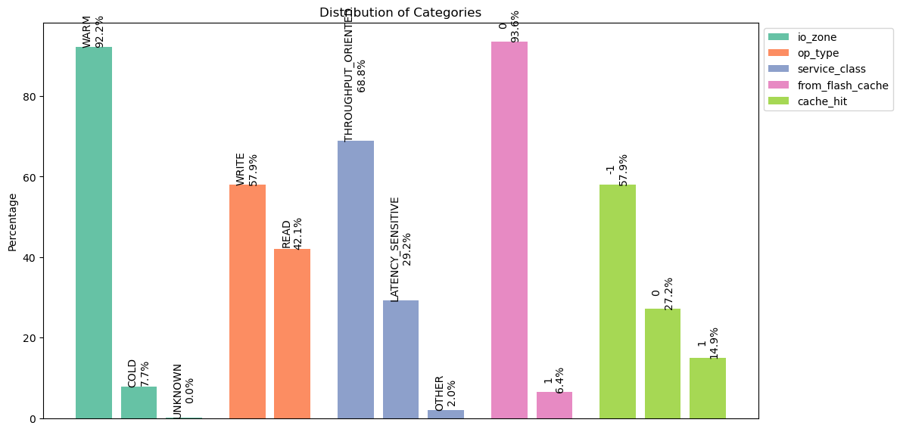

**cluster1_16TB_20240215_data-00099-of-00100:**

Number of traces: 144059

Number of distinct files: 10197

IO Zone Distribution:

WARM: 139924 (97.13%)

COLD: 4099 (2.85%)

UNKNOWN: 36 (0.02%)

Operation Type Distribution:

WRITE: 89398 (62.06%)

READ: 54661 (37.94%)

Service Class Distribution:

THROUGHPUT_ORIENTED: 92843 (64.45%)

LATENCY_SENSITIVE: 47270 (32.81%)

OTHER: 3946 (2.74%)

From Flash Cache Distribution:

0: 135418 (94.00%)

1: 8641 (6.00%)

Cache Hit Distribution:

-1: 89398 (62.06%)

0: 34784 (24.15%)

1: 19877 (13.80%)

Request I/O Size Analysis:

Distinct sizes: 33874

Lowest size: 0 bytes (0.00 KB)

Highest size: 8404992 bytes (8.02 MB)

Top 10 sizes (most frequent):

0 bytes (0.00 KB): 20868 (14.49%)

1050624 bytes (1.00 MB): 12037 (8.36%)

262144 bytes (256.00 KB): 5877 (4.08%)

1048576 bytes (1.00 MB): 5167 (3.59%)

262656 bytes (256.50 KB): 3394 (2.36%)

36864 bytes (36.00 KB): 3345 (2.32%)

55296 bytes (54.00 KB): 1846 (1.28%)

2101248 bytes (2.00 MB): 1783 (1.24%)

282624 bytes (276.00 KB): 1774 (1.23%)

264192 bytes (258.00 KB): 1309 (0.91%)

Response I/O Size Analysis:

Distinct sizes: 1344

Lowest size: 0 bytes (0.00 KB)

Highest size: 8404992 bytes (8.02 MB)

Top 10 sizes (most frequent):

0 bytes (0.00 KB): 93058 (64.60%)

262144 bytes (256.00 KB): 5873 (4.08%)

1050624 bytes (1.00 MB): 5191 (3.60%)

36864 bytes (36.00 KB): 3300 (2.29%)

262656 bytes (256.50 KB): 2973 (2.06%)

1048576 bytes (1.00 MB): 2402 (1.67%)

55296 bytes (54.00 KB): 1839 (1.28%)

282624 bytes (276.00 KB): 1762 (1.22%)

264192 bytes (258.00 KB): 1303 (0.90%)

43008 bytes (42.00 KB): 1193 (0.83%)

Disk I/O Size Analysis:

Distinct sizes: 33406

Lowest size: 0 bytes (0.00 KB)

Highest size: 8417280 bytes (8.03 MB)

Top 10 sizes (most frequent):

0 bytes (0.00 KB): 40745 (28.28%)

1050624 bytes (1.00 MB): 6648 (4.61%)

1052672 bytes (1.00 MB): 5389 (3.74%)

1048576 bytes (1.00 MB): 4961 (3.44%)

266240 bytes (260.00 KB): 2817 (1.96%)

262144 bytes (256.00 KB): 2182 (1.51%)

40960 bytes (40.00 KB): 1606 (1.11%)

258048 bytes (252.00 KB): 1044 (0.72%)

2105344 bytes (2.01 MB): 661 (0.46%)

32768 bytes (32.00 KB): 658 (0.46%)

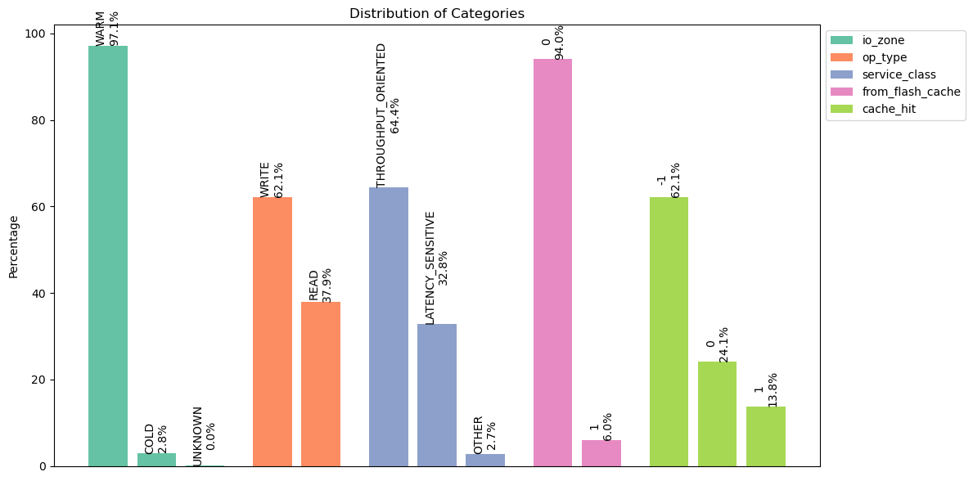

**cluster1_16TB_20240305_data-00060-of-00100:**

Number of traces: 159130

Number of distinct files: 10822

IO Zone Distribution:

WARM: 154880 (97.33%)

COLD: 4214 (2.65%)

UNKNOWN: 36 (0.02%)

Operation Type Distribution:

WRITE: 93435 (58.72%)

READ: 65695 (41.28%)

Service Class Distribution:

THROUGHPUT_ORIENTED: 110694 (69.56%)

LATENCY_SENSITIVE: 42539 (26.73%)

OTHER: 5897 (3.71%)

From Flash Cache Distribution:

0: 149792 (94.13%)

1: 9338 (5.87%)

Cache Hit Distribution:

-1: 93435 (58.72%)

0: 41444 (26.04%)

1: 24251 (15.24%)

Request I/O Size Analysis:

Distinct sizes: 32529

Lowest size: 0 bytes (0.00 KB)

Highest size: 8404992 bytes (8.02 MB)

Top 10 sizes (most frequent):

0 bytes (0.00 KB): 24562 (15.44%)

1050624 bytes (1.00 MB): 12401 (7.79%)

262144 bytes (256.00 KB): 6384 (4.01%)

1048576 bytes (1.00 MB): 6192 (3.89%)

36864 bytes (36.00 KB): 4262 (2.68%)

55296 bytes (54.00 KB): 3733 (2.35%)

262656 bytes (256.50 KB): 3338 (2.10%)

282624 bytes (276.00 KB): 1991 (1.25%)

43008 bytes (42.00 KB): 1538 (0.97%)

73728 bytes (72.00 KB): 1447 (0.91%)

Response I/O Size Analysis:

Distinct sizes: 1222

Lowest size: 0 bytes (0.00 KB)

Highest size: 8404992 bytes (8.02 MB)

Top 10 sizes (most frequent):

0 bytes (0.00 KB): 98934 (62.17%)

262144 bytes (256.00 KB): 6381 (4.01%)

36864 bytes (36.00 KB): 4204 (2.64%)

1048576 bytes (1.00 MB): 3792 (2.38%)

55296 bytes (54.00 KB): 3691 (2.32%)

262656 bytes (256.50 KB): 2745 (1.73%)

1050624 bytes (1.00 MB): 2695 (1.69%)

282624 bytes (276.00 KB): 1979 (1.24%)

43008 bytes (42.00 KB): 1531 (0.96%)

73728 bytes (72.00 KB): 1422 (0.89%)

Disk I/O Size Analysis:

Distinct sizes: 32072

Lowest size: 0 bytes (0.00 KB)

Highest size: 8417280 bytes (8.03 MB)

Top 10 sizes (most frequent):

0 bytes (0.00 KB): 48813 (30.67%)

1050624 bytes (1.00 MB): 9436 (5.93%)

1048576 bytes (1.00 MB): 5219 (3.28%)

1052672 bytes (1.00 MB): 4008 (2.52%)

266240 bytes (260.00 KB): 2753 (1.73%)

40960 bytes (40.00 KB): 2147 (1.35%)

262144 bytes (256.00 KB): 2061 (1.30%)

49152 bytes (48.00 KB): 1080 (0.68%)

61440 bytes (60.00 KB): 1069 (0.67%)

258048 bytes (252.00 KB): 1014 (0.64%)

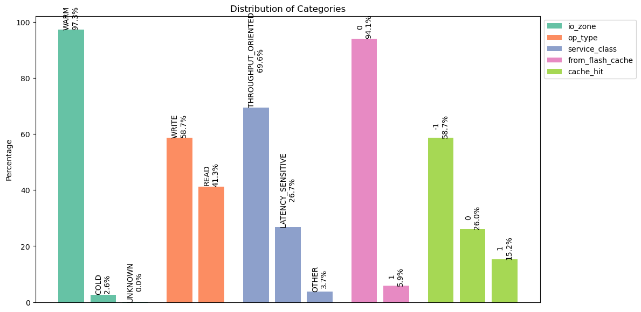

**cluster1_16TB_20240305_data-00096-of-00100:**

Number of traces: 159130

Number of distinct files: 11932

IO Zone Distribution:

WARM: 153571 (96.51%)

COLD: 5521 (3.47%)

UNKNOWN: 38 (0.02%)

Operation Type Distribution:

WRITE: 93475 (58.74%)

READ: 65655 (41.26%)

Service Class Distribution:

THROUGHPUT_ORIENTED: 115888 (72.83%)

LATENCY_SENSITIVE: 38130 (23.96%)

OTHER: 5112 (3.21%)

From Flash Cache Distribution:

0: 148388 (93.25%)

1: 10742 (6.75%)

Cache Hit Distribution:

-1: 93475 (58.74%)

0: 40316 (25.34%)

1: 25339 (15.92%)

Request I/O Size Analysis:

Distinct sizes: 33096

Lowest size: 0 bytes (0.00 KB)

Highest size: 8404992 bytes (8.02 MB)

Top 10 sizes (most frequent):

0 bytes (0.00 KB): 25308 (15.90%)

1050624 bytes (1.00 MB): 13731 (8.63%)

262144 bytes (256.00 KB): 7883 (4.95%)

1048576 bytes (1.00 MB): 7731 (4.86%)

262656 bytes (256.50 KB): 3682 (2.31%)

36864 bytes (36.00 KB): 3316 (2.08%)

55296 bytes (54.00 KB): 2499 (1.57%)

2101248 bytes (2.00 MB): 1785 (1.12%)

282624 bytes (276.00 KB): 1431 (0.90%)

541728 bytes (529.03 KB): 1372 (0.86%)

Response I/O Size Analysis:

Distinct sizes: 1398

Lowest size: 0 bytes (0.00 KB)

Highest size: 8404992 bytes (8.02 MB)

Top 10 sizes (most frequent):

0 bytes (0.00 KB): 100840 (63.37%)

262144 bytes (256.00 KB): 7868 (4.94%)

1048576 bytes (1.00 MB): 5476 (3.44%)

36864 bytes (36.00 KB): 3267 (2.05%)

262656 bytes (256.50 KB): 3140 (1.97%)

1050624 bytes (1.00 MB): 2996 (1.88%)

55296 bytes (54.00 KB): 2469 (1.55%)

282624 bytes (276.00 KB): 1416 (0.89%)

24576 bytes (24.00 KB): 1271 (0.80%)

43008 bytes (42.00 KB): 1181 (0.74%)

Disk I/O Size Analysis:

Distinct sizes: 32572

Lowest size: 0 bytes (0.00 KB)

Highest size: 8417280 bytes (8.03 MB)

Top 10 sizes (most frequent):

0 bytes (0.00 KB): 50647 (31.83%)

1050624 bytes (1.00 MB): 10077 (6.33%)

1048576 bytes (1.00 MB): 6350 (3.99%)

1052672 bytes (1.00 MB): 4903 (3.08%)

266240 bytes (260.00 KB): 2450 (1.54%)

262144 bytes (256.00 KB): 1819 (1.14%)

40960 bytes (40.00 KB): 1579 (0.99%)

20480 bytes (20.00 KB): 1225 (0.77%)

1056768 bytes (1.01 MB): 882 (0.55%)

49152 bytes (48.00 KB): 829 (0.52%)

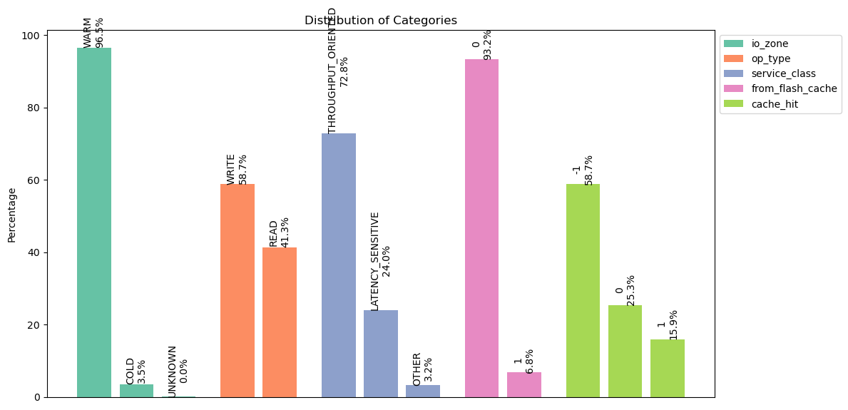

**cluster1_16TB_20240315_data-00023-of-00100:**

Number of traces: 146021

Number of distinct files: 11532

IO Zone Distribution:

WARM: 142439 (97.55%)

COLD: 3556 (2.44%)

UNKNOWN: 26 (0.02%)

Operation Type Distribution:

WRITE: 85183 (58.34%)

READ: 60838 (41.66%)

Service Class Distribution:

THROUGHPUT_ORIENTED: 94321 (64.59%)

LATENCY_SENSITIVE: 43040 (29.48%)

OTHER: 8660 (5.93%)

From Flash Cache Distribution:

0: 135495 (92.79%)

1: 10526 (7.21%)

Cache Hit Distribution:

-1: 85183 (58.34%)

0: 35748 (24.48%)

1: 25090 (17.18%)

Request I/O Size Analysis:

Distinct sizes: 31663

Lowest size: 0 bytes (0.00 KB)

Highest size: 8404992 bytes (8.02 MB)

Top 10 sizes (most frequent):

0 bytes (0.00 KB): 22746 (15.58%)

1050624 bytes (1.00 MB): 12031 (8.24%)

262144 bytes (256.00 KB): 6612 (4.53%)

1048576 bytes (1.00 MB): 5375 (3.68%)

36864 bytes (36.00 KB): 4671 (3.20%)

262656 bytes (256.50 KB): 4580 (3.14%)

76 bytes (0.07 KB): 3821 (2.62%)

24576 bytes (24.00 KB): 2103 (1.44%)

55296 bytes (54.00 KB): 1852 (1.27%)

43008 bytes (42.00 KB): 1564 (1.07%)

Response I/O Size Analysis:

Distinct sizes: 1493

Lowest size: 0 bytes (0.00 KB)

Highest size: 8404992 bytes (8.02 MB)

Top 10 sizes (most frequent):

0 bytes (0.00 KB): 89841 (61.53%)

262144 bytes (256.00 KB): 6607 (4.52%)

36864 bytes (36.00 KB): 4610 (3.16%)

262656 bytes (256.50 KB): 4109 (2.81%)

1050624 bytes (1.00 MB): 3202 (2.19%)

1048576 bytes (1.00 MB): 2823 (1.93%)

24576 bytes (24.00 KB): 2077 (1.42%)

55296 bytes (54.00 KB): 1841 (1.26%)

43008 bytes (42.00 KB): 1556 (1.07%)

282624 bytes (276.00 KB): 1487 (1.02%)

Disk I/O Size Analysis:

Distinct sizes: 31116

Lowest size: 0 bytes (0.00 KB)

Highest size: 8417280 bytes (8.03 MB)

Top 10 sizes (most frequent):

0 bytes (0.00 KB): 47836 (32.76%)

1050624 bytes (1.00 MB): 8163 (5.59%)

1048576 bytes (1.00 MB): 4769 (3.27%)

1052672 bytes (1.00 MB): 3876 (2.65%)

76 bytes (0.07 KB): 3821 (2.62%)

266240 bytes (260.00 KB): 2909 (1.99%)

262144 bytes (256.00 KB): 2280 (1.56%)

40960 bytes (40.00 KB): 1600 (1.10%)

141 bytes (0.14 KB): 1371 (0.94%)

258048 bytes (252.00 KB): 980 (0.67%)

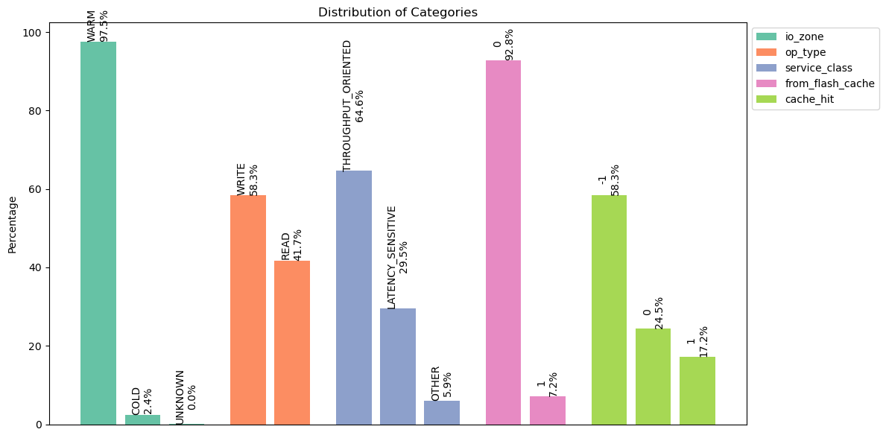

**cluster1_16TB_20240315_data-00071-of-00100:**

Number of traces: 146021

Number of distinct files: 11072

IO Zone Distribution:

WARM: 142903 (97.86%)

COLD: 3089 (2.12%)

UNKNOWN: 29 (0.02%)

Operation Type Distribution:

WRITE: 85379 (58.47%)

READ: 60642 (41.53%)

Service Class Distribution:

THROUGHPUT_ORIENTED: 104388 (71.49%)

LATENCY_SENSITIVE: 36999 (25.34%)

OTHER: 4634 (3.17%)

From Flash Cache Distribution:

0: 133841 (91.66%)

1: 12180 (8.34%)

Cache Hit Distribution:

-1: 85379 (58.47%)

0: 36493 (24.99%)

1: 24149 (16.54%)

Request I/O Size Analysis:

Distinct sizes: 31937

Lowest size: 0 bytes (0.00 KB)

Highest size: 8404992 bytes (8.02 MB)

Top 10 sizes (most frequent):

0 bytes (0.00 KB): 22536 (15.43%)

1050624 bytes (1.00 MB): 10743 (7.36%)

262144 bytes (256.00 KB): 8979 (6.15%)

1048576 bytes (1.00 MB): 5537 (3.79%)

262656 bytes (256.50 KB): 3930 (2.69%)

36864 bytes (36.00 KB): 3563 (2.44%)

55296 bytes (54.00 KB): 2011 (1.38%)

282624 bytes (276.00 KB): 1772 (1.21%)

264192 bytes (258.00 KB): 1403 (0.96%)

43008 bytes (42.00 KB): 1327 (0.91%)

Response I/O Size Analysis:

Distinct sizes: 1308

Lowest size: 0 bytes (0.00 KB)

Highest size: 8404992 bytes (8.02 MB)

Top 10 sizes (most frequent):

0 bytes (0.00 KB): 90240 (61.80%)

262144 bytes (256.00 KB): 8975 (6.15%)

36864 bytes (36.00 KB): 3516 (2.41%)

262656 bytes (256.50 KB): 3450 (2.36%)

1048576 bytes (1.00 MB): 2814 (1.93%)

1050624 bytes (1.00 MB): 2137 (1.46%)

55296 bytes (54.00 KB): 2000 (1.37%)

282624 bytes (276.00 KB): 1758 (1.20%)

264192 bytes (258.00 KB): 1401 (0.96%)

43008 bytes (42.00 KB): 1307 (0.90%)

Disk I/O Size Analysis:

Distinct sizes: 31516

Lowest size: 0 bytes (0.00 KB)

Highest size: 8417280 bytes (8.03 MB)

Top 10 sizes (most frequent):

0 bytes (0.00 KB): 46685 (31.97%)

1050624 bytes (1.00 MB): 8184 (5.60%)

1048576 bytes (1.00 MB): 4910 (3.36%)

1052672 bytes (1.00 MB): 3364 (2.30%)

266240 bytes (260.00 KB): 2756 (1.89%)

262144 bytes (256.00 KB): 2170 (1.49%)

40960 bytes (40.00 KB): 1740 (1.19%)

258048 bytes (252.00 KB): 1081 (0.74%)

49152 bytes (48.00 KB): 742 (0.51%)

61440 bytes (60.00 KB): 720 (0.49%)

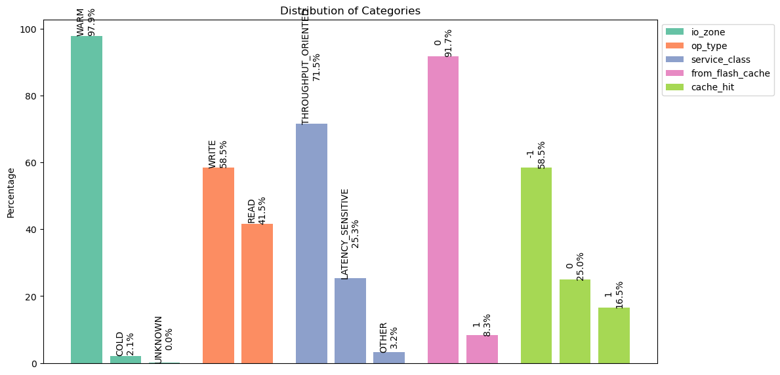

**cluster1_16TB_20240315_data-00099-of-00100:**

Number of traces: 145944

Number of distinct files: 10890

IO Zone Distribution:

WARM: 143101 (98.05%)

COLD: 2808 (1.92%)

UNKNOWN: 35 (0.02%)

Operation Type Distribution:

WRITE: 81673 (55.96%)

READ: 64271 (44.04%)

Service Class Distribution:

THROUGHPUT_ORIENTED: 108020 (74.01%)

LATENCY_SENSITIVE: 32340 (22.16%)

OTHER: 5584 (3.83%)

From Flash Cache Distribution:

0: 134146 (91.92%)

1: 11798 (8.08%)

Cache Hit Distribution:

-1: 81673 (55.96%)

0: 35351 (24.22%)

1: 28920 (19.82%)

Request I/O Size Analysis:

Distinct sizes: 29988

Lowest size: 0 bytes (0.00 KB)

Highest size: 8404992 bytes (8.02 MB)

Top 10 sizes (most frequent):

0 bytes (0.00 KB): 22312 (15.29%)

1050624 bytes (1.00 MB): 11898 (8.15%)

262144 bytes (256.00 KB): 7369 (5.05%)

262656 bytes (256.50 KB): 5114 (3.50%)

1048576 bytes (1.00 MB): 5103 (3.50%)

36864 bytes (36.00 KB): 3993 (2.74%)

55296 bytes (54.00 KB): 2903 (1.99%)

282624 bytes (276.00 KB): 1780 (1.22%)

2101248 bytes (2.00 MB): 1742 (1.19%)

73728 bytes (72.00 KB): 1394 (0.96%)

Response I/O Size Analysis:

Distinct sizes: 1455

Lowest size: 0 bytes (0.00 KB)

Highest size: 8404992 bytes (8.02 MB)

Top 10 sizes (most frequent):

0 bytes (0.00 KB): 86803 (59.48%)

262144 bytes (256.00 KB): 7361 (5.04%)

262656 bytes (256.50 KB): 4607 (3.16%)

36864 bytes (36.00 KB): 3960 (2.71%)

55296 bytes (54.00 KB): 2890 (1.98%)

1048576 bytes (1.00 MB): 2169 (1.49%)

1050624 bytes (1.00 MB): 1954 (1.34%)

282624 bytes (276.00 KB): 1773 (1.21%)

73728 bytes (72.00 KB): 1376 (0.94%)

43008 bytes (42.00 KB): 1360 (0.93%)

Disk I/O Size Analysis:

Distinct sizes: 29372

Lowest size: 0 bytes (0.00 KB)

Highest size: 8417280 bytes (8.03 MB)

Top 10 sizes (most frequent):

0 bytes (0.00 KB): 51232 (35.10%)

1050624 bytes (1.00 MB): 9499 (6.51%)

1048576 bytes (1.00 MB): 4221 (2.89%)

266240 bytes (260.00 KB): 2905 (1.99%)

1052672 bytes (1.00 MB): 2590 (1.77%)

262144 bytes (256.00 KB): 2157 (1.48%)

40960 bytes (40.00 KB): 1656 (1.13%)

258048 bytes (252.00 KB): 1035 (0.71%)

32768 bytes (32.00 KB): 928 (0.64%)

49152 bytes (48.00 KB): 753 (0.52%)

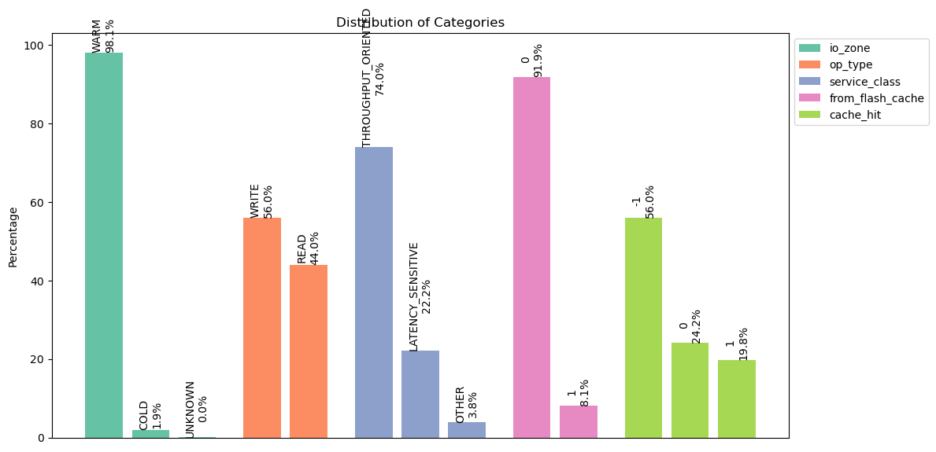

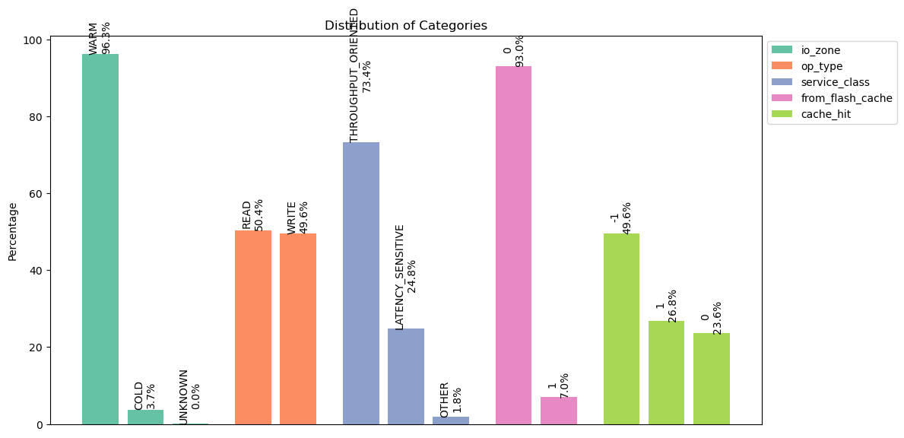

**cluster1_16TB_20240115_data-00094-of-00100:**

Number of traces: 168591

Number of distinct files: 14019

IO Zone Distribution:

WARM: 163585 (97.03%)

COLD: 4967 (2.95%)

UNKNOWN: 39 (0.02%)

Operation Type Distribution:

WRITE: 90930 (53.94%)

READ: 77661 (46.06%)

Service Class Distribution:

THROUGHPUT_ORIENTED: 121291 (71.94%)

LATENCY_SENSITIVE: 43371 (25.73%)

OTHER: 3929 (2.33%)

From Flash Cache Distribution:

0: 158240 (93.86%)

1: 10351 (6.14%)

Cache Hit Distribution:

-1: 90930 (53.94%)

0: 39427 (23.39%)

1: 38234 (22.68%)

Request I/O Size Analysis:

Distinct sizes: 35133

Lowest size: 0 bytes (0.00 KB)

Highest size: 8404992 bytes (8.02 MB)

Top 10 sizes (most frequent):

0 bytes (0.00 KB): 26290 (15.59%)

1050624 bytes (1.00 MB): 10728 (6.36%)

262144 bytes (256.00 KB): 7202 (4.27%)

1048576 bytes (1.00 MB): 6771 (4.02%)

32832 bytes (32.06 KB): 6353 (3.77%)

262656 bytes (256.50 KB): 4986 (2.96%)

36864 bytes (36.00 KB): 3464 (2.05%)

16416 bytes (16.03 KB): 3221 (1.91%)

279072 bytes (272.53 KB): 2881 (1.71%)

55296 bytes (54.00 KB): 2539 (1.51%)

Response I/O Size Analysis:

Distinct sizes: 1481

Lowest size: 0 bytes (0.00 KB)

Highest size: 8404992 bytes (8.02 MB)

Top 10 sizes (most frequent):

0 bytes (0.00 KB): 103954 (61.66%)

262144 bytes (256.00 KB): 7197 (4.27%)

32832 bytes (32.06 KB): 4091 (2.43%)

262656 bytes (256.50 KB): 3869 (2.29%)

36864 bytes (36.00 KB): 3399 (2.02%)

16416 bytes (16.03 KB): 2897 (1.72%)

1048576 bytes (1.00 MB): 2714 (1.61%)

55296 bytes (54.00 KB): 2521 (1.50%)

32768 bytes (32.00 KB): 1653 (0.98%)

1050624 bytes (1.00 MB): 1633 (0.97%)

Disk I/O Size Analysis:

Distinct sizes: 34613

Lowest size: 0 bytes (0.00 KB)

Highest size: 8417280 bytes (8.03 MB)

Top 10 sizes (most frequent):

0 bytes (0.00 KB): 64524 (38.27%)

1050624 bytes (1.00 MB): 8329 (4.94%)

1048576 bytes (1.00 MB): 5822 (3.45%)

266240 bytes (260.00 KB): 3039 (1.80%)

1052672 bytes (1.00 MB): 2703 (1.60%)

262144 bytes (256.00 KB): 2598 (1.54%)

36864 bytes (36.00 KB): 2189 (1.30%)

40960 bytes (40.00 KB): 1588 (0.94%)

32768 bytes (32.00 KB): 1130 (0.67%)

53248 bytes (52.00 KB): 874 (0.52%)

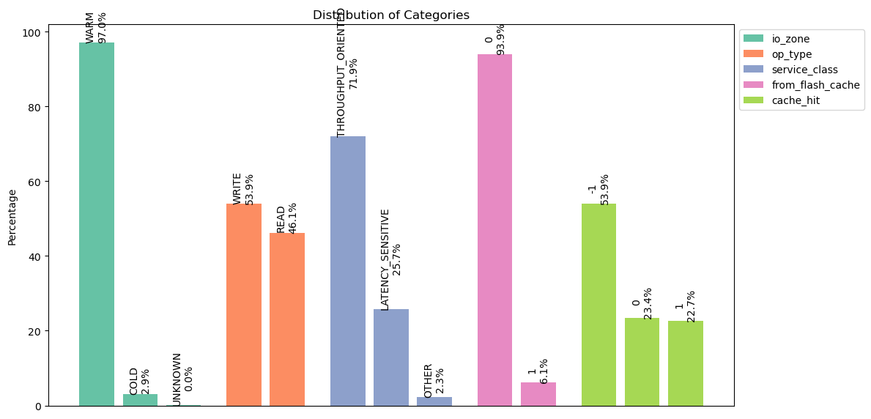

**cluster1_16TB_20240115_data-00099-of-00100:**

Number of traces: 168540

Number of distinct files: 15481

IO Zone Distribution:

WARM: 161693 (95.94%)

COLD: 6813 (4.04%)

UNKNOWN: 34 (0.02%)

Operation Type Distribution:

WRITE: 92038 (54.61%)

READ: 76502 (45.39%)

Service Class Distribution:

THROUGHPUT_ORIENTED: 125426 (74.42%)

LATENCY_SENSITIVE: 38432 (22.80%)

OTHER: 4682 (2.78%)

From Flash Cache Distribution:

0: 157180 (93.26%)

1: 11360 (6.74%)

Cache Hit Distribution:

-1: 92038 (54.61%)

0: 44263 (26.26%)

1: 32239 (19.13%)

Request I/O Size Analysis:

Distinct sizes: 34947

Lowest size: 0 bytes (0.00 KB)

Highest size: 8404992 bytes (8.02 MB)

Top 10 sizes (most frequent):

0 bytes (0.00 KB): 28051 (16.64%)

1050624 bytes (1.00 MB): 12054 (7.15%)

1048576 bytes (1.00 MB): 7910 (4.69%)

262144 bytes (256.00 KB): 7868 (4.67%)

262656 bytes (256.50 KB): 5085 (3.02%)

32832 bytes (32.06 KB): 4704 (2.79%)

36864 bytes (36.00 KB): 3164 (1.88%)

433 bytes (0.42 KB): 2633 (1.56%)

279072 bytes (272.53 KB): 2404 (1.43%)

16416 bytes (16.03 KB): 2126 (1.26%)

Response I/O Size Analysis:

Distinct sizes: 1652

Lowest size: 0 bytes (0.00 KB)

Highest size: 8404992 bytes (8.02 MB)

Top 10 sizes (most frequent):

0 bytes (0.00 KB): 103579 (61.46%)

262144 bytes (256.00 KB): 7867 (4.67%)

262656 bytes (256.50 KB): 4186 (2.48%)

1048576 bytes (1.00 MB): 3670 (2.18%)

36864 bytes (36.00 KB): 3117 (1.85%)

1050624 bytes (1.00 MB): 2897 (1.72%)

32832 bytes (32.06 KB): 2721 (1.61%)

32768 bytes (32.00 KB): 1794 (1.06%)

16416 bytes (16.03 KB): 1749 (1.04%)

55296 bytes (54.00 KB): 1691 (1.00%)

Disk I/O Size Analysis:

Distinct sizes: 34294

Lowest size: 0 bytes (0.00 KB)

Highest size: 8417280 bytes (8.03 MB)

Top 10 sizes (most frequent):

0 bytes (0.00 KB): 60290 (35.77%)

1050624 bytes (1.00 MB): 8618 (5.11%)

1048576 bytes (1.00 MB): 6879 (4.08%)

1052672 bytes (1.00 MB): 4130 (2.45%)

266240 bytes (260.00 KB): 3145 (1.87%)

262144 bytes (256.00 KB): 2683 (1.59%)

433 bytes (0.42 KB): 2629 (1.56%)

36864 bytes (36.00 KB): 2043 (1.21%)

40960 bytes (40.00 KB): 1623 (0.96%)

32768 bytes (32.00 KB): 974 (0.58%)

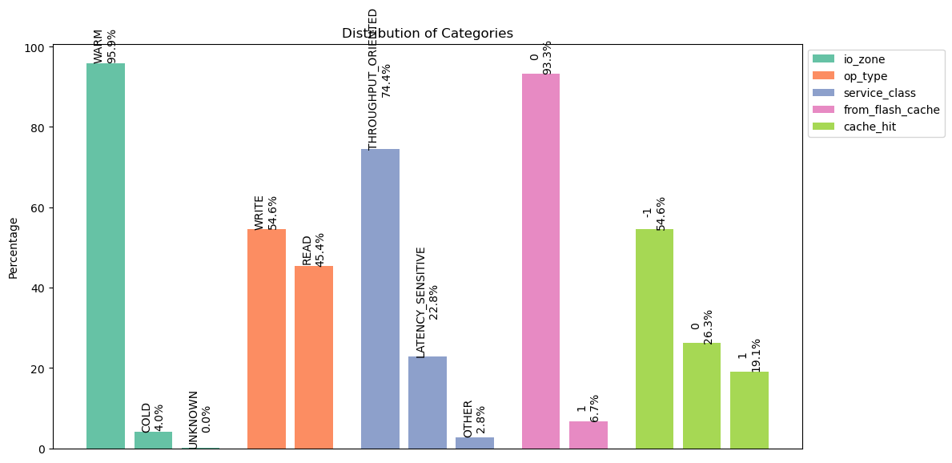

**cluster2_16TB_20240125_data-00023-of-00100:**

Number of traces: 109954

Number of distinct files: 8798

IO Zone Distribution:

WARM: 99810 (90.77%)

COLD: 10010 (9.10%)

UNKNOWN: 134 (0.12%)

Operation Type Distribution:

WRITE: 60437 (54.97%)

READ: 49517 (45.03%)

Service Class Distribution:

OTHER: 58099 (52.84%)

THROUGHPUT_ORIENTED: 39978 (36.36%)

LATENCY_SENSITIVE: 11877 (10.80%)

From Flash Cache Distribution:

0: 105079 (95.57%)

1: 4875 (4.43%)

Cache Hit Distribution:

-1: 60437 (54.97%)

0: 25675 (23.35%)

1: 23842 (21.68%)

Request I/O Size Analysis:

Distinct sizes: 15931

Lowest size: 0 bytes (0.00 KB)

Highest size: 8404992 bytes (8.02 MB)

Top 10 sizes (most frequent):

1050624 bytes (1.00 MB): 37829 (34.40%)

0 bytes (0.00 KB): 27768 (25.25%)

2101248 bytes (2.00 MB): 5144 (4.68%)

1048576 bytes (1.00 MB): 1523 (1.39%)

525312 bytes (513.00 KB): 1378 (1.25%)

541728 bytes (529.03 KB): 1322 (1.20%)

24576 bytes (24.00 KB): 1265 (1.15%)

546816 bytes (534.00 KB): 1171 (1.06%)

18432 bytes (18.00 KB): 975 (0.89%)

4202496 bytes (4.01 MB): 853 (0.78%)

Response I/O Size Analysis:

Distinct sizes: 1024

Lowest size: 0 bytes (0.00 KB)

Highest size: 8404992 bytes (8.02 MB)

Top 10 sizes (most frequent):

0 bytes (0.00 KB): 75047 (68.25%)

1050624 bytes (1.00 MB): 15511 (14.11%)

2101248 bytes (2.00 MB): 2180 (1.98%)

24576 bytes (24.00 KB): 1260 (1.15%)

546816 bytes (534.00 KB): 1170 (1.06%)

18432 bytes (18.00 KB): 969 (0.88%)

86016 bytes (84.00 KB): 713 (0.65%)

1048576 bytes (1.00 MB): 692 (0.63%)

36864 bytes (36.00 KB): 626 (0.57%)

525312 bytes (513.00 KB): 586 (0.53%)

Disk I/O Size Analysis:

Distinct sizes: 14822

Lowest size: 0 bytes (0.00 KB)

Highest size: 8417280 bytes (8.03 MB)

Top 10 sizes (most frequent):

0 bytes (0.00 KB): 51610 (46.94%)

1050624 bytes (1.00 MB): 15250 (13.87%)

1052672 bytes (1.00 MB): 6756 (6.14%)

1056768 bytes (1.01 MB): 3966 (3.61%)

1048576 bytes (1.00 MB): 2083 (1.89%)

2105344 bytes (2.01 MB): 1449 (1.32%)

16384 bytes (16.00 KB): 949 (0.86%)

524288 bytes (512.00 KB): 874 (0.79%)

528384 bytes (516.00 KB): 798 (0.73%)

2101248 bytes (2.00 MB): 465 (0.42%)

**cluster2_16TB_20240218_data-00032-of-00100:**

Number of traces: 97579

Number of distinct files: 8498

IO Zone Distribution:

WARM: 86878 (89.03%)

COLD: 10590 (10.85%)

UNKNOWN: 111 (0.11%)

Operation Type Distribution:

WRITE: 50412 (51.66%)

READ: 47167 (48.34%)

Service Class Distribution:

OTHER: 50217 (51.46%)

THROUGHPUT_ORIENTED: 32414 (33.22%)

LATENCY_SENSITIVE: 14948 (15.32%)

From Flash Cache Distribution:

0: 92737 (95.04%)

1: 4842 (4.96%)

Cache Hit Distribution:

-1: 50412 (51.66%)

0: 26971 (27.64%)

1: 20196 (20.70%)

Request I/O Size Analysis:

Distinct sizes: 13651

Lowest size: 0 bytes (0.00 KB)

Highest size: 8404992 bytes (8.02 MB)

Top 10 sizes (most frequent):

1050624 bytes (1.00 MB): 35845 (36.73%)

0 bytes (0.00 KB): 22737 (23.30%)

2101248 bytes (2.00 MB): 4874 (4.99%)

1048576 bytes (1.00 MB): 2728 (2.80%)

24576 bytes (24.00 KB): 1594 (1.63%)

541728 bytes (529.03 KB): 1281 (1.31%)

18432 bytes (18.00 KB): 1137 (1.17%)

4202496 bytes (4.01 MB): 802 (0.82%)

525312 bytes (513.00 KB): 665 (0.68%)

9681 bytes (9.45 KB): 422 (0.43%)

Response I/O Size Analysis:

Distinct sizes: 1037

Lowest size: 0 bytes (0.00 KB)

Highest size: 8404992 bytes (8.02 MB)

Top 10 sizes (most frequent):

0 bytes (0.00 KB): 60383 (61.88%)

1050624 bytes (1.00 MB): 19634 (20.12%)

1048576 bytes (1.00 MB): 2248 (2.30%)

2101248 bytes (2.00 MB): 2052 (2.10%)

24576 bytes (24.00 KB): 1593 (1.63%)

18432 bytes (18.00 KB): 1134 (1.16%)

541728 bytes (529.03 KB): 554 (0.57%)

36864 bytes (36.00 KB): 400 (0.41%)

9681 bytes (9.45 KB): 375 (0.38%)

4202496 bytes (4.01 MB): 368 (0.38%)

Disk I/O Size Analysis:

Distinct sizes: 12619

Lowest size: 0 bytes (0.00 KB)

Highest size: 8417280 bytes (8.03 MB)

Top 10 sizes (most frequent):

0 bytes (0.00 KB): 42933 (44.00%)

1050624 bytes (1.00 MB): 12754 (13.07%)

1052672 bytes (1.00 MB): 10460 (10.72%)

1056768 bytes (1.01 MB): 3795 (3.89%)

1048576 bytes (1.00 MB): 3404 (3.49%)

2105344 bytes (2.01 MB): 1411 (1.45%)

2101248 bytes (2.00 MB): 489 (0.50%)

524288 bytes (512.00 KB): 459 (0.47%)

528384 bytes (516.00 KB): 345 (0.35%)

2109440 bytes (2.01 MB): 283 (0.29%)

**cluster2_16TB_20240315_data-00074-of-00100:**

Number of traces: 95516

Number of distinct files: 6384

IO Zone Distribution:

WARM: 83224 (87.13%)

COLD: 12149 (12.72%)

UNKNOWN: 143 (0.15%)

Operation Type Distribution:

READ: 51299 (53.71%)

WRITE: 44217 (46.29%)

Service Class Distribution:

OTHER: 66851 (69.99%)

THROUGHPUT_ORIENTED: 20222 (21.17%)

LATENCY_SENSITIVE: 8443 (8.84%)

From Flash Cache Distribution:

0: 90786 (95.05%)

1: 4730 (4.95%)

Cache Hit Distribution:

-1: 44217 (46.29%)

1: 27625 (28.92%)

0: 23674 (24.79%)

Request I/O Size Analysis:

Distinct sizes: 12921

Lowest size: 0 bytes (0.00 KB)

Highest size: 8404992 bytes (8.02 MB)

Top 10 sizes (most frequent):

1050624 bytes (1.00 MB): 29230 (30.60%)

0 bytes (0.00 KB): 20341 (21.30%)

24576 bytes (24.00 KB): 7850 (8.22%)

18432 bytes (18.00 KB): 4411 (4.62%)

2101248 bytes (2.00 MB): 4128 (4.32%)

541728 bytes (529.03 KB): 2056 (2.15%)

36864 bytes (36.00 KB): 913 (0.96%)

546816 bytes (534.00 KB): 657 (0.69%)

32832 bytes (32.06 KB): 643 (0.67%)

4202496 bytes (4.01 MB): 638 (0.67%)

Response I/O Size Analysis:

Distinct sizes: 908

Lowest size: 0 bytes (0.00 KB)

Highest size: 8404992 bytes (8.02 MB)

Top 10 sizes (most frequent):

0 bytes (0.00 KB): 54624 (57.19%)

1050624 bytes (1.00 MB): 14960 (15.66%)

24576 bytes (24.00 KB): 7807 (8.17%)

18432 bytes (18.00 KB): 4402 (4.61%)

2101248 bytes (2.00 MB): 1518 (1.59%)

36864 bytes (36.00 KB): 908 (0.95%)

541728 bytes (529.03 KB): 823 (0.86%)

546816 bytes (534.00 KB): 657 (0.69%)

43008 bytes (42.00 KB): 428 (0.45%)

55296 bytes (54.00 KB): 386 (0.40%)

Disk I/O Size Analysis:

Distinct sizes: 12070

Lowest size: 0 bytes (0.00 KB)

Highest size: 8417280 bytes (8.03 MB)

Top 10 sizes (most frequent):

0 bytes (0.00 KB): 47966 (50.22%)

1050624 bytes (1.00 MB): 10846 (11.36%)

1052672 bytes (1.00 MB): 6500 (6.81%)

1056768 bytes (1.01 MB): 3292 (3.45%)

1048576 bytes (1.00 MB): 1129 (1.18%)

2105344 bytes (2.01 MB): 1049 (1.10%)

20480 bytes (20.00 KB): 863 (0.90%)

524288 bytes (512.00 KB): 712 (0.75%)

16384 bytes (16.00 KB): 608 (0.64%)

12288 bytes (12.00 KB): 603 (0.63%)

**cluster3_18TB_20240129_data-00088-of-00100:**

Number of traces: 168675

Number of distinct files: 8626

IO Zone Distribution:

WARM: 155923 (92.44%)

COLD: 12601 (7.47%)

UNKNOWN: 151 (0.09%)

Operation Type Distribution:

WRITE: 117674 (69.76%)

READ: 51001 (30.24%)

Service Class Distribution:

THROUGHPUT_ORIENTED: 77769 (46.11%)

LATENCY_SENSITIVE: 72758 (43.14%)

OTHER: 18148 (10.76%)

From Flash Cache Distribution:

0: 158339 (93.87%)

1: 10336 (6.13%)

Cache Hit Distribution:

-1: 117674 (69.76%)

0: 26192 (15.53%)

1: 24809 (14.71%)

Request I/O Size Analysis:

Distinct sizes: 23855

Lowest size: 0 bytes (0.00 KB)

Highest size: 8404992 bytes (8.02 MB)

Top 10 sizes (most frequent):

0 bytes (0.00 KB): 23126 (13.71%)

1050624 bytes (1.00 MB): 15392 (9.13%)

1048576 bytes (1.00 MB): 12912 (7.65%)

262656 bytes (256.50 KB): 5711 (3.39%)

262144 bytes (256.00 KB): 4644 (2.75%)

2101248 bytes (2.00 MB): 2184 (1.29%)

157176 bytes (153.49 KB): 793 (0.47%)

15271 bytes (14.91 KB): 693 (0.41%)

528384 bytes (516.00 KB): 674 (0.40%)

16384 bytes (16.00 KB): 591 (0.35%)

Response I/O Size Analysis:

Distinct sizes: 1404

Lowest size: 0 bytes (0.00 KB)

Highest size: 8404992 bytes (8.02 MB)

Top 10 sizes (most frequent):

0 bytes (0.00 KB): 122133 (72.41%)

1048576 bytes (1.00 MB): 8414 (4.99%)

262656 bytes (256.50 KB): 5608 (3.32%)

262144 bytes (256.00 KB): 4605 (2.73%)

1050624 bytes (1.00 MB): 4177 (2.48%)

2101248 bytes (2.00 MB): 990 (0.59%)

157176 bytes (153.49 KB): 792 (0.47%)

15271 bytes (14.91 KB): 693 (0.41%)

528384 bytes (516.00 KB): 673 (0.40%)

135168 bytes (132.00 KB): 545 (0.32%)

Disk I/O Size Analysis:

Distinct sizes: 23265

Lowest size: 0 bytes (0.00 KB)

Highest size: 8417280 bytes (8.03 MB)

Top 10 sizes (most frequent):

0 bytes (0.00 KB): 47935 (28.42%)

1048576 bytes (1.00 MB): 10499 (6.22%)

1050624 bytes (1.00 MB): 9884 (5.86%)

1052672 bytes (1.00 MB): 6286 (3.73%)

262144 bytes (256.00 KB): 973 (0.58%)

266240 bytes (260.00 KB): 832 (0.49%)

1056768 bytes (1.01 MB): 805 (0.48%)

16384 bytes (16.00 KB): 664 (0.39%)

4096 bytes (4.00 KB): 483 (0.29%)

2105344 bytes (2.01 MB): 457 (0.27%)

**cluster3_18TB_20240307_data-00051-of-00100:**

Number of traces: 175702

Number of distinct files: 10597

IO Zone Distribution:

WARM: 154337 (87.84%)

COLD: 21243 (12.09%)

UNKNOWN: 122 (0.07%)

Operation Type Distribution:

WRITE: 111358 (63.38%)

READ: 64344 (36.62%)

Service Class Distribution:

THROUGHPUT_ORIENTED: 101140 (57.56%)

LATENCY_SENSITIVE: 64672 (36.81%)

OTHER: 9890 (5.63%)

From Flash Cache Distribution:

0: 162217 (92.33%)

1: 13485 (7.67%)

Cache Hit Distribution:

-1: 111358 (63.38%)

0: 34854 (19.84%)

1: 29490 (16.78%)

Request I/O Size Analysis:

Distinct sizes: 25555

Lowest size: 0 bytes (0.00 KB)

Highest size: 8404992 bytes (8.02 MB)

Top 10 sizes (most frequent):

0 bytes (0.00 KB): 26504 (15.08%)

1050624 bytes (1.00 MB): 22800 (12.98%)

1048576 bytes (1.00 MB): 14563 (8.29%)

262656 bytes (256.50 KB): 7894 (4.49%)

262144 bytes (256.00 KB): 5703 (3.25%)

2101248 bytes (2.00 MB): 2877 (1.64%)

525312 bytes (513.00 KB): 961 (0.55%)

528384 bytes (516.00 KB): 894 (0.51%)

135168 bytes (132.00 KB): 784 (0.45%)

1048577 bytes (1.00 MB): 707 (0.40%)

Response I/O Size Analysis:

Distinct sizes: 1381

Lowest size: 0 bytes (0.00 KB)

Highest size: 8404992 bytes (8.02 MB)

Top 10 sizes (most frequent):

0 bytes (0.00 KB): 118025 (67.17%)

1048576 bytes (1.00 MB): 9915 (5.64%)

1050624 bytes (1.00 MB): 8735 (4.97%)

262656 bytes (256.50 KB): 7705 (4.39%)

262144 bytes (256.00 KB): 5662 (3.22%)

2101248 bytes (2.00 MB): 1253 (0.71%)

528384 bytes (516.00 KB): 885 (0.50%)

135168 bytes (132.00 KB): 773 (0.44%)

55296 bytes (54.00 KB): 539 (0.31%)

32768 bytes (32.00 KB): 538 (0.31%)

Disk I/O Size Analysis:

Distinct sizes: 25004

Lowest size: 0 bytes (0.00 KB)

Highest size: 8417280 bytes (8.03 MB)

Top 10 sizes (most frequent):

0 bytes (0.00 KB): 55994 (31.87%)

1048576 bytes (1.00 MB): 12297 (7.00%)

1050624 bytes (1.00 MB): 12008 (6.83%)

1052672 bytes (1.00 MB): 10582 (6.02%)

1056768 bytes (1.01 MB): 1480 (0.84%)

262144 bytes (256.00 KB): 768 (0.44%)

2105344 bytes (2.01 MB): 685 (0.39%)

266240 bytes (260.00 KB): 655 (0.37%)

16384 bytes (16.00 KB): 545 (0.31%)

28 bytes (0.03 KB): 479 (0.27%)

**cluster3_18TB_20240315_data-00089-of-00100:**

Number of traces: 169134

Number of distinct files: 6971

IO Zone Distribution:

WARM: 161457 (95.46%)

COLD: 7600 (4.49%)

UNKNOWN: 77 (0.05%)

Operation Type Distribution:

WRITE: 130540 (77.18%)

READ: 38594 (22.82%)

Service Class Distribution:

LATENCY_SENSITIVE: 95559 (56.50%)

THROUGHPUT_ORIENTED: 60616 (35.84%)

OTHER: 12959 (7.66%)

From Flash Cache Distribution:

0: 159166 (94.11%)

1: 9968 (5.89%)

Cache Hit Distribution:

-1: 130540 (77.18%)

1: 19825 (11.72%)

0: 18769 (11.10%)

Request I/O Size Analysis:

Distinct sizes: 23550

Lowest size: 0 bytes (0.00 KB)

Highest size: 8404992 bytes (8.02 MB)

Top 10 sizes (most frequent):

0 bytes (0.00 KB): 20253 (11.97%)

1050624 bytes (1.00 MB): 13417 (7.93%)

1048576 bytes (1.00 MB): 7137 (4.22%)

262656 bytes (256.50 KB): 6300 (3.72%)

262144 bytes (256.00 KB): 3612 (2.14%)

2101248 bytes (2.00 MB): 2098 (1.24%)

587 bytes (0.57 KB): 1536 (0.91%)

585 bytes (0.57 KB): 944 (0.56%)

638 bytes (0.62 KB): 743 (0.44%)

135168 bytes (132.00 KB): 645 (0.38%)

Response I/O Size Analysis:

Distinct sizes: 1218

Lowest size: 0 bytes (0.00 KB)

Highest size: 8404992 bytes (8.02 MB)

Top 10 sizes (most frequent):

0 bytes (0.00 KB): 133935 (79.19%)

262656 bytes (256.50 KB): 6230 (3.68%)

1048576 bytes (1.00 MB): 4115 (2.43%)

262144 bytes (256.00 KB): 3611 (2.13%)

1050624 bytes (1.00 MB): 3370 (1.99%)

2101248 bytes (2.00 MB): 923 (0.55%)

135168 bytes (132.00 KB): 638 (0.38%)

528384 bytes (516.00 KB): 477 (0.28%)

282624 bytes (276.00 KB): 414 (0.24%)

36864 bytes (36.00 KB): 319 (0.19%)

Disk I/O Size Analysis:

Distinct sizes: 23060

Lowest size: 0 bytes (0.00 KB)

Highest size: 8417280 bytes (8.03 MB)

Top 10 sizes (most frequent):

0 bytes (0.00 KB): 40078 (23.70%)

1050624 bytes (1.00 MB): 9165 (5.42%)

1048576 bytes (1.00 MB): 5925 (3.50%)

1052672 bytes (1.00 MB): 4188 (2.48%)

587 bytes (0.57 KB): 1536 (0.91%)

585 bytes (0.57 KB): 944 (0.56%)

638 bytes (0.62 KB): 743 (0.44%)

266240 bytes (260.00 KB): 689 (0.41%)

1056768 bytes (1.01 MB): 672 (0.40%)

262144 bytes (256.00 KB): 656 (0.39%)

