SKILLBRIDGE AI
Smart Career & Skill Recommendation System
AI/ML Internship Project • IBM BOB Masterclass 1 project candidate
Prepared by: [Your Name] | Institute: [Your Institute] | Date: [Submission Date]
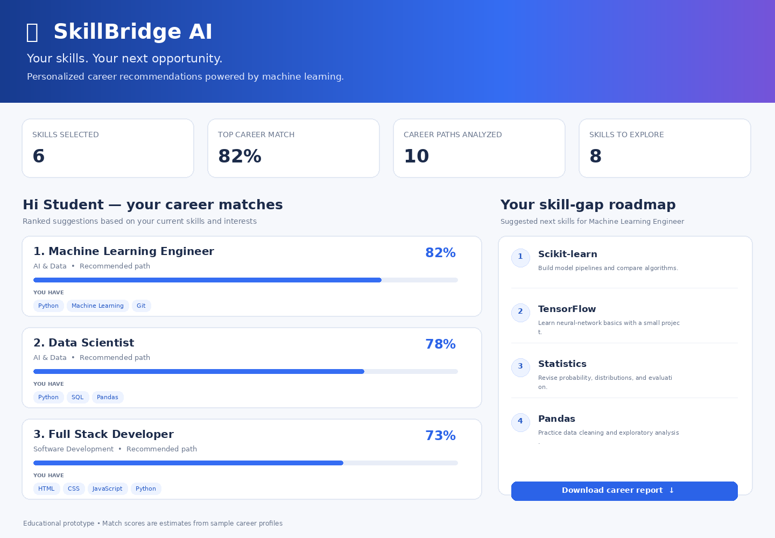

Abstract
SkillBridge AI is a web-based educational prototype that helps students explore career paths aligned with their current skills. Users select skills and interests, and the system ranks sample career profiles using TF-IDF text features, cosine similarity, and a transparent skill-coverage component. The dashboard displays career match estimates, matched skills, missing skills, and a short learning roadmap. A downloadable CSV allows users to keep a copy of recommendations.

1. Introduction
Students often find it difficult to connect classroom learning with job-role expectations. Career information can be spread across many sources, and students may not know which skills to prioritize. SkillBridge AI demonstrates how a lightweight machine-learning workflow can organize role descriptions and produce explainable, skill-based suggestions.

2. Problem Statement
There is a need for a simple, accessible tool that compares a student's self-reported skills with a collection of career profiles and highlights relevant next learning steps. The prototype addresses this need without requiring paid APIs or storing personal information.

3. Objectives
- Build an interactive career recommendation dashboard.
- Represent role descriptions and skills using TF-IDF.
- Rank roles with cosine similarity and skill-coverage signals.
- Identify skill gaps and offer starter learning actions.
- Export recommendations to CSV for later review.

4. System Requirements
Hardware: a laptop/desktop with 4 GB RAM recommended and internet access for initial package installation. Software: Python 3.10+, VS Code or another editor, Streamlit, pandas, and scikit-learn. The application runs locally in a browser and does not need a database or API key.

5. Methodology
First, each career role is represented by its skill list and a short description. TF-IDF converts the text into weighted numerical vectors. The user's selected skills are transformed using the same vectorizer. Cosine similarity estimates textual alignment between the profile and each role. Skill coverage is calculated as the fraction of a role's listed skills selected by the user. The prototype combines these signals: match score = 0.55 × cosine similarity + 0.45 × skill coverage. Scores are shown as relative fit estimates and capped below 100 to avoid implying certainty.

6. System Design and Implementation
The user interface is built with Streamlit. The sidebar collects the user's name, education, career interests, and skills. The main dashboard shows summary metrics and ranked role cards. Each card includes the match estimate, existing skills, and skills to develop. A roadmap panel provides brief learning actions for the highest-ranked role. The CSV download is generated in memory from the ranked results.

7. System Output
For a sample profile containing Python, SQL, HTML, CSS, JavaScript, and Git, the dashboard returns a ranked list of career paths. The exact ordering and scores depend on selected skills. The included screenshot is a design preview; run the app to capture a live screenshot from your own environment before submission.

8. Experiments and Evaluation
Functional checks should include: (1) a profile with Python and SQL, (2) a web-focused profile with HTML, CSS, and JavaScript, (3) a design-focused profile with Figma and user research, and (4) a profile with only one selected skill. Confirm that the app produces rankings, shows matched/missing skills, and downloads a valid CSV. Because this starter project uses a small illustrative role catalog and no labeled ground-truth dataset, accuracy, precision, recall, or employment outcomes are not claimed. A formal evaluation would require a curated dataset and expert-reviewed relevance labels.

9. Advantages
- Simple, interactive UI suitable for student demonstrations.
- Uses established text-processing and similarity methods.
- Shows why a role may fit by exposing overlapping skills.
- Highlights skill gaps and actionable learning suggestions.
- Runs locally without paid services or API credentials.
- Exports results for offline review.

10. Limitations and Ethical Considerations
The role dataset is small and illustrative; it may not reflect current hiring requirements or regional demand. User-entered skills are not verified, and a match score is not a probability of getting hired. Recommendations can reflect omissions or biases in the catalog. Users should treat results as a starting point and consult instructors, mentors, and current job descriptions. Avoid collecting unnecessary personal data.

11. Future Scope
- Expand the role catalog using licensed, current, and validated data.
- Add optional resume parsing with clear consent and local processing where possible.
- Evaluate ranking quality with expert-labeled test examples.
- Add multilingual explanations and accessibility testing.
- Offer project suggestions mapped to each skill gap.
- Add privacy-conscious profiles and progress tracking only when needed.

12. Conclusion
SkillBridge AI demonstrates an end-to-end AI/ML concept that turns a self-reported skill profile into ranked career suggestions and a practical learning roadmap. It combines text similarity with an understandable skill-coverage signal in an accessible dashboard. The prototype is suitable for learning and demonstration, while broader deployment would require better data, evaluation, and privacy review.

References
- Scikit-learn documentation, Feature extraction: https://scikit-learn.org/stable/modules/feature_extraction.html
- Scikit-learn documentation, Pairwise metrics and cosine similarity: https://scikit-learn.org/stable/modules/metrics.html
- Streamlit documentation: https://docs.streamlit.io/
- Pandas documentation: https://pandas.pydata.org/docs/

Appendix: Running the Project
Install dependencies with `python -m pip install -r requirements.txt`, then run `streamlit run app.py`. See README.md for Windows and VS Code instructions.

