

CS2053 - OBJECT ORIENTED PROGRAMMING WITH JAVA
Mini Project Report

STUDENT INTERNSHIP TRACKER

Submitted
By
VAISHNAVI PM - [1RUA25BCA0114]
MRUDULA B - [1RUA25BCA0070]
WRUTHAMBARA R - [1RUA25BCA0119]

Under the guidance of:
Dr./Prof. K THENMOZHI

School of Computer Science and Engineering
RV University, Bangalore

School of Computer Science and Engineering

CERTIFICATE

Certified that the CS2053 - Object Oriented Programming with Java, Project work titled
STUDENT INTERNSHIP TRACKER is carried out by [VAISHNAVI PM] ([1RUA25BCA0114]) [MRUDULA B] ([1RUA25BCA0070]) [WRUTHAMBARA R]
([1RUA25BCA0119]) who are Bonafide students of the School of Computer Science and Engineering, RV University, Bengaluru, during the year 2026-27. It is certified that all corrections/ suggestions from all the continuous internal evaluations have been incorporated into the project and in this report.

Faculty Guide Program Director
Dr./Prof. K Thenmozhi

ABSTRACT
- Problem Statement: Students often lose track of multiple internship applications, missing critical interview schedules and updates due to lack of a centralized tracking mechanism.
- Objectives: To build a lightweight, standalone Java web application for tracking placement and internship statuses using OOP principles and a database backend.
- Methodology: A monolithic Java application utilizing the built-in com.sun.net.httpserver for routing and JDBC for database interactions, eliminating the need for heavy external web containers.
- Tools Used: Java SE Development Kit 8+, Apache NetBeans IDE, MySQL Workbench 8.0, mysql-connector-java.jar, and HTML/CSS for the UI.
- Key Outcomes: A fully functional CRUD dashboard that allows users to seamlessly add, edit, view, and delete internship application records in real-time with color-coded status tracking.

1. Introduction
Tracking placement and internship applications is a crucial task for university students. As students apply to numerous companies across varying roles, maintaining an organized record of application phases (Applied, Interviewing, Selected, Rejected) becomes challenging. Traditional methods like static spreadsheets lack automated UI updates, data integrity constraints, and real-time visualization. The Student Internship Tracker project addresses this gap by providing a centralized, digital dashboard. Built on core Object-Oriented Programming (OOP) concepts, this project highlights the significance of database-driven applications in solving real-world organizational problems.

2. Scope of the Project
- Boundaries: The application is designed as a standalone, monolithic local web server running on localhost:8080.
- Assumptions: The user has a local MySQL server installed and running on port 3306 with the required database schema pre-configured.
- Limitations: The current iteration operates locally for a single user and lacks multitenant authentication or cloud hosting capabilities.
- Intended Applications: The primary use case is for individual university students aiming to digitally organize and track their ongoing placement and internship application life cycles.

3. Coding
- Observations & Results: The application successfully establishes a connection to the MySQL database via JDBC and launches a built-in Java HTTP server. The custom Request Handlers efficiently process GET requests to render the dynamic HTML/CSS UI and POST requests to execute CRUD (Create, Read, Update, Delete) SQL statements.
- Challenges Encountered: Handling raw HTTP POST form data parsing natively without a framework required careful string manipulation and URL decoding. Additionally, designing a responsive, modern UI entirely within Java StringBuilder required precise inline CSS structuring.
- Effectiveness: The proposed solution is highly effective. Using prepared statements prevents SQL injection, while the custom routing showcases a deep understanding of OOP Encapsulation and abstraction.
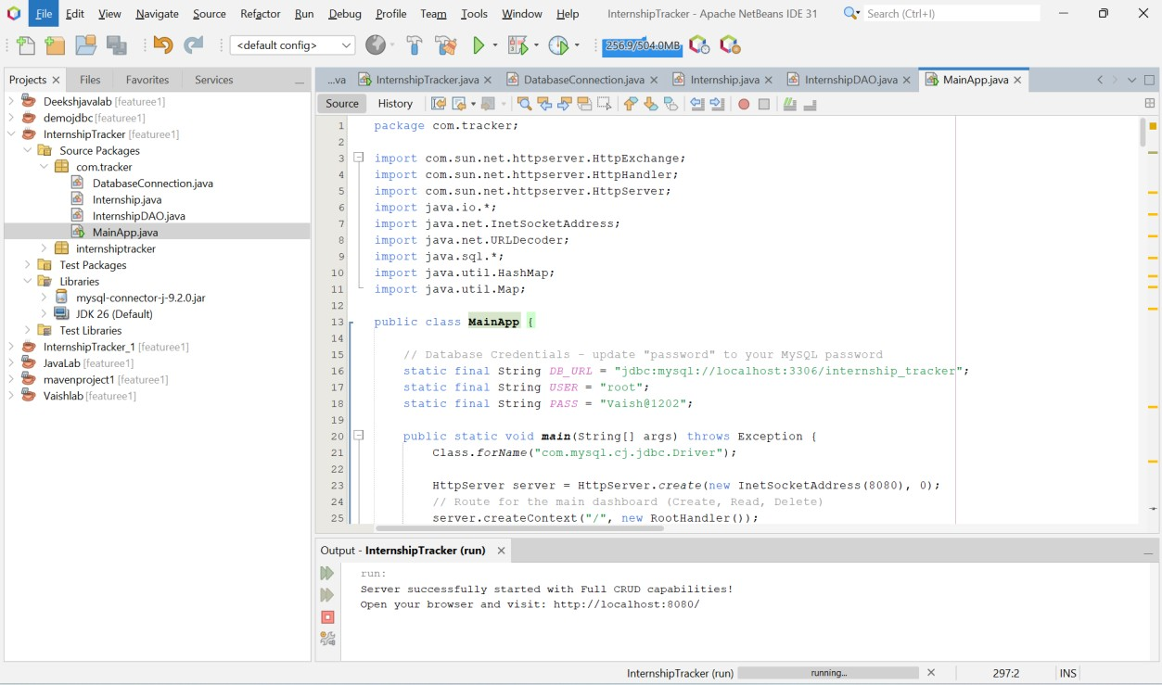

MainApp.java package com.tracker;

import com.sun.net.httpserver.HttpExchange; import com.sun.net.httpserver.HttpHandler; import com.sun.net.httpserver.HttpServer; import java.io.*; import java.net.InetSocketAddress; import java.net.URLDecoder; import java.sql.*; import java.util.HashMap; import java.util.Map;

public class MainApp {

// Database Credentials - update "password" to your MySQL password static final String DB_URL = "jdbc:mysql://localhost:3306/internship_tracker"; static final String USER = "root"; static final String PASS = "Vaish@1202";

public static void main(String[] args) throws Exception {
Class.forName("com.mysql.cj.jdbc.Driver");

HttpServer server = HttpServer.create(new InetSocketAddress(8080), 0);
// Route for the main dashboard (Create, Read, Delete) server.createContext("/", new RootHandler()); // Route for the edit page (Update) server.createContext("/edit", new EditHandler());

server.setExecutor(null); server.start();

System.out.println("Server successfully started with Full CRUD capabilities!");
System.out.println("Open your browser and visit: http://localhost:8080/");
}

// --- HANDLERS ---

static class RootHandler implements HttpHandler {
@Override public void handle(HttpExchange exchange) throws IOException { if ("POST".equalsIgnoreCase(exchange.getRequestMethod())) {
InputStreamReader isr = new InputStreamReader(exchange.getRequestBody(), "utf-8");
BufferedReader br = new BufferedReader(isr);
Map<String, String> formData = parseFormData(br.readLine());

String action = formData.get("action"); if ("create".equals(action)) { createRecord(formData); } else if ("delete".equals(action)) { deleteRecord(formData.get("id")); } else if ("update".equals(action)) { updateRecord(formData);
}

// Redirect to avoid form resubmission exchange.getResponseHeaders().set("Location", "/"); exchange.sendResponseHeaders(303, -1);
return;
}

// GET Request - Show Dashboard
String response = generateDashboardHTML(); exchange.sendResponseHeaders(200, response.getBytes().length);
OutputStream os = exchange.getResponseBody();
os.write(response.getBytes()); os.close();
}
}

static class EditHandler implements HttpHandler {
@Override public void handle(HttpExchange exchange) throws IOException {
String query = exchange.getRequestURI().getQuery();
Map<String, String> params = parseFormData(query); String id = params.get("id");

String response = generateEditHTML(id); exchange.sendResponseHeaders(200, response.getBytes().length); OutputStream os = exchange.getResponseBody(); os.write(response.getBytes()); os.close();
}
}

// --- DATABASE CRUD OPERATIONS ---

private static void createRecord(Map<String, String> data) {
String sql = "INSERT INTO student_internships (student_name, roll_number, company_name, job_role, status) VALUES (?, ?, ?, ?, ?)"; try (Connection conn = DriverManager.getConnection(DB_URL, USER, PASS);
PreparedStatement pstmt = conn.prepareStatement(sql)) { pstmt.setString(1, data.get("name")); pstmt.setString(2, data.get("roll")); pstmt.setString(3, data.get("company")); pstmt.setString(4, data.get("role")); pstmt.setString(5, data.get("status")); pstmt.executeUpdate();
} catch (Exception e) { e.printStackTrace(); }
}

private static void updateRecord(Map<String, String> data) {
String sql = "UPDATE student_internships SET student_name=?, roll_number=?, company_name=?, job_role=?, status=? WHERE id=?"; try (Connection conn = DriverManager.getConnection(DB_URL, USER, PASS); PreparedStatement pstmt = conn.prepareStatement(sql)) { pstmt.setString(1, data.get("name")); pstmt.setString(2, data.get("roll")); pstmt.setString(3, data.get("company")); pstmt.setString(4, data.get("role")); pstmt.setString(5, data.get("status")); pstmt.setInt(6, Integer.parseInt(data.get("id"))); pstmt.executeUpdate();
} catch (Exception e) { e.printStackTrace(); }
}

private static void deleteRecord(String id) {
String sql = "DELETE FROM student_internships WHERE id=?"; try (Connection conn = DriverManager.getConnection(DB_URL, USER, PASS); PreparedStatement pstmt = conn.prepareStatement(sql)) { pstmt.setInt(1, Integer.parseInt(id)); pstmt.executeUpdate();
} catch (Exception e) { e.printStackTrace(); }
}

// --- HELPER METHODS ---

private static Map<String, String> parseFormData(String formData) { Map<String, String> map = new HashMap<>(); if (formData == null || formData.isEmpty()) return map;
try {
String[] pairs = formData.split("&"); for (String pair : pairs) { String[] kv = pair.split("="); if (kv.length > 1) { map.put(kv[0], URLDecoder.decode(kv[1], "UTF-8"));
} else if (kv.length == 1) { map.put(kv[0], "");
}
}
} catch (Exception e) { e.printStackTrace(); } return map;
}

private static String getSharedCSS() { return "<style>" +
"body { font-family: 'Poppins', sans-serif; background-color: #f4f7fe; color: #2b3674; margin: 0; padding: 20px; }" +
".container { max-width: 1000px; margin: 0 auto; }" +
".header { text-align: center; margin-bottom: 30px; }" +
".header h1 { color: #4318FF; margin: 0; font-size: 2.5rem; }" +
".header p { color: #a3aed1; margin: 5px 0 0 0; }" +
".card { background: #ffffff; padding: 30px; border-radius: 20px; box-shadow: 0px 4px 15px rgba(0, 0, 0, 0.05); margin-bottom: 30px; }" +
".card h2 { margin-top: 0; color: #2b3674; font-size: 1.5rem; border-bottom: 2px solid #f4f7fe; padding-bottom: 10px; margin-bottom: 20px; }" +
".form-grid { display: grid; grid-template-columns: repeat(auto-fit, minmax(250px, 1fr)); gap: 20px; margin-bottom: 20px; }" +
".form-group { display: flex; flex-direction: column; }" +
"label { font-weight: 500; margin-bottom: 8px; font-size: 0.9rem; color: #2b3674; }" +
"input, select { padding: 12px 15px; border: 1px solid #e0e5f2; border-radius: 10px; font-size: 1rem; font-family: 'Poppins', sans-serif; background: #fcfcfc; transition: all 0.3s ease; }" +
"input:focus, select:focus { outline: none; border-color: #4318FF; background: #fff; box-shadow: 0 0 0 3px rgba(67, 24, 255, 0.1); }" +
"button { background-color: #4318FF; color: white; border: none; padding: 15px 30px; border-radius:
10px; cursor: pointer; font-size: 1rem; font-weight: 600; width: 100%; transition: all 0.3s ease; }" +
"button:hover { background-color: #3311db; transform: translateY(-2px); box-shadow: 0 5px 15px rgba(67, 24, 255, 0.3); }" +
"table { width: 100%; border-collapse: collapse; text-align: left; }" +
"th { background-color: #f4f7fe; color: #a3aed1; font-weight: 600; padding: 15px; border-radius: 10px
10px 0 0; font-size: 0.9rem; text-transform: uppercase; }" +
"td { padding: 15px; border-bottom: 1px solid #f4f7fe; color: #2b3674; font-weight: 500; }" +
"tr:hover td { background-color: #f8fafe; }" +
".badge { padding: 6px 12px; border-radius: 20px; font-size: 0.85rem; font-weight: 600; }" +
".status-applied { background: #e0f2fe; color: #0284c7; }" +
".status-interview { background: #fef08a; color: #a16207; }" +
".status-selected { background: #dcfce3; color: #166534; }" +
".status-rejected { background: #fee2e2; color: #991b1b; }" +
".action-forms { display: flex; gap: 8px; }" +
".action-forms form { margin: 0; }" +
".btn-sm { padding: 8px 15px; font-size: 0.85rem; width: auto; border-radius: 8px; text-decoration: none; display: inline-block; text-align: center; font-weight: 500; box-shadow: none; }" +
".btn-edit { background: #f1f5f9; color: #334155; border: 1px solid #cbd5e1; }" +
".btn-edit:hover { background: #e2e8f0; transform: translateY(0); box-shadow: none; color: #0f172a; }" +
".btn-delete { background: #fee2e2; color: #991b1b; }" +
".btn-delete:hover { background: #fecaca; transform: translateY(0); box-shadow: none; }" +
"</style>";
}

// --- HTML GENERATORS ---

private static String generateDashboardHTML() { StringBuilder html = new StringBuilder(); html.append("<!DOCTYPE html><html><head><title>Internship Tracker</title>"); html.append("<meta name='viewport' content='width=device-width, initial-scale=1.0'>");
html.append("<link href='[https://fonts.googleapis.com/css2?family=Poppins:wght@300;400;500;600&display=swap](https://fonts.
googleapis.com/css2?family=Poppins:wght@300;400;500;600&display=swap)' rel='stylesheet'>"); html.append(getSharedCSS()); html.append("</head><body><div class='container'>");

html.append("<div class='header'><h1>Internship Tracker</h1><p>Manage and track your application progress</p></div>");

// CREATE Form html.append("<div class='card'><h2>Add New Application</h2>"); html.append("<form method='POST' action='/'>"); html.append("<input type='hidden' name='action' value='create'>"); html.append("<div class='form-grid'>");
html.append("<div class='form-group'><label>Student Name</label><input type='text' name='name' required></div>");
html.append("<div class='form-group'><label>Roll Number</label><input type='text' name='roll' required></div>");
html.append("<div class='form-group'><label>Company Name</label><input type='text' name='company' required></div>");
html.append("<div class='form-group'><label>Job Role</label><input type='text' name='role' required></div>"); html.append("<div class='form-group'><label>Status</label><select name='status'>");
html.append("<option value='Applied'>Applied</option><option value='Interview Scheduled'>Interview Scheduled</option>"); html.append("<option value='Selected'>Selected</option><option value='Rejected'>Rejected</option>"); html.append("</select></div>"); html.append("</div><button type='submit'>Save Application</button></form></div>");

// READ Table (with UPDATE/DELETE buttons) html.append("<div class='card'><h2>Recent Applications</h2><div style='overflow-x:auto;'>"); html.append("<table><tr><th>Student</th><th>Roll
No</th><th>Company</th><th>Role</th><th>Status</th><th>Actions</th></tr>");

try (Connection conn = DriverManager.getConnection(DB_URL, USER, PASS);
Statement stmt = conn.createStatement();
ResultSet rs = stmt.executeQuery("SELECT * FROM student_internships ORDER BY id DESC")) {

while (rs.next()) {
String id = rs.getString("id");
String status = rs.getString("status"); String badgeClass = "badge "; if(status.equals("Applied")) badgeClass += "status-applied"; else if(status.equals("Interview Scheduled")) badgeClass += "status-interview"; else if(status.equals("Selected")) badgeClass += "status-selected"; else if(status.equals("Rejected")) badgeClass += "status-rejected";

html.append("<tr>"); html.append("<td>").append(rs.getString("student_name")).append("</td>"); html.append("<td>").append(rs.getString("roll_number")).append("</td>"); html.append("<td>").append(rs.getString("company_name")).append("</td>"); html.append("<td>").append(rs.getString("job_role")).append("</td>");
html.append("<td><span
class='").append(badgeClass).append("'>").append(status).append("</span></td>");

// Action Buttons (Edit goes to GET /edit, Delete is a POST form) html.append("<td><div class='action-forms'>");
html.append("<a href='/edit?id=").append(id).append("' class='btn-sm btn-edit'>Edit</a>"); html.append("<form method='POST' action='/'>")
.append("<input type='hidden' name='action' value='delete'>")
.append("<input type='hidden' name='id' value='").append(id).append("'>")
.append("<button type='submit' class='btn-sm btn-delete' onclick=\"return confirm('Are you sure you want to delete this record?');\">Delete</button>")
.append("</form>"); html.append("</div></td></tr>");
}
} catch (Exception e) { html.append("<tr><td colspan='6' style='color: red;'>Error loading database records.</td></tr>");
}

html.append("</table></div></div></div></body></html>"); return html.toString();
}

private static String generateEditHTML(String id) { Map<String, String> record = new HashMap<>(); try (Connection conn = DriverManager.getConnection(DB_URL, USER, PASS);
PreparedStatement pstmt = conn.prepareStatement("SELECT * FROM student_internships WHERE id=?")) { pstmt.setInt(1, Integer.parseInt(id)); ResultSet rs = pstmt.executeQuery(); if (rs.next()) { record.put("name", rs.getString("student_name"));
record.put("roll", rs.getString("roll_number")); record.put("company", rs.getString("company_name")); record.put("role", rs.getString("job_role")); record.put("status", rs.getString("status"));
}
} catch (Exception e) { e.printStackTrace(); }

StringBuilder html = new StringBuilder(); html.append("<!DOCTYPE html><html><head><title>Edit Application</title>");
html.append("<link href='[https://fonts.googleapis.com/css2?family=Poppins:wght@300;400;500;600&display=swap](https://fonts. googleapis.com/css2?family=Poppins:wght@300;400;500;600&display=swap)' rel='stylesheet'>"); html.append(getSharedCSS()); html.append("</head><body><div class='container'>");

html.append("<div class='header'><h1>Edit Internship</h1><p>Update application details</p></div>"); html.append("<div class='card'><h2>Update Details for ").append(record.get("name")).append("</h2>");

// UPDATE Form html.append("<form method='POST' action='/'>"); html.append("<input type='hidden' name='action' value='update'>"); html.append("<input type='hidden' name='id' value='").append(id).append("'>");

html.append("<div class='form-grid'>");
html.append("<div class='form-group'><label>Student Name</label><input type='text' name='name' value='").append(record.get("name")).append("' required></div>");
html.append("<div class='form-group'><label>Roll Number</label><input type='text' name='roll' value='").append(record.get("roll")).append("' required></div>");
html.append("<div class='form-group'><label>Company Name</label><input type='text' name='company' value='").append(record.get("company")).append("' required></div>");
html.append("<div class='form-group'><label>Job Role</label><input type='text' name='role' value='").append(record.get("role")).append("' required></div>");

html.append("<div class='form-group'><label>Status</label><select name='status'>"); String[] statuses = {"Applied", "Interview Scheduled", "Selected", "Rejected"}; for (String s : statuses) {
String selected = s.equals(record.get("status")) ? "selected" : "";
html.append("<option value='").append(s).append("'
").append(selected).append(">").append(s).append("</option>");
}
html.append("</select></div>");

html.append("</div>"); html.append("<div style='display:flex; gap:10px; margin-top: 10px;'>"); html.append("<button type='submit' style='flex:2;'>Save Updates</button>");
html.append("<a href='/' class='btn-sm btn-edit' style='flex:1; padding: 15px; font-size: 1rem; borderradius: 10px;'>Cancel</a>"); html.append("</div></form></div></div></body></html>");

return html.toString();
}
}

4. ScreenShorts

[Insert Output Dashboard Screen Short Here]
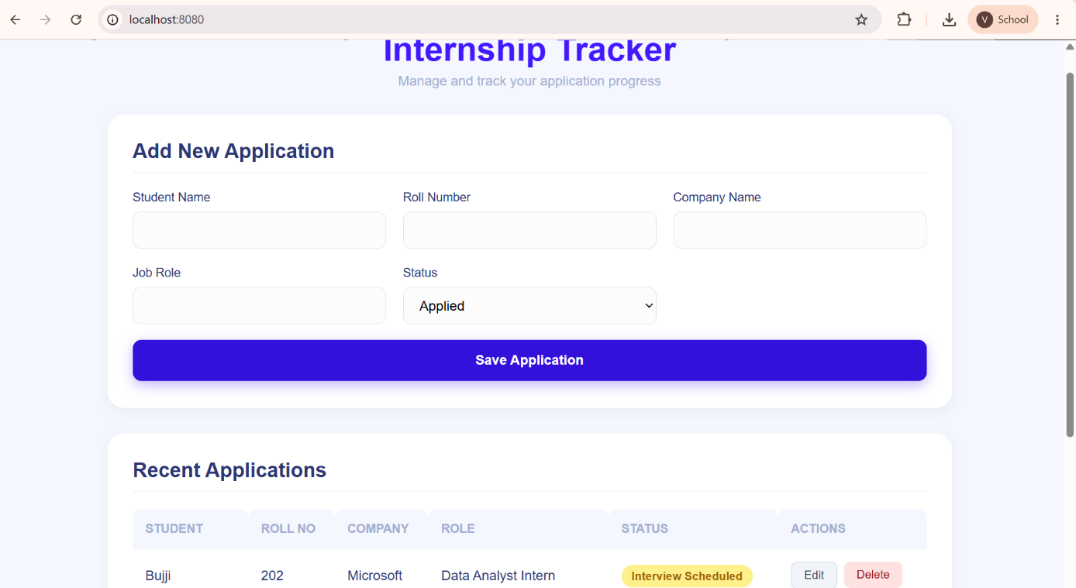
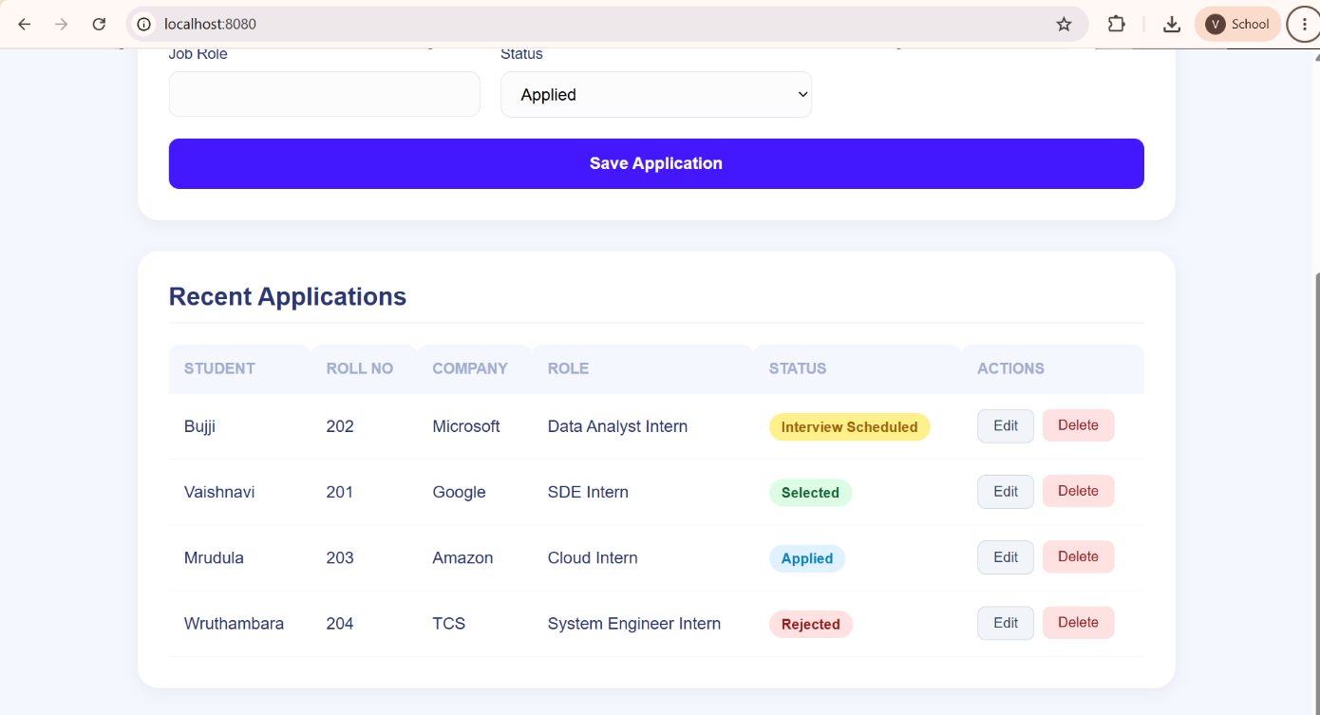

[Insert Database Connection Test / MySQL Workbench Screen]

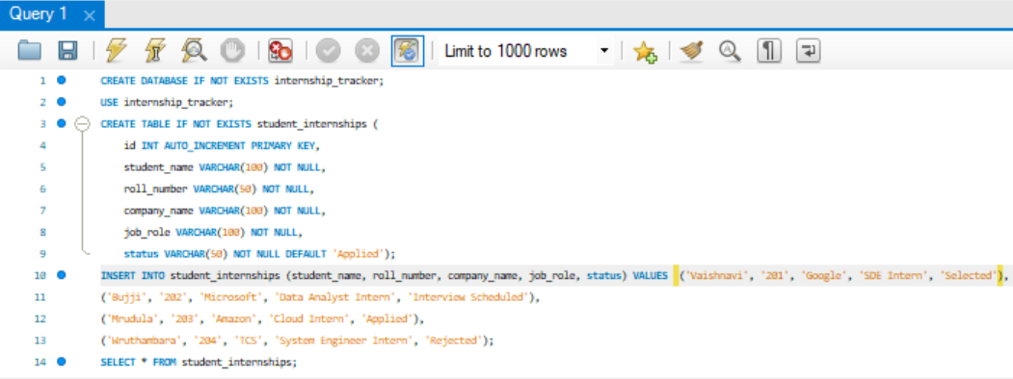
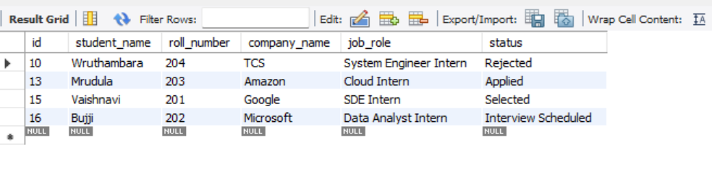

5. Conclusion
In conclusion, the Student Internship Tracker successfully demonstrates the integration of Java OOP principles with a relational DBMS. By utilizing Java's built-in HttpServer and JDBC, the project achieved a lightweight, highly responsive web application without relying on heavy enterprise frameworks. The key findings illustrate that direct database manipulation through prepared statements is secure and efficient. This project significantly contributed to our understanding of backend routing, database connectivity, and dynamic frontend generation using core Java.

6. AI Tool Usage Report
Name of the AI tool used: ChatGPT Classic
Purpose of usage: To generate the responsive CSS styling for the frontend dashboard and to boilerplate the HTTP Server routing logic.
Sample prompts used: “Give me the webpage code in main java class only”, “Add CSS and make the webpage more interactive and aesthetic” , “Add all CRUD operations for this”.
Generated outputs: Complete HTML/CSS code strings embedded within Java, and JDBC methods for insert, update, and delete.
Modifications made by the student: Customized the database connection string, adjusted the port number, manually resolved URL decoding logic for edge cases, and formatted the HTML output to match the specific project requirements.
Contribution of the AI tool: The tool significantly reduced frontend UI development time, allowing the team to focus on the core backend OOP logic and JDBC data flow, ensuring a polished final product.

