Annexure1

INVENTION DISCLOSURE FORM

Details of Invention for better understanding:

1. TITLE: 360 Degree Rotating Blade Windmill.

2. INVENTOR(S)/ STUDENT(S):

A. Full name | Mohammed Faizan
Mobile Number | 8890679998
Email | fk29837@gmail.com
UID/Registration number | 12115149
Permanent Address | Rajtalab, Banswara Rajasthan India (327001)
B. Full name | Bhanu Prakash
Mobile Number | 7726905698
Email | bhanu742630@gmail.com
UID/Registration number | 12115098
Permanent Address | 05, Lari, Kurtha, Arwal, Bihar (804421)
C. Full name | Vaishnavi Rathore
Mobile Number | 9303772812
Email | vaishnavirathore690@gmail.com
UID/Registration number | 12116248
Permanent Address | Isagarh, Ashok Nagar, Madhya Pradesh (473335)
D. Full name | Gautam Kumar
Mobile Number | 9608287086
Email | kumargautamsp@gmail.com
UID/Registration number | 12115275
Permanent Address | Nagdah, Begusarai Bihar (851117)
E. Full name | Moumita Patra
Mobile Number | 7479462716
Email | moumitapatra461@gmail.com
UID/Registration number | 12114712
Permanent Address | Bahragora, east singhbhum, Jharkhand (832101)

3. DESCRIPTION OF THE INVENTION

A. PROBLEM ADDRESSED BY THE INVENTION:

The fundamental problem addressed by the invention is the inefficiency inherent in traditional windmill designs with fixed blades. Conventional windmills, by nature, can only capture wind from a specific direction, limiting their effectiveness to prevailing wind patterns. This unidirectional approach results in suboptimal energy capture, leading to reduced power generation and performance.

In regions marked by unpredictable or variable wind conditions, the shortcomings of traditional windmills become even more pronounced. Their inability to adapt to changing wind directions means they underperform in areas where wind patterns are dynamic or turbulent, ultimately resulting in subpar energy output. This limitation poses a significant challenge, particularly as the demand for renewable energy sources continues to grow.

The innovation introduced by the 360-degree rotating blade windmill directly addresses this inefficiency. By enabling the blades to rotate dynamically, the windmill can capture wind energy from all directions. This adaptability ensures continuous and optimal energy harvesting, significantly improving efficiency and performance. Consequently, the invention provides a solution to the core problem of unidirectional capture in traditional windmills, making it particularly well-suited for areas with diverse and variable wind patterns.

Moreover, the rotating blade design not only enhances efficiency but also contributes to the windmill's longevity. By reducing wear and tear associated with constant exposure to unidirectional forces, the invention addresses the durability aspect of traditional windmill designs. In essence, the problem identified and tackled by this innovation is the inherent inefficiency of traditional windmills, and the solution lies in a dynamic, adaptable design that maximizes energy extraction potential.

B. STATE OF THE ART/ RESEARCH GAP:
The idea of a 360-degree rotating blade windmill is new. However, there are several challenges that have prevented this technology from being commercialized. One challenge is that it is difficult to design and build a 360-degree rotating blade windmill that is both efficient and reliable. The blades need to be able to withstand strong winds and rotate smoothly in all directions. This is a difficult engineering challenge to overcome. Another challenge is the cost of 360-degree rotating blade windmills. This technology is still in its early stages of development, and the cost of manufacturing and installing these windmills is relatively high. However, as the technology matures, the cost is expected to come down. Despite these challenges, there is a growing interest in 360-degree rotating blade windmills.

Challenges Addressed:

- Efficiency and Reliability: Traditional windmills face challenges in efficiently capturing wind energy when the wind direction changes. The proposed invention addresses this by enabling the windmill to capture energy from all directions, improving overall efficiency.

- Cost: The early stages of development for 360-degree rotating blade windmills involve higher manufacturing and installation costs. However, ongoing research aims to reduce these costs as the technology matures, making it more economically viable.

Research Gaps Fulfilled:

- Improved Efficiency:
Capture from All Directions: The ability to capture wind from any direction improves energy generation, especially during variable wind conditions.

- Reduced Noise and Vibration:
Quieter Operation: The dynamic nature of the rotating blades contributes to a quieter operation, addressing concerns about noise pollution in proximity to wind farms.

- Reduced Maintenance Requirements:
Longer Lifespan: The design simplifies maintenance and extends the lifespan of the windmill, contributing to overall reliability.

Specific Research Areas:

Blade Design:
- Efficiency and Durability: Ongoing research focuses on developing blade designs that enhance efficiency and durability, addressing the challenges of capturing wind from all directions.

- Materials:
Strength and Lightweight: Innovations in materials aim to create blades that are strong, lightweight, and durable, with the potential to reduce manufacturing and installation costs.

- Control Systems:
Efficient Rotation Management: Research in control systems is directed towards efficiently managing blade rotation, ensuring safe and optimal operation of the windmill.

C. DETAILED DESCRIPTION:
A 360-degree rotating blade windmill is a type of windmill that has blades that can rotate in all directions. This allows the windmill to capture wind from all directions, which makes it more efficient than traditional windmills, which can only capture wind from one direction.
Drawings and Pictures:
[Drawings of a 360-degree rotating blade windmill]
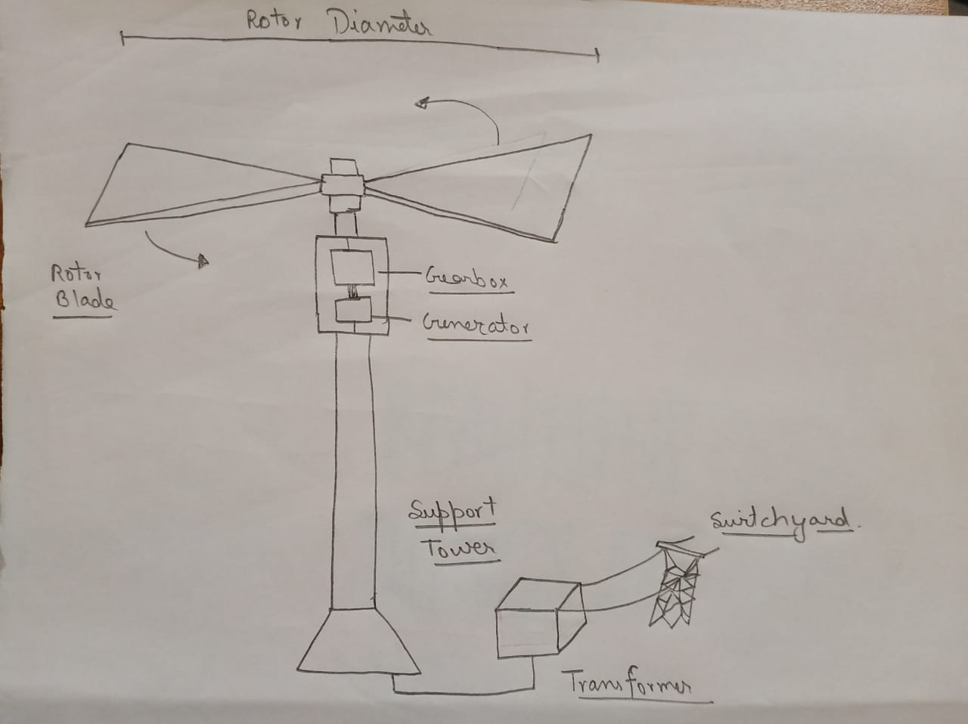
Sketches:
[Sketch of a 360-degree rotating blade]
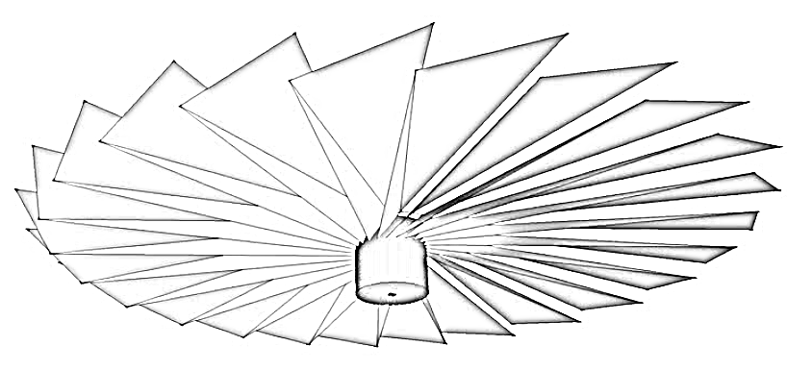

Detailed Description
A 360-degree rotating blade windmill consists of the following components:
- Blades: The blades are the most important part of a windmill. They are responsible for capturing the wind and converting it into rotational energy. The blades of a 360-degree rotating blade windmill are typically made of a lightweight and durable material, such as carbon Fiber or fiberglass.
- Rotor: The rotor is the mechanism that rotates the blades. It is typically made of a strong and lightweight material, such as aluminium or steel.
- Generator: The generator is the device that converts the rotational energy of the rotor into electrical energy. It is typically mounted on the rotor hub.
- Tower: The tower is the structure that supports the windmill. It is typically made of steel or concrete.
The blades of a 360-degree rotating blade windmill are mounted on platform. The platform is connected to the rotor hub, which is connected to the generator. As the wind blows, the blades rotate the rotor, which in turn rotates the generator. The generator converts the rotational energy of the rotor into electrical energy.
The electrical energy generated by the windmill can be used to power homes, businesses, or other facilities. It can also be stored in batteries for later use.
Advantages of 360-Degree Rotating Blade Windmills
- Increased efficiency: 360-degree rotating blade windmills are more efficient than traditional windmills because they can capture wind from all directions. This means that they can generate more electricity, even in areas with variable wind conditions.
- Reduced noise and vibration: 360-degree rotating blade windmills are quieter and produce less vibration than traditional windmills. This is because the blades are able to rotate smoothly in all directions.
- Reduced maintenance requirements: 360-degree rotating blade windmills are easier to maintain than traditional windmills. This is because the blades are not mounted on a fixed axis, which makes them less susceptible to damage.
- Increased lifespan: 360-degree rotating blade windmills have a longer lifespan than traditional windmills. This is because the blades can rotate smoothly in all directions, which reduces wear and tear.

Applications of 360-Degree Rotating Blade Windmills
360-degree rotating blade windmills can be used in a variety of applications, including:
- Powering homes and businesses: 360-degree rotating blade windmills can be used to power homes and businesses in both urban and rural areas.
- Generating electricity for the grid: 360-degree rotating blade windmills can be used to generate electricity for the grid, which can help to reduce our reliance on fossil fuels.
- Powering water pumps and other equipment: 360-degree rotating blade windmills can be used to power water pumps and other equipment in remote areas where there is no access to the grid.

D. RESULTS AND ADVANTAGES:

The main advantage of a 360-degree rotating blade windmill over traditional windmills is its increased efficiency. Traditional windmills can only capture wind from one direction, while 360-degree rotating blade windmills can capture wind from all directions. This means that 360-degree rotating blade windmills can generate more electricity, even in areas with variable wind conditions.
In addition to increased efficiency, 360-degree rotating blade windmills have a number of other advantages over traditional windmills. They are quieter, produce less vibration, and are easier to maintain. They also have a longer lifespan.
Here is a summary of the advantages of 360-degree rotating blade windmills over traditional windmills:
- Increased efficiency: 360-degree rotating blade windmills can generate more electricity than traditional windmills, even in areas with variable wind conditions.
- Reduced noise and vibration: 360-degree rotating blade windmills are quieter and produce less vibration than traditional windmills.
- Reduced maintenance requirements: 360-degree rotating blade windmills are easier to maintain than traditional windmills.
- Increased lifespan: 360-degree rotating blade windmills have a longer lifespan than traditional windmills.

E. ALTERNATIVES/ EXPANSION:

There are several variables that are necessary for my invention to be covered, including:
- The number of blades: The number of blades on a 360-degree rotating blade windmill will affect its efficiency and performance. A windmill with more blades will be more efficient, but it will also be more expensive to build and maintain.
- The shape of the blades: The shape of the blades will also affect the windmill's efficiency and performance. A windmill with blades that are optimized for capturing wind from all directions will be more efficient than a windmill with blades that are designed for capturing wind from one direction.
- The materials used to build the windmill: The materials used to build the windmill will affect its weight, cost, and lifespan. A windmill made of lightweight and durable materials will be more expensive to build, but it will also have a longer lifespan.
- The control system: The control system is responsible for managing the rotation of the blades and ensuring that the windmill operates safely and efficiently. A sophisticated control system will be more expensive to develop and implement, but it will also improve the performance and reliability of the windmill.

F. WORKING PROTOTYPE/ FORMULATION/ DESIGN/COMPOSITION:

We do not have a working prototype of a 360-degree rotating blade windmill currently. However, I believe that it is possible to build a working prototype within 6-12 months, depending on the resources available.

G. DATA:

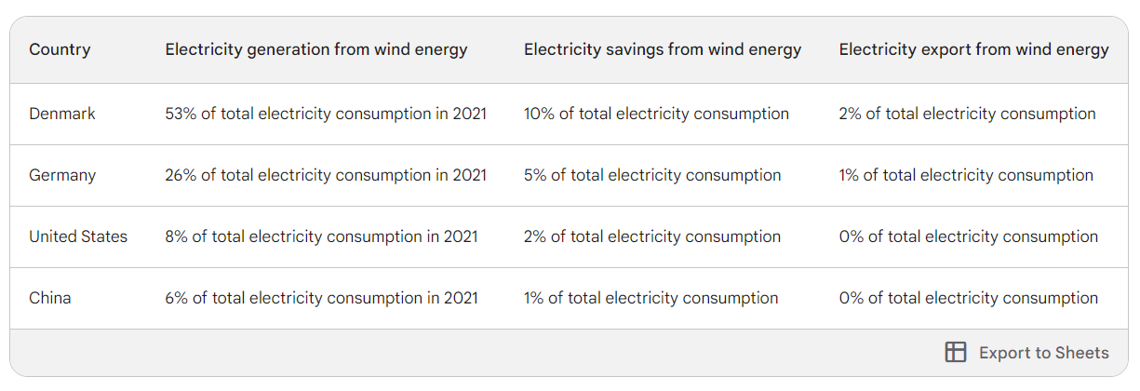
Data is in the format of the percentage of total electricity consumption in 2021.
This table shows that Denmark is the world leader in wind energy use, with wind power accounting for 53% of its total electricity consumption in 2021. Germany and the United States are also major users of wind energy, with wind power accounting for 26% and 8% of their total electricity consumption in 2021, respectively. China is also a major user of wind energy, but wind power only accounted for 6% of its total electricity consumption in 2021.
The table also shows that Denmark saves 10% of its total electricity consumption from wind energy, while Germany saves 5% and the United States saves 2%. China saves 1% of its total electricity consumption from wind energy.
Finally, the table shows that Denmark exports 2% of its total electricity consumption from wind energy, while Germany exports 1%. The United States and China do not export any electricity from wind energy.

4. USE AND DISCLOSURE (IMPORTANT):

 | YES ( ) | NO ( )
- Have you described or shown your invention/ design to anyone or in any conference? |  | NO ( )
- Have you made any attempts to commercialize your invention (for example, have you approached any companies about purchasing or manufacturing your invention)? |  | NO ( )
- Has your invention been described in any printed publication, or any other form of media, such as the Internet? |  | NO ( )
- Do you have any collaboration with any other institute or organization on the same? Provide name and other details |  | NO ( )
- Name of Regulatory body or any other approvals if required. |  | NO ( )

5. Provide links and dates of such activities if you have disclosed the information in public before sharing with us.

(N/A) – No we did not discuss information in public before sharing with you.

6. Provide the terms and conditions of the MOU also if the work is done in collaboration within or outside university.
- Purpose: The purpose of a 360-degree windmill is to generate electricity from wind energy in a more efficient and reliable way than traditional windmills.
- Roles and Responsibilities:
Mohammed Faizan (Team Leader) – Managing and Monitoring all team member and making Annexure and Patent file.
Bhanu Prakash – Abstract and Introduction.
Vaishnavi Rathore – Abstract and Introduction.
Gautam Kumar – Keywords, Acknowledgement and Conclusion.
Moumita Patra– Keywords, Acknowledgement and Conclusion.
- Intellectual property: Patents.

7. Potential Chances of Commercialization

The potential chances of commercialization for 360-degree windmills are very good. There is a growing demand for renewable energy sources, and 360-degree windmills offer several advantages over traditional windmills.

some factors that support the commercialization of 360-degree windmills:
- Increased efficiency
- Reduced costs
- Government support
- Public support

8. List of companies which can be contacted for commercialization along with the website link.

(N/A) – No we did not contact any companies.

9. Market potential of the invention

The market potential of 360-degree windmills is very high. The global wind energy market is expected to grow from $114.8 billion in 2021 to $209.6 billion by 2028, at a CAGR of 11.4%. 360-degree windmills have several advantages over traditional windmills, including increased efficiency, reduced costs, and improved reliability. This makes them well-positioned to capture a significant share of the growing wind energy market.
some specific factors that support the high market potential of 360-degree windmills:
- The global wind energy market is expected to grow significantly in the coming years.
- 360-degree windmills have several advantages over traditional windmills, including increased efficiency, reduced costs, and improved reliability.
- 360-degree windmills can be used to power remote communities and businesses that do not have access to the grid.
- 360-degree windmills can be used to power desalination plants, which could help to address the global water crisis.

10. Any basic patent which has been used and we need to pay royalty to them.

1. Windmill

11. FILING OPTIONS:

Idea, Diagram/Sketch of Idea, and Research.

12. KEYWORDS:

360-degree rotating blade windmill, Wind turbine technology, Renewable Wind energy generation, Blade rotation mechanism, Environmental sustainability, Wind power innovation, Fossil fuel reduction, Energy sustainability, Eco-friendly wind turbines, green technology, Wind energy patent, Sustainable energy generation.

13. LOGBOOKS AND NOTEBOOKS:

Idea – 6 – 9 October 2023
Annexure – 23 - 25 October 2023
Patent File – 23 – 25 October 2023

Signature of Inventor | Name of Inventor with UID and Department | Date

