Week 8: Jenkins Automation
Task -1 MAVEN INSTALLATION
Step1: Prerequisites (java version)
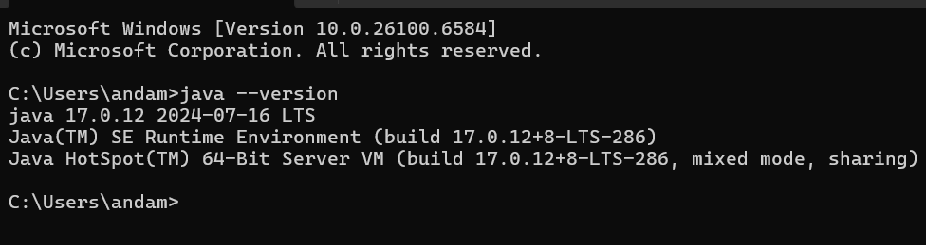
Step 2: Download Maven
Version 3.9.11
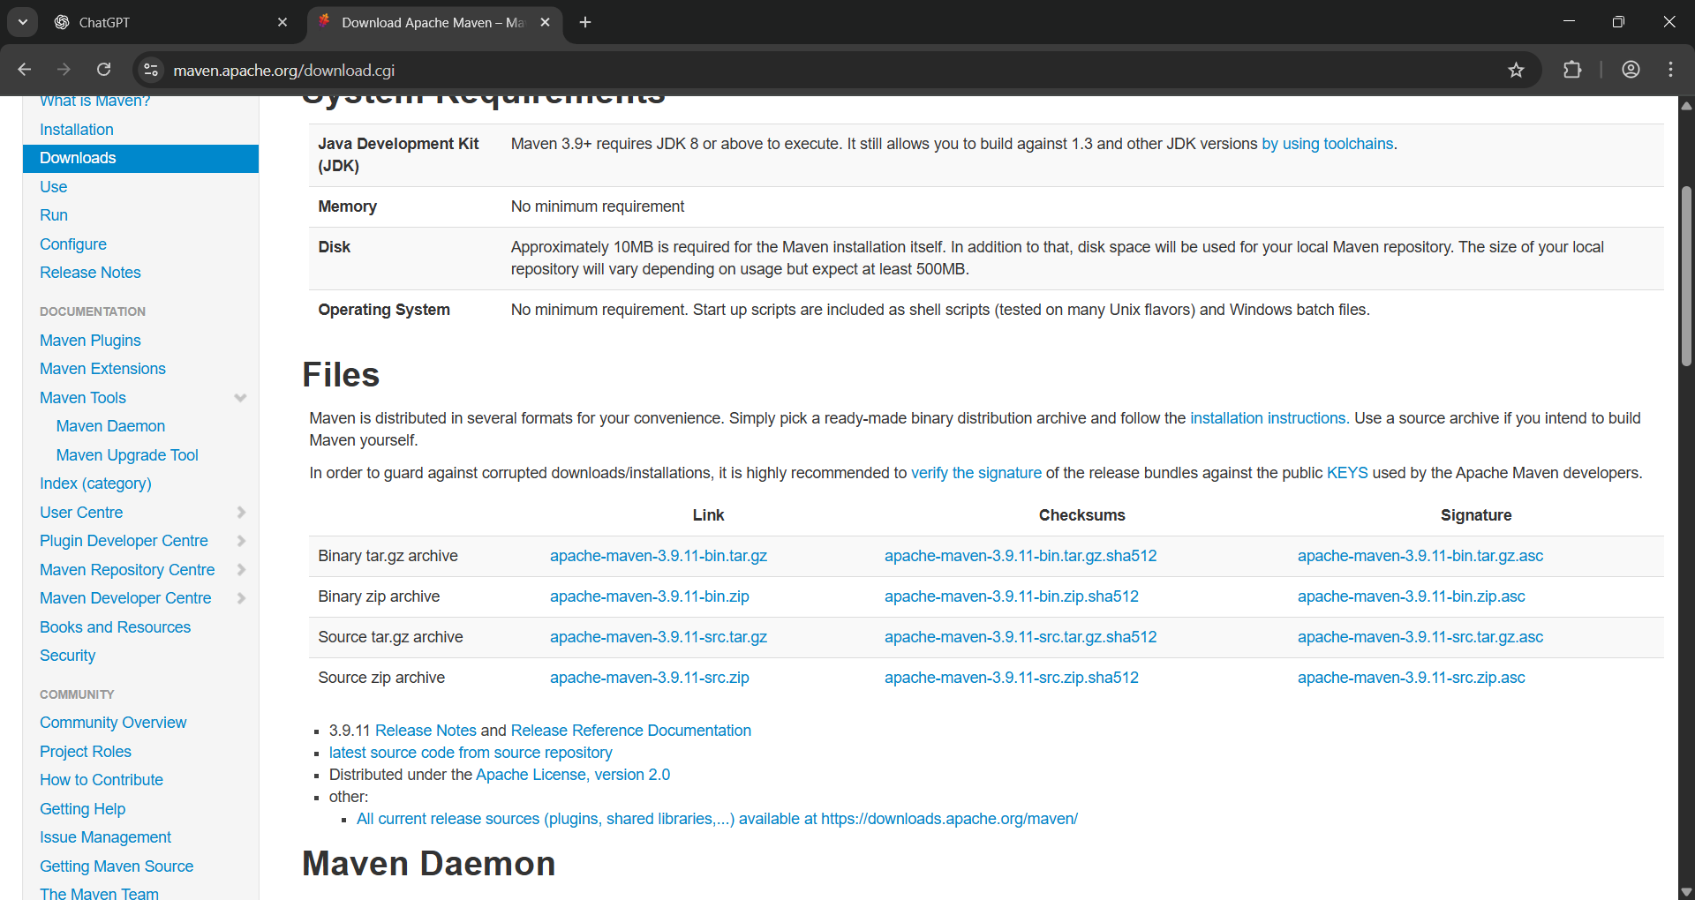
Step 3: Extract Maven
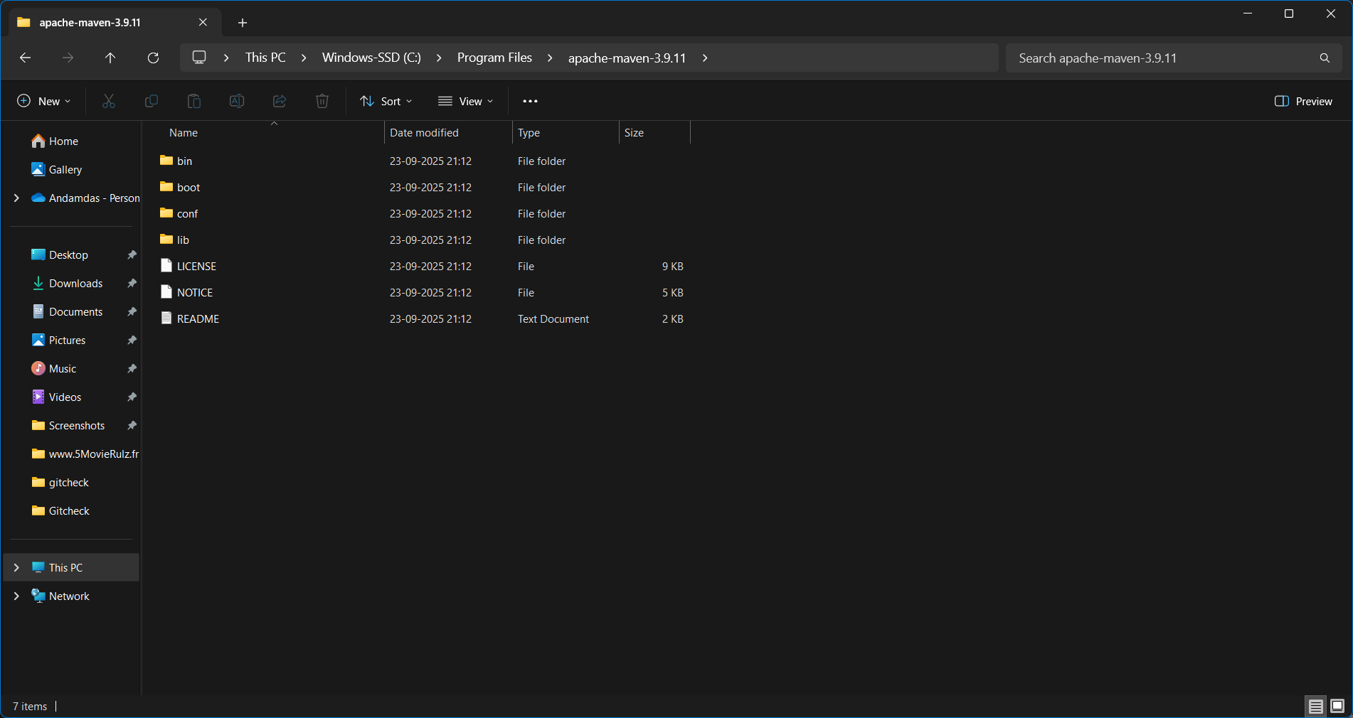
Step 4: Set Environment Variables
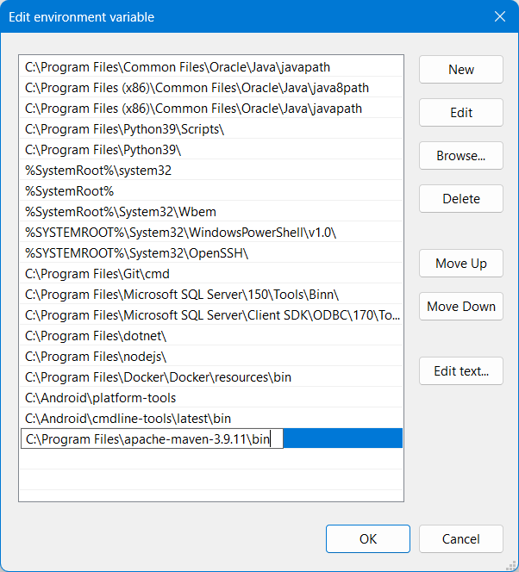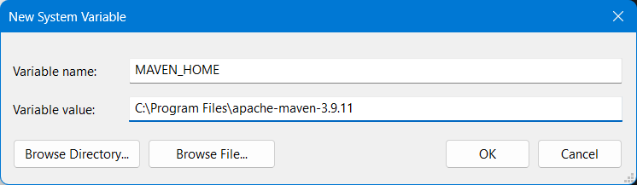
Step 5: Verify Installation
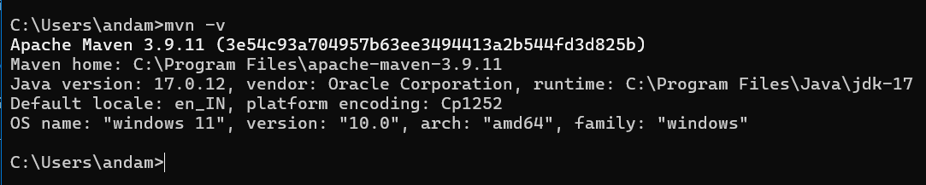
Task-2 JENKINS INSTALLATION
Step 1: Prerequisites
Step 2: Download Jenkins
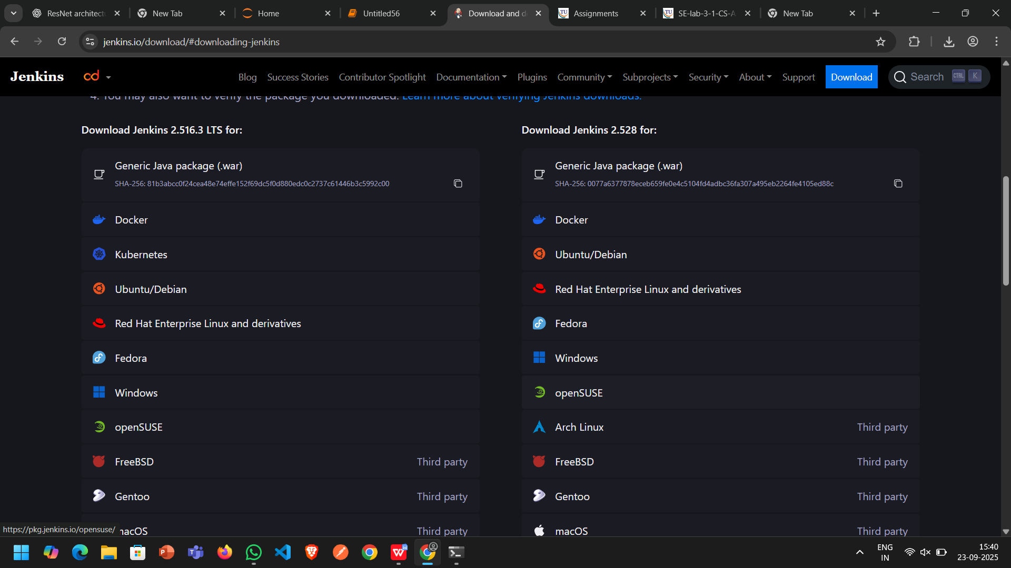
Step 3: Installation
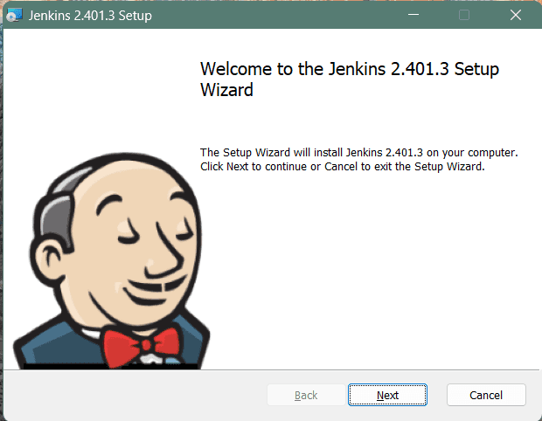
Step 4: Set User Details
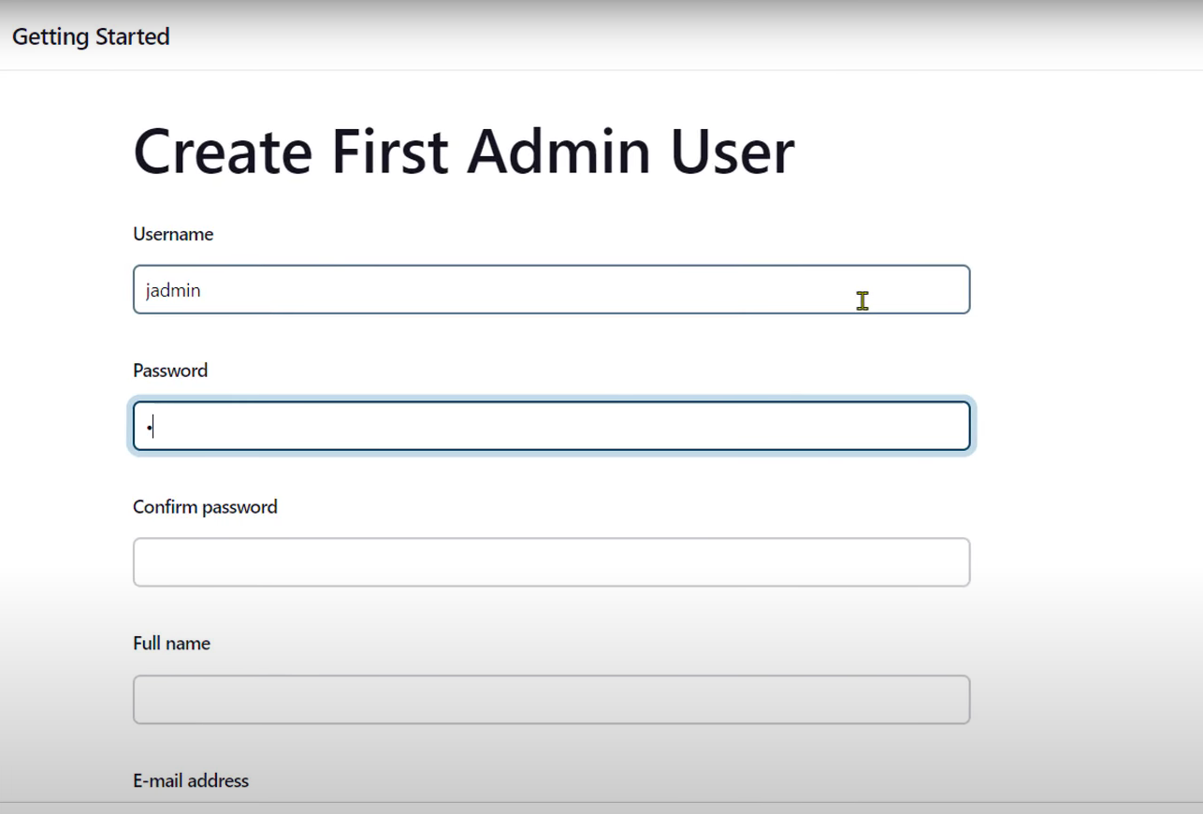
Step 5: Verify Installation
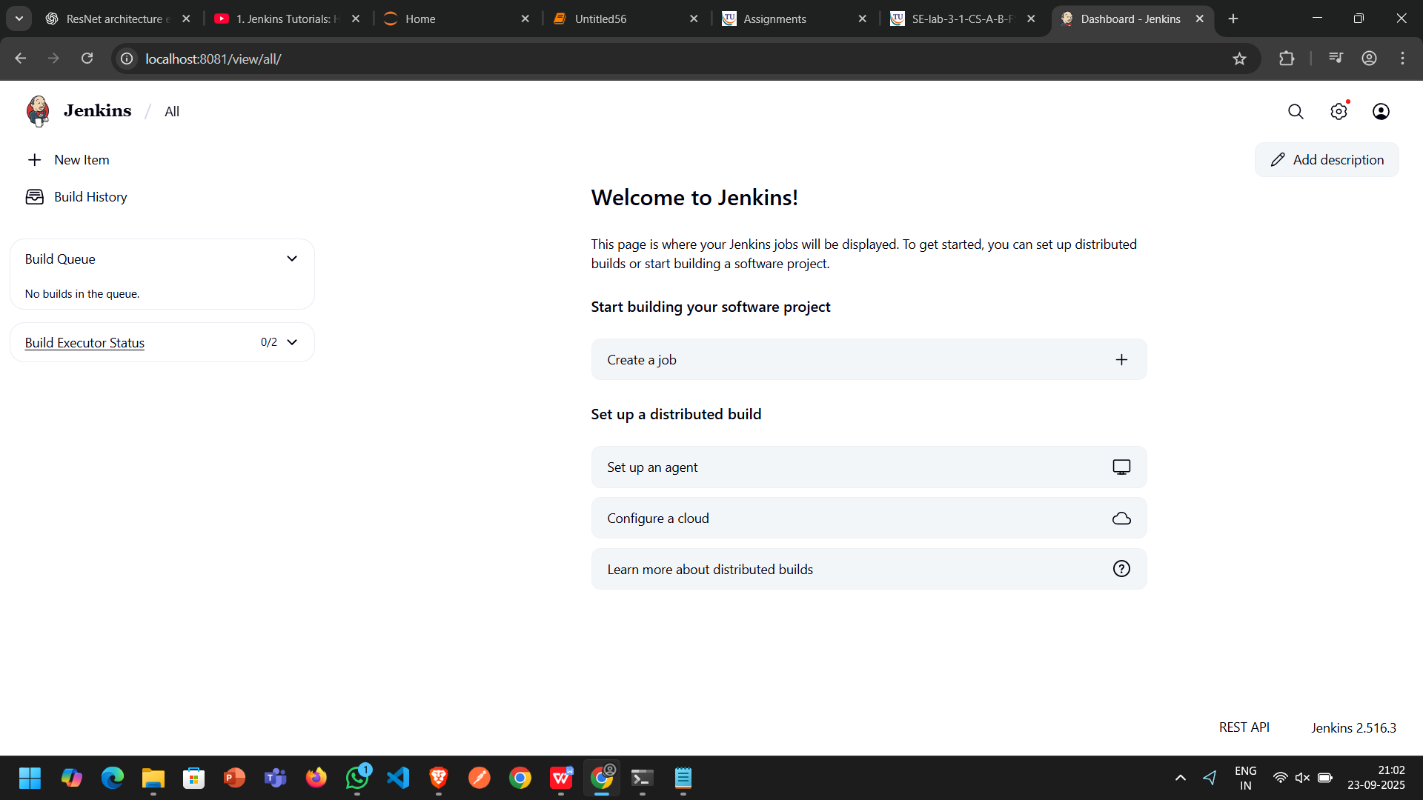

Task-3 Add Maven to Jenkins
Step 1: Copy bin path
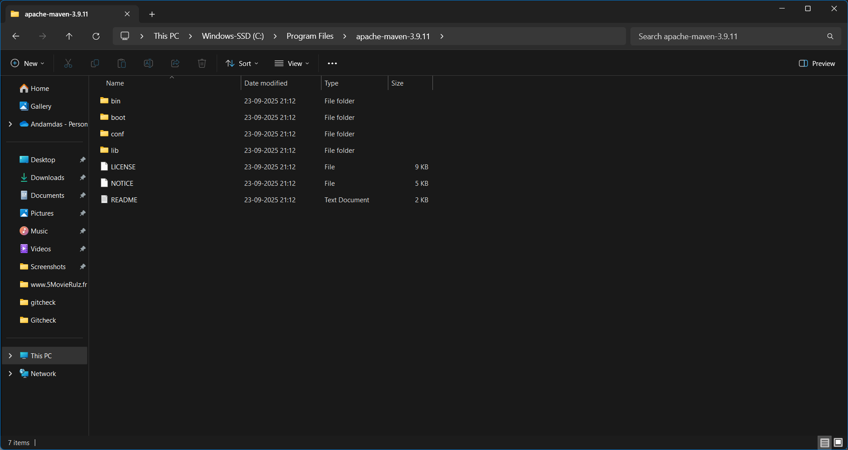
Step 2: Set Environment Variables
Step 3: Set maven in Jenkins Configure Tools
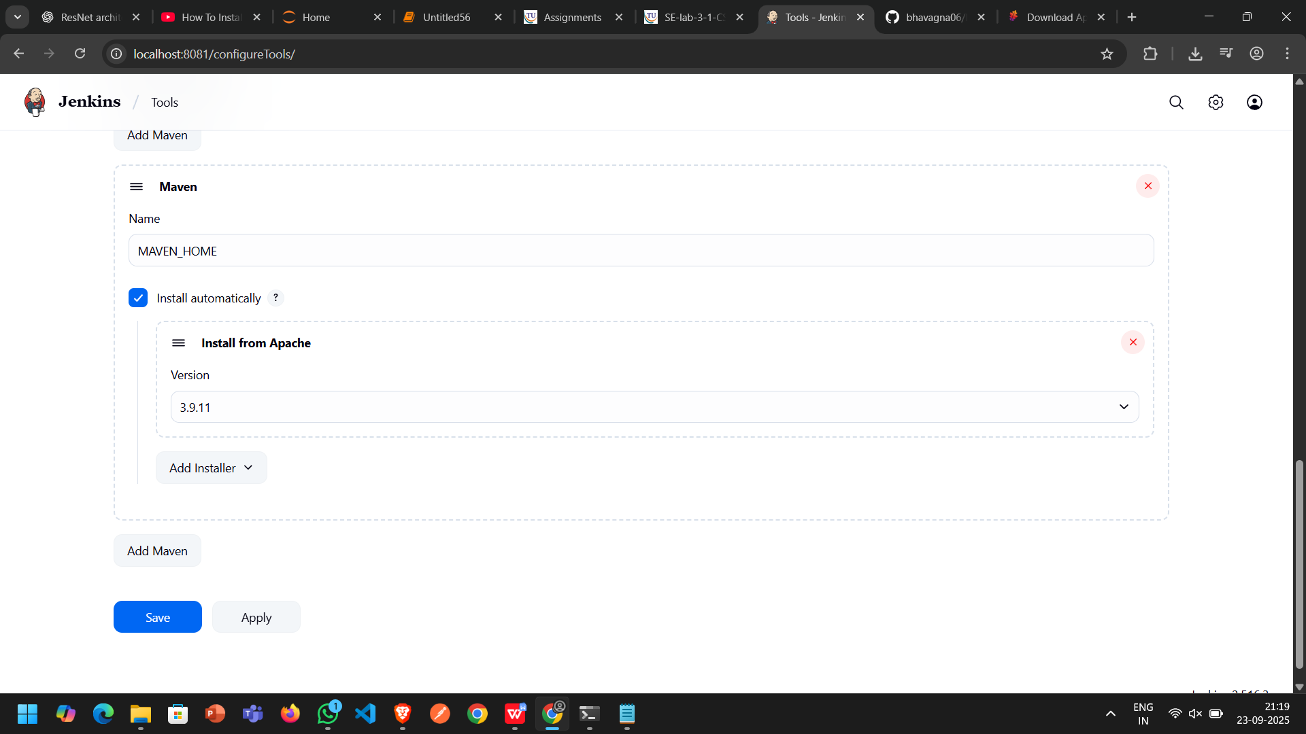
Apply and Save

Task-4 Maven java Automation
I. Maven Java Automation Steps:
Step 1: Open Jenkins (localhost:8081)
Click on "New Item" (left side menu )
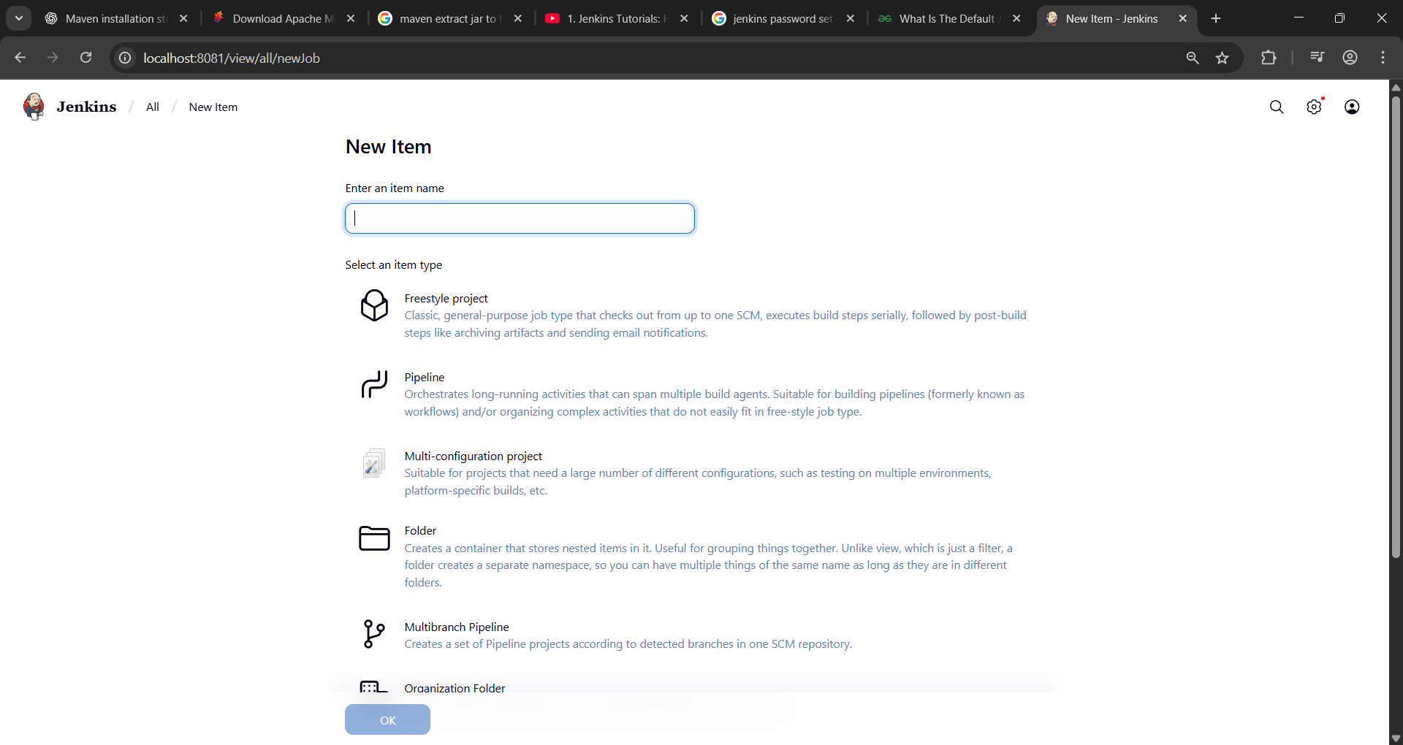
Step 2: Create Freestyle Project (e.g., MavenJava_Build)
Enter project name (e.g., MavenJava_Build)
Click "OK"
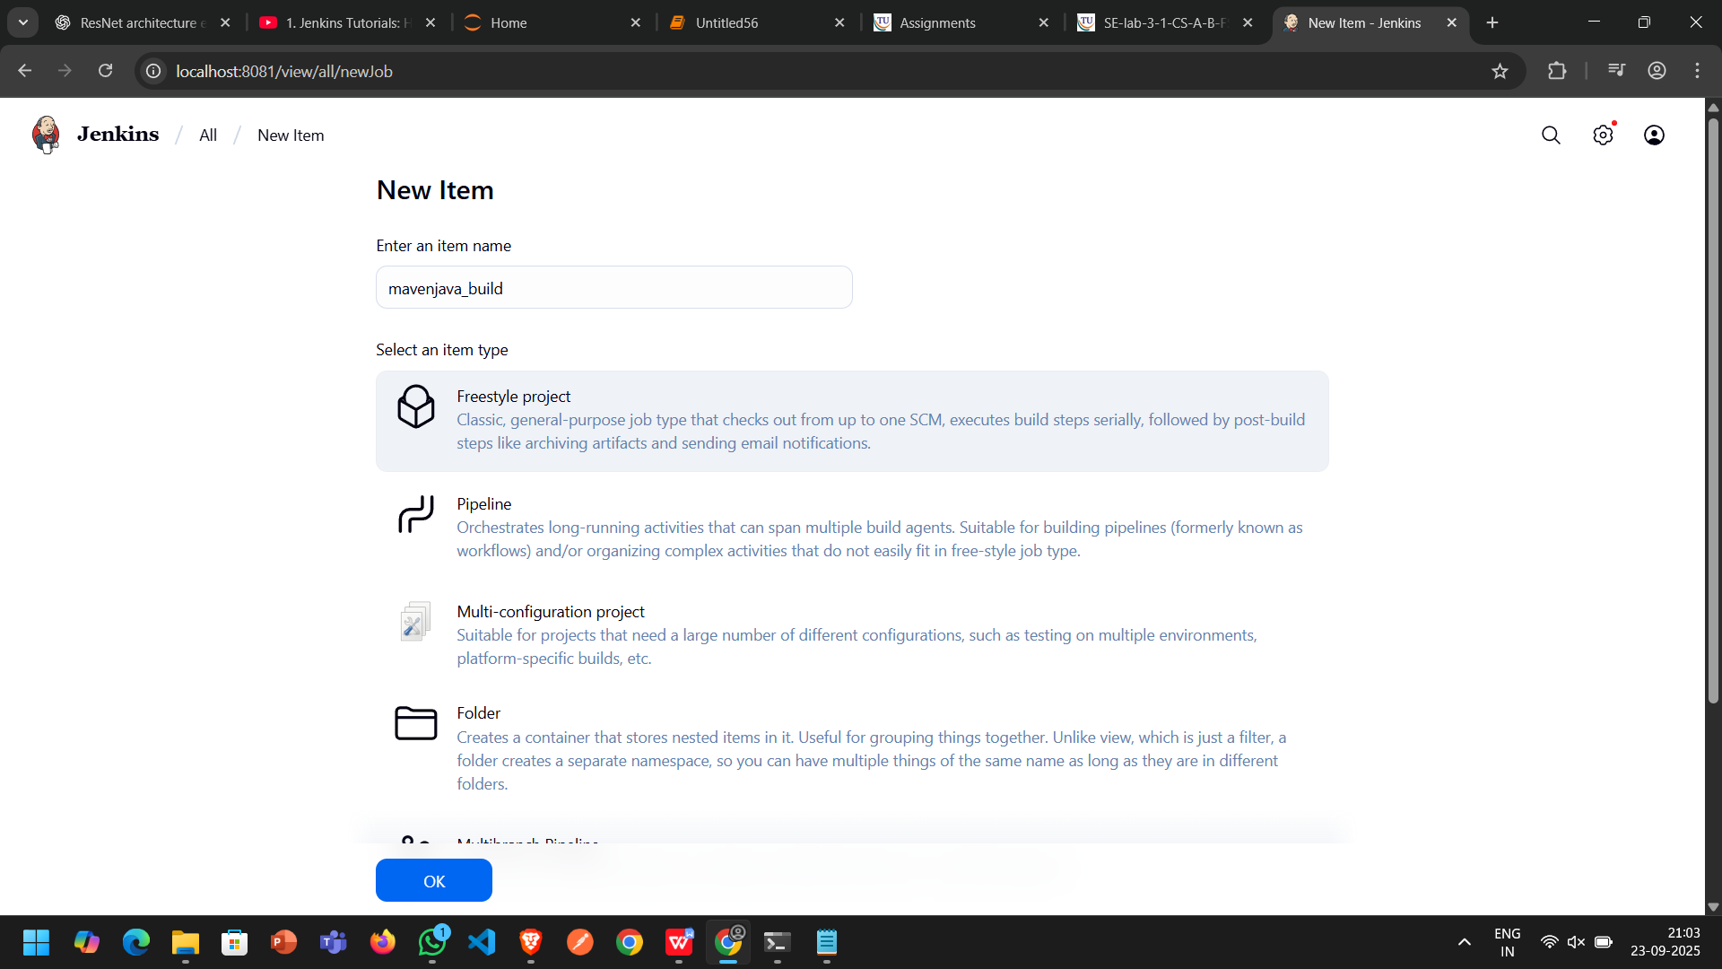
Configure the project:
Description: "Java Build demo"
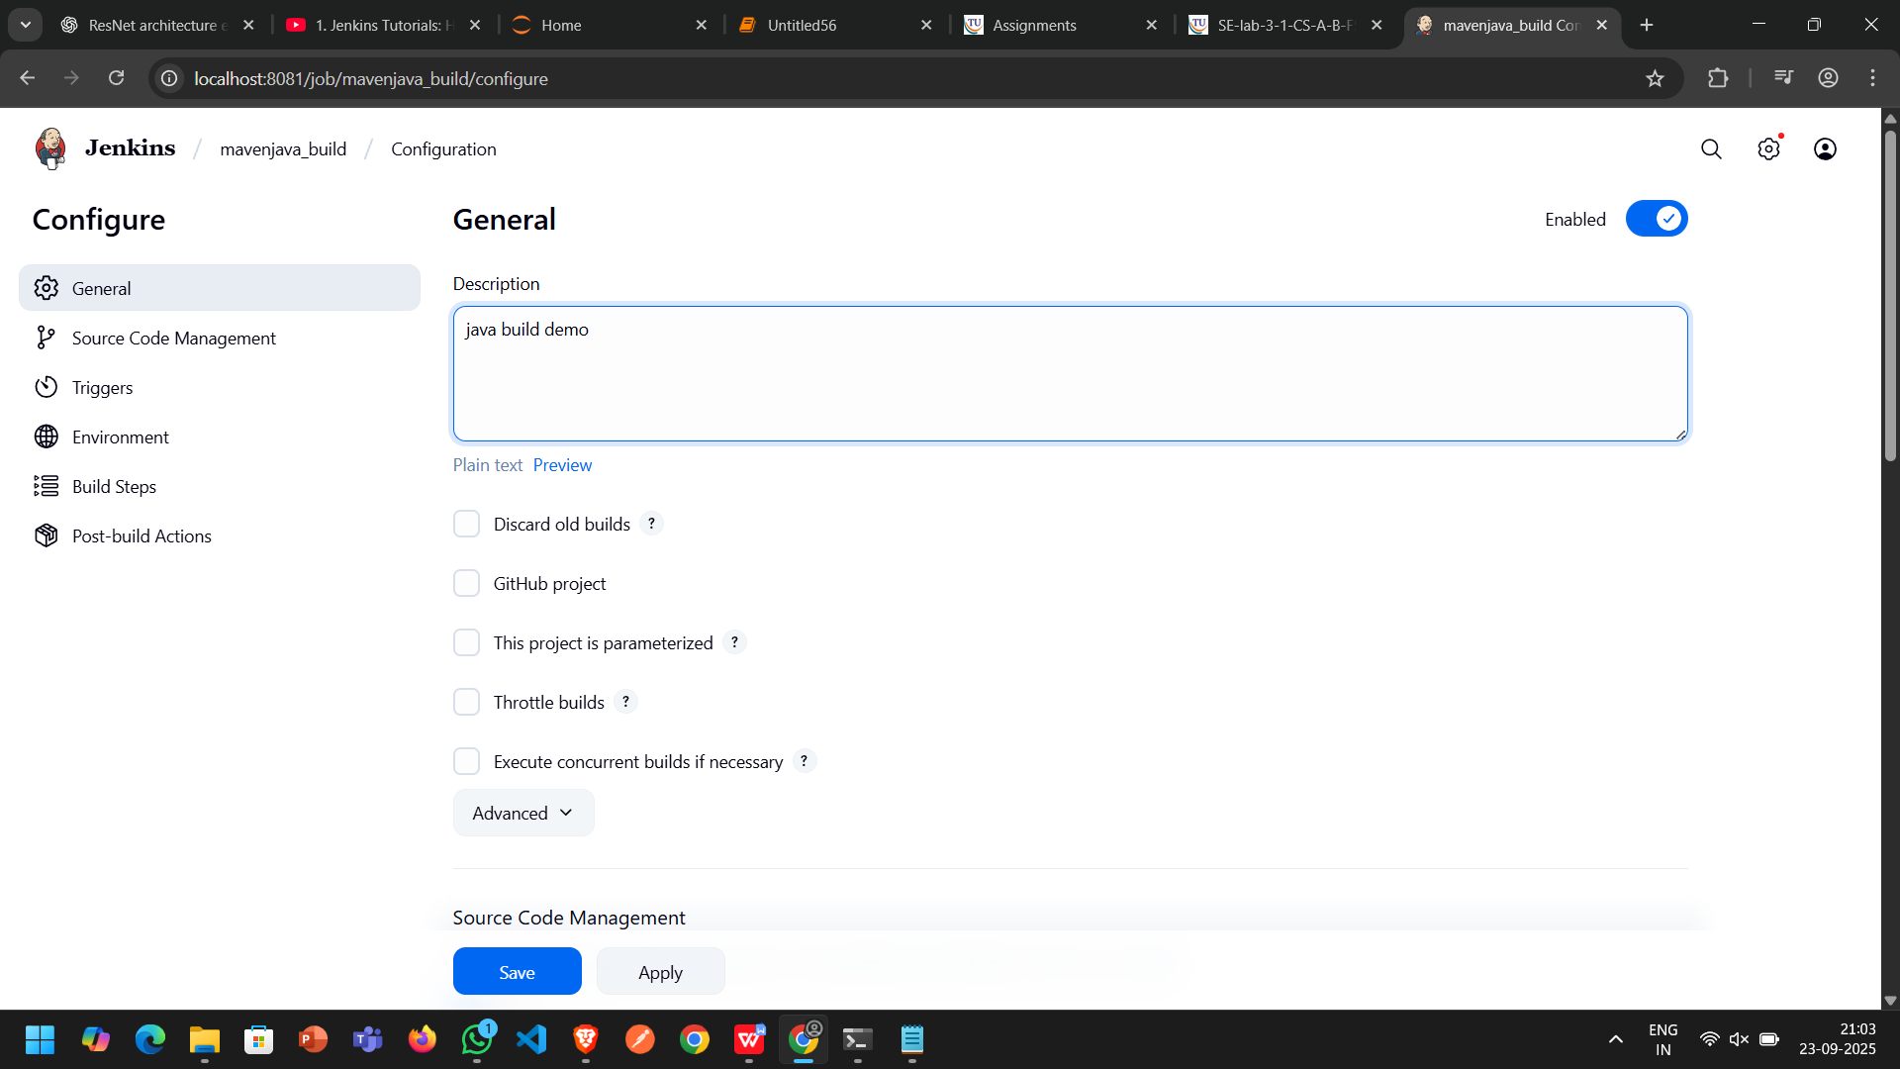
Source Code Management: Git repository URL: [https://github.com/bhavagna06/Maven.git]
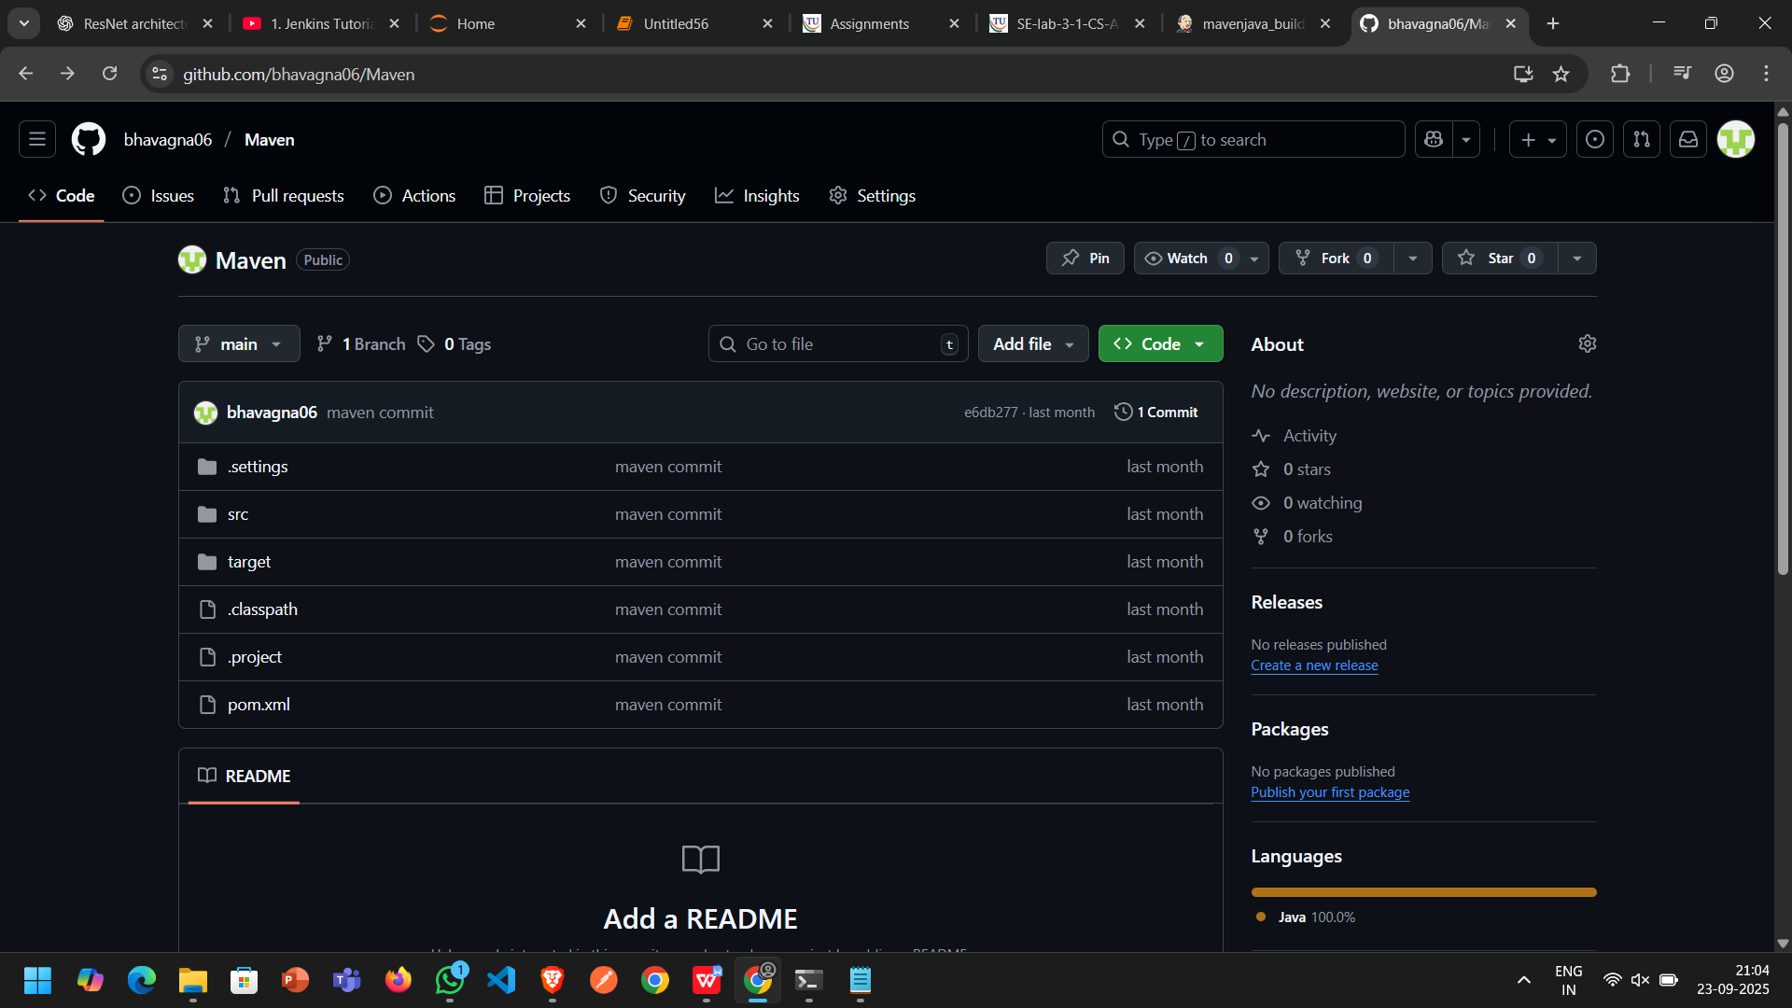
Branches to build: */Main or */master
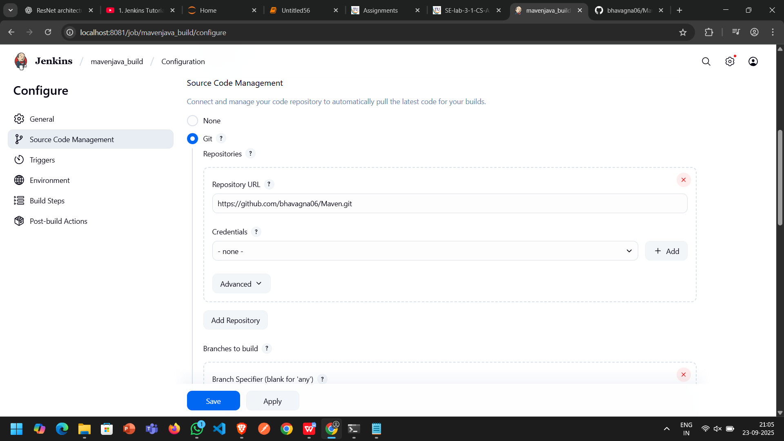

Build Steps: Add Build Step -> "Invoke top-level Maven targets"
Maven version: MAVEN_HOME
Goals: clean

Add Build Step -> "Invoke top-level Maven targets"
Maven version: MAVEN_HOME
Goals: install
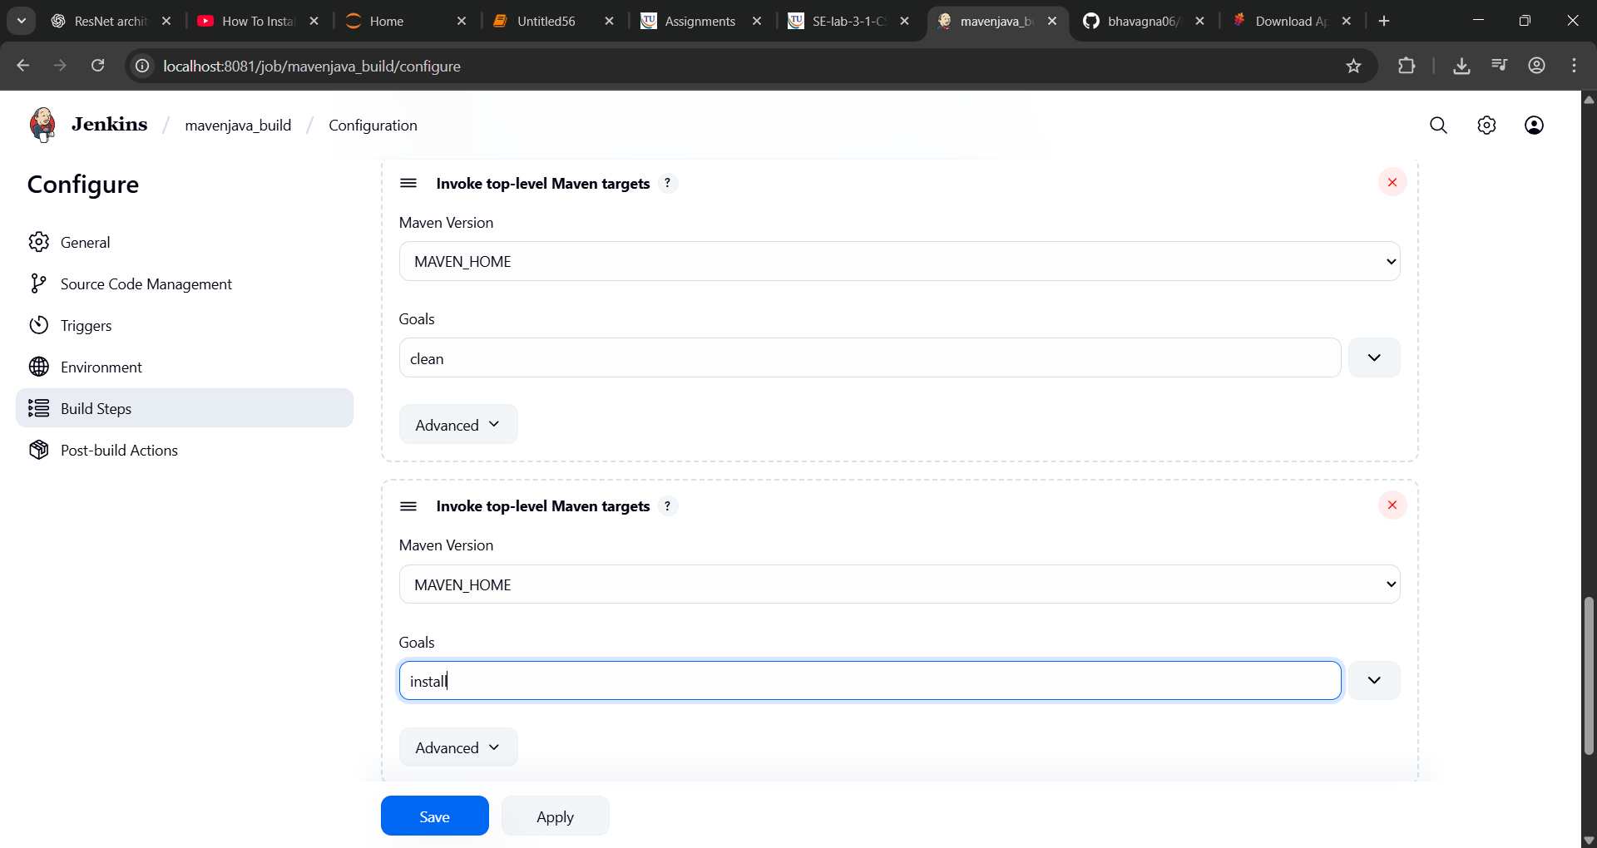
Post-build Actions: Add Post Build Action -> "Archive the artifacts"
Files to archive: **/*
Add Post Build Action -> "Build other projects"
Projects to build: MavenJava_Test
Trigger: Only if build is stable
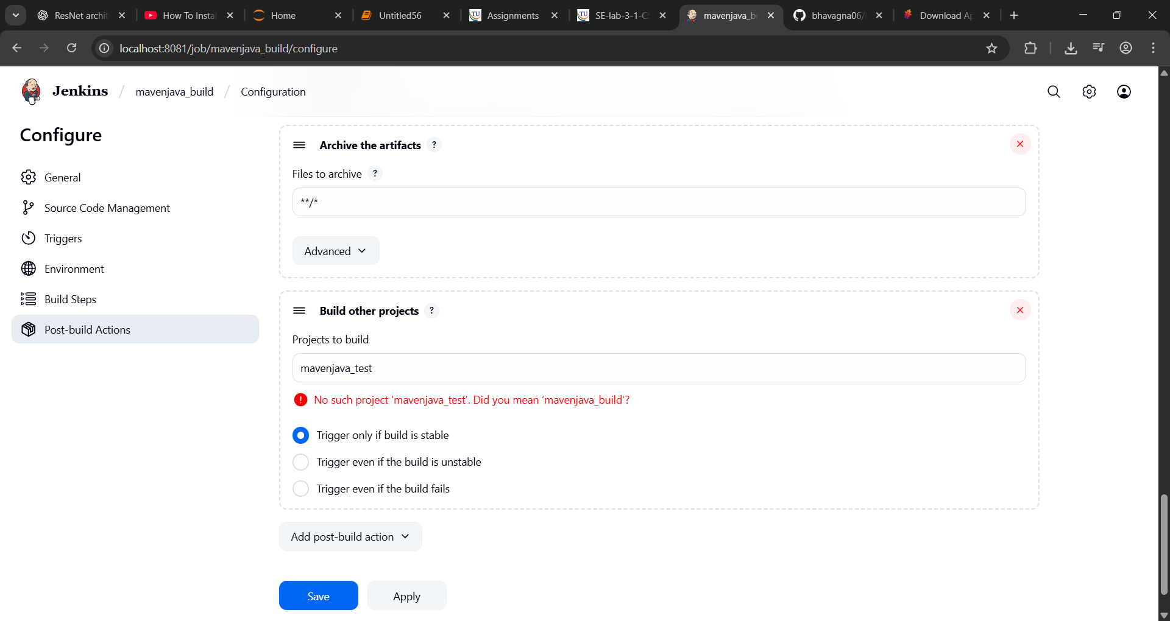
Apply and Save
Step 3: Create Freestyle Project (e.g., MavenJava_Test)
Enter project name (e.g., MavenJava_Test) ├── Click "OK"
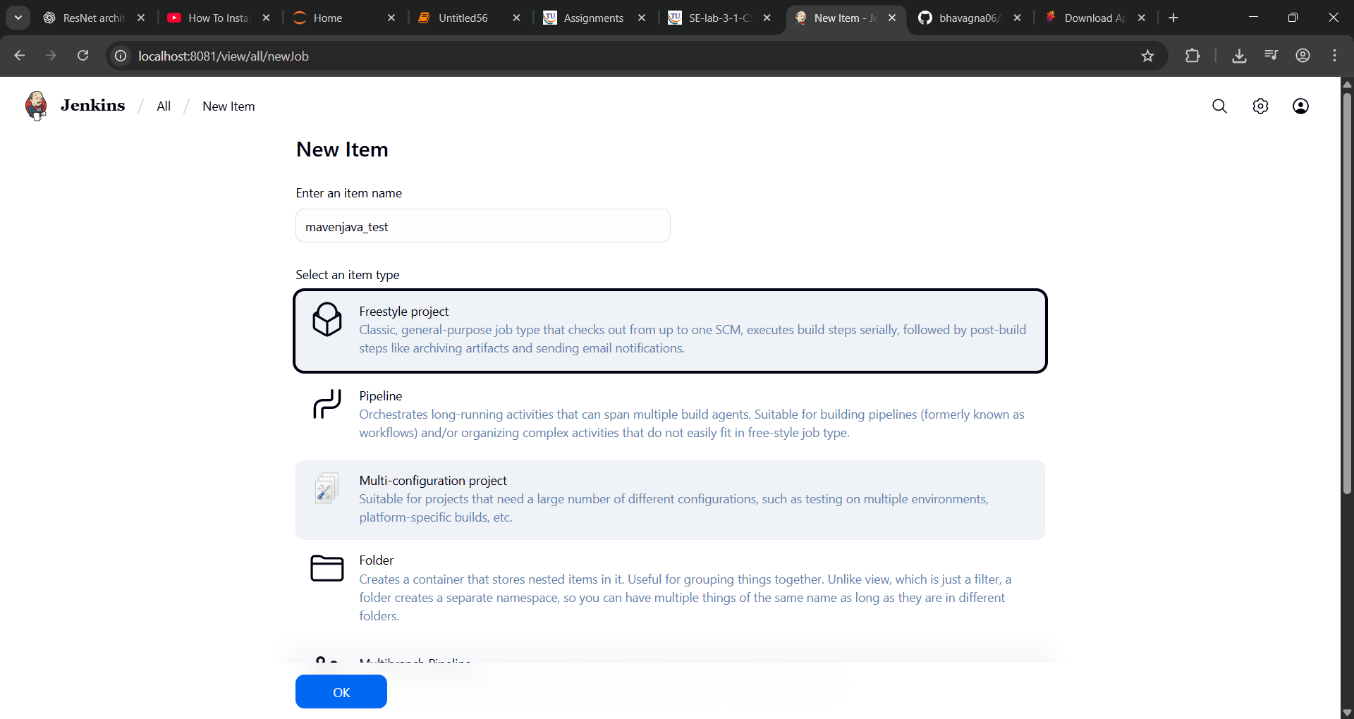
Configure the project:
Description: "Test demo"
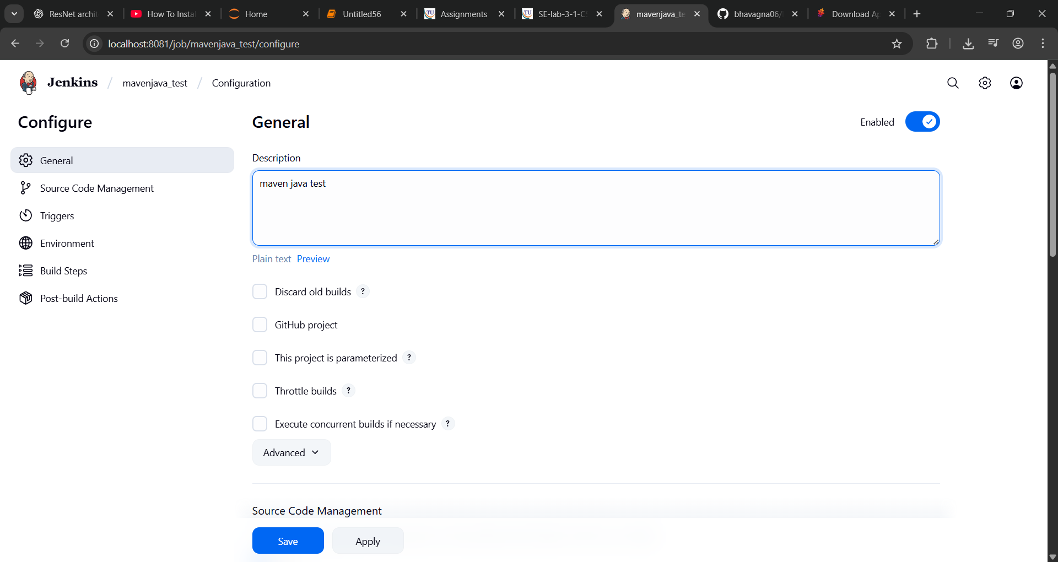
Build Environment:
Check: "Delete the workspace before build starts"
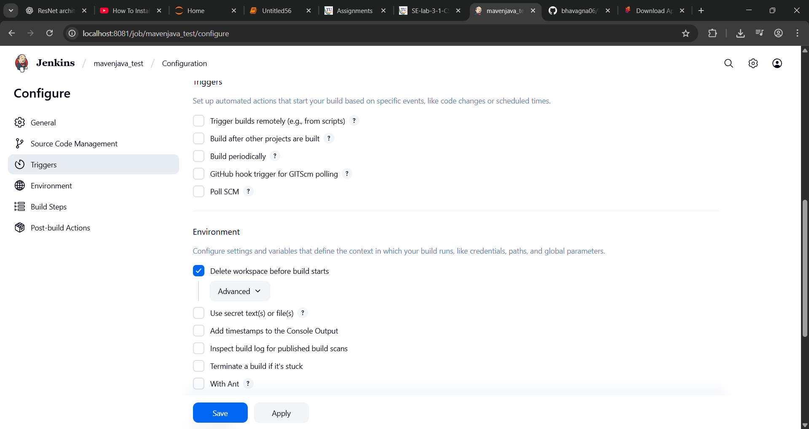
Add Build Step -> "Copy artifacts from another project"
Project name: MavenJava_Build
Build: Stable build only
Artifacts to copy: **/*
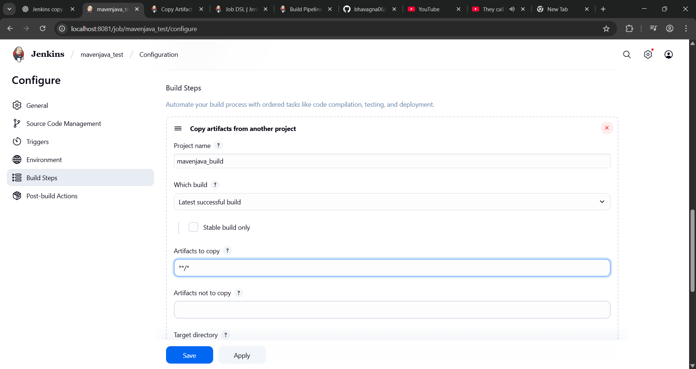Add Build Step -> "Invoke top-level Maven targets"
Maven version: MAVEN_HOME
Goals: test
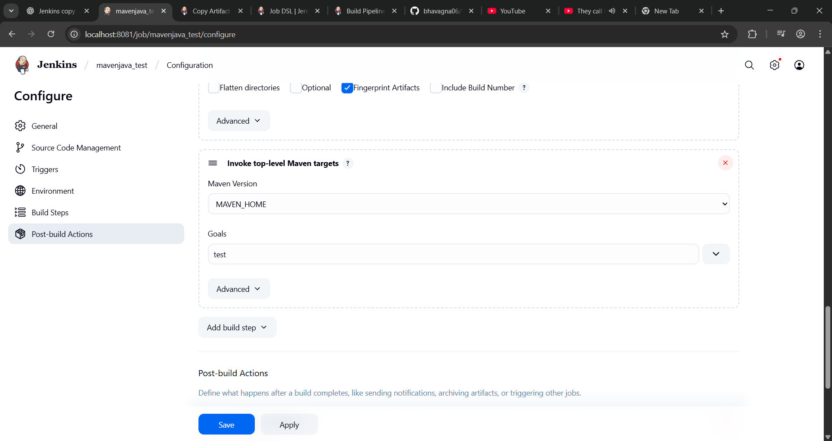
Post-build Actions: Add Post Build Action -> "Archive the artifacts"
Files to archive: **/*
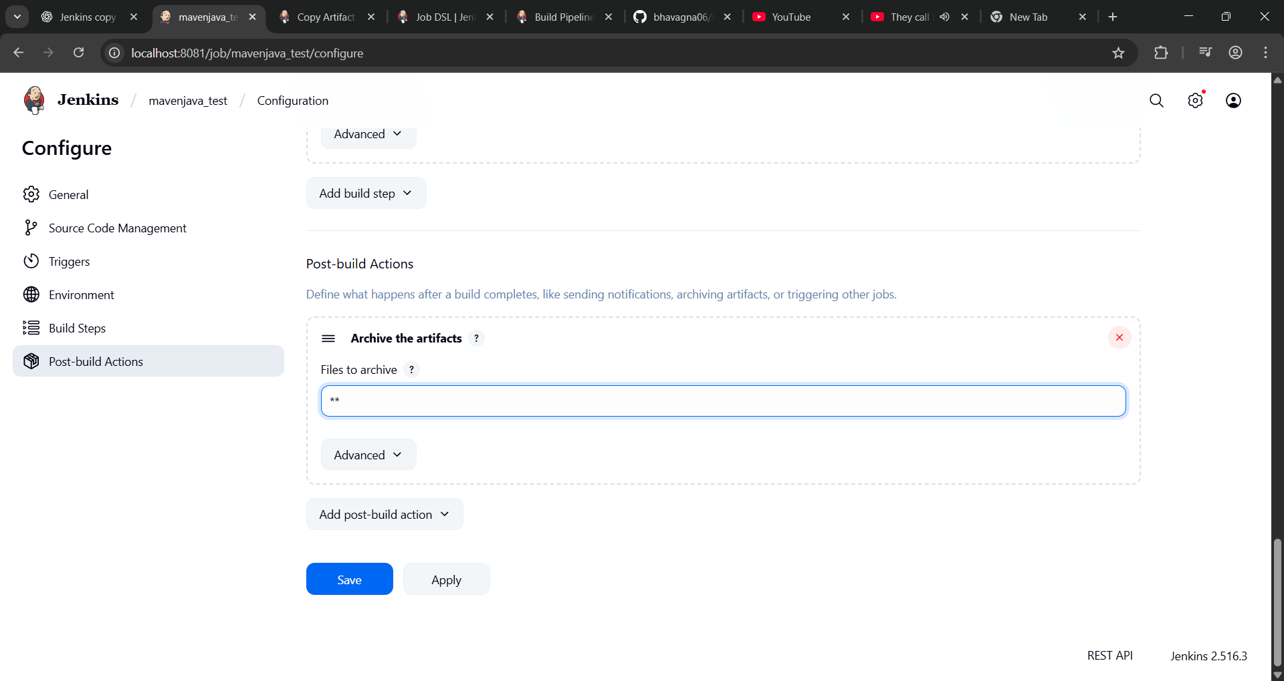
Apply and Save
Step 4: Create Pipeline View for Maven Java project
Click "+" beside "All" on the dashboard
Enter name: Java_Pipeline
Select "Build pipeline view"
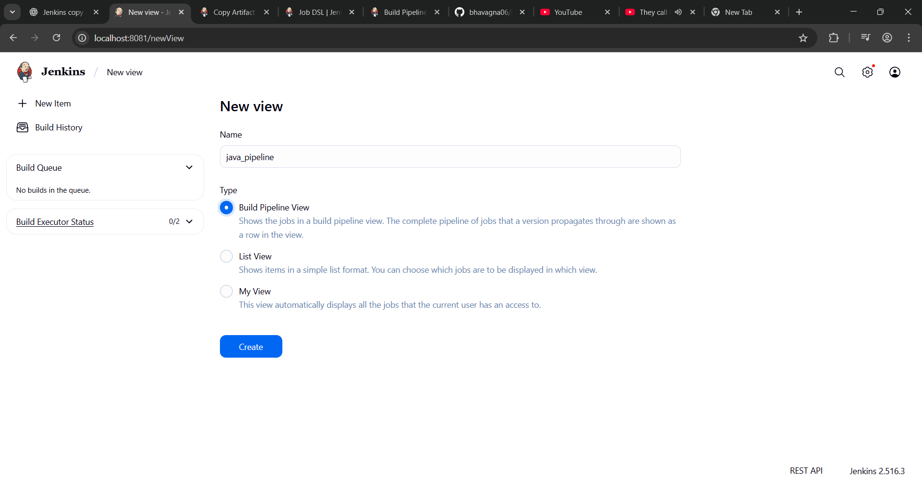
create Pipeline Flow: Layout: Based on upstream/downstream relationship
Initial job: MavenJava_Build
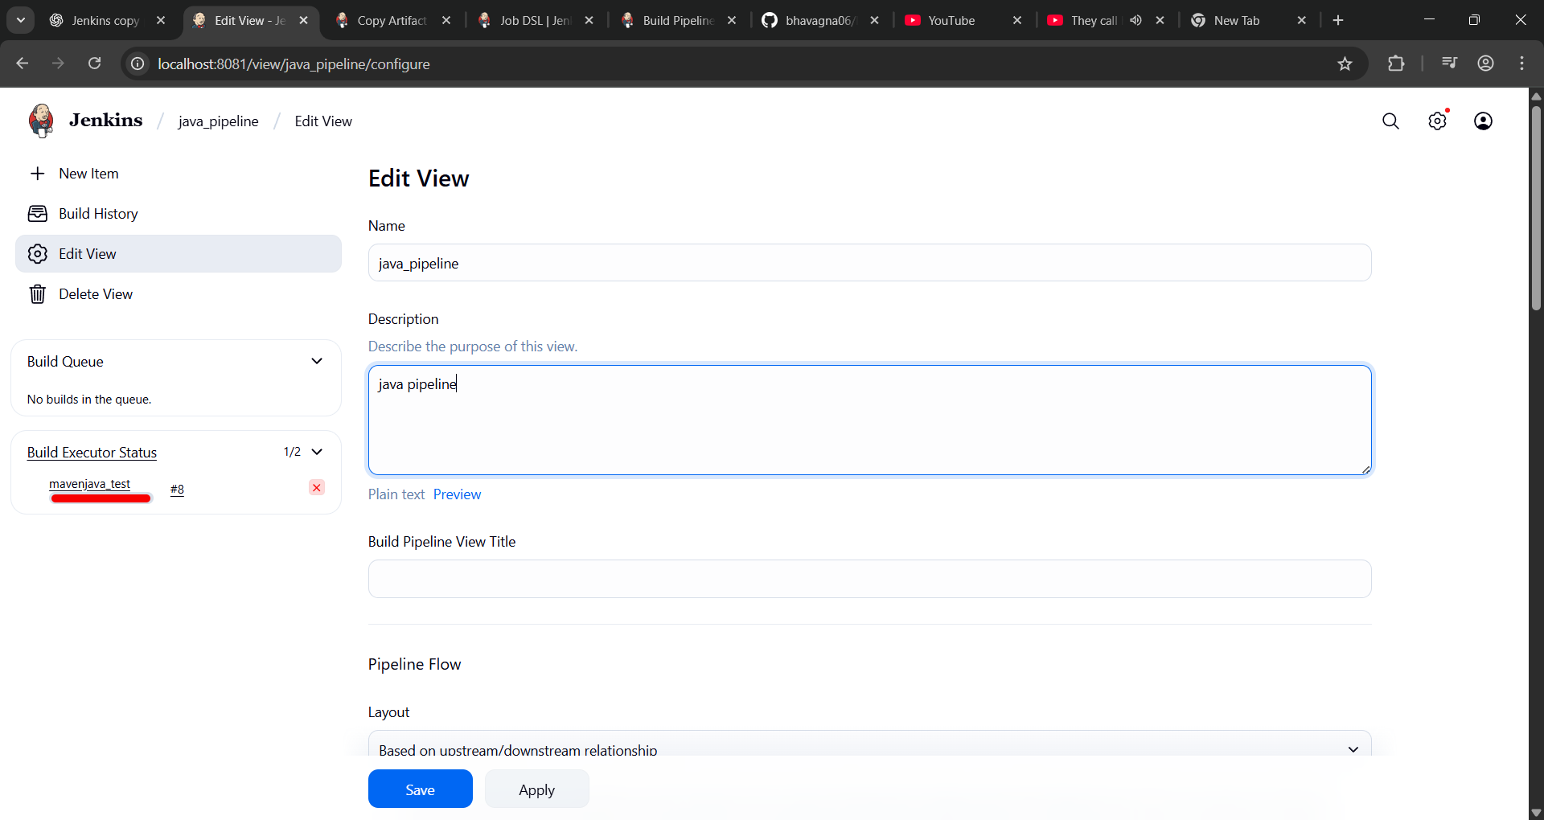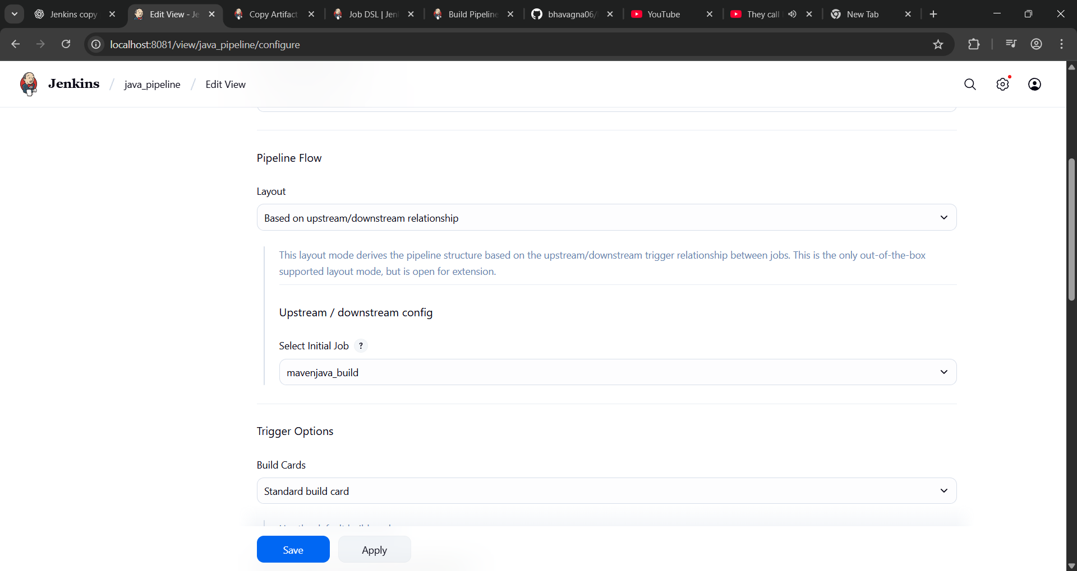
Apply and Save OK
Step 5: Run the Pipeline and Check Output
Click on the trigger to run the pipeline
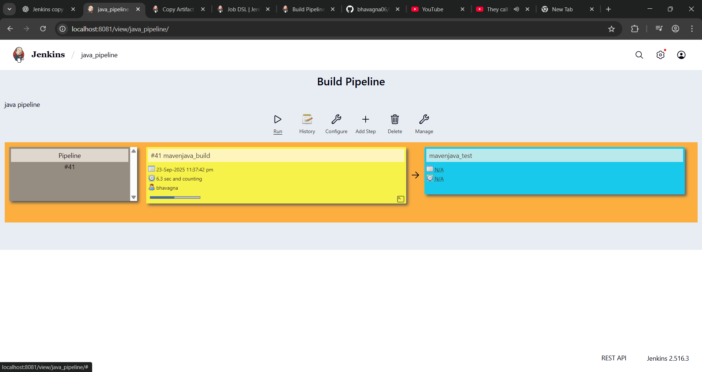
click on the small black box to open the console to check if the build is success
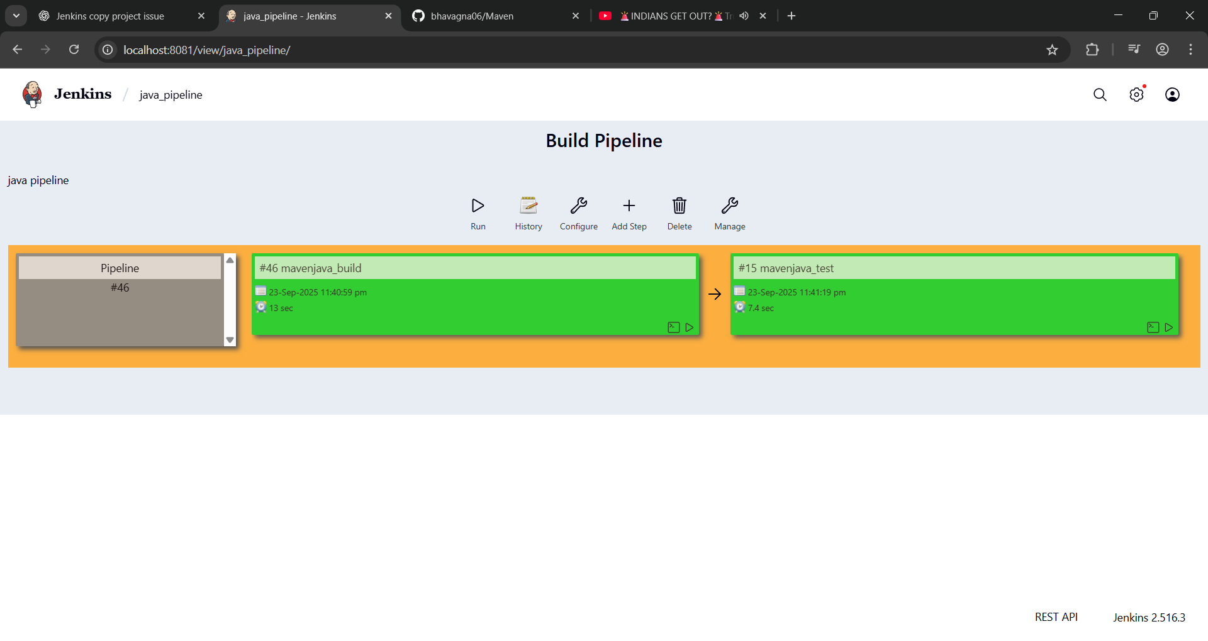

II. Maven Web Automation Steps:
Step 1: Open Jenkins (localhost:8081)
├── Click on "New Item" (left side menu)
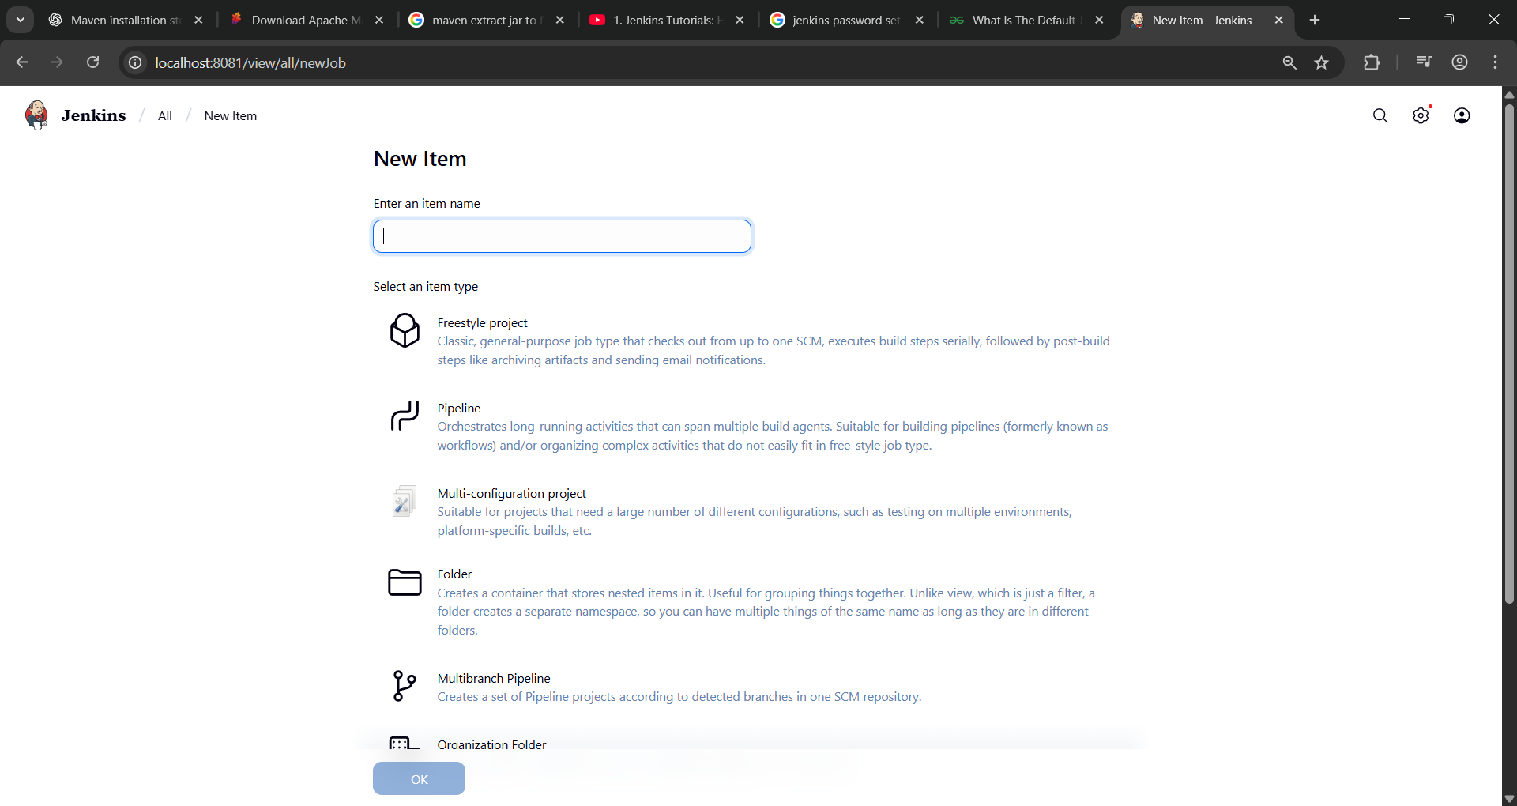

Step 2: Create Freestyle Project (e.g., MavenWeb_Build)
├── Enter project name (e.g., MavenWeb_Build)
├── Click "OK"
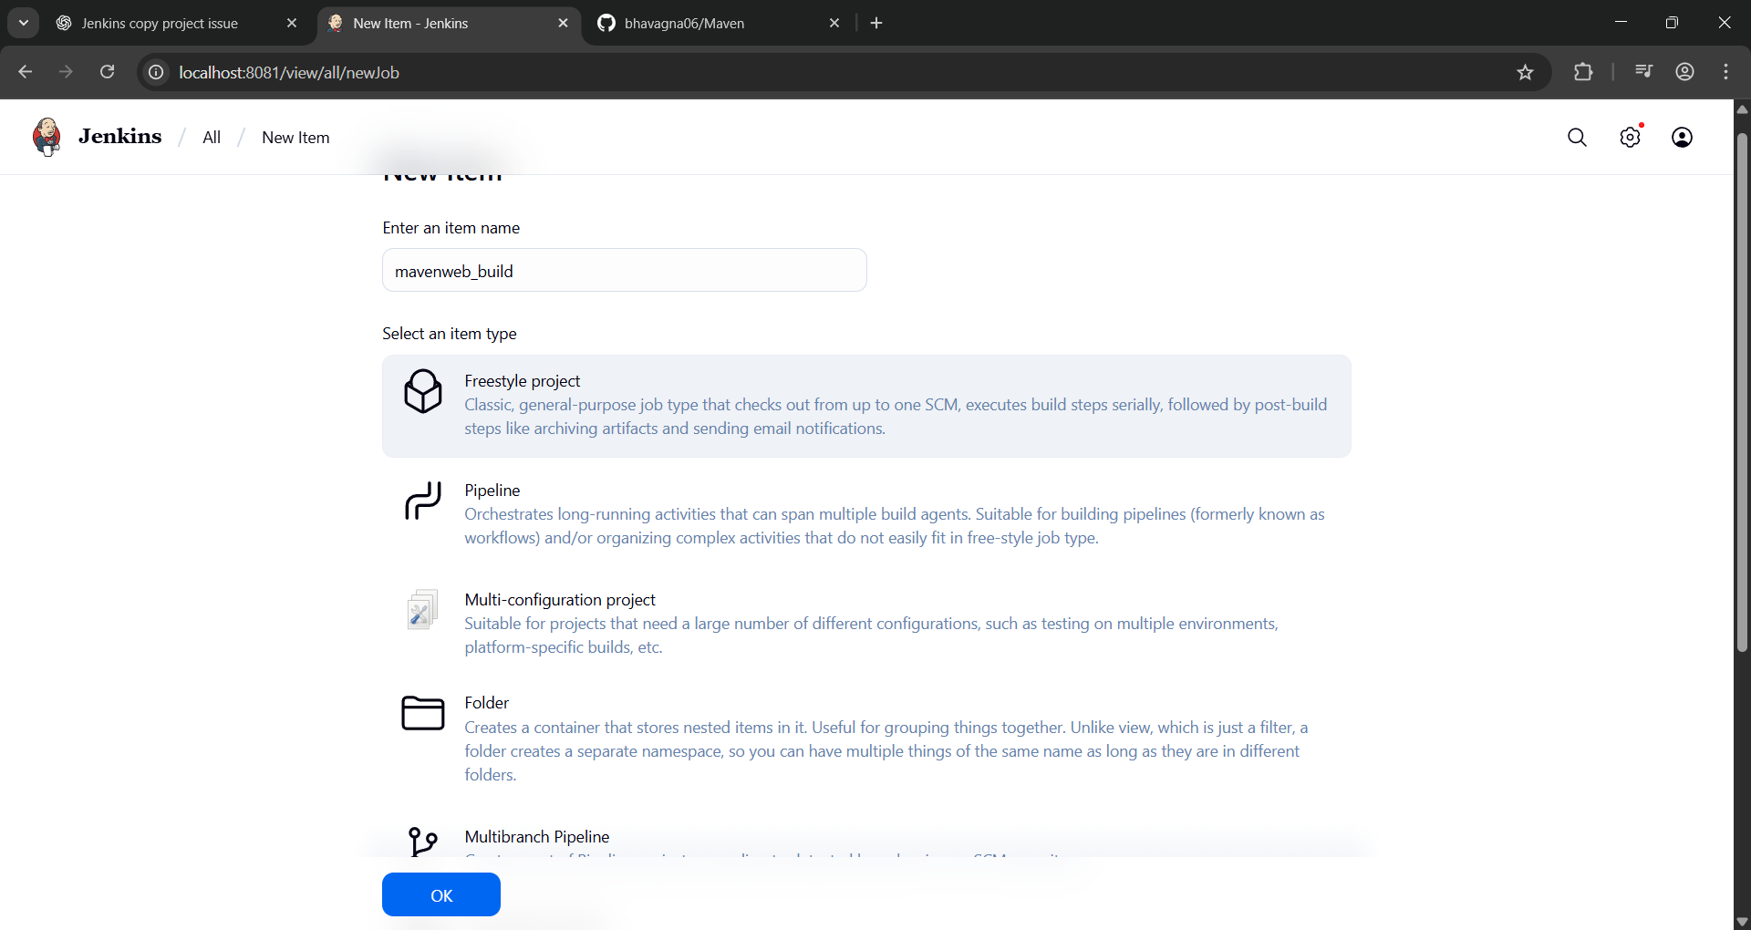

Configure the project:
├── Description: "Web Build demo"
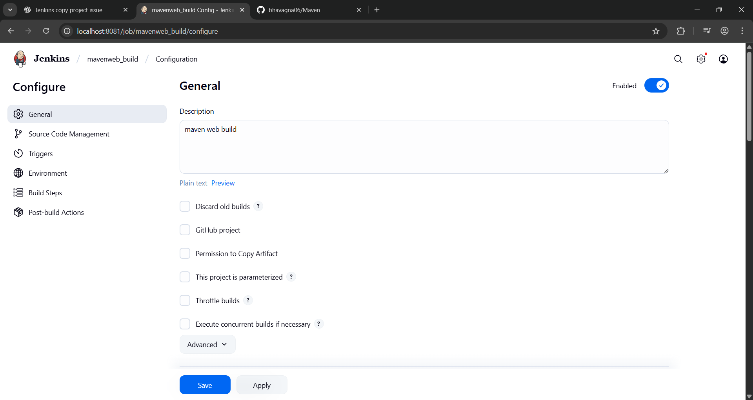
Source Code Management:
└── Git repository URL: [https://github.com/bhavagna06/maven-web-app.git]
├── Branches to build: */Main or master
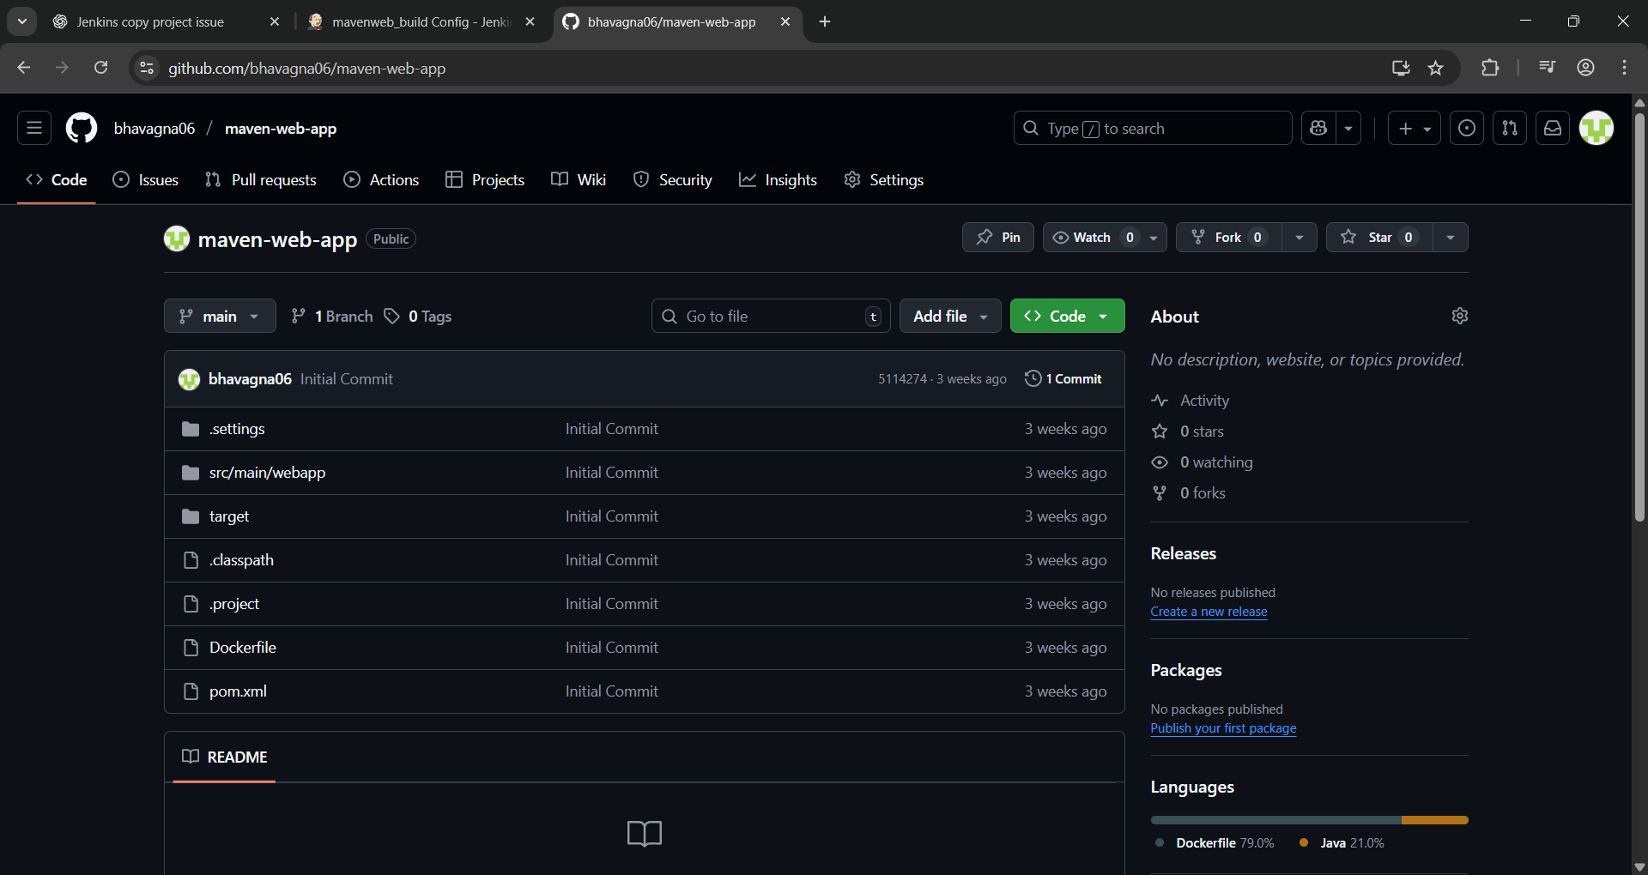
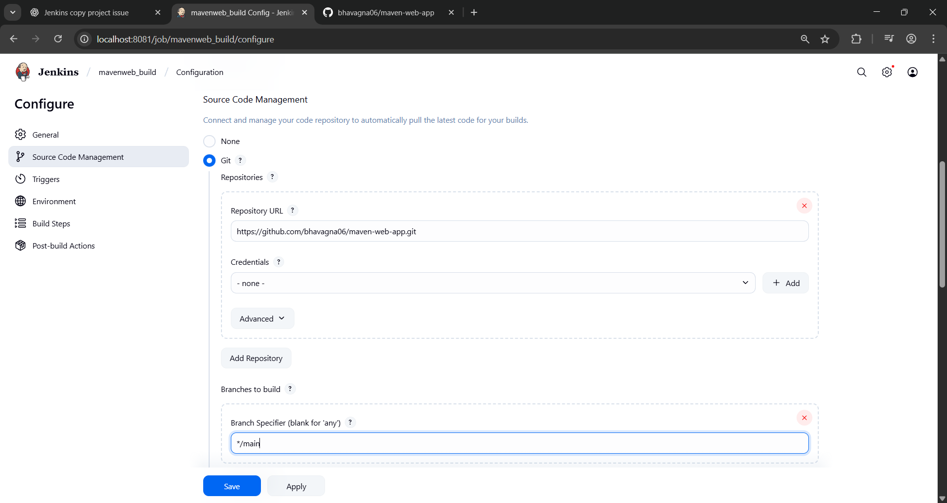
Build Steps:
├── Add Build Step -> "Invoke top-level Maven targets"
└── Maven version: MAVEN_HOME
└── Goals: clean
├── Add Build Step -> "Invoke top-level Maven targets"
└── Maven version: MAVEN_HOME
└── Goals: install
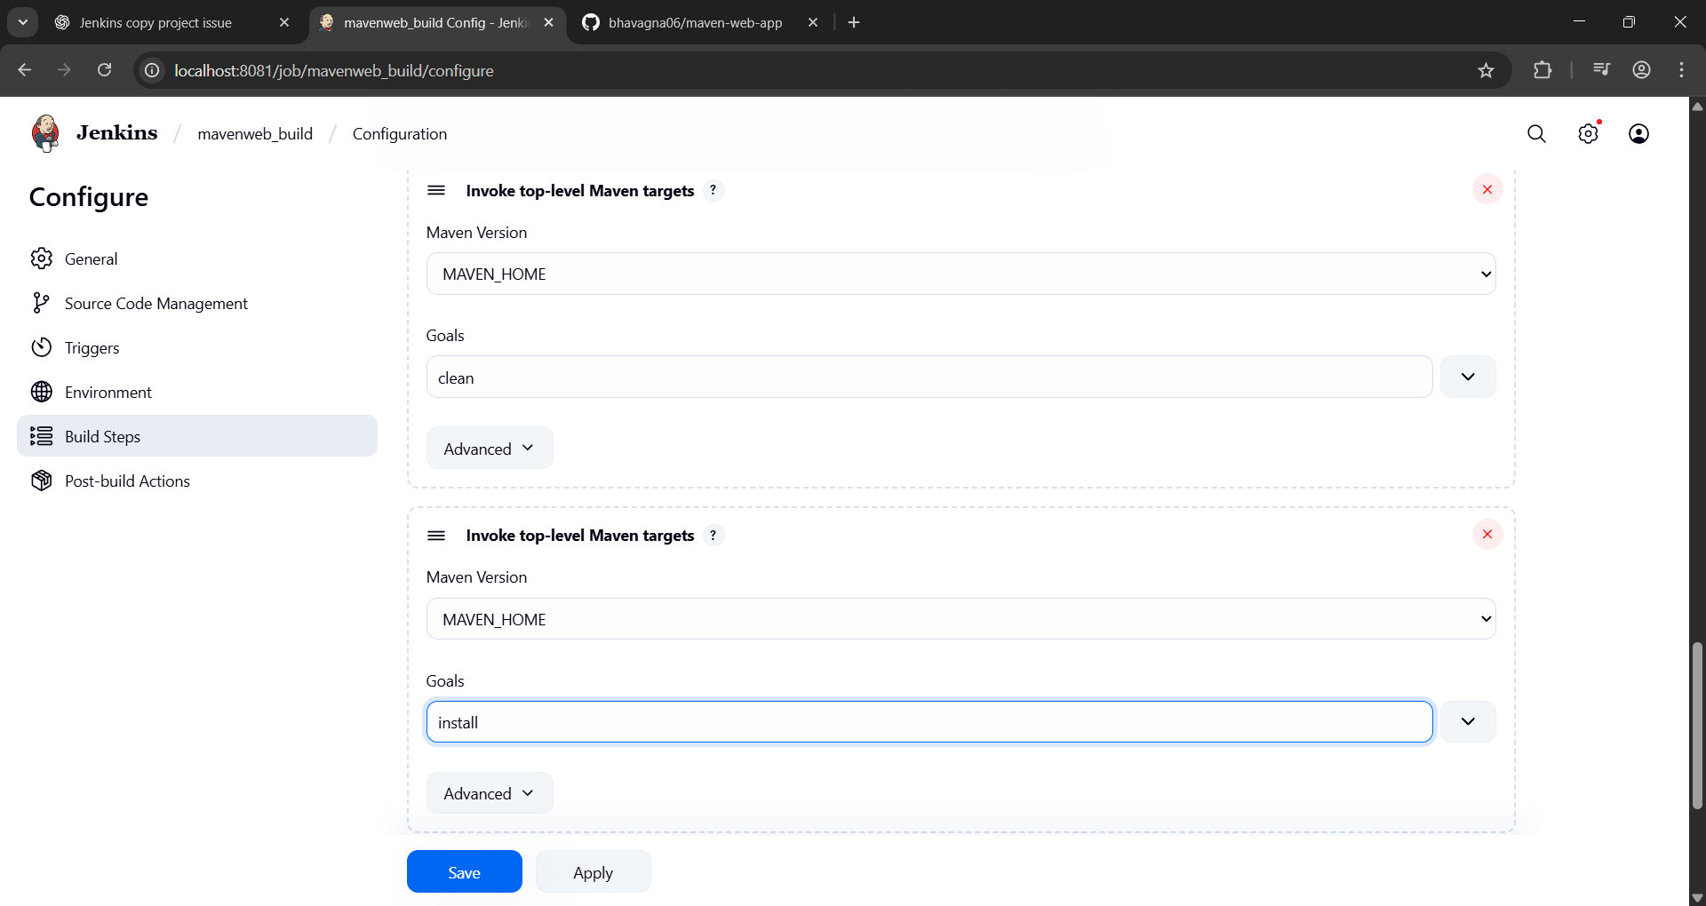
Post-build Actions:
├── Add Post Build Action -> "Archive the artifacts"
└── Files to archive: **/*
├── Add Post Build Action -> "Build other projects"
└── Projects to build: MavenWeb_Test
└── Trigger: Only if build is stable
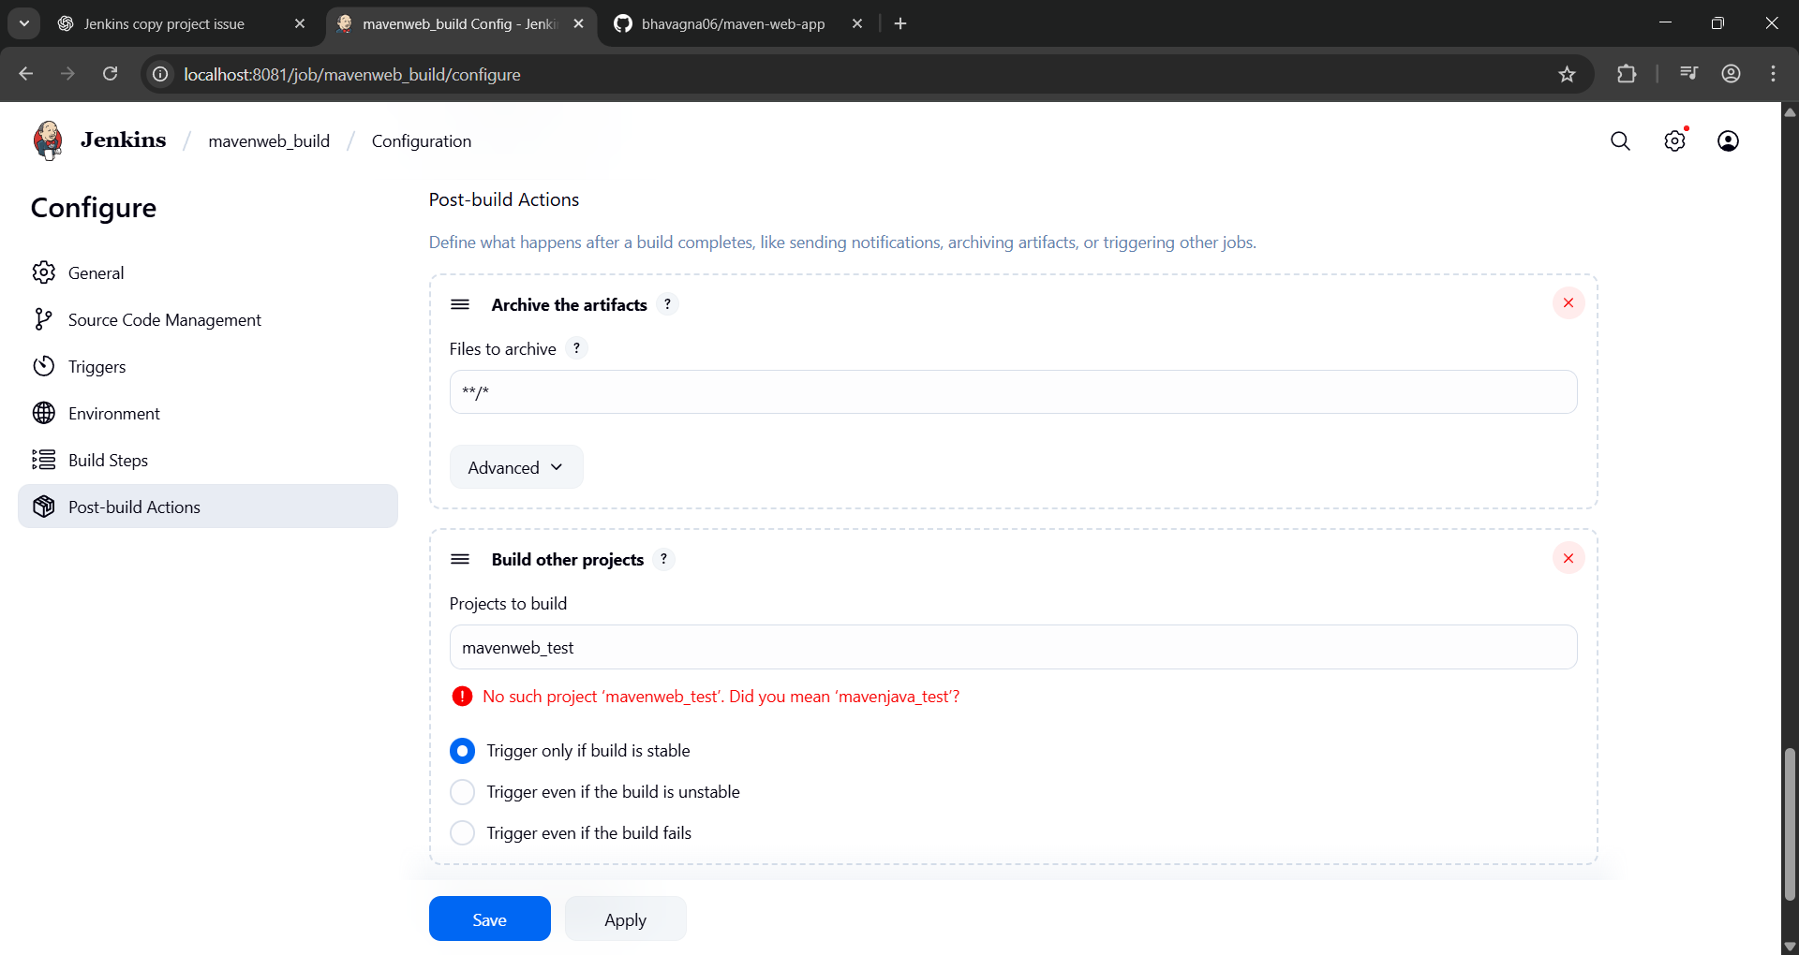
└── Apply and Save

Step 3: Create Freestyle Project (e.g., MavenWeb_Test)
├── Enter project name (e.g., MavenWeb_Test)
├── Click "OK"
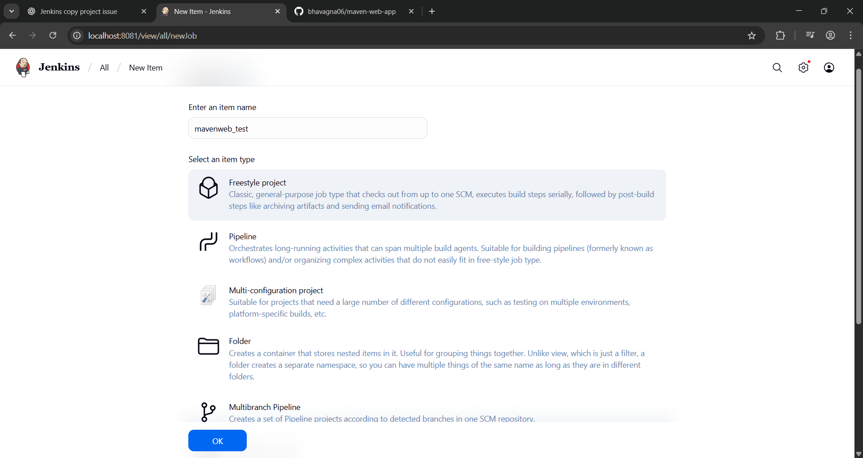
Configure the project:
├── Description: "Test demo"
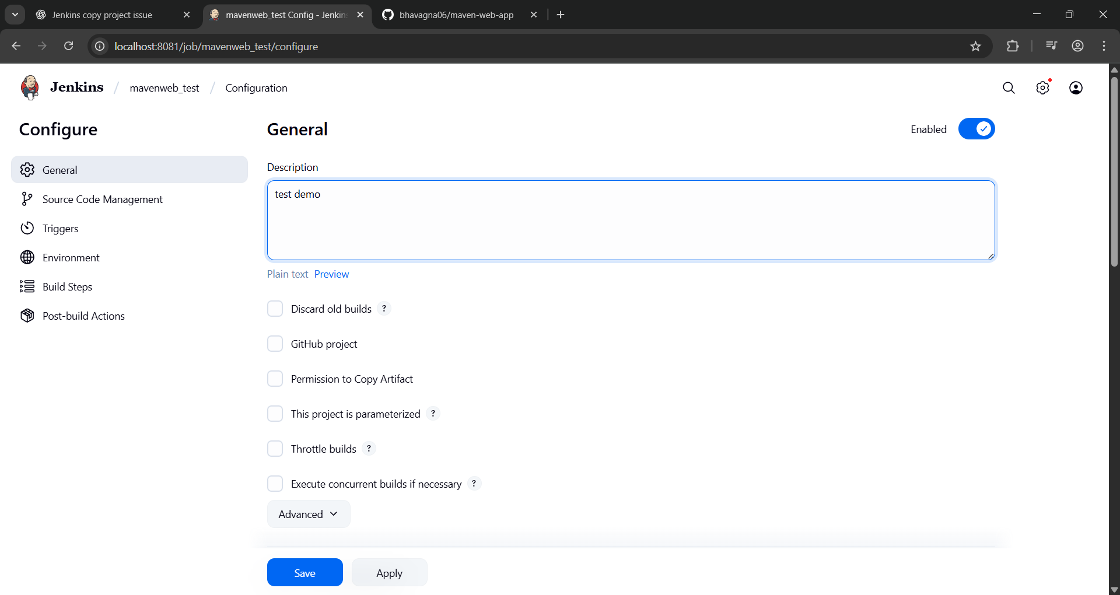
Build Environment:
└── Check: "Delete the workspace before build starts"
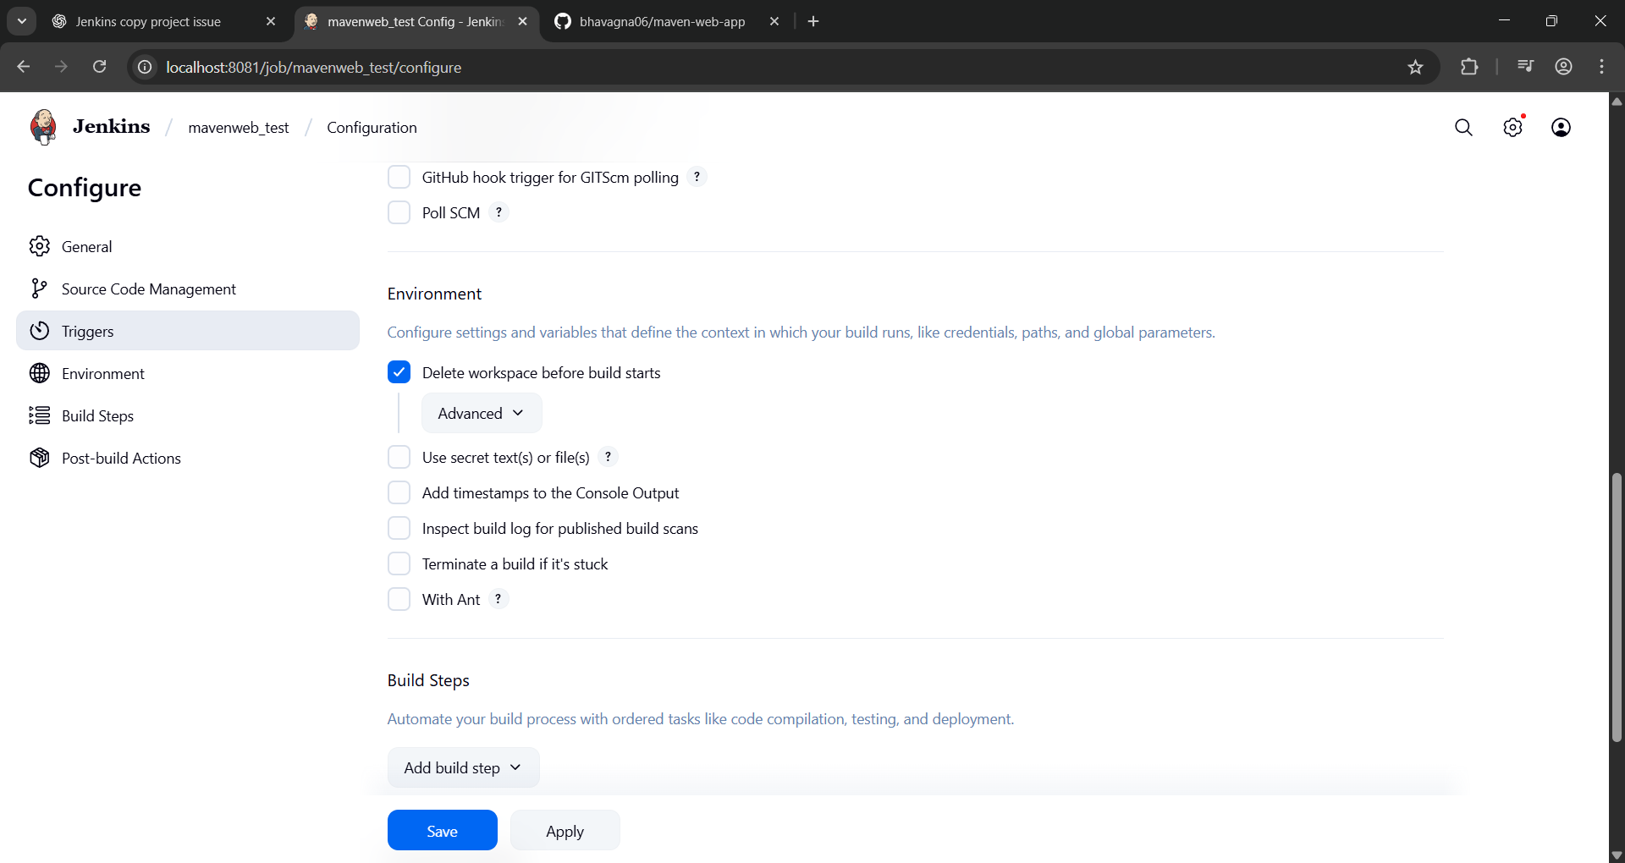
Add Build Step -> "Copy artifacts from another project"
└── Project name: MavenWeb_Build
└── Build: Stable build only
└── Artifacts to copy: **/*
Add Build Step -> "Invoke top-level Maven targets"
└── Maven version: MAVEN_HOME
└── Goals: test
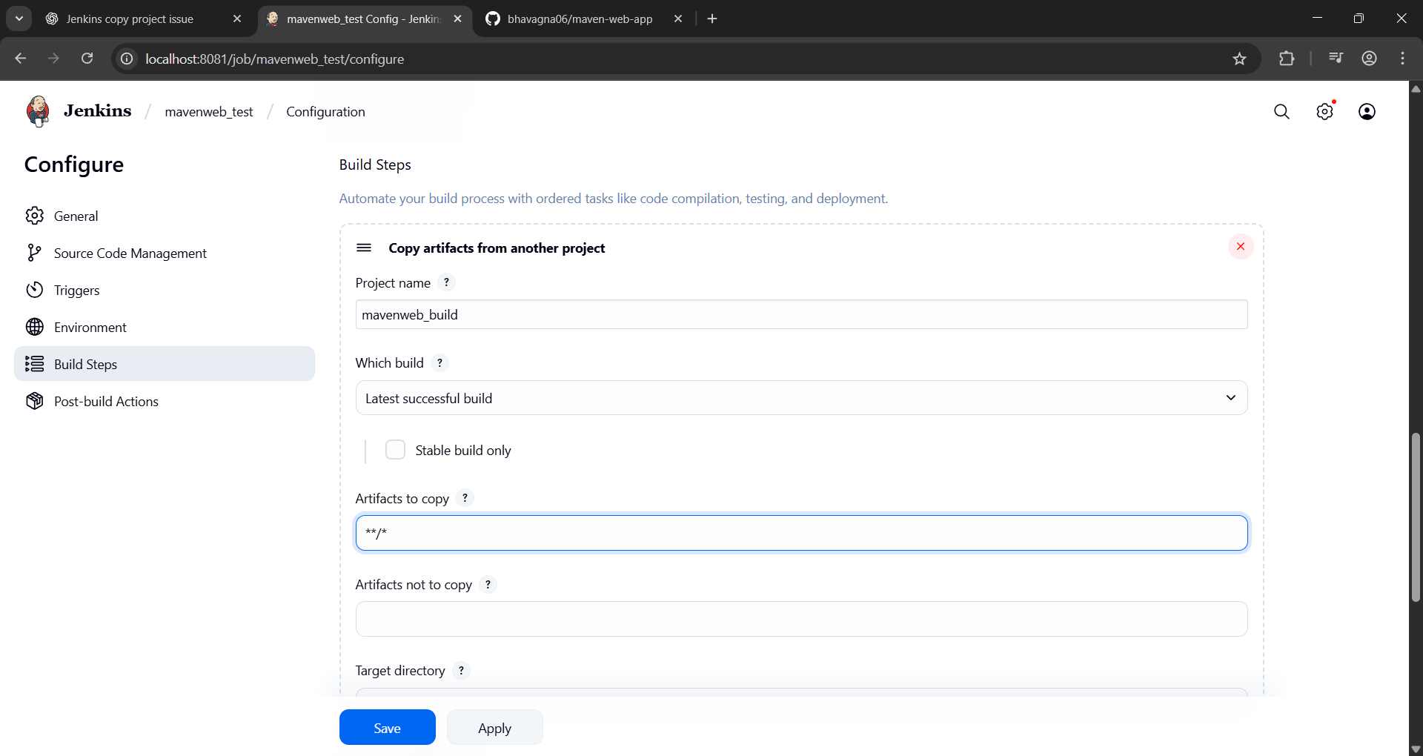
Post-build Actions:
├── Add Post Build Action -> "Archive the artifacts"
└── Files to archive: **/*
├── Add Post Build Action -> "Build other projects"
└── Projects to build: MavenWeb_Deploy
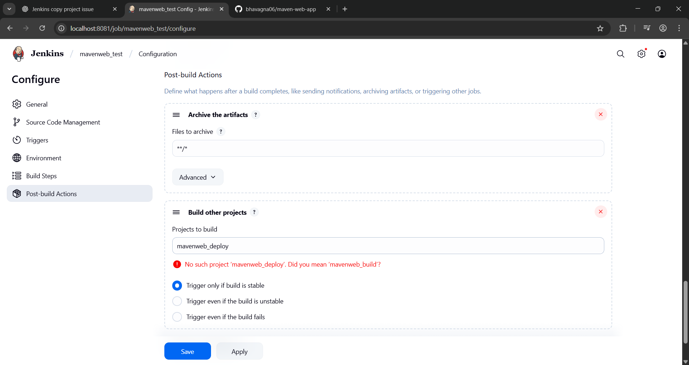
Apply and Save

Step 4: Create Freestyle Project (e.g., MavenWeb_Deploy)
├── Enter project name (e.g., MavenWeb_Deploy)
├── Click "OK"
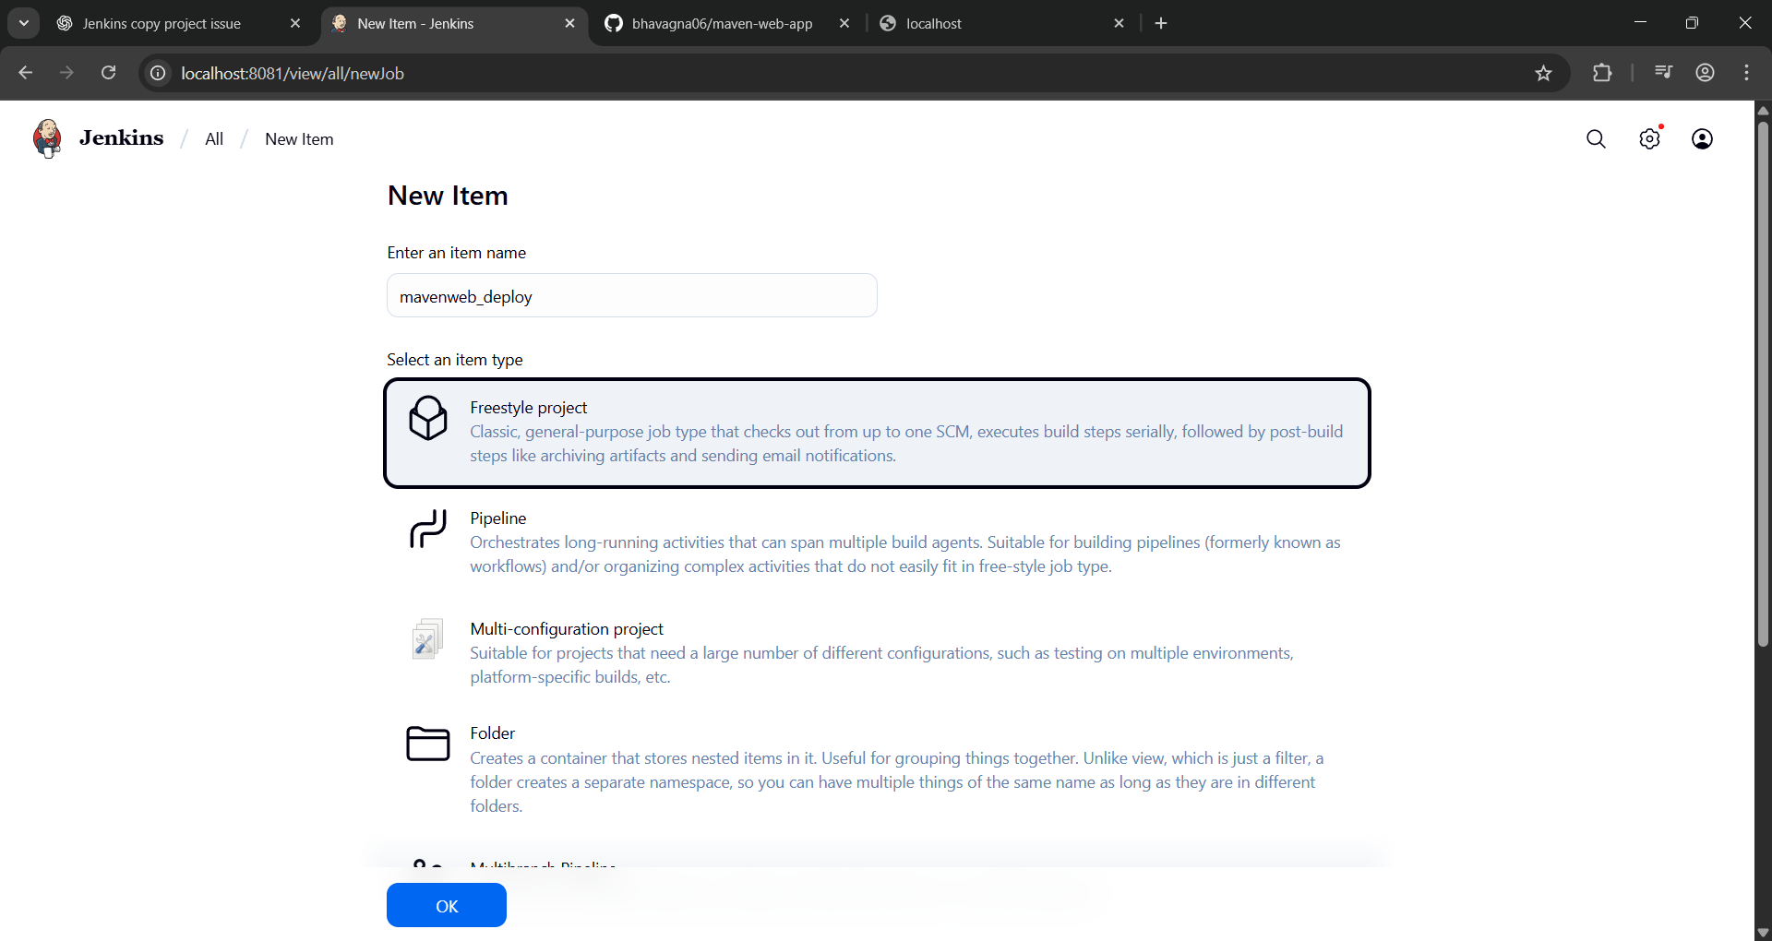
Configure the project:
├── Description: "Web Code Deployment"
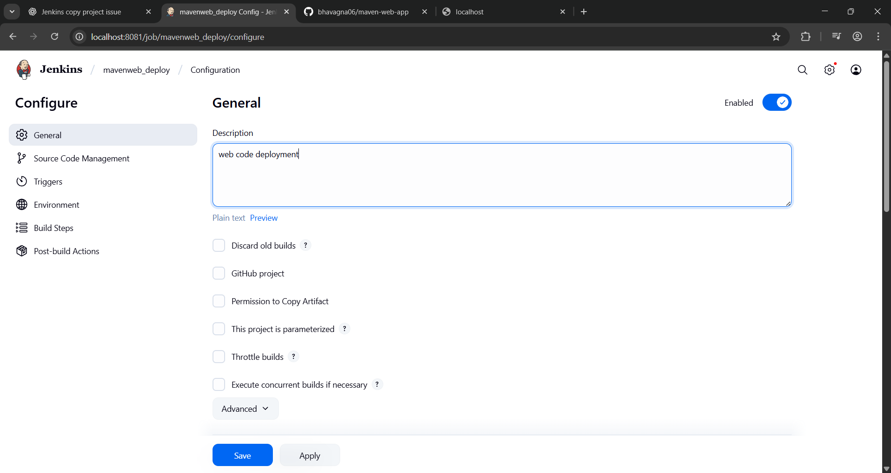
Build Environment:
└── Check: "Delete the workspace before build starts"
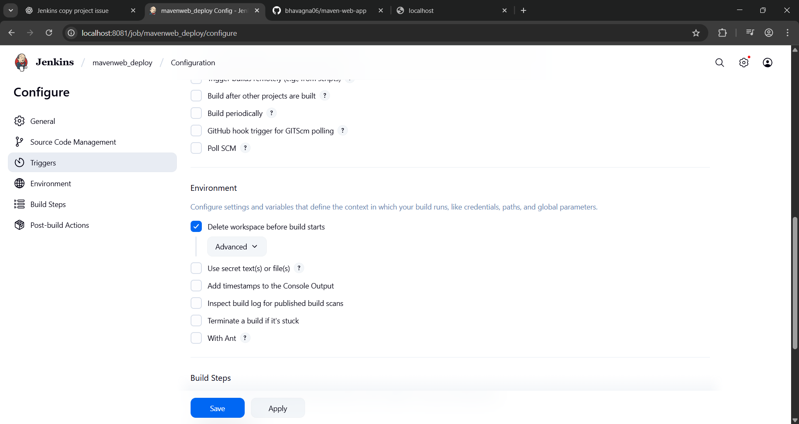
Add Build Step -> "Copy artifacts from another project"
└── Project name: MavenWeb_Test
└── Build: Stable build only
└── Artifacts to copy: **/*
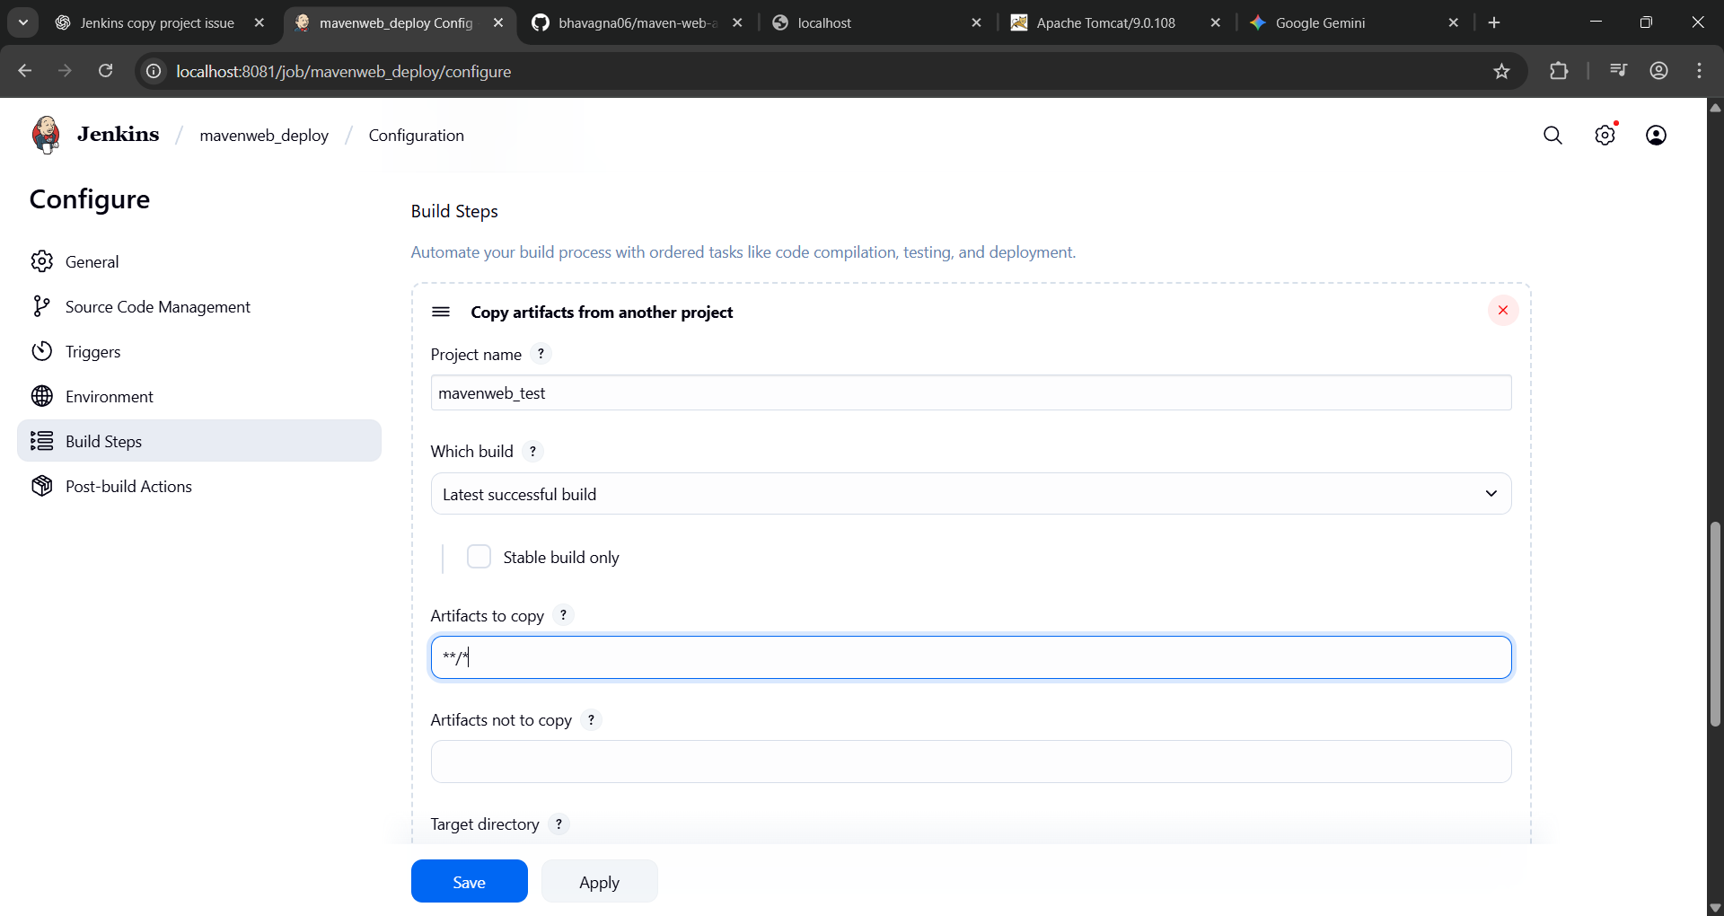
Post-build Actions:
├── Add Post Build Action -> "Deploy WAR/EAR to a container"
└── WAR/EAR File: **/*.war
└── Context path: Webpath
└── Add container -> Tomcat 9.x remote
└── Credentials: Username: admin, Password: 1234
── Tomcat URL: https://localhost:8080/
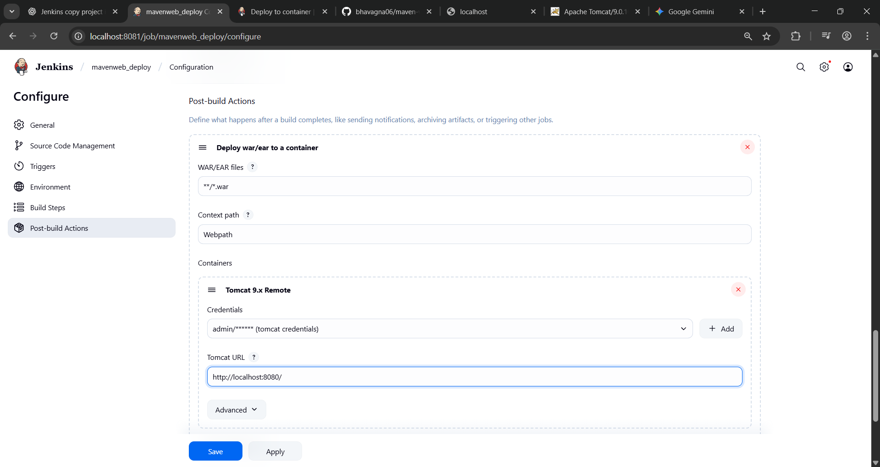

└── Apply and Save

└── Step 5: Create Pipeline View for MavenWeb
├── Click "+" beside "All" on the dashboard
├── Enter name: MavenWeb_Pipeline
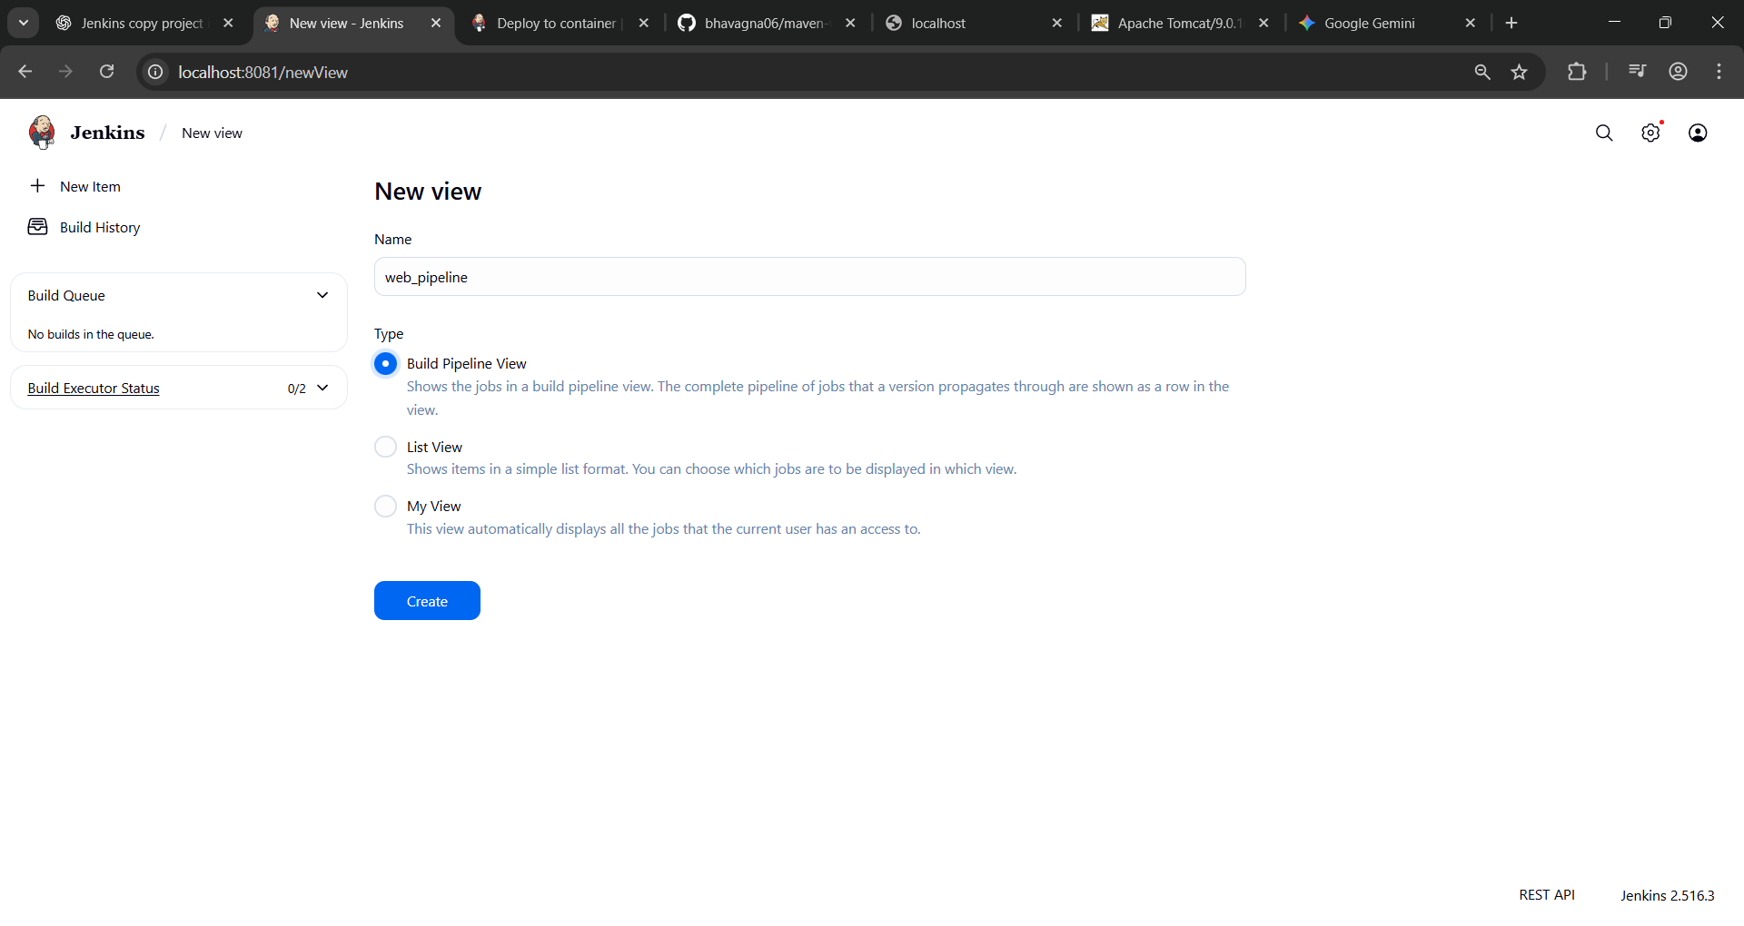
Select "Build pipeline view"
└── Pipeline Flow:
├── Layout: Based on upstream/downstream relationship
├── Initial job: MavenWeb_Build
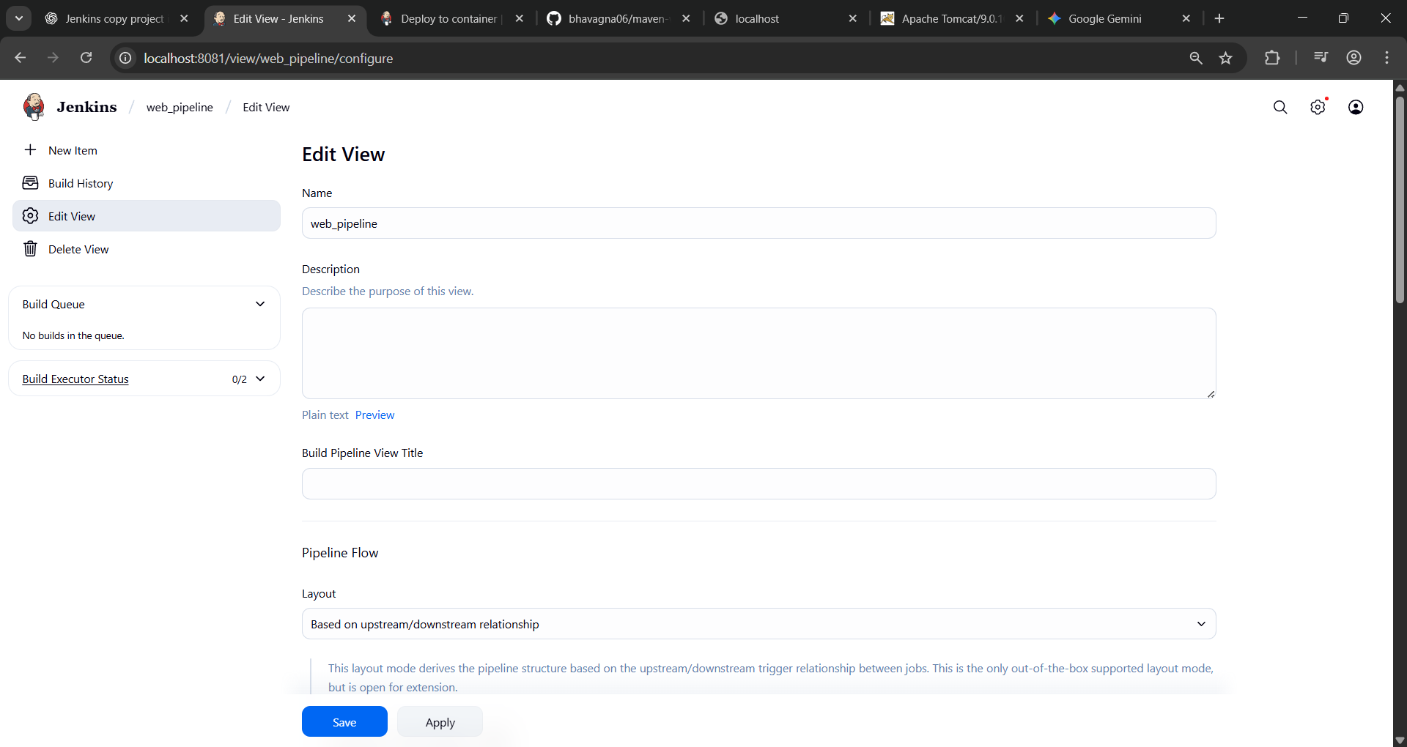
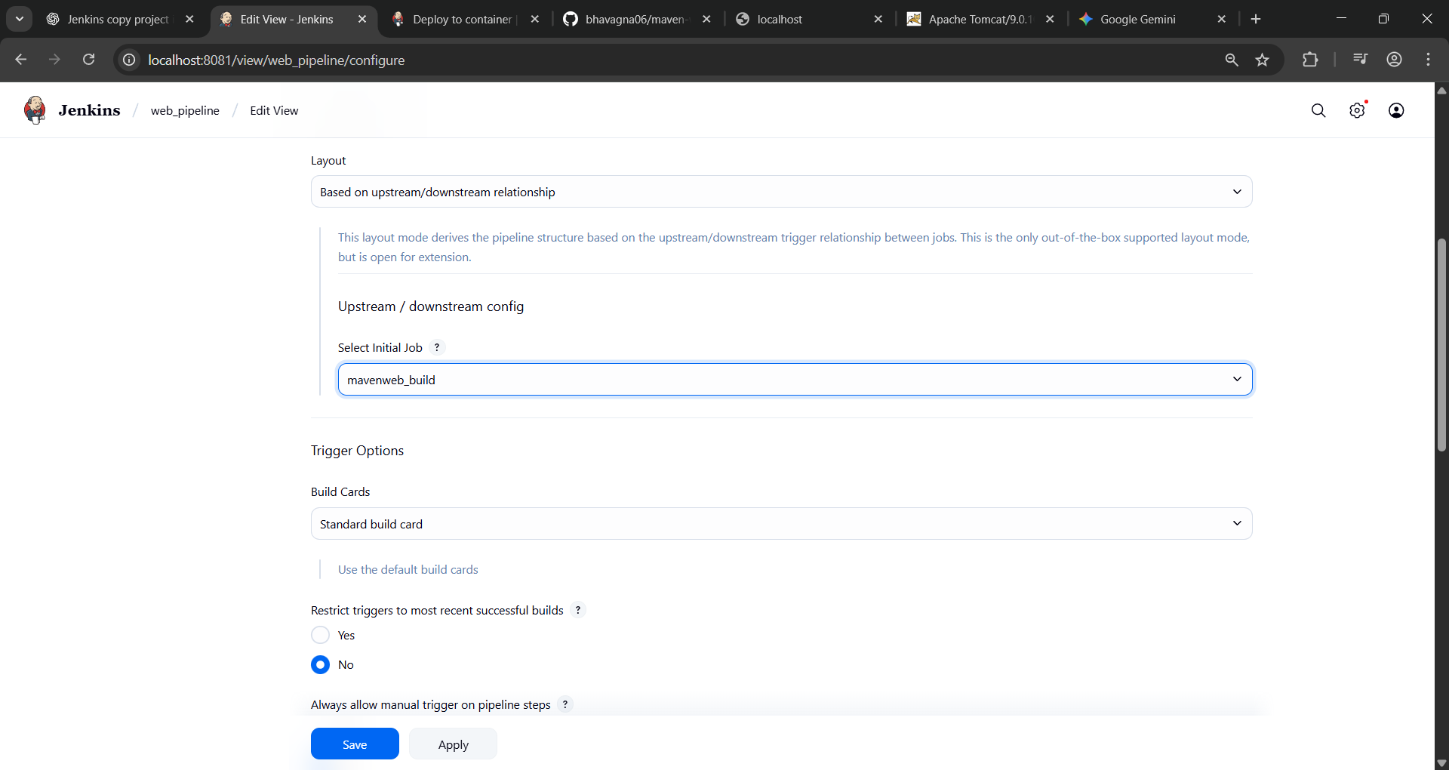
└── Apply and Save

└── Step 6: Run the Pipeline and Check Output
├── Click on the trigger “RUN” to run the pipeline
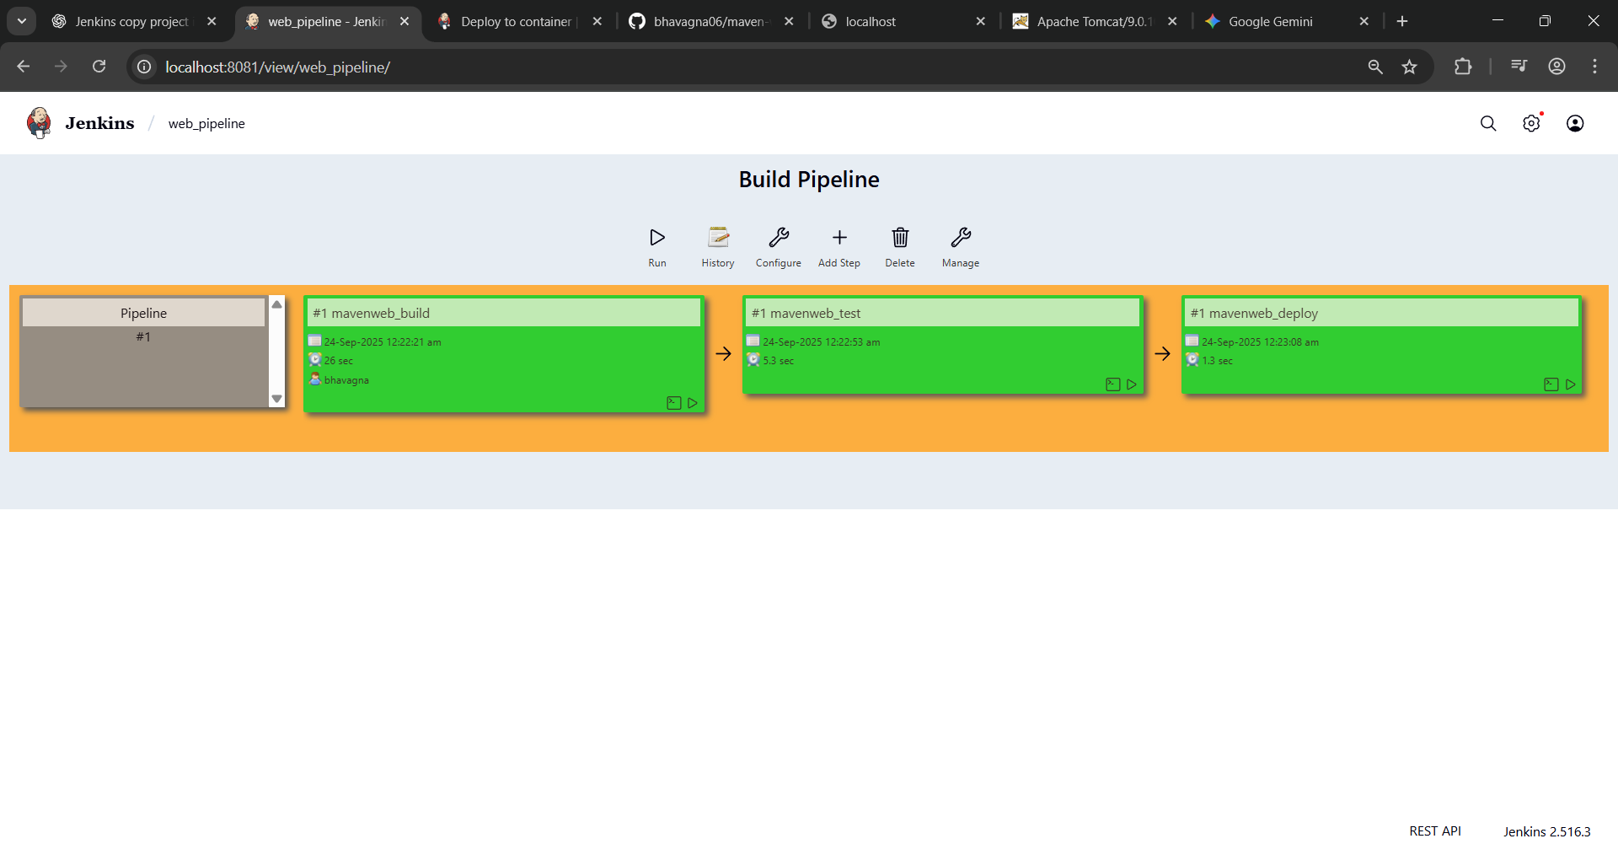
Note:
- After Click on Run -> click on the small black box to open the console to check if the build is success
- Now we see all the build has success if it appears in green color
├── Open Tomcat homepage in another tab
├── Click on the "/webpath" option under the manager app
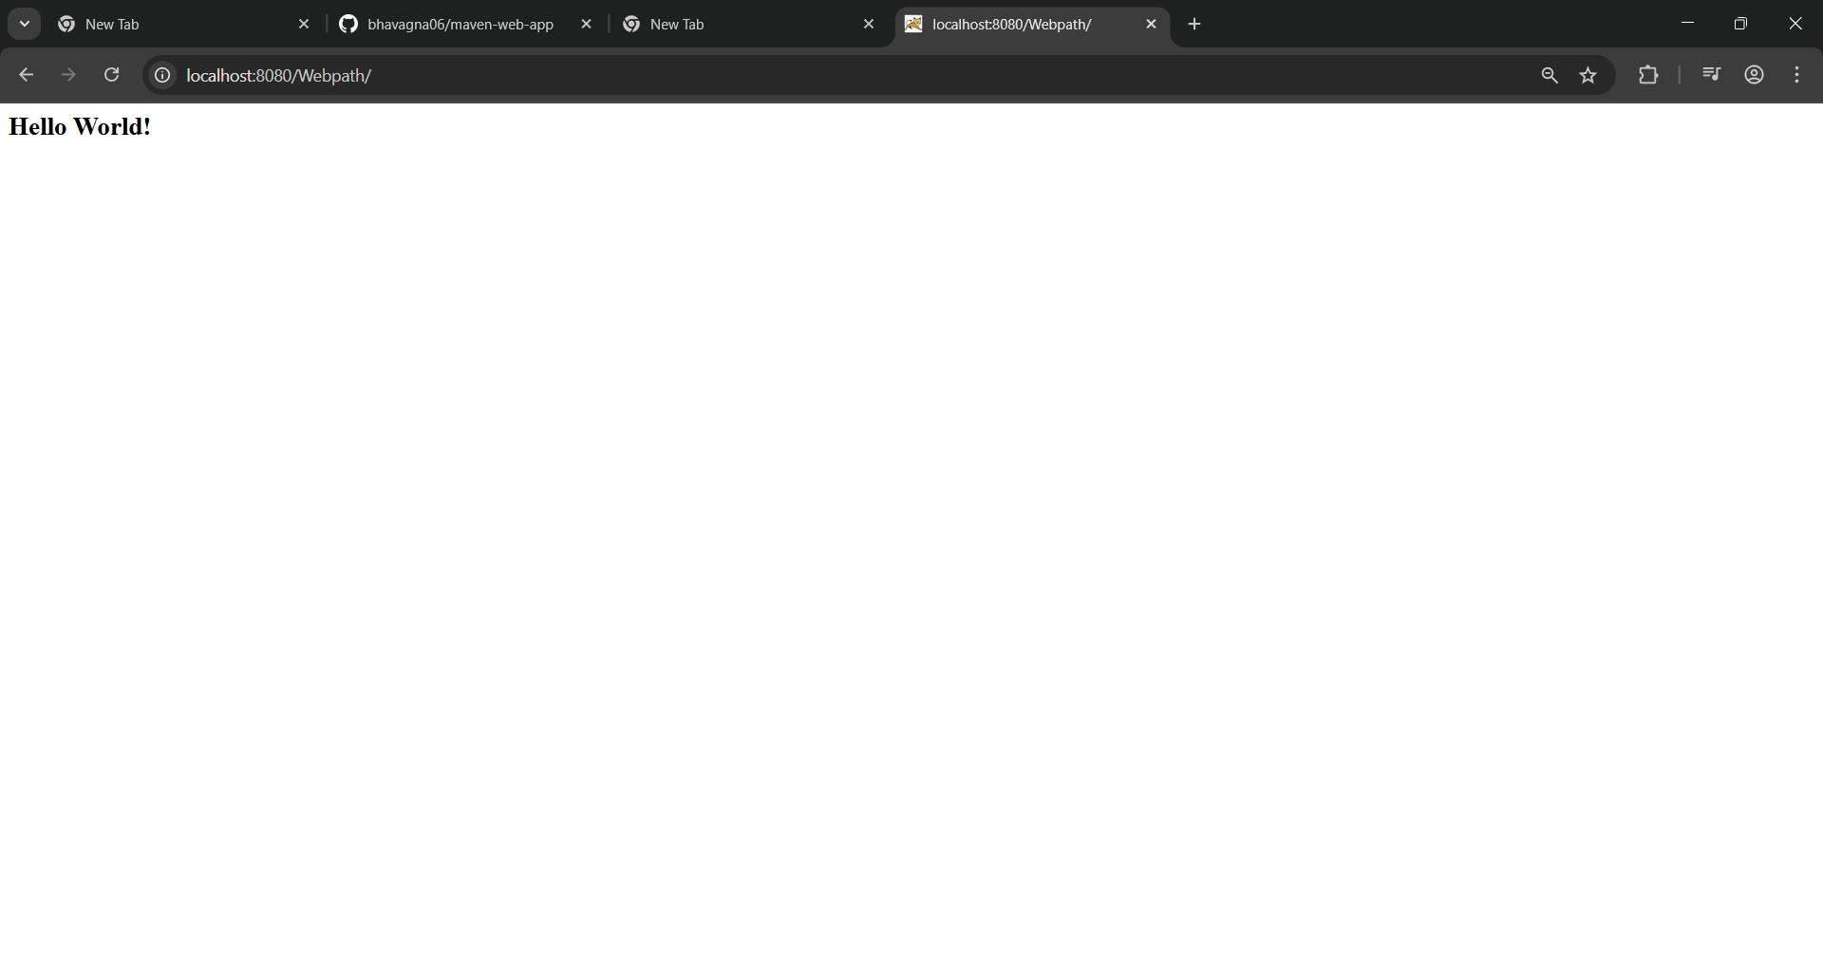
- Questions on Jenkins
- What is Jenkins primarily used for?
Jenkins is used for continuous integration (CI) and continuous deployment/Delivery (CD).
- What is feature of Jenkins?
pipeline support, extensibility
- What is the default port on which Jenkins runs?
8080
- What can be integrated with Jenkins for version control?
Git
- What is the purpose of Jenkins plugins?
Plugins help in functionality like scm, email and tools
- Which type of Jenkins job is best suited for running one-off tasks or small scripts?
Freestyle project
- How can you manage sensitive information such as API keys in Jenkins?
It is stored in Jenkins credentials plugin
- What does the "blue ocean" feature in Jenkins refer to?
Blue Ocean is a modern UI for Jenkins ,improves usability and user-friendly
- What does the "blue ocean" feature in Jenkins refer to?
Blue Ocean is a modern UI for Jenkins ,improves usability and user-friendly
- Which Jenkins component allows for distributed builds across multiple machines?
It uses Master-Agent Architecture
- List at least five Jenkins plugins that you would consider important for a microservices-based application CI/CD pipeline. Briefly explain the purpose of each plugin.
Git Plugin → Integrates Git repositories for version control.Pipeline Plugin → Allows defining CI/CD pipelines using Groovy (Jenkinsfile).Docker Plugin → Builds, runs, and manages Docker containers for microservices
- Explain the steps you would take to install a plugin in Jenkins through the Jenkins UI. What considerations would you keep in mind regarding plugin compatibility and updates?
In Manage Plugins we can search for plugin and install
- Explain the steps you would take to install a plugin in Jenkins through the Jenkins UI. What considerations would you keep in mind regarding plugin compatibility and updates?
Dashboard ->Manage Jenkins->Manage plugin ->install
- After installing a plugin, explain how you would configure it within Jenkins. For example, if you installed the Git Plugin, what steps would you take to set it up for your pipeline?
After installation configure it with global tools and add credentials and it in pipeline
- Discuss common issues that might arise when using Jenkins plugins, such as dependency conflicts or version compatibility problems. How would you troubleshoot these issues?
Version compatibility, Dependency conflict

