TWO PLAYER COIN GAME

A
Mini Project Report

Submitted in partial fulfilment of the
Requirements for the award of the Degree of
BACHELOR OF ENGINEERING
IN
COMPUTER SCIENCE & ENGINEERING
By
G.Saipriya
1602-19-733-095
P.Vaishnavi Reddy
1602-19-733-114

Department of Computer Science & Engineering
Vasavi College of Engineering (Autonomous)
(Affiliated to Osmania University)
Ibrahimbagh, Hyderabad-31
2019
Vasavi College of Engineering (Autonomous)
(Affiliated to Osmania University)
Hyderabad-500 031
Department of Computer Science & Engineering
DECLARATION BY THE CANDIDATE
I, G.Saipriya, bearing hall ticket number, 1602-19-733-095, hereby declare that the project report entitled “Two Player Coin Game” Department of Computer Science & Engineering, VCE, Hyderabad, is submitted in partial fulfilment of the requirement for the award of the degree of Bachelor of Engineering in Computer Science & Engineering.
This is a record of bonafide work carried out by me and the results embodied in this project report have not been submitted to any other university or institute for the award of any other degree or diploma.
G.Saipriya,
1602-19-733-095.

Vasavi College of Engineering (Autonomous)
(Affiliated to Osmania University)
Hyderabad-500 031
Department of Computer Science & Engineering
BONAFIDE CERTIFICATE
This is to certify that the project entitled “Two Player Coin Game” being submitted by G.SaiPriya, bearing 1602-19-733-095, in partial fulfilment of the requirements for the award of the degree of Bachelor of Engineering in Computer Science & Engineering is a record of bonafide work carried out by him/her under my guidance.

Dr. Nagaratna P Hegde
Professor
Dept. of CSE,

ACKNOWLEDGEMENT

I would like to express our heartfelt gratitude to Smt. V.Sireesha, our project guide, for her valuable guidance and constant support, along with her capable instruction and persistent encouragement.

I am grateful to our Head of Department, Dr. T. Adilakshmi, for her steady support and the provision of every resource required for the completion of this project.

I would like to take this opportunity to thank our Principal, Dr. S. V. RAMANA, as well as the management of the institute, for having designed an excellent learning atmosphere.

ABSTRACT
There is an array of coins with different worth. Two players playing this game can pick a coin from either of the left or right end. The player with maximum sum will win. Both players are optimally playing the game. If player one wins the game print PLAYER 1 WINS else if player 2 wins print PLAYER 2 WINS if they both have equal sum at the end, print DRAW.
To solve this problem, we will use Dynamic programming so that optimal solution is achieved.

TABLE OF CONTENTS
1) Introduction-01
2) System Analysis/overview of proposed system-02
3) System Design- 03
4) Pseudo Algorithm/Implementation -04
5) Results-21
6) Testing-23
8) conclusion and future work-24
9) References-25

LIST OF FIGURES

Figure 1: Results
Figure 2: Testing

INTRODUCTION
Dynamic programming
Dynamic Programming is mainly an optimization over plain recursion. Wherever we see a recursive solution that has repeated calls for same inputs, we can optimize it using Dynamic Programming. The idea is to simply store the results of subproblems, so that we do not have to re-compute them when needed later. This simple optimization reduces time complexities from exponential to polynomial. For example, if we write simple recursive solution for Fibonacci Numbers, we get exponential time complexity and if we optimize it by storing solutions of subproblems, time complexity reduces to linear
- The problem should be able to be divided into smaller overlapping sub-problem.
- An optimum solution can be achieved by using an optimum solution of smaller sub-problems.
- Dynamic algorithms use Memoization.

SYSTEM ANALYSIS
In this approach, first we find Count the sum of all coins that are odd-numbered. (Let the odd-numbered coins be X)
Count the sum of all coins that are even-numbered. (Let the even-numbered coins be Y)
If X > Y, take the left-most coin first. Choose all odd-numbered coins in subsequent moves.
If X < Y, take the right-most coin first. Choose all even-numbered coins in subsequent moves.
If X == Y, you will guarantee to get a tie if you stick with taking only even-numbered/odd-numbered coins

SYSTEM DESIGN
Following is the recursive solution that is based on the above two choices. We take a maximum of two choices.

F(i, j) represents the maximum value the user
can collect from i'th coin to j'th coin.

F(i, j) = Max(Vi + min(F(i+2, j), F(i+1, j-1) ),
Vj + min(F(i+1, j-1), F(i, j-2) ))
As user wants to maximise the number of coins.

Base Cases
F(i, j) = Vi If j == i
F(i, j) = max(Vi, Vj) If j == i + 1

The above relation exhibits overlapping sub-problems. In the above relation, F(i+1, j-1) is calculated twice.

PSEUDO ALGORITHM/IMPLEMENTATION
Algorithm:
- To design an optimal strategy, we apply the dynamic programming technique. In this case, since player1 and player2 can remove coins from either end of the line, to define subproblems is in terms of a range of indices for the coins, assuming they are initially numbered from 1 to n.
- Thus, let us define the following indexed parameter: Mi,j = the maximum value of coins taken by player1, for coins numbered i to j, assuming player2 plays optimally.
- Therefore, the optimal value for player1 is determined by M1,n. Let us assume that the values of the coins are stored in an array, V , so that coin 1 is of Value V [1], coin 2 is of Value V [2], and so on.
- To determine a recursive definition for Mi,j , we note that, given the line of coins from coin i to coin j, the choice for player1 at this point is either to take coin i or coin j and thereby gain a coin of value V [i] or V [j].
- Once that choice is made, play turns to player2, who we are assuming is playing optimally. Thus, he will make the choice among his possibilities that minimizes the total amount that player1 can get from the coins that remain.
- In other words, player1 must choose based on the following reasoning: • If j = i + 1, then she should pick the larger of V [i] and V [j], and the game is over.
- • Otherwise, if player1 looses coin i, then she gets a total value of min{Mi+1,j−1, Mi+2,j} + V [i].
- Otherwise, if player1 chooses coin j, then she gets a total value of min{Mi,j−2, Mi+1,j−1} + V [j]. Since these are all the choices that player2 has, and she is trying to maximize her returns, then we get the following recurrence equation, for j > i+1, where j−i+1 is even: Mi,j = max {min{Mi+1,j−1, Mi+2,j} + V [i], min{Mi,j−2, Mi+1,j−1} + V [j]} . In addition, for i = 1, 2, . . . , n − 1, we have the initial condition Mi,i+1 = max{V [i], V [i + 1]}.
- We can compute the Mi,j values, then, using memoization, by starting with the definitions for the above initial conditions and then computing all the Mi,j ’s where j − i + 1 is 4, then for all such values where j − i + 1 is 6, and so on.
- Since there are O(n) iterations in this algorithm and each iteration runs in O(n) time, the total time for this algorithm is O(n 2 ). Of course, this algorithm simply computes all the relevant Mi,j values, including the final value, M1,n.
- To recover the actual game strategy for player1 (and player2), we simply need to note for each Mi,j whether player1 should choose coin i or coin j, which we can determine from the definition of Mi,j . And given this choice, we then know the optimal choice for player2, and that determines if the next choice for player1 is based on Mi+2,j , Mi+1,j−1, or Mi,j−2.

Below is the implementation of the above algorithm.

Code:
#include<stdio.h>
#include<stdbool.h>
#include<ctype.h>
#include<stdlib.h>
#include<string.h>
#include<string.h>
struct players
{
char First_Name[20];
char Last_Name[20];
char Gender;
char Email;
char nickname[20];
};
struct players p1,p2;
int max(int x, int y)
{
int max=0;
if(x>y)
{ max=x;}
else {max=y;}
return max;
}
int min(int x,int y)
{
int min=0;
if(x<y){
min=x;
}
else {
min=y;
}
}
void Welcomescreen(void)
{
printf("\n\n\n\n\t\t\t##############################");
printf("\n\t\t\t #########******** Welcome To ************#######\t\t");
printf("\n\n\n\t\t ////////**** TWO COIN GAME ****//// ");
printf("\n\n\n\t\t$$$$$ GO $$$$\t\t");
printf("\n\n\n\n\n\t\t\t ######## let's play #######");
printf("\n\t\t\tenter any key to continue");
getchar();
system("clear");
}
void title(void)
{
printf("\n\n\n\n\n\t\t\t ######## enter details to signup #######");
printf("\n\n\n\t\t\n*********enter to go*******");
getchar();
system("clear");
}
void signup(void)
{
int b,valid,L=0;
A:
printf("\n\n\n enter first_name");
//scanf("%s",p1.First_name);
scanf("%s",p1.First_Name);

if(strlen(p1.First_Name)>20||strlen(p1.First_Name)<2)
{
printf("\n\t Invalid :( \t The max range for first name is 20 and min range is 2 :)");
goto A;
}
else
{
for (b=0;b<strlen(p1.First_Name);b++)
{
if (isalpha(p1.First_Name[b]))
{
valid=1;
}
else
{
valid=0;
break;
}
if(!valid)
{
printf("\n\t\t First name contain Invalid character :( Enter again :)");
goto A;
}
}
}
B:
printf("\n\t\t\tLast Name: ");
scanf("%s",p1.Last_Name);

if(strlen(p1.Last_Name)>20||strlen(p1.Last_Name)<2)
{
printf("\n\t Invalid :( \t The max range for last name is 20 and min range is 2 :)");
goto B;
}
else
{
for (b=0;b<strlen(p1.Last_Name);b++)
{
if (isalpha(p1.Last_Name[b]))
{
valid=1;
}
else
{
valid=0;
break;
}
}
if(!valid)
{
printf("\n\t\t Last name contain Invalid character :( Enter again :)");
goto B;
}
}

getchar();
system("clear");

}
/* else
{
printf("\n\t\tInvalid Input\n");
goto sd;
}
*/

int main(void)

{
Welcomescreen();
title();
signup();

int n;
printf("start the game enter number of coins");
scanf("%d",&n);

int a[n];

for(int i=0;i<n;i++)

scanf("%d",&a[i]);
char s1[20],s2[20];
printf("enter player1 name");
scanf("%s",s1);
printf("enter player2 name");
scanf("%s",s2);

int table[n][n];

for(int i=0;i<n;i++)

{

table[i][i]=a[i];

if(i != n-1)

table[i][i+1]=max(a[i],a[i+1]);

}

int x,y,z,r,c;

bool flag = true;

for(int i=2;i<n;i++)

{

for(int j=0;j+i<n;j++)

{

r=j;

c=j+i;

x=table[r+2][c];

y=table[r+1][c-1];

z=table[r][c-2];

if(r == 0 && c == n-1)

{

if(max(a[r]+min(x,y),a[c]+min(y,z)) == a[r]+min(x,y))

flag=true;

else

flag= false;

}

table[r][c]=max(a[r]+min(x,y),a[c]+min(y,z));

}

}

int player1,player2;

printf("%d\n",table[0][n-1]);;

if(flag)

printf("%d\n",table[1][n-1]);

else

printf("%d\n",table[0][n-2]);

player1=table[0][n-1];

player2=(flag)?table[1][n-1]:table[0][n-2];

if(player1 > player2)

printf("\n%s 1 WINS",s1);

else if(player2 > player1)

printf("\n%s WINS",s2);

else

printf("DRAW");

}

RESULT

TESTING
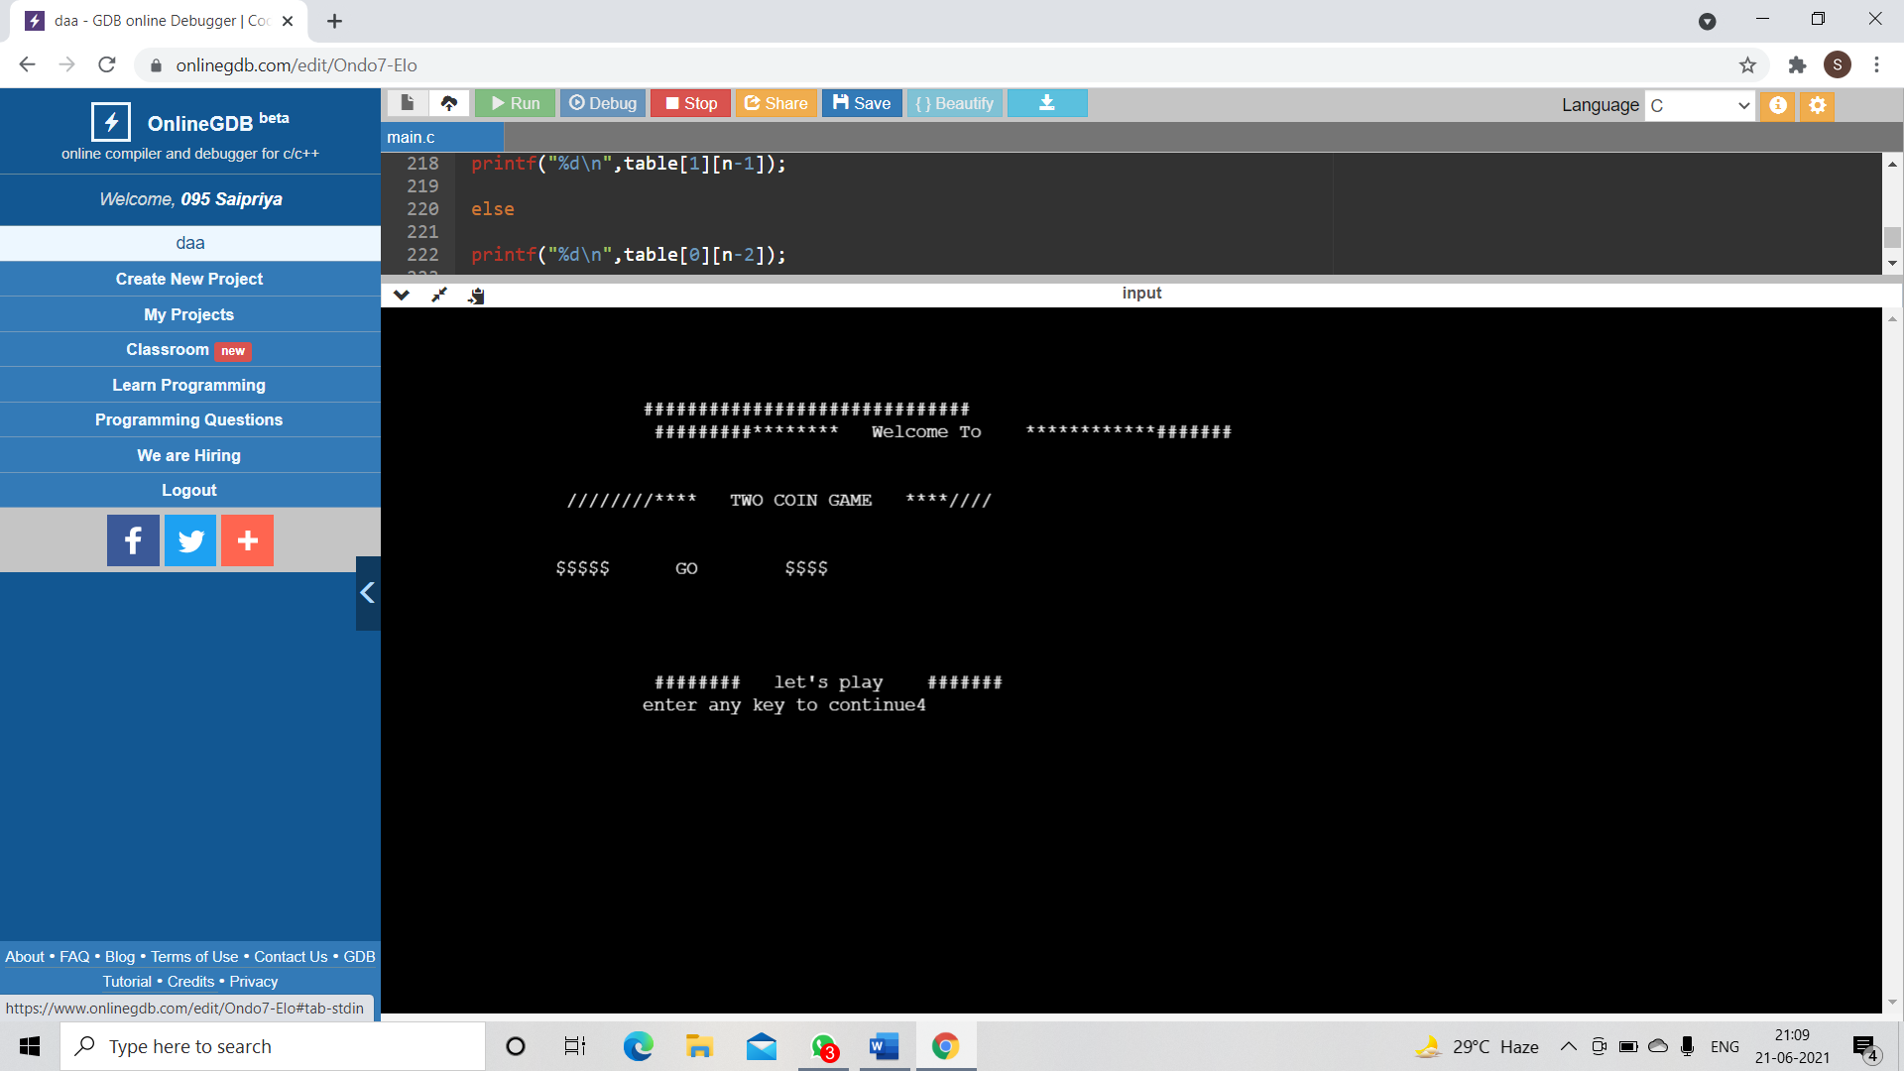

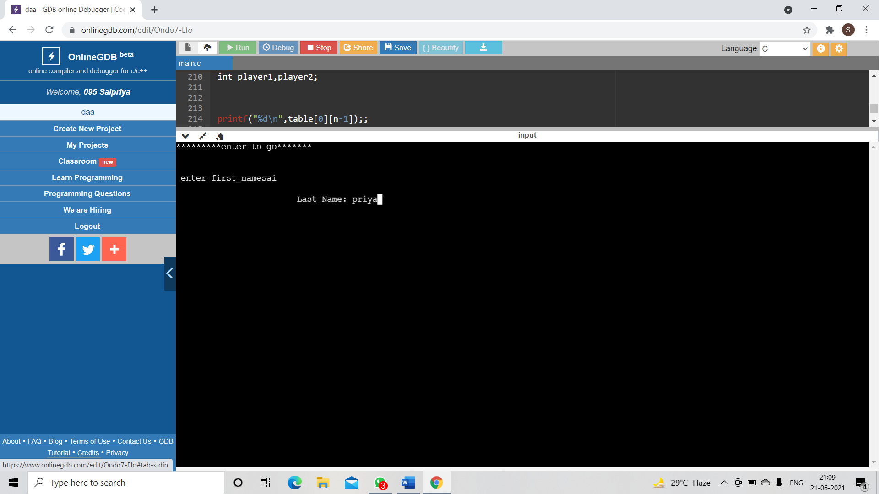

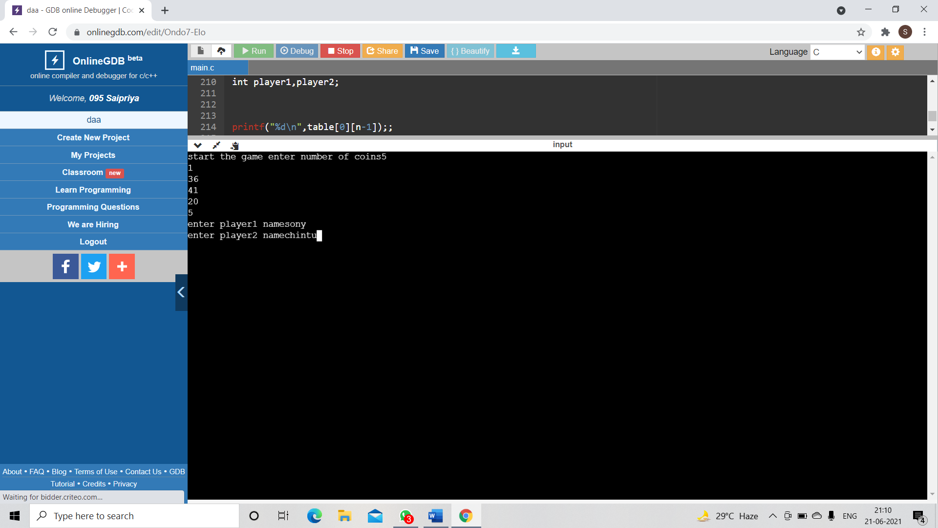
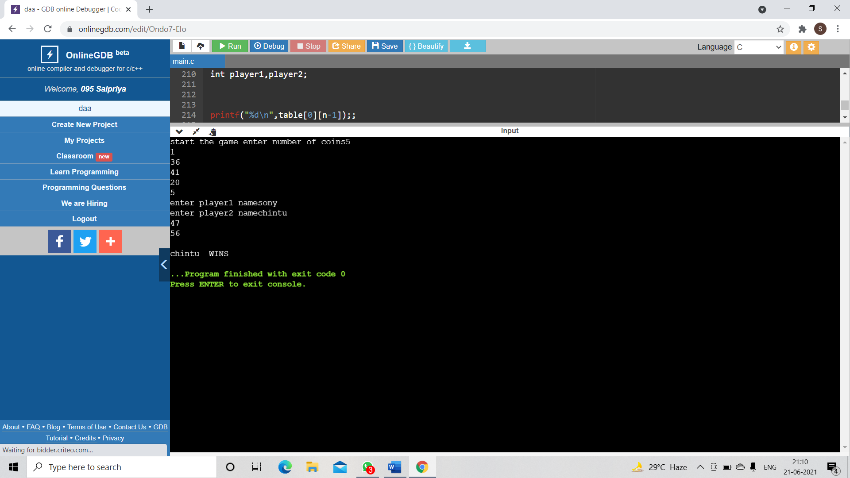
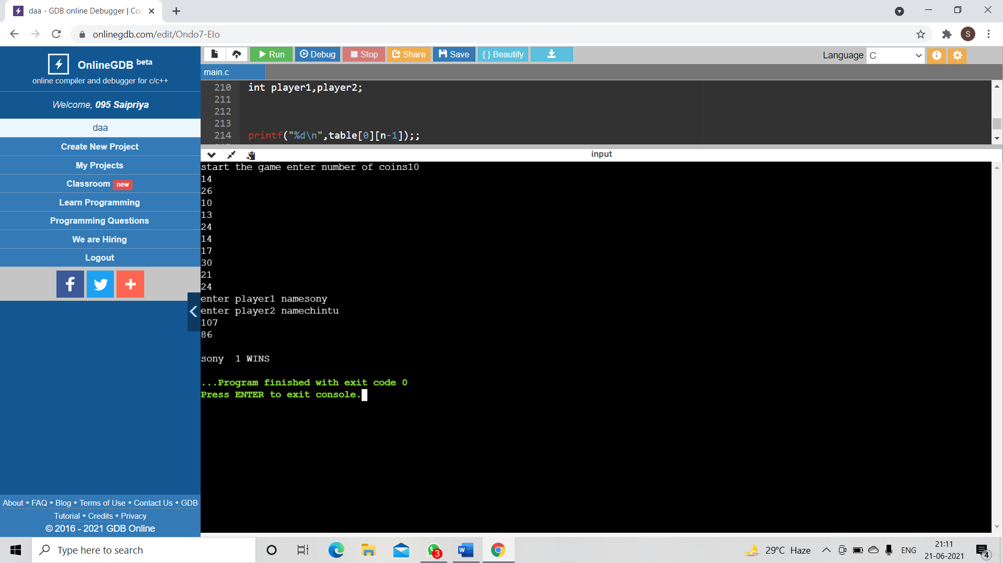
CONCLUSION AND FUTURE WORK
Since there are O(n) iterations in this algorithm and each iteration runs in O(n) time, the total time for this algorithm is O(n 2 ).

We would like to add few more things to our project like multiple
number of players having access to win optimally. We are working on
adding these aspects to our project .

REFERENCES

