The first part of the game is the landing page (index.html). It contains the title of the game and a short description, along with 2 buttons (Start and Help). When the player press the Start button, he/she will be redirected to the form page to fill up their username and email that will be used to claim their prize (for top 3 players with highest score). When the player press the Help button, a popup about the game story and brief gameplay guide will show up. This gives the player an idea about the game before they start playing.

The second part of the game is the form page (form.html). Players that have pressed the Start button will be redirected to this page to enter their username and email for prize claiming if they are the top 3 highest scoring players. The player will not be redirected to the game page if the username or email already existed in the database or if both the fields are left empty. The player will be redirected only if they enter a valid username-email pair that exists in the database or an entirely new username-email pair that does not exist in the database. There will also be input validation so that the correct information can be sent to the database.

The third part is the loading page (loading.html). It has lottie implementation together with a randomly generated joke using API to entertain the player while the game redirects the player to the game page.

The fourth part of the game is the game page (game.html). This page consists of 2 parts, the first part being the player score and remaining time, and the second part being the 3x3 game grid. Whenever the player hits a childhood snack, there will be a sound effect played and the player's score will increase by 10 per childhood snack hit. As for the fast food, it will be game over for the player even if one is hit. The alternative way to game over is to survive until the timer runs out. When a game is over, an alert will pop up. Players are to acknowledge the alert before the game redirects them to the leaderboard page. Note that every game has random speed set, so this game is a combination of skill and luck. This is to make it a bit more unpredictable, thus making the game a tad more engaging.

The last part of the game is the leaderboard page (leaderboard.html). This page shows the top 10 performers in the game, ranked from the player that scored highest to lowest (limited to 10 players shown). The top 3 players will have their username and score presented in gold, silver and bronze background respectively, while others will have a dark blue background. This is to highlight the top performers and encourage other players to challenge them and break the new high score.

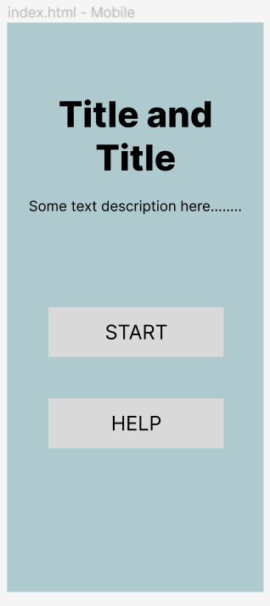

Landing page in mobile view.

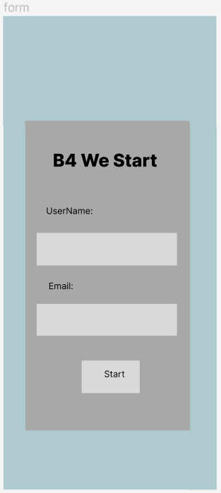

Form page in mobile view.

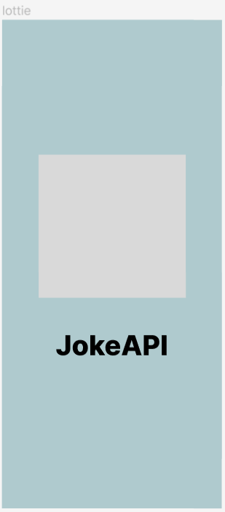

Loading page in mobile view.

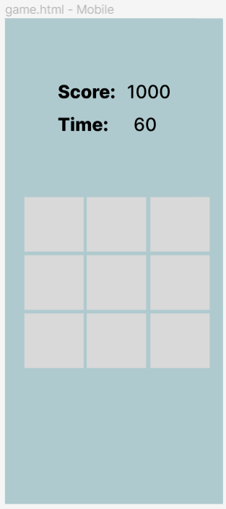

Game page in mobile view.

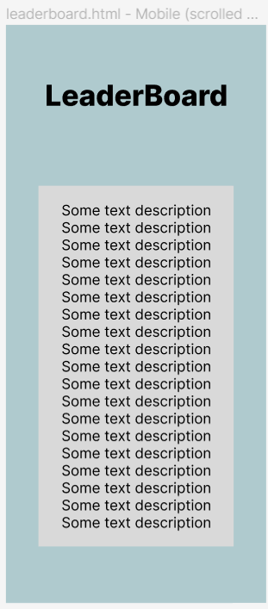

Leaderboard page in mobile view.