Confirmation message was not displayed on changing the Personal details
Before changing the last name:
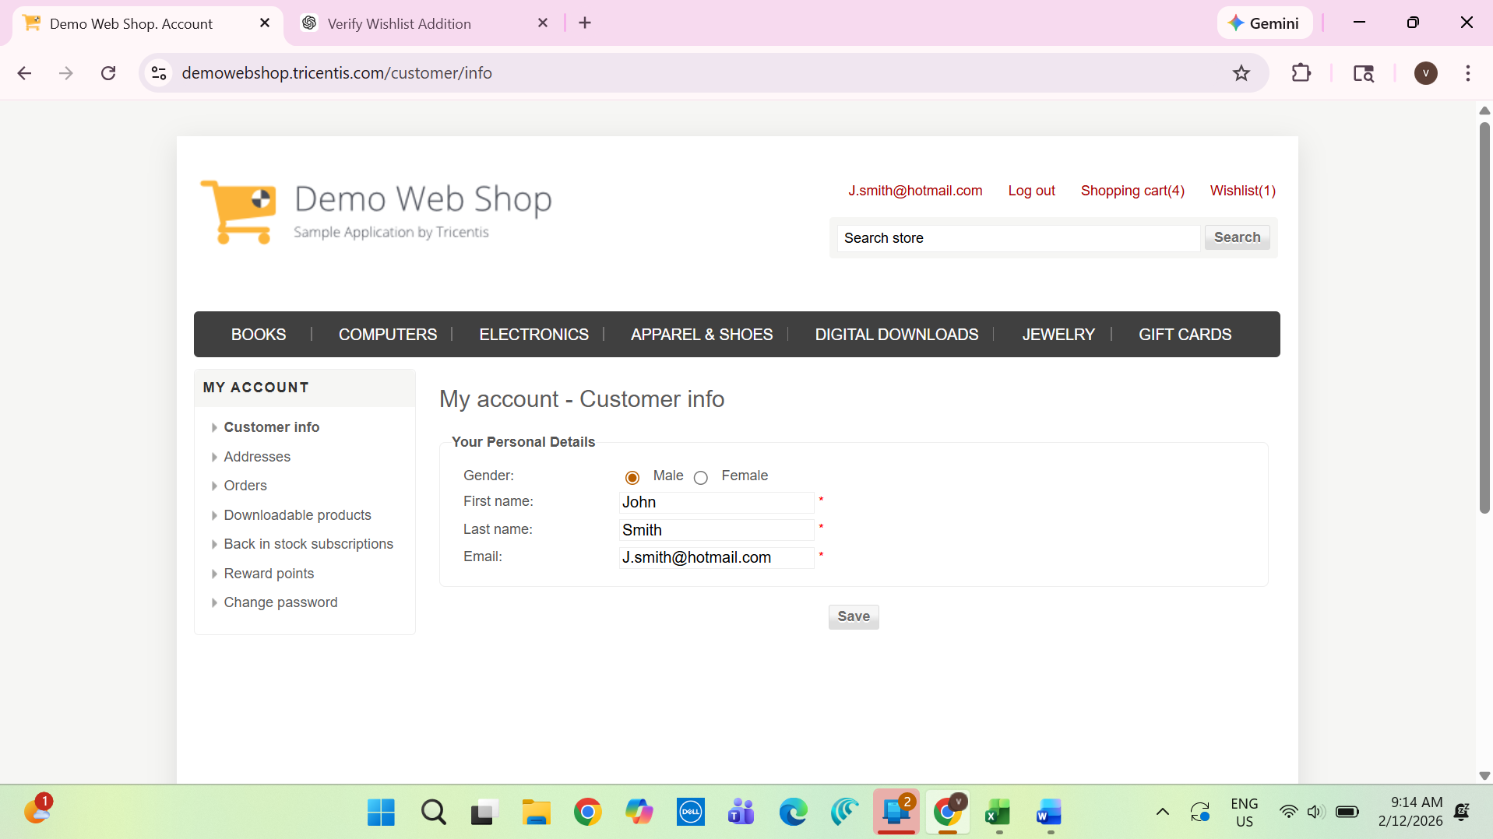
After changing the last name no success message:

