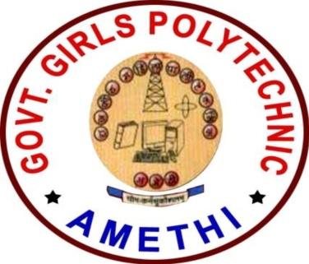
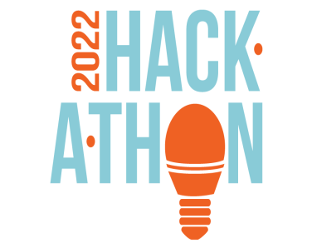
GOVERNMENT GIRLS POLYTECHNIC
AMETHI
INTERNAL HACKATHON (SIH2022)
Date: 6th May, 2022
Jury Panel

Judges :
 |  | 
Principal sir-  Mr. S.K. Singh | Head of Computer Department-  Mr. Md. Aslam | Lecturer-  Mr. C.K. Shukla

Total Number of Team: 2
Total Number of Nominated Top Team:

Participating Team:
Team 1: Rock Coders

S.NO. | MEMBERS | PROBLEM  STATEMENT | THEME
1. | Swadha Mishra | AICTE Event/Activity (Workshops,Talks,  FDP,Meeting etc) management system (DR709) | Smart Education
2. | Shubhi Pandey |  | Smart Education
3. | Shweta Yadav |  | Smart Education
4. | Anshika |  | Smart Education
5. | Saima Sultana |  | Smart Education
6. | Vishakha  Kesharwani |  | Smart Education

Team 2: Genuine Coders

S.NO. | MEMBERS | PROBLEM  STATEMENT | THEME
1. | Shikha Singh | Real time tracking of students learning’s outcomes and their academic progress across schools (OS872) | Smart Education
2. | Saumya Agrahari |  | Smart Education
3. | Ankita Singh |  | Smart Education
4. | Omika Singh |  | Smart Education
5. | Nandini Tiwari |  | Smart Education
6. | Divya Tiwari |  | Smart Education

About The Event :

ABOUT THE EVENT:
A Hackathon , also known as a codefest, is a social coding event that brings computer programmers and other interested people together to improve upon or build a new software program.
The word Hackathon is a portmanteau of the words hacker, which means clever programmer, and marathon, an event marked by endurance.

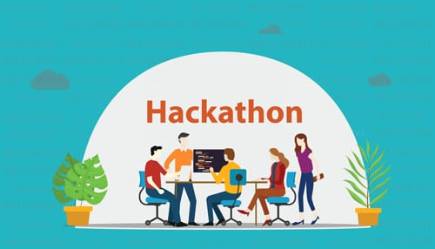

The concept of the Hackathon, also called a Hack Day or hack fest, was born out of the open source community. The first event labeled a Hackathon was the OpenBSD Hackathon in Calgary, Canada, on June 4, 1999.
Today, engineering departments ,especially those at web-based companies, adopt the practice as a way of introducing intrapreneurship into the enterprise.
HOW DO HACKATHON WORKS ?
Hackathons are usually theme- based. An organizer chooses a theme that aligns with its business goals and appeals to the right teams, sponsors, and partners. After that, they :
- Set up judging criteria and pick a Hackathon jury.
- Decide on a prizes.
- Pick a right venue.
- Arrange food and drinks if the Hackathon event is offline.
- Set up equipment for offline events and arrange the necessary software.
TYPES OF HACKATHON:
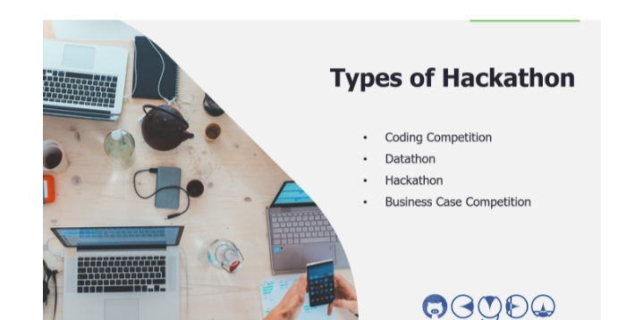
- Coding competition: Hackathon, by looking at this word which is “Hack” plus “Marathon”, you can immediately link it with intensive coding competitions.
- Datathon: Datathon is a subset of coding competition, it also has online and offline version, why I put it in another category is that kind of competition has one focus which is told by the name, Data.
- Hackathon: Most of the common competitions named Hackathon are less technology-driven, or I would say they have a weighting of bussiness element in the judging criteria.
4.Bussiness case competition: Sometimes, you can find business case competitions also use the name, Hackathon, as the organiser may want to include more technology components. If you see this in the rule, most likely it is a business case competition. If you are a business person and may not know how to do the modelling, you may like this type of competition.
