SPOOLING
Spooling is a process in which data is temporarily held to be used and executed by a device, program, or system. Data is sent to and stored in memory or other volatile storage until the program or computer requests it for execution.
SPOOL is an acronym for simultaneous peripheral operations online. Generally, the spool is maintained on the computer's physical memory, buffers, or the I/O device-specific interrupts. The spool is processed in ascending order, working based on a FIFO (first-in, first-out) algorithm.
Spooling refers to putting data of various I/O jobs in a buffer. This buffer is a special area in memory or hard disk which is accessible to I/O devices. An operating system does the following activities related to the distributed environment:
- Handles I/O device data spooling as devices have different data access rates.
- Maintains the spooling buffer, which provides a waiting station where data can rest while the slower device catches up.
- Maintains parallel computation because of the spooling process as a computer can perform I/O in parallel order. It becomes possible to have the computer read data from a tape, write data to disk, and write out to a tape printer while it is doing its computing task.

How Spooling Works in Operating System
In an operating system, spooling works in the following steps, such as:
- Spooling involves creating a buffer called SPOOL, which is used to hold off jobs and data till the device in which the SPOOL is created is ready to make use and execute that job or operate on the data.
- When a faster device sends data to a slower device to perform some operation, it uses any secondary memory attached as a SPOOL buffer. This data is kept in the SPOOL until the slower device is ready to operate on this data. When the slower device is ready, then the data in the SPOOL is loaded onto the main memory for the required operations.
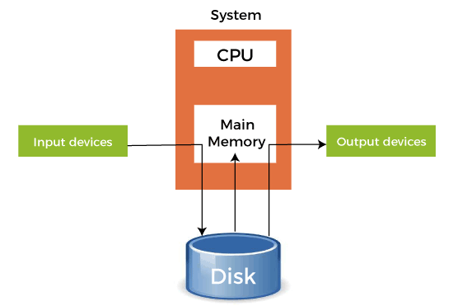
- Spooling considers the entire secondary memory as a huge buffer that can store many jobs and data for many operations. The advantage of Spooling is that it can create a queue of jobs that execute in FIFO order to execute the jobs one by one.
- A device can connect to many input devices, which may require some operation on their data. So, all of these input devices may put their data onto the secondary memory (SPOOL), which can then be executed one by one by the device. This will make sure that the CPU is not idle at any time. So, we can say that Spooling is a combination of buffering and queuing.
- After the CPU generates some output, this output is first saved in the main memory. This output is transferred to the secondary memory from the main memory, and from there, the output is sent to the respective output devices.

- Example of Spooling

The biggest example of Spooling is printing. The documents which are to be printed are stored in the SPOOL and then added to the queue for printing. During this time, many processes can perform their operations and use the CPU without waiting while the printer executes the printing process on the documents one-by-one.
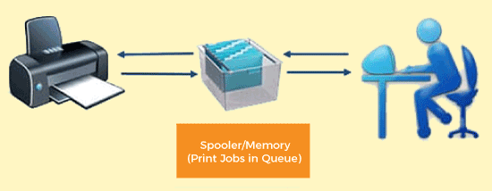

Many features can also be added to the Spooling printing process, like setting priorities or notification when the printing process has been completed or selecting the different types of paper to print on according to the user's choice

- Difference between spooling and buffering
Terms | Spooling | Buffering
Definition | Spooling, an acronym of Simultaneous Peripheral Operation Online (SPOOL), puts data into a temporary working area to be accessed and processed by another program or resource. | Buffering is an act of storing data temporarily in the buffer. It helps in matching the speed of the data stream between the sender and receiver.
Resource requirement | Spooling requires less resource management as different resources manage the process for specific jobs. | Buffering requires more resource management as the same resource manages the process of the same divided job.
Internal implementation | Spooling overlaps the input and output of one job with the computation of another job. | Buffering overlaps the input and output of one job with the computation of the same job.
Efficient | Spooling is more efficient than buffering. | Buffering is less efficient than spooling.
Processor | Spooling can also process data at remote sites. The spooler only has to notify when a process gets completed at the remote site to spool the next process to the remote side device. | Buffering does not support remote processing.
Size on memory | It considers the disk as a huge spool or buffer. | Buffer is a limited area in the main memory.

