SLE-3: Architectural Design (Full C4 Model)
Course: 02AML204 – Introduction to Artificial Intelligence
PRN: 26UAM303
Name: Vaishnavi Satish Patil
Division: A
Date: 11/10/2026

1. System Title & Short Description
Title: Maze Solving System using BFS and DFS Algorithms
Description: This system is designed to find the optimal path from a start point to an end point in a grid-based maze. It utilizes Artificial Intelligence search strategies (Breadth-First Search and Depth-First Search) to analyze the maze structure, track unvisited nodes, and display the final solution path.

2. Context Diagram (Level 1)
Short Explanation: The Level 1 context diagram shows the system as a single central box. The user provides the maze configuration and algorithm choice as input, and the system processes it to return the final path output.
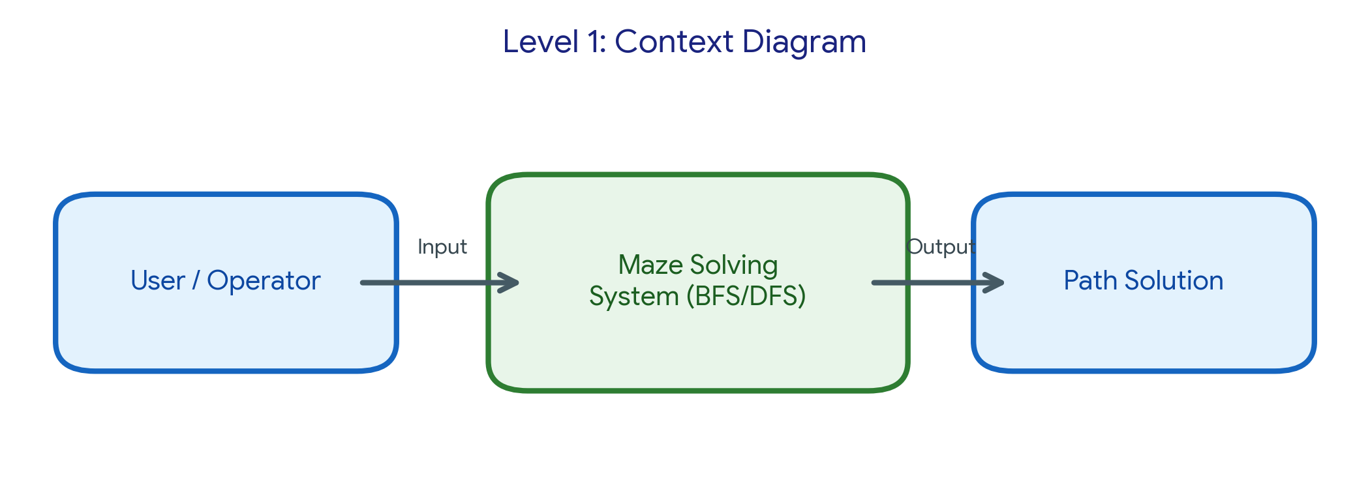

3. Container Diagram (Level 2)
The system is broken down into 5 main containers:
- • Input Module: Accepts the maze configuration, start/goal coordinates, and algorithm choice (BFS/DFS) from the user.
- • Search Engine: Runs the core logic, traversing states according to BFS or DFS rules.
- • Memory / Visited Set: Stores already visited nodes to prevent infinite loops and redundant checks.
- • Path Reconstructor: Traces backward from the goal state once found to construct the final path.
- • Output Module: Displays the final solved path visually or textually.
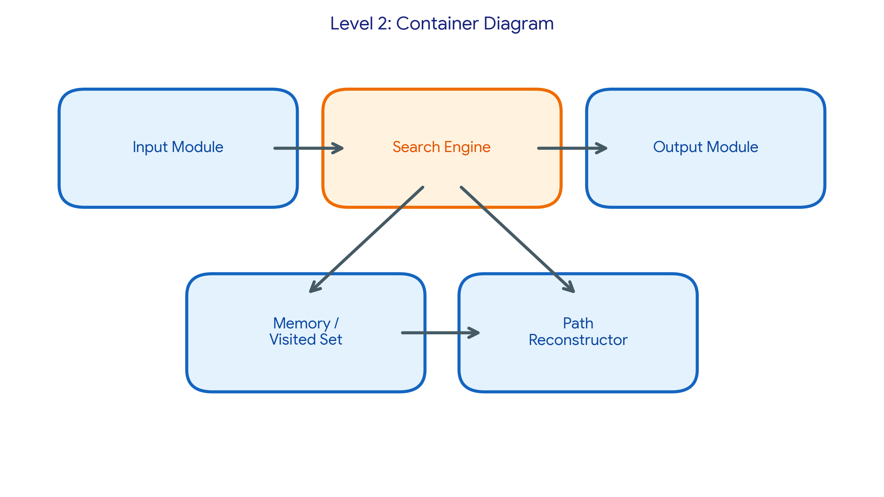

4. Component Diagram (Level 3)
Selected Main Container: Search Engine
Internal Components:
- • Frontier / Open List: Manages the queue (for BFS) or stack (for DFS) of pending nodes to explore.
- • Explored / Closed Set: Stores nodes that have already been fully processed.
- • Goal Test Component: Checks whether the current node matches the target goal state.
- • Node Successor Generator: Generates valid adjacent movements (Up, Down, Left, Right) from the current position.
Short Explanation: Inside the Search Engine container, these components collaborate to manage state expansion and efficient graph traversal.
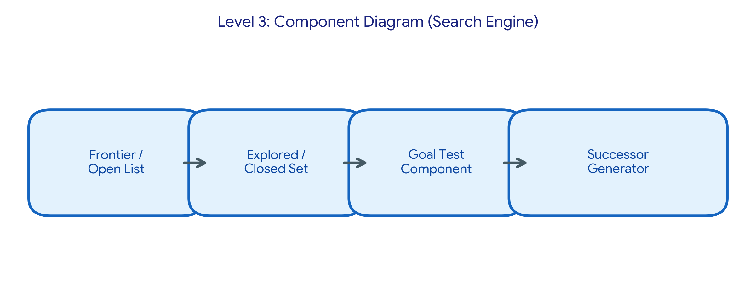

5. Code Level Overview (Level 4)
Main classes and functions:
- • class Node : Stores position, state, parent pointer, and path cost.
- • class MazeProblem : Defines the grid layout, start state, and goal state.
- • def bfs_search() : Implements Breadth-First Search using a queue structure.
- • def dfs_search() : Implements Depth-First Search using a stack structure.
- • def reconstruct_path() : Combines steps from the goal back to the start.

6. Design Decisions
Modularizing the search strategies into separate components (Frontier, Visited Set, Path Reconstructor) improves code readability and maintainability. Using a dedicated visited set avoids redundant checks and speeds up the search process.

7. AI Contribution Note
- • AI tools used: Gemini (For structuring the C4 model guidelines, generating diagrams, and formatting)
- • What AI helped with: Understanding how to structure the four levels of the C4 architectural model and drafting diagrams.
- • What I did myself: System design, defining the BFS/DFS logic structure, and compiling the overall report.

8. Conclusion
Working on this architecture assignment helped clarify how to view software systems from a high-level context down to code-level implementation details. The C4 model effectively organizes complex search algorithm components in a clean and structured manner.

