WEEK 2 ASSIGNMENT
NumPy and Pandas for Data Analytics

Python Fundamentals for Data Analytics
Duration: 1 Week (7 Days)
Total Marks: 100

Student Name | Vaishnavi Sulthan
College Name | IARE
Branch | Data Science

Assignment Objective
This assignment develops practical skills in NumPy and Pandas, two core Python libraries for data analytics. It covers array creation and manipulation, numerical calculations, DataFrame operations, CSV inspection, filtering and sorting, missing-value handling, merging, concatenation, GroupBy summaries, pivot tables, and exporting processed data.

Environment and Dataset
Python 3 with NumPy, Pandas, and Matplotlib is used. The included sales_dataset.csv is a small illustrative dataset created for this assignment. It contains 12 orders across four regions, with a few deliberately missing values for the cleaning task. The figures and numerical findings in this report are based on this dataset.
pip install numpy pandas matplotlib
Run each task from the folder containing sales_dataset.csv. Save each task as the named .py file. Screenshots are included as illustrative output/analysis visuals; before submission, run the scripts in your own environment and add screenshots that show your actual code and terminal/notebook output.

Task 1: NumPy Introduction & Arrays (10 Marks)
Objective: Create one-dimensional and two-dimensional arrays and inspect their properties.

Python file: task1_numpy_arrays.py

Source code
import numpy as np
numbers = np.array([5, 10, 15, 20, 25, 30, 35, 40, 45, 50])
print("One-dimensional array:", numbers)
print("Shape:", numbers.shape)
print("Size:", numbers.size)
print("Data type:", numbers.dtype)
matrix = np.array([[1, 2, 3], [4, 5, 6]])
print("\nTwo-dimensional array:")
print(matrix)
print("2D shape:", matrix.shape)

Explanation
np.array() creates an array. shape reports its dimensions, size reports the number of elements, and dtype identifies the stored data type. The first array contains ten values; the second contains two rows and three columns.

Representative output
One-dimensional array: [ 5 10 15 20 25 30 35 40 45 50]
Shape: (10,)
Size: 10
Data type: int64 # may be int32 on some systems
Two-dimensional array:
[[1 2 3]
[4 5 6]]
2D shape: (2, 3)

Task 2: NumPy Indexing, Slicing & Reshaping (10 Marks)
Objective: Access elements and ranges, select rows and columns, and reshape arrays.

Python file: task2_indexing_reshaping.py

Source code
import numpy as np
arr = np.array([10, 20, 30, 40, 50, 60, 70, 80, 90, 100])
print("Original array:", arr)
print("Element at index 2:", arr[2])
print("Elements from index 2 to 5:", arr[2:6])
matrix = np.array([[1, 2, 3], [4, 5, 6], [7, 8, 9]])
print("\n2D array:")
print(matrix)
print("First row:", matrix[0])
print("Second column:", matrix[:, 1])
print("Element at row 2, column 3:", matrix[1, 2])
reshaped = arr.reshape(2, 5)
print("\nReshaped array (2 rows, 5 columns):")
print(reshaped)
print("Original array remains:", arr)

Explanation
Indexing retrieves a single element, slicing extracts a range, and two-dimensional indexing selects rows or columns. reshape(2, 5) changes the layout while preserving all ten values.

Representative output
Element at index 2: 30
Elements from index 2 to 5: [30 40 50 60]
First row: [1 2 3]
Second column: [2 5 8]
Element at row 2, column 3: 6
Reshaped array:
[[ 10 20 30 40 50]
[ 60 70 80 90 100]]

Task 3: NumPy Mathematical & Statistical Operations (10 Marks)
Objective: Perform arithmetic and statistical calculations on numerical arrays.

Python file: task3_numpy_statistics.py

Source code
import numpy as np
a = np.array([10, 20, 30, 40, 50])
b = np.array([1, 2, 3, 4, 5])
print("Addition:", a + b)
print("Subtraction:", a - b)
print("Multiplication:", a * b)
print("Division:", a / b)
print("Mean:", np.mean(a))
print("Median:", np.median(a))
print("Minimum:", np.min(a))
print("Maximum:", np.max(a))
print("Standard deviation:", round(np.std(a), 2))
print("Sum:", np.sum(a))

Explanation
Arithmetic operations are performed element by element. NumPy's mean, median, min, max, std, and sum functions provide common summaries. np.std() calculates population standard deviation by default.

Representative output
Addition: [11 22 33 44 55]
Subtraction: [ 9 18 27 36 45]
Multiplication: [ 10 40 90 160 250]
Division: [10. 10. 10. 10. 10.]
Mean: 30.0
Median: 30.0
Minimum: 10
Maximum: 50
Standard deviation: 14.14
Sum: 150

Task 4: Pandas Series & DataFrame (10 Marks)
Objective: Create a Series and DataFrame, inspect labels, and add a new column.

Python file: task4_pandas_dataframe.py

Source code
import pandas as pd
scores = pd.Series([82, 91, 76, 88], name="Marks")
print("Pandas Series:")
print(scores)
data = {
"Name": ["Asha", "Ravi", "Meena", "Kiran"],
"Branch": ["CSE", "ECE", "CSE", "IT"],
"Marks": [82, 91, 76, 88]
}
df = pd.DataFrame(data)
print("\nOriginal DataFrame:")
print(df)
print("\nColumn names:", df.columns.tolist())
print("Index:", df.index.tolist())
df["Result"] = df["Marks"].apply(lambda mark: "Pass" if mark >= 40 else "Fail")
print("\nUpdated DataFrame:")
print(df)

Explanation
A Series is a one-dimensional labeled structure; a DataFrame stores tabular data. columns and index expose column and row labels. The Result column is added using a simple rule based on marks.

Representative output
Column names: ['Name', 'Branch', 'Marks']
Index: [0, 1, 2, 3]
Updated DataFrame:
Name Branch Marks Result
0 Asha CSE 82 Pass
1 Ravi ECE 91 Pass
2 Meena CSE 76 Pass
3 Kiran IT 88 Pass

Task 5: Reading & Inspecting Data (10 Marks)
Objective: Load a CSV and inspect its rows, shape, column names, types, and summary statistics.

Python file: task5_read_inspect_csv.py

Source code
import pandas as pd
df = pd.read_csv("sales_dataset.csv")
print("First five rows:")
print(df.head())
print("\nLast five rows:")
print(df.tail())
print("\nRows and columns:", df.shape)
print("\nColumn names:", df.columns.tolist())
print("\nData types:")
print(df.dtypes)
print("\nDataFrame information:")
df.info()
print("\nNumerical summary:")
print(df.describe())

Explanation
read_csv() loads the dataset. head() and tail() preview records; shape returns row and column counts; dtypes shows column types; info() reports non-null counts; describe() summarizes numeric columns.

Representative output
Rows and columns: (12, 9)
Column names: ['OrderID', 'Date', 'Region', 'Product', 'Category',
'Units', 'UnitPrice', 'Salesperson', 'CustomerRating']
Missing values are present in Units and CustomerRating.
Use df.info() and df.describe() for full inspection.

Task 6: Selecting, Filtering & Sorting Data (10 Marks)
Objective: Select fields and records, apply conditions, and sort data.

Python file: task6_filter_sort.py

Source code
import pandas as pd
df = pd.read_csv("sales_dataset.csv")
df["Sales"] = df["Units"] * df["UnitPrice"]
print("Selected columns:")
print(df[["OrderID", "Region", "Product", "Sales"]])
print("\nFirst three rows:")
print(df.iloc[0:3])
print("\nOrders with sales above 300:")
print(df[df["Sales"] > 300])
print("\nNorth region orders with at least 2 units:")
print(df[(df["Region"] == "North") & (df["Units"] >= 2)])
print("\nSales ascending:")
print(df.sort_values("Sales", ascending=True)[["OrderID", "Sales"]])
print("\nSales descending:")
print(df.sort_values("Sales", ascending=False)[["OrderID", "Sales"]])

Explanation
Use a list of column names to select columns and iloc for positional rows. Boolean masks filter records; & combines conditions and each condition is wrapped in parentheses. sort_values() orders records. Missing values are addressed in Task 7.

Task 7: Handling Missing Values (10 Marks)
Objective: Identify missing data, count it, remove incomplete rows, and fill selected missing values.

Python file: task7_missing_values.py

Source code
import pandas as pd
df = pd.read_csv("sales_dataset.csv")
print("Missing values by column:")
print(df.isna().sum())
dropped_df = df.dropna()
print("\nRows after dropping records with any missing values:", len(dropped_df))
clean_df = df.copy()
clean_df["Units"] = clean_df["Units"].fillna(clean_df["Units"].median())
clean_df["CustomerRating"] = clean_df["CustomerRating"].fillna(
clean_df["CustomerRating"].median()
)
print("\nMissing values after filling:")
print(clean_df.isna().sum())
print("\nCleaned dataset:")
print(clean_df)

Explanation
Missing values can distort summaries and cause errors or reduce usable records. dropna() removes rows with missing values. fillna() replaces missing values; the median is used here for numeric fields because it is less sensitive to extreme values. The appropriate method depends on the data meaning.

Task 8: Merge, Concatenate, GroupBy & Pivot Table (15 Marks)
Objective: Combine datasets and summarize sales by region and category.

Python file: task8_merge_groupby_pivot.py

Source code
import pandas as pd
orders = pd.read_csv("sales_dataset.csv")
orders["Units"] = orders["Units"].fillna(orders["Units"].median())
orders["CustomerRating"] = orders["CustomerRating"].fillna(orders["CustomerRating"].median())
orders["Sales"] = orders["Units"] * orders["UnitPrice"]
staff = pd.DataFrame({
"Salesperson": ["Anil", "Sara", "Meena", "Ravi"],
"ExperienceYears": [3, 4, 2, 5]
})
merged_df = pd.merge(orders, staff, on="Salesperson", how="left")
print("Merged data:")
print(merged_df[["OrderID", "Salesperson", "ExperienceYears", "Sales"]])
combined_df = pd.concat([orders.iloc[:6], orders.iloc[6:]], ignore_index=True)
print("\nConcatenated shape:", combined_df.shape)
region_summary = orders.groupby("Region").agg(
TotalSales=("Sales", "sum"),
AverageSales=("Sales", "mean"),
OrderCount=("OrderID", "count"),
MinimumSales=("Sales", "min"),
MaximumSales=("Sales", "max")
).round(2)
print("\nRegion summary:")
print(region_summary)
pivot = pd.pivot_table(
orders, values="Sales", index="Region", columns="Category",
aggfunc="sum", fill_value=0
)
print("\nPivot table:")
print(pivot)

Explanation
merge() joins on a shared Salesperson key. concat() stacks rows and resets the index. groupby() with agg() calculates total, average, count, minimum, and maximum sales. pivot_table() summarizes sales with regions as rows and categories as columns.

Representative output
Concatenated shape: (12, 10)
Region summary (rounded):
sum mean count min max
Region
East 530.0 176.67 3 45.0 360.0
North 1780.0 593.33 3 120.0 1300.0
South 900.0 300.00 3 100.0 650.0
West 1990.0 663.33 3 150.0 1300.0
Pivot table:
Category Accessories Electronics
Region
East 170.0 360.0
North 120.0 1660.0
South 250.0 650.0
West 150.0 1840.0

Task 9: Exporting Data (5 Marks)
Objective: Export cleaned data to CSV and verify the saved file.

Python file: task9_export_csv.py

Source code
import pandas as pd
df = pd.read_csv("sales_dataset.csv")
df["Units"] = df["Units"].fillna(df["Units"].median())
df["CustomerRating"] = df["CustomerRating"].fillna(df["CustomerRating"].median())
df["Sales"] = df["Units"] * df["UnitPrice"]
output_file = "processed_sales_dataset.csv"
df.to_csv(output_file, index=False)
print("Processed data exported to:", output_file)
verified_df = pd.read_csv(output_file)
print("\nFirst five exported rows:")
print(verified_df.head())
print("\nExported shape:", verified_df.shape)
print("\nMissing values:")
print(verified_df.isna().sum())

Explanation
to_csv() writes the DataFrame to a CSV. index=False avoids adding an unnecessary index column. Reading the file back verifies that the export exists and preserves the expected data.

Task 10: Mini Data Analysis Project (10 Marks)
Objective: Analyze a sample sales dataset, clean missing values, filter and sort records, summarize groups, create a pivot table, and export the cleaned data.

Python file: task10_mini_sales_analysis.py

Source code
import numpy as np
import pandas as pd
df = pd.read_csv("sales_dataset.csv")
print("Original shape:", df.shape)
print("Missing values before cleaning:")
print(df.isna().sum())
df["Units"] = df["Units"].fillna(df["Units"].median())
df["CustomerRating"] = df["CustomerRating"].fillna(df["CustomerRating"].median())
df["Sales"] = df["Units"] * df["UnitPrice"]
print("\nOrders with sales of at least 300:")
print(df[df["Sales"] >= 300][["OrderID", "Region", "Product", "Sales"]])
print("\nTop orders by sales:")
print(df.sort_values("Sales", ascending=False)[["OrderID", "Product", "Sales"]].head())
region_analysis = df.groupby("Region").agg(
TotalSales=("Sales", "sum"),
AverageSales=("Sales", "mean"),
NumberOfOrders=("OrderID", "count")
).round(2)
print("\nRegion analysis:")
print(region_analysis)
product_analysis = df.groupby("Product")["Sales"].sum().sort_values(ascending=False)
print("\nTotal sales by product:")
print(product_analysis)
pivot = pd.pivot_table(df, values="Sales", index="Region", columns="Category",
aggfunc="sum", fill_value=0)
print("\nPivot table:")
print(pivot)
values = df["Sales"].to_numpy()
print("\nTotal sales:", round(np.sum(values), 2))
print("Average order sales:", round(np.mean(values), 2))
print("Median order sales:", round(np.median(values), 2))
print("Highest order sales:", round(np.max(values), 2))
df.to_csv("final_sales_analysis.csv", index=False)
print("\nExported final_sales_analysis.csv")

Explanation
This project calculates Sales as Units × UnitPrice, fills missing numeric values with medians, filters high-value orders, sorts orders, summarizes performance by region and product, and creates a region/category pivot table. NumPy is used to calculate overall statistics. The final cleaned dataset is exported to CSV.

Representative output
Dataset size: 12 rows × 9 original columns (Sales is added)
Total sales: 5,200.00
Average order sales: 433.33
Median order sales: 255.00
Highest order sales: 1,300.00
Region totals:
Region
West 1990.0
North 1780.0
South 900.0
East 530.0
Product totals:
Product
Laptop 3250.0
Monitor 1260.0
Keyboard 375.0
Mouse 315.0

Mini Project Visualizations
The charts below are generated from the supplied illustrative dataset. They provide a visual comparison of regional sales, product sales, and the region/category pivot summary.

Figure 1. Total sales by region
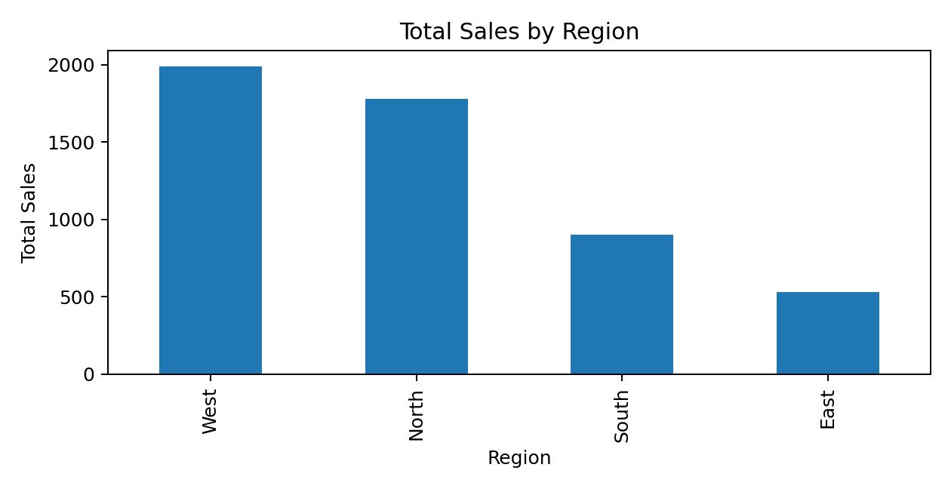

Figure 2. Total sales by product
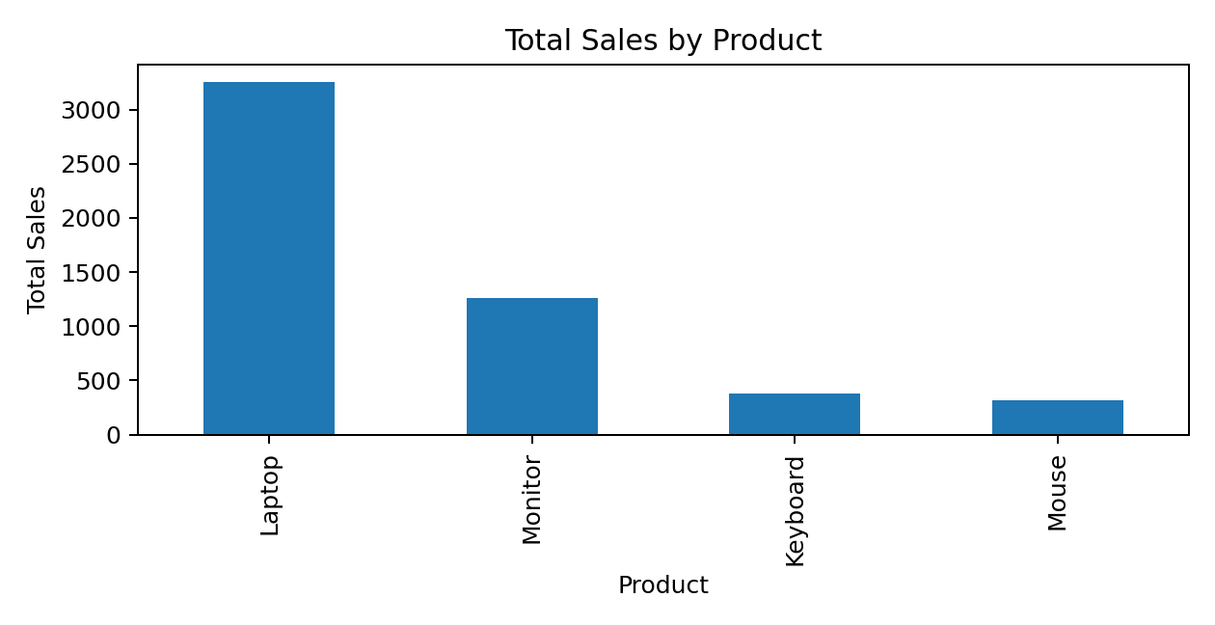

Figure 3. Sales by region and category
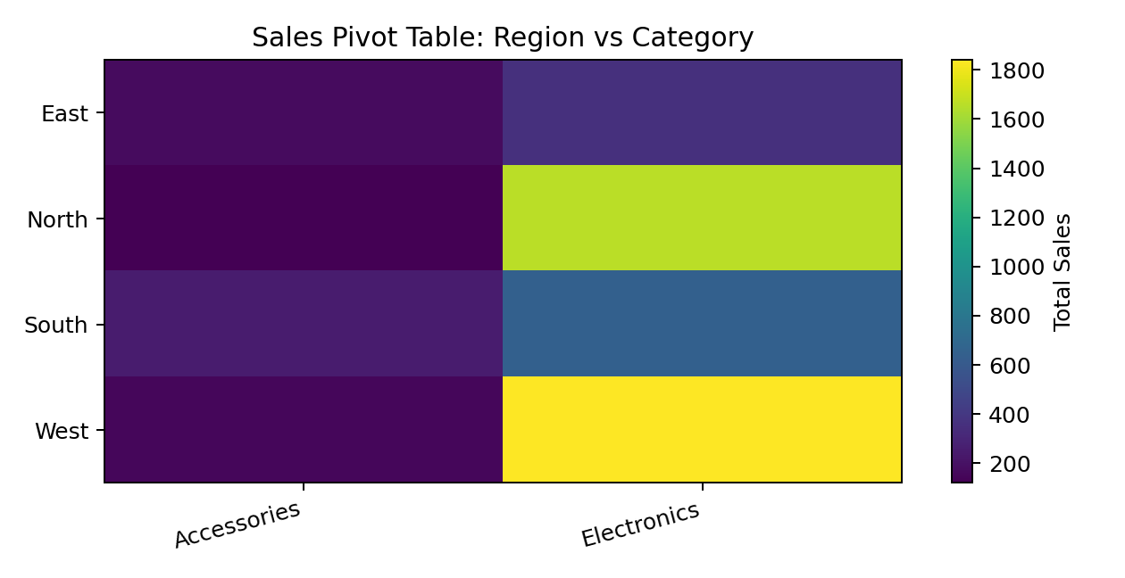

Key Findings from the Sample Dataset
1. Total calculated sales across the 12 sample orders are 5,200.00 monetary units.
2. Average sales per order are 433.33; the median order value is 255.00.
3. The highest single order value is 1,300.00.
4. West is the highest-sales region in this sample, with total sales of 1,990.00.
5. Laptop is the highest-sales product in this sample, with total sales of 3,250.00.
These findings describe only the small teaching dataset created for this assignment. They should not be interpreted as real company performance.

Submission Checklist
- Confirm student name is Vaishnavi Sulthan and college is IARE.
- Enter your branch/section if required by your instructor.
- Save the ten code sections as separate .py files using the filenames in this report.
- Keep sales_dataset.csv in the same folder as the scripts.
- Run each script and capture actual screenshots of your own code and outputs.
- Include sales_dataset.csv, processed_sales_dataset.csv, and final_sales_analysis.csv in the submission folder.
- Upload the code files, dataset, processed files, and screenshots to Google Drive.
- Set sharing permission to Anyone with the link — Viewer if permitted by your institution.
- Add your Google Drive folder link to the final report.
- Export or use the provided PDF, check readability, and submit the completed version.

Suggested Google Drive Folder Structure
Week2_NumPy_Pandas_Assignment/
Week_2_NumPy_Pandas_Assignment_Vaishnavi_Sulthan.pdf
task1_numpy_arrays.py
task2_indexing_reshaping.py
task3_numpy_statistics.py
task4_pandas_dataframe.py
task5_read_inspect_csv.py
task6_filter_sort.py
task7_missing_values.py
task8_merge_groupby_pivot.py
task9_export_csv.py
task10_mini_sales_analysis.py
sales_dataset.csv
processed_sales_dataset.csv
final_sales_analysis.csv
screenshots/

Conclusion
This assignment demonstrates how NumPy and Pandas can be used to prepare, analyze, summarize, and export data. NumPy supports efficient numerical operations, while Pandas provides practical tools for inspecting, cleaning, filtering, grouping, combining, and reshaping tabular datasets. The mini project connects these skills in a complete workflow and introduces visual reporting.

