**NLP EXPT-1**

**Review Of Emotion Based Chatbot and Music Recommendation Systems**

A critical review of papers on music recommending systems have been carried out in this section.

Emotion based music recommendation algorithms are complex to combine with a chatbot system. A base of a chatbot is the knowledge it is provided, its ability to carry out a conversation using the provided knowledge. T Tulasi Sasidhar [5] has formed an emotion detection model which is trained on a dataset of hindi+english mixed texts which will not be as comfortable to talk to as a chatbot with a custom-built dataset.

On the other hand,Dr. Soman K. P[6] has formed a dataset composed of tweets extracted from Twitter to enhance the chatbot’s response system. Thus, engaging a more realistic conversation between the computer machine and the user.

Emotion recognition is easy but when there are a number of emotions to detect, it becomes difficult. Shun-Hao Chang [7] proposed a system which is capable of detecting only Positive/Negative/Neutral emotions only whereas, H. Immanuel James [8] crafted a system that was capable of detecting whether the user was Happy/Angry/Surprise/Sad only.

These papers are good enough to detect the basic emotions but these emotions are not enough to recommend a song based on them that would be appropriate for the users.

Many Music recommending chatbots use direct APIs to suggest songs based on the user's chats with the chatbot. In case of the “MusicBot: Evaluating Critiquing-Based Music Recommenders with Conversational Interaction”, by Yucheng Jin, Wanling Cai, Li Chen, Nyi Nyi Htun, and Katrien Verbert[9], the bot created lets the user input their chats in the form of voice as well as text. This research shows that the chatbot sends the actionable data for music selection through the Spotify Web App and chats with the user and provides songs to them simultaneously. The paper evaluates and focuses more on the critiquing techniques with conversational interaction.

The paper shows that the main aim is to evaluate the critiquing-based techniques and focus on the same to make the chatbot better but fails to emphasize on the recommendation algorithm.

**Proposed System**

Music chatbot is the base of the proposed system. The user talking to the bot is Jambot and it is responsible for taking text input from the user and feeding it to the tone analyzer to get the emotion of the conversation and then recommend songs to the user. The IBM WatsonTone Analyzer[10] service uses linguistic analysis to detect emotional and language tones in written text.

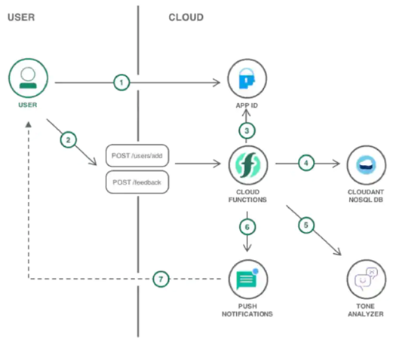

Last.FM is a music streaming website which offers APIs for developers to combine their services with their own websites and applications.

NLTK is a popular Python programming language for working with human language data. It includes a suite of text processing libraries for classification, tokenization, stemming, tagging, parsing, and semantic reasoning, wrappers for industrial-strength NLP libraries, and an active discussion forum, as well as easy-to-use interfaces to over 50 corpora and lexical resources like WordNet. NLTK is ideal for linguists, engineers, students, educators, academics, and industry users alike, thanks to a hands-on guide that introduces programming foundations alongside topics in computational linguistics, as well as rich API documentation. For Windows, Mac OS X, and Linux, NLTK is available. Best of all, NLTK is a community-driven, free, open-source project. "An excellent tool for teaching and working in computational linguistics using Python," according to NLTK.

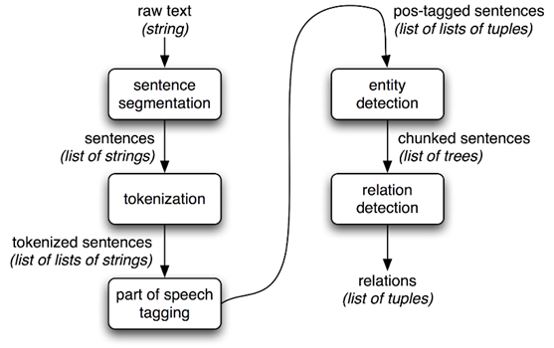

**Algorithm:**

***Deep Neural Networks*:**

Deep neural networks have recently become the standard tool for solving a variety of computer vision problems. Whereas training a neural network is outside the OpenVX scope, importing a pretrained network and running inference on it is an important part of the OpenVX functionality. The concept of the Graph API of nodes representing functions and links representing data is very convenient for implementing deep neural networks with OpenVX. In fact, each neural network unit can be represented as a graph node. OpenVX has a special data type representing tensors to provide data exchange between these nodes, and the nodes themselves are implemented in the OpenVX Neural Network Extension.[11]

***Natural Language Processing (NLP):***

Natural language processing (NLP) is the ability of a computer program to understand human language as it is spoken and written -- referred to as natural language. It is a component of artificial intelligence.[12]

**Workflow:**

Figure 3 illustrates the working flow of JamBot. The working flow consists of seven steps: (1) The user initiates a conversation with the bot. The chat continued in formal and informal English. The user can chat with the bot for a total of 7 messages which can be increased by the developers. (2) The web client transfers the message to the backend server in the form of an array for natural language understanding implemented by the developers. (3) The message is processed and matched to a corresponding intent . (Intents are defined beforehand by developers) (4) When a certain intent is identified by the backend, it sends a formatted response to continue with the conversation which creates a new res(response) list. (5) At the click of the “Get Music Recommendation” button, all the user texts are sent to the backend in a compact form for emotion analysis with the help of IBM Tone Analyzer[9] which analyzes mood from the array of steamed words by linguistic analysis. (6) The detected emotion is used to pull song recommendations by using an application programming interface (API) provided by Last FM API (7) The songs are displayed to the user in the form of clickable links which redirects the users to the music playing website.

**References**

[1]Research reveals pain and pleasure of sad music

<https://www.dur.ac.uk/news/newsitem/?itemno=28329> (Accessed on: 19/02/2022)

[2]Jenny Hole, Martin Hirsch, Elizabeth Ball, Catherine Meads, *“Music as an aid for postoperative recovery in adults: a systematic review and meta-analysis”*<https://www.thelancet.com/journals/lancet/article/PIIS0140-6736(15)60169-6/fulltext>

[3]Daniel Jurafsky and James H. Martin, “Speech and Language Processing: An Introduction to Natural Language Processing, Computational Linguistics and Speech Recognition”, Prentice Hall IncPublications, 2nd Edition, 1999.

[4]M. Milenkovic, “The Future is Now – 37 Fascinating Chatbot Statistics”, published on 30th Oct, 2019.

Available at [https://www.smallbizgenius.net/by-the-numbers/chatbot-statistics/. Last accessed on 10th Dec, 2019](https://www.smallbizgenius.net/by-the-numbers/).

[5]T Tulasi Sasidhar, Premjith B, Soman K P, ”Emotion Detection in Hinglish(Hindi+English) Code-Mixed Social Media Text”,Procedia Computer Science,Volume 171,2020,Pages 1346-1352,ISSN 1877-0509,

[https://doi.org/10.1016/j.procs.2020.04.144.](https://www.sciencedirect.com/science/article/pii/S1877050920311236?via%3Dihub)

[6]K. S. Naveenkumar, Vinayakumar, R., and Dr. Soman K. P., “Amrita-CEN-SentiDB 1: Improved Twitter Dataset for Sentimental Analysis and Application of Deep learning”, in 2019 10th International Conference on Computing, Communication and Networking Technologies (ICCCNT), Kanpur, India, 2019.

[7]S. Chang, A. Abdul, J. Chen and H. Liao, ”A personalized music recommendation system using convolutional neural networks approach,” 2018 IEEE International Conference on Applied System Invention (ICASI), 2018, pp. 47-49, doi: 10.1109/ICASI.2018.8394293.

[8]“Emotion based Music Recommendation System”, H.Immanuel James, J.James Anto Arnold, J.Maria Masilla Ruban, M.Tamilarasan,R.Saranya, International Research Journal of Engineering and Technology(IRJET), Volume:06 Issue:03—Mar 2019

[9]Yucheng Jin, Wanling Cai, Li Chen, Nyi Htun, and Katrien Verbert. 2019. MusicBot: Evaluating Critiquing-Based Music Recommenders with Conversational Interaction. In The 28th ACM International Conference on Information and Knowledge Management (CIKM ’19), November 3–7, 2019, Beijing, China. ACM, New York, NY, USA, 10 pages.<https://dl.acm.org/doi/10.1145/3357384.3357923>

[10]Watson Tone Analyzer - IBM

<https://www.ibm.com/in-en/cloud/watson-tone-analyzer?utm_content=SRCWW&p1=Search&p4=43700054068244095&p5=e&gclid=CjwKCAiA9aKQBhBREiwAyGP5ldHtU74eLxMDvfxc-kgJhB0gwFTDZaF5GT_BSkgDqwbJdZLjR5RUKRoCMb8QAvD_BwE&gclsrc=aw.ds>

[11] Frank Brill, Victor Erukhimov, Radha Giduthuru, Stephen Ramm “OpenVX Programming Guide” eBook ISBN: 9780128166192

<https://www.elsevier.com/books/T/A/9780128164259> (Accessed on: 22/02/2022)

[12] Ben Lutkevich “Natural Language Processing”

<https://www.techtarget.com/searchenterpriseai/definition/natural-language-processing-NLP>

[13]A. Nair, S. Pillai, G. S. Nair and A. T, "Emotion Based Music Playlist Recommendation System using Interactive Chatbot," 2021 6th International Conference on Communication and Electronics Systems (ICCES), 2021, pp. 1767-1772, doi: 10.1109/ICCES51350.2021.9489138.