Instagram – Functional & UI Test Report
Module Name: | Instagram - Social Media Functional Test Cases
Test Case ID: | str_id_01
Tester Name: | Prajapati Yash
Test Case Description: | To validate the functionality of Instagram login, account access, profile management, user search, posts, likes, comments, follows, stories, direct messaging, notifications, and basic navigation workflows.
Prerequisites: | Stable internet connection
Environment Information: | Webpage URL: https://www.instagram.com/

Scenario ID: i1
Scenario | Open Instagram
Test Steps | 1. Open Instagram website/app  2. Wait for the home/login page to load
Test Input | Instagram URL
Expected Results | Instagram page loads successfully
Actual Results | Instagram page loads successfully
Status | Pass
Comments | Basic navigation tested
Screenshots:
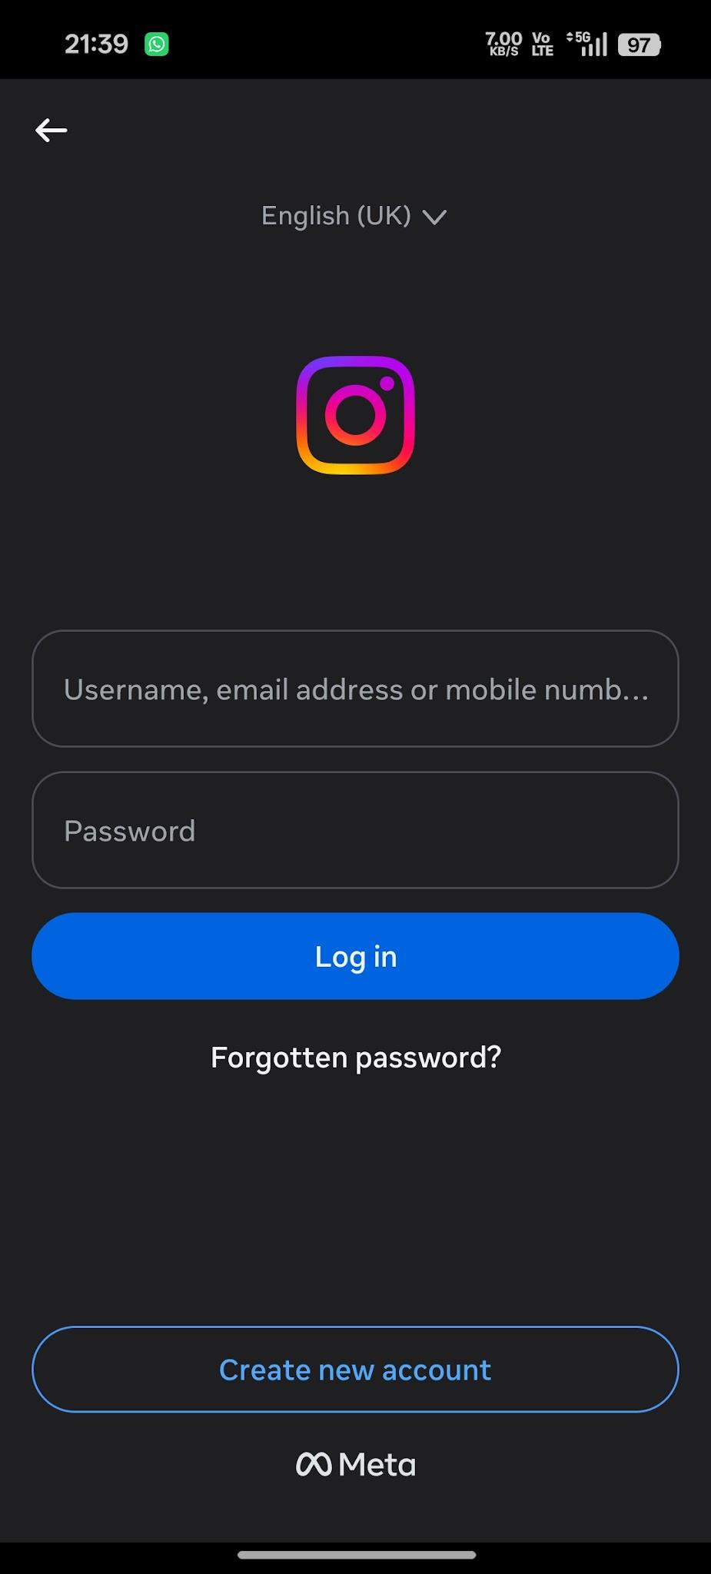

Scenario ID: i2
Scenario | Login with valid credentials
Test Steps | 1. Open login page  2. Enter valid username  3. Enter valid password  4. Tap Log In
Test Input | Valid registered account
Expected Results | User is authenticated and Instagram home page is displayed
Actual Results | Home page is displayed after login
Status | Pass
Comments | Positive login test
Screenshots: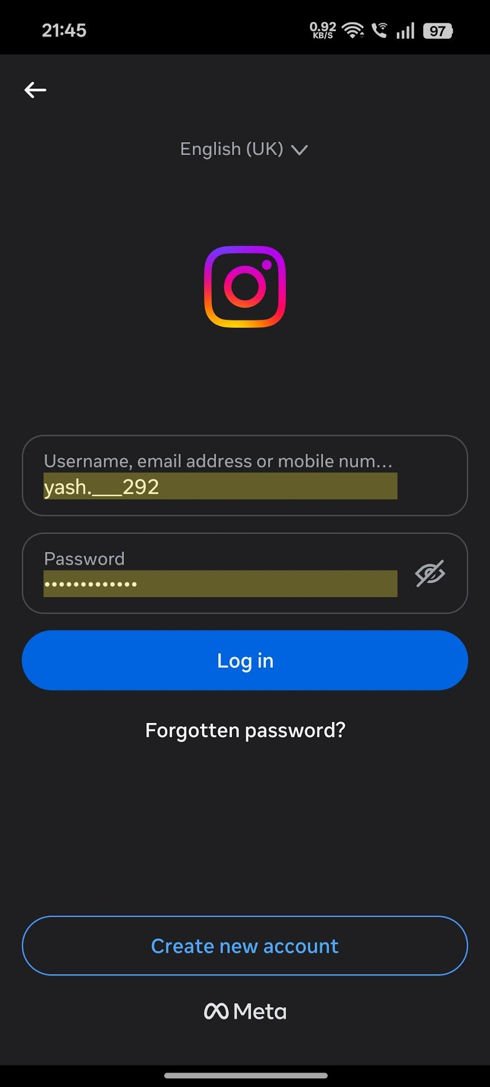

Scenario ID: i3
Scenario | Reject invalid login
Test Steps | 1. Open login page  2. Enter invalid username/password  3. Tap Log In
Test Input | Invalid credentials
Expected Results | Appropriate error message is displayed and login is rejected
Actual Results | Error message is displayed
Status | Pass
Comments | Negative login test
Screenshots:
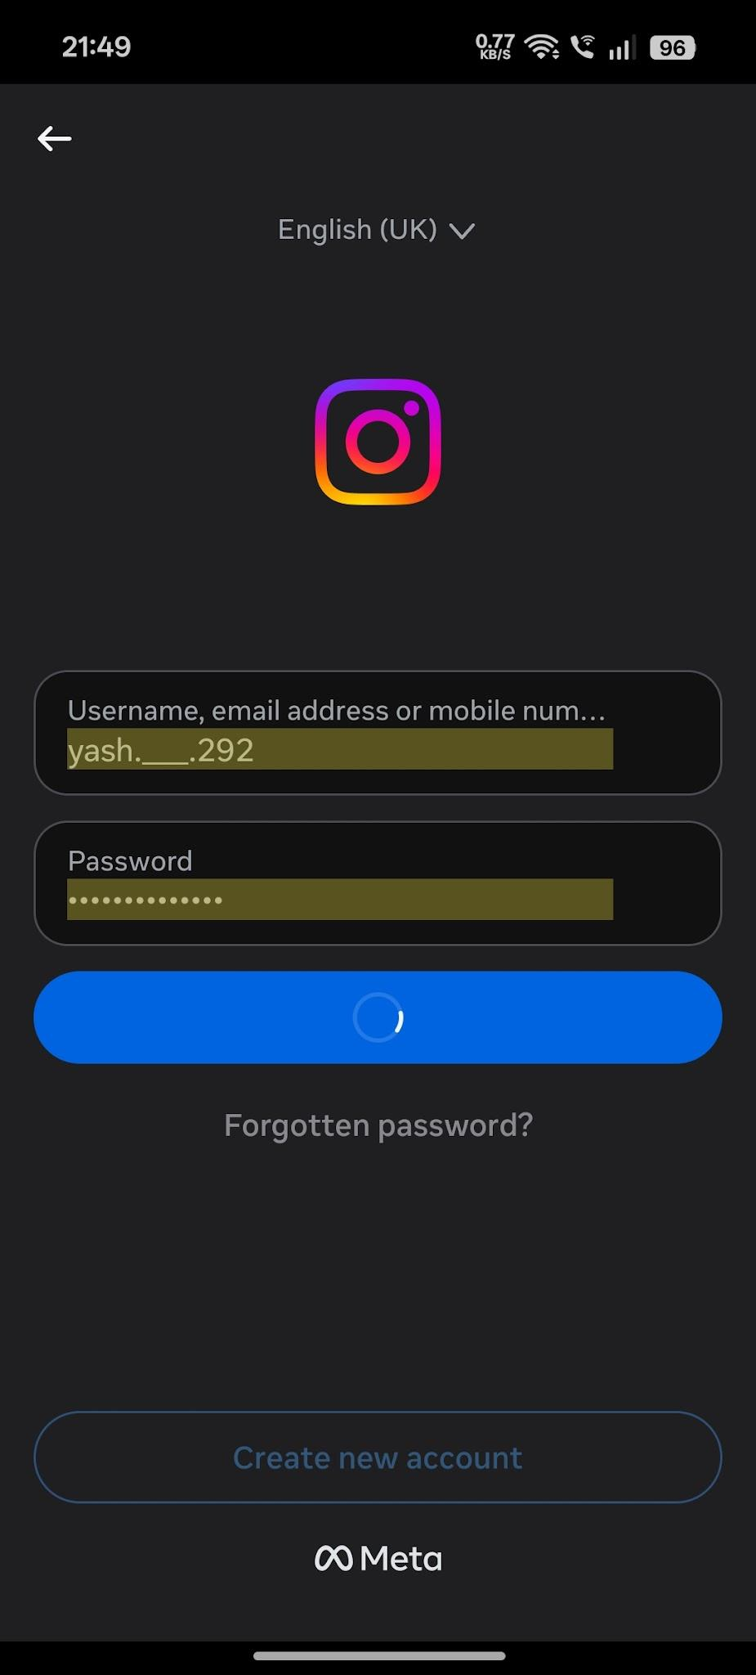

Scenario ID: i4
Scenario | Search user
Test Steps | 1. Tap search  2. Enter username/name  3. Select result
Test Input | Existing Instagram user
Expected Results | Relevant search results are displayed
Actual Results | Relevant user result is displayed
Status | Pass
Comments | Search validation
Screenshots:
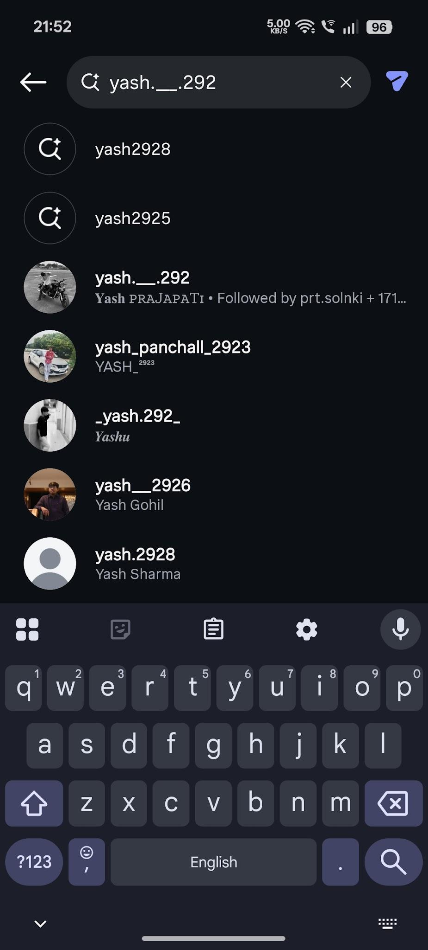

Scenario ID: i5
Scenario | View profile
Test Steps | 1. Search for a user  2. Open the profile
Test Input | Available user profile
Expected Results | Profile page opens with username, bio and available posts
Actual Results | Profile page opens correctly
Status | Pass
Comments | Profile validation
Screenshots:
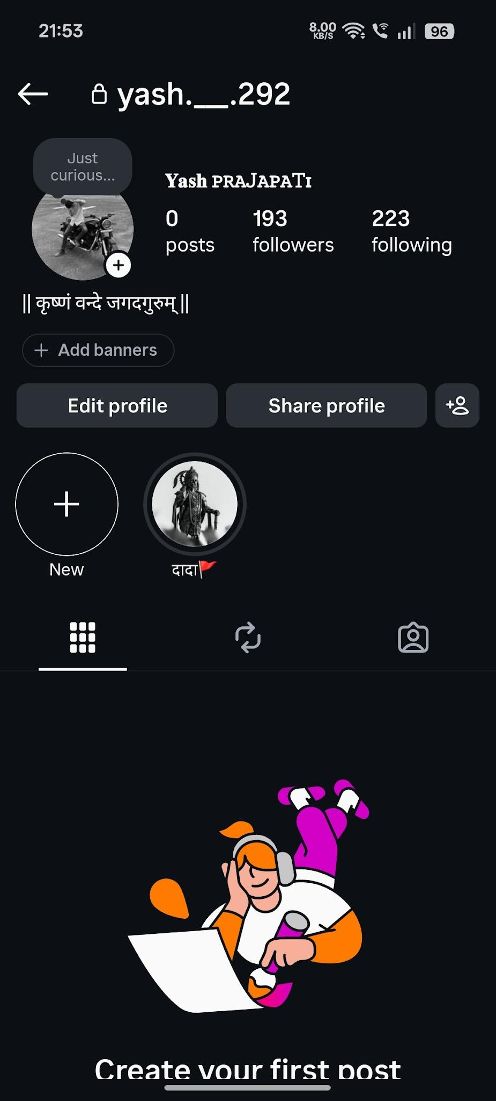

Scenario ID: i6
Scenario | Follow user
Test Steps | 1. Open another user's profile  2. Tap Follow
Test Input | Public user account
Expected Results | Follow status changes successfully
Actual Results | Follow status changes successfully
Status | Pass
Comments | Follow functionality
Screenshots:
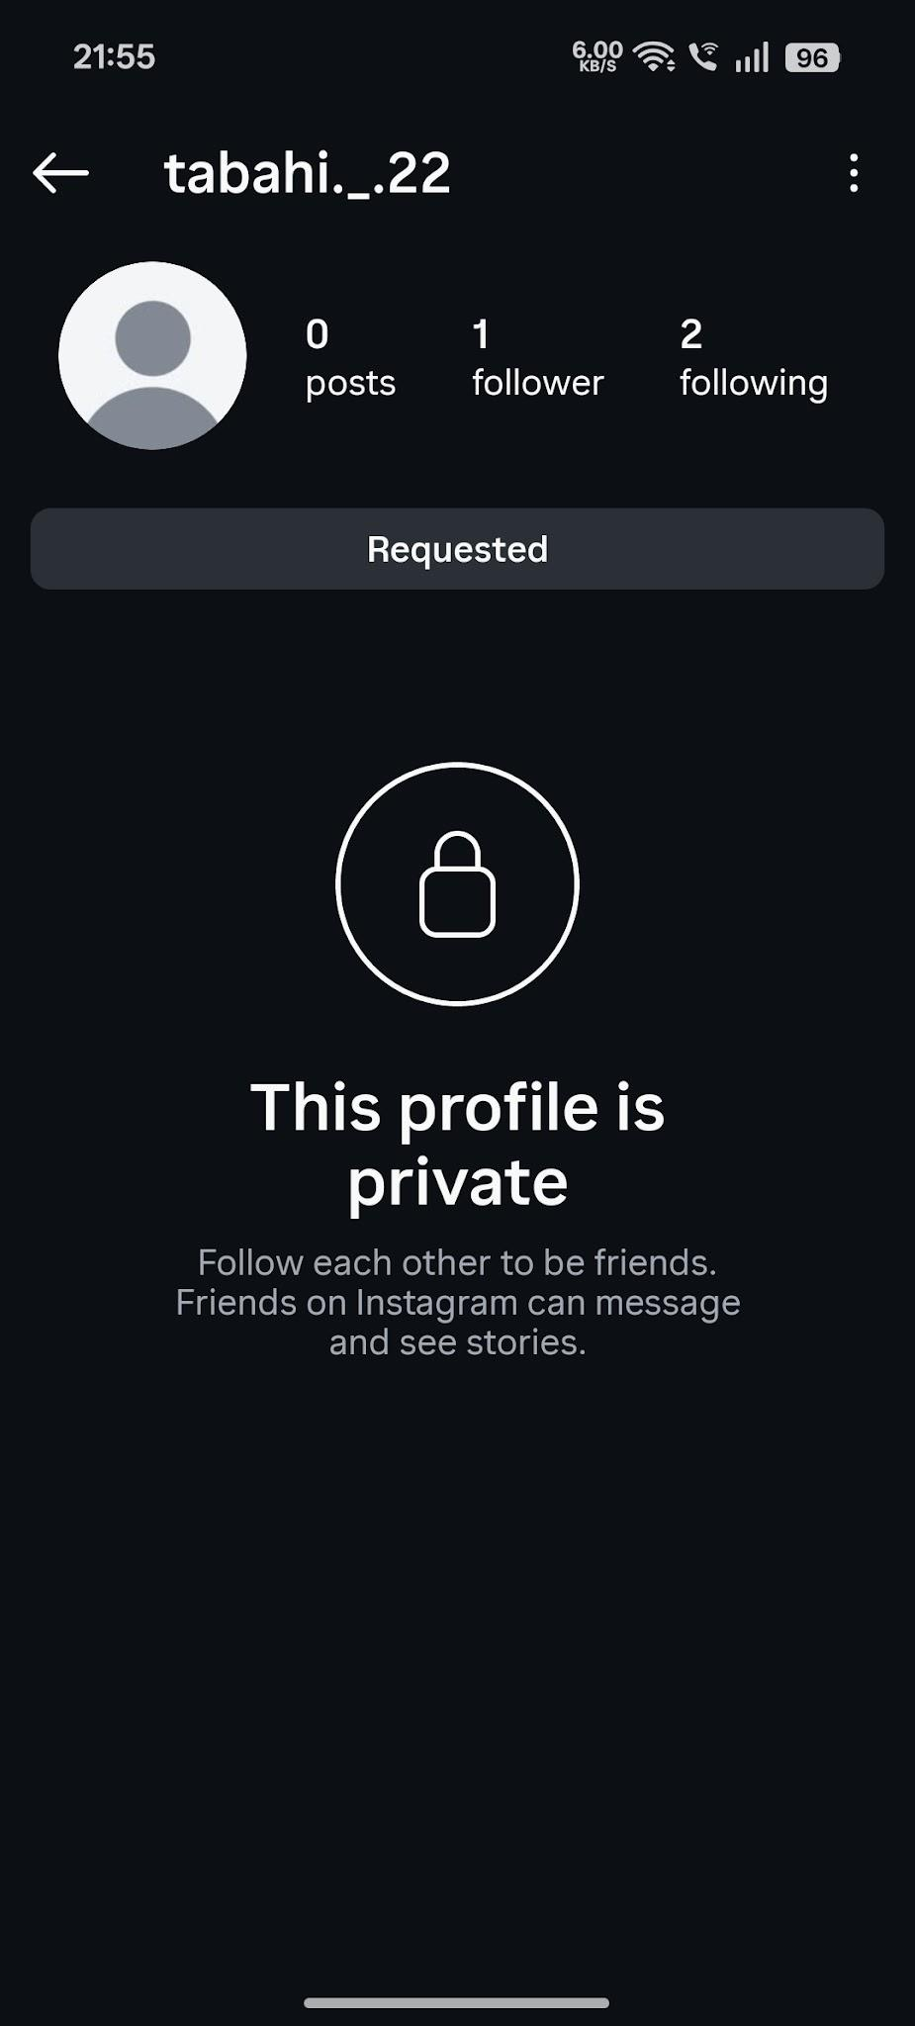

Scenario ID: i7
Scenario | Unfollow user
Test Steps | 1. Open followed user's profile  2. Tap Following/Unfollow  3. Confirm if required
Test Input | Followed user
Expected Results | User is unfollowed successfully
Actual Results | User is unfollowed successfully
Status | Pass
Comments | Unfollow functionality
Screenshots:
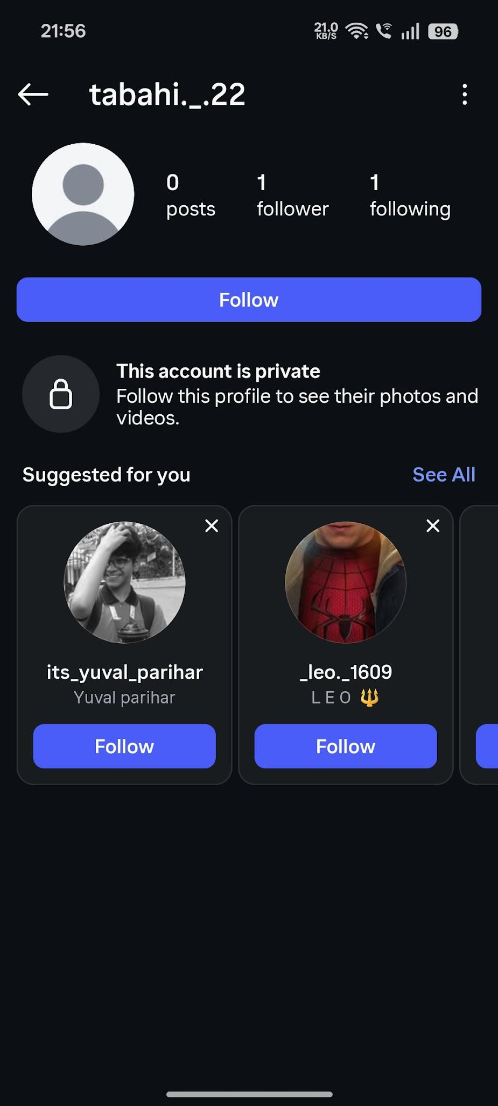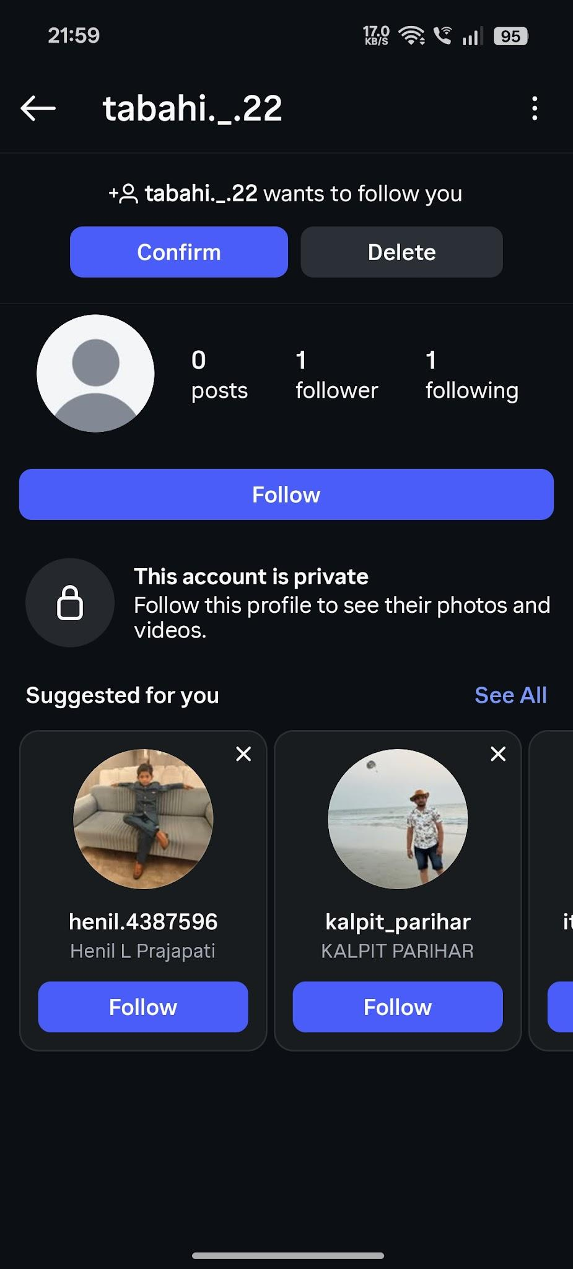
Scenario ID: i8
Scenario | Create post
Test Steps | 1. Tap create/+  2. Select image/video  3. Add caption  4. Share
Test Input | Valid test image and caption
Expected Results | Post is uploaded and appears on user's profile/feed
Actual Results | Post appears successfully
Status | Pass
Comments | Post creation
Screenshots:
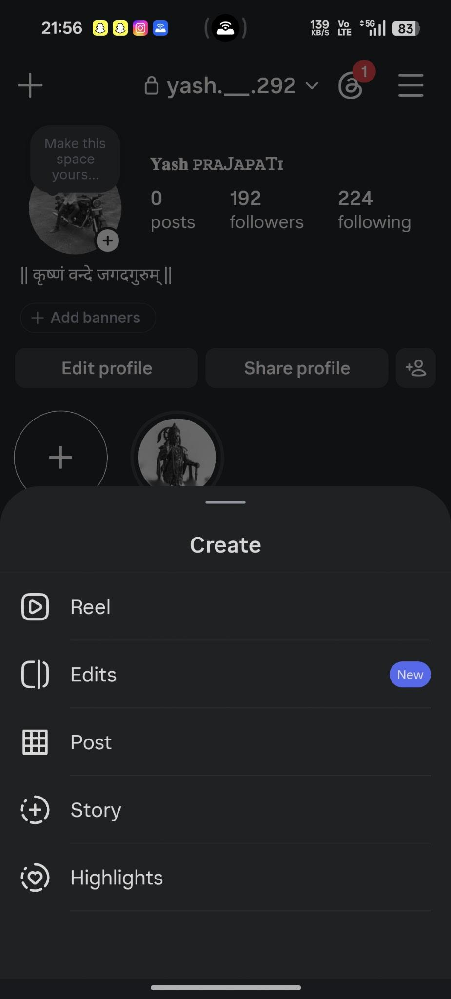
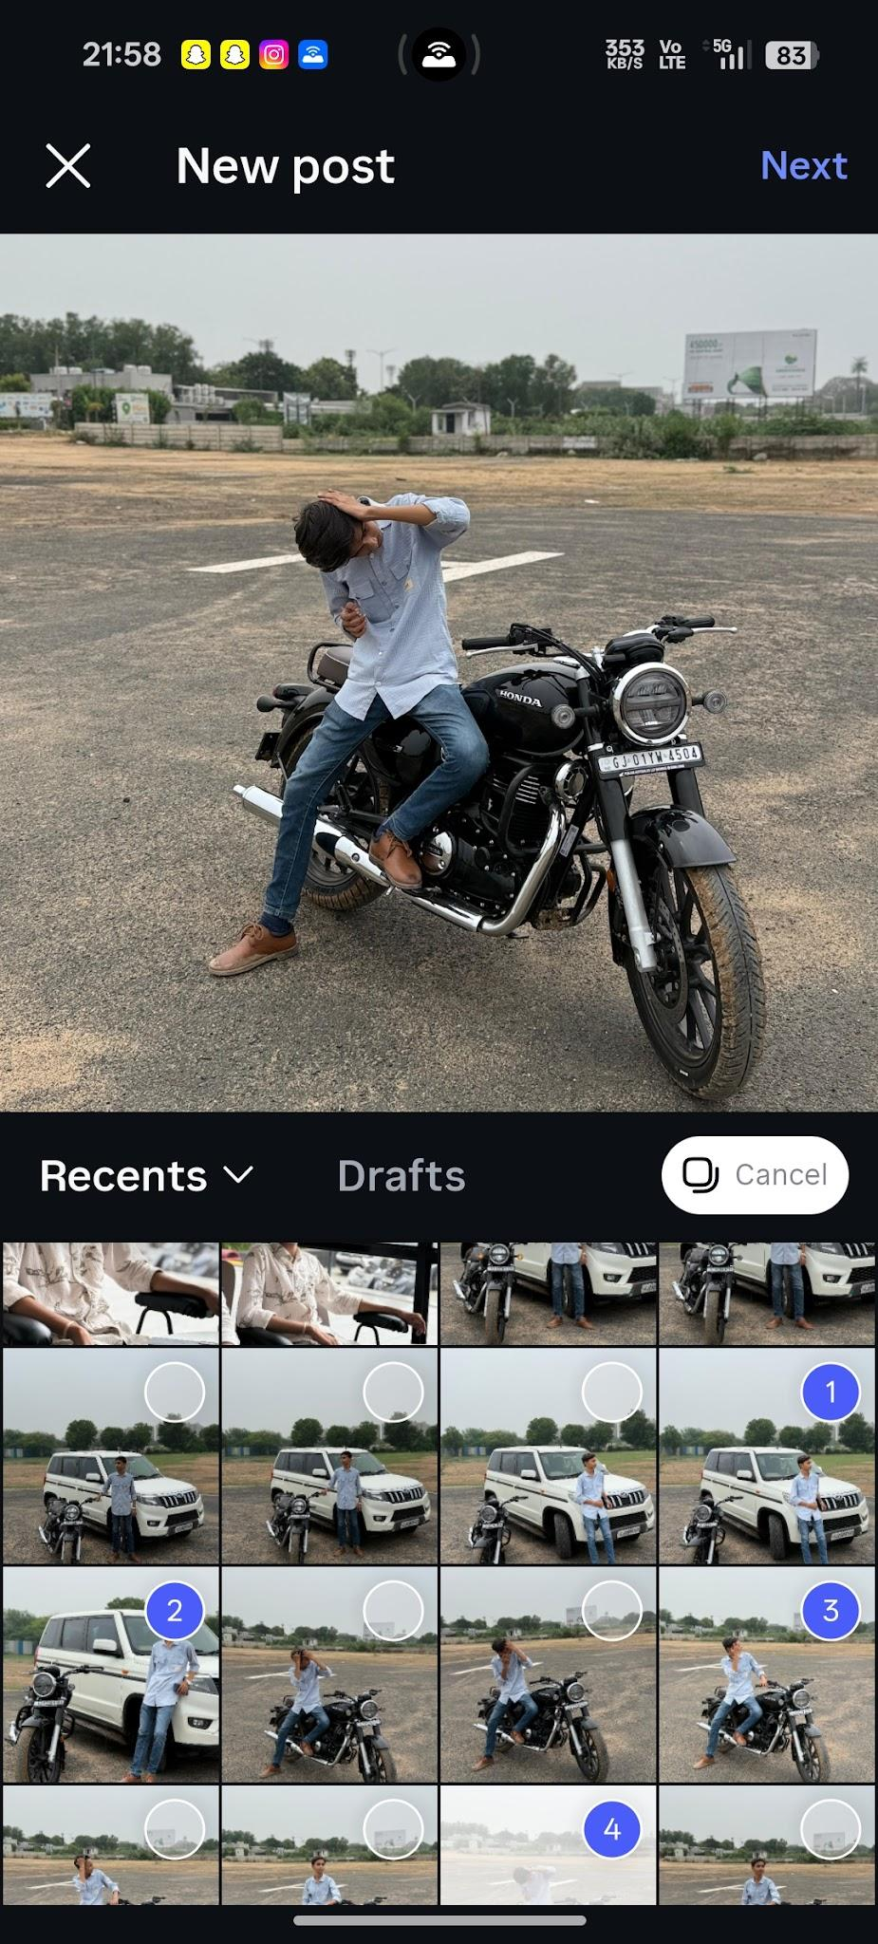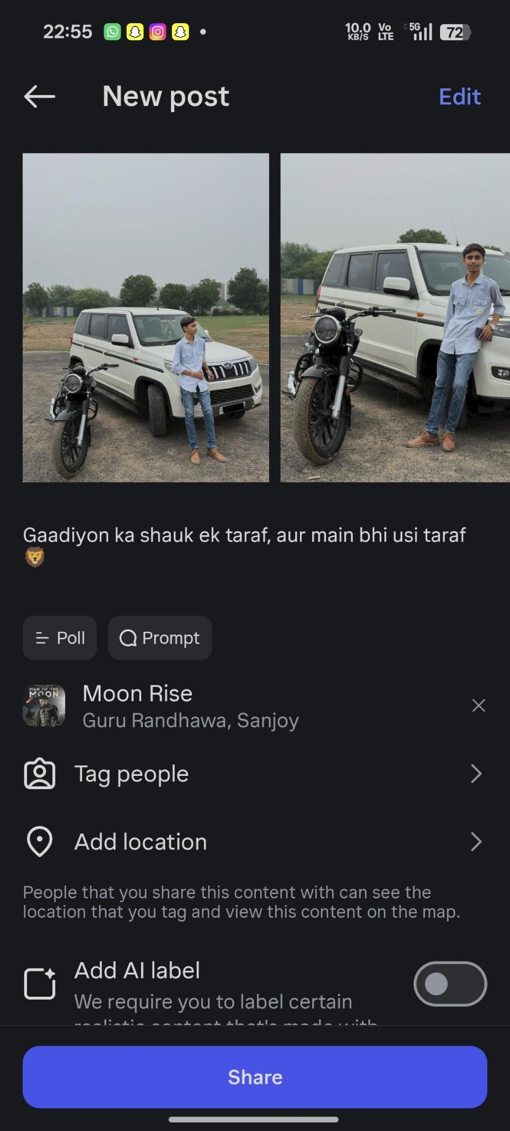
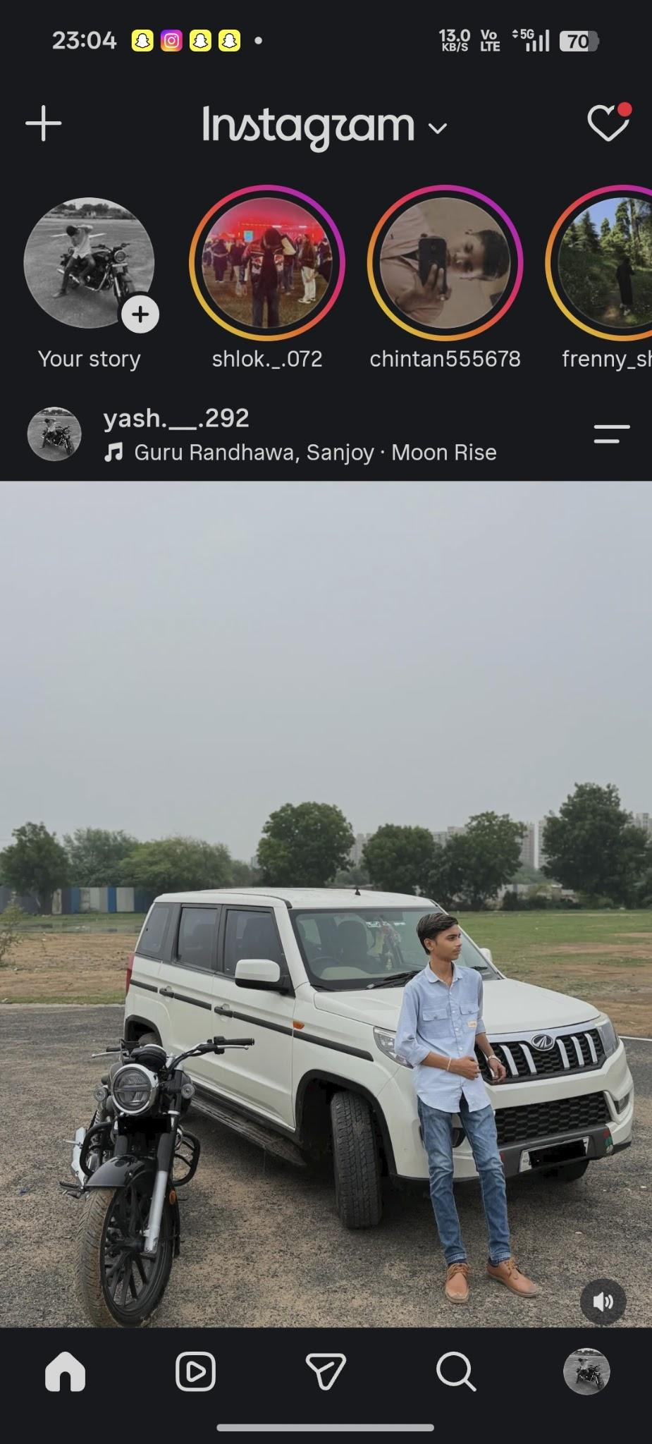

Scenario ID: i9
Scenario | Like post
Test Steps | 1. Open a post  2. Tap Like
Test Input | Available post
Expected Results | Like is applied and like state/count is updated
Actual Results | Like is applied
Status | Pass
Comments | Like validation
Screenshots:
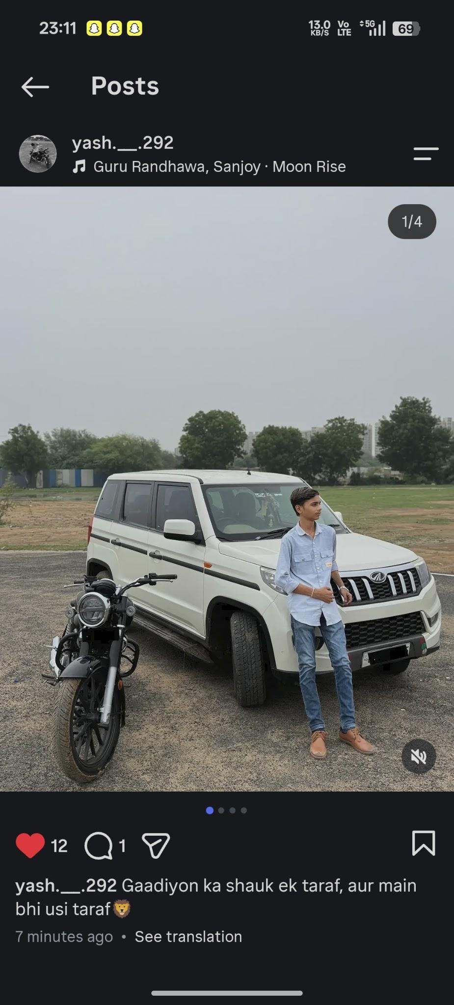

Scenario ID: i10
Scenario | Unlike post
Test Steps | 1. Open a liked post  2. Tap Like again
Test Input | Liked post
Expected Results | Like is removed and state/count is updated
Actual Results | Like is removed
Status | Pass
Comments | Negative like-state test
Screenshots:
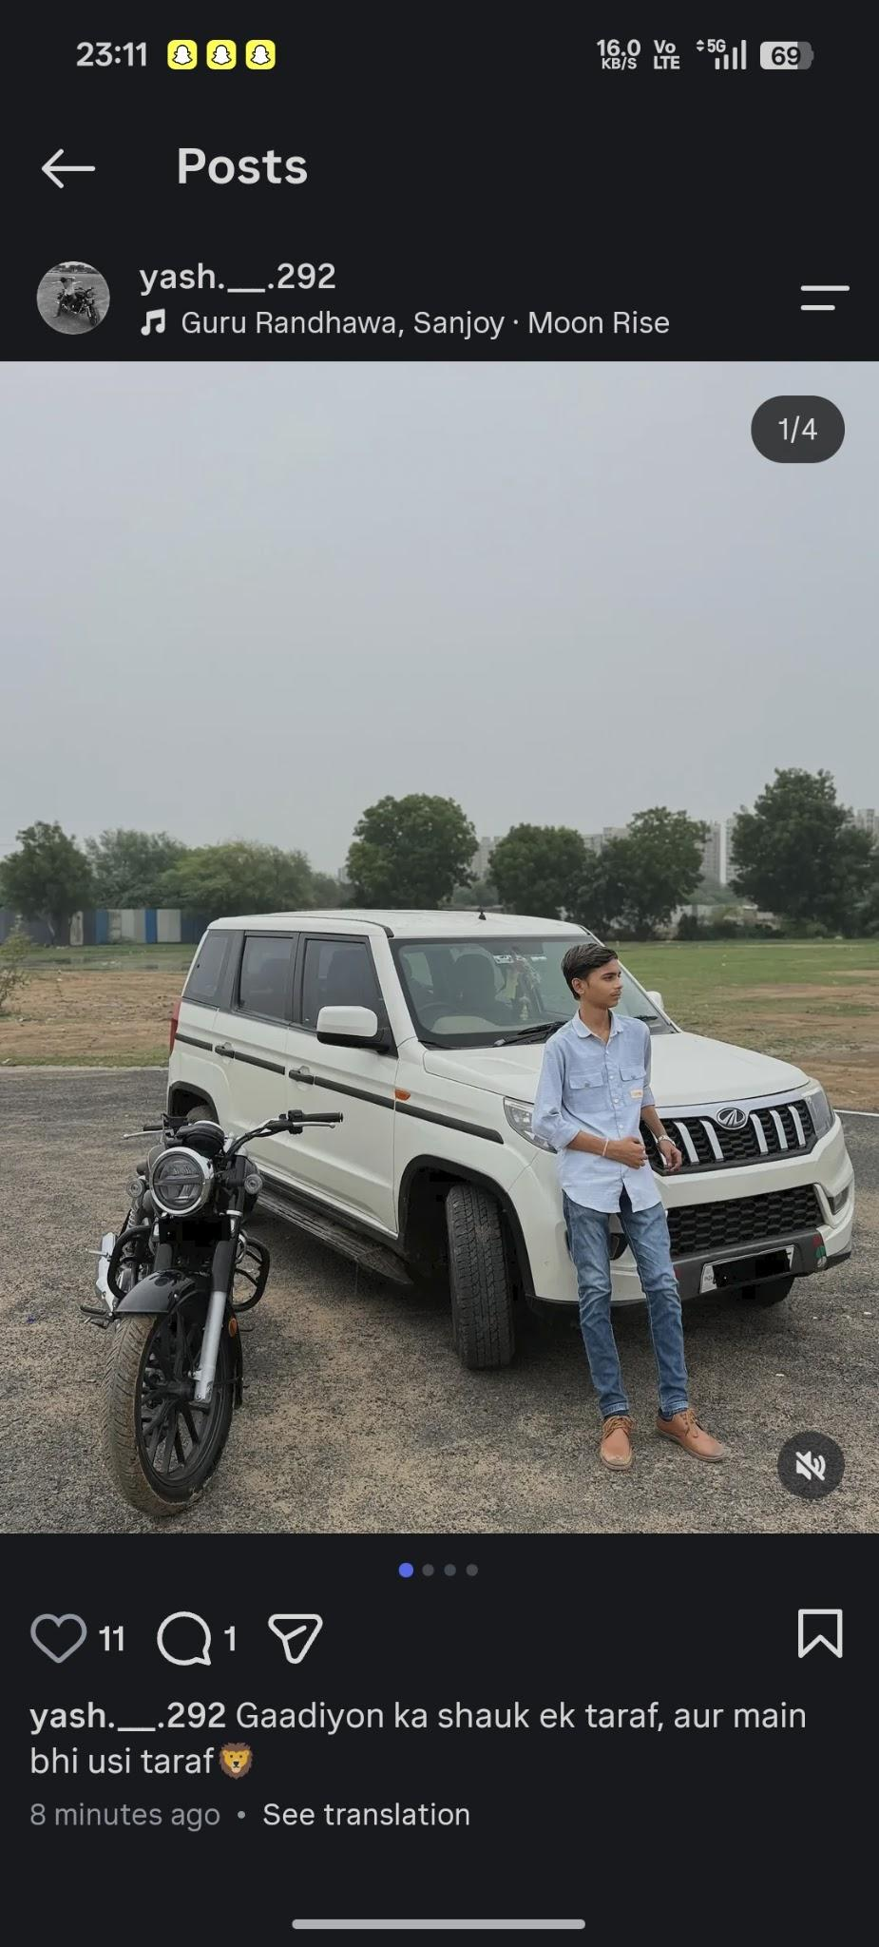

Scenario ID: i11
Scenario | Add comment
Test Steps | 1. Open a post  2. Enter comment  3. Submit
Test Input | Valid comment text
Expected Results | Comment is added and displayed under the post
Actual Results | Comment is displayed
Status | Pass
Comments | Comment validation
Screenshots:
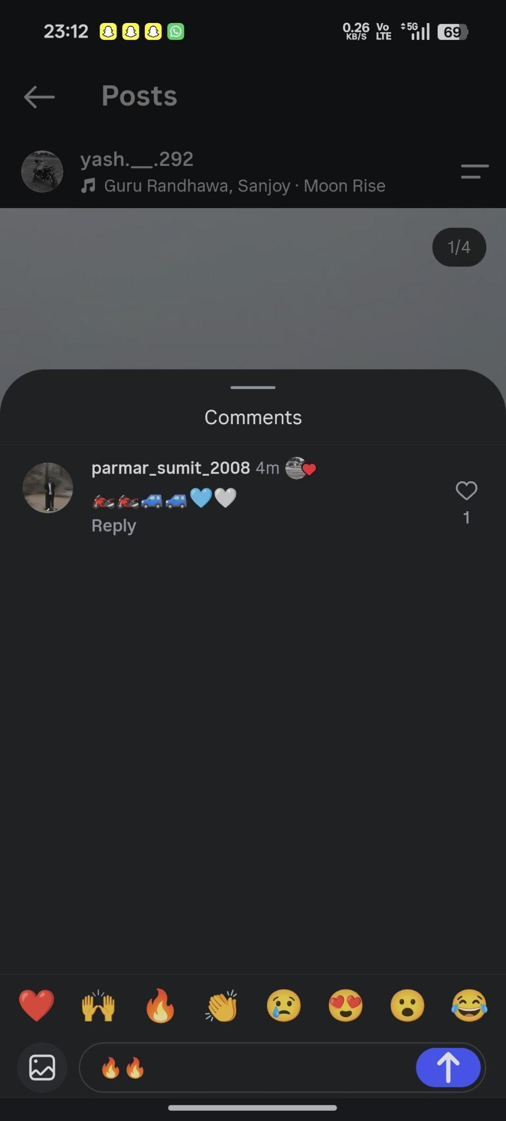
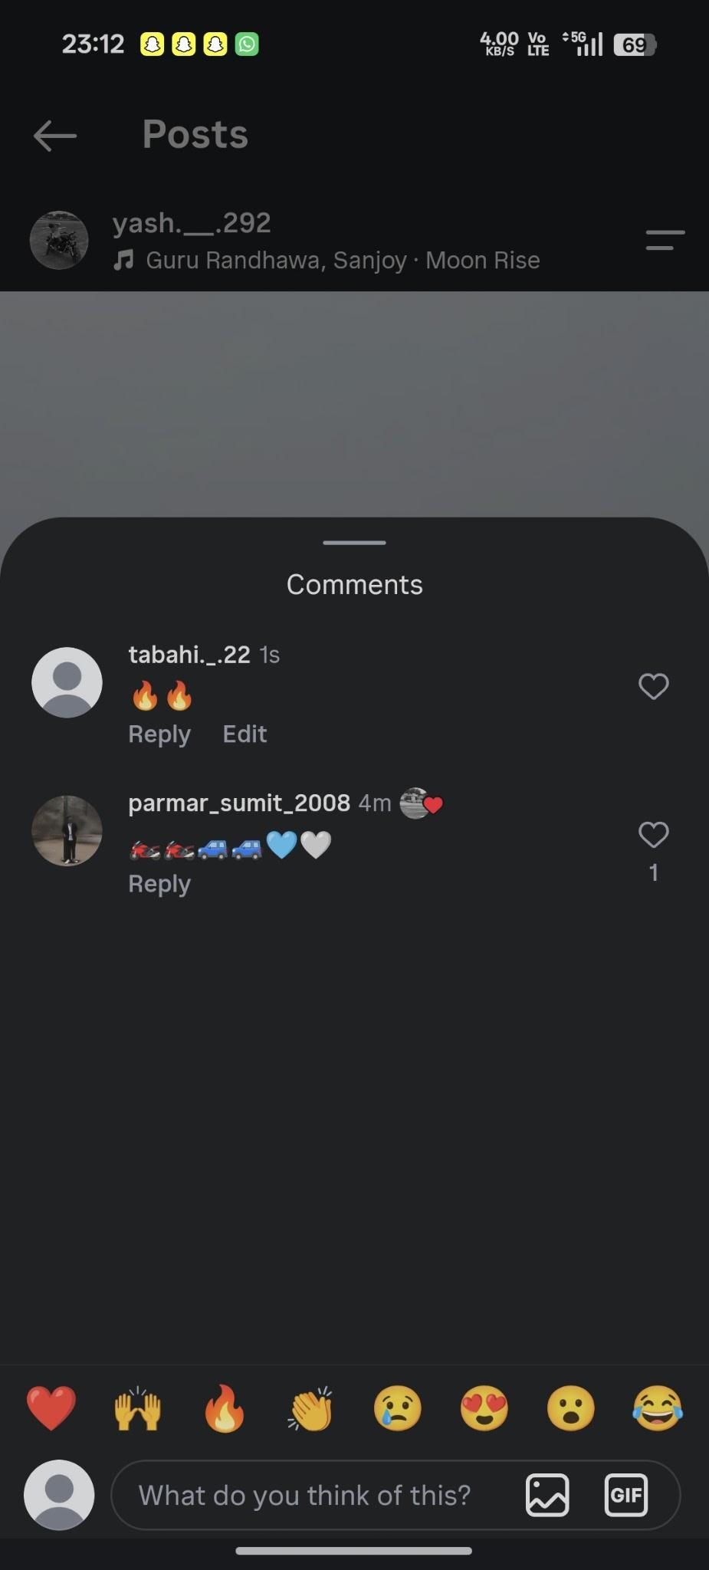

Scenario ID: i12
Scenario | Delete own comment
Test Steps | 1. Open own comment  2. Open comment options  3. Delete
Test Input | Own comment
Expected Results | Comment is removed after confirmation
Actual Results | Comment is removed
Status | Pass
Comments | Comment deletion

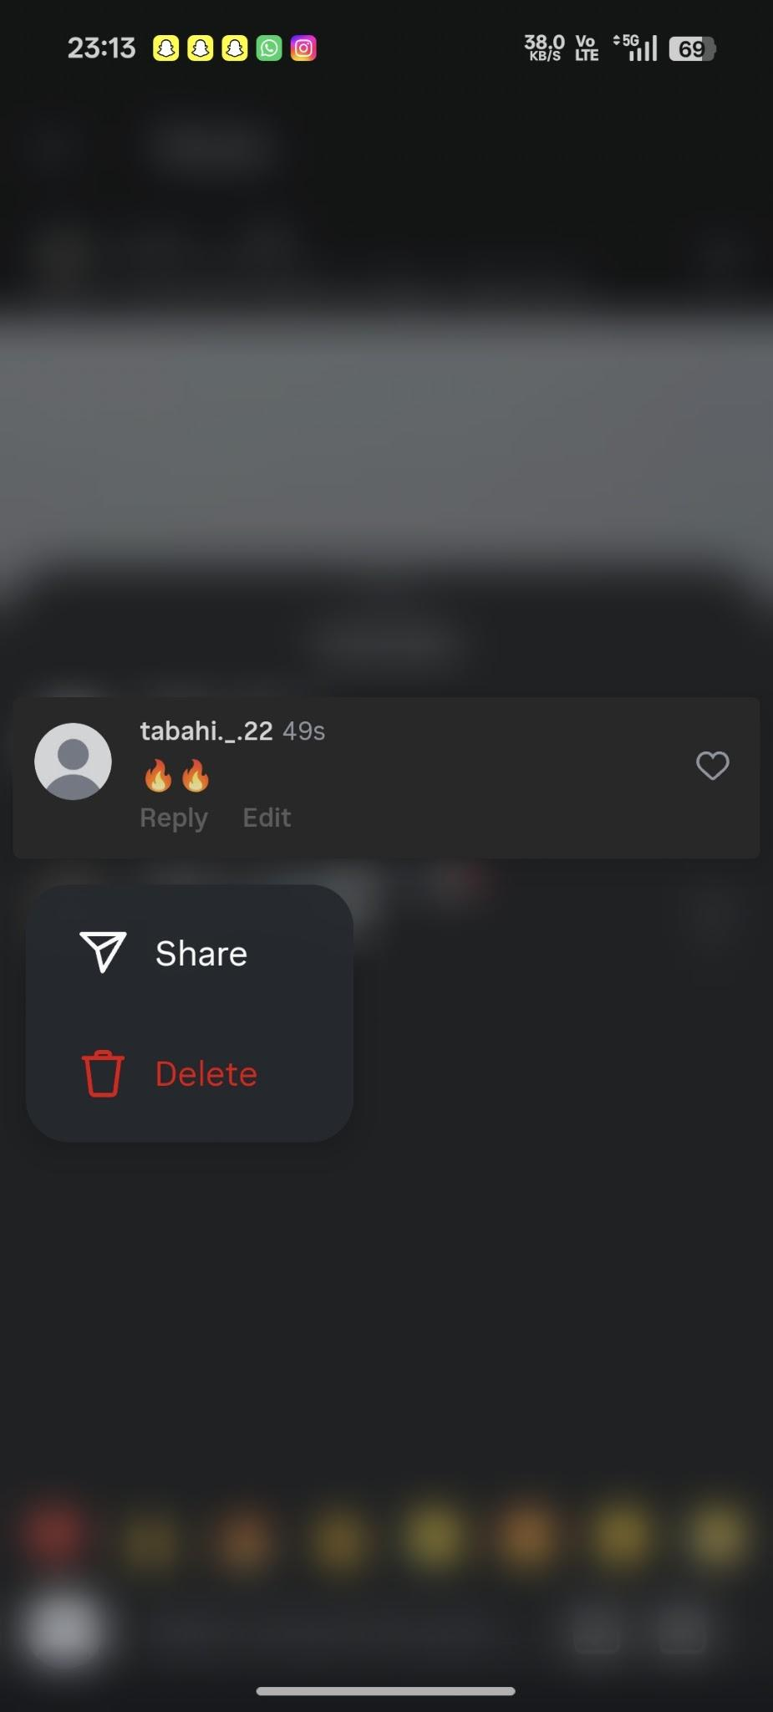

Scenario ID: i13
Scenario | View story
Test Steps | 1. Open a profile with an active story  2. Tap story
Test Input | Available story
Expected Results | Story opens and can be viewed through available story controls
Actual Results | Story opens successfully
Status | Pass
Comments | Story viewing

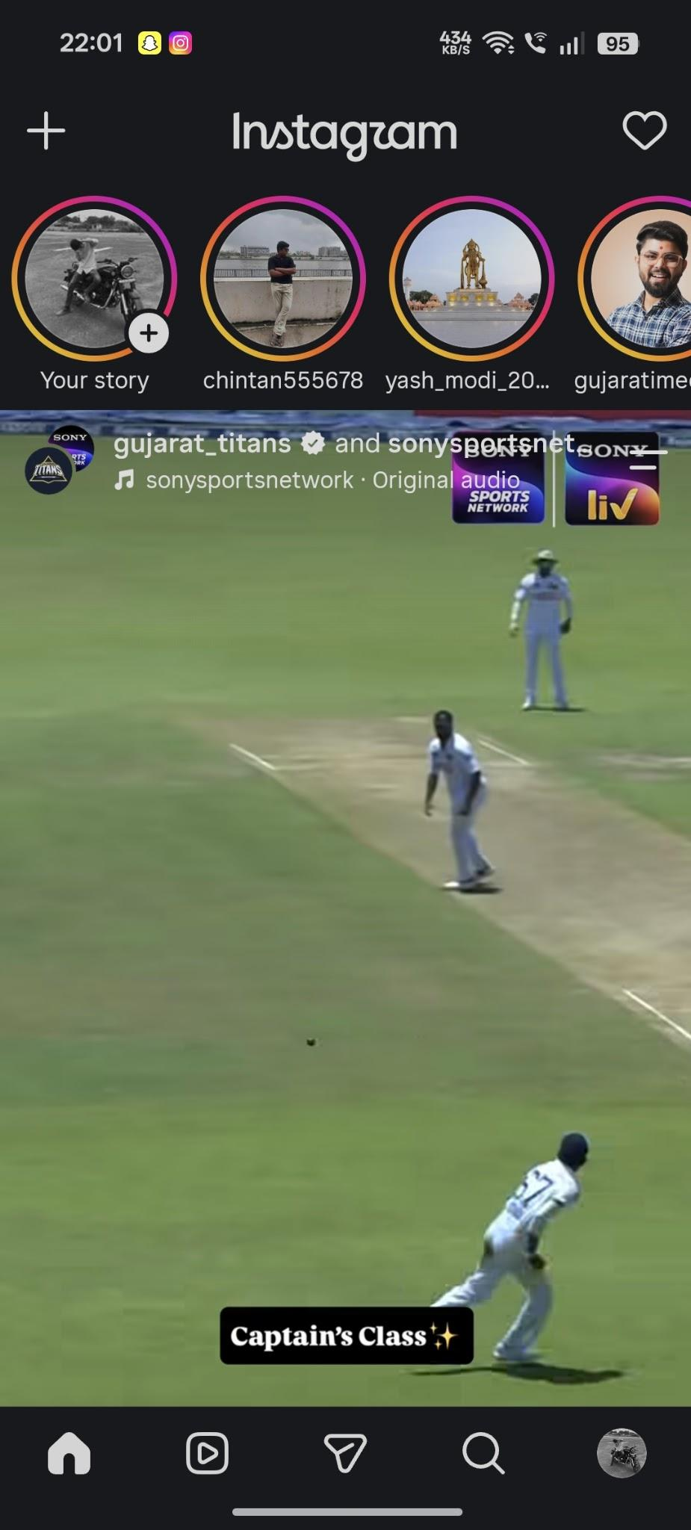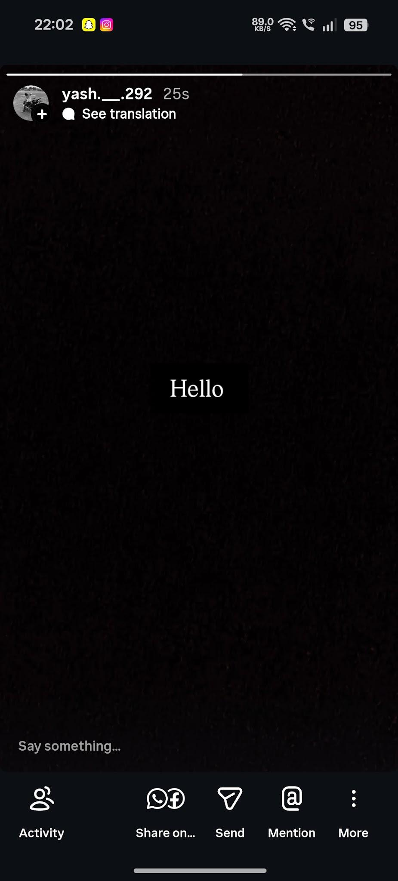
Scenario ID: i14
Scenario | Send direct message
Test Steps | 1. Open Messages  2. Select a user  3. Enter message  4. Send
Test Input | Valid message text
Expected Results | Message is sent and displayed in the conversation
Actual Results | Message is displayed as sent
Status | Pass
Comments | Messaging validation

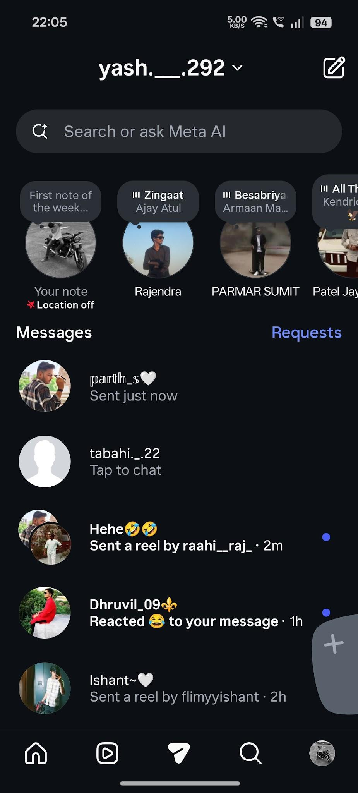
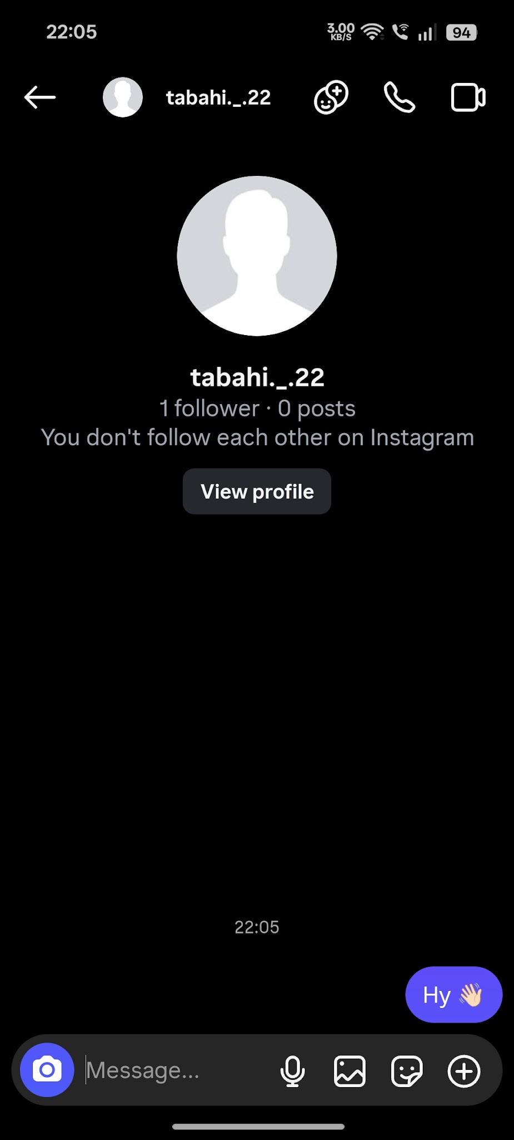
Scenario ID: i15
Scenario | Reject empty message
Test Steps | 1. Open a chat  2. Leave message field empty  3. Attempt to send
Test Input | Blank message
Expected Results | System should not send an empty message
Actual Results | Empty message is not sent
Status | Pass
Comments | Negative messaging test
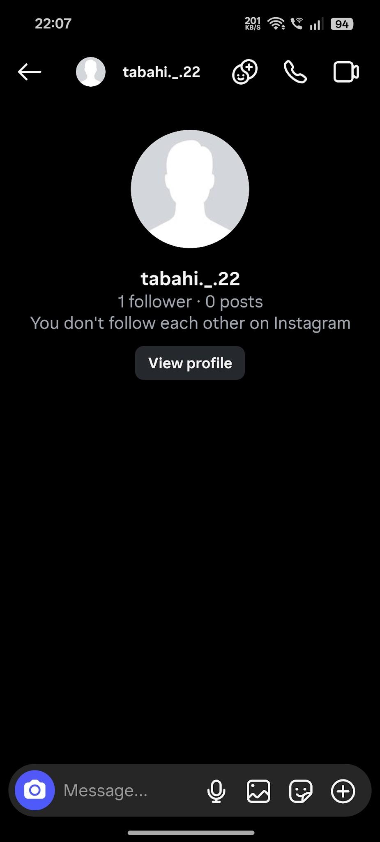

Scenario ID: i16
Scenario | Receive/view notifications
Test Steps | 1. Open notifications/activity  2. Check recent activity
Test Input | Account with recent activity
Expected Results | Relevant likes, follows or comments are displayed
Actual Results | Recent activity is displayed
Status | Pass
Comments | Notification validation
Screenshots:
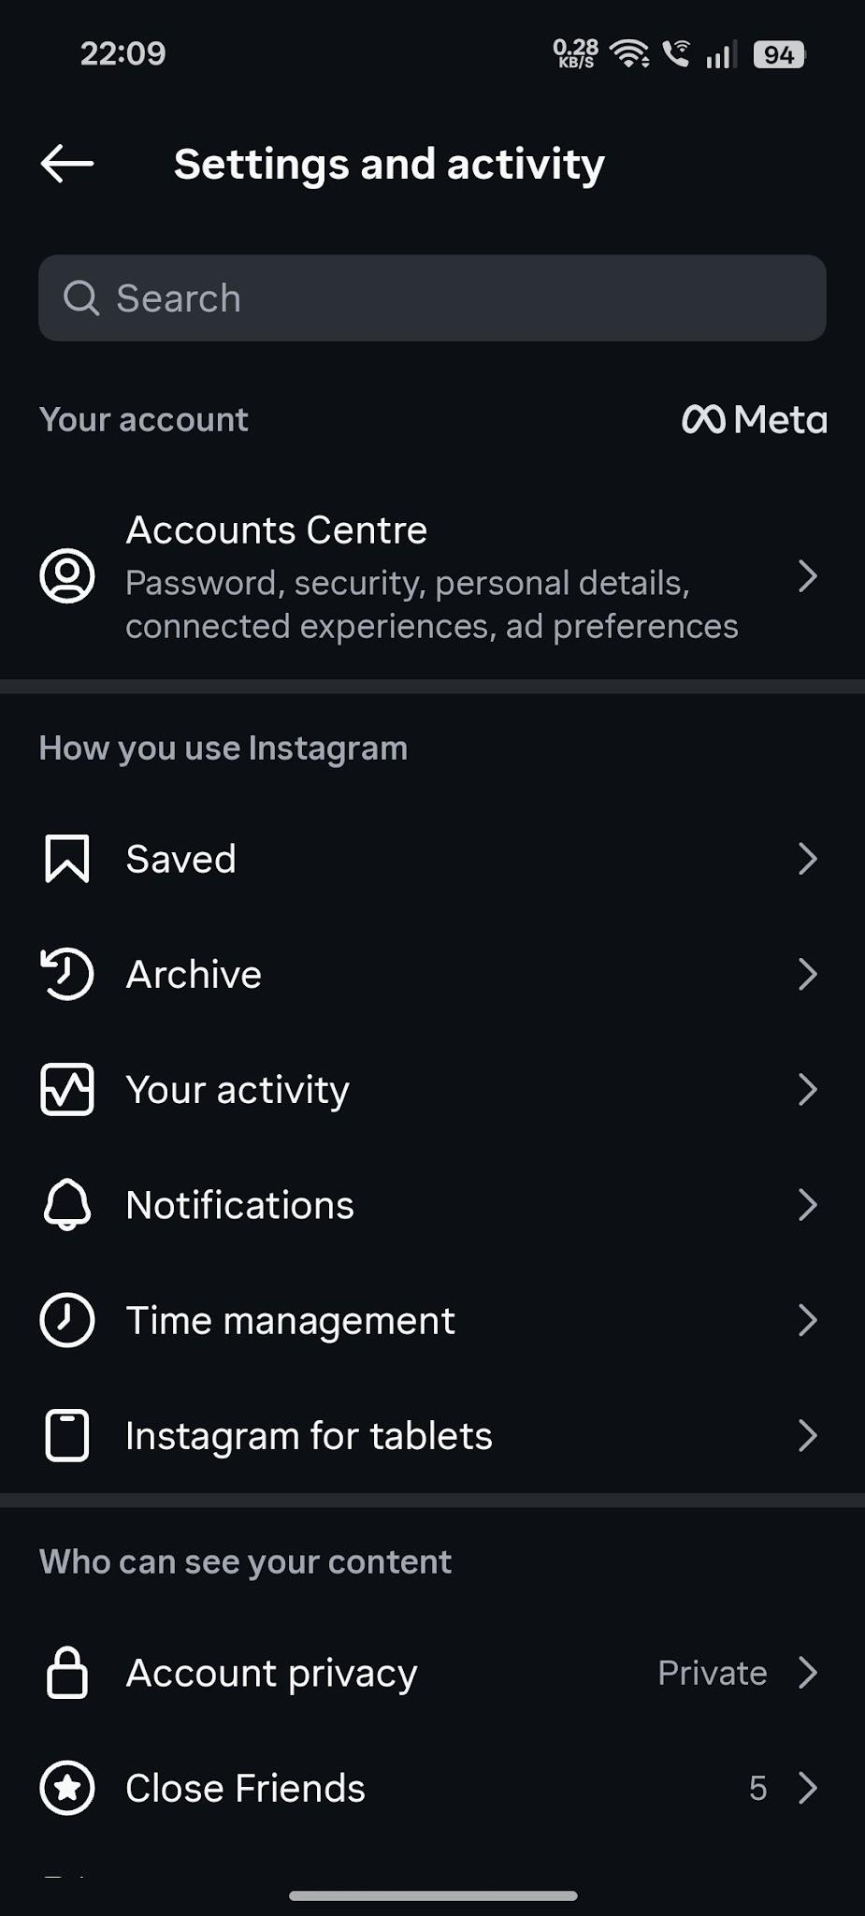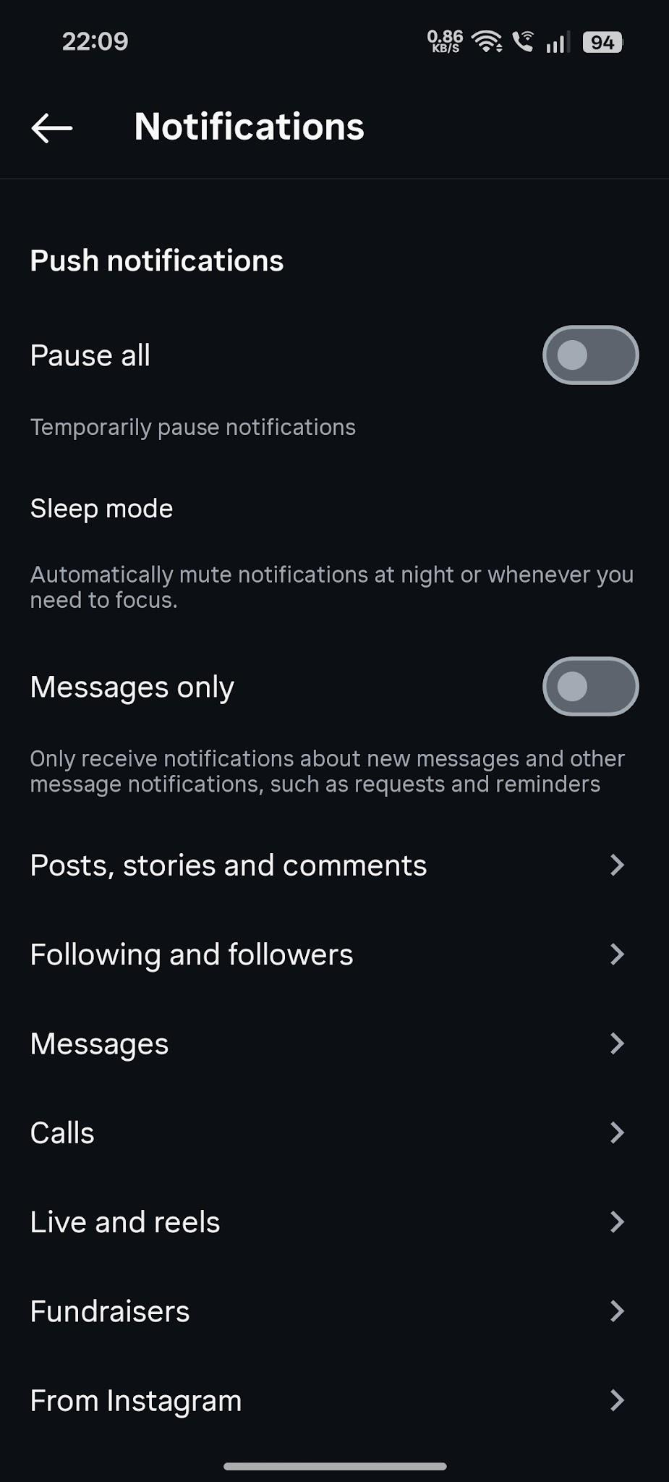

Scenario ID: i17
Scenario | Edit profile
Test Steps | 1. Open profile  2. Select Edit Profile  3. Change bio  4. Save
Test Input | Valid profile changes
Expected Results | Updated profile information is saved and displayed
Actual Results | Updated information is displayed
Status | Pass
Comments | Profile editing

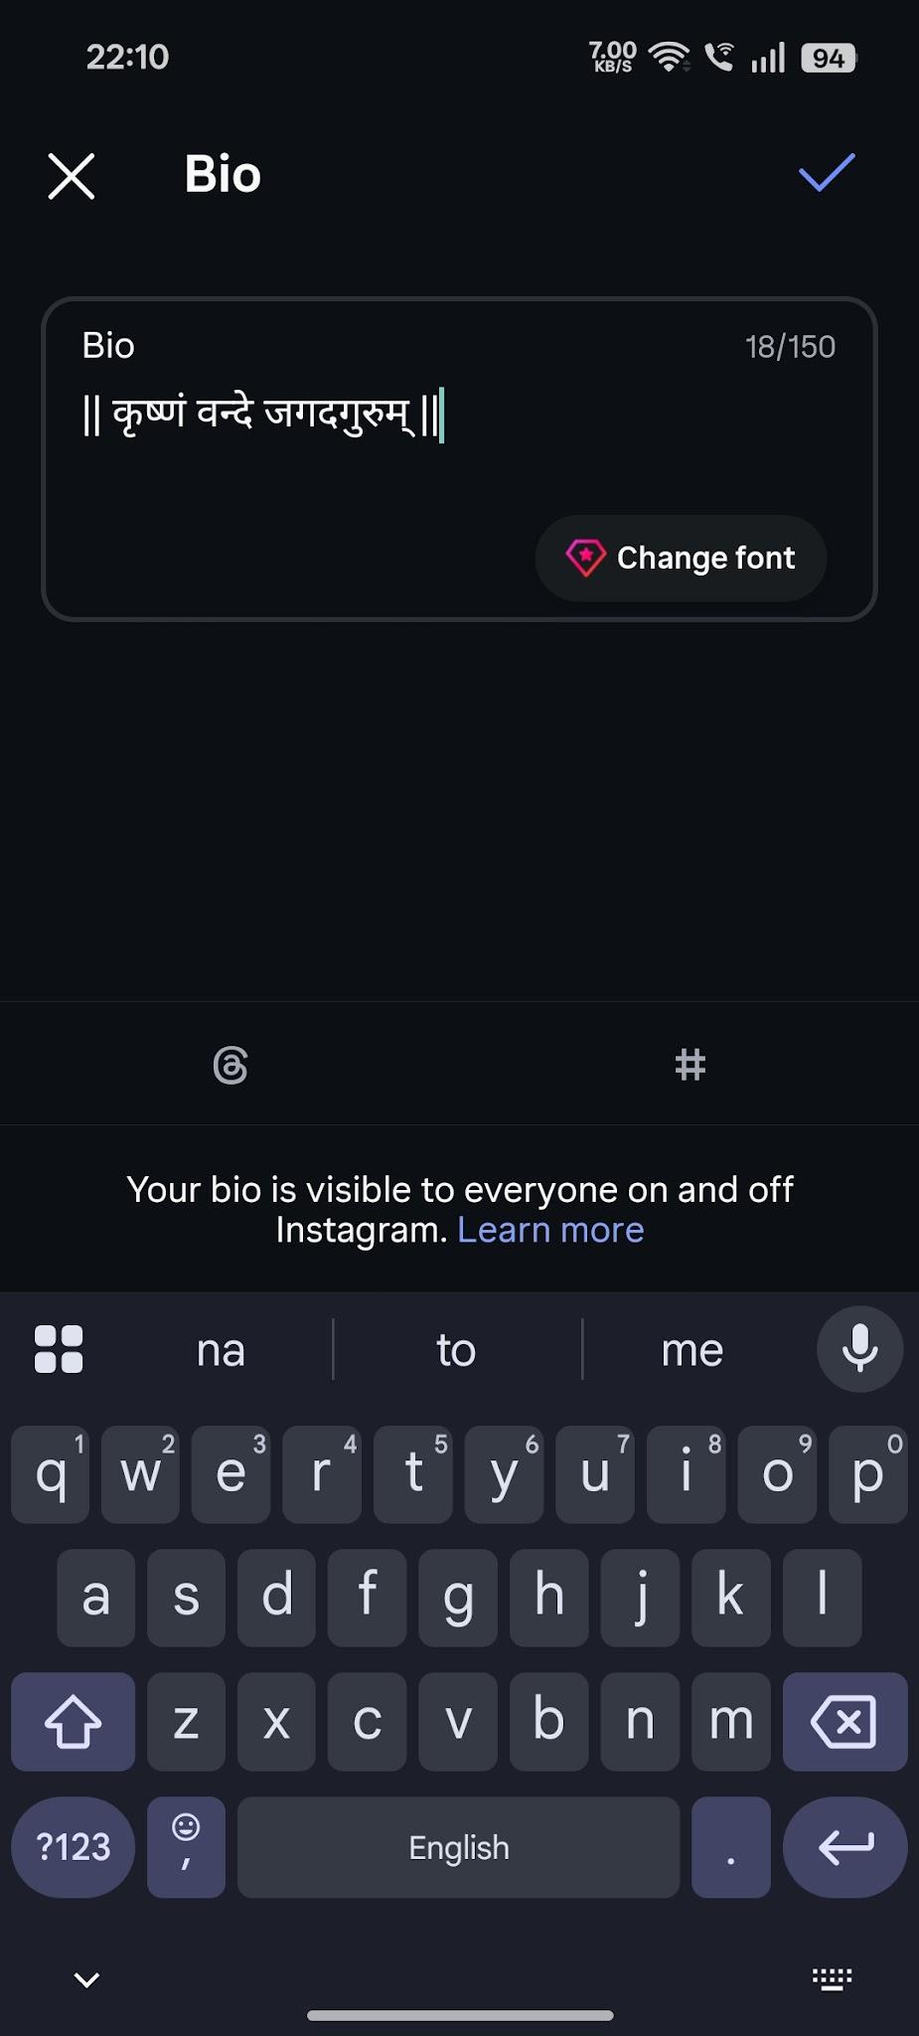

Scenario ID: i18
Scenario | Logout
Test Steps | 1. Open profile/settings  2. Select Log Out  3. Confirm
Test Input | Logged-in account
Expected Results | User is logged out and login page is displayed
Actual Results | Login page is displayed
Status | Pass
Comments | Authentication exit test
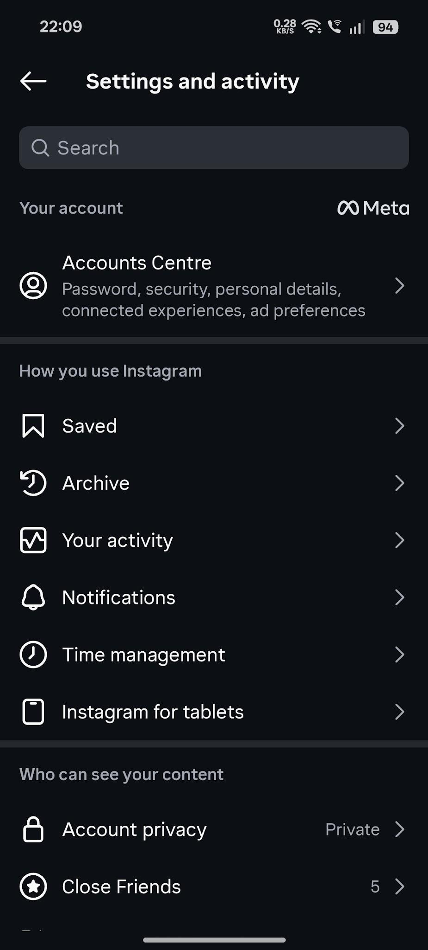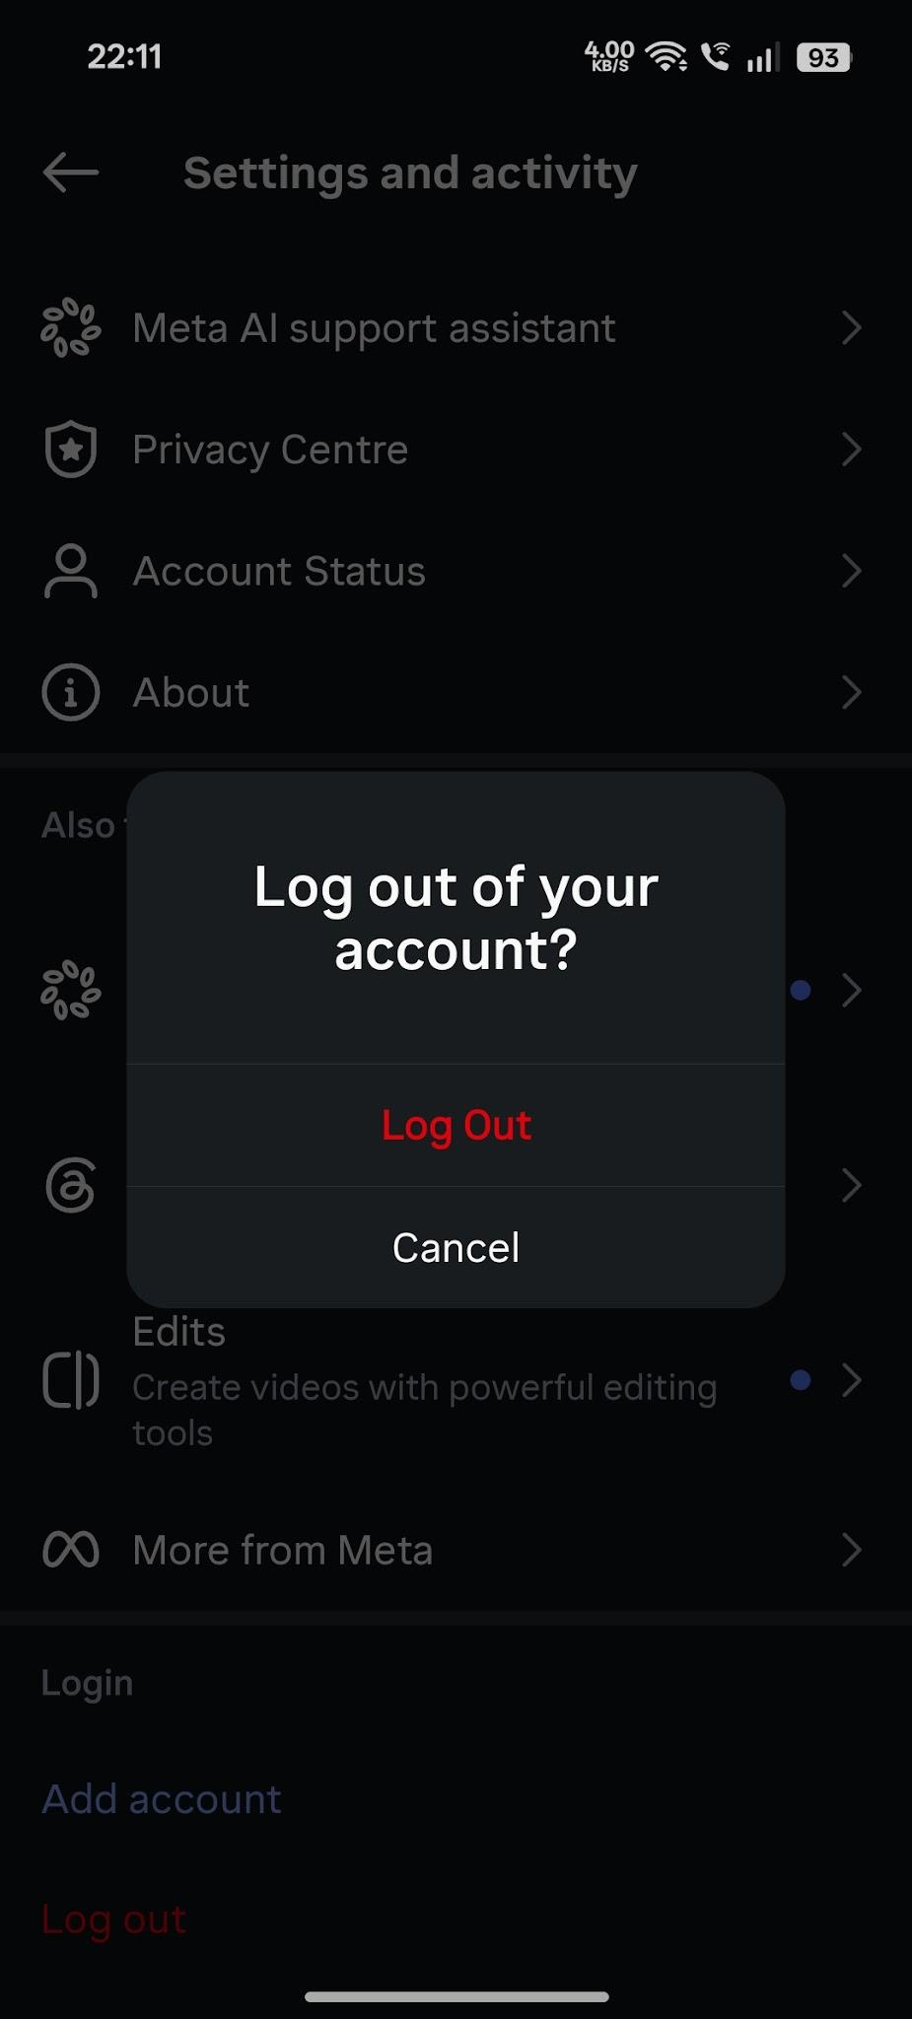

Scenario ID: i19
Scenario | Responsive UI check
Test Steps | 1. Open Instagram on desktop browser  2. Resize browser/window  3. Check feed, navigation, buttons and profile controls
Test Input | Desktop browser at different widths
Expected Results | UI remains readable and controls remain usable without unintended overlap
Actual Results | UI remains readable and controls remain usable
Status | Pass
Comments | Basic responsive UI check

Scenario ID: i20
Scenario | Back navigation
Test Steps | 1. Open a profile/post/message  2. Navigate back  3. Check application state
Test Input | Back navigation
Expected Results | User can navigate back without application crash and flow remains understandable
Actual Results | Back navigation works without crash
Status | Pass
Comments | Navigation usability test

Summary of Test Results
Total Test Cases | 20
Passed | 20
Failed | 0
Pass % | 100.00%

Conclusion and Recommendations
Pass Rate: 100.00% — The Instagram test scenarios documented in this report cover the primary social media functional workflows. The recorded results indicate that the tested scenarios completed successfully.
Recommendations
Continue testing with additional real-world negative cases, authentication/session timeout cases, privacy and access-control cases, notification scenarios, accessibility checks, and cross-browser/mobile responsiveness checks before considering the workflow fully validated.
Bug Reports
No failed test cases were recorded in this report, so no specific bug report is generated.

