Module Name: BookMyShow Application – Functional & UI Test Cases
Website URL : https://in.bookmyshow.com
Tester Name : Vaishnavi Thakor
Scenario ID : 1
Scenario : Valid Log In
Test Steps :
Log IN Page
Enter Details (Valid Phone Number: 9876543210 & Correct OTP)
Successful
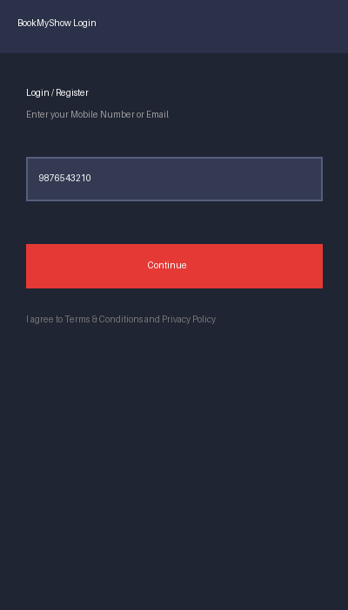
Scenario ID : 2
Scenario : Invalid Mobile Number
Test Steps :
Log IN Page
Enter Invalid Mobile Number (8 digits: 98765432) and click Continue
Validation Error Displayed
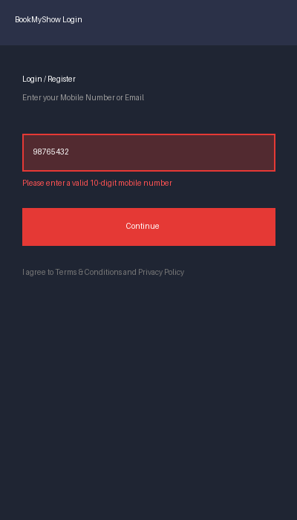
Scenario ID : 3
Scenario : Invalid OTP
Test Steps :
Log IN Page
Enter Valid Mobile Number and Incorrect OTP (000000)
Error Message Displayed
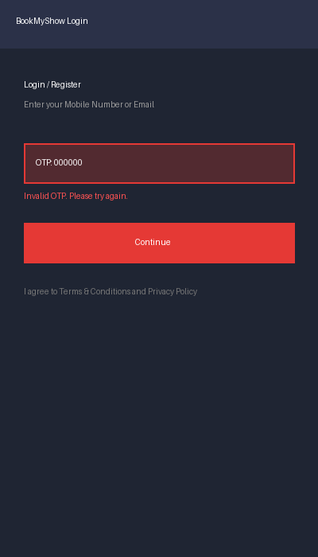
Scenario ID : 4
Scenario : Empty Input
Test Steps :
Log IN Page
Keep Field Blank
Button Disabled / Validation Required
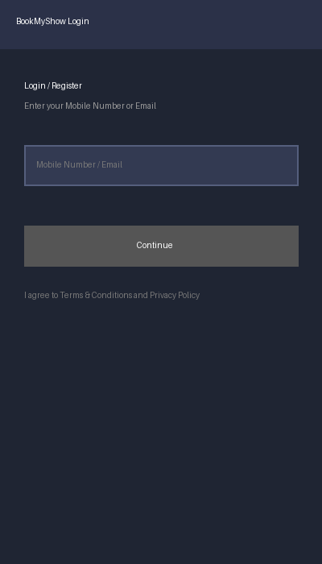
Test Case Summary
TC ID | Mobile / Email | OTP / Details | Expected Result
TC-01 | Valid | Valid | Login Successful
TC-02 | InValid | Valid | Login Rejected
TC-03 | Valid | InValid | Login Rejected
TC-04 | Blank | Blank | Validation Displayed

