PRACTICAL 9: SOFTWARE TESTING REPORT
Module Name: BookMyShow - Black Box, Integration & System Test Suite
Tester Name: Student / Tester
Webpage URL: https://in.bookmyshow.com/
1. Black Box Testing
Test Case: TC_BB_01
• Testing Type: Black Box Testing
• TC ID: TC_BB_01
• Execution:
Scenario: Valid Login
Steps:
1. Navigate to BookMyShow
2. Click 'Login’'
3. Enter registered mobile number
4. Enter valid OTP
5. Click 'Submit’
• Screenshot:

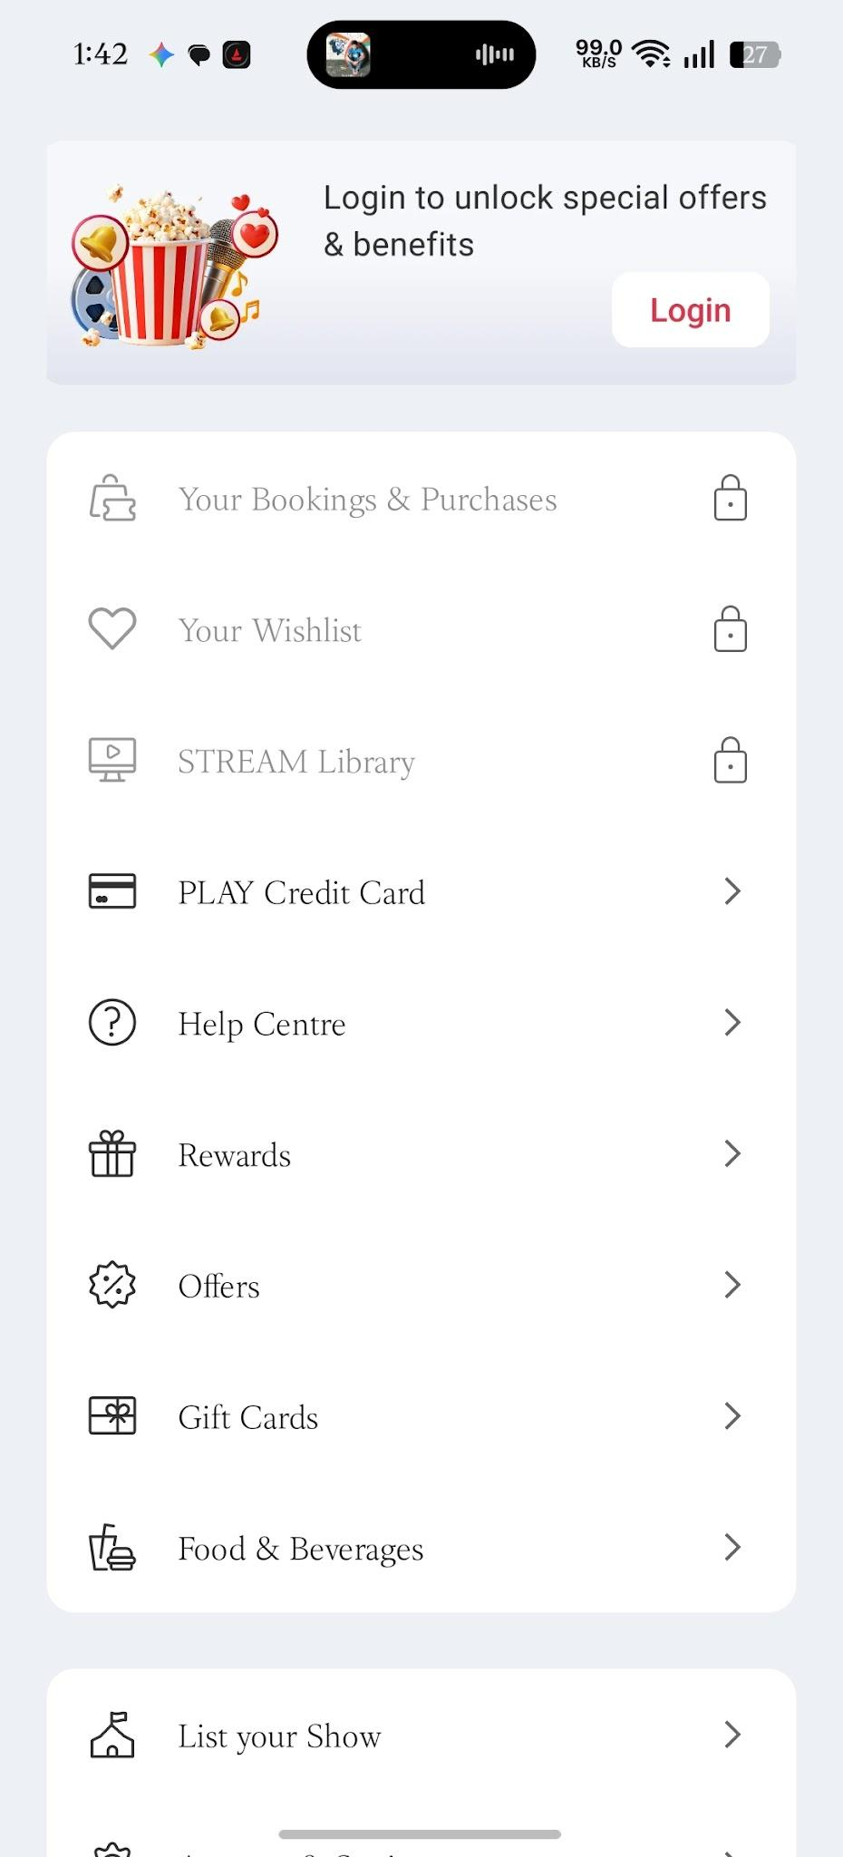
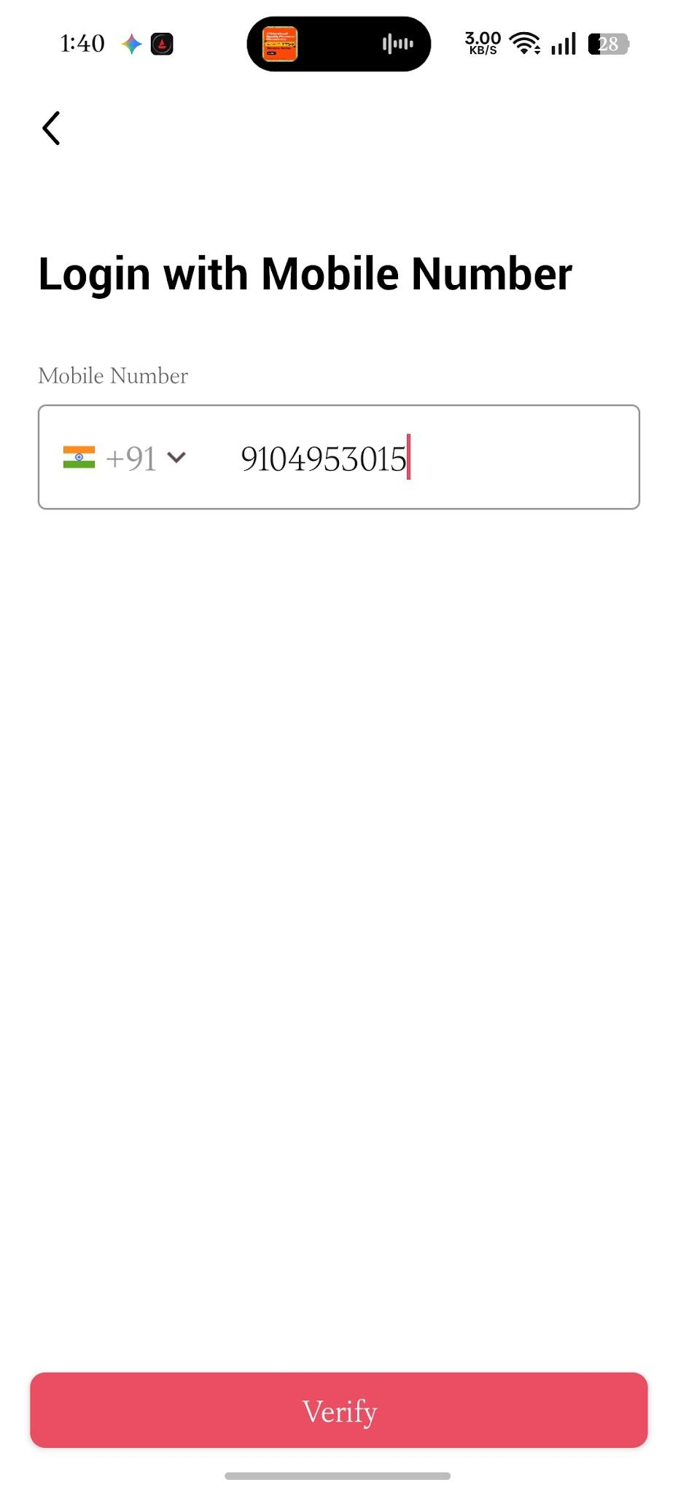
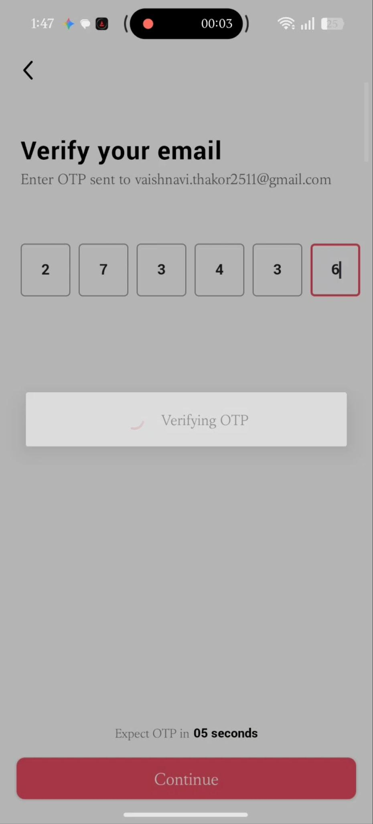
• Result: PASS (User successfully logs in and profile name appears in top right header.)
Test Case: TC_BB_02
• Testing Type: Black Box Testing
• TC ID: TC_BB_02
• Execution:
Scenario: Invalid Login
Steps:
1. Navigate to BookMyShow
2. Click 'Login'
3. Enter valid mobile number
4. Enter incorrect OTP
5. Click 'Submit'
Input Data: Mobile: 910495****, OTP: *****
• Screenshot:
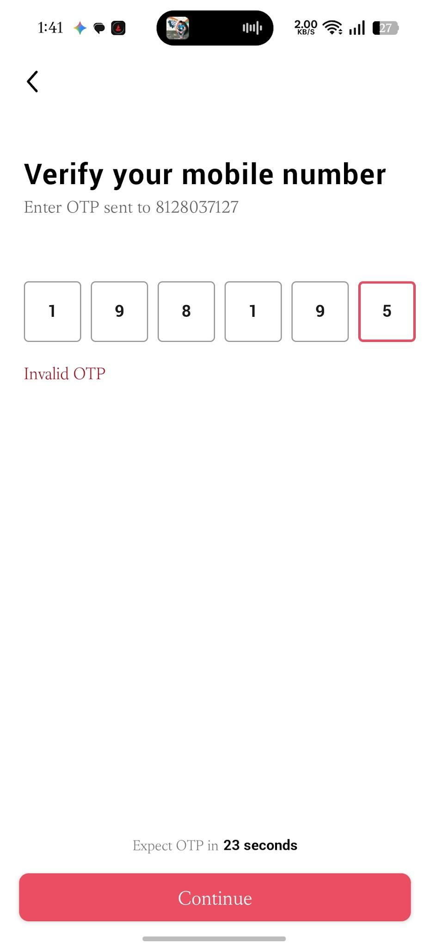
• Result: PASS (Display error message: 'Invalid OTP, please try again'. Login fails.)
Test Case: TC_BB_03
• Testing Type: Black Box Testing
• TC ID: TC_BB_03
• Execution:
Scenario: Blank Login
Steps:
1. Navigate to BookMyShow
2. Click 'Login'
3. Leave input field blank
4. Click 'Continue'
Input Data: Mobile: [Blank]
• Screenshot:
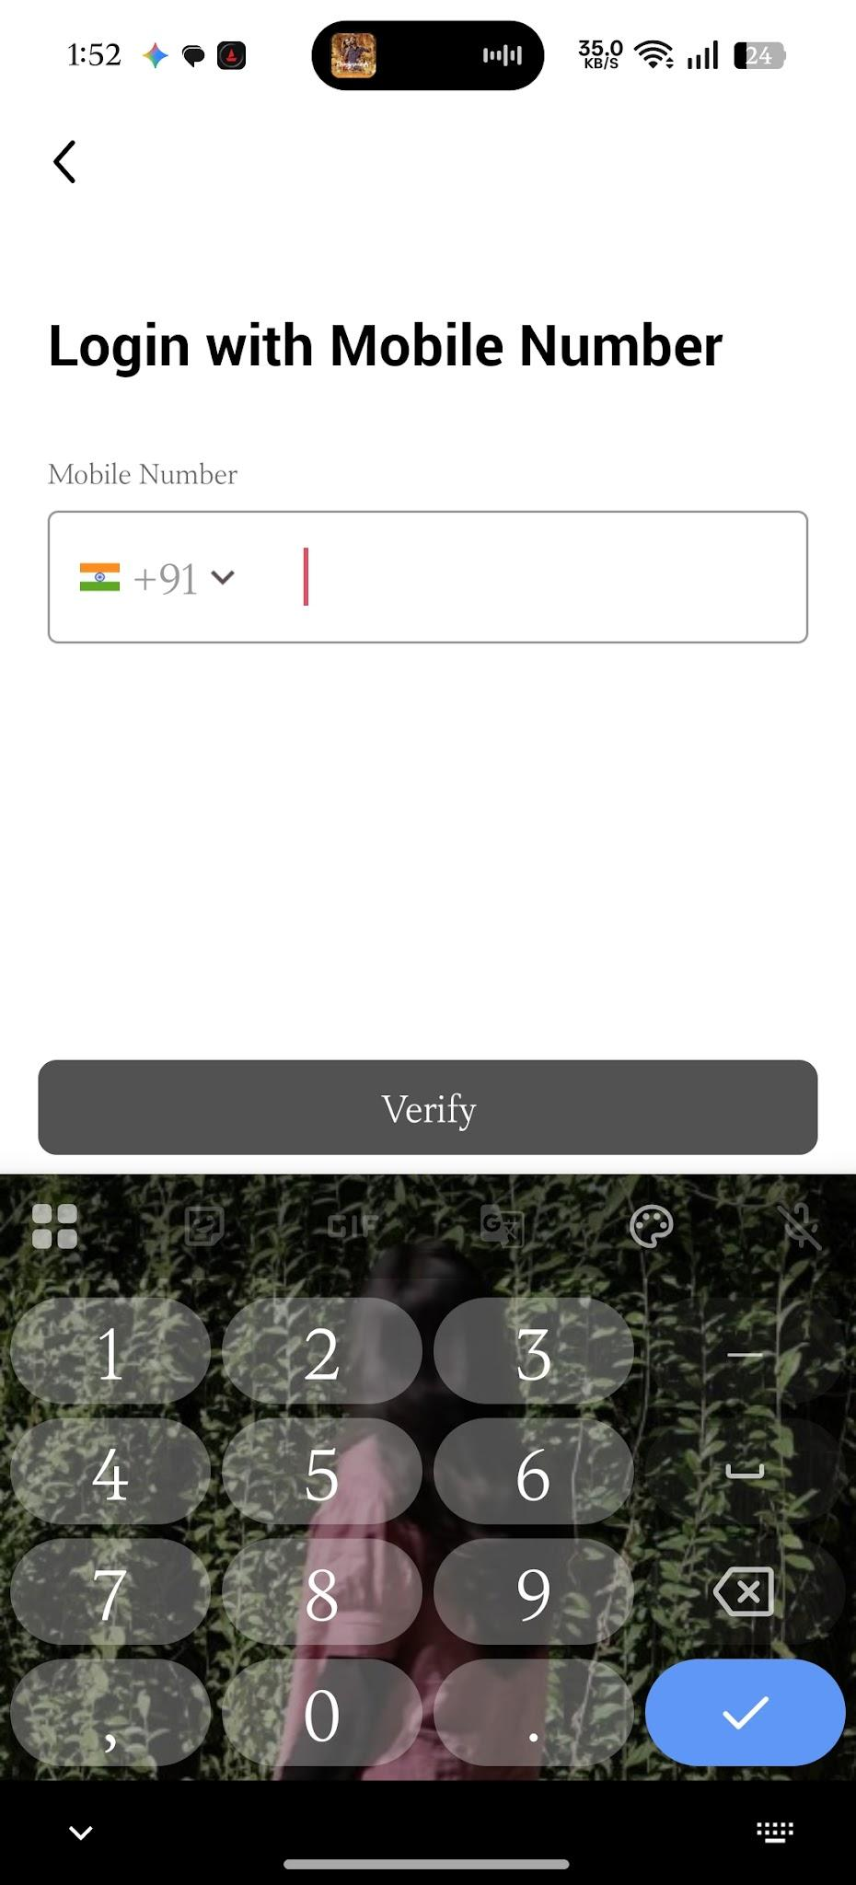
• Result: PASS (Prompt 'Please enter a valid mobile number or email address'. Submit button disabled.)
2. Integration Testing
Test Case: TC_INT_01
• Testing Type: Integration Testing
• TC ID: TC_INT_01
• Execution:
Scenario: Login -> Home/Dashboard
Steps:
1. Authenticate user via valid login process
2. Verify user session redirection to Homepage
Input Data: Valid credentials
• Screenshot:

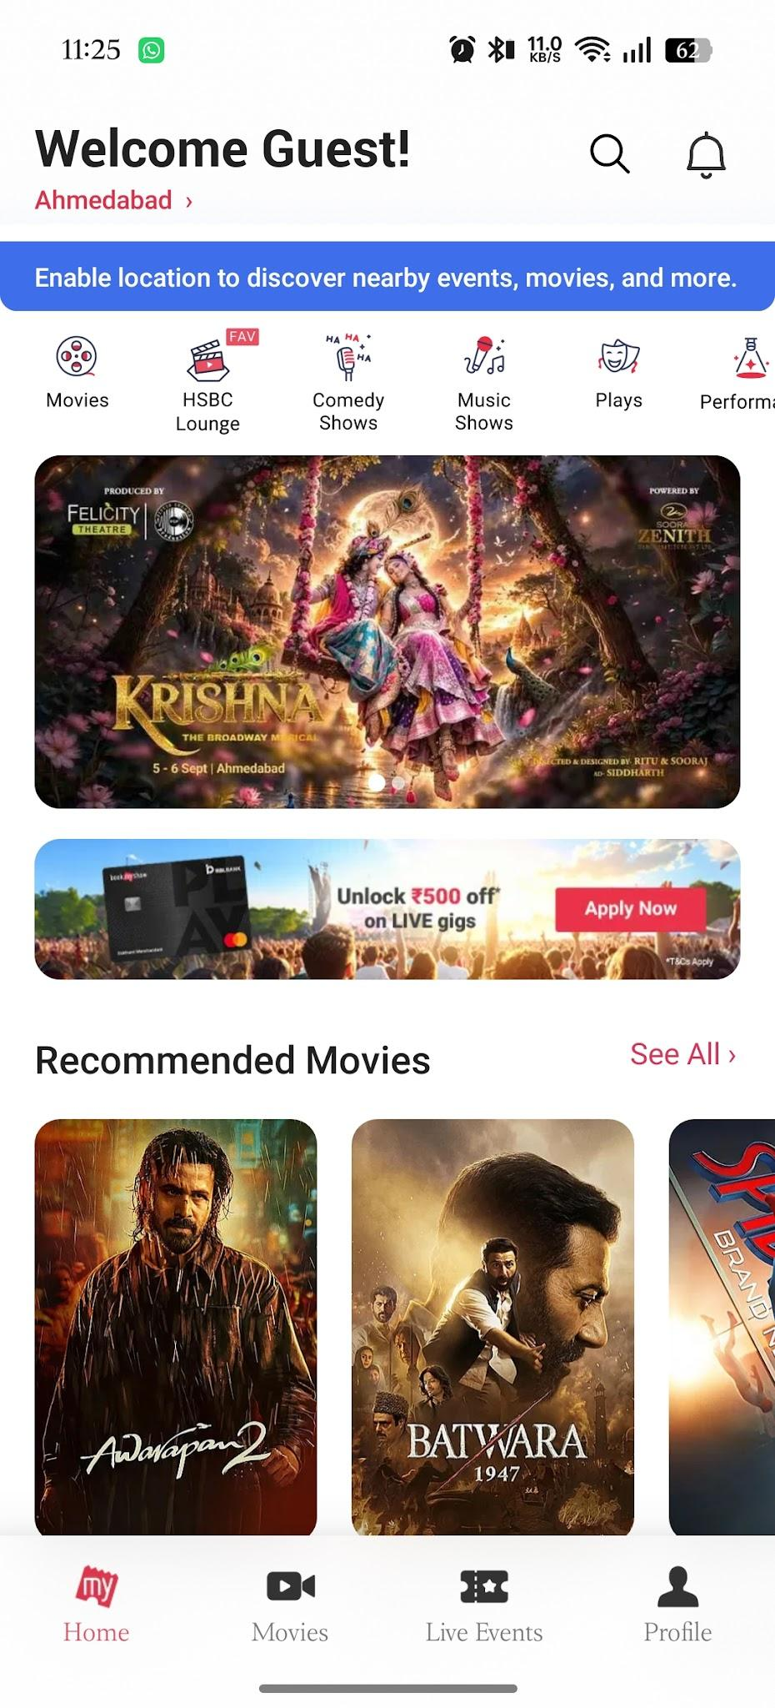

• Result: PASS (System passes user credentials to session manager and redirects to personalized home page.)
Test Case: TC_INT_02
• Testing Type: Integration Testing
• TC ID: TC_INT_02
• Execution:
Scenario: Home -> Ticket Booking Module
Steps:
1. From Homepage, select a movie
2. Choose Cinema & Show timing
3. Select seats and proceed to Checkout
Input Data: Movie: Avatar 3, Seats: A1, A2
• Screenshot:
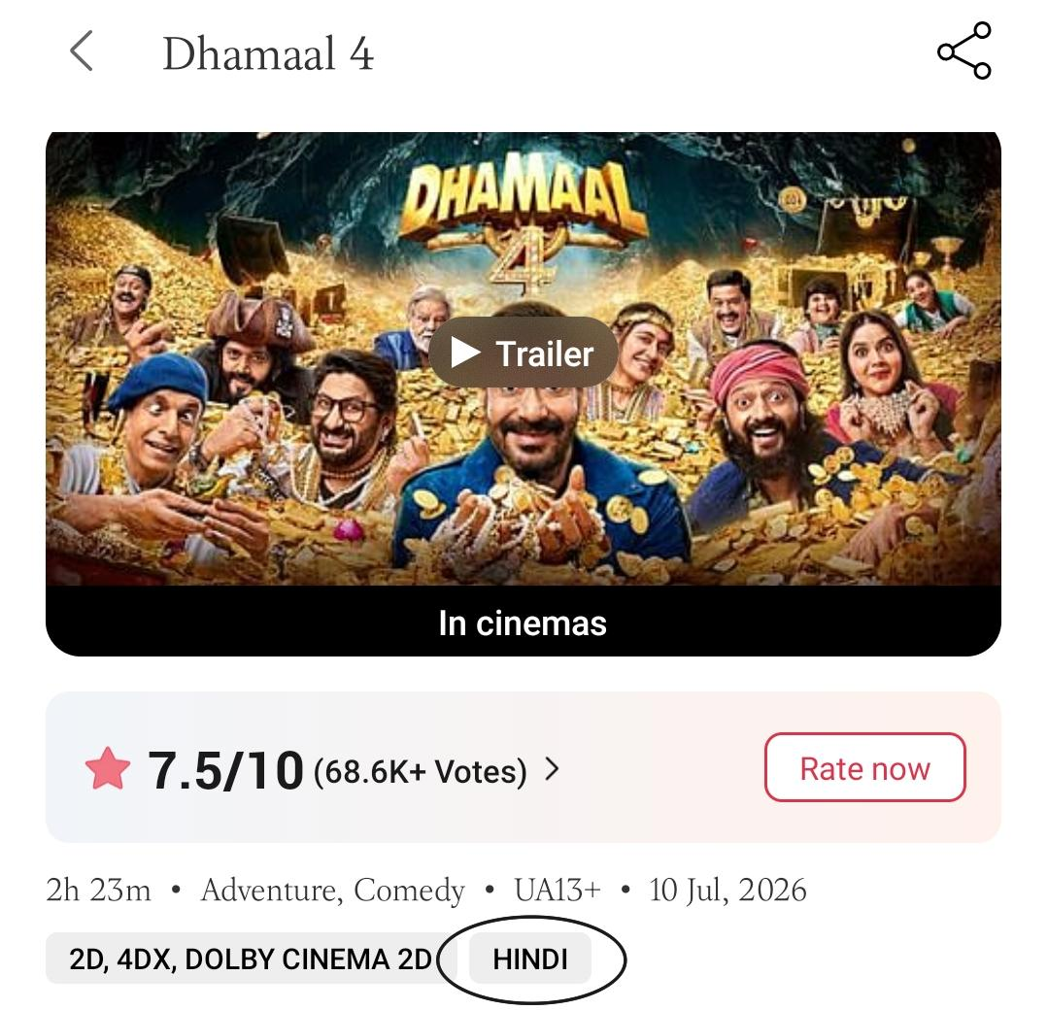
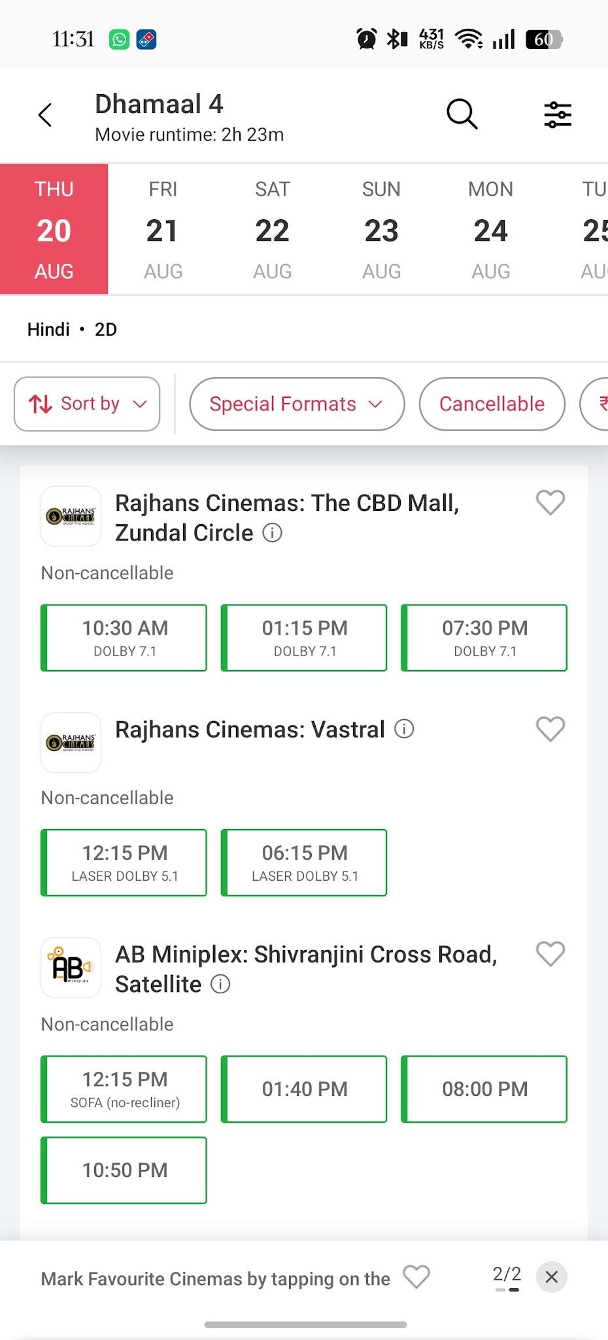
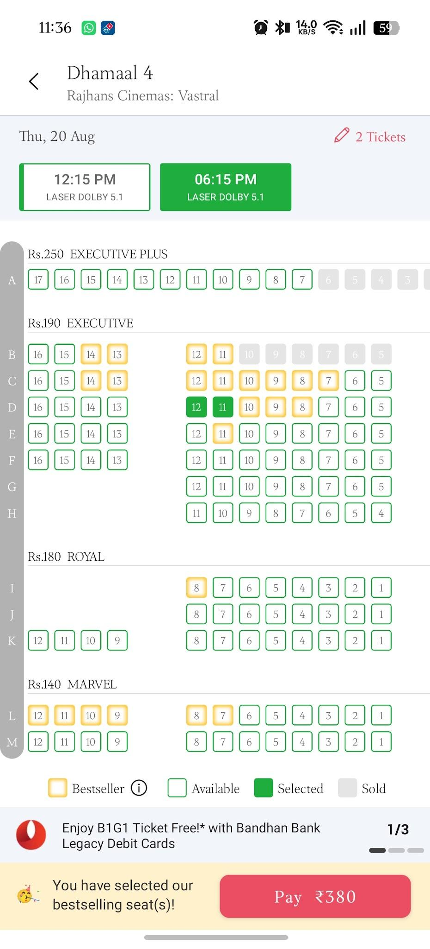
• Result: PASS (System correctly transfers selected seat IDs and calculated total price to checkout module.)
3. System Testing
Test Case: TC_SYS_01
• Testing Type: System Testing
• TC ID: TC_SYS_01
• Execution:
Scenario: Complete Ticket Booking Workflow
Steps:
1. Open BookMyShow & Select City
2. Login to account
3. Search & select movie
4. Pick date, theater, time, and seat
5. Proceed to payment page
6. Apply promo code & complete payment via UPI
7. Check ticket confirmation
Input Data: City: Mumbai, Movie: Inception, Payment: UPI
• Screenshot:
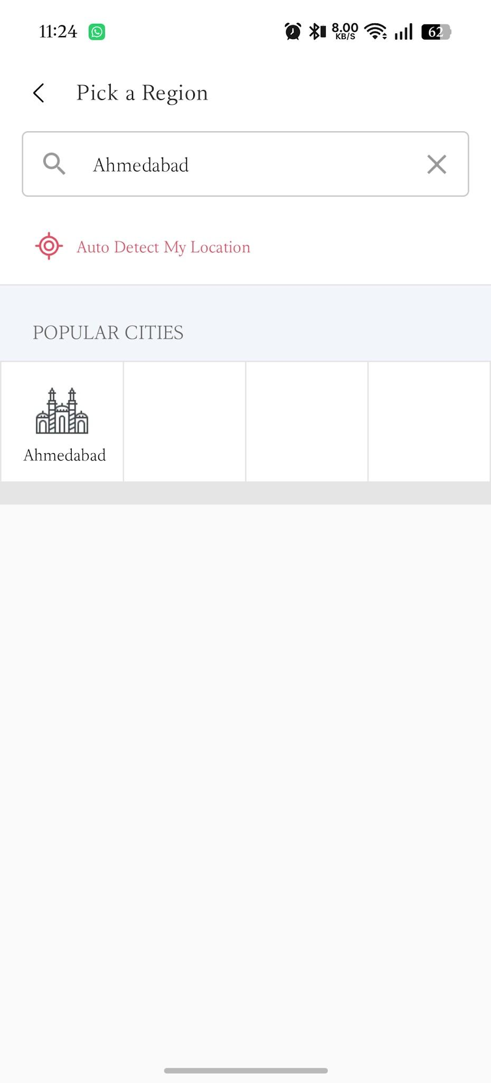
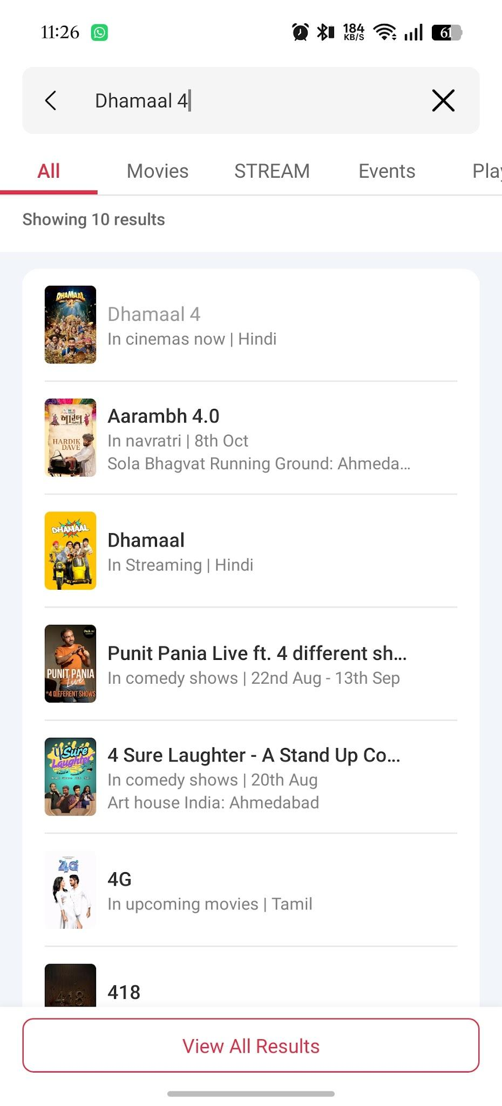
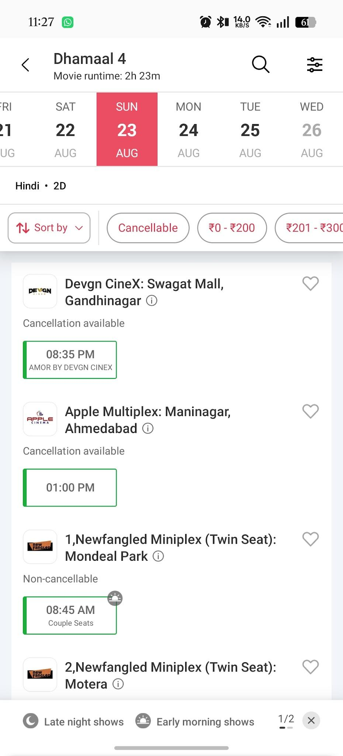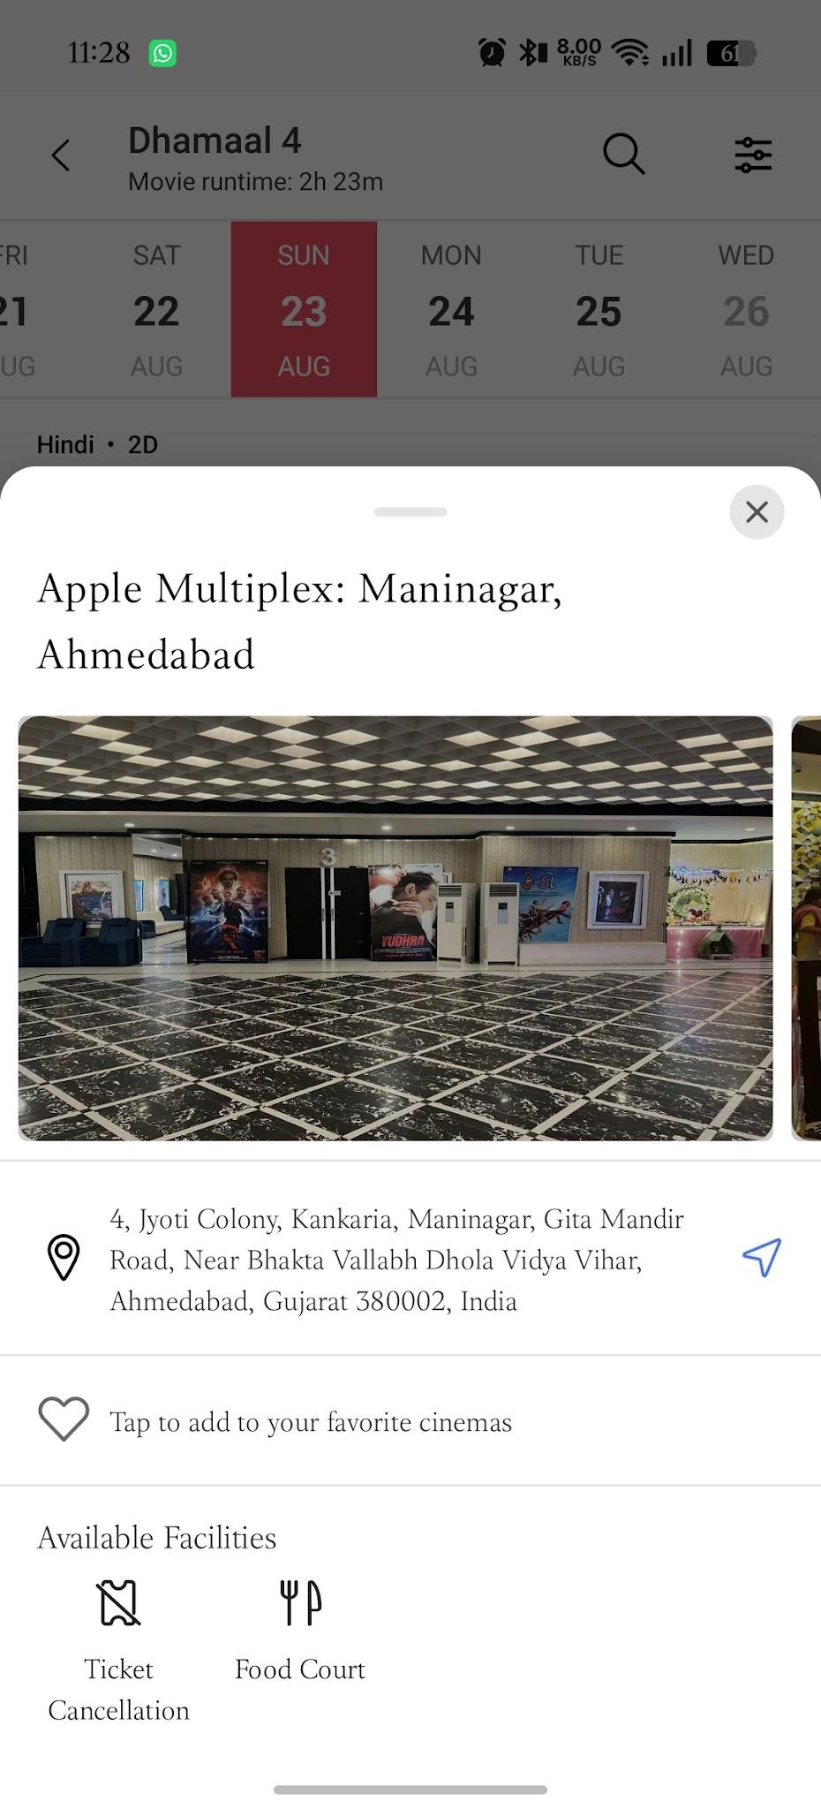
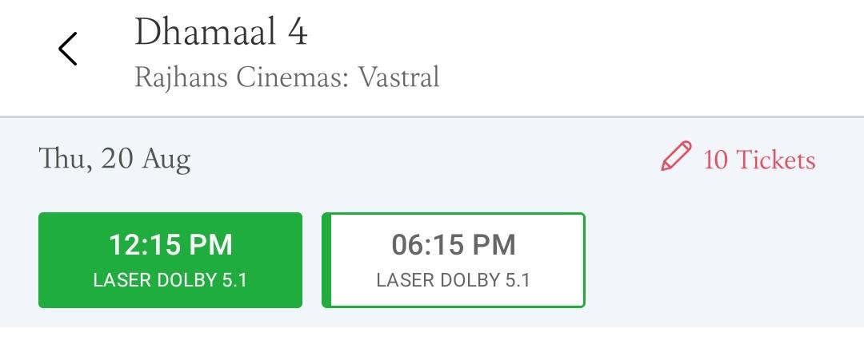
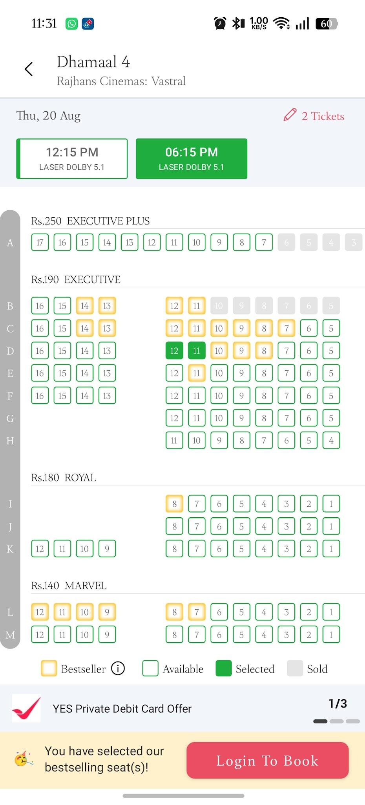
• Result: PASS (Complete end-to-end flow executes successfully. Booking confirmation SMS/Email generated with QR code.)
4. White Box Testing
Test Case: TC_WB_01
• Testing Type: White Box Testing
• TC ID: TC_WB_01
• Execution:
Coverage Type: Statement Coverage
Input / Scenario: num_tickets = 0
Path Executed: Statement 1 -> Statement 2 (Invalid)
• Screenshot: [Insert Screenshot Here]
• Result: PASS (Output: 'Invalid ticket count')
Test Case: TC_WB_02
• Testing Type: White Box Testing
• TC ID: TC_WB_02
• Execution:
Coverage Type: Branch Coverage
Input / Scenario: num_tickets = 2, price = 300, promo = 'MOVIE50'
Path Executed: Total > 500 True Branch -> Promo MOVIE50 Branch
• Screenshot: [Insert Screenshot Here]
• Result: PASS (Output: 600)
Test Case: TC_WB_03
• Testing Type: White Box Testing
• TC ID: TC_WB_03
• Execution:
Coverage Type: Branch Coverage
Input / Scenario: num_tickets = 1, price = 200, promo = 'FIRST100'
Path Executed: Total > 500 False Branch -> Promo FIRST100 Branch
• Screenshot: [Insert Screenshot Here]
• Result: PASS (Output: 120)
Test Case: TC_WB_04
• Testing Type: White Box Testing
• TC ID: TC_WB_04
• Execution:
Coverage Type: Path Coverage
Input / Scenario: num_tickets = 1, price = 100, promo = 'NONE'
Path Executed: Total > 500 False Branch -> No Promo Branch
• Screenshot: [Insert Screenshot Here]
• Result: PASS (Output: 120)

