Command |  | What it does / Why you use it
python -m pip install django |  | Installs Django framework into your Python environment. You need this before using any Django commands.
django-admin startproject <project_name> (or) python -m  django startproject <project_name> |  | Creates a new Django project folder structure: settings, URLs, WSGI/ASGI files, manage.py. This sets up the “skeleton” of your web-app.
python manage.py startapp <app_name> |  | Inside a project, creates a new “app” — a submodule representing a feature or domain (e.g. tasks, users). Generates folders + files (models, views, admin, etc.).
python manage.py makemigrations <app_name> |  | Checks your models.py for any changes (new model classes or fields), and creates migration files (which describe schema changes) — but doesn’t apply them yet.
python manage.py migrate |  | Applies pending migrations: creates or modifies database tables according to your models. For example, if you defined a model in tasks.models, migrate will create its table in database (SQLite by default).
python manage.py runserver [port] |  | Starts Django’s built-in development server. By default, it runs on port 8000 (accessible at http://127.0.0.1:8000/). If you want a different port, you can specify e.g. runserver 8080. Good for local testing.
python manage.py createsuperuser |  | Lets you create an admin/superuser account so you can access Django’s admin interface (to manage models via web). Useful for testing or managing data manually.
python manage.py test |  | Runs tests defined in any tests.py within your apps. Useful to verify your code works as expected (unit tests, integration tests).
python manage.py shell |  | Opens an interactive Python shell with your Django project loaded — useful for quick experimentation / debugging / playing with models.

🧪 Example typical workflow when you build something new:
- Modify models.py → 2. makemigrations → 3. migrate → 4. runserver → 5. Test in browser or with test.

My Project Structure and Explanation of Each File
Below is the project structure I used, along with a clear explanation of the purpose of every file and folder.
task-analyzer/ ← project root
│ ├── manage.py ← command-line utility to run Django commands :
│ └── task_analyzer/ ← Django project package
│ ├── __init__.py ← Makes this directory a Python package :
│ ├── settings.py ← Main settings/configuration (database, INSTALLED_APPS, middleware, static files etc.)
│ ├── urls.py ← URL routing: maps URLs to views/controllers }
│ └── wsgi.py (or asgi.py) ← Entry point for WSGI (production/web-server), bridges Django to web server
├── tasks/ ← A Django “app” you created (for tasks logic)
│ ├── migrations/ ← Stores migration files (database schema history)
│ ├── models.py ← Define data models (tables) via Django ORM :
│ ├── views.py ← Define view functions / endpoints (the logic when a URL is hit) :
│ ├── admin.py ← Register models to Django admin UI, to manage via web UI :
│ ├── apps.py ← App configuration meta-details (name, signals, readiness) : }
│ ├── serializers.py / scoring.py / urls.py / etc. ← Custom files depending on your project needs (e.g. API serializers, business logic, routing) |
│ └── tests.py ← Write tests for your app (unit tests / integration tests) :
├── frontend/ ← Your static front-end (HTML, CSS, JS) — if you combine Django backend with a simple front-end
└── requirements.txt ← List of Python dependencies (Django version, other packages) — useful for reproducible environment

Example Full Setup + Run Workflow (from scratch)
Suppose you start fresh. Here’s sequence of commands + what you expect:
# 1. Install Django
python -m pip install django

# 2. Create project
django-admin startproject task_analyzer

cd task_analyzer

# 3. Create an app
python manage.py startapp tasks

# 4. (Optional) add any custom files in tasks/ — e.g. scoring.py, serializers.py, urls.py

# 5. Add 'tasks' to INSTALLED_APPS in task_analyzer/settings.py

# 6. Prepare database — create tables
python manage.py makemigrations tasks
python manage.py migrate

# 7. Create superuser (to access admin)
python manage.py createsuperuser

# 8. Run the development server on default port 8000
python manage.py runserver
# → open browser at http://127.0.0.1:8000/

# 9. If you want to run tests:
python manage.py test

Simple and Clear Breakdown of Each Command and File in the Project
- manage.py — your “control panel”: run server, migrations, create apps, run tests, etc. Without it, you can’t do most Django tasks.
- startproject / startapp — create skeleton boilerplate automatically, so you don’t have to manually create many files.
- models.py — design the shape of your data (what tables, what fields).
- migrations / migrate — convert your model definitions into actual database tables and keep schema in sync as you change models.
- views.py + urls.py — define how your app responds to web requests / URLs.
- admin.py / createsuperuser — provide quick admin UI to manage your data (easy for testing and controlling data).
- runserver — quickly start a local server to test your app in a browser — great for development.
- tests.py / test command — for verifying your code works correctly (especially important as project grows).
Screenshots of After compiling the Commands
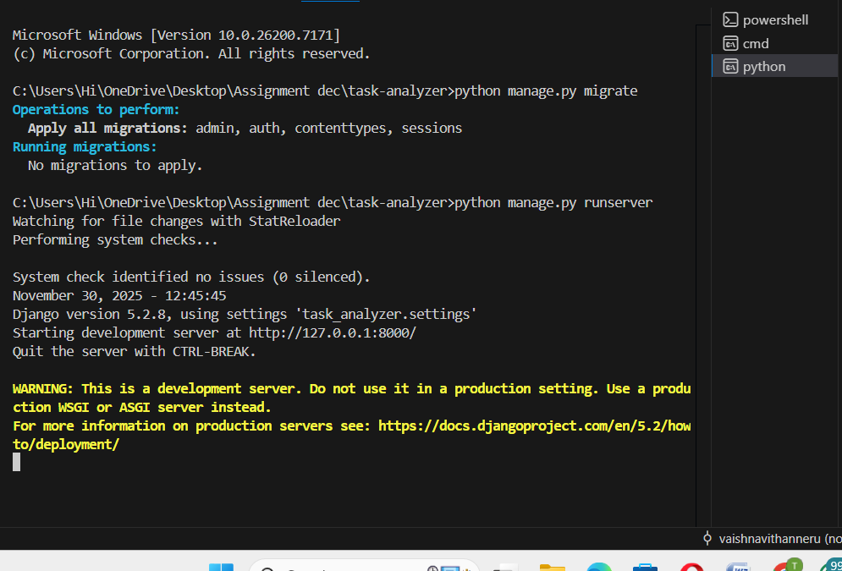

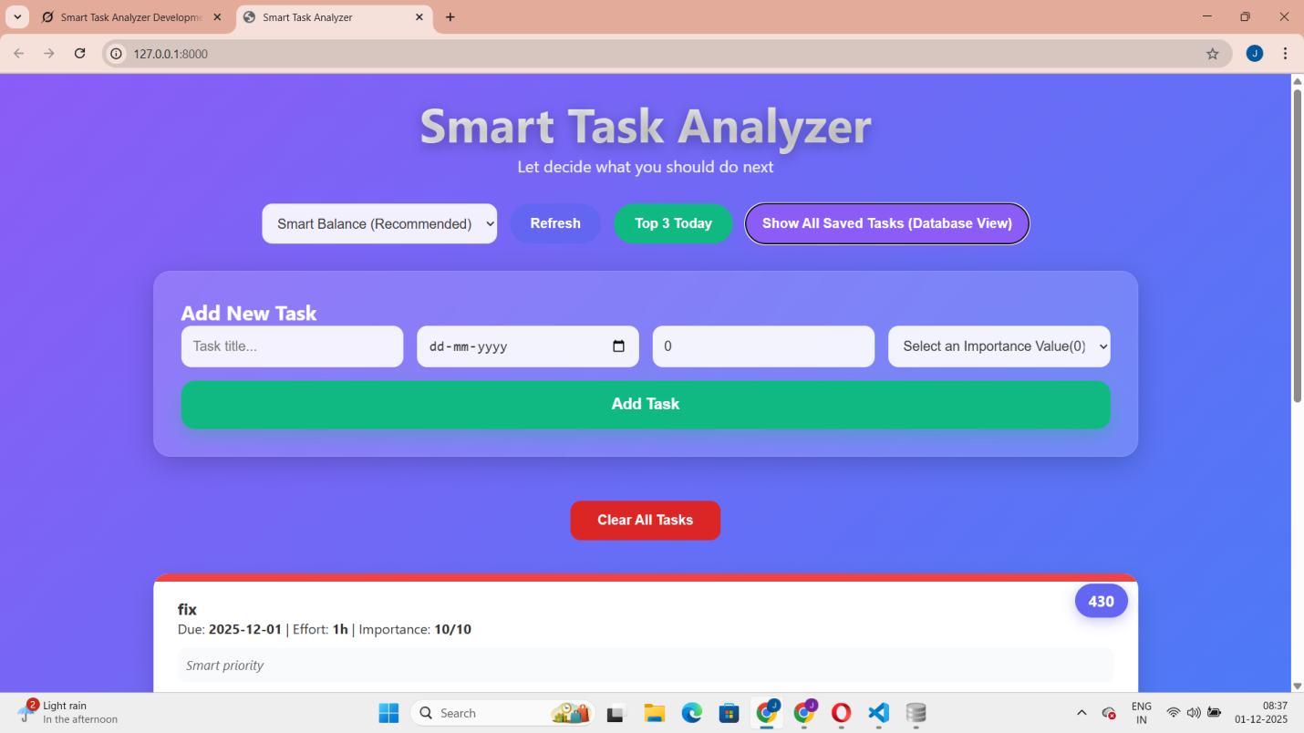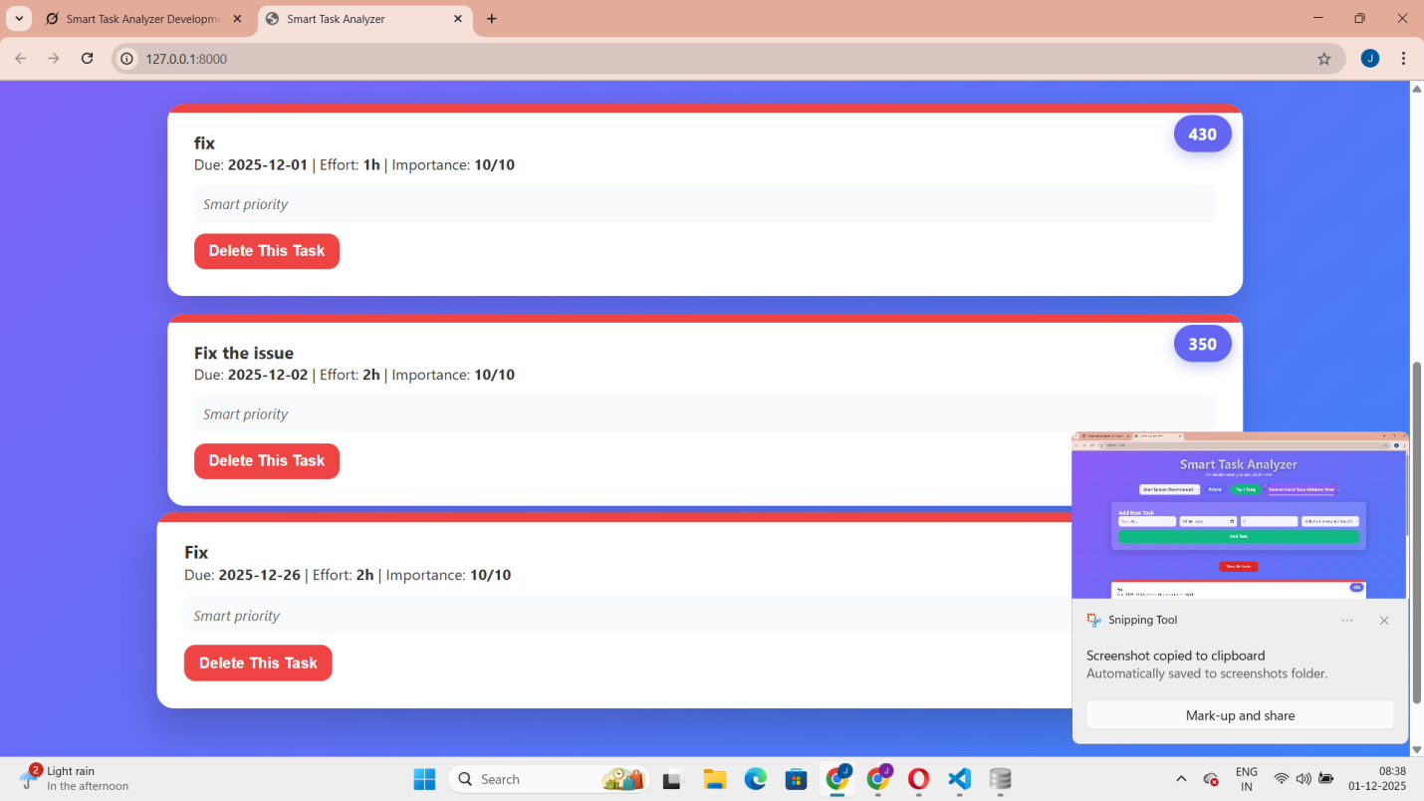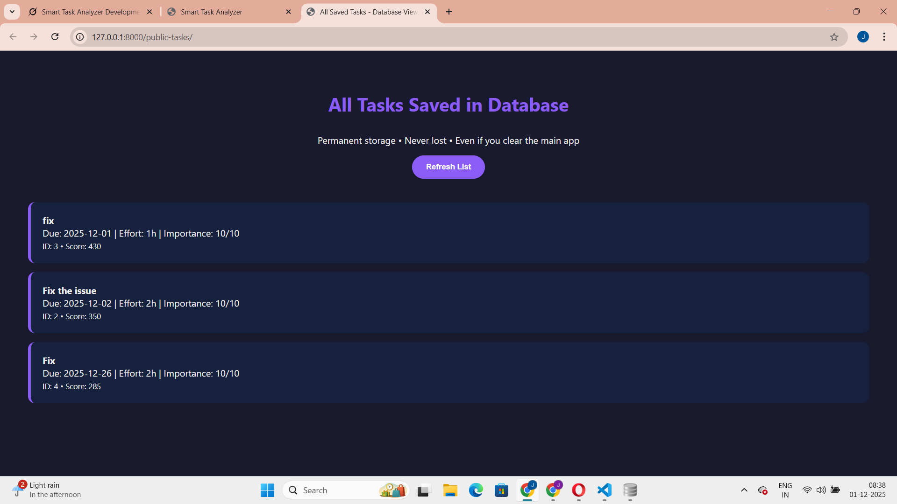

Database stored in file named as db.sqlite3 in that tasks_task

