INTRODUCTION

* 1. Overview

The process of creating info graphics is sometimes referred to as data visualization. Designers start by researching the topic and gathering data and then organizing in into a visual it into a visual format.

* 1. Purpose

As in the example below, info graphics use striking, engaging visuals to communicate information quickly and clearly. Info graphics are a valuable tool for visual communication.

Problem Definition & Design Thinking

2.1 Empathy map

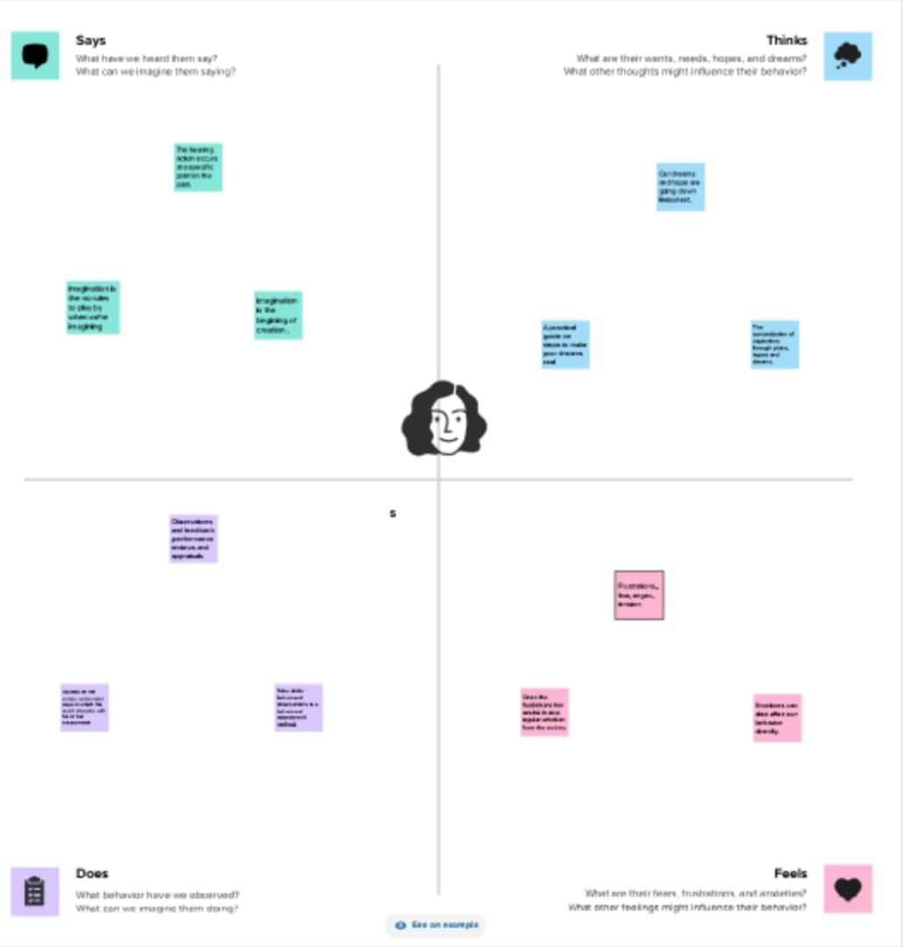

2.2 Ideation & Brainstorming map

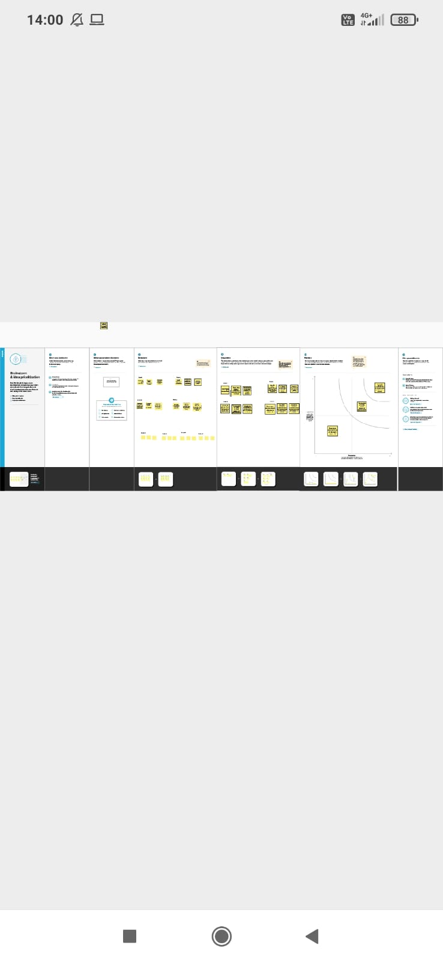

3 RESULT

.

4 ADVANTAGES & DISADVANTAGES

4.1 ADVANTAGE

 Info graphics can make it easier to access the key points of your material in a way that is easy to consume.

4.2 DISADVANTAGE

To make the infographic engaging, you need to create a format that is simple to read, includes relevant pictures, and conveys information.

5 APPLICATIONS

I have used canva application and mural application.

6. Conclusion

We have created book cover with the help of canva

7. Future scope

We were planning to join the graphic designing course.