CODE – DISPLAYING SIGNAL 1

import matplotlib.pyplot as plt

import numpy as np

fig, axs = plt.subplots()

dt = 0.01

t = np.arange(0, 10, dt)

x1 = np.cos(6* np.pi * t)

axs.set_title(" x1 Signal")

axs.plot(x1, color='C0')

axs.set_xlabel("Time")

axs.set_ylabel("Amplitude")

plt.show()

OUTPUT –

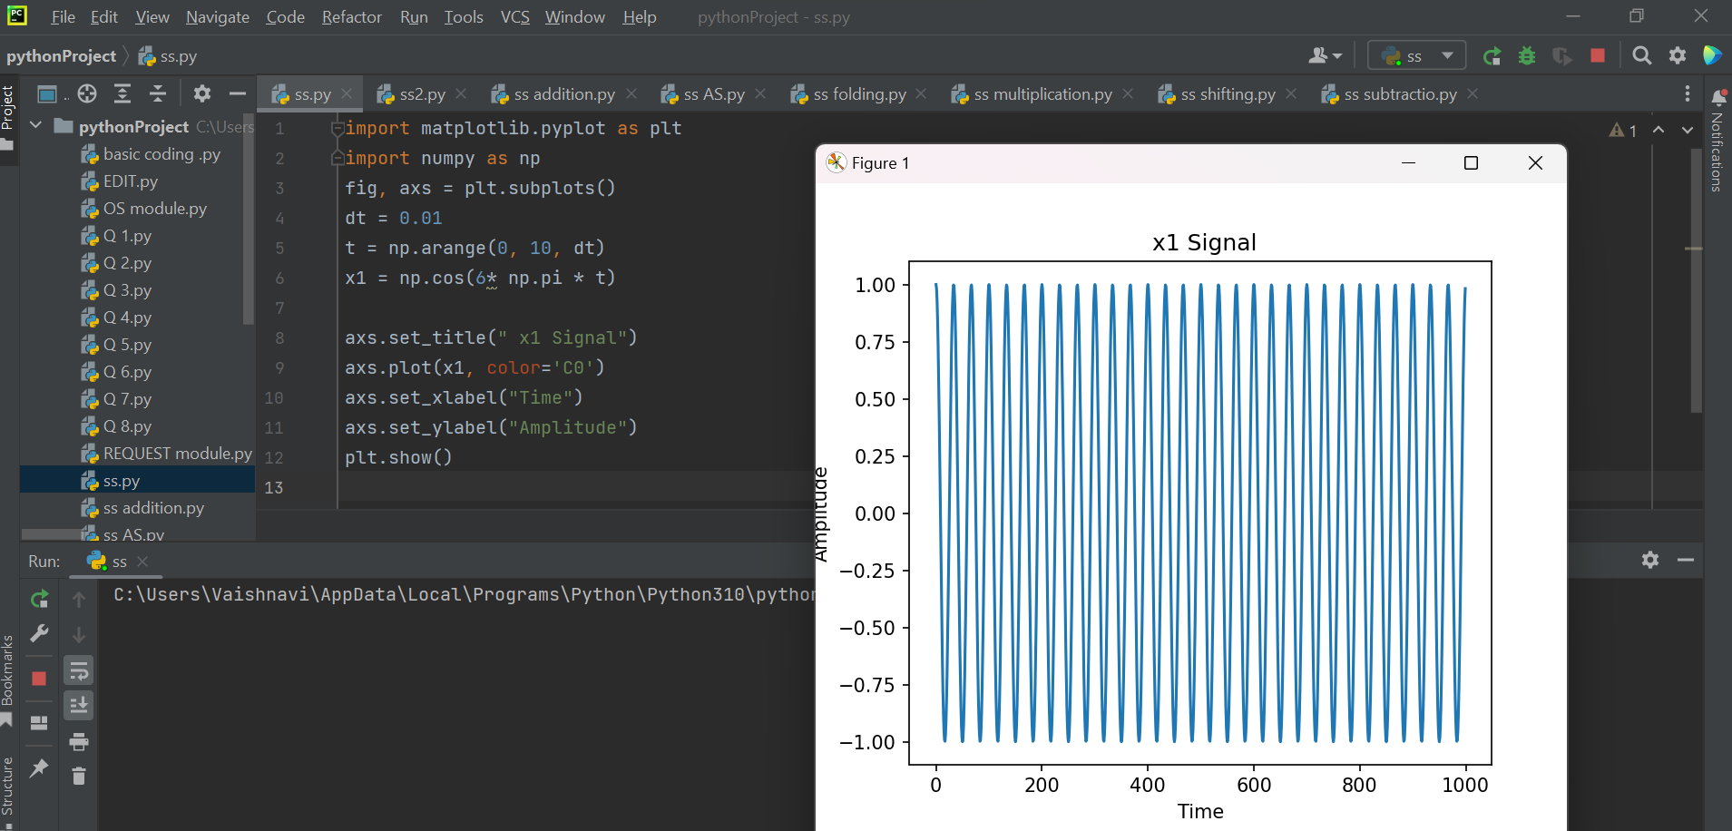

CODE – DISPLAYING SIGNAL 2

import matplotlib.pyplot as plt

import numpy as np

fig, axs = plt.subplots()

dt = 0.01

t = np.arange(0, 10, dt)

x2 = np.sin(2 * np.pi * t)

axs.set_title("x2 Signal")

axs.plot(x2, color='C0')

axs.set_xlabel("Time")

axs.set_ylabel("Amplitude")

plt.show()

OUTPUT –

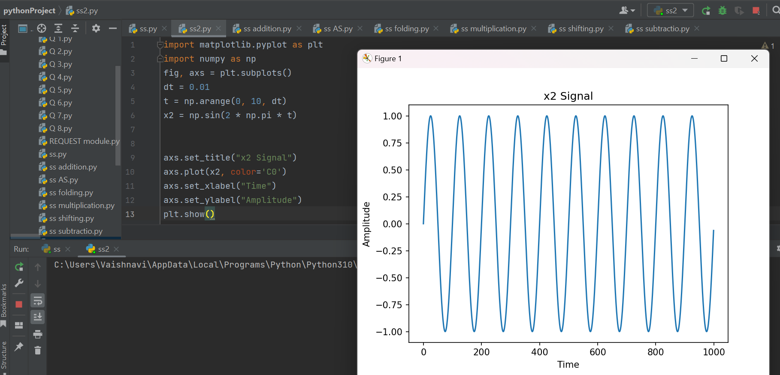

CODE – ADDITION OF 2 SIGNALS

import matplotlib.pyplot as plt

import numpy as np

fig, axs = plt.subplots()

dt = 0.01

t = np.arange(0, 10, dt)

x1 = np.cos(6* np.pi * t)

x2 = np.sin(2 * np.pi * t)

y1 = x1+x2

axs.set_title("Addition of Signals")

axs.plot(t, y1, color='C0')

axs.set_xlabel("Time")

axs.set_ylabel("Amplitude")

plt.show()

OUTPUT –

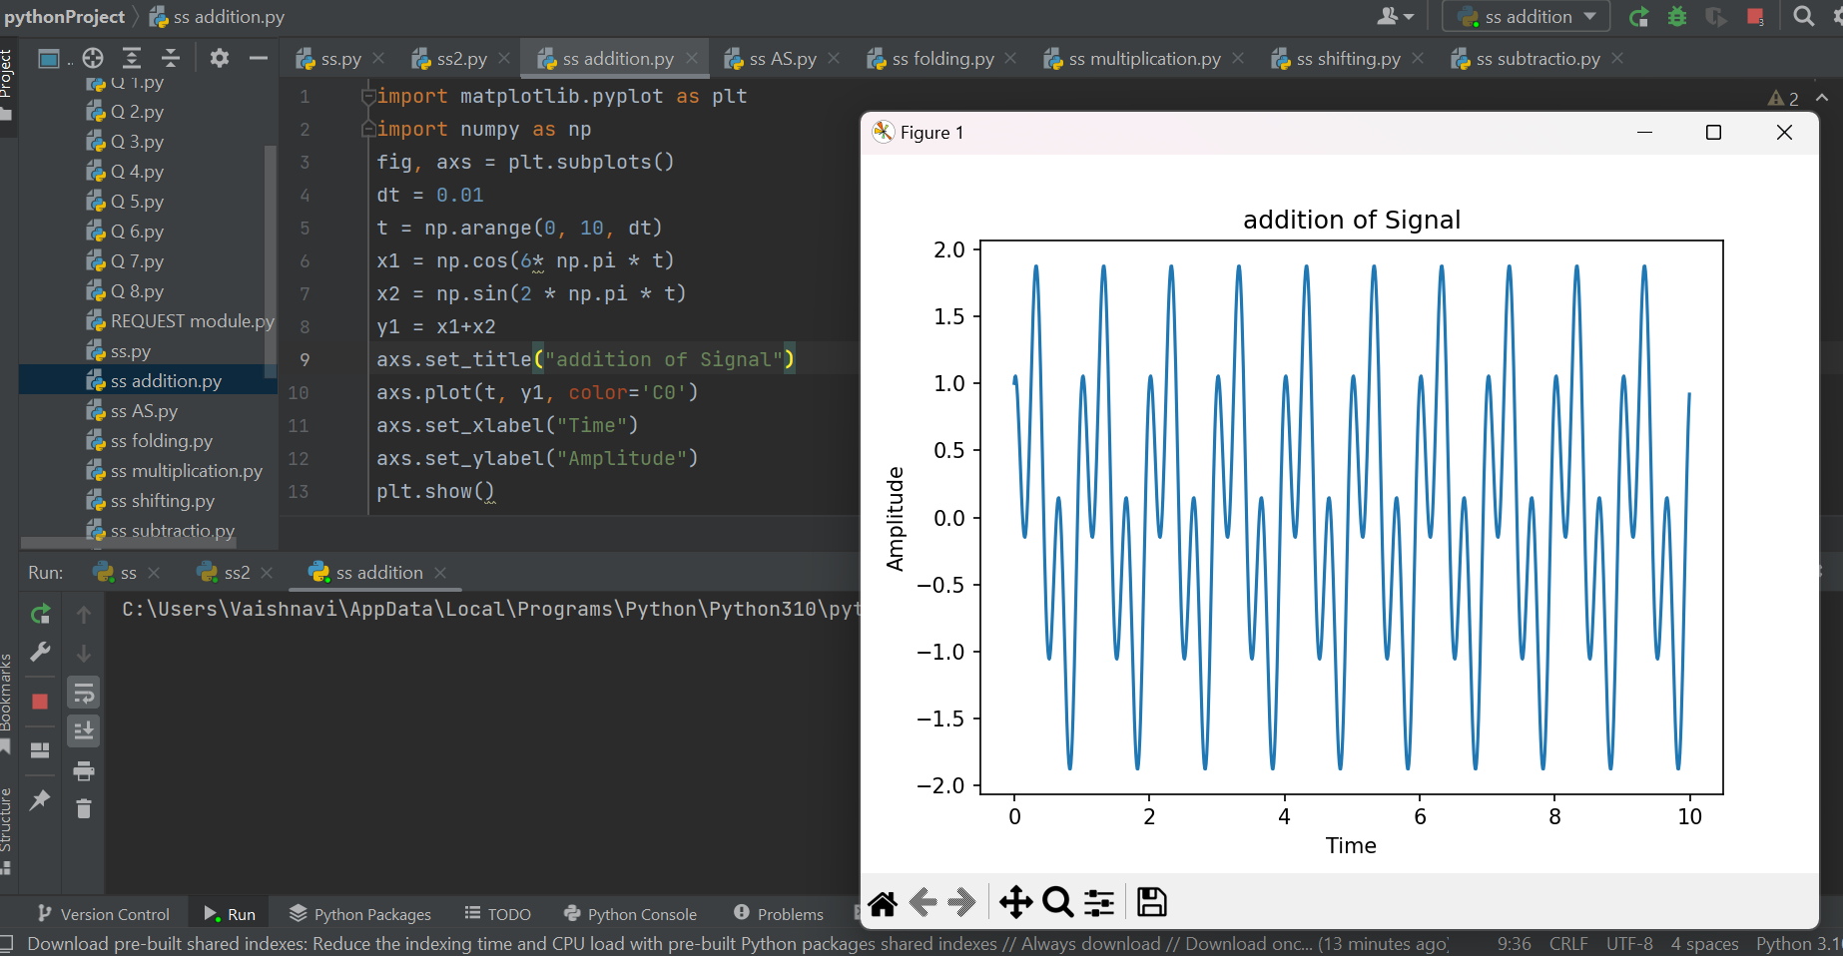

CODE – SUBTRACTION OF 2 SIGNALS

import matplotlib.pyplot as plt

import numpy as np

fig, axs = plt.subplots()

dt = 0.01

t = np.arange(0, 10, dt)

x1 = np.sin(4 * np.pi * t)

x2 = np.cos(2 * np.pi * t)

y1 = x1-x2

axs.set_title("Subtraction of Signals")

axs.plot(t, y1, color='C0')

axs.set_xlabel("Time")

axs.set_ylabel("Amplitude")

plt.show()

OUTPUT –

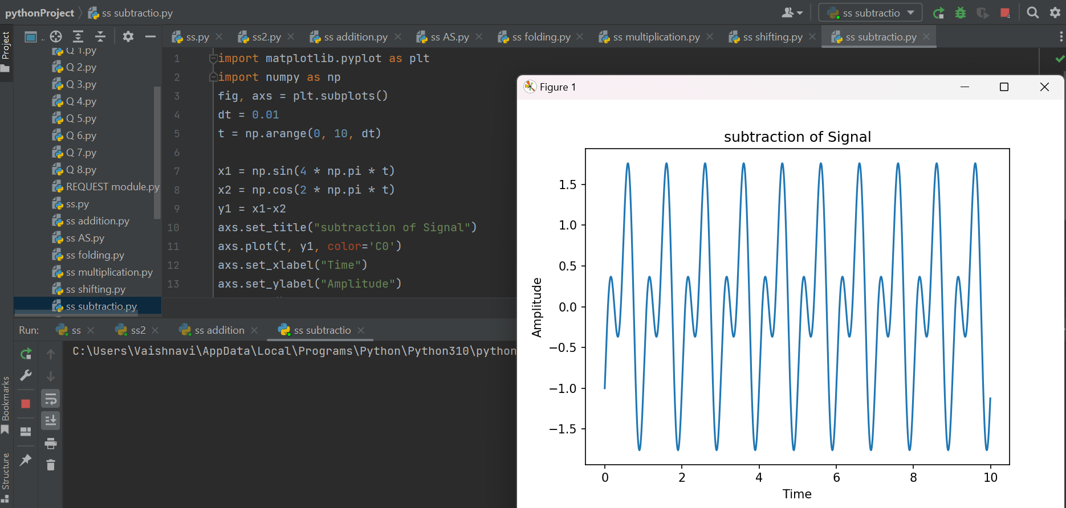

CODE – MULTIPLICATION OF 2 SIGNALS

import matplotlib.pyplot as plt

import numpy as np

fig, axs = plt.subplots()

dt = 0.01

t = np.arange(0, 10, dt)

x1 = np.cos(6 * np.pi * t)

x2 = np.sin(4 * np.pi * t)

y1=x1*x2

axs.plot(x1,x2, color='C0')

axs.set_xlabel("Time")

axs.set_ylabel("Amplitude")

axs.set_title(" Multiplication of Signals")

plt.show()

OUTPUT -

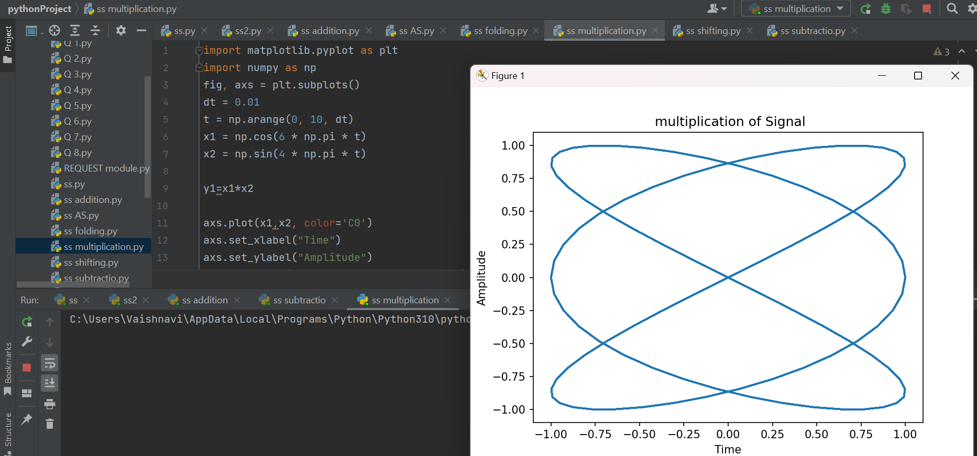

CODE – AMPLITUDE SCALING OF 2 SIGNALS

import matplotlib.pyplot as plt

import numpy as np

fig, axs = plt.subplots()

dt = 0.01

t = np.arange(0, 10, dt)

x1 = np.sin(4 * np.pi * t)

x2 = np.sin(4 * np.pi * t)

a = 5

y1 = a*x2

axs.set_title(" Amplitude Scaling of Signals")

axs.plot(t, y1, color='C0')

axs.set_xlabel("Time")

axs.set_ylabel("Amplitude")

plt.show()

OUTPUT –

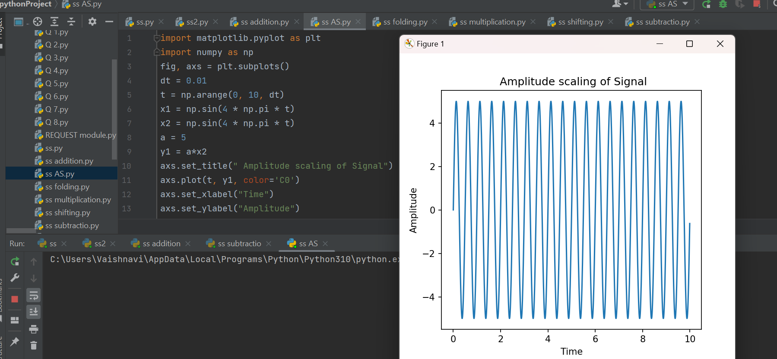

CODE – FOLDING OF 2 SIGNALS

import matplotlib.pyplot as plt

import numpy as np

fig, axs = plt.subplots()

dt = 0.01

t = np.arange(0, 10, dt)

x1 = np.sin(4 * np.pi * t)

x2 = np.sin(4 * np.pi * t)

y1 = -x1;

axs.set_title(" Folded Signal")

axs.plot(y1, color='C0')

axs.set_xlabel("Time")

axs.set_ylabel("Amplitude")

plt.show()

OUTPUT –

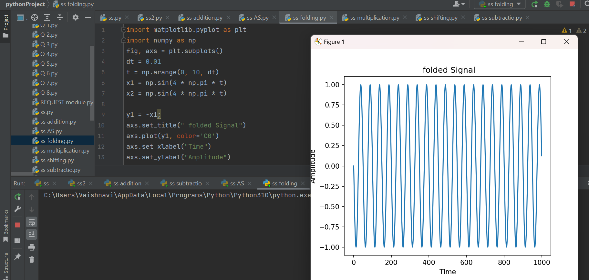

CODE – SHIFTING OF 2 SIGNALS

import matplotlib.pyplot as plt

import numpy as np

fig, axs = plt.subplots()

dt = 0.01

t = np.arange(0, 10, dt)

x1 = np.sin(4 * np.pi * t)

y1 = x1*(t-3);

y2 = x1*(t+4);

axs.set_title("Time shifting of Signals")

axs.plot(y1,y2, color='C0')

axs.set_xlabel("Time")

axs.set_ylabel("Amplitude")

plt.show()

OUTPUT –

