1

A.

SELECT FIRST_NAME AS WORKER_NAME FROM Worker;  
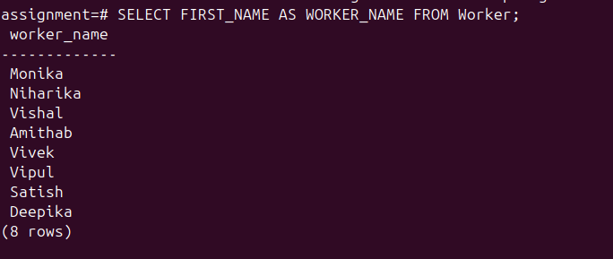

B.

SELECT UPPER(FIRST_NAME) FROM Worker;

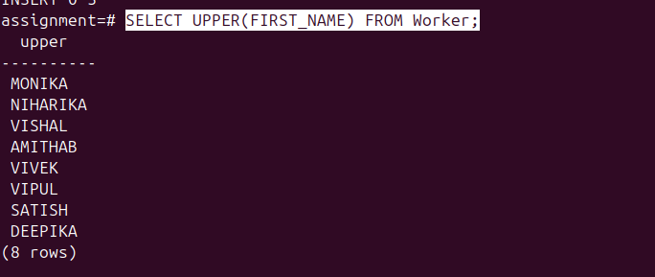

C.

SELECT DISTINCT DEPARTMENT FROM Worker;

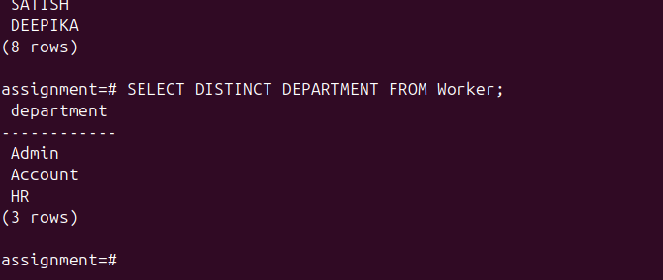

D.

SELECT POSITION('a' IN FIRST_NAME) FROM Worker WHERE FIRST_NAME = 'Amithab';

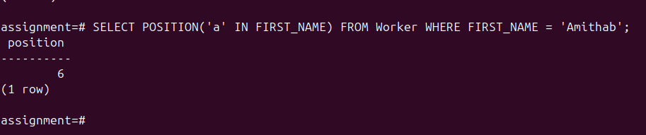

E.

SELECT RTRIM(FIRST_NAME) FROM Worker;  


F.

SELECT LTRIM(DEPARTMENT) FROM Worker;



G.

SELECT REPLACE(FIRST_NAME, 'a', 'A') FROM Worker;

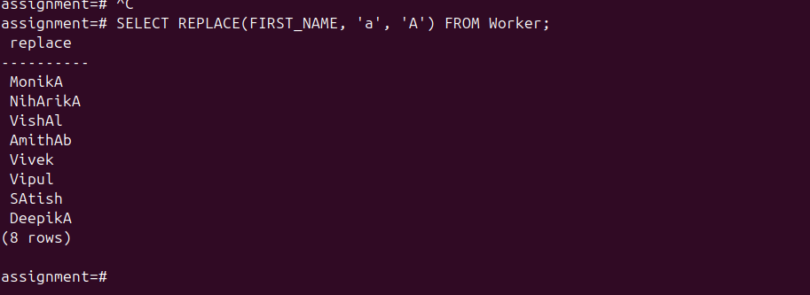

H.

SELECT CONCAT(FIRST_NAME,' ' ,LAST_NAME) AS COMPLETE_NAME FROM Worker;

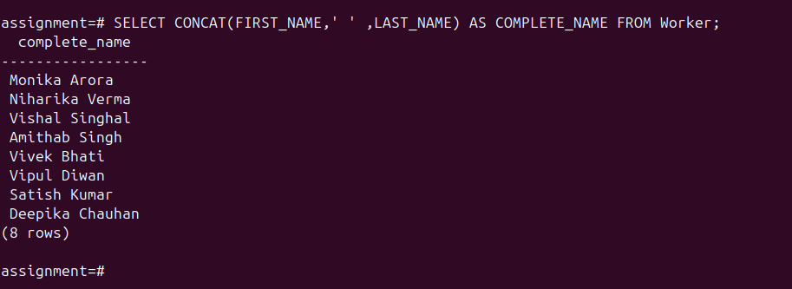

I.

SELECT * FROM Worker ORDER BY FIRST_NAME ASC;  
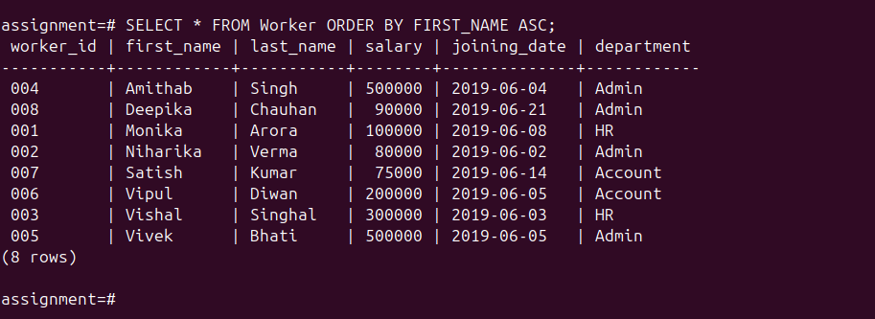

J.

SELECT * FROM Worker ORDER BY FIRST_NAME ASC, DEPARTMENT DESC;

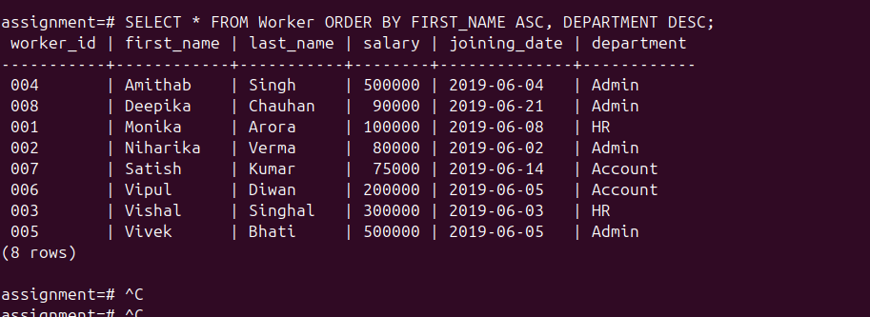

K.

SELECT * FROM Worker WHERE FIRST_NAME LIKE '%a%';  
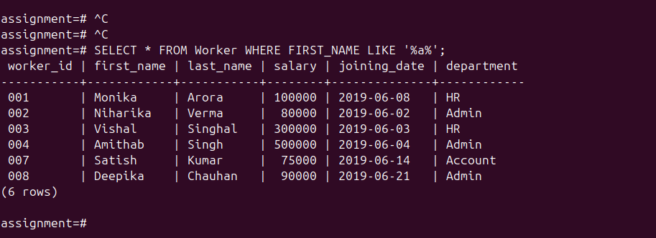

L.

SELECT FIRST_NAME, LAST_NAME FROM Worker WHERE SALARY BETWEEN 50000 AND 100000;

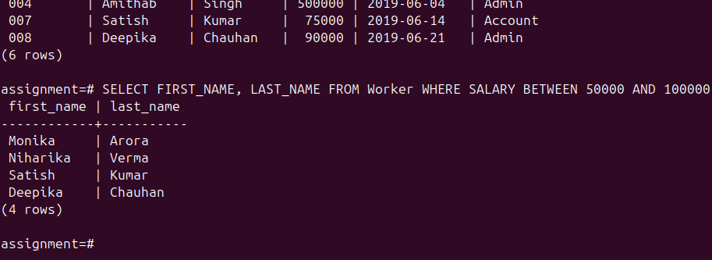

M.

SELECT * FROM Worker ORDER BY WORKER_ID LIMIT (SELECT COUNT(*) / 2 FROM Worker);

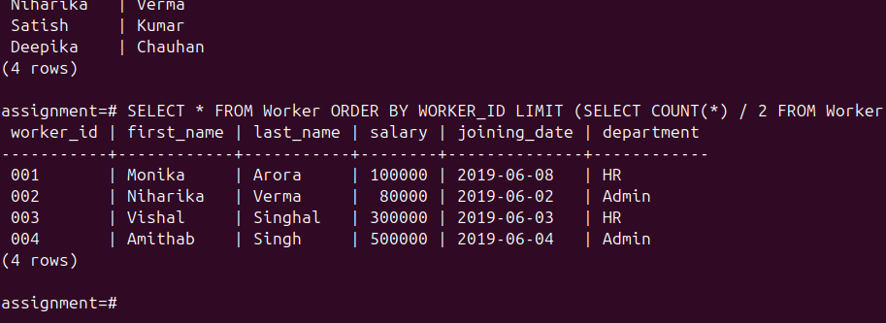

N.

SELECT * FROM Worker ORDER BY WORKER_ID DESC LIMIT 1;  
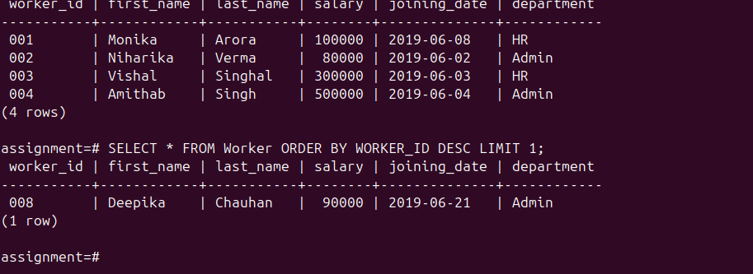

O.

UPDATE Worker SET FIRST_NAME = LAST_NAME,LAST_NAME = FIRST_NAME;



2.

A.

SELECT DISTINCT Salary FROM EmployeeInfo ORDER BY Salary DESC OFFSET 2 LIMIT 1;

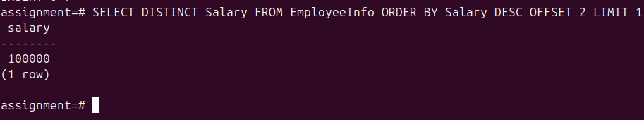

B.

SELECT MAX(salary) AS third_highest_salary FROM employeeinfo WHERE salary < ( SELECT MAX(salary) FROM employeeinfo WHERE salary < (SELECT MAX(salary) FROM employeeinfo));  
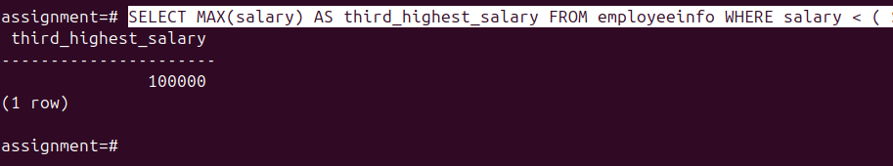

C.

SELECT EmpFname, EmpLname, Department, Salary, COUNT(*) FROM EmployeeInfo GROUP BY EmpFname, EmpLname, Department, Salary HAVING COUNT(*) > 1;

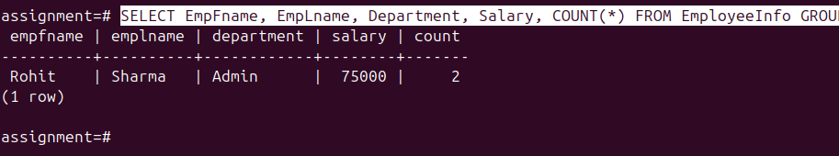

D.

SELECT

CASE

WHEN ROW_NUMBER() OVER (ORDER BY EmpID) % 2 = 0 THEN 'Even'

ELSE 'Odd'

END AS RecordType,

EmpID, EmpFname, EmpLname, Department, Salary

FROM EmployeeInfo

ORDER BY EmpID;

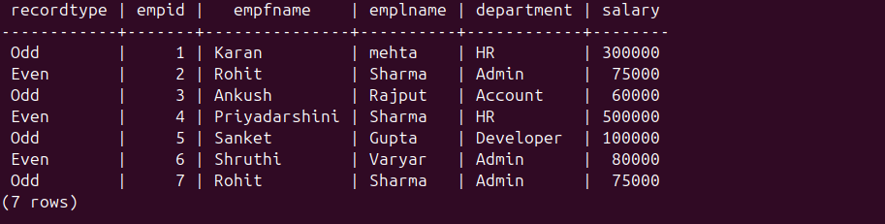

E.

(SELECT * FROM EmployeeInfo ORDER BY EmpID ASC LIMIT 1) UNION (SELECT * FROM EmployeeInfo ORDER BY EmpID DESC LIMIT 1);  
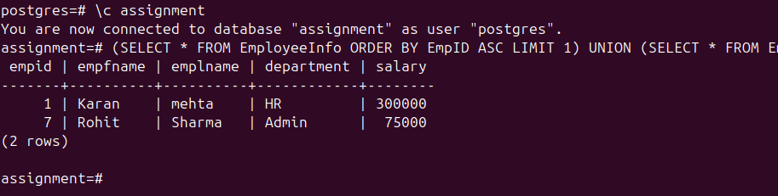  
F.

CREATE TABLE EmployeeInfo_Copy AS SELECT * FROM EmployeeInfo;



G.

SELECT e1.EmpID, e1.EmpFname, e1.EmpLname, e1.Department, e1.Salary FROM EmployeeInfo e1 JOIN EmployeeInfo e2 ON e1.Department = e2.Department AND e1.EmpID != e2.EmpID ORDER BY e1.Department, e1.EmpID;  
  


H.

SELECT * FROM EmployeeInfo ORDER BY EmpID DESC LIMIT 3;  


I.

SELECT * FROM EmployeeInfo WHERE EmpLname LIKE '____a';  
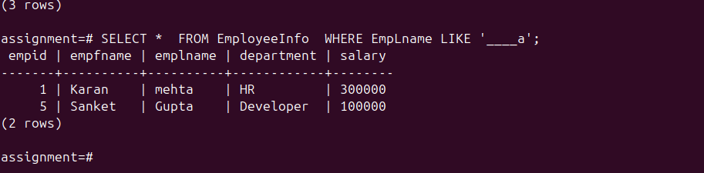

3

A.

SELECT

i.item_category AS Category,

SUM(CASE WHEN EXTRACT(DOW FROM o.order_date) = 1 THEN o.quantity ELSE 0 END) AS Monday,

SUM(CASE WHEN EXTRACT(DOW FROM o.order_date) = 2 THEN o.quantity ELSE 0 END) AS Tuesday,

SUM(CASE WHEN EXTRACT(DOW FROM o.order_date) = 3 THEN o.quantity ELSE 0 END) AS Wednesday,

SUM(CASE WHEN EXTRACT(DOW FROM o.order_date) = 4 THEN o.quantity ELSE 0 END) AS Thursday,

SUM(CASE WHEN EXTRACT(DOW FROM o.order_date) = 5 THEN o.quantity ELSE 0 END) AS Friday,

SUM(CASE WHEN EXTRACT(DOW FROM o.order_date) = 6 THEN o.quantity ELSE 0 END) AS Saturday,

SUM(CASE WHEN EXTRACT(DOW FROM o.order_date) = 0 THEN o.quantity ELSE 0 END) AS Sunday

FROM Orders o

JOIN Items i ON o.item_id = i.item_id

GROUP BY i.item_category

ORDER BY i.item_category;

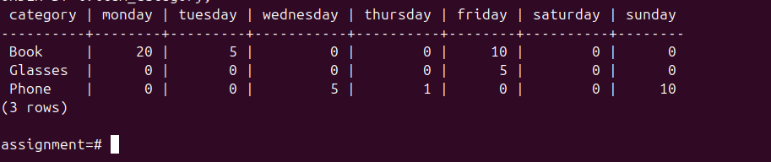

4.

SELECT

d.Name AS Department,

e.Name AS Employee,

e.Salary

FROM Employee e

JOIN Department d ON e.DepartmentId = d.Id

WHERE e.Salary IN (

SELECT Salary

FROM Employee e2

WHERE e2.DepartmentId = e.DepartmentId

ORDER BY Salary DESC

LIMIT 3

)

ORDER BY d.Name, e.Salary DESC;

