Scheduling & Triggering Test Runs
Not every test run should wait for a human to trigger it. Nightly regression sweeps, hourly smoke checks against production, and pre-release validation all need to fire on a schedule, independent of any code push. This note covers cron-based CI triggers, avoiding overlapping runs, and structuring schedules across environments and timezones.

Cron syntax primer
Most CI platforms schedule jobs using standard five-field cron syntax. A quick reference, since the field order is easy to misremember under time pressure:
Field | Allowed values | Example meaning
Minute | 0–59 | 0 = on the hour
Hour | 0–23 (UTC, almost always) | 2 = 2am UTC
Day of month | 1–31 | * = every day
Month | 1–12 | * = every month
Day of week | 0–6 (0 = Sunday) | 1-5 = weekdays only
# minute hour day-of-month month day-of-week
0 2 * * * # every day at 02:00 UTC
*/30 * * * * # every 30 minutes
0 6 * * 1-5 # weekdays at 06:00 UTC

Triggering on a schedule
GitHub Actions, GitLab CI, and most other platforms expose a schedule trigger directly in the pipeline definition, entirely separate from push or pull-request triggers:
on:
schedule:
- cron: '0 2 * * *' # nightly full regression
- cron: '*/30 6-22 * * *' # smoke check every 30 min, working hours
workflow_dispatch: {} # allow manual re-runs of the same workflow
Keeping workflow_dispatch alongside the schedule trigger costs nothing and is worth doing by default — it lets anyone re-run the exact same scheduled job on demand, which is invaluable when investigating whether last night's failure was a fluke.
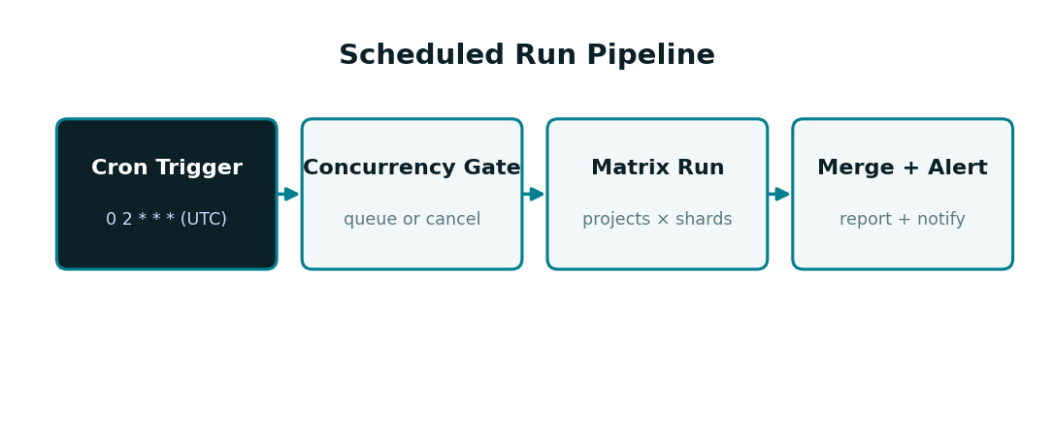

Designing cadence per environment
Not every environment needs the same schedule or the same depth of coverage. A common pattern splits cadence by both frequency and scope:
Environment | Cadence | Scope | Reasoning
Production | Every 15–30 min | Smoke only (@smoke tag) | Fast signal on customer-facing breakage; must stay short
Staging | Nightly | Full regression | Deeper coverage where slower runs are acceptable
Feature/preview environments | On demand only | Scoped to the changed area | Ephemeral; scheduling adds little value
Release candidate | Once, pre-release | Full regression + visual suite | Highest-stakes gate; run everything

Preventing overlapping runs
A schedule that fires more often than the suite takes to run will eventually overlap with itself, especially after a slow dependency install or a temporarily larger suite. Concurrency groups cancel or queue overlapping runs rather than letting them pile up:
concurrency:
group: nightly-regression-${{ github.ref }}
cancel-in-progress: false # queue, don't cancel, for scheduled full runs
For smoke checks, the opposite choice is usually correct — cancel-in-progress: true — since a stale smoke result is worse than a skipped one, and the next scheduled run is only minutes away regardless.

Matrix strategy combined with schedule
Scheduled triggers compose with the same matrix strategies used for push-triggered runs, so a nightly job can still shard and parallelize across projects exactly like any other run:
on:
schedule:
- cron: '0 2 * * *'
jobs:
nightly:
strategy:
matrix:
project: [chromium, firefox, webkit]
shardIndex: [1, 2, 3]
shardTotal: [3]
steps:
- run: npx playwright test --project=${{ matrix.project }} --shard=${{ matrix.shardIndex }}/${{ matrix.shardTotal }}

Alerting on scheduled-run failures
A scheduled run has no pull request to annotate and no author waiting on a status check, so failures need an explicit push notification rather than relying on someone noticing a red check:
- Route nightly regression failures to a shared channel, not an individual — ownership rotates and individual routing goes stale
- Include a direct link to the merged HTML report in the alert, not just a pass/fail count
- Distinguish “new failure” from “still failing from last night” in the alert text — a repeated failure needs a different response than a fresh one
- Page someone (not just a channel message) only for production smoke failures — nightly regression failures rarely justify interrupting anyone off-hours

Timezone considerations
Cron schedules on most CI platforms run in UTC regardless of where the team is based, which creates two easy-to-miss failure modes for distributed teams:
- A “nightly” run scheduled for 2am UTC may land in the middle of the workday for a team based in Asia-Pacific, competing with active development for runner capacity
- Daylight saving transitions in one region can silently shift a run's local-time meaning even though the UTC cron expression never changed
Anchoring schedule discussions to UTC explicitly, and documenting the intended local-time meaning alongside the cron expression, avoids a schedule quietly drifting out of sync with what it was originally designed to achieve.
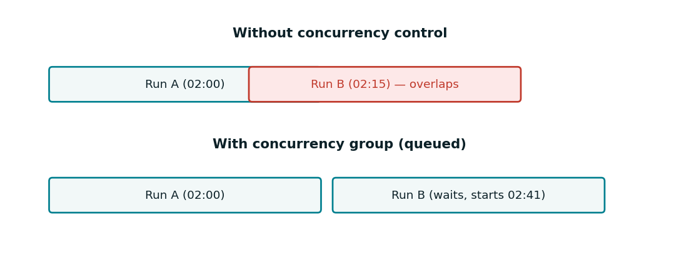

Manual re-runs and backfills
workflow_dispatch inputs make it possible to re-run a scheduled job with adjusted parameters — a narrower project list, a specific shard, or a different environment — without touching the schedule definition itself:
on:
workflow_dispatch:
inputs:
environment:
type: choice
options: [staging, production]
default: staging
project:
type: string
default: 'chromium,firefox,webkit'
This is the mechanism most teams use to investigate a scheduled failure interactively — re-running just the failing project or shard, rather than the full nightly suite, while debugging.

Summary
Scheduling a Playwright suite well is mostly about matching cadence and scope to what each environment actually needs, then protecting that schedule from overlapping with itself and making sure a failure at 2am UTC reaches someone who can act on it. None of the individual pieces — cron syntax, concurrency groups, matrix strategies — are unique to testing; the judgment is in how they're combined for a given suite's shape.

