**Introduction**

* Java is an object-oriented, class-based, secured, platform-independent, and general-purpose programming language.
* originally developed by James Gosling at Sun Microsystems and released in 1995

**Different Editions of Java**

There are four editions of the Java programming language:

* ***Java Platform, Standard Edition (Java SE)* :**
* Java SE, also known as Core Java.
* Most basic and standard version of java.
* It consists of a wide variety of general-purpose APIs (like java.lang, java.util) as well as many special-purpose APIs.
* Java SE is used to create Desktop applications.
* ***Java Platform, Enterprise Edition (Java EE):***
* The Java EE platform is built on top of theJava SE platform.
* has a much larger usage of Java, like the development of web services, networking, server-side scripting, and other various web-based applications.
* Java EE uses HTML, CSS, JavaScript, etc., so as to create web pages and web services. It is also one of the most widely used web development standards.
* ***Java Platform, Micro Edition (Java ME):***
* It is widely used for developing embedded systems, mobiles, and small devices.
* Java ME uses many libraries and APIs of Java SE, as well as many of its own.
* The basic aim of this edition is to work on mobiles, wireless devices, set top boxes, etc. Most of the apps developed for the phones were built on Java ME only.
* ***JavaFX:***
* JavaFX is another edition of java technology,which is now merged with Java SE 8.
* It is mainly used to create rich GUI (Graphical User Interface) in java apps. It is supported by both desktop environments as well as web browsers.

**JDK, JRE, and JVM**

JDK, JRE, and JVM are the most important parts of the Java programming language. Without these, you can not develop and run java programs on your machine.

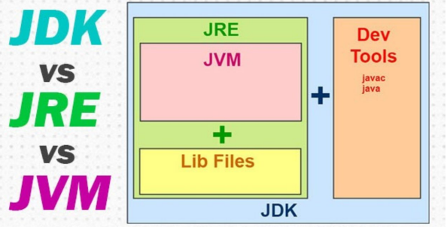

**1.JDK:** JDK stands for Java Development Kit. JDK provides an environment to develop and execute the java program. JDK is a kit that includes two things - Development Tools to provide an environment to develop your Java programs and JRE to execute your Java programs.

**2.JRE:** JRE stands for Java Runtime Environment. JRE provides an environment to only run (not develop) the java programs onto your machine. JRE is only used by the end-users of the system. JRE consists of libraries and other files that JVM uses at runtime.

**3.JVM:** JVM stands for Java Virtual Machine, which is a very important part of both JDK and JRE because it is inbuilt in both. Whatever java program you run using JDK and JRE goes into the JVM and JVM is responsible for executing the java program line by line.