**Field Work**

**On**

**Instagram**

**(Social Media Platform App)**

**Submitted**

**to**

**KCES’s Institute of Management and Research, Jalgaon**



**Submitted by**

**Name: Ms.Vaishnavi Bhaskar Pawar**

**Email id:vaishpawar2006@gmail.com**

**Name: Ms.Damini Digambar Kolhe**

**Email id:daminikolhe22@gmail.com**

**Under the Guidance of**

**Name**: **Prof. Sweta phegade**

**In Partial Fulfillment of**

**Master of Computer Application(Integrated)**

**KCES’s Institute of Management and Research, Jalgaon**

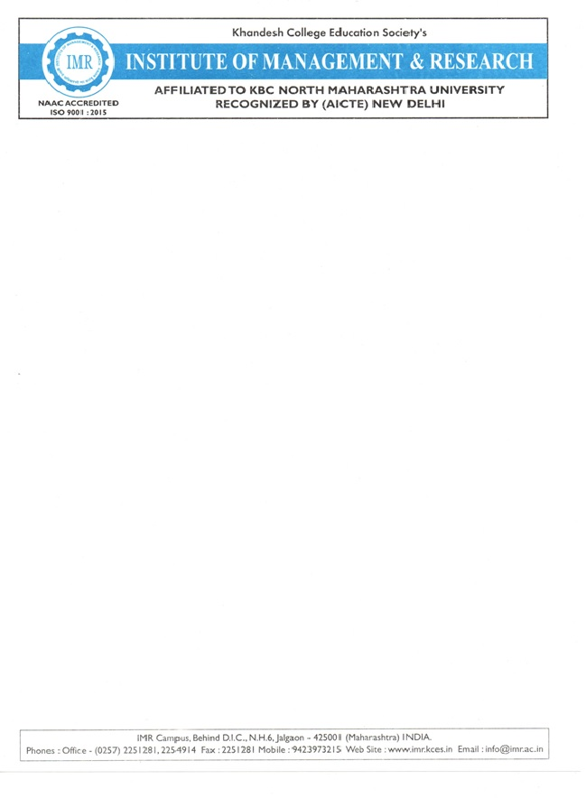

**CERTIFICATE**

This is to certify that **Ms. Vaishnavi Bhaskar Pawar & Damini Digambar Kolhe** student’s of IMCA from **KCES’S Institute of Management and Research,Jalgaon** has completed the Filed work entitled **Instagram (Social Media Platform App)** both has submitted satisfactory field report in partial fulfillment of the requirement for the degree of IMCA during academic year **2025-2026.**

It is the original work and sincerely completed the field work. I am fully satisfied

with his/there performance.

Prof. Mrs.Sweta phegade Prof.Mrs.Sweta phegade

**Internal Guide Coordinator**

Prof. Mrs.Dipali Kirange

**External Examiner I / Examiner II HOD**



**ACKNOWLEDGEMENT**

We have great pleasure in submitting this Field Work on **“Instagram (Social Media Platform App)”** to **KCES’s Institute of Management and Research, Jalgaon.**

 It is humble brief that any Field Work can be carried out with success by a two person. Many other personalities helpings to accomplished this project and it is our duty to express our appreciation to them.

 We are indebted to **Mrs.Sweta Phegde Mam** for helping us as guide and  allow us to do the Field Work at their site.

 We wish to thank the teaching staff, our friends and persons who help us directly or indirectly for completion of Field Work.

**DECLARATION**

We hereby declare that the project work entitled **“Instagram”** has carried out result on the basis of investigations and analysis by us under the guidance of **Mrs. Sweta phegade.**

 We further declare that this work has not been submitted in partly or fully to any other University or Institute for the award of any other degree. Material obtained from other source has been daily acknowledged in the Field Work.

**INDEX**

|  |  |
| --- | --- |
| **Sr. No.** | **Topic** |
| 1 | Abstract |
| 2 | Introduction |
| 3 | Project Field Work Topic / Literature Review |
| 4 | Objectives |
| 5 | Methodology |
| 6 | Result and Discussion |
| 7 | Recommendations and Future Work |
| 8 | Suggestion |
| 9 | Conclusion |
| 10 | References |
| 11 | Questionnaire |

1)Abstract:

This survey was conducted to understand how people use Instagram in their daily lives. The main aim was to study the purpose, usage time, and effects of Instagram on users. A questionnaire was given to different users to collect their opinions and habits related to Instagram. The results showed that most people use Instagram for entertainment, communication, and sharing photos or videos. Some users also use it for business or study purposes. However, many users spend a lot of time on Instagram, which sometimes affects their studies or work. Overall, the survey helped to understand the positive and negative sides of using Instagram in simple and clear ways.

**2)Introduction:**

This survey on Instagram users is conducted to understand how people use Instagram in their daily lives. It helps to know why users prefer Instagram, how much time they spend on it, and what type of content they like to watch or post. The survey also studies how Instagram affects their behavior, lifestyle, and communication with friends and family.The main purpose of this survey is to collect opinions and experiences from different Instagram users. By analyzing the answers, we can find out the positive and negative impacts of Instagram on users. It will also help to understand whether Instagram is being used mainly for fun, social connection,learning,or,businesspromotion.In short, this Instagram user survey aims to explore the usage pattern, satisfaction level, and influence of Instagram on people’s daily lives. The information collected will be useful for improving user experience and promoting healthy social media habits.

**3)Project Field Work Topic / Literature Review:**

Field Work Topic:

"A Study on the Usage and Impact of Instagram Among Students"

Literature Review:

Instagram is one of the most popular social media platforms used by young people today. It allows users to share photos, videos, and stories with their friends and followers. Many students use Instagram for entertainment, communication, and learning new things.

Previous studies have shown that Instagram helps people stay connected and express their creativity. However, it can also affect users' time management and sometimes lead to addiction or low self-esteem due to comparison with others.

Researchers found that the way people use Instagram depends on their purpose — some use it for fun, some for education, and others for business or self-promotion. Overall, Instagram has both positive and negative effects on users, depending on how wisely it is used.

**4)Objectives:**

1. To understand user behavior on Instagram, including how often and for what purposes people use the platform.

2. To identify the most popular features of Instagram such as Reels, Stories, Posts, and Direct Messages.

3. To study the impact of Instagram on users’ daily lives, communication, and social interactions.

4. To analyze user preferences regarding content types (entertainment, education, fashion, etc.).

**5)Methodology:**

1. Purpose of the Study:

The main purpose of this survey was to understand how people use Instagram and what they like or dislike about it.

2. Survey Method:

A questionnaire was used to collect information from Instagram users. The questions were related to their usage habits, time spent, favorite features, and opinions about the app.

3. Data Collection:

The data was collected through Google Forms / printed questionnaires / online survey links shared with students, friends, and other Instagram users.

4. Sample Size:

A total of (mention your number, e.g., 50 or 100) people participated in the survey. The sample included both male and female users of different age groups.

5. Sampling Method:

A random sampling method was used, where participants were chosen randomly from Instagram users.

**6)Result and Discussion:**

After completing the Instagram user survey, the following results were found:

Most users use Instagram daily for entertainment, sharing photos, and chatting with friends.

A large number of users said they spend 1–3 hours per day on Instagram.

Many users follow celebrities, influencers, and friends to stay updated.

Reels and stories are the most liked features because they are short and interesting.

Some users also use Instagram for business and promotion of their products or talents.

A few users said that too much use of Instagram can waste time and affect studies.

Discussion

From the results, it can be said that Instagram is very popular among youth.

It is used for both entertainment and communication. However, it also has some negative effects like addiction and distraction from studies.

If used properly, Instagram can be a good platform for learning, marketing, and creativity.

So, users should try to balance their time and use Instagram in a useful way.

**7)Recommendations and Future Work:**

1. Instagram should add more privacy and security features to protect user data.

2. The app can include tools to control screen time and reduce addiction.

3. Instagram should show more educational and positive content to help users use it in a better way.

4. It can improve its reporting system to stop fake accounts and cyberbullying.

5. Instagram can add more options for small businesses and creators to earn money.

Future Work:

1. In the future, more detailed surveys can be done with a larger number of users.

2. Future studies can compare Instagram with other social media platforms like Facebook or TikTok.

3. Researchers can study how Instagram affects mental health and relationships.

4. Future work can also focus on how Instagram helps in education or business promotion.

**8)Suggestion:**

1. Instagram should make its app easier and faster to use for all types of users.

2. It should reduce unwanted ads that disturb the user experience.

3. Instagram can add more privacy options to keep users’ data safe.

4. It should give users better control over what they see, like choosing the type of posts or reels.

5. Instagram can limit fake accounts and harmful content.

6. It should add new creative filters and editing tools for posts and stories.

**9)Conclusion:**

From the Instagram user survey, it is clear that most people use Instagram regularly for entertainment, communication, and sharing photos or videos. Many users enjoy features like Reels and Stories, which make the app more interesting. Instagram also helps users stay connected with friends and follow their favorite celebrities or brands. However, some users feel that spending too much time on Instagram can affect their studies or daily routine. Overall, Instagram is a popular and useful social media platform that plays an important role in people’s lives today.

**10)References:**

[*https://www.instagram.in/*](https://www.instagram.in/)

1. Instagram Official Website:

Information about Instagram features and updates was taken from the official Instagram website — www.instagram.com

2. News Articles and Blogs:

Some data and facts were collected from online articles and blogs that discuss Instagram usage and trends among users.

3. Survey Responses:

The information was also gathered from the responses of people who took part in the Instagram user survey.

4. Research Papers and Reports:

Basic ideas were taken from online research papers about social media usage and its effects on people.

5. Personal Observation:

Some points were based on personal experience and observation while using Instagram.

**11)Questionnaire:**

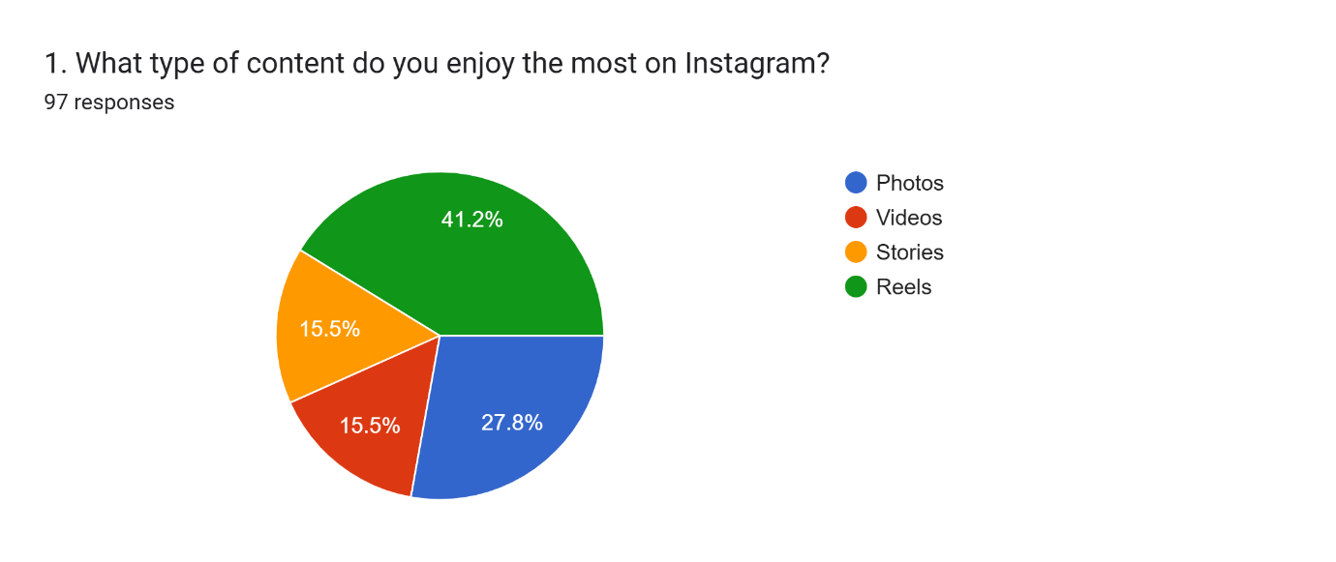

Forms response chart. Question title: 


2. How often do you check Instagram?. Number of responses: 97 responses.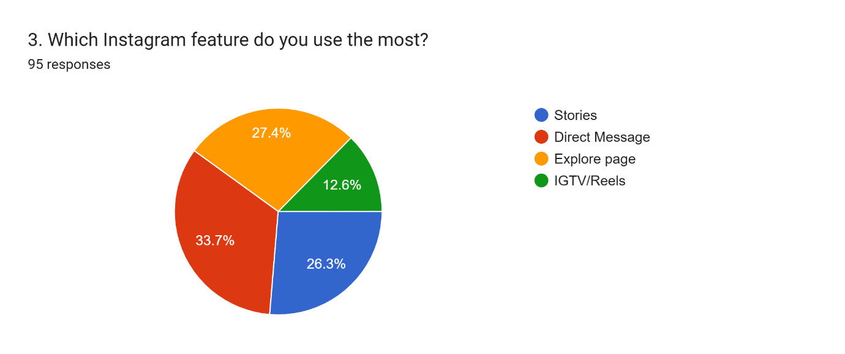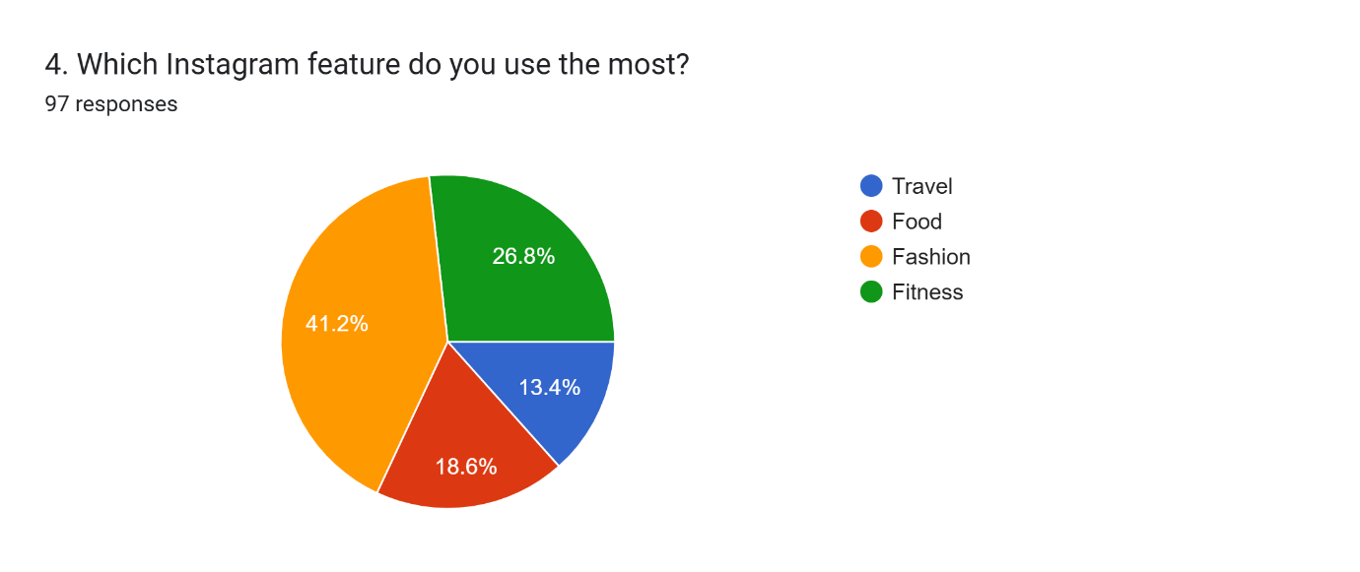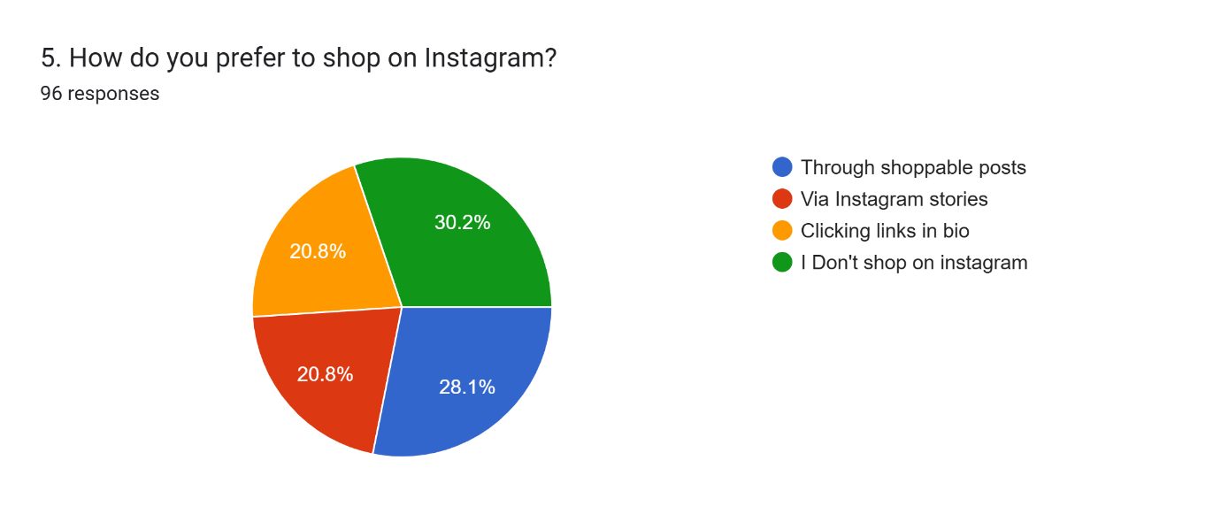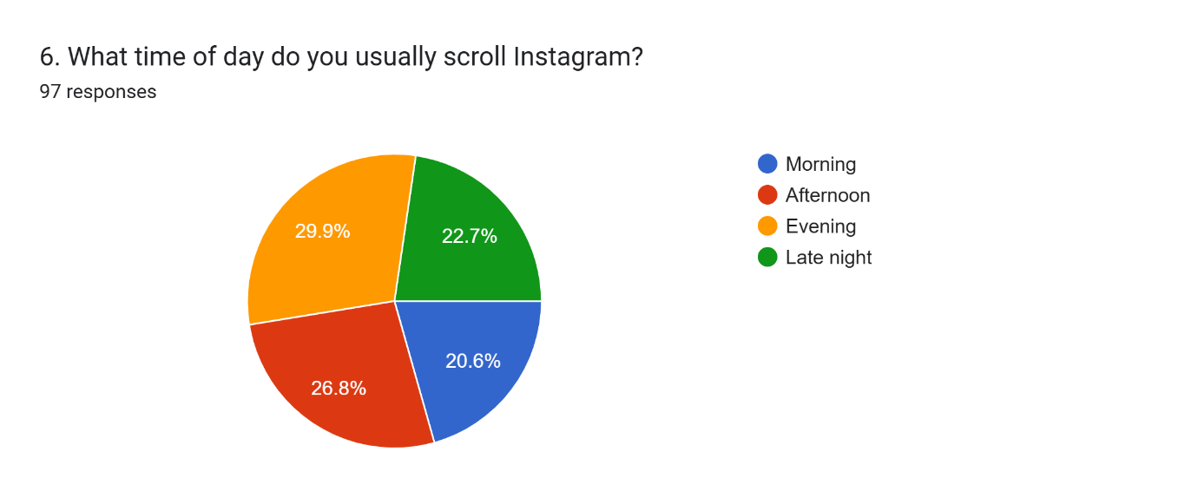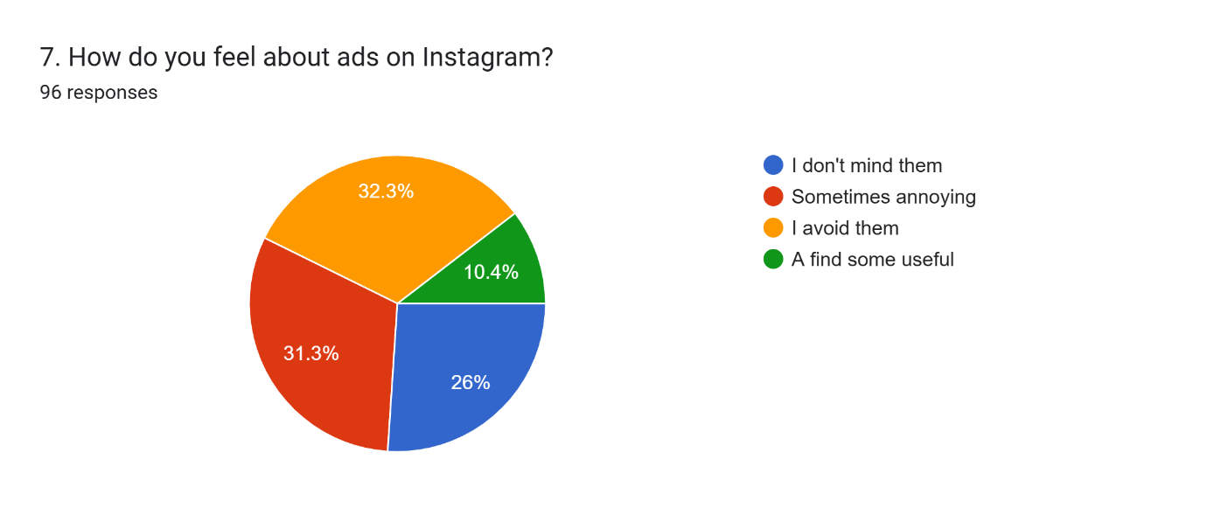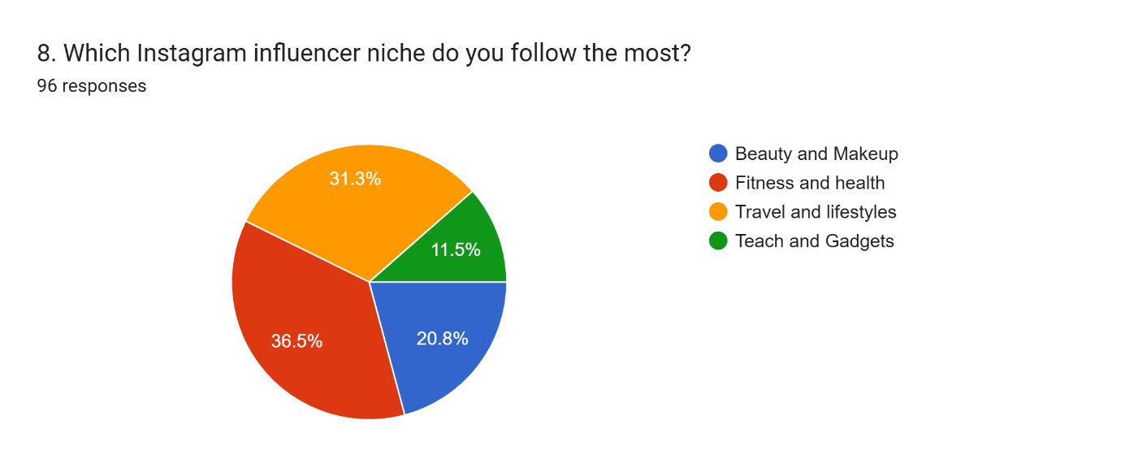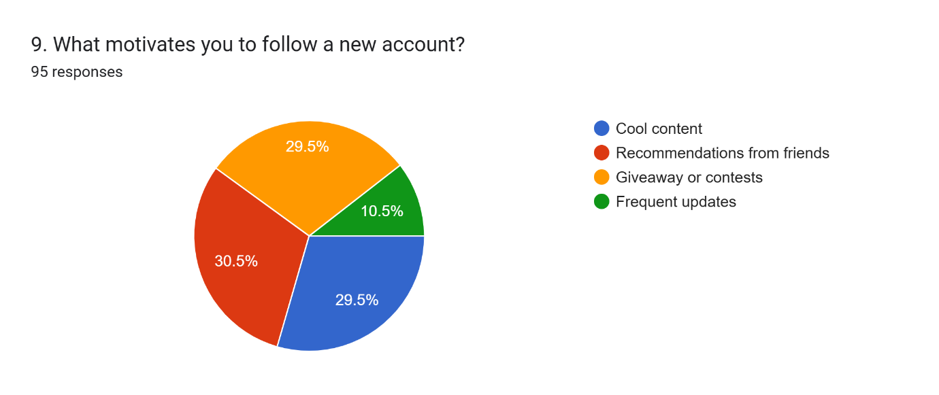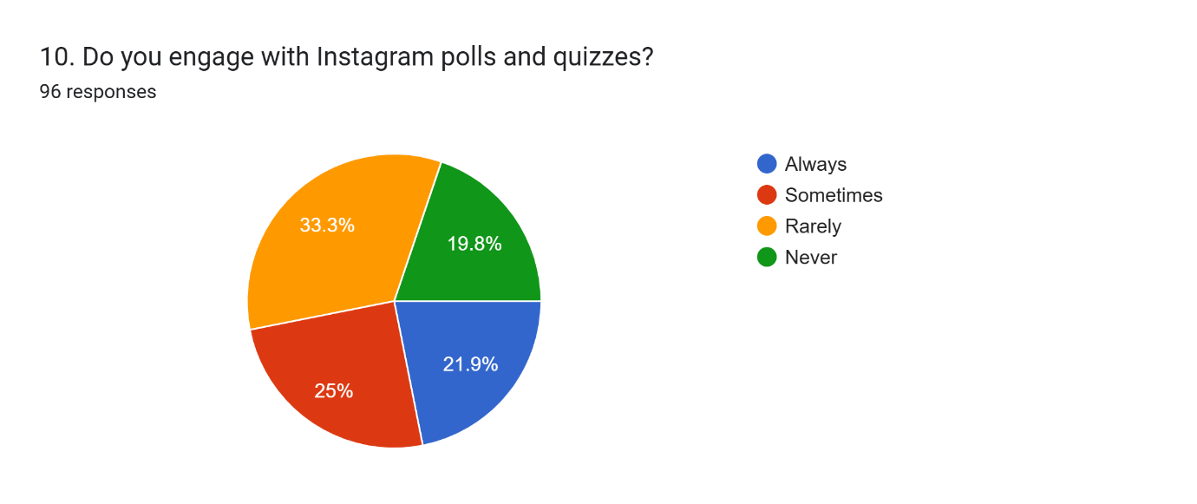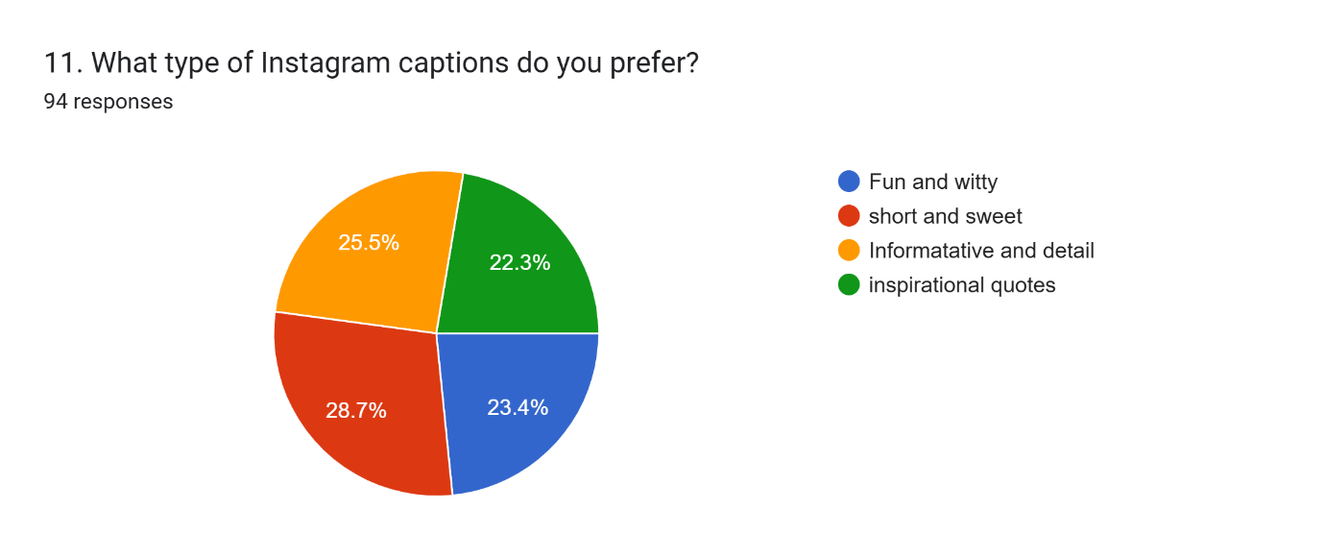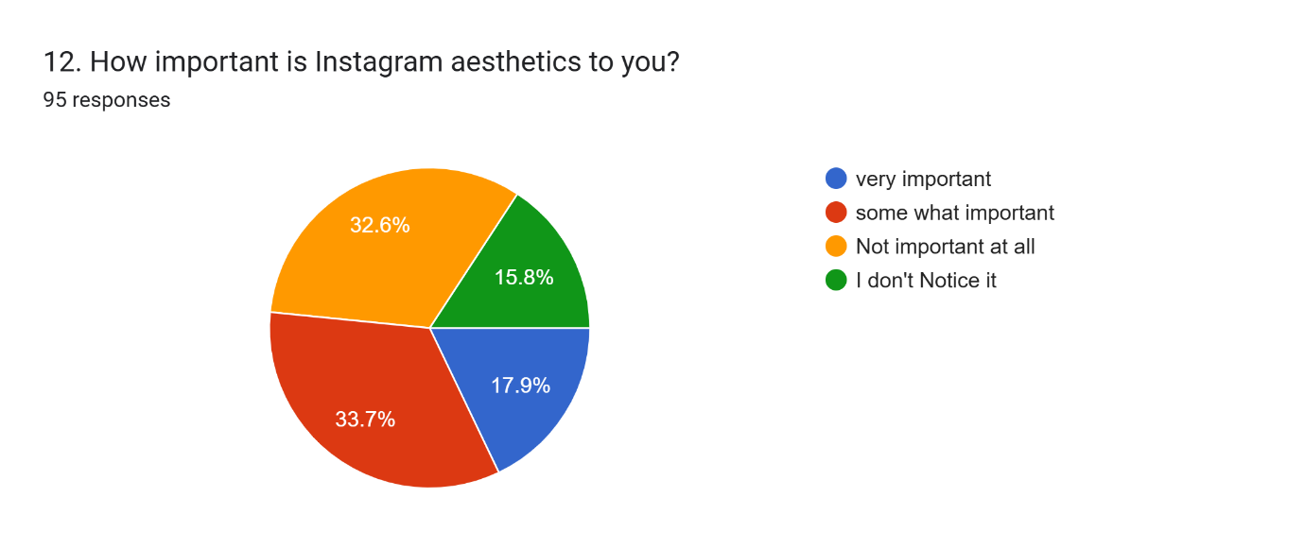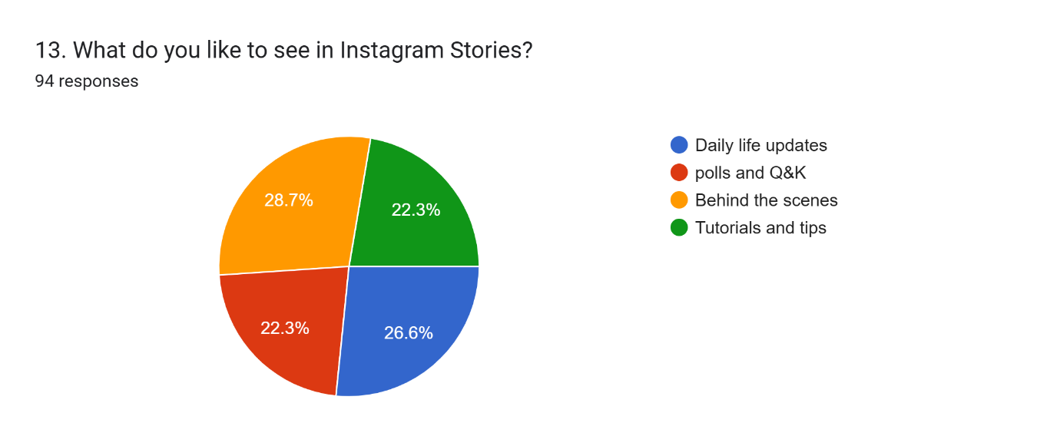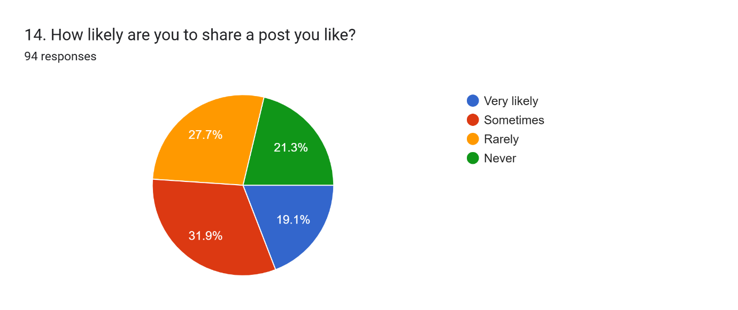Forms response chart. Question title: 15. What kind of giveaways do you prefer?


. Number of responses: 94 responses.

