The output for the programs are as follows:

1. Palindrome

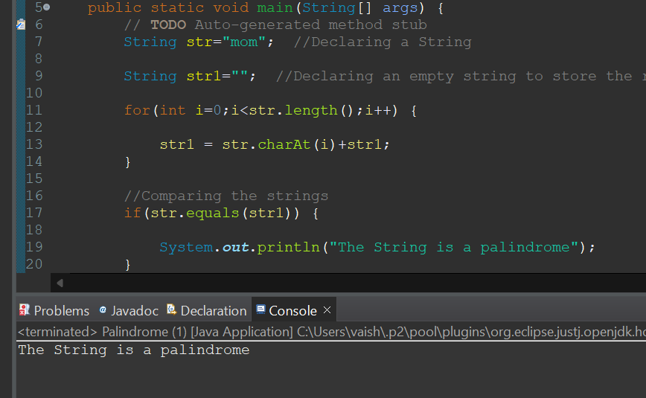

1. Reverse of string

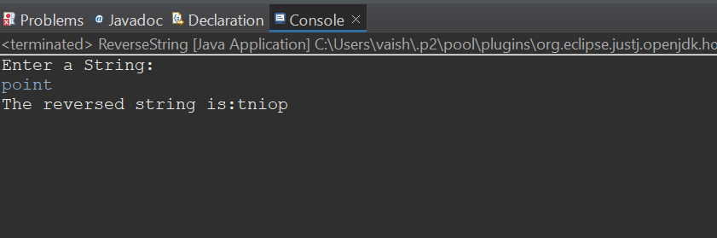

1. The number pattern printing

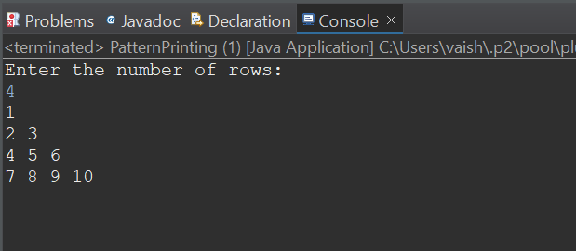

1. Star Pattern Printing

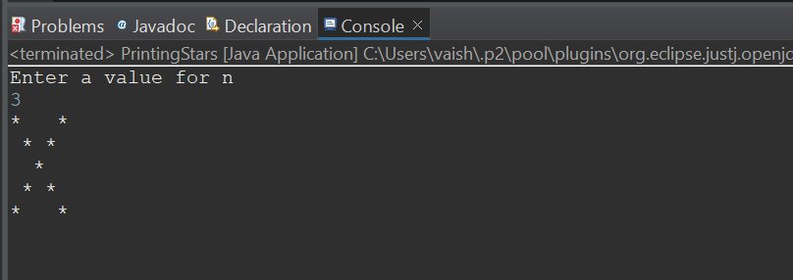

1. Grading System

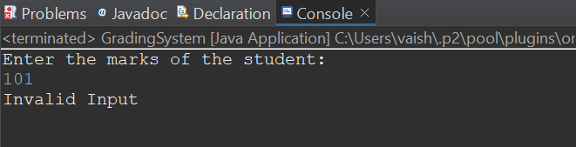

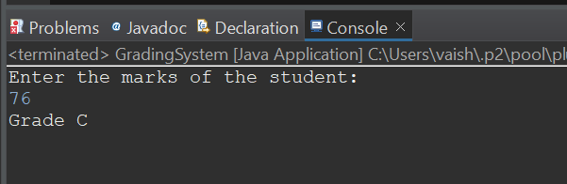

1. Hotel Traiff

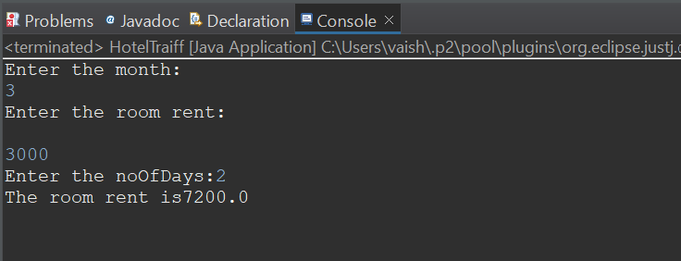

7.Largest Number

