SkillBridge AI – An Agentic Career Readiness and Opportunity Orchestration Platform
A Mini Project Report Submitted in the partial fulfillment of the requirements for the award of the degree of

BACHELOR OF TECHNOLOGY

In
DEPARTMENT OF COMPUTER SCIENCE ENGINNERING
By
Somu Vaishnavi – 2420030024
Maineni Srihitha - 2420030405

Under the Esteemed Guidance of

Dr.Neelima Gogineni





K L (Deemed to be) University
DEPARTMENT OF COMPUTER SCIENCE ENGINEERING

DECLARATION

The Mini Project Report entitled SkillBridge AI – An Agentic Career Readiness and Opportunity Orchestration Platform is a record of Bonafide work of Somu Vaishnavi – 2420030024, Maineni Srihitha – 2420030405. submitted in partial fulfillment for the award of B. Tech in Computer Science and Engineering to the K L University. The results embodied in this report have not been copied from any other departments/University/Institute.

Somu Vaishnavi – 2420030024
Maineni Srihitha - 2420030405

K L (Deemed to be) University
DEPARTMENT OF COMPUTER SCIENCE ENGINEERING

CERTIFICATE

This is certify that the mini project based report entitled SkillBridge AI – An Agentic Career Readiness and Opportunity Orchestration Platform is a bonafide work done and submitted by Somu Vaishnavi – 2420030024, Maineni Srihitha – 2420030405. in partial fulfillment of the requirements for the award of the degree of BACHELOR OF TECHNOLOGY in Department of Computer Science Engineering, K L (Deemed to be University), during the academic year 2026-2027.

Signature of the Course Co-ordinator Signature of HOD

ACKNOWLEDGEMENT

The success in this project would not have been possible but for the timely help and guidance rendered by many people. Our wish to express my sincere thanks to all those who has assisted us in one way or the other for the completion of my project.

Our greatest appreciation to my guide, Dr.Neelima Gogineni, Department of Computer Science which cannot be expressed in words for his/her tremendous support, encouragement and guidance for this project.

We express our gratitude to Dr. P.Venkateshwar Sir (CSE), Head of the Department for Computer Science Engineering for providing us with adequate facilities, ways and means by which we are able to complete this project-based Lab.

We thank all the members of teaching and non-teaching staff members, and also who have assisted me directly or indirectly for successful completion of this project. Finally, I sincerely thank my parents, friends and classmates for their kind help and cooperation during my work.

Somu Vaishnavi – 2420030024
Maineni Srihitha - 2420030405

TABLE OF CONTENTS

S.No. | Contents | Page no.
1. | Abstract | 6
2. | Introduction | 7
3. | Literature survey | 8-9
4. | Problem Statement and Objectives | 10
5. | Hardware and Software requirements | 11
6. | Implementation | 12-18
7. | Results & Discussion | 19-22
8. | Conclusion & Future Scope | 23
9. | References | 24

- ABSTRACT
The transition from academic education to a suitable career is challenging for students due to rapidly changing industry requirements, diverse career paths, and the difficulty of identifying the skills required for specific job roles. Students often struggle to evaluate their current competencies, identify skill gaps, plan their learning journey, and determine whether they are ready for internships, projects, or entry-level opportunities. Existing career guidance and recommendation platforms generally provide isolated services such as skill assessment, course recommendation, or job matching, but they do not provide a continuous and autonomous career-readiness process.
To address this need, the proposed “SkillBridge AI – An Agentic Career Readiness and Opportunity Orchestration Platform” introduces an AI-based automated agentic system that integrates skill assessment, career mapping, skill-gap identification, personalized planning, progress monitoring, and opportunity recommendation. The system maintains a dynamic student profile containing information such as skills, education, projects, certifications, assessments, interests, and career goals. This information is processed to understand the student's current capabilities and career objectives.
The proposed system introduces an AI Career Digital Twin that continuously represents and updates the student's career-readiness state. A Skill Assessment Agent evaluates the student's competencies, while a Gap Analysis Agent compares the current skill profile with the competency requirements of the selected career role. The identified gaps are provided to a Career Planning Agent, which generates a prioritized and personalized career-readiness plan containing learning activities, milestones, and recommended actions.
The platform further introduces an Adaptive Career Recovery Agent that monitors student progress and detects situations such as poor assessment performance, missed milestones, or insufficient progress. Based on these observations, the agent dynamically modifies the recommended career plan. An Opportunity Matching Agent evaluates the student's readiness against relevant internships, projects, and entry-level opportunities and generates an Opportunity Readiness Score along with suitable recommendations.
To support reliable communication and scalability, SkillBridge AI follows a Service-Oriented Architecture (SOA) with microservices. The system incorporates Spring Cloud Gateway, Eureka Service Discovery, REST APIs, Apache Kafka for event-driven communication, and PostgreSQL using the database-per-service pattern. Security is implemented using Spring Security, JWT, RBAC, CORS, and TLS/SSL, while JUnit, Spring Boot testing, Data JPA testing, and Postman support system validation. Agile development practices using Jira and CI/CD through GitHub Actions are also incorporated into the development workflow.
Collectively, the proposed SkillBridge AI platform aims to bridge the gap between students' existing competencies and industry-required career skills by providing continuous, personalized, and adaptive career guidance. The system has potential societal value by supporting quality education, skill development, employability, and access to career opportunities, aligning primarily with SDG 4 (Quality Education) and SDG 8 (Decent Work and Economic Growth).
Team Members:
- Somu Vaishnavi – 2420030024
- Maineni Srihitha - 2420030405
- INTRODUCTION

In today’s rapidly evolving job market, students and early-career professionals face significant challenges in identifying suitable career paths, understanding the skills required for specific roles, finding relevant learning resources, and discovering appropriate internship and job opportunities. Traditional career guidance platforms often provide static recommendations based on limited user information and require users to manually search across multiple platforms. This fragmented approach can make career planning time-consuming, inefficient, and difficult to personalize.
SkillBridge AI – An Agentic Career Readiness and Opportunity Orchestration Platform is proposed as an intelligent platform that helps users plan and improve their careers through personalized, AI-driven guidance. The system analyzes a user's skills, career goals, interests, and current readiness level to identify skill gaps and generate suitable learning and career recommendations. It aims to connect the complete career-development process, from assessing existing skills to recommending learning plans and relevant opportunities.
The platform follows an Agentic AI approach, where specialized AI agents can perform different tasks and coordinate with one another rather than relying on a single static recommendation mechanism. These agents can analyze user profiles, evaluate skill gaps, recommend learning paths, identify relevant opportunities, and support personalized career planning. The system can continuously use the available information to provide more context-aware recommendations and reduce the amount of manual effort required from users.
From a software architecture perspective, SkillBridge AI is designed using a microservices-based architecture with Spring Boot and Spring Cloud. Independent services are responsible for major functional areas such as user management, skills, career information, learning plans, opportunities, and notifications. Eureka Service Discovery enables communication and discovery between services, while an API Gateway provides a centralized entry point for client requests. PostgreSQL databases follow the database-per-service approach to maintain service independence and data isolation. REST APIs are used for service communication, while technologies such as Apache Kafka can support asynchronous event-driven communication.
Security is incorporated through mechanisms such as JWT-based authentication, role-based access control (RBAC), CORS, and secure service communication. The platform can support different roles such as students, mentors, recruiters, and administrators, enabling role-specific access to functionality.
Overall, SkillBridge AI aims to transform career planning from a fragmented and largely manual process into a personalized, intelligent, and orchestrated career-readiness workflow. By combining Agentic AI with microservices, service discovery, event-driven communication, secure APIs, and personalized recommendations, the platform provides a scalable foundation for helping users identify their career goals, bridge skill gaps, create actionable learning plans, and discover relevant opportunities.

- LITERATURE SURVEY

3.1 LinkedIn – Job and Career Recommendation
LinkedIn is a professional networking and career platform that provides personalized job recommendations based on information such as a user's profile, education, experience, skills, location, and job preferences. It helps users discover job opportunities that match their professional background and career interests. Users can also maintain their skills and experience to improve the relevance of recommendations. However, LinkedIn mainly focuses on professional networking and opportunity discovery rather than providing a complete personalized skill-development plan.

3.2 Handshake – Student Career and Opportunity Platform
Handshake is a career platform designed mainly for students and early-career professionals to discover internships, jobs, events, and career opportunities. It uses information such as job interests, preferred locations, skills, and experience to provide relevant opportunities. The platform also enables students to connect with employers and build professional profiles. However, its primary focus is opportunity discovery and recruitment rather than automatically identifying skill gaps and generating an end-to-end learning roadmap.

3.3 My Next Move – Career Exploration System
My Next Move is a career exploration platform that helps users identify suitable career options based on their interests and preferences. It provides information about hundreds of career choices and allows users to explore careers based on interests, industries, and job requirements. The platform can recommend career options based on a user's interest profile. However, it does not provide a complete agent-based workflow connecting career selection with personalized skill-gap analysis, learning plans, and opportunity recommendations.

3.4 Forage – Virtual Job Simulation Platform
Forage provides virtual job simulations that allow students to gain practical experience related to real-world professional roles. Users can select simulations from different industries and complete tasks similar to workplace activities. This approach helps students understand industry expectations and develop practical skills. However, Forage primarily provides predefined simulations and does not dynamically analyze an individual's complete skill profile to generate a personalized career-readiness roadmap.

3.5 Google Career Certificates – Job-Ready Skill Development
Google Career Certificates provide structured training programs for developing job-ready skills in areas such as data analytics, cybersecurity, IT support, project management, and AI. These programs focus on practical learning and preparation for entry-level career opportunities. They demonstrate how structured learning paths can help users acquire skills required by industry. However, the learning paths are mainly predefined and are not dynamically generated according to an individual's complete skill gaps and career objectives.

3.6 SkillGap AI – AI-Based Career Guidance
SkillGap AI is an AI-powered career guidance system that focuses on personalized skill-gap analysis and learning-roadmap generation. It uses techniques such as resume parsing, natural language processing, semantic similarity, vector embeddings, and large language models to compare a user's skills with job requirements. It can also provide recommendations for projects and interviews. However, SkillBridge AI extends this concept by integrating multiple specialized agents for profiling, skill-gap analysis, learning planning, opportunity matching, and orchestration.

3.7 GenAI Skill Gap Analyzer and Personalized Learning Path
The GenAI Skill Gap Analyzer combines generative AI with skill assessment, personalized learning paths, career recommendations, resume analysis, and job recommendations. The objective is to bridge the gap between academic education and industry requirements by providing personalized career-development guidance. This demonstrates the potential of Generative AI for analyzing user skills and creating learning roadmaps. However, the system does not provide the complete multi-agent orchestration and microservices-based workflow proposed in SkillBridge AI.

3.8 Find Your Flow – AI-Based Career Guidance
Find Your Flow is an AI-powered career guidance and portfolio-management system that uses large language models, similarity-based career mapping, academic information, and activity tracking to generate personalized career pathways. It also provides a digital portfolio for managing skills, certifications, projects, and achievements. Its microservice-oriented architecture makes it relevant to the architectural design of SkillBridge AI. However, SkillBridge AI focuses more strongly on agent-based orchestration of profiling, skill-gap analysis, learning planning, and opportunity discovery.

3.9 Research Gap
The existing systems demonstrate the usefulness of AI and recommendation technologies in career exploration, skill development, learning recommendations, job matching, and career preparation. However, most existing platforms focus on only one or a few of these functions. Some systems concentrate on job discovery, while others focus on learning, skill-gap analysis, or career guidance.
SkillBridge AI addresses this gap by integrating user profiling, skill-gap analysis, personalized learning-plan generation, opportunity matching, and notification/orchestration into a unified platform. The proposed system uses specialized AI agents along with a microservices architecture, API Gateway, Eureka Service Discovery, PostgreSQL, REST APIs, Kafka, JWT, and role-based access control to provide an integrated and adaptive career-readiness solution.

- Problem Statement and Objectives

Problem Statement: Students and job seekers often struggle to identify their skill gaps, choose suitable career paths, and find relevant learning and employment opportunities in a personalized and systematic manner.
Problem Description: Existing career platforms often provide separate services for career guidance, skill development, and job recommendations. There is a need for an integrated intelligent system that can analyze a user's profile, identify skill gaps, recommend personalized learning paths, and match relevant career opportunities.
Objectives:
- Personalized Career Profiling: Analyze the user's skills, interests, qualifications, and career goals.
- Skill Gap Identification: Identify the skills required for a target career and compare them with the user's existing skills.
- Personalized Learning: Generate suitable learning paths and development plans to bridge identified skill gaps.
- Opportunity Recommendation: Recommend relevant internships, jobs, and projects based on the user's skills and career goals.
- Agentic Orchestration: Use specialized AI agents to collaboratively perform profiling, skill analysis, learning recommendations, and opportunity matching.
- Integrated Platform: Provide these capabilities through a scalable and secure microservices-based platform.

- HARDWARE AND SOFTWARE REQUIREMENTS
Hardware Requirements:
- Processor: Intel Core i5 / AMD Ryzen 5 or higher
- RAM: Minimum 8 GB; 16 GB recommended for running multiple microservices, Kafka, PostgreSQL, and AI components simultaneously
- Storage: Minimum 20 GB free space; SSD recommended for better application performance
- System Architecture: 64-bit processor and operating system
- Network: Stable internet connection for downloading dependencies, accessing APIs, and retrieving opportunity-related information
- Display: Minimum 1366 × 768 resolution for comfortable development and testing
- Input Devices: Standard keyboard and mouse
Software Requirements:
- Operating System: Windows 10/11
- Programming Languages: Java 21, JavaScript/TypeScript, HTML5, CSS3, SQL
- Frameworks: Spring Boot, Spring Cloud, React.js
- Database: PostgreSQL 17
- AI Technology: Ollama and Large Language Models (LLMs)
- Architecture & Communication: Microservices, REST APIs, Eureka, API Gateway, Apache Kafka
- Development Tools: VS Code, Spring Tool Suite, Maven, Git, GitHub
- Testing Tools: Postman

- IMPLEMENTATION
- Frontend: The frontend of SkillBridge AI provides an interactive interface through which users can register, log in, manage their profiles, view their skills, identify skill gaps, access personalized learning plans, and explore relevant career opportunities. The frontend communicates with the backend through REST APIs.
- Backend: The backend is implemented using Java, Spring Boot, and Spring Cloud following a microservices architecture. Separate services are used for user management, skill management, career management, learning plans, opportunities, and notifications. Eureka Server is used for service discovery and the API Gateway manages requests between the frontend and backend services.
- API Integration: REST APIs are used to connect the frontend with the backend microservices. The API Gateway provides a single entry point for client requests and routes them to the appropriate service. Apache Kafka is used for event-driven communication between services where required.
1. Frontend (HTML, CSS, JavaScript): The frontend is developed using React.js along with HTML, CSS, and JavaScript. The major frontend components/pages include:
- App.jsx: Main React application and routing configuration.
- Login.jsx: Provides user login functionality.
- Register.jsx: Allows new users to create an account.
- Dashboard.jsx: Displays personalized career information and recommendations.
- Profile.jsx: Displays and manages user profile information.
- Skills.jsx: Allows users to view and manage their skills.
- Career.jsx: Displays career roles and required skills.
- LearningPlan.jsx: Displays personalized learning plans and skill-development activities.
- Opportunities.jsx: Displays recommended internships, jobs, and projects.
- Navbar.jsx: Provides navigation between different sections of the application.
- api.js: Contains functions used to communicate with backend REST APIs.
- App.css / index.css: Contains styling and layout definitions.
App.jsx:-
import { BrowserRouter, Routes, Route } from "react-router-dom";
import Login from "./pages/Login";
import Register from "./pages/Register";
import Dashboard from "./pages/Dashboard";
import Profile from "./pages/Profile";
import Skills from "./pages/Skills";
import CareerGoals from "./pages/CareerGoals";
import SkillGap from "./pages/SkillGap";
import CareerPlan from "./pages/CareerPlan";
import Progress from "./pages/Progress";
import Opportunities from "./pages/Opportunities";
import Notifications from "./pages/Notifications";

function App() {
return (
<BrowserRouter>
<Routes>

<Route path="/" element={<Login />} />
<Route path="/login" element={<Login />} />
<Route path="/register" element={<Register />} />
<Route path="/dashboard" element={<Dashboard />} />
<Route path="/profile" element={<Profile />} />
<Route path="/skills" element={<Skills />} />
<Route path="/career-goals" element={<CareerGoals />} />
<Route path="/skill-gap" element={<SkillGap />} />
<Route path="/career-plan" element={<CareerPlan />} />
<Route path="/progress" element={<Progress />} />
<Route path="/opportunities" element={<Opportunities />} />
<Route path="/notifications" element={<Notifications />} />

</Routes>
</BrowserRouter>
);
}
export default App;

2. Backend (JAVA):
The backend is implemented using Spring Boot microservices. Each service has its own responsibility and database.
User Service
- User.java: Entity class representing user information.
- UserRepository.java: Provides database operations for users.
- UserService.java: Contains user-related business logic.
- UserController.java: Provides REST APIs for user operations.
Skill Service
- Skill.java: Represents user skill information.
- SkillRepository.java: Handles skill database operations.
- SkillService.java: Contains skill-related business logic.
- SkillController.java: Provides skill management REST APIs.
Career Service
- Career.java: Represents career roles and required skills.
- CareerRepository.java: Handles career data.
- CareerService.java: Contains career-related business logic.
- CareerController.java: Provides career-related REST APIs.
Plan Service
- LearningPlan.java: Represents personalized learning plans.
- PlanRepository.java: Handles learning-plan data.
- PlanService.java: Contains learning-plan business logic.
- PlanController.java: Provides learning-plan REST APIs.
Opportunity Service
- Opportunity.java: Represents jobs, internships, and projects.
- OpportunityRepository.java: Handles opportunity data.
- OpportunityService.java: Contains opportunity-related business logic.
- OpportunityController.java: Provides opportunity recommendation APIs.
Notification Service
- Notification.java: Represents user notifications.
- NotificationRepository.java: Handles notification data.
- NotificationService.java: Contains notification logic.
- NotificationController.java: Provides notification APIs.

UserService.java:-
package user_service.service;
import user_service.dto.UserRequest;
import user_service.dto.UserResponse;
import user_service.entity.User;
import user_service.exception.UserNotFoundException;
import user_service.repository.UserRepository;
import org.springframework.security.access.AccessDeniedException;
import org.springframework.security.core.Authentication;
import org.springframework.security.core.context.SecurityContextHolder;
import org.springframework.security.crypto.password.PasswordEncoder;
import org.springframework.stereotype.Service;
import java.util.List;
@Service
public class UserService {
private final UserRepository userRepository;
private final PasswordEncoder passwordEncoder;
public UserService(
UserRepository userRepository,
PasswordEncoder passwordEncoder) {
this.userRepository = userRepository;
this.passwordEncoder = passwordEncoder;
}
// CREATE USER
public UserResponse createUser(UserRequest request) {
User user = new User();
user.setName(request.getName());
user.setEmail(request.getEmail());
// Encrypt password before saving
user.setPassword(
passwordEncoder.encode(request.getPassword())
);
user.setRole(request.getRole());
user.setCareerGoal(request.getCareerGoal());
User savedUser = userRepository.save(user);
return convertToResponse(savedUser);
}
// GET USER BY ID
public UserResponse getUserById(Long id) {
User user = userRepository.findById(id)
.orElseThrow(() -> new UserNotFoundException(id));
// Get currently authenticated user from JWT
Authentication authentication =
SecurityContextHolder.getContext().getAuthentication();
String loggedInEmail = authentication.getName();
// Check whether logged-in user is ADMIN
boolean isAdmin = authentication.getAuthorities()
.stream()
.anyMatch(authority ->
authority.getAuthority().equals("ROLE_ADMIN")
);
// Check whether requested profile belongs
// to the currently logged-in user
boolean isOwnProfile =
user.getEmail().equals(loggedInEmail);
// Allow only ADMIN or the owner of the profile
if (!isAdmin && !isOwnProfile) {
throw new AccessDeniedException(
"You can only view your own profile"
);
}
return convertToResponse(user);
}
// GET ALL USERS
public List<UserResponse> getAllUsers() {
return userRepository.findAll()
.stream()
.map(this::convertToResponse)
.toList();
}
// UPDATE USER
public UserResponse updateUser(
Long id,
UserRequest request) {

User user = userRepository.findById(id)
.orElseThrow(() -> new UserNotFoundException(id));
user.setName(request.getName());
user.setEmail(request.getEmail());
// Encrypt new password before saving
user.setPassword(
passwordEncoder.encode(request.getPassword())
);
user.setRole(request.getRole());
user.setCareerGoal(request.getCareerGoal());
User updatedUser = userRepository.save(user);
return convertToResponse(updatedUser);
}
// DELETE USER
public void deleteUser(Long id) {
User user = userRepository.findById(id)
.orElseThrow(() -> new UserNotFoundException(id));
userRepository.delete(user);
}
// CONVERT ENTITY TO RESPONSE DTO
private UserResponse convertToResponse(User user) {
return new UserResponse(
user.getId(),
user.getName(),
user.getEmail(),
user.getRole(),
user.getCareerGoal()
);
}
}

3. API Integration
The frontend and backend services are integrated using RESTful APIs.
- ApiService / api.js: Sends HTTP requests from the React frontend to the backend.
- API Gateway: Acts as the single entry point for frontend requests.
- Eureka Server: Performs service discovery and allows microservices to locate each other.
- REST Controllers: Expose backend endpoints for user, skill, career, plan, opportunity, and notification operations.
- Apache Kafka: Enables asynchronous event-based communication between selected microservices.
- PostgreSQL: Stores service-specific data using a database-per-service approach.
- JWT and Spring Security: Provide authentication and role-based authorization for protected APIs.
Frontend → API Gateway → Microservice
Example API call:
const getUsers = async () => {
const response = await fetch("http://localhost:8080/api/users");
return await response.json();
};

API Flow
React Frontend → API Gateway → Eureka Service Discovery → Appropriate Microservice → PostgreSQL Database
For event-driven operations:
Microservice → Kafka → Other Microservice(s)

- RESULTS & DISCUSSION
The developed SkillBridge AI platform successfully integrates career profiling, skill management, career planning, learning recommendations, and opportunity management through a microservices-based architecture.
7.1 Dashboard
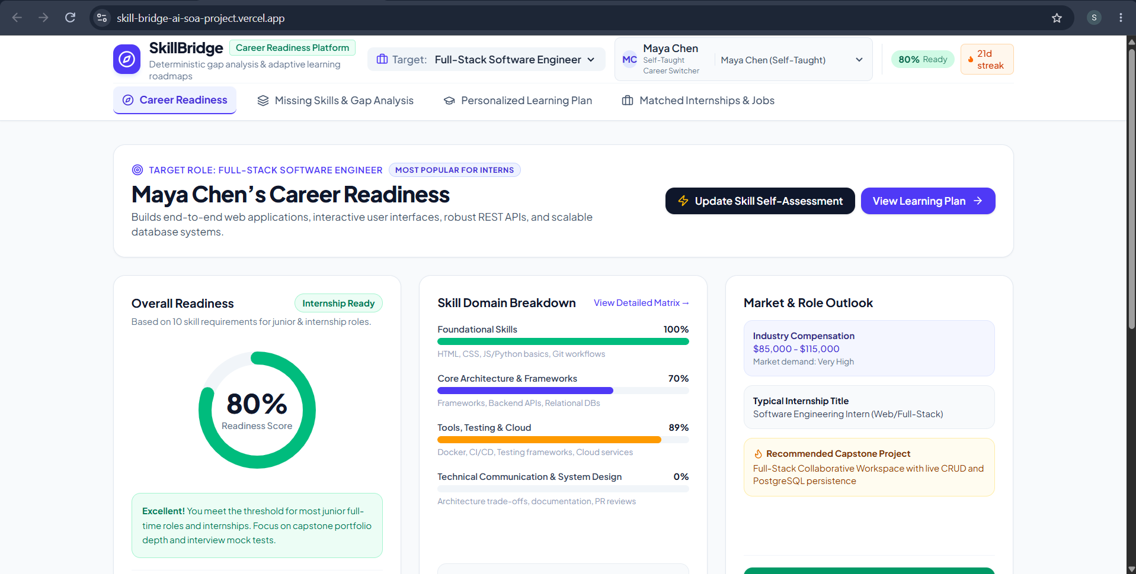The dashboard provides a centralized view of the user's career-readiness information. It displays relevant profile details, skills, career goals, learning progress, and recommendations.
7.2 Skills Page
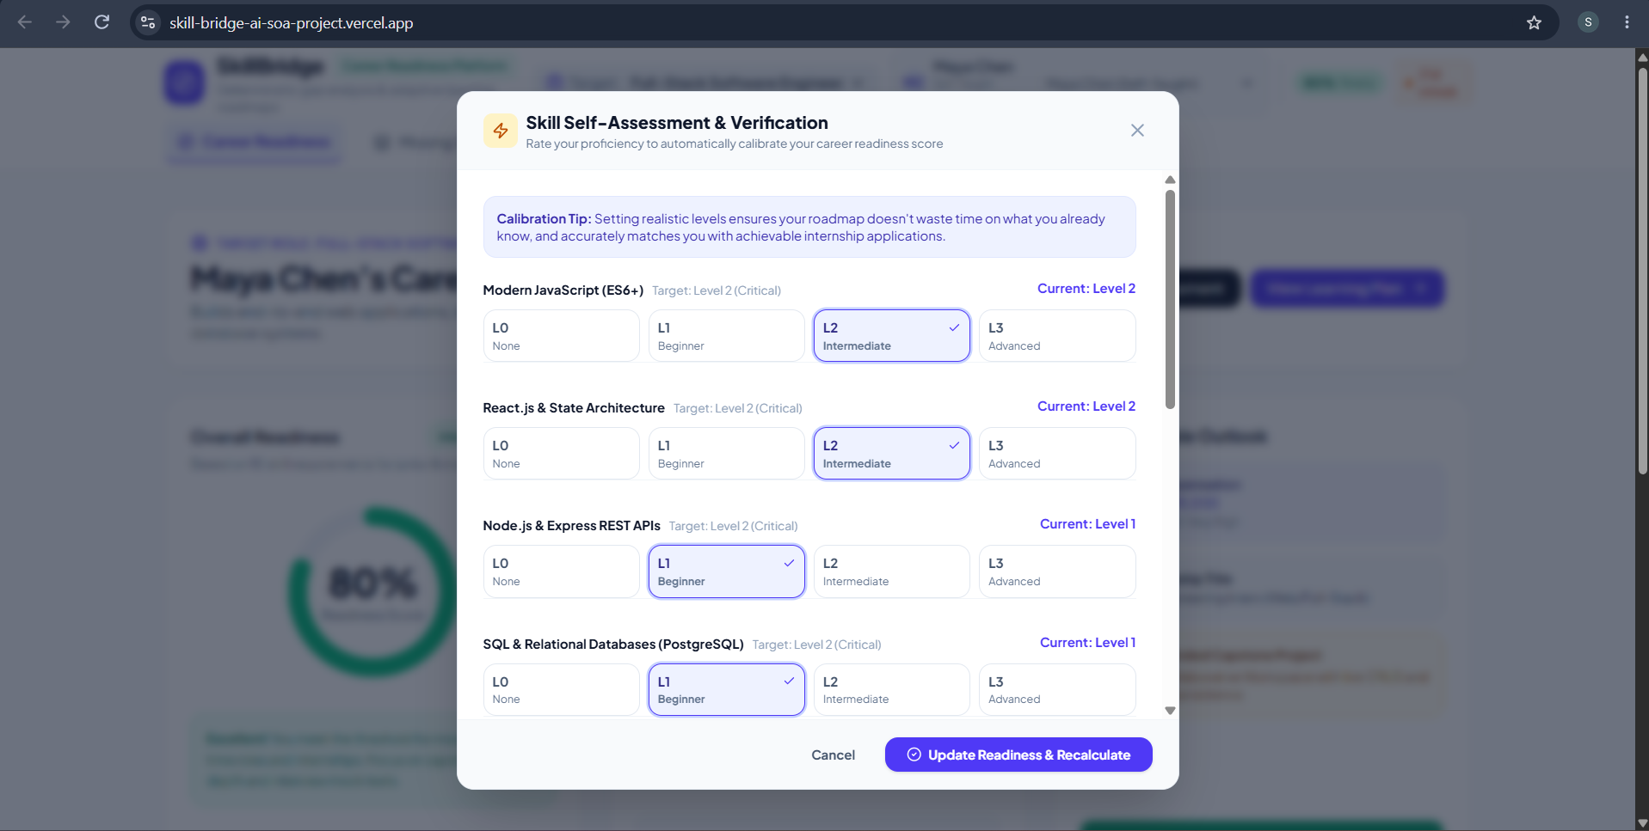The skills page allows users to add and manage their skills. This information is used to identify skill gaps and generate suitable career recommendations.
7.3 Skill Gap Analysis Page
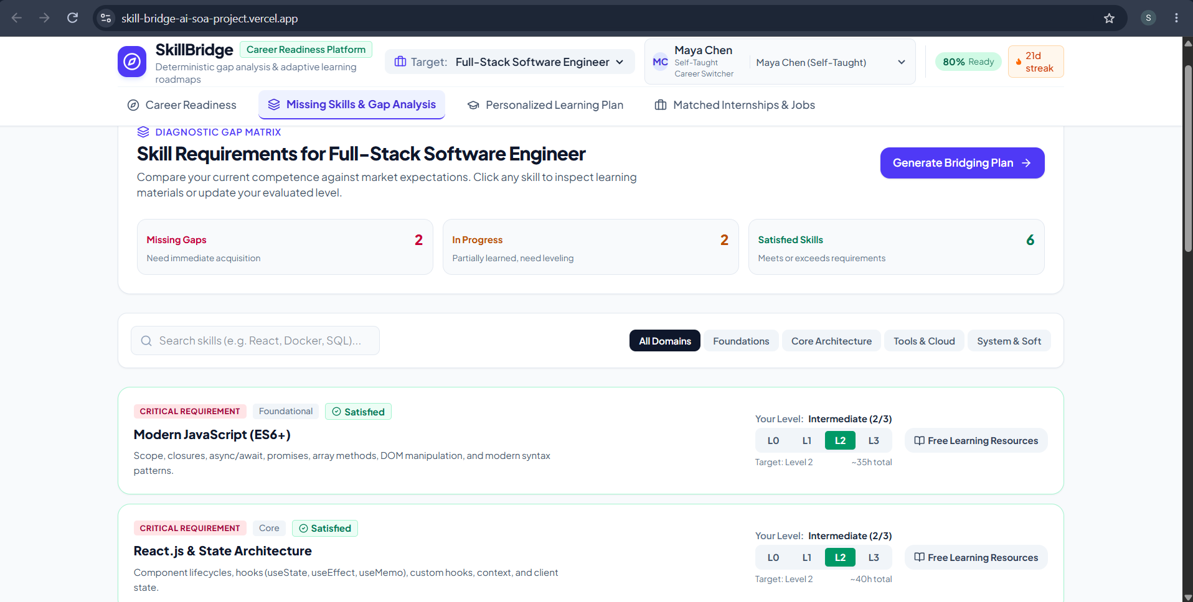The system compares the user's existing skills with the skills required for a selected career. The identified gaps help determine the skills that need further development.
7.4 Personalized Learning Plan
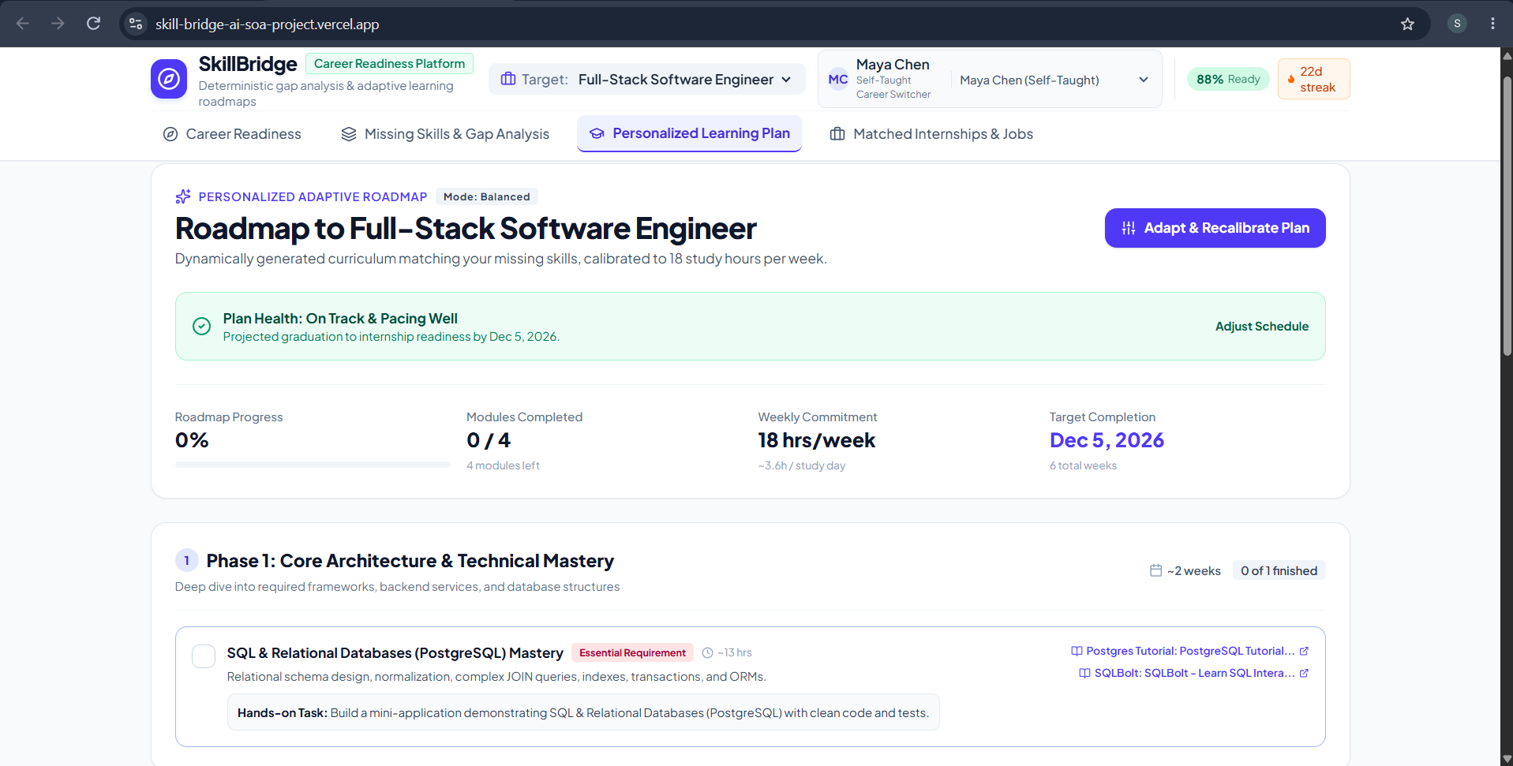The system generates a personalized learning plan based on the identified skill gaps. This provides users with a structured approach to improving their career readiness.

7.5 Opportunity Recommendation Page
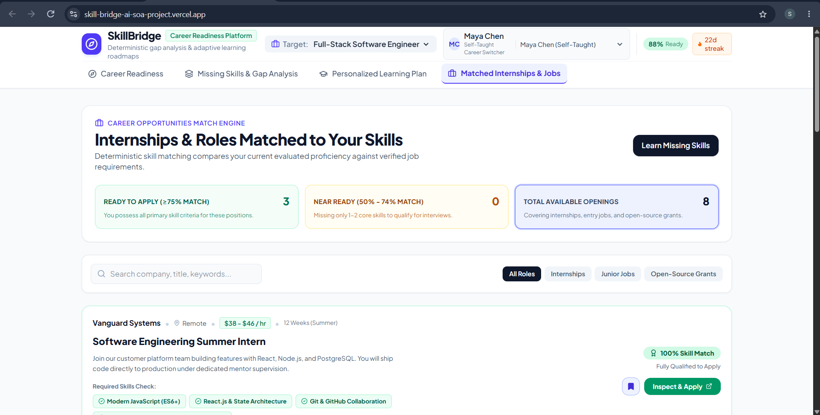The system recommends relevant internships, jobs, and projects according to the user's skills and career interests. This helps users identify suitable opportunities.
7.9 Eureka Service Dashboard
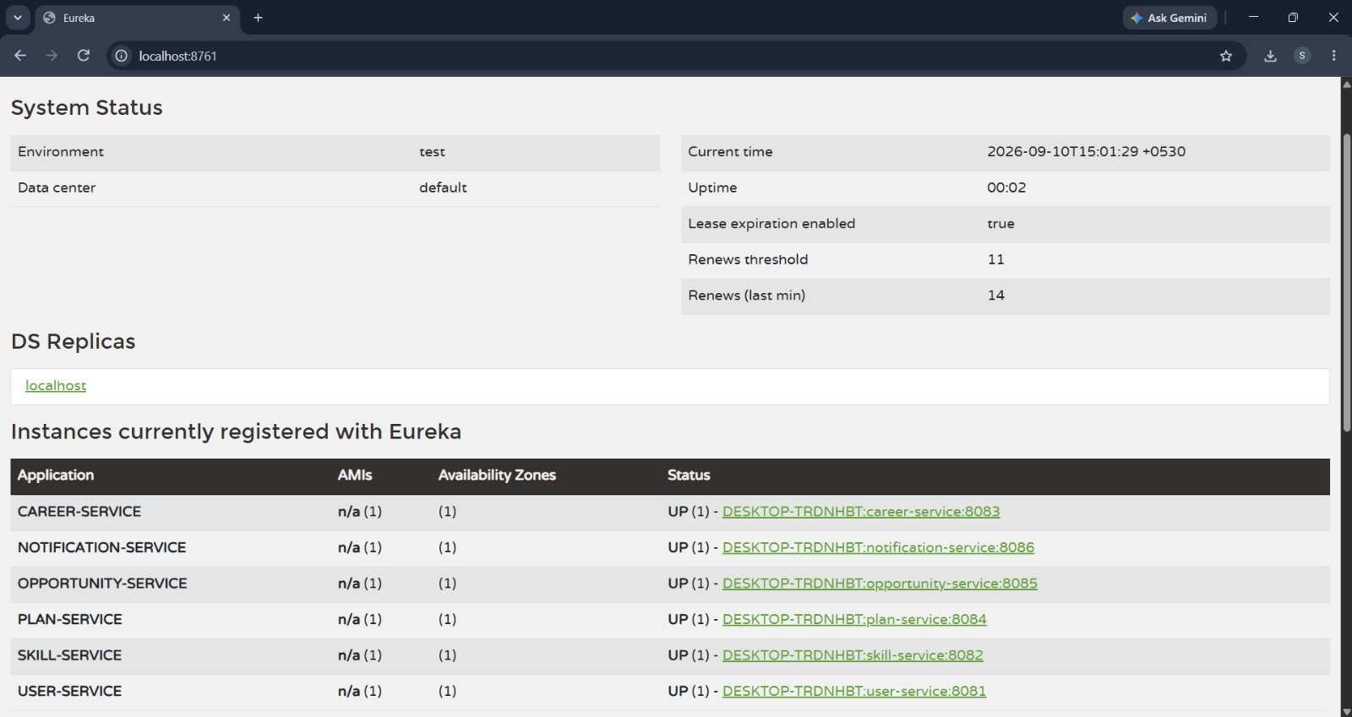The Eureka dashboard displays the registered microservices and their running status. It demonstrates successful service discovery within the SkillBridge AI architecture.

7.10 API Testing
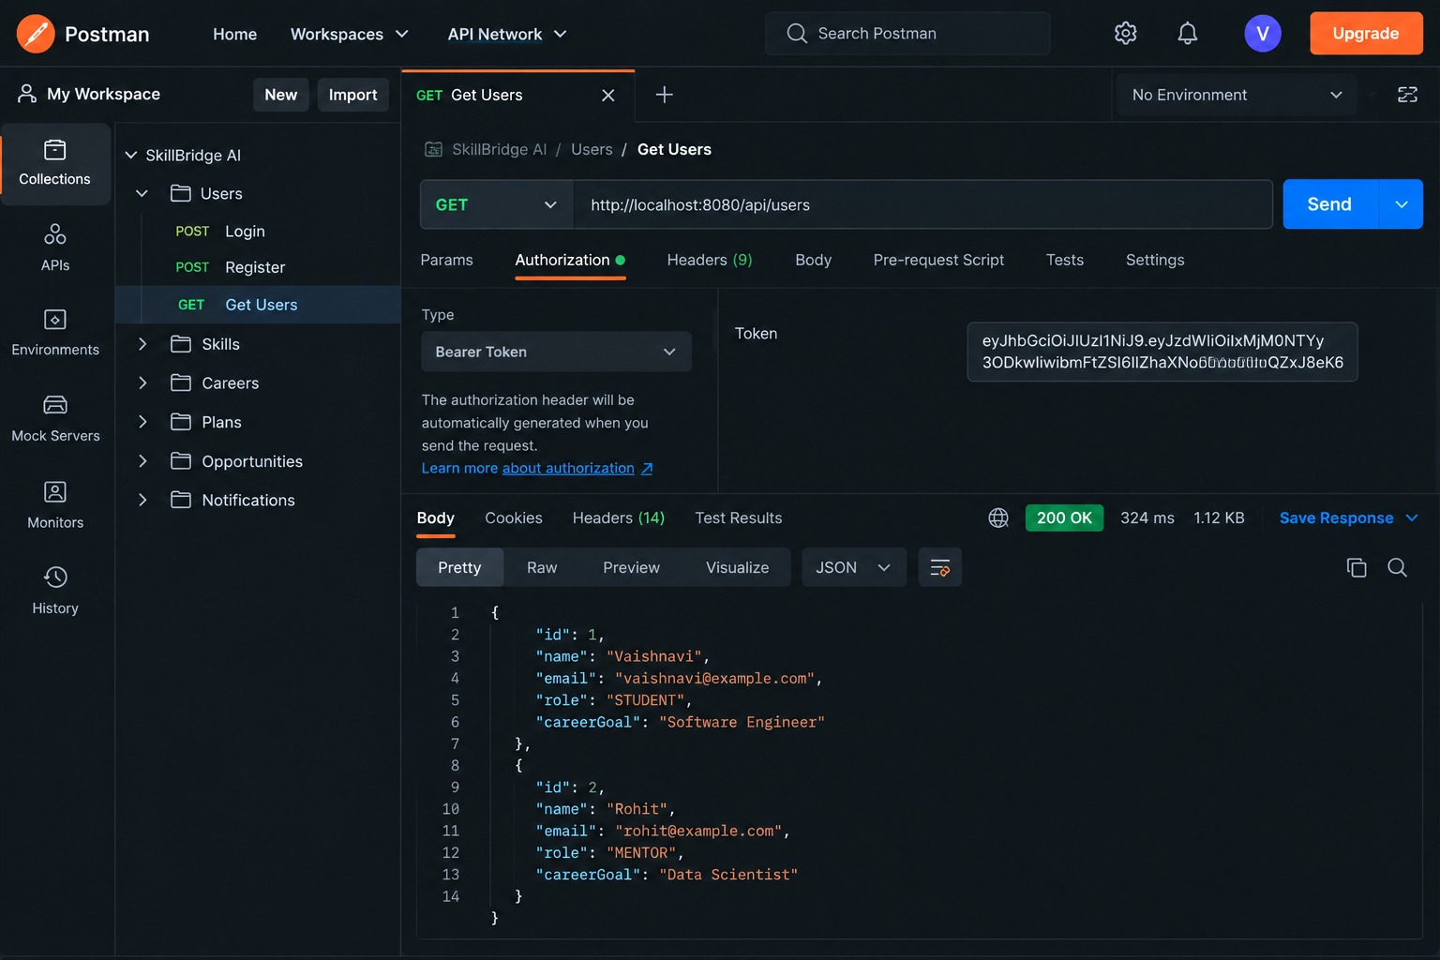The APIs are tested using Postman to verify communication between the frontend, API Gateway, and backend microservices. Successful responses confirm the functionality of the implemented services.

- CONCLUSION & FUTURE SCOPE

8.1 Conclusion
SkillBridge AI successfully addresses the challenges faced by students and job seekers in identifying suitable career paths, understanding skill gaps, developing relevant skills, and finding career opportunities. The project integrates Agentic AI with a microservices-based architecture to provide personalized career profiling, skill-gap analysis, learning plans, and opportunity recommendations. The implementation demonstrates that combining AI-driven recommendations with scalable backend services can provide a more structured and personalized career-readiness experience. Thus, the major objectives of the project were achieved by providing an integrated platform for career guidance and opportunity orchestration.
8.2 Future Scope
Short-Term Enhancements
- Improve the accuracy of AI-generated career and skill recommendations.
- Add more career roles, skills, courses, internships, and job opportunities.
- Enhance the user interface and provide better visualization of skill gaps and learning progress.
Medium-Term Enhancements
- Integrate real-time job and internship data from external platforms.
- Introduce AI-based resume analysis and automated resume improvement.
- Add AI-powered mock interviews and personalized interview feedback.
- Enable continuous learning recommendations based on user progress.
Long-Term Enhancements
- Develop a fully autonomous multi-agent career assistant capable of continuously monitoring user progress and career opportunities.
- Introduce advanced predictive analytics to identify emerging skills and future career opportunities.
- Extend the platform to support multiple languages and larger numbers of users.
- Deploy the system on cloud infrastructure for improved scalability, availability, and accessibility.

- REFERENCES

- LinkedIn – Job Recommendations and Career Opportunities
https://www.linkedin.com/help/linkedin/answer/a512279
- Handshake – Student Career and Opportunity Platform
https://joinhandshake.com/students/
- My Next Move – Career Exploration
https://www.mynextmove.org/
- Forage – Virtual Job Simulations and Career Experiences
https://www.theforage.com/
- Google Career Certificates – Job-Ready Skills
https://grow.google/intl/en_in/certificates/
- SkillGap AI – AI-Based Career Guidance and Skill Gap Analysis
https://www.ijfmr.com/research-paper.php?id=77353
- GenAI Skill Gap Analyzer and Personalized Learning Path
https://www.ijcrt.org/viewfull.php?p_id=IJCRT2604855
- Find Your Flow – AI-Based Career Guidance System
https://ijcrt.org/viewfull.php?paper=IJCRT26A4063
- Spring Boot – Official Documentation
https://spring.io/projects/spring-boot
- Apache Kafka – Official Documentation
https://kafka.apache.org/documentation/
- PostgreSQL – Official Documentation
https://www.postgresql.org/docs/
- Ollama – Official Documentation
https://ollama.com/

