
DEPARTMENT OF CSE
PROJECT ABSTRACT SUBMISSION
COURSE: SOA PROGRAMMING AND MICROSERVICES– (24SDCS03) A.Y. 2026 - 2027
TITLE OF THE PROJECT | SkillBridge AI – An Agentic Career Readiness and Opportunity Orchestration Platform
S. No. | University ID | Name
1 | 2420030024 | Somu Vaishnavi
2 | 2420030405 | Maineni Srihitha
Name of the Guide |  | Dr. Neelima Gogineni

Abstract:
The transition from academic education to a suitable career is challenging for students due to rapidly changing industry requirements, diverse career paths, and the difficulty of identifying the skills required for specific job roles. Students often struggle to evaluate their current competencies, identify skill gaps, plan their learning journey, and determine whether they are ready for internships, projects, or entry-level opportunities. Existing career guidance and recommendation platforms generally provide isolated services such as skill assessment, course recommendation, or job matching, but they do not provide a continuous and autonomous career-readiness process.
To address this need, the proposed “SkillBridge AI – An Agentic Career Readiness and Opportunity Orchestration Platform” introduces an AI-based automated agentic system that integrates skill assessment, career mapping, skill-gap identification, personalized planning, progress monitoring, and opportunity recommendation. The system maintains a dynamic student profile containing information such as skills, education, projects, certifications, assessments, interests, and career goals. This information is processed to understand the student's current capabilities and career objectives.
The proposed system introduces an AI Career Digital Twin that continuously represents and updates the student's career-readiness state. A Skill Assessment Agent evaluates the student's competencies, while a Gap Analysis Agent compares the current skill profile with the competency requirements of the selected career role. The identified gaps are provided to a Career Planning Agent, which generates a prioritized and personalized career-readiness plan containing learning activities, milestones, and recommended actions.
The platform further introduces an Adaptive Career Recovery Agent that monitors student progress and detects situations such as poor assessment performance, missed milestones, or insufficient progress. Based on these observations, the agent dynamically modifies the recommended career plan. An Opportunity Matching Agent evaluates the student's readiness against relevant internships, projects, and entry-level opportunities and generates an Opportunity Readiness Score along with suitable recommendations.
To support reliable communication and scalability, SkillBridge AI follows a Service-Oriented Architecture (SOA) with microservices. The system incorporates Spring Cloud Gateway, Eureka Service Discovery, REST APIs, Apache Kafka for event-driven communication, and PostgreSQL using the database-per-service pattern. Security is implemented using Spring Security, JWT, RBAC, CORS, and TLS/SSL, while JUnit, Spring Boot testing, Data JPA testing, and Postman support system validation. Agile development practices using Jira and CI/CD through GitHub Actions are also incorporated into the development workflow.
Collectively, the proposed SkillBridge AI platform aims to bridge the gap between students' existing competencies and industry-required career skills by providing continuous, personalized, and adaptive career guidance. The system has potential societal value by supporting quality education, skill development, employability, and access to career opportunities, aligning primarily with SDG 4 (Quality Education) and SDG 8 (Decent Work and Economic Growth).

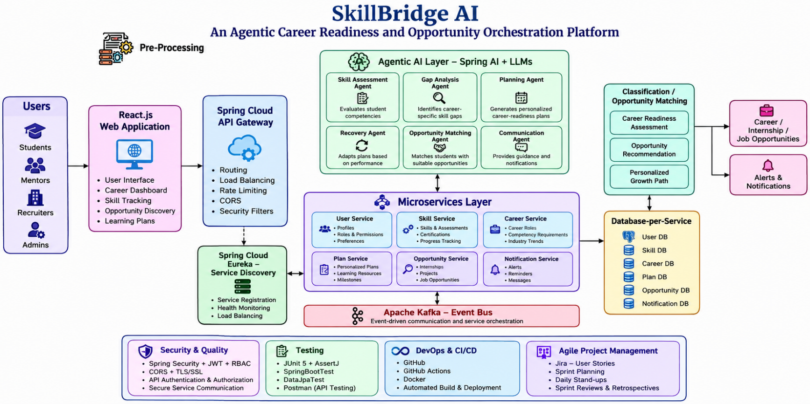
Project Architecture/Project Overview:

