**PROGRAM CODE:**

#include<stdio.h>

void main()

{

char g;

float income,bonus=0;

int id;

printf("enter your id: ");

scanf("%d",&id);

printf("enter income: ");

scanf("%f",&income);

printf("enter m or f: ");

scanf(" %c",&g);

if (g=='m')

{

printf("Bonus is 5 %% of income\n");

bonus+=0.05*income;

}

else

{

printf("Bonus is 10 %% of income\n");

bonus+=0.1*income;

}

if (income<10000)

{

printf("Bonus is increased by 2 %% of income\n");

bonus+=0.02*income;

}

printf("employee id:%d\n",id);

printf("employee salary:%f\n",income);

printf("employee bonus:%f\n",bonus);

}

**OUTPUT:**

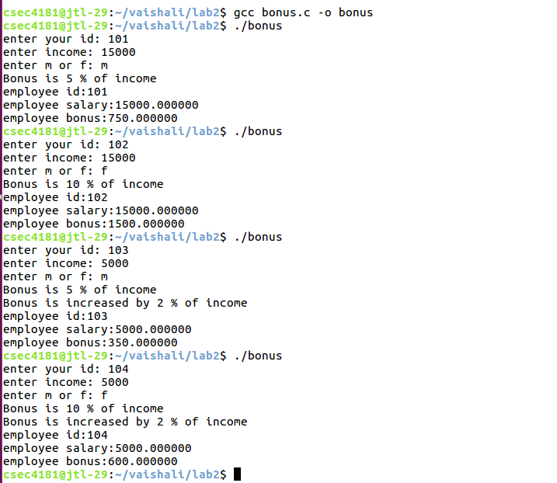

**PROGRAM CODE:**

#include<stdio.h>

void main()

{

char ch;

printf("enter a character: ");

scanf("%c",&ch);

if (ch=='a' || ch=='e' || ch=='i' || ch=='o' || ch=='u')

{

printf("it is a vowel\n");

}

else

printf("it is not a vowel\n");

}

**OUTPUT:**

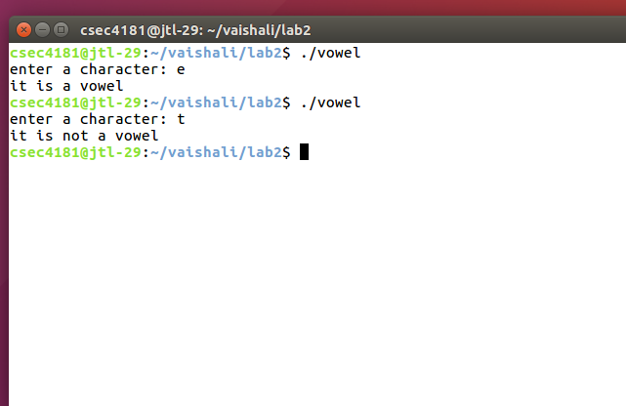

**PROGRAM CODE:**

#include<stdio.h>

void main()

{

float tax,income;

printf("enter your income: ");

scanf("%f",&income);

if (income<150000)

{

printf("no tax\n");

}

else if (150000<=income && income<300000)

{

printf("Tax is 10 %% of income\n");

tax=0.1*income;

}

else if (300001<=income && income<500000)

{

printf("Tax is 20 %% of income\n");

tax=0.2*income;

}

else

{

printf("Tax is 30 %% of income\n");

tax=0.3*income;

}

printf("Tax to be paid: %f\n",tax);

}

**OUTPUT:**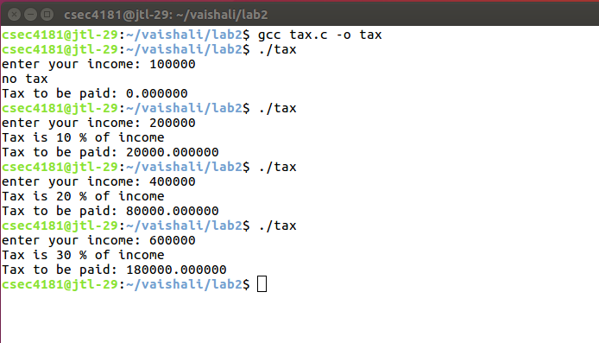

**PROGRAM CODE:**

#include<stdio.h>

void main()

{

int a=0,b=1,c=-1;

float x=2.5,y=0.0;

printf("a=a+(b=b-(c=c*10))\n");

printf("a= %d\n",a=a+(b=b-(c=c*10)));

printf("x*y<a+b||c= %d\n",x*y<a+b||c);

printf("(x>y)+!a||c++= %d\n",(x>y)+!a||c++);

printf("x*5 && 5 || (b/c)= %d\n" ,x*5 && 5 || (b/c));

}

**OUTPUT:**

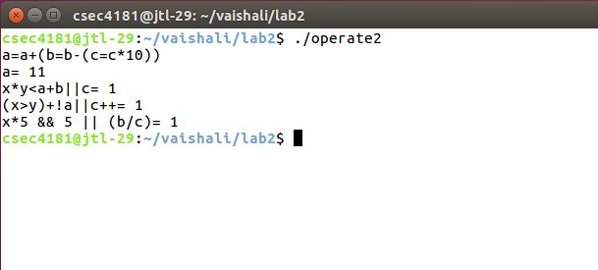

**PROGRAM CODE:**

#include<stdio.h>

void main()

{

int x;

printf("3*4+5*6=%d\n",3*4+5*6);

printf("3*(4+5)*6=%d\n",3*(4+5)*6);

printf("3*4%5/2=%d\n",3*4%5/2);

printf("3*(4%5)/2=%d\n",3*(4%5)/2);

printf("3*4%(5/2)=%d\n",3*4%(5/2));

printf("3*((4%5)/2)=%d\n",3*((4%5)/2));

}

**OUTPUT:**

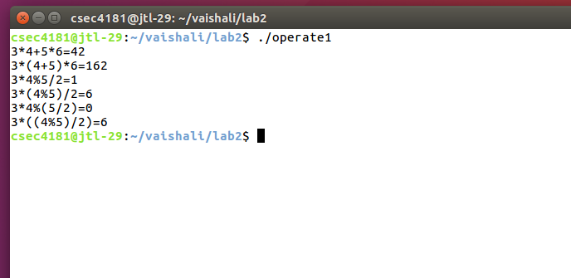

**PROGRAM CODE:**

#include<stdio.h>

#include<math.h>

void main()

{

float a,b,c,d,e,total,average;

printf("enter the marks obtained in english: ");

scanf("%f" ,&a);

printf("enter the marks obtained in maths: ");

scanf("%f" ,&b);

printf("enter the marks obtained in physics: ");

scanf("%f" ,&c);

printf("enter the marks obtained in chemistry: ");

scanf("%f" ,&d);

printf("enter the marks obtained in python: 70");

scanf("%f" ,&e);

total=a+b+c+d+e;

average=(total)/5;

printf("the total marks obtained:%f \n",total);

printf("the average is:%f \n",average);

if (average>=75)

{

printf("You have obtained Distinction\n");

}

else if (average>=60 && average<75)

{

printf("You have obtained First class\n");

}

else if (average>=50 && average<60)

{

printf("You have obtained Second class\n");

}

else if (average>=40 && average<50)

{

printf("You have obtained Third class\n");

}

else

printf("You have failed\n");

}

**OUTPUT:**

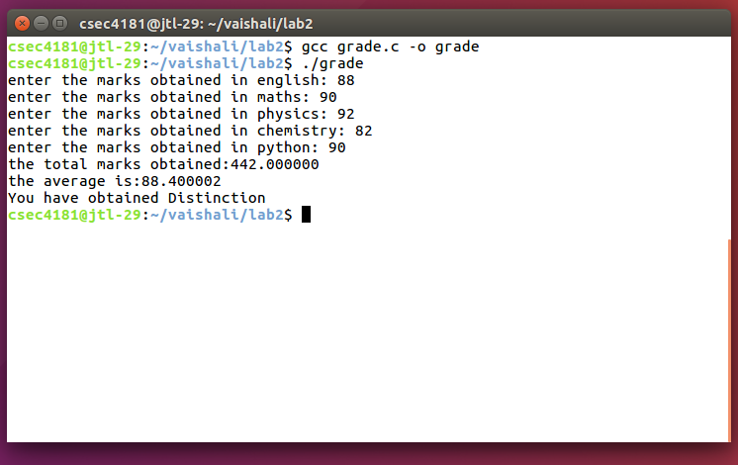

**OUTPUT:**

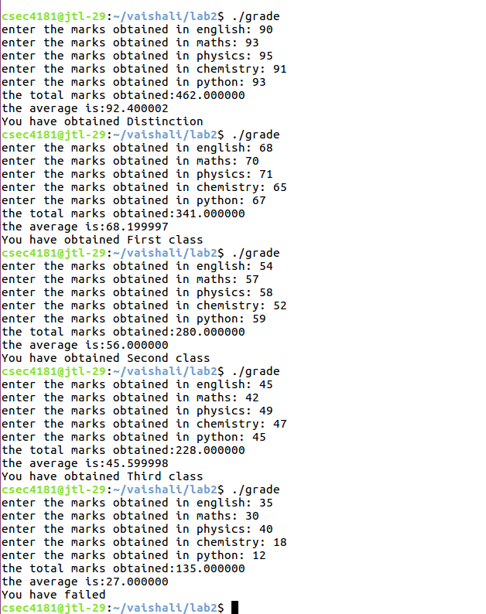

**PROGRAM CODE:**

#include<stdio.h>

#include<math.h>

void main()

{

float a,b,c,d,x1,x2;

printf("enter the coefficient of x^2: ");

scanf("%f",&a);

printf("enter the coefficient of x: ");

scanf("%f",&b);

printf("enter the constant term: ");

scanf("%f",&c);

d=sqrt((b*b)-(4*a*c));

if (d>0)

{

x1=(-b+d)/(2*a);

x2=(-b-d)/(2*a);

printf("The roots are real and unequal\n");

printf("The roots are %f,%f\n",x1,x2);

}

else if (d==0)

{

x1=(-b+d)/(2*a);

printf("The roots are real and equal\n");

printf("The roots are %f,%f\n",x1,x1);

}

else

{

printf("The equation has no real roots\n");

}

}

**OUTPUT:**

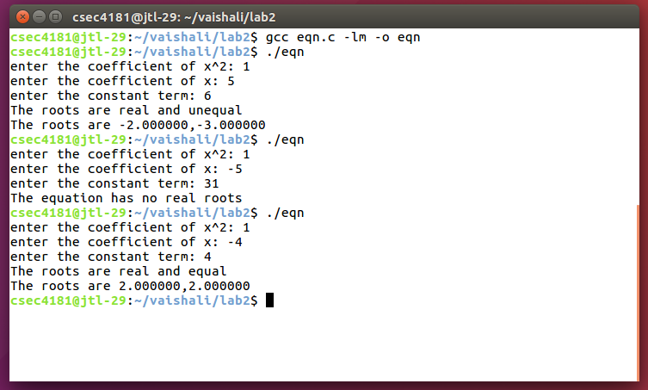

**PROGRAM CODE:**

#include<stdio.h>

void main()

{

char ch;

printf("enter a character: ");

scanf("%c",&ch);

if (ch>='A' && ch<='Z')

{

printf("the given character %c is in uppercase\n",ch);

printf("the lowercase of the given character %c is %c\n",ch,ch+32);

}

else

{

printf("the given character %c is in lowercase\n",ch);

printf("the uppercase of the given character %c is %c\n",ch,ch-32);

}

}

**OUTPUT:**

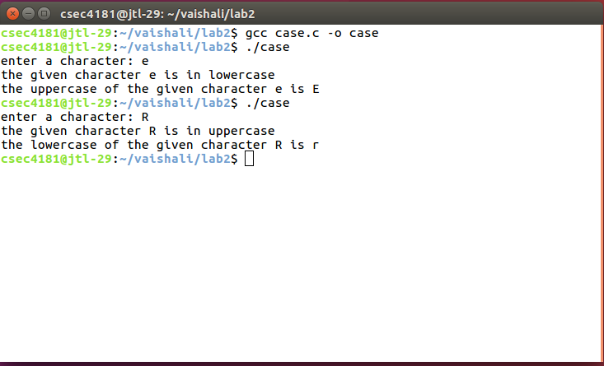

**PROGRAM CODE:**

#include<stdio.h>

void main()

{

float a,b,c,min;

printf("enter the first number : ");

scanf("%f" ,&a);

printf("enter the second number : ");

scanf("%f" ,&b);

printf("enter the third number : ");

scanf("%f" ,&c);

min=(a<b)&&(a<c)?a:(b<c)&&(b<a)?b:c;

printf("The smallest number is %f\n",min);

}

**OUTPUT:**

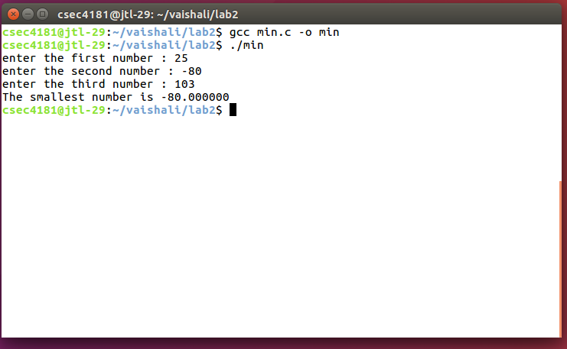

**PROGRAM CODE:**

#include<stdio.h>

void main()

{

int year;

printf("enter the year: ");

scanf("%d",&year);

if (year%4==0)

{

if (year%100==0)

{

if (year%400==0)

{

printf("the year is both leap and centurion year\n");

}

else

{

printf("the year is centurion year but not leap year\n");

}

}

else

{

printf("it is a leap year\n");

}

}

else

printf("it is an ordinary year\n");

}

**OUTPUT:**

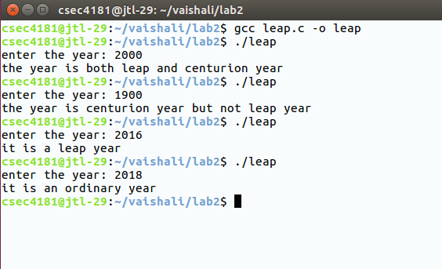

**PROGRAM CODE:**  
/*program to calculate GPA*/  
#include<stdio.h>

void main()

{

float eng,maths,phy,chem,python;

float ceng=4,cmaths=4,cphy=3,cchem=3,cpython=3;

float c,e,m,p,ch,py,x,gpa;

printf("enter grade points obtained in english: ");

scanf("%f",&eng);

printf("enter grade points obtained in mathematics: ");

scanf("%f",&maths);

printf("enter grade points obtained in physics: ");

scanf("%f",&phy);

printf("enter grade points obtained in chemistry: ");

scanf("%f",&chem);

printf("enter grade points obtained in python: ");

scanf("%f",&python);

e=eng*ceng;

m=maths*cmaths;

p=phy*cphy;

ch=chem*cchem;

py=python*cpython;

x=e+m+p+ch+py;

c=ceng+cmaths+cphy+cchem+cpython;

gpa=x/c;

printf("\n");

printf("SUBJECT\tGRADE POINTS\tCREDITS\n");

printf("\n");

printf("english\t%f\t%f\n",eng,ceng);

printf("maths\t%f\t%f\n",maths,cmaths);

printf("physics\t%f\t%f\n",phy,cphy);

printf("chem\t%f\t%f\n",chem,cchem);

printf("python\t%f\t%f\n",python,cpython);

printf("\n");

printf("your gpa is %f\n",gpa);

}

**OUTPUT:**  
enter grade points obtained in english: 10  
enter grade points obtained in mathematics: 9  
enter grade points obtained in physics: 8  
enter grade points obtained in chemistry: 10  
enter grade points obtained in python: 9

SUBJECT    GRADE POINTS    CREDITS

english    10.000000    4.000000  
maths    9.000000    4.000000  
physics    8.000000    3.000000  
chem    10.000000    3.000000  
python    9.000000    3.000000

Your GPA is 9.235294