**PROGRAM CODE AND OUTPUT:**

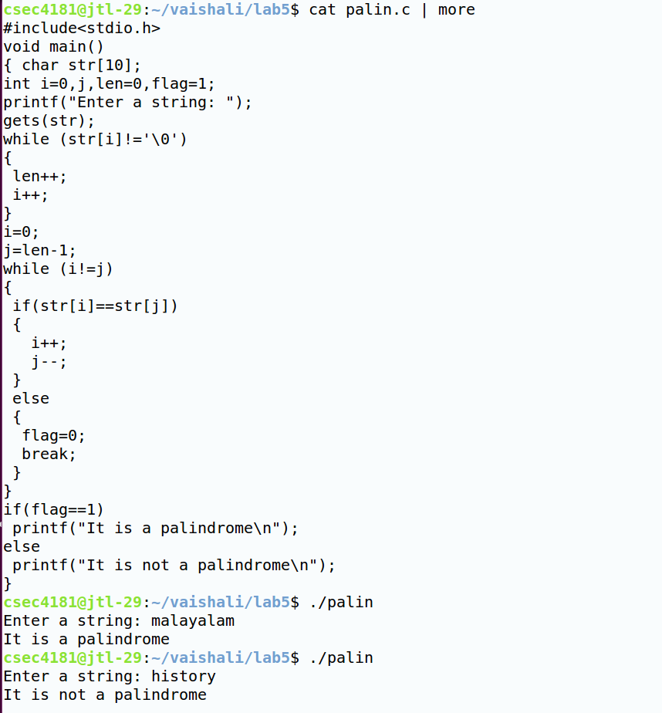

**PROGRAM CODE AND OUTPUT:**

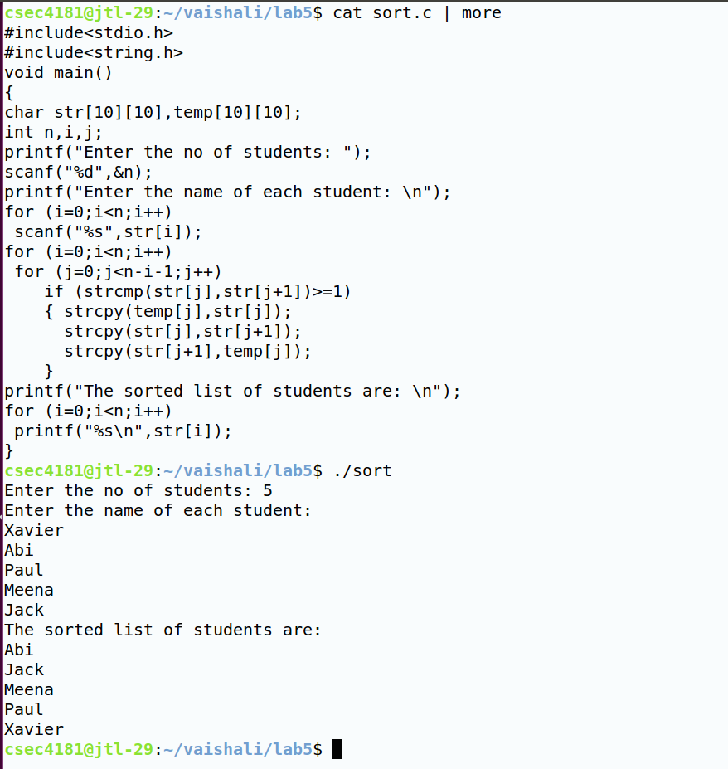

**PROGRAM CODE AND OUTPUT:**

