**Ex.No.3 Remote Login into a VM**

1. **Create two VMs and install Ubuntu 16.04 server**

Creation of Server1:

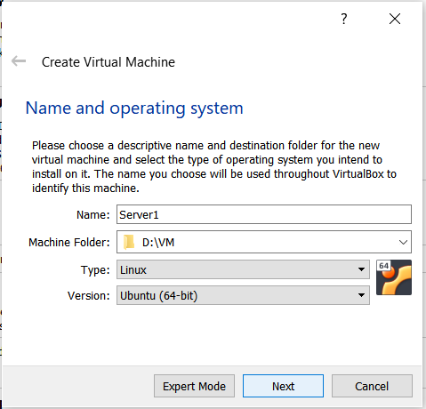

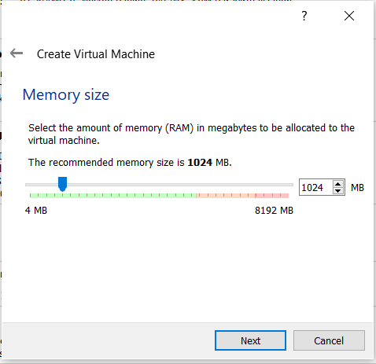

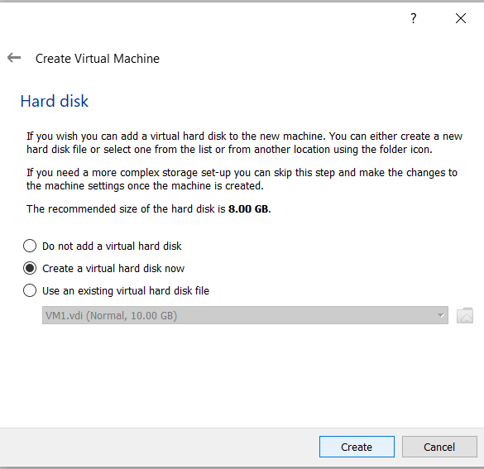

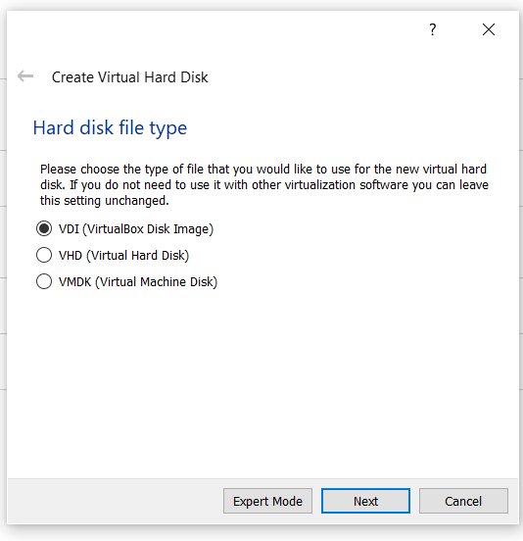

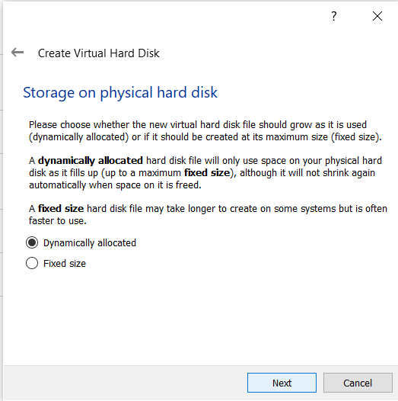

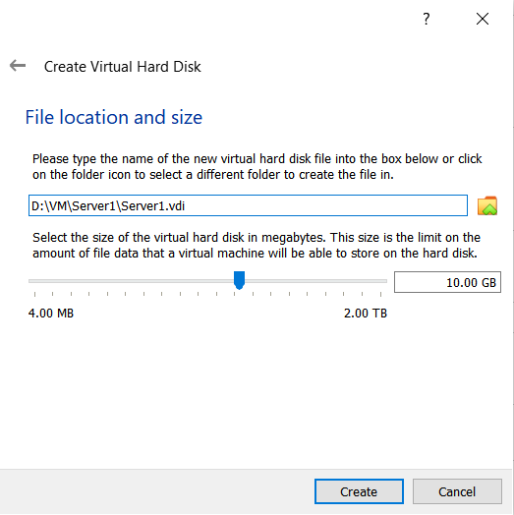

Change the network settings to Bridged adapter

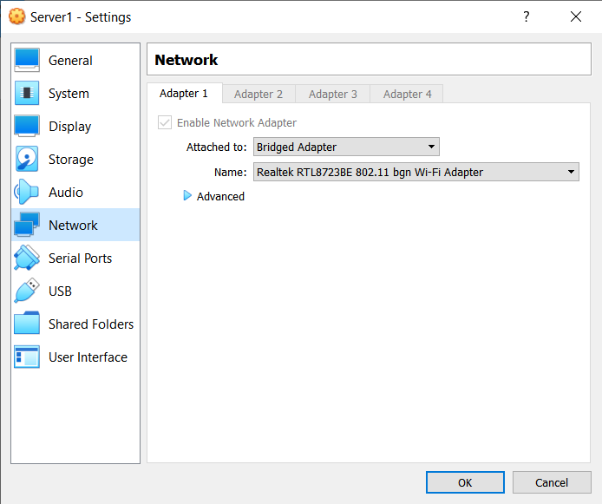

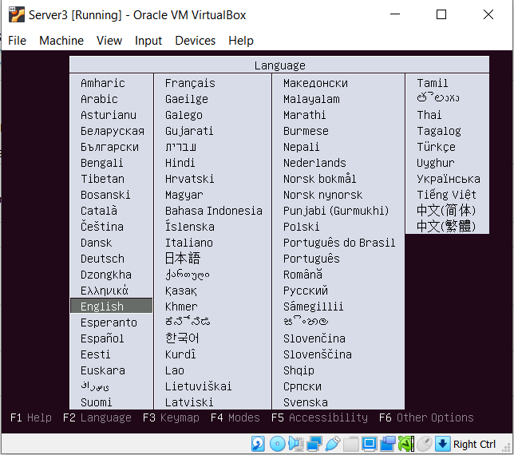

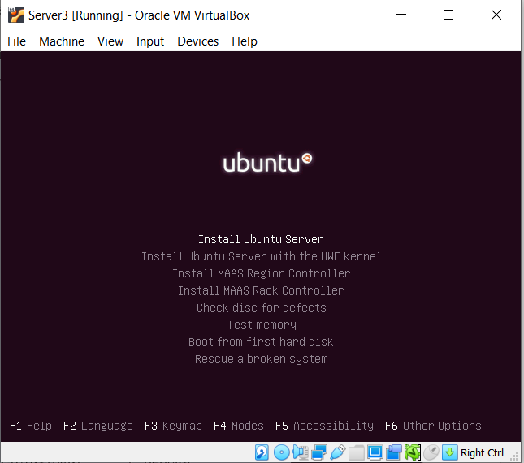

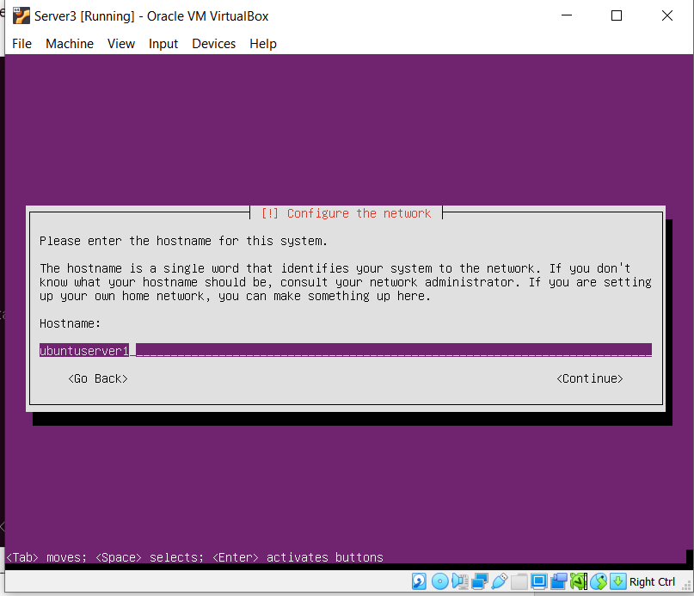

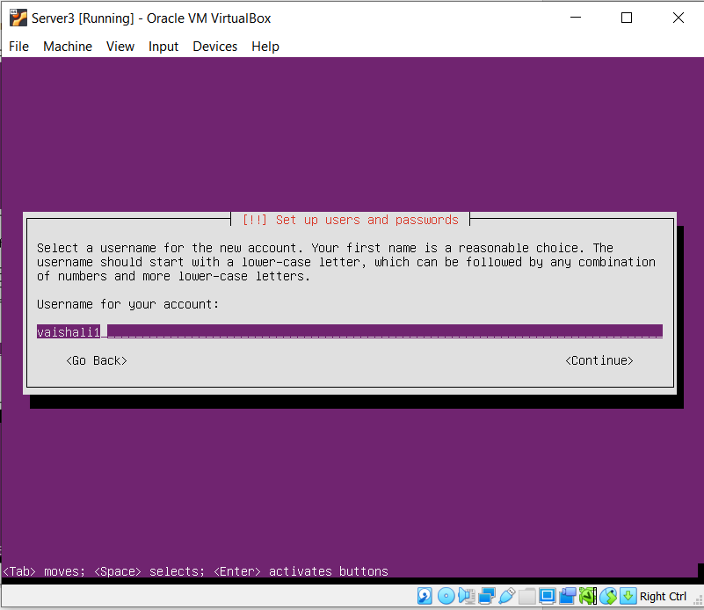

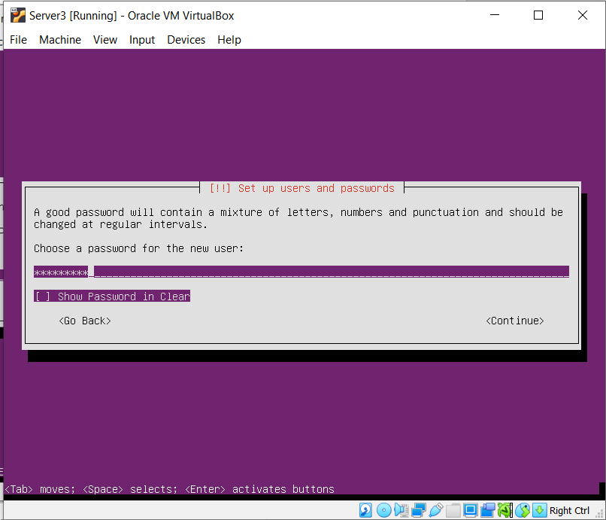

Installation of Open SSH

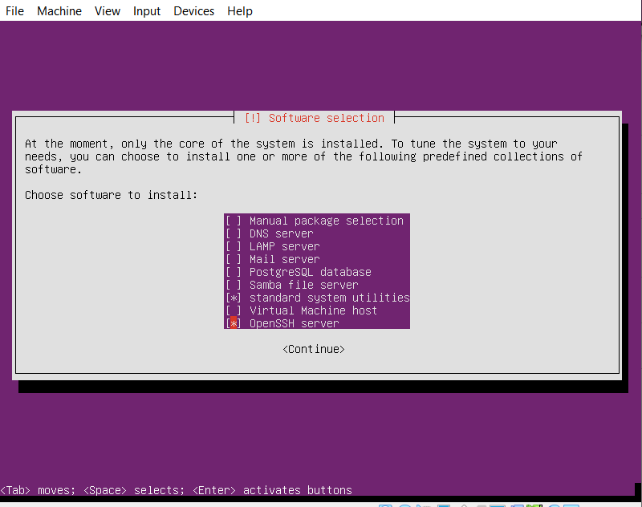

**VM1**

**Hostname: ubuntuserver1**

**Username:vaishali1**

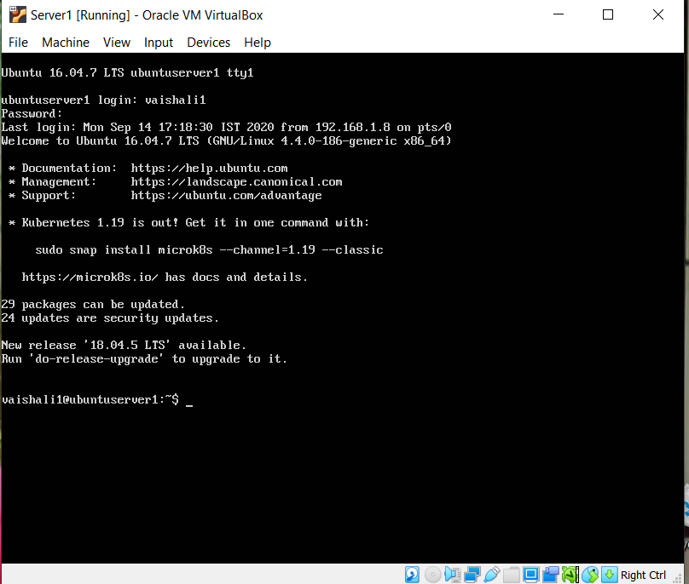

Similarly another VM is created and Ubuntu 16.04 server is installed.

**VM2**

**Hostname: ubuntuserver2**

**Username:vaishali2**

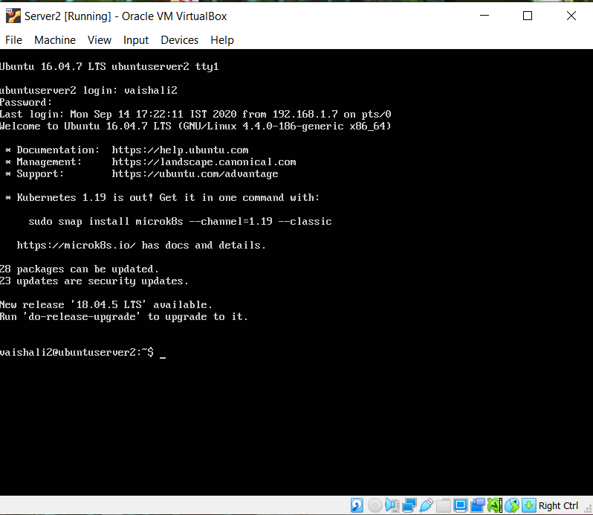

**JDK installation in VM2**

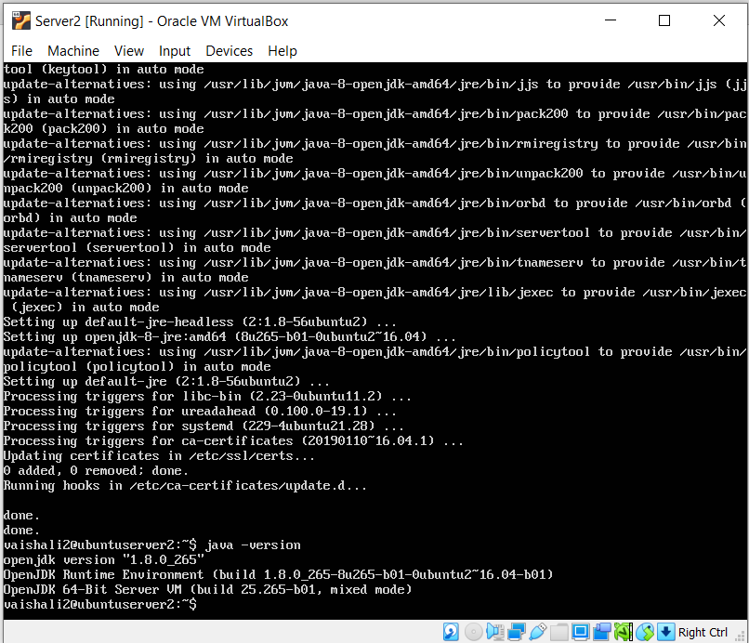

**ifconfig in VM1**

IP address of VM1 is 192.168.1.7

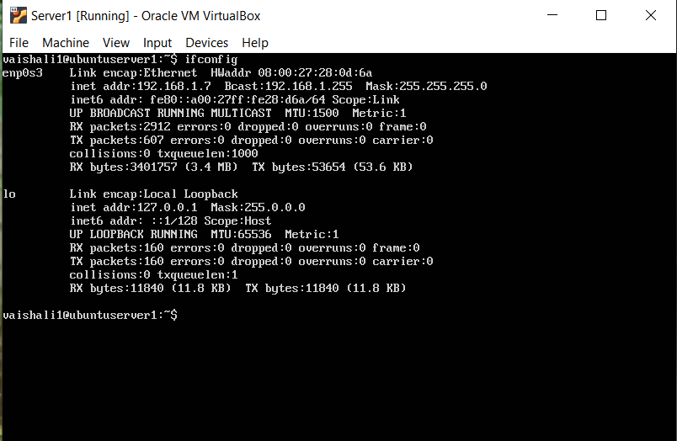

**ifconfig in VM2**

IP address of VM1 is 192.168.1.8

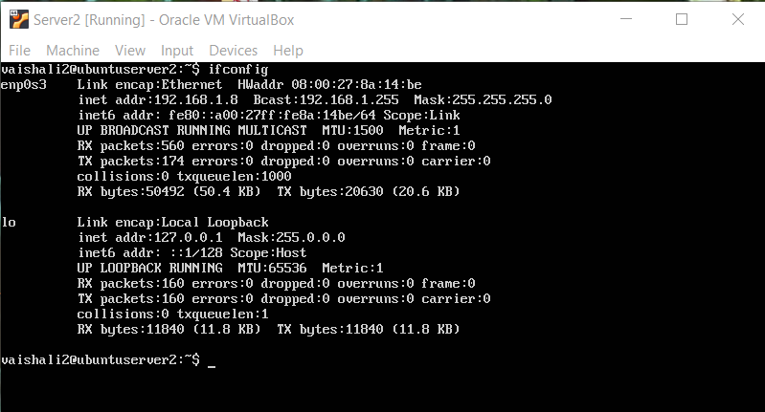

1. **Remote login with password**

* Ping VM1 from VM2

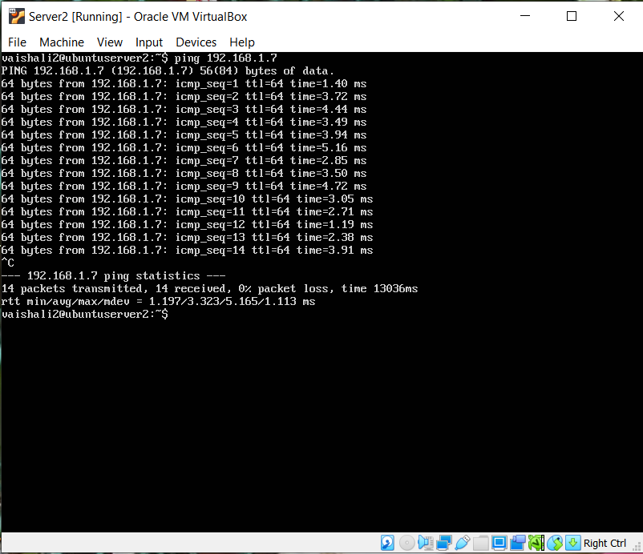

* Ping VM2 from VM1

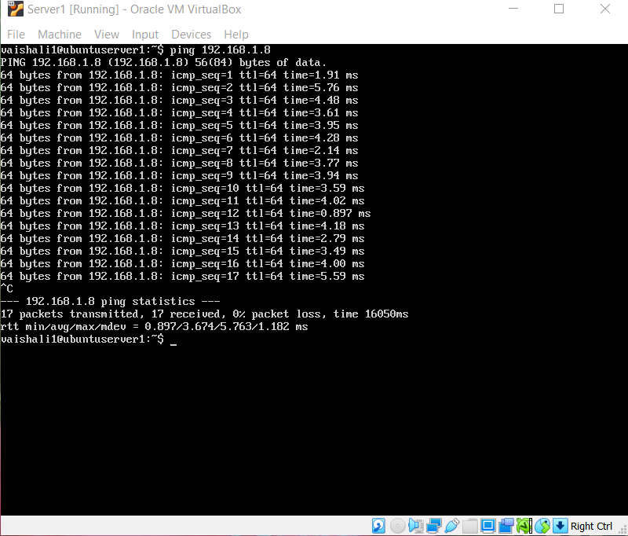

* **Remote login to VM2 from VM1 using SSH (with password)**

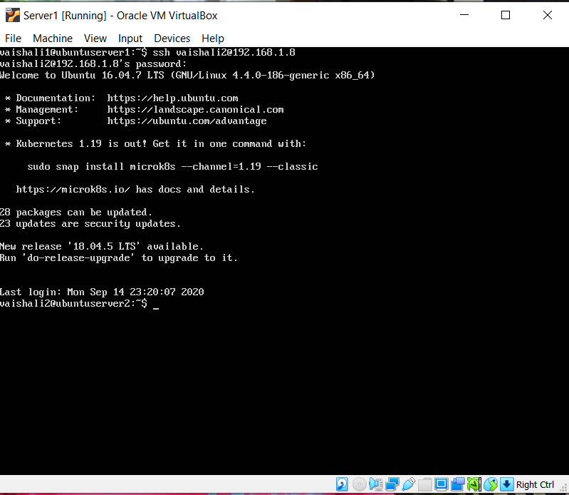

* **hello.java in VM2**

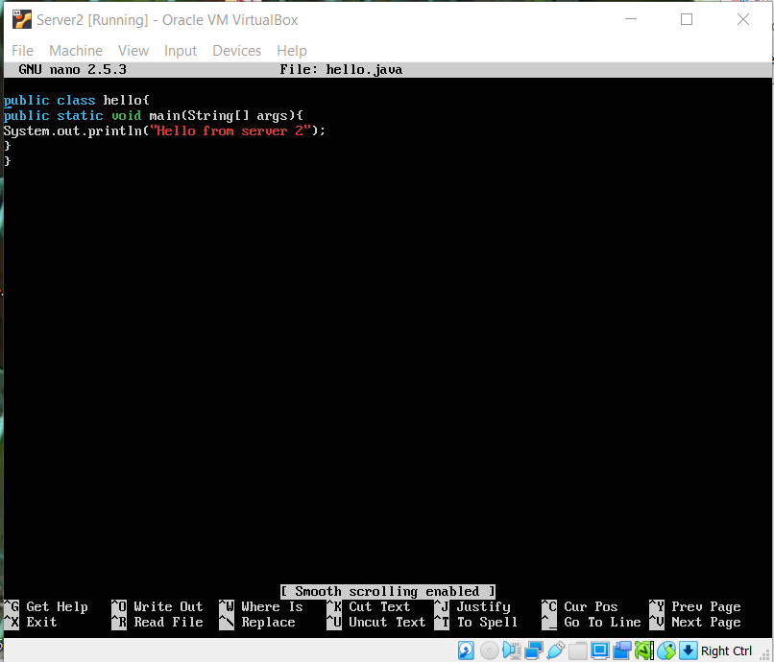

* **Execution of hello.java in VM2 from VM1**

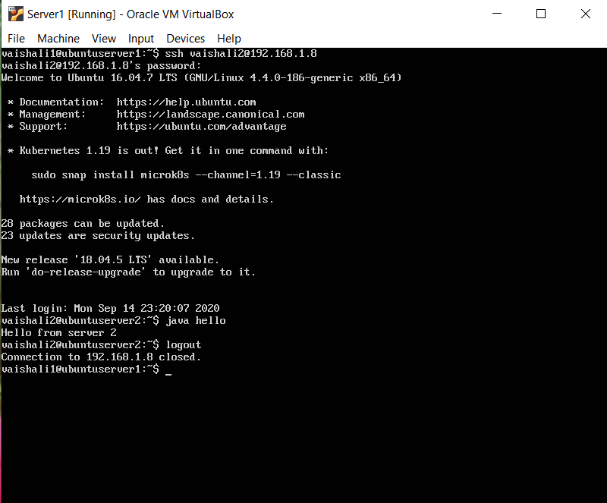

* **Installation of java in VM1 from VM2**

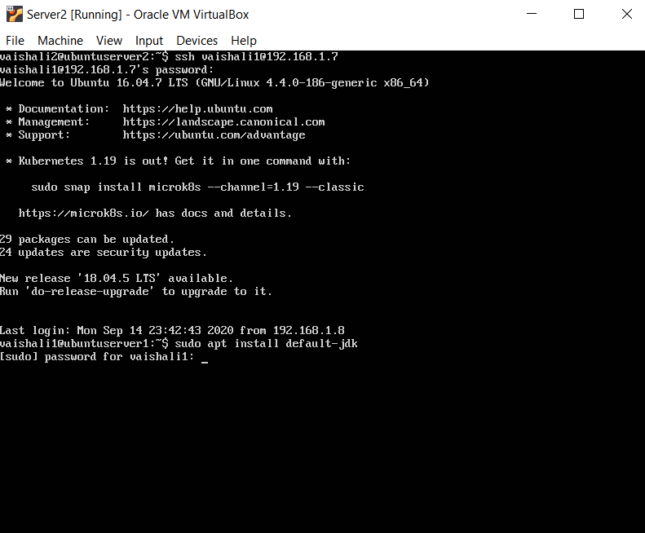

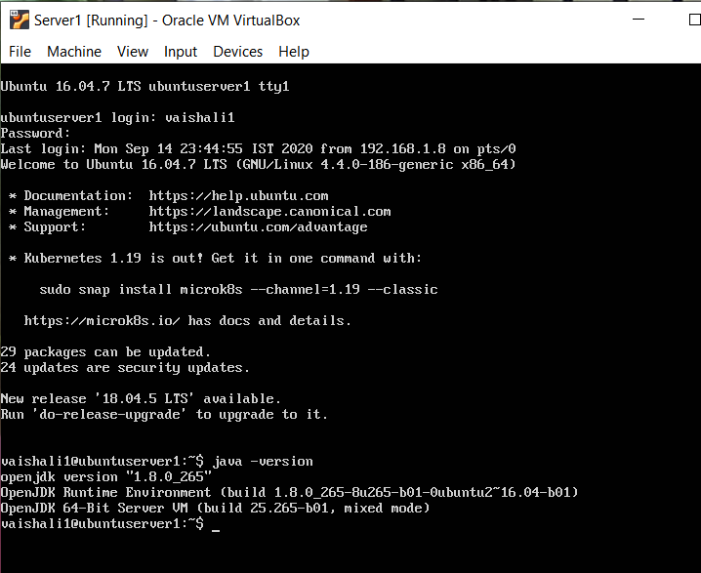

1. **Remote login without password**

* Create ssh-keypair using the command $ ssh-keygen –t rsa and change permission for id_rsa.pub as 700.

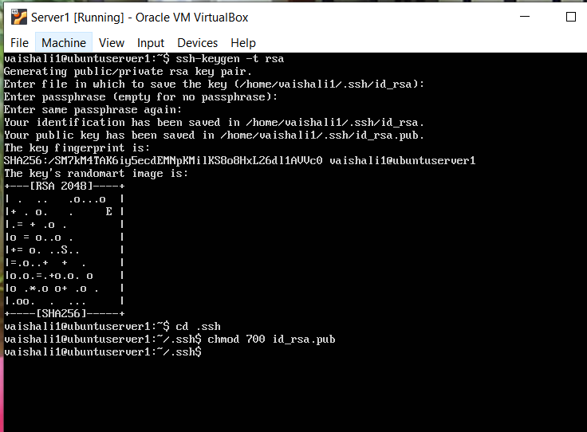

* Copy authorized_keys / id_rsa.pub into VM2 using the command

$ ssh-copy-id <UsernameVM2>@<IP_Address_VM2>

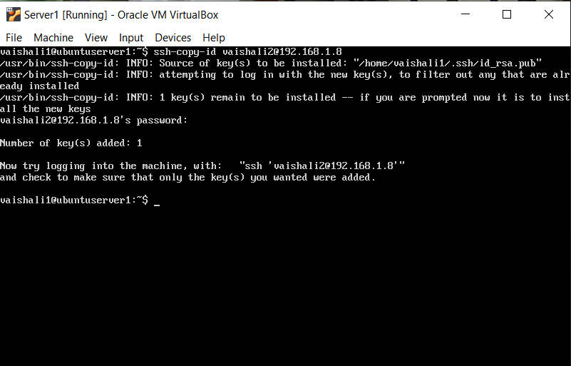

* Remote login into VM2 from VM1 $ ssh <usernameVM2>@<IP_Address_VM2>

