**Ex.No.4 File Transfer between Virtual Machines**

1. Two VMs are created and Ubuntu 16.04 server has been installed with open-ssh server.
2. Ping VM1 from VM2

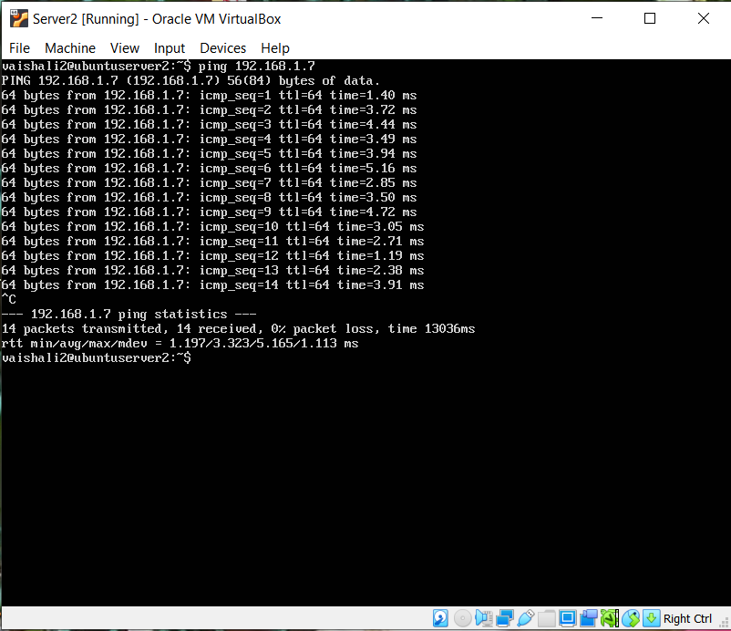

Ping VM2 from VM1

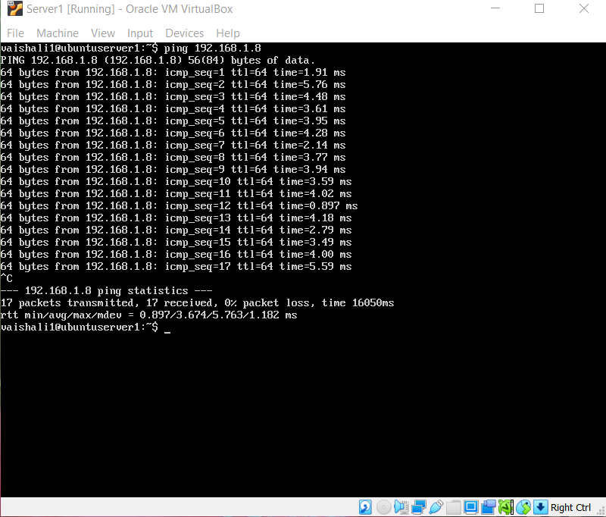

1. SSH public key and private keys are generated using the command:

ssh-keygen –t rsa

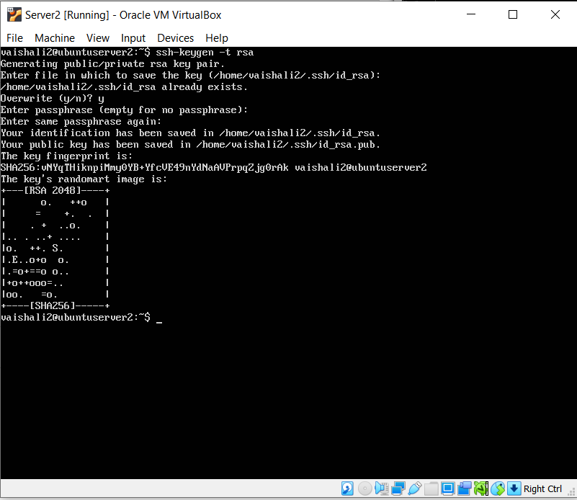

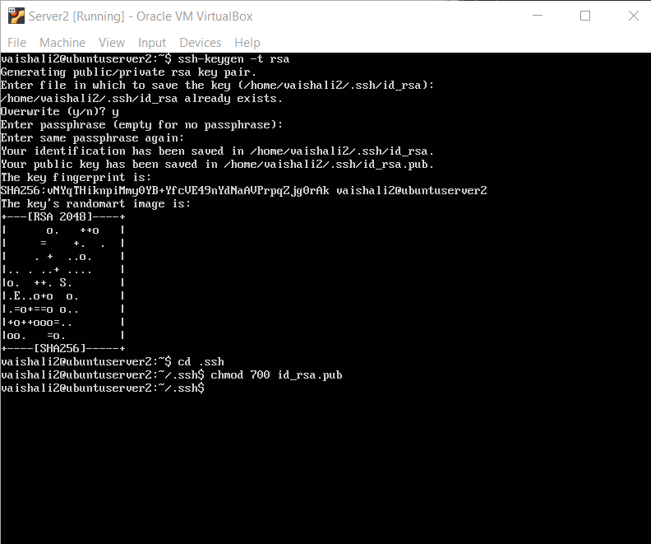

1. **Exchange of keys using ssh-copy-id**

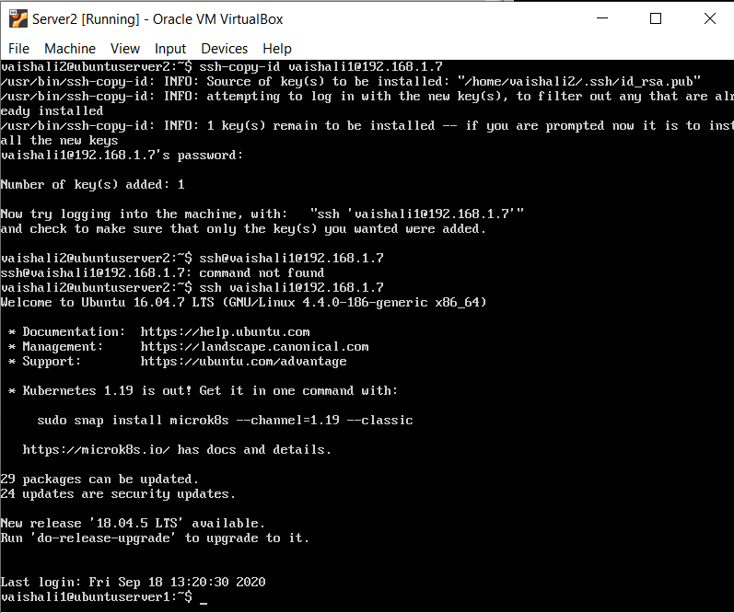

1. **File Transfer between VMs on same Host and different Hosts**
2. **a) Transfer File from VM1 to VM2 using Secure copy command (scp)**

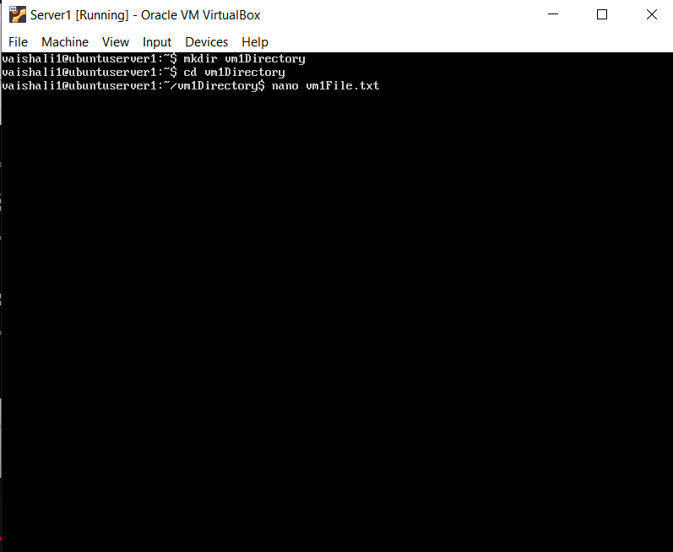

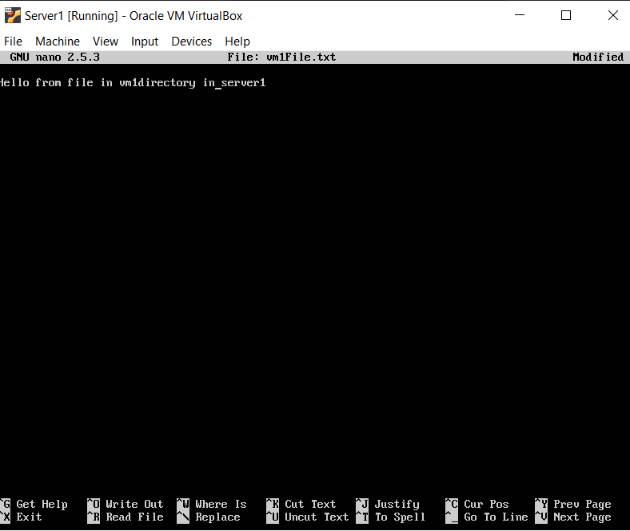



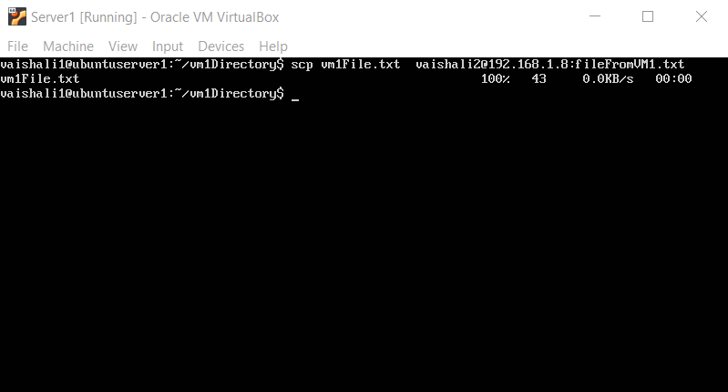

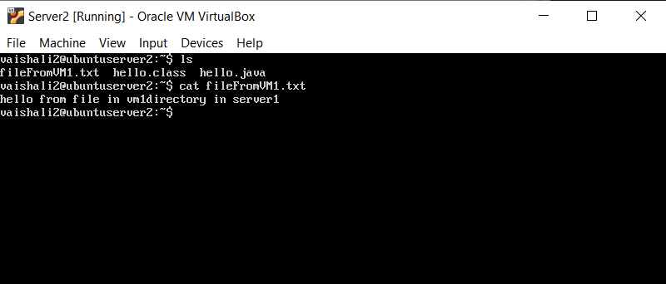

1. **b) Transfer Directory from VM1 to VM2 using Secure copy command (scp)**

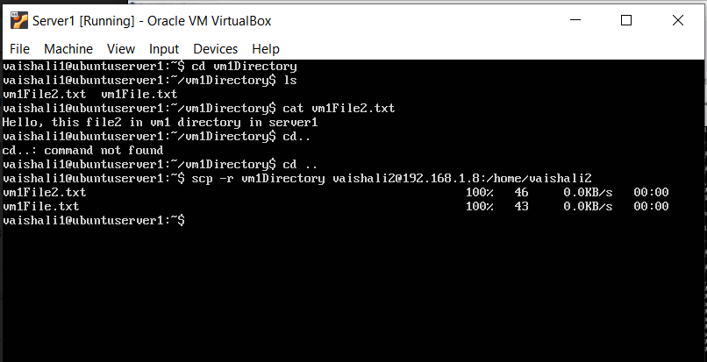

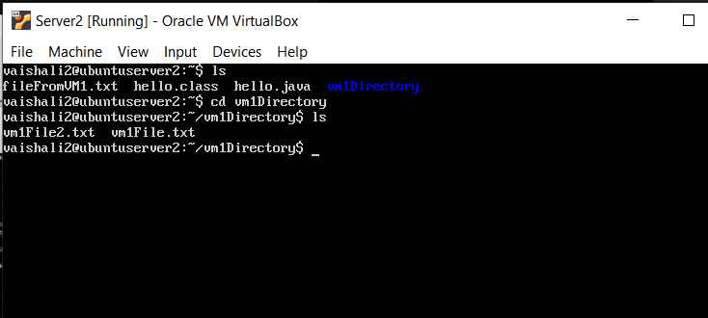

**2. a) Transfer File from VM2 to VM1 using Secure copy command (scp)**

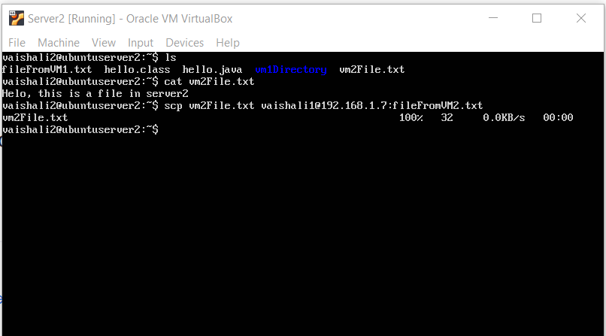

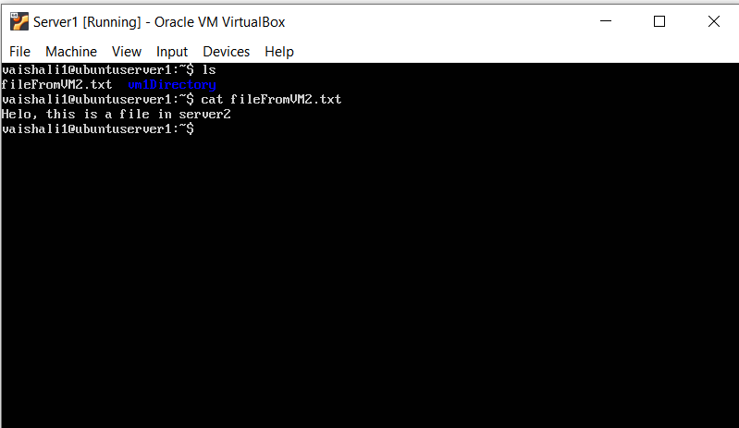

**2. b) Transfer Directory from VM2 to VM1 using Secure copy command (scp)**

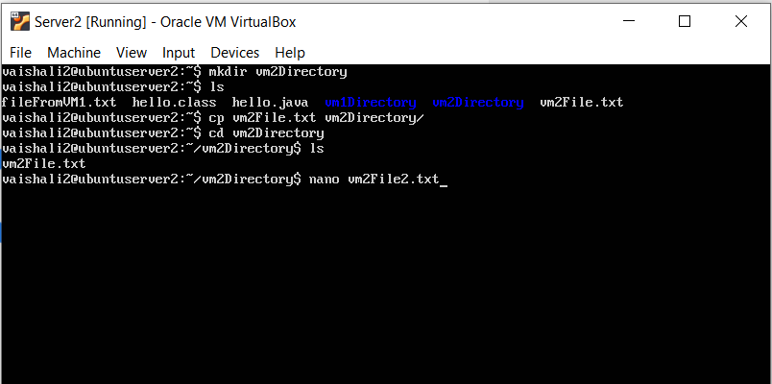

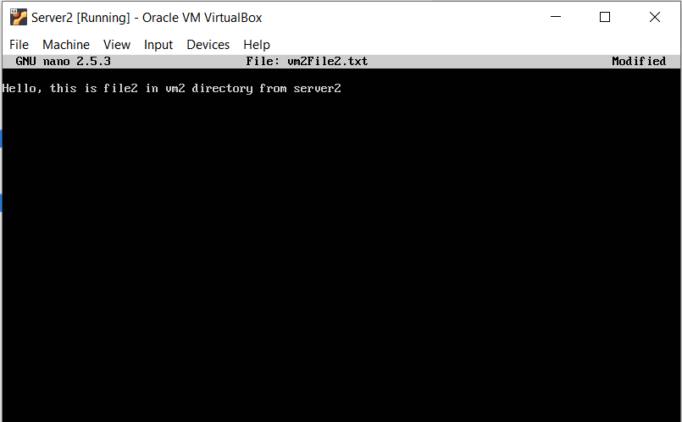

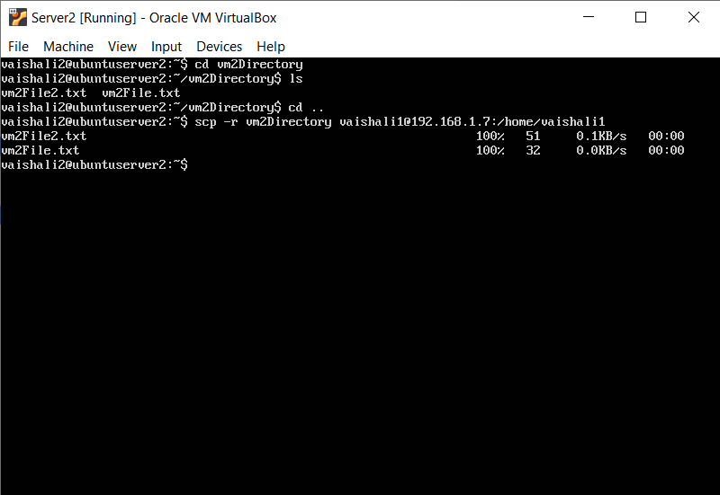

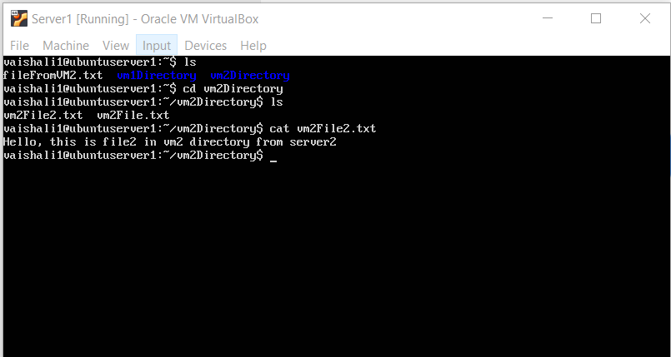

**3. Receive a file from VM1 to VM2 using Secure copy command (scp)**

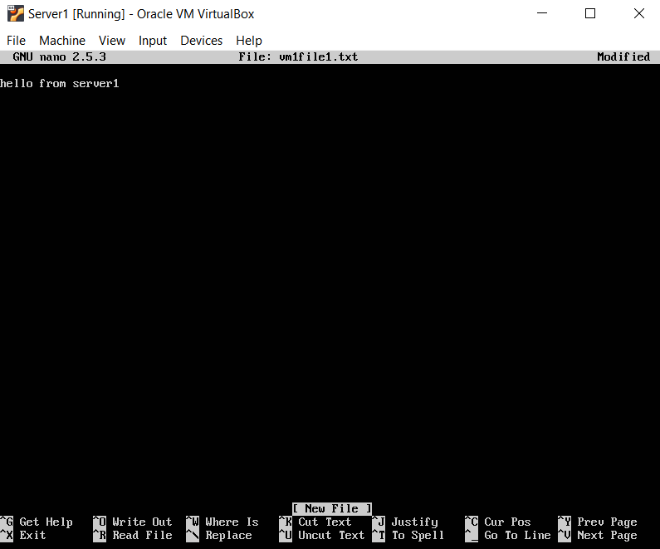

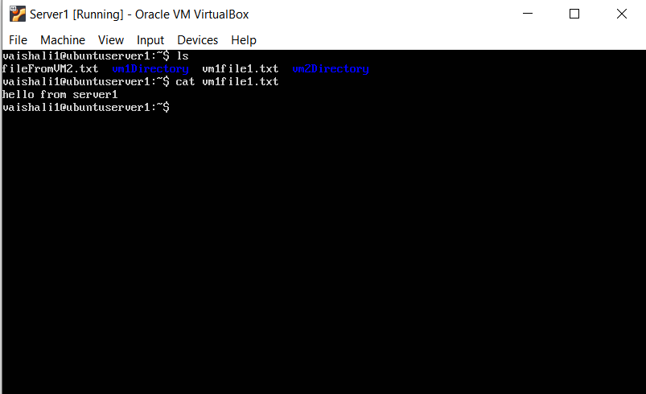

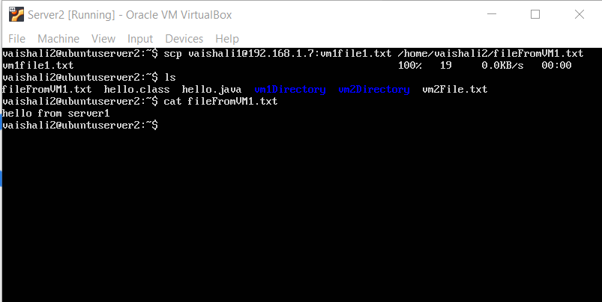

**4. Transfer a file from physical machine (Windows as host OS) to VM1.**

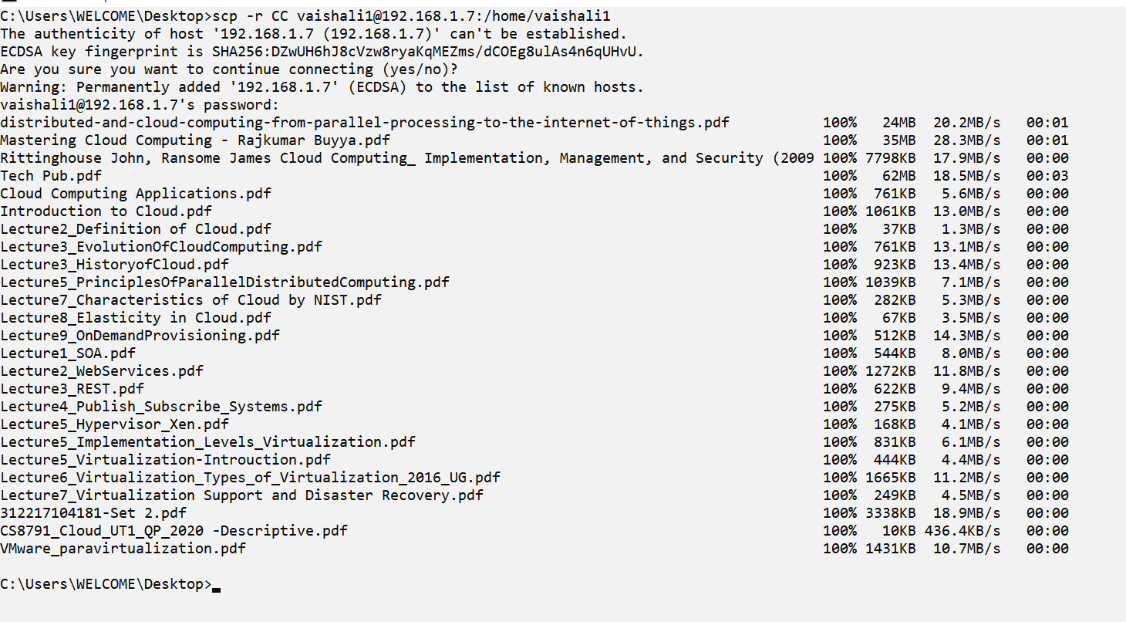

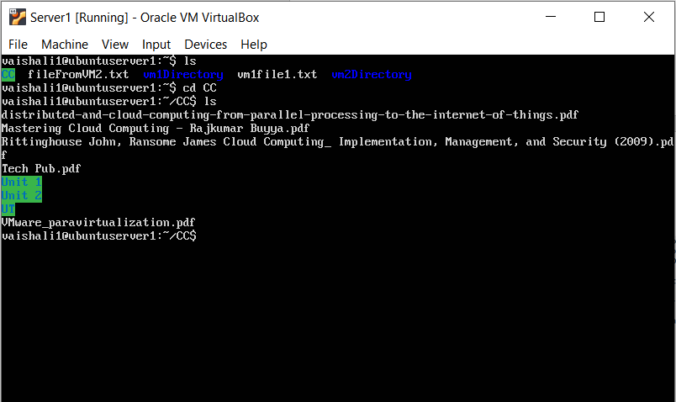

**5. Try to transfer a file from VM1 to physical machine (Windows as host OS).**

