**Ex.No.6: Developing Simple Application on Google App Engine**

1. Install Google App Engine SDK for Python in Host OS (Windows)

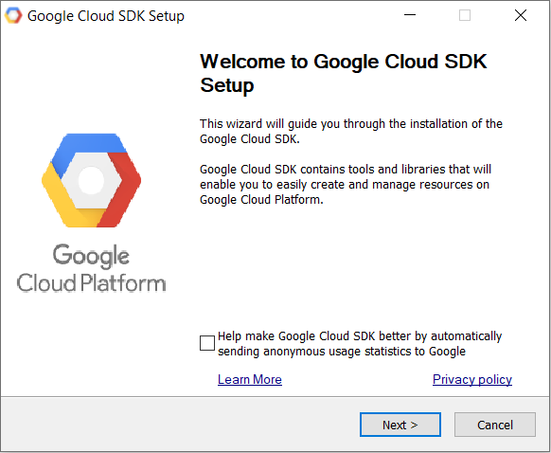

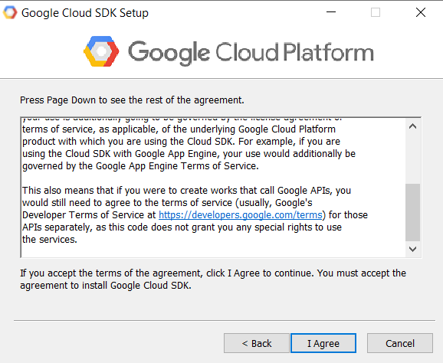

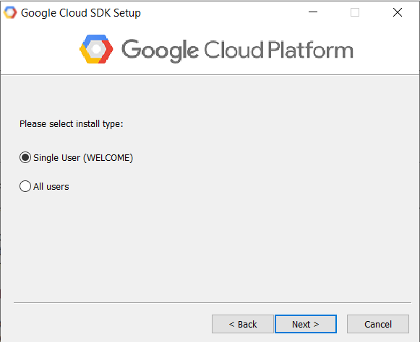

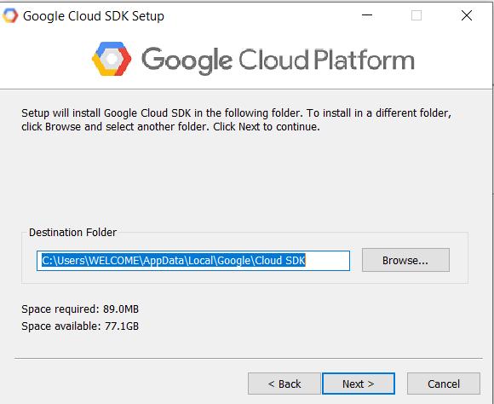

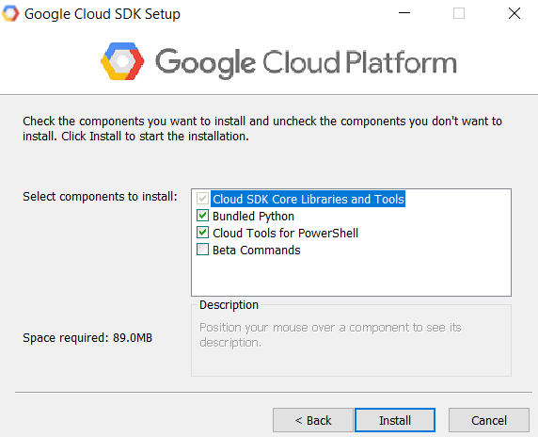

2)Execute install.bat

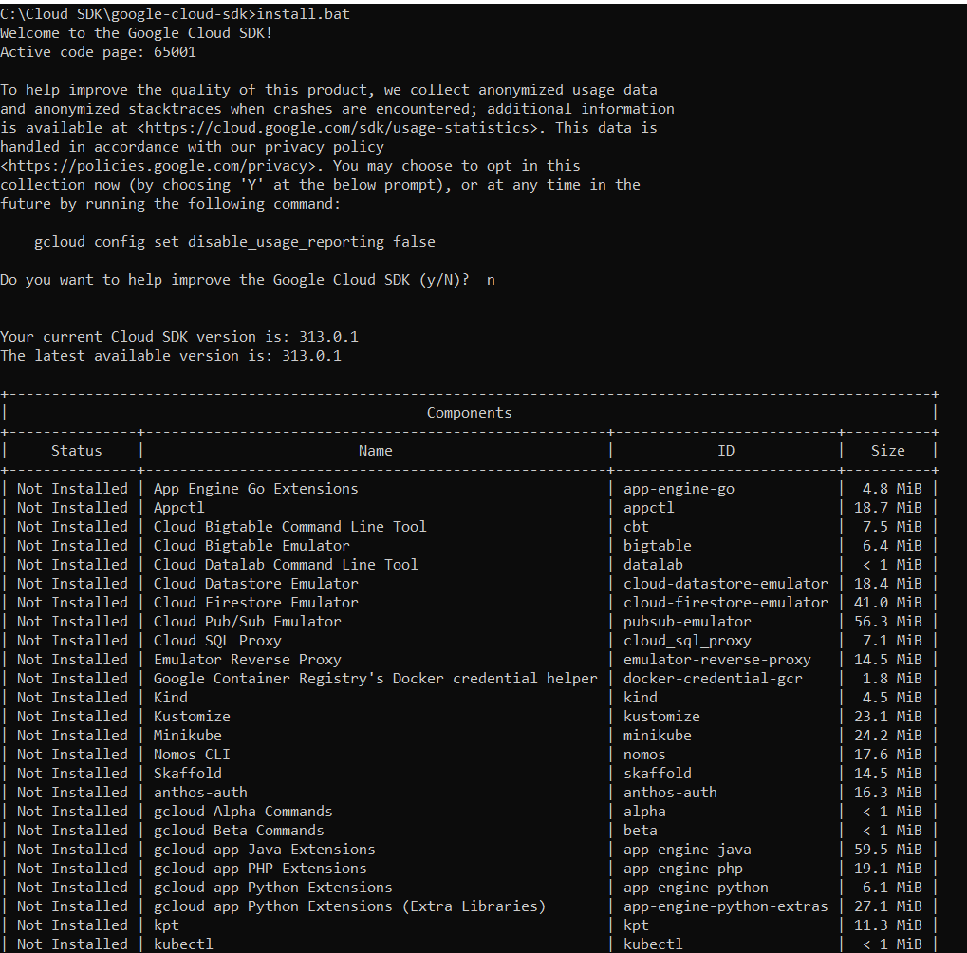

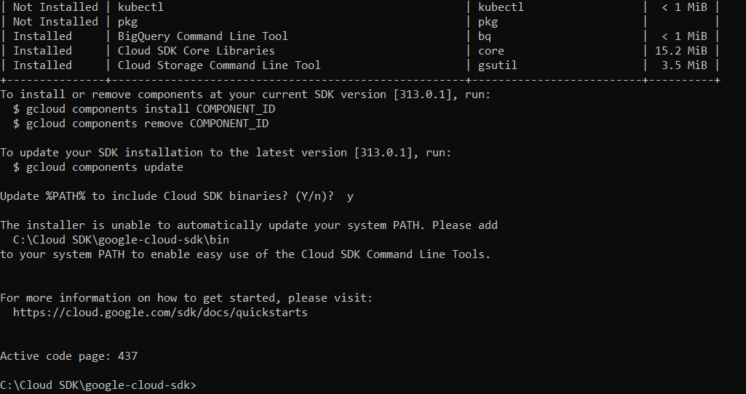

1. Add the path to bin:

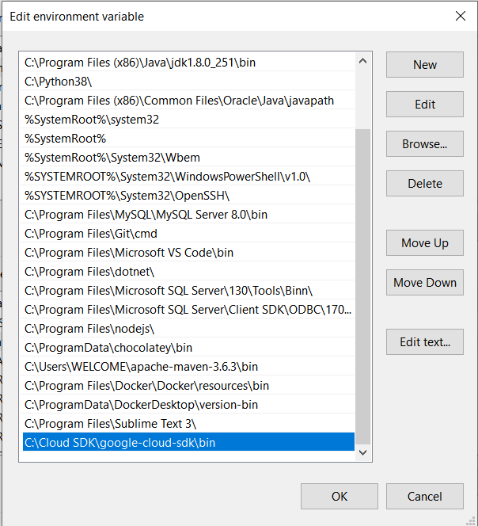

1. Check the installation using “gcloud version” command

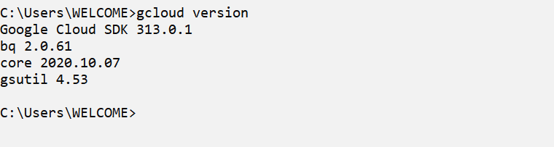

1. Use the command “gcloud init” to initialise the sdk

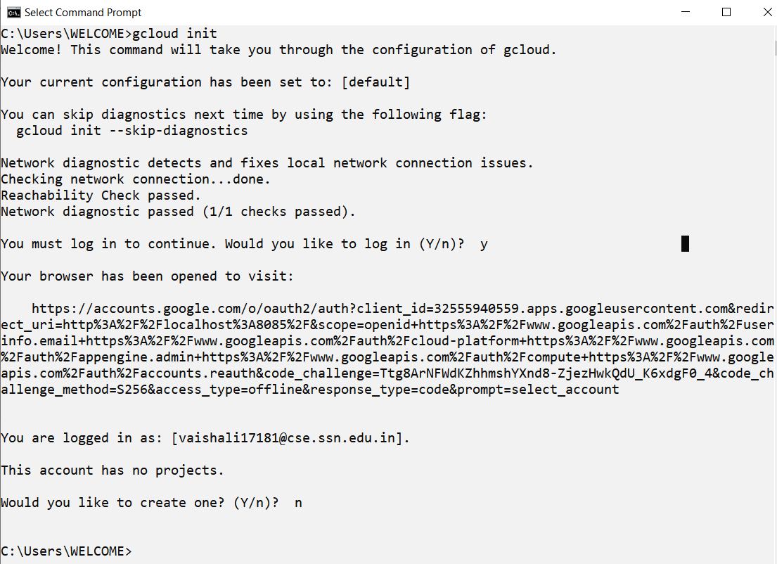

1. a) Create a project using “gcloud projects create PROJ_ID”

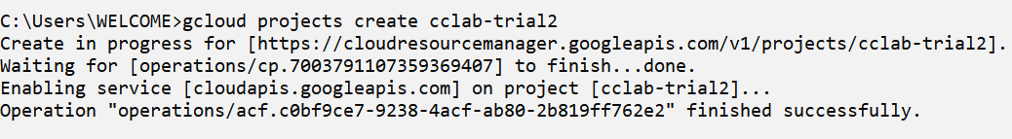

b) Configure the project using “gcloud config set project PROJ_ID”

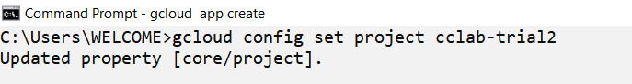

c) Create a gcloud application using “gcloud app create”

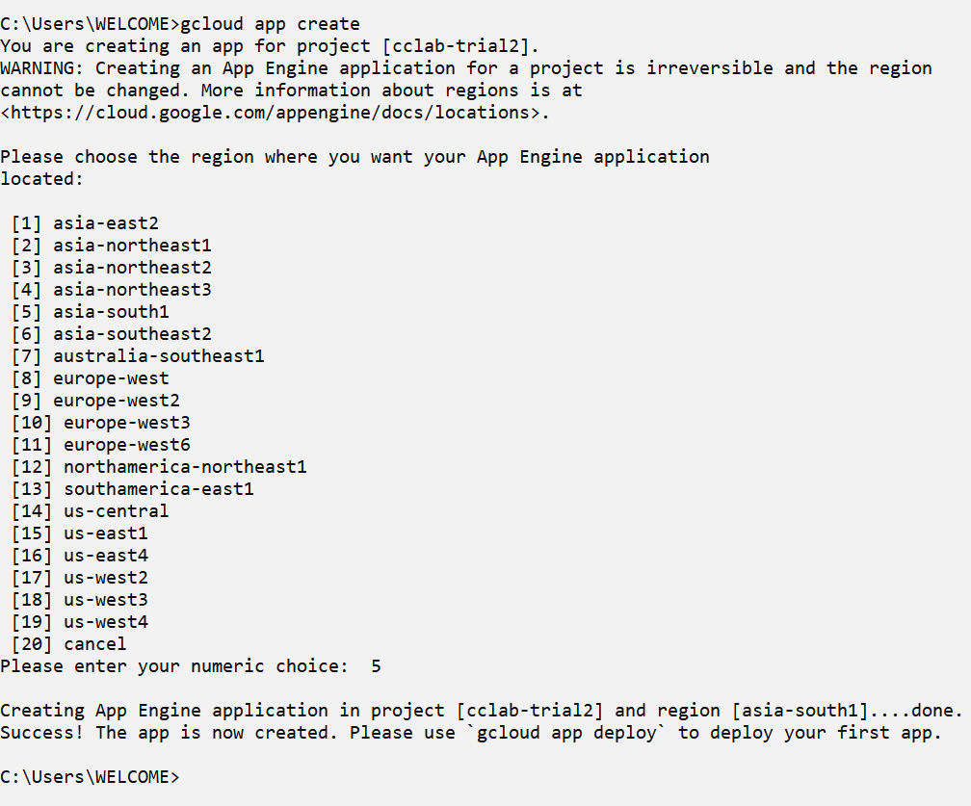

d) List the projects using “gcloud projects list”

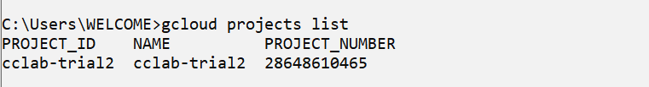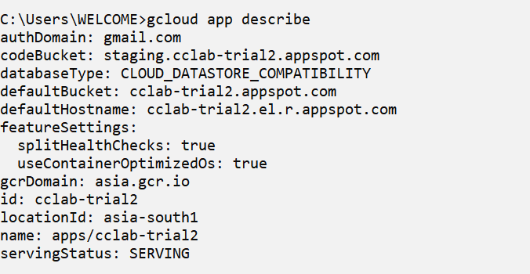

7)Log into the google cloud console and if the project has been created

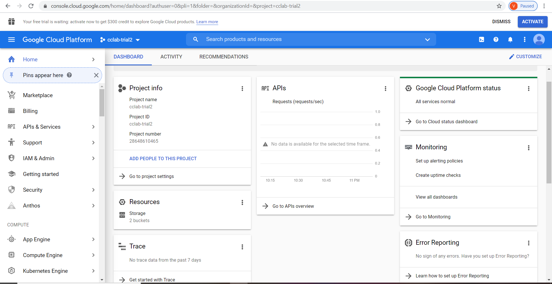

8) Create a simple python web application using flask framework

The folder structure is :

cloudAppp

static

style.css

requirements.txt

main.py

app.yaml

index.html

template

**app.yaml**

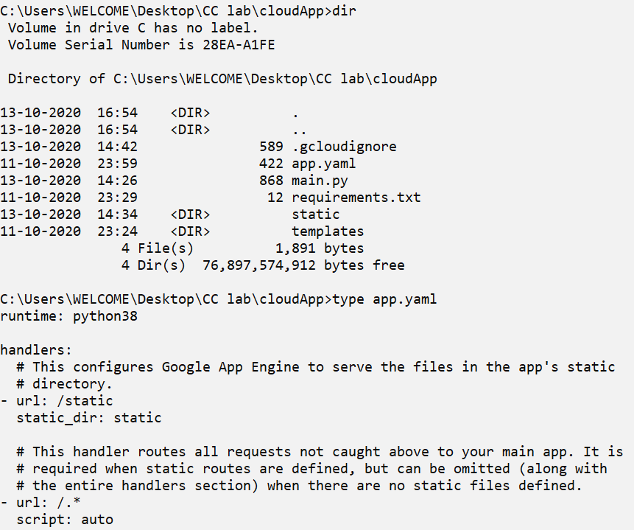

**main.py**

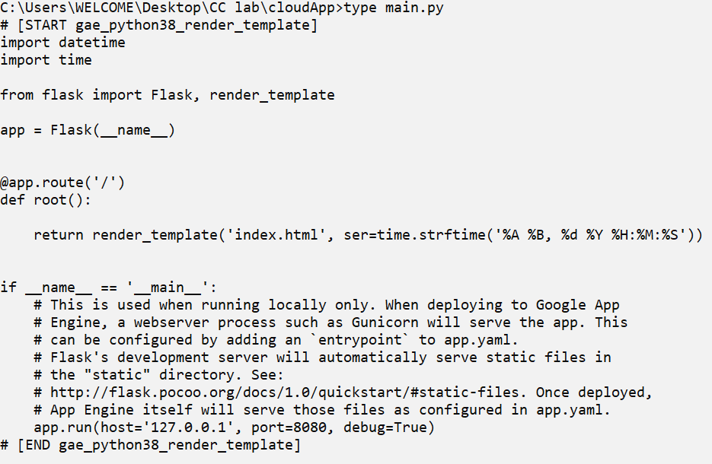

**requirements.txt:**

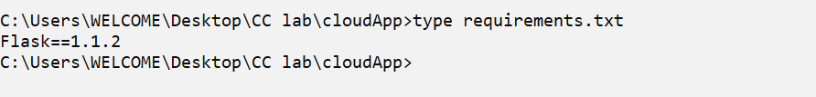

**index.html:**

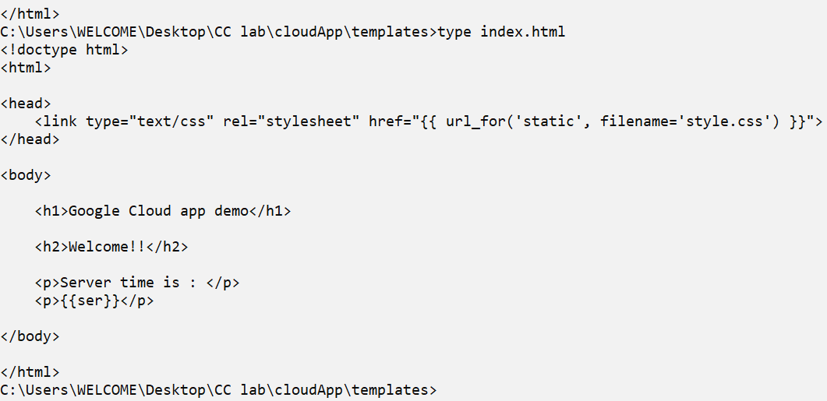

**style.css:**

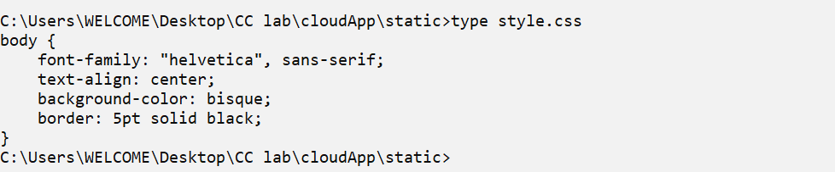

**9)** Run the web application in local environment



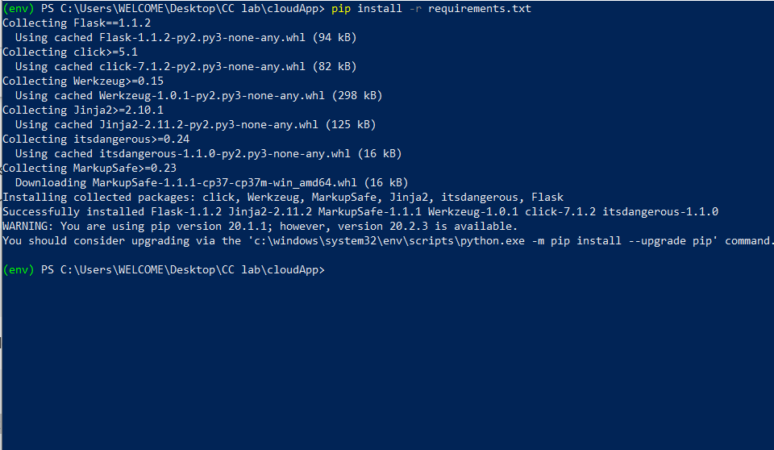

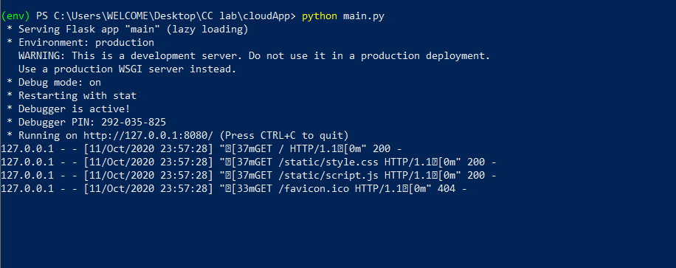

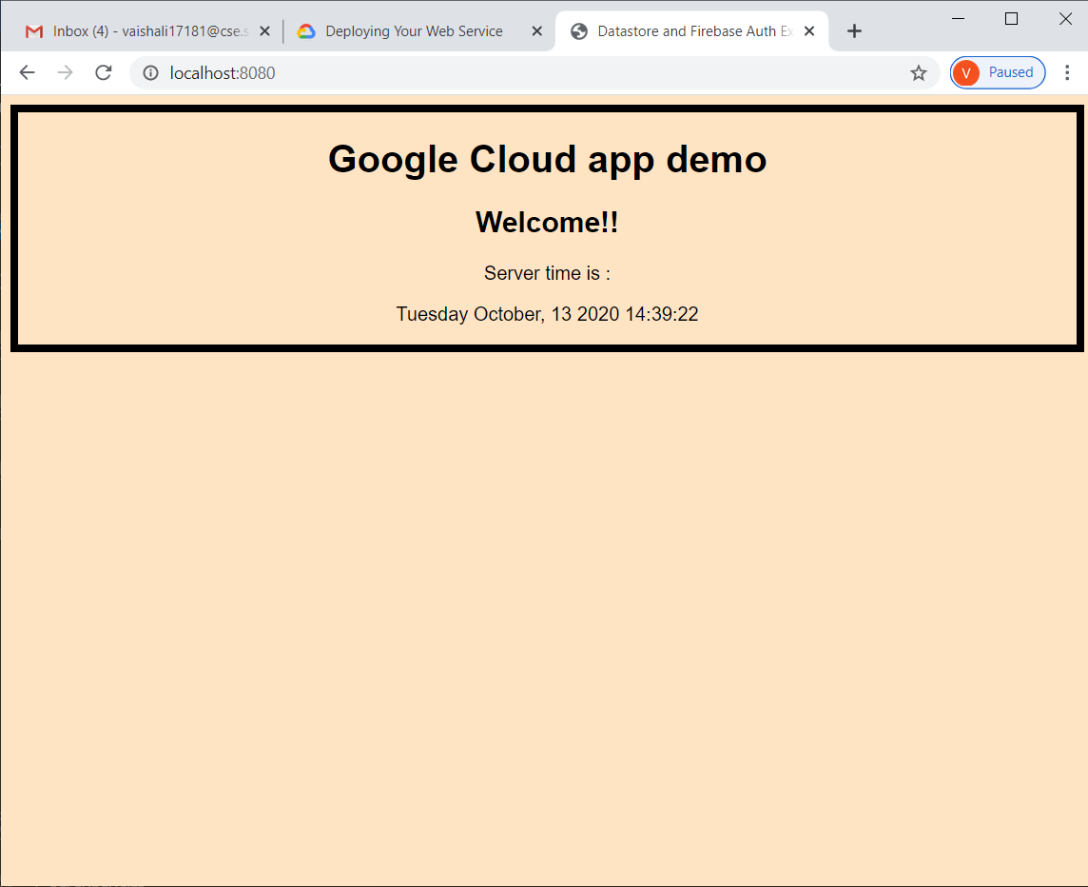

**9)** Deploy using “gcloud app deploy”

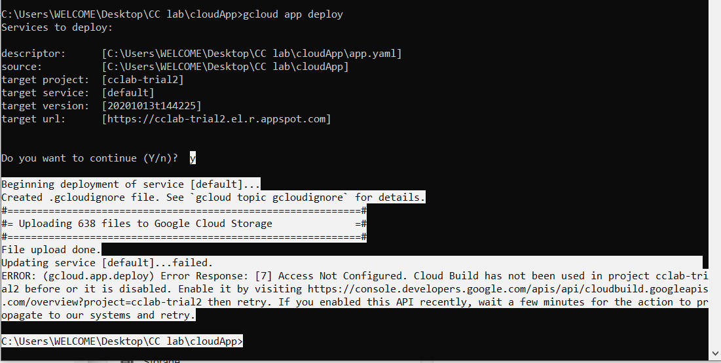

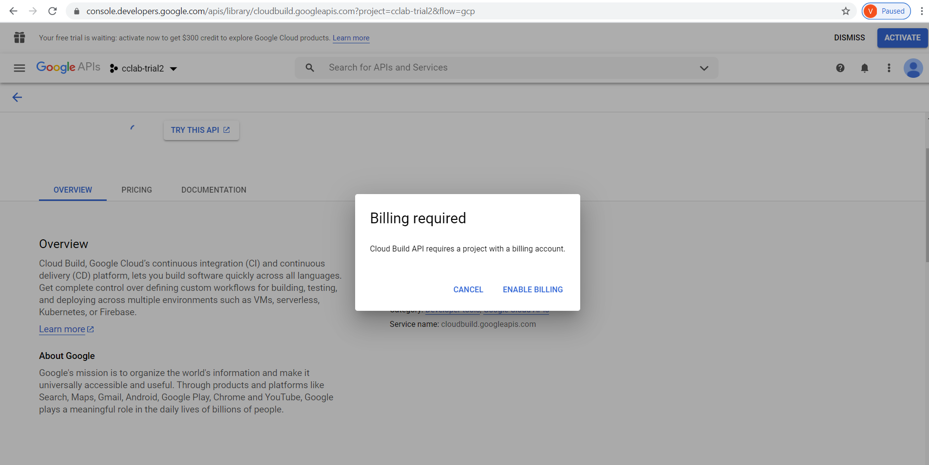

Since billing account is required, the app couldn’t be deployed.