SSN COLLEGE OF ENGINEERING, KALAVAKKAM

DEPARTMENT OF COMPUTER SCIENCE & ENGINEERING

Internet Programming Lab – CS8661

Programming Assignment 3 – Creation and validation of Complaint Registration Form

Design the following registration form with the necessary control elements, styles and scripts. Check the validity of each and every control element. If every field satisfies the condition, script should alert “Successful Registration”.

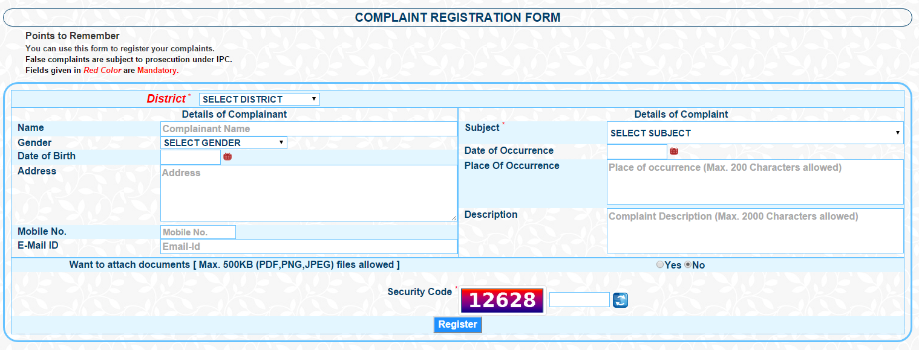

1. Check whether name field has been filled, has valid characters
2. Retrieve the value of gender and print
3. Validate the given date and print
4. Retrieve the address and print
5. Check whether the mobile number field has been filled and has valid number in that
6. Check whether Email-Id field has been filled and has valid email id in that field
7. Select a file from the local file system to upload the document
8. Include radio buttons for Gender and retrieve the value of clicked radio button
9. Include check boxes for Education of Complainant and retrieve the value of clicked checkbox