**inline.html**

<html>

<head>

</head>

<body>

<p style="margin-left:20px;

margin-right:20px;

background-color:pink;

color:blue"

>This is the first paragraph! <br> This is the first paragraph! <br> This is the first paragraph! <br> </p>

<p style="margin-left:30px;

margin-right:30px;

background-color:black;

color:yellow"

>This is the second paragraph! <br> This is the second paragraph! <br> This is the second paragraph! <br> </p>

<p style="text-indent:1cm;

background-color:green;

color:white"

>This is the third paragraph! <br> This is the third paragraph! <br> This is the third paragraph! <br> </p>

<p style="margin-left:20px;

margin-right:20px;

background-color:pink;

color:blue"

>This is the fourth paragraph! <br> This is the fourth paragraph! <br> This is the fourth paragraph! <br> </p>

<p style="margin-left:30px;

margin-right:30px;

background-color:black;

color:yellow"

>This is the fifth paragraph! <br> This is the fifth paragraph! <br> This is the fifth paragraph! <br> </p>

<p style="text-indent:1cm;

background-color:green;

color:white"

>This is the sixth paragraph! <br> This is the sixth paragraph! <br> This is the sixth paragraph! <br> </p>

</body>

</html>

**embedded.html**

<html>

<head>

<style type="text/css">

#p1{ margin-left:20px;

margin-right:20px;

background-color:pink;

color:blue

}

#p2{ margin-left:30px;

margin-right:30px;

background-color:black;

color:yellow

}

#p3{ text-indent:1cm;

background-color:green;

color:white

}

</style>

</head>

<body>

<p id="p1">This is the first paragraph! <br> This is the first paragraph! <br> This is the first paragraph! <br> </p>

<p id="p2">This is the second paragraph! <br> This is the second paragraph! <br> This is the second paragraph! <br> </p>

<p id="p3">This is the third paragraph! <br> This is the third paragraph! <br> This is the third paragraph! <br> </p>

<p id="p1">This is the fourth paragraph! <br> This is the fourth paragraph! <br> This is the fourth paragraph! <br> </p>

<p id="p2">This is the fifth paragraph! <br> This is the fifth paragraph! <br> This is the fifth paragraph! <br> </p>

<p id="p3">This is the sixth paragraph! <br> This is the sixth paragraph! <br> This is the sixth paragraph! <br> </p>

</body>

</html>

**external.html**

<html>

<head>

<link rel="stylesheet"

type="text/css"

href="style1.css"

title="normal">

</head>

<body>

<p class="class1">This is the first paragraph! <br> This is the first paragraph! <br> This is the first paragraph! <br> </p>

<p class="class2">This is the second paragraph! <br> This is the second paragraph! <br> This is the second paragraph! <br> </p>

<p class="class3">This is the third paragraph! <br> This is the third paragraph! <br> This is the third paragraph! <br> </p>

<p class="class1">This is the fourth paragraph! <br> This is the fourth paragraph! <br> This is the fourth paragraph! <br> </p>

<p class="class2">This is the fifth paragraph! <br> This is the fifth paragraph! <br> This is the fifth paragraph! <br> </p>

<p class="class3">This is the sixth paragraph! <br> This is the sixth paragraph! <br> This is the sixth paragraph! <br> </p>

</body>

</html>

**style1.css**

.class1{

margin-left:20px;

margin-right:20px;

background-color:pink;

color:blue

}

.class2{

margin-left:30px;

margin-right:30px;

background-color:black;

color:yellow

}

.class3{

text-indent:1cm;

background-color:green;

color:white

}

**OUTPUT:**

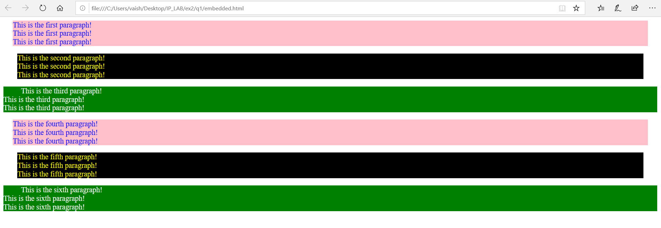

**q2.html**

<html>

<head>

<link rel="stylesheet"

type="text/css"

href="style1.css"

title="normal">

<link rel="alternate stylesheet"

type="text/css"

href="style2.css"

title="special">

</head>

<body>

<p>

Hello , How are you? <br>

Hello , How are you? <br>

Hello , How are you? <br>

</p>

</body>

</html>

**style1.css**

p

{background-color:pink;

color:blue

}

**style2.css**

p

{background-color:green;

color:yellow;

letter-spacing:2em

}

**OUTPUT:**

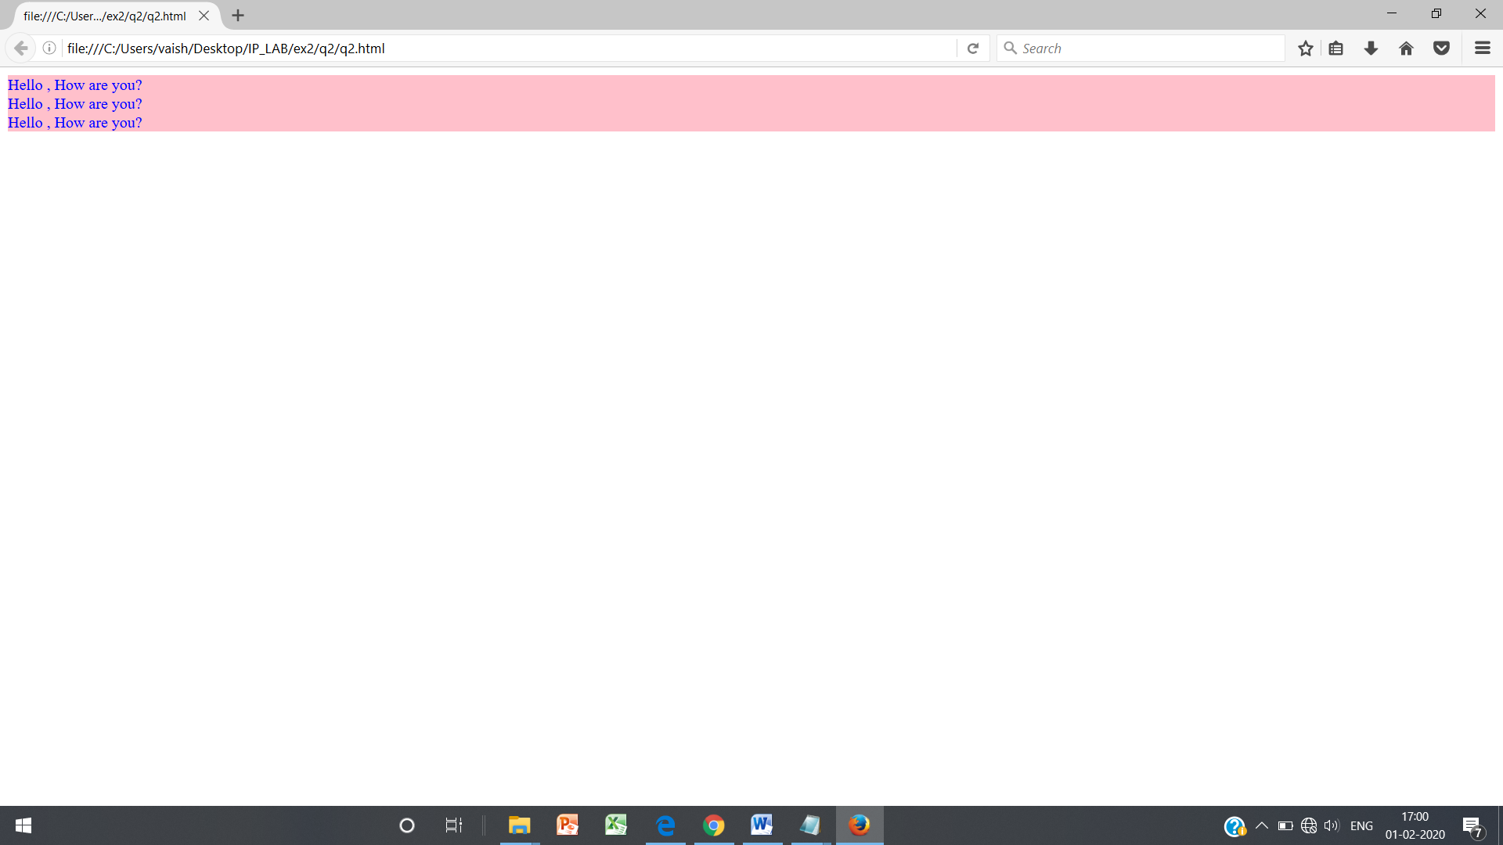

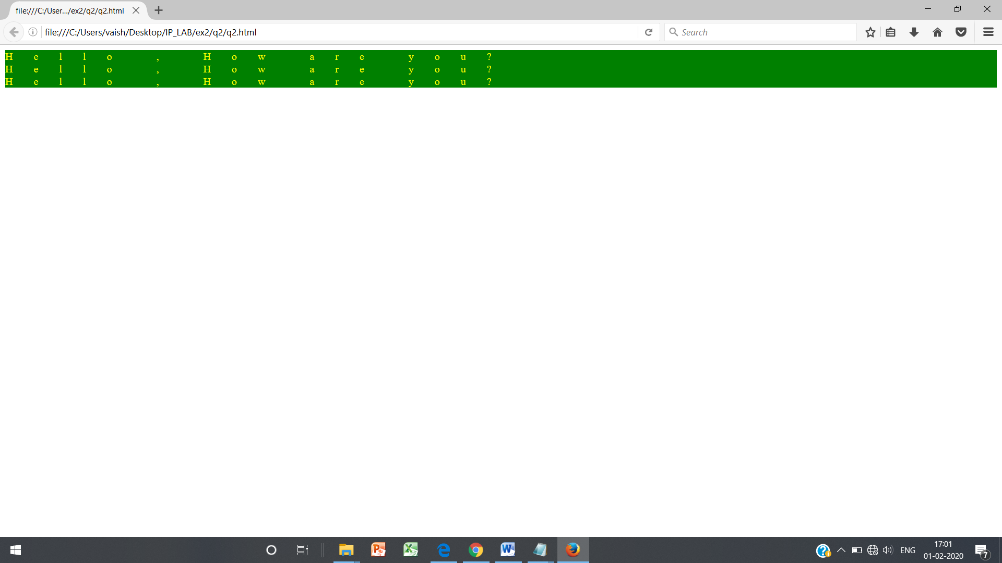

**q3.html**

<html>

<head>

<style type="text/css">

*{background-color:yellow;

}

a:link {color:blue}

a:visited {color:red}

a:hover {color:green}

a:active {color:pink}

caption {font-weight:bold}

th {font-weight:normal; font-style:italic}

td {font-family:sans-serif; font-size:14pt}

</style>

</head>

<body>

<h3>

<table border=2 cellspacing="5" cellpadding="5" >

<caption>A test table with merged cells</caption>

<tr> <td rowspan="2"></td> <th colspan="2">average</th> <th rowspan="2">Red eyes</th> </tr>

<tr> <th>Height</th> <th>Weight</th> </tr>

<tr> <th>Male</th> <td>1.9</td> <td>0.003</td> <td>40%</td> </tr>

<tr> <th>Female</th> <td>1.7</td> <td>0.002</td> <td>43%</td> </tr>

</table>

</h3>

<a href="https://www.gmail.com" >Gmail </a><br>

<a href="https://www.google.com" >Google </a><br>

<a href="https://www.yahoo.com" >Yahoo </a><br>

<a href="https://www.ssn.net" >SSN Intranet </a><br>

</body>

</html>

**OUTPUT:**

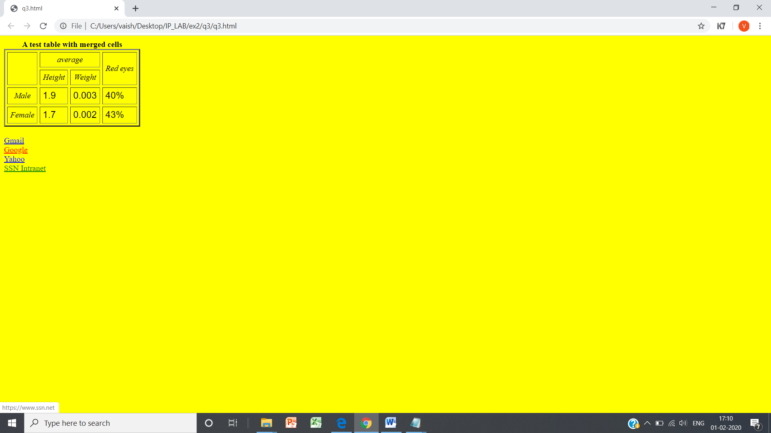

**main.html**

<html>

<head>

<link rel="stylesheet"

type="text/css"

href="style.css"

title="normal">

<link rel="alternate stylesheet"

type="text/css"

href="style2.css"

title="special">

<style type="text/css">

#d1 { height:20%;

max-width:100%;

border-color:#0099ff;

border-width:5pt;

border-style:solid;

}

#d2 { height:80%;

max-width:100%;

border-color:#0099ff;

border-width:5pt;

border-style:solid;

}

#d3 { height:99%;

width:19.5%;

border-left: #ff9999 3pt solid;

border-top: #ff9999 3pt solid;

border-bottom: #ff9999 3pt solid;

border-right: #ff9999 2pt solid;

float:left;

}

#d4 { height:99%;

width:79%;

border: #ff9999 3pt solid;

float:right;

}

table{

width: 100%;

height :96%;

text-align: center;

border-collapse: separate;

}

#top { height:100%;

max-width:100%;

vertical-align: middle;

}

#img_div {

height:100%;

width:20%;

float:left;

}

#title_div{

text-align:center;

vertical-align: middle;

}

span {

vertical-align: middle;

font-size:40pt;

}

</style>

</head>

<body>

<div id="d1">

<div id="img_div">

<img src="logo.png" id="top"/>

</div>

<div id="title_div">

<span>PS International Higher Secondary School </span>

</div>

</div>

<div id="d2" >

<div id="d3">

<h3>

<table border=2 cellspacing="2" cellpadding="2">

<tr><td><a href="home.html" target="i1">Home</a></td></tr>

<tr><td><a href="fee.html" target="i1">Fee Structure</a></td></tr>

<tr><td><a href="academ.html" target="i1">Academics</a></td></tr>

<tr><td><a href="achieve.html" target="i1">Achievements</a></td></tr>

<tr><td><a href="results.html" target="i1">Results</a></td></tr>

<tr><td><a href="contact.html" target="i1">Contact us</a></td></tr>

</table>

</h3>

</div>

<div id="d4" name="div4">

<iframe height="100%" width="100%" name="i1"> </iframe>

</div>

</div>

</body>

</html>

**home.html**

<html>

<head>

<link rel="stylesheet"

type="text/css"

href="style.css"

title="normal">

<style type="text/css">

#p1 {

font-size: 13pt;

font-style: italic;

color: blue;

}

</style>

</head>

<body>

<center><h1>HOME</h1>

<p id="p1">

The PS International Higher Secondary School is a recognized landmark in its pursuit of excellence in education, holistic development and human excellence, is deeply dedicated to the mission of building <span id="emp">Global Citizens with Indian Values"</span>, with an emphasis on value education, and respect for our rich cultural heritage.

</p>

<p>

PS International Higher Secondary School has been set up by the Learning Leadership Foundation (a public charitable trust) under the dynamic leadership of <span id="emp"> Dr. PS, Director <span>. The PS International Higher Secondary School come directly under their purview and follow the tried and tested methodology of the teaching – learning process that has been the mainstay of academic excellence in over 50 years.

</p>

<p>

The Learning Leadership Foundation comprises a group of enterprising people, who

have considerable experience in education, and are recognized for <span id="emp">'professional development initiatives',</span> for teachers. The School is backed by the combined strength of over a decade of <span id="emp">'thought leadership' </span> in best pedagogic practices of the Learning Leadership Foundation and more than five decades of academic excellence of PS International Higher Secondary School. The option of the School Transportation is provided for all the Campus, in all the locations, both in Chennai.

</p>

</center>

<div id="d6">

<img src="logo.png" id="bottom"/>

</div>

</body>

</html>

**fee.html**

<html>

<head>

<link rel="stylesheet"

type="text/css"

href="style.css"

title="normal">

</head>

<body>

<center><h1>FEE STRUCTURE</h1>

<h3>

<table border=2 cellspacing="2" cellpadding="2">

<tr>

<th>Registration Fee</th>

<td>25</td>

<td></td>

<td></td>

</tr>

<tr id="emp">

<th>School Dues</th>

<th>LKG-V</th>

<th>VI-X</th>

<th>XI-XII</th>

</tr>

<tr>

<th>Admission Fees</th>

<td>200</td>

<td>200</td>

<td>200</td>

</tr>

<tr>

<th>Annual Charges</th>

<td>3745 p.a</td>

<td>3745 p.a</td>

<td>3745 p.a</td>

</tr>

<tr>

<th>Development charges</th>

<td>275 p.a</td>

<td>295 p.a</td>

<td>315 p.a</td>

</tr>

<tr>

<th>Tuition fee to be paid quaterly</th>

<td>1840 p.m</td>

<td>1995 p.m</td>

<td>2115 p.m</td>

</tr>

</table>

</h3>

</center>

<div id="d6">

<img src="logo.png" id="bottom"/>

</div>

</body>

</html>

**achieve.html**

<html>

<head>

<link rel="stylesheet"

type="text/css"

href="style.css"

title="normal">

</head>

<body>

<center><h1>ACHIEVEMENTS</h1></center>

<h3>

<ol>

<li>Hero Honda Inter Schools Athletics meet was held at Gems International School.

more than 40 schools of District Gurgaon participated in the meet. Director Hero

Honda was Chief Guest. Our participants brought many laurels to the school.

<ul>

<li> Deepak Yadav (Class X) bagged the Gold Medal in boys under 18years.</li>

<li> Our Relay team Girls under 18 years got the Bronze Medal. The participants were: Renu Yadav, Komal Yadav, Simral, Shereya.</li>

<li> Student Simral (Class VII) won a Silver Medal in age group under 14 years and Bronze Medal in age group under 18 years.</li>

<li> Nitesh Yadav (Class VIII) bagged the Gold Medal in age group Boys under 4 years. </li>

</ul>

</li>

<br/>

<li>

Haryana State Roller Skating Championship was held at Faridabad from 17th Dec.

to 19th Dec. 2010. Our participants brought many laurels to the school. The results

are as follows:

</li>

<br/>

<li>Yuthika Khatri (Class VII) bagged Gold Medals and Bronze Medals in the

following events:

<ul>

<li>500 mtrs. Rink Race Gold Medal</li>

<li>5000 mtrs. Road Race Gold Medal</li>

<li>1000 mtrs. Rink Race Gold Medal</li>

</ul>

</li>

<br/>

</ol>

</h3>

<div id="d6">

<img src="logo.png" id="bottom"/>

</div>

</body>

</html>

**contact.html**

<html>

<head>

<link rel="stylesheet"

type="text/css"

href="style.css"

title="normal">

</head>

<body>

<center>

<h1>CONTACT US</h1>

<pre><h3>

PS International Higher Secondary School

Rajiv Gandhi Salai (OMR)

Kalavakkam - 603 110

Tamil Nadu, India

Phone: +91 44 27469700

Email: info@psi.edu.in

</h3></pre>

</center>

<div id="d6">

<img src="logo.png" id="bottom"/>

</div>

</body>

</html>

**style1.css**

*{font: 14pt;}

a:link {color:red}

a:visited {color:violet}

a:hover {color:blue}

a:active {color:yellow}

ol li {

font-style: italic;

font-size: 20pt;

}

ul li{

font-family: cursive;

font-size: 20pt;

list-style-type:disc;

}

#d6 { height:100px;

width:100px;

position:fixed;

bottom:2pt;

right:10pt;

}

#bottom { height:100%;

max-width:100%;

}

#emp{

font-weight: bold;

color:pink;

}

**style2.css**

*{background-color: yellow;

color: red;

font-size: 15pt;

letter-spacing: 1em;

}

a:link {color:red}

a:visited {color:violet}

a:hover {color:blue}

a:active {color:yellow}

**OUTPUT:**

