**dom.java**

import org.w3c.dom.*;

import javax.xml.parsers.*;

import java.util.Scanner;

public class dom{

public static void main(String[] args) {

DocumentBuilderFactory dbf=DocumentBuilderFactory.newInstance();

try{

DocumentBuilder db=dbf.newDocumentBuilder();

Document doc=db.parse("input.xml");

Scanner s=new Scanner(System.in);

System.out.println("\nEnter the roll no: ");

String r=s.next();

//System.out.println(doc.getDocumentElement().getNodeName());

NodeList l=doc.getElementsByTagName("student");

for(int i=0;i<l.getLength();i++){

Node n=l.item(i);

if(n.getNodeType()==Node.ELEMENT_NODE){

Element elt=(Element)n;

if(elt.getAttribute("rno").equals(r)){

System.out.println("Roll no : " + elt.getAttribute("rno"));

System.out.println("Name : " + elt.getElementsByTagName("name").item(0).getTextContent());

System.out.println("Address : "+ elt.getElementsByTagName("address").item(0).getTextContent());

System.out.println("Mobile : "+elt.getElementsByTagName("mob").item(0).getTextContent());

}

}

}

}

catch(Exception e){ System.out.println(e); }

}

}

**input.xml**

<?xml version="1.0" encoding="UTF-8"?>

<class>

<student rno="1">

<name>Snneha</name>

<address>Third road</address>

<mob>9884006632</mob>

</student>

<student rno="2">

<rollno>2</rollno>

<name>Vaish</name>

<address>Second road</address>

<mob>91761906832</mob>

</student>

<student rno="3">

<name>jack</name>

<address>first road</address>

<mob>8764423632</mob>

</student>

<student rno="4">

<name>jill</name>

<address>fourth road</address>

<mob>7338766632</mob>

</student>

<student rno="5">

<name>humpty</name>

<address>fifth road</address>

<mob>678889632</mob>

</student>

</class>

**OUTPUT:**

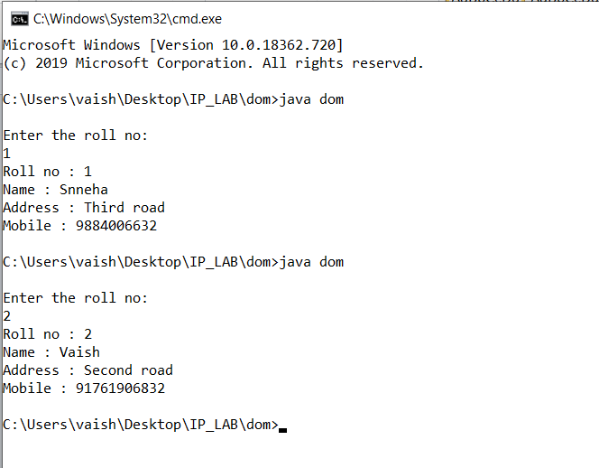

**saxParser.java**

import org.xml.sax.*;

import javax.xml.parsers.*;

import java.util.Scanner;

import org.xml.sax.helpers.DefaultHandler;

public class saxParser {

public static void main(String args[]){

SAXParserFactory spf=SAXParserFactory.newInstance();

try{

SAXParser sp=spf.newSAXParser();

Scanner s=new Scanner(System.in);

System.out.println("\nEnter the roll no: ");

String r=s.next();

UserHandler handler = new UserHandler(r);

sp.parse("input.xml", handler);

}

catch(Exception e){System.out.println(e);}

}

}

class UserHandler extends DefaultHandler {

boolean fname = false;

boolean fadd = false;

boolean fmob = false;

String r = null;

String rollno=null;

public UserHandler(String r){

this.r=r;

}

public void startElement(String uri, String localName,String qName,

Attributes att) throws SAXException {

if (qName.equals("student"))

rollno=att.getValue("rno");

if(r.equals(rollno))

{

if (qName.equals("name"))

fname = true;

if (qName.equals("address"))

fadd = true;

if (qName.equals("mob"))

fmob = true;

}

}

public void endElement(String uri, String localName,

String qName) throws SAXException {

//System.out.println("End Element :" + qName);

}

public void characters(char ch[], int start, int length) throws SAXException {

if (fname) {

System.out.println("Name : " + new String(ch, start, length));

fname = false;

}

if (fadd) {

System.out.println("Address : " + new String(ch, start, length));

fadd = false;

}

if (fmob) {

System.out.println("Mobile: " + new String(ch, start, length));

fmob = false;

}

}

}

**OUTPUT:**

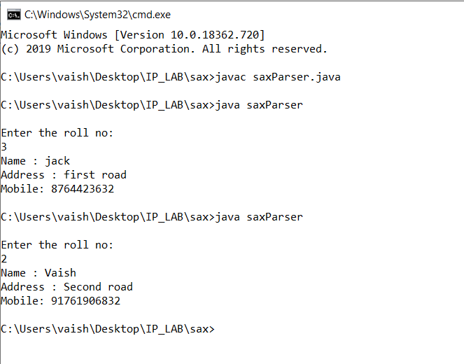

**index.html**

<html>

<body>

<form method="get" action="hello.php">

<input type="submit" >

</form>

</body>

</html>

**hello.php**

<?php

echo "hello"

?>

**OUTPUT:**



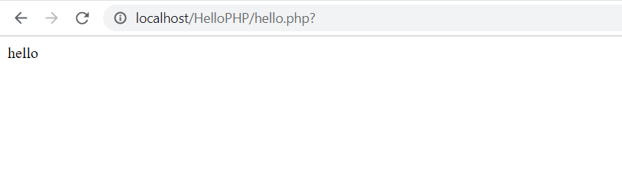

**index.html**

<html>

<body>

<h3>CRUD PHP</h3>

<form method="get" action="insert.php">

Enter name: <input type="text" name="t1"><br><br>

Enter age: <input type="text" name="t2"><br><br>

Enter dob: <input type="text" name="t3"><br><br>

Enter address: <input type="text" name="t4"><br><br>

Enter mobile no: <input type="text" name="t5"><br><br>

Enter email id: <input type="text" name="t6"><br><br>

<input type="submit" value="Insert record"><br><br>

</form>

<form method="get" action="update.php">

Enter name: <input type="text" name="t1"><br><br>

Enter age: <input type="text" name="t2"><br><br>

Enter dob: <input type="text" name="t3"><br><br>

Enter address: <input type="text" name="t4"><br><br>

Enter mobile no: <input type="text" name="t5"><br><br>

Enter email id: <input type="text" name="t6"><br><br>

<input type="submit" value="Update record"><br><br>

</form>

<form method="get" action="delete.php">

Enter name: <input type="text" name="t1"><br><br>

<input type="submit" value="Delete record"><br>

</form>

<form method="get" action="display.php">

<input type="submit" value="Display records">

</form>

</body>

</html>

**delete.php**

<html>

<?php

$con=new mysqli("localhost:3306","root","","test");

if($con->connect_error)

echo "Falied";

else

{

$sql = "select * from stud";

$result = $con->query($sql);

echo "<br><p>Before deletion</p>";

echo "<br><table border=\"1\">";

echo "<tr><th>NAME</th><th>AGE</th><th>DATE</th><th>ADDRESS</th><th>PHONE</th><th>EMAIL</th></tr>";

if ($result->num_rows>0)

{

while ($row = $result->fetch_assoc())

echo "<tr><td>".$row["name"]."</td><td>".$row["age"]."</td><td>".$row["dob"]."</td><td>".$row["addr"]."</td><td>".$row["mob"]."</td><td>".$row["email"]."</td></tr>";

}

echo "</table>";

$del = "delete from stud where name=?";

$stmt=mysqli_prepare($con,$del);

mysqli_stmt_bind_param($stmt,"s",$name);

$name=$_GET["t1"];

mysqli_stmt_execute($stmt);

echo "<br><p>After deletion</p>";

$result = $con->query($sql);

echo "<br><table border=\"1\">";

echo "<tr><th>NAME</th><th>AGE</th><th>DATE</th><th>ADDRESS</th><th>PHONE</th><th>EMAIL</th></tr>";

if ($result->num_rows>0)

{

while ($row = $result->fetch_assoc())

echo "<tr><td>".$row["name"]."</td><td>".$row["age"]."</td><td>".$row["dob"]."</td><td>".$row["addr"]."</td><td>".$row["mob"]."</td><td>".$row["email"]."</td></tr>";

}

echo "</table>";

}

?>

</html>

**display.php**

<html>

<?php

$con=new mysqli("localhost:3306","root","","test");

if($con->connect_error)

echo "Falied";

else

{

$sql = "select * from stud";

$result = $con->query($sql);

echo "<br><table border=\"1\">";

echo "<tr><th>NAME</th><th>AGE</th><th>DATE</th><th>ADDRESS</th><th>PHONE</th><th>EMAIL</th></tr>";

if ($result->num_rows>0)

{

while ($row = $result->fetch_assoc())

echo "<tr><td>".$row["name"]."</td><td>".$row["age"]."</td><td>".$row["dob"]."</td><td>".$row["addr"]."</td><td>".$row["mob"]."</td><td>".$row["email"]."</td></tr>";

}

echo "</table>";

}

?>

</html>

**insert.php**

<html>

<?php

$regexName = '/^[A-Za-z]+$/';

$regexAge = '/^[0-9]{2}$/';

$regexNum = '/^[0-9]{10}$/';

$regexMail = '/^[a-zA-Z][a-zA-Z0-9]+\@[a-z]+\.[a-z]+$/';

$flag=0;

$name=$_GET["t1"];

$age=$_GET["t2"];

$dob=$_GET["t3"];

$addr=$_GET["t4"];

$mob=$_GET["t5"];

$email=$_GET["t6"];

if(preg_match($regexName, $name)) {

if(preg_match($regexAge, $age)) {

if(preg_match($regexNum, $mob)) {

if(preg_match($regexMail, $email)) {

$flag=1;

}

else {

echo "Invalid e-mail id";

}

}

else {

echo "Invalid phone number";

}

}

else {

echo "Invalid age";

}

}

else {

echo "Invalid name";

}

echo "<br><br>";

if($flag==1)

{

$con=new mysqli("localhost:3306","root","","test");

if($con->connect_error)

echo "Falied";

else

{

$sql = "select * from stud";

$result = $con->query($sql);

echo "<br><p>Before insertion</p>";

echo "<br><table border=\"1\">";

echo "<tr><th>NAME</th><th>AGE</th><th>DATE</th><th>ADDRESS</th><th>PHONE</th><th>EMAIL</th></tr>";

if ($result->num_rows>0)

{

while ($row = $result->fetch_assoc())

echo "<tr><td>".$row["name"]."</td><td>".$row["age"]."</td><td>".$row["dob"]."</td><td>".$row["addr"]."</td><td>".$row["mob"]."</td><td>".$row["email"]."</td></tr>";

}

echo "</table>";

$ins = "insert into stud values(?,?,?,?,?,?)";

$stmt=mysqli_prepare($con,$ins);

mysqli_stmt_bind_param($stmt,"ssssss",$name,$age,$dob,$addr,$mob,$email);

mysqli_stmt_execute($stmt);

echo "<br><p>After insertion</p>";

$result = $con->query($sql);

echo "<br><table border=\"1\">";

echo "<tr><th>NAME</th><th>AGE</th><th>DATE</th><th>ADDRESS</th><th>PHONE</th><th>EMAIL</th></tr>";

if ($result->num_rows>0)

{

while ($row = $result->fetch_assoc())

echo "<tr><td>".$row["name"]."</td><td>".$row["age"]."</td><td>".$row["dob"]."</td><td>".$row["addr"]."</td><td>".$row["mob"]."</td><td>".$row["email"]."</td></tr>";

}

echo "</table>";

}

}

?>

</html>

**update.php**

<html>

<?php

$regexName = '/^[A-Za-z]+$/';

$regexAge = '/^[0-9]{2}$/';

$regexNum = '/^[0-9]{10}$/';

$regexMail = '/^[a-zA-Z][a-zA-Z0-9]+\@[a-z]+\.[a-z]+$/';

$flag=0;

$name=$_GET["t1"];

$age=$_GET["t2"];

$dob=$_GET["t3"];

$addr=$_GET["t4"];

$mob=$_GET["t5"];

$email=$_GET["t6"];

if(preg_match($regexName, $name)) {

if(preg_match($regexAge, $age)) {

if(preg_match($regexNum, $mob)) {

if(preg_match($regexMail, $email)) {

$flag=1;

}

else {

echo "Invalid e-mail id";

}

}

else {

echo "Invalid phone number";

}

}

else {

echo "Invalid age";

}

}

else {

echo "Invalid name";

}

echo "<br><br>";

if($flag==1)

{

$con=new mysqli("localhost:3306","root","","test");

if($con->connect_error)

echo "Falied";

else

{

$sql = "select * from stud";

$result = $con->query($sql);

echo "<br><p>Before updation</p>";

echo "<br><table border=\"1\">";

echo "<tr><th>NAME</th><th>AGE</th><th>DATE</th><th>ADDRESS</th><th>PHONE</th><th>EMAIL</th></tr>";

if ($result->num_rows>0)

{

while ($row = $result->fetch_assoc())

echo "<tr><td>".$row["name"]."</td><td>".$row["age"]."</td><td>".$row["dob"]."</td><td>".$row["addr"]."</td><td>".$row["mob"]."</td><td>".$row["email"]."</td></tr>";

}

echo "</table>";

$upd = "update stud set age=?, dob=?, addr=?, mob=?, email=? where name=?";

$stmt=mysqli_prepare($con,$upd);

mysqli_stmt_bind_param($stmt,"ssssss",$age,$dob,$addr,$mob,$email,$name);

mysqli_stmt_execute($stmt);

echo "<br><p>After updation</p>";

$result = $con->query($sql);

echo "<br><table border=\"1\">";

echo "<tr><th>NAME</th><th>AGE</th><th>DATE</th><th>ADDRESS</th><th>PHONE</th><th>EMAIL</th></tr>";

if ($result->num_rows>0)

{

while ($row = $result->fetch_assoc())

echo "<tr><td>".$row["name"]."</td><td>".$row["age"]."</td><td>".$row["dob"]."</td><td>".$row["addr"]."</td><td>".$row["mob"]."</td><td>".$row["email"]."</td></tr>";

}

echo "</table>";

}

}

?>

</html>

**OUTPUT:**

