**CODE:**

**activity.xml:**

*<?*xml version="1.0" encoding="utf-8"*?>*<ScrollView  
 xmlns:android="http://schemas.android.com/apk/res/android"  
 xmlns:app="http://schemas.android.com/apk/res-auto"  
 xmlns:tools="http://schemas.android.com/tools"  
 tools:context=".MainActivity"  
 android:layout_width="match_parent"  
 android:layout_height="wrap_content"  
 android:fillViewport="true"  
 >  
 <RelativeLayout  
 android:layout_width="match_parent"  
 android:layout_height="match_parent"  
 tools:context=".MainActivity">  
  
 <TextView  
 android:id="@+id/tv1"  
 android:layout_width="match_parent"  
 android:layout_height="wrap_content"  
 android:text="HOSPITAL REGISTRATION FORM"  
 android:textColor="#214d90"  
 android:textSize="36sp"  
 android:textStyle="normal"  
 android:gravity="center"  
 android:typeface="serif"  
 android:layout_marginTop="10dp"  
 android:layout_marginLeft="10dp"  
 android:layout_marginRight="10dp"  
 />  
  
 <TextView  
 android:id="@+id/name_tv"  
 android:layout_width="125dp"  
 android:layout_height="45dp"  
 android:layout_below="@+id/tv1"  
 android:layout_alignParentLeft="true"  
 android:layout_marginLeft="10dp"  
 android:layout_marginTop="10dp"  
 android:text="Name"  
 android:textColor="#005ae4"  
 android:textSize="25sp"  
 android:typeface="serif" />  
  
 <EditText  
 android:id="@+id/name_et"  
 android:layout_width="wrap_content"  
 android:layout_height="45dp"  
 android:layout_below="@+id/tv1"  
 android:layout_alignParentRight="true"  
 android:layout_marginTop="10dp"  
 android:layout_marginRight="10dp"  
 android:hint="Enter your name"  
 android:inputType="text"  
 android:textColor="#005ae4"  
 android:textSize="25sp"  
 android:typeface="serif" />  
  
 <TextView  
 android:id="@+id/address_tv"  
 android:layout_width="125dp"  
 android:layout_height="45dp"  
 android:layout_below="@+id/name_tv"  
 android:layout_alignParentLeft="true"  
 android:layout_marginLeft="10dp"  
 android:layout_marginTop="10dp"  
 android:text="Address"  
 android:textColor="#005ae4"  
 android:textSize="25sp"  
 android:typeface="serif" />  
  
 <EditText  
 android:id="@+id/address_et"  
 android:layout_width="wrap_content"  
 android:layout_height="45dp"  
 android:layout_below="@+id/name_et"  
 android:layout_alignParentRight="true"  
 android:layout_marginTop="10dp"  
 android:layout_marginRight="10dp"  
 android:hint="Enter your address"  
 android:inputType="textMultiLine|textPostalAddress"  
 android:textColor="#005ae4"  
 android:textSize="25sp"  
 android:typeface="serif" />  
 <TextView  
 android:id="@+id/age_tv"  
 android:layout_width="125dp"  
 android:layout_height="45dp"  
 android:layout_below="@+id/address_tv"  
 android:layout_alignParentLeft="true"  
 android:layout_marginLeft="10dp"  
 android:layout_marginTop="10dp"  
 android:text="Age"  
 android:textColor="#005ae4"  
 android:textSize="25sp"  
 android:typeface="serif" />  
  
 <EditText  
 android:id="@+id/age_et"  
 android:layout_width="wrap_content"  
 android:layout_height="45dp"  
 android:layout_below="@+id/address_et"  
 android:layout_alignParentRight="true"  
 android:layout_marginTop="10dp"  
 android:layout_marginRight="10dp"  
 android:hint="Enter your age"  
 android:inputType="number"  
 android:textColor="#005ae4"  
 android:textSize="25sp"  
 android:typeface="serif" />  
  
 <TextView  
 android:id="@+id/dob_tv"  
 android:layout_width="125dp"  
 android:layout_height="45dp"  
 android:layout_below="@+id/age_tv"  
 android:layout_alignParentLeft="true"  
 android:layout_marginLeft="10dp"  
 android:layout_marginTop="10dp"  
 android:text="DOB"  
 android:textColor="#005ae4"  
 android:textSize="25sp"  
 android:typeface="serif" />  
  
 <DatePicker  
 android:id="@+id/date_dp"  
 android:layout_width="305dp"  
 android:layout_height="400dp"  
 android:layout_below="@+id/age_et"  
 android:layout_alignParentRight="true"  
 android:layout_marginTop="15dp"  
 android:layout_marginRight="15dp"  
 android:inputType="date" />  
  
 <TextView  
 android:id="@+id/gender_tv"  
 android:layout_width="125dp"  
 android:layout_height="45dp"  
 android:layout_below="@+id/dob_tv"  
 android:layout_alignParentLeft="true"  
 android:layout_marginLeft="13dp"  
 android:layout_marginTop="367dp"  
 android:text="Gender"  
 android:textColor="#005ae4"  
 android:textSize="25sp"  
 android:typeface="serif" />  
  
 <RadioGroup  
 android:id="@+id/gd_rg"  
 android:layout_width="wrap_content"  
 android:layout_height="wrap_content"  
 android:layout_below="@+id/date_dp"  
 android:layout_toRightOf="@+id/gender_tv"  
 android:layout_marginTop="10dp"  
 android:layout_marginRight="10dp"  
 >  
  
 <RadioButton  
 android:layout_width="wrap_content"  
 android:layout_height="wrap_content"  
 android:text="Male">  
 </RadioButton>  
 <RadioButton  
 android:layout_width="wrap_content"  
 android:layout_height="wrap_content"  
 android:text="Female"  
 >  
 </RadioButton>  
 <RadioButton  
 android:layout_width="wrap_content"  
 android:layout_height="wrap_content"  
 android:text="Transgender">  
 </RadioButton>  
  
 </RadioGroup>  
  
 <TextView  
 android:id="@+id/ms_tv"  
 android:layout_width="125dp"  
 android:layout_height="wrap_content"  
 android:layout_below="@+id/gender_tv"  
 android:layout_alignParentLeft="true"  
 android:layout_marginLeft="12dp"  
 android:layout_marginTop="62dp"  
 android:text="Marital Status"  
 android:textColor="#005ae4"  
 android:textSize="25sp"  
 android:typeface="serif" />  
  
 <Spinner  
 android:id="@+id/ms_sp"  
 android:layout_width="wrap_content"  
 android:layout_height="wrap_content"  
 android:layout_below="@id/gd_rg"  
 android:layout_toRightOf="@+id/ms_tv"  
 android:layout_marginTop="28dp"  
 android:layout_marginRight="147dp"  
 android:entries="@array/marital">  
  
 </Spinner>  
  
 <TextView  
 android:id="@+id/contact_tv"  
 android:layout_width="125dp"  
 android:layout_height="wrap_content"  
 android:layout_below="@+id/ms_tv"  
 android:layout_alignParentLeft="true"  
 android:layout_marginLeft="10dp"  
 android:layout_marginTop="10dp"  
 android:text="Contact Number"  
 android:textColor="#005ae4"  
 android:textSize="25sp"  
 android:typeface="serif" />  
  
 <EditText  
 android:id="@+id/contact_et"  
 android:layout_width="wrap_content"  
 android:layout_height="45dp"  
 android:layout_below="@+id/ms_sp"  
 android:layout_alignParentRight="true"  
 android:layout_marginTop="42dp"  
 android:layout_marginRight="13dp"  
 android:layout_marginLeft="5dp"  
 android:hint="Enter phone number"  
 android:inputType="phone"  
 android:textColor="#005ae4"  
 android:textSize="25sp"  
 android:typeface="serif" />  
  
 <TextView  
 android:id="@+id/time_tv"  
 android:layout_width="118dp"  
 android:layout_height="84dp"  
 android:layout_below="@+id/contact_tv"  
 android:layout_alignParentLeft="true"  
 android:layout_marginLeft="10dp"  
 android:layout_marginTop="10dp"  
 android:text="Registration Time"  
 android:textColor="#005ae4"  
 android:textSize="25sp"  
 android:typeface="serif" />  
  
 <TimePicker  
 android:id="@+id/time_tp"  
 android:layout_width="260dp"  
 android:layout_height="337dp"  
 android:layout_below="@+id/contact_et"  
 android:layout_alignParentRight="true"  
 android:layout_marginLeft="10dp"  
 android:layout_marginTop="15dp">  
  
 </TimePicker>  
  
  
 </RelativeLayout>  
</ScrollView>

**MainActivity.java:**

package com.example.ex1new;  
  
import androidx.appcompat.app.AppCompatActivity;  
  
import android.os.Bundle;  
  
public class MainActivity extends AppCompatActivity {  
  
 @Override  
 protected void onCreate(Bundle savedInstanceState) {  
 super.onCreate(savedInstanceState);  
 setContentView(R.layout.*activity_main*);  
 }  
}

**OUTPUT:**

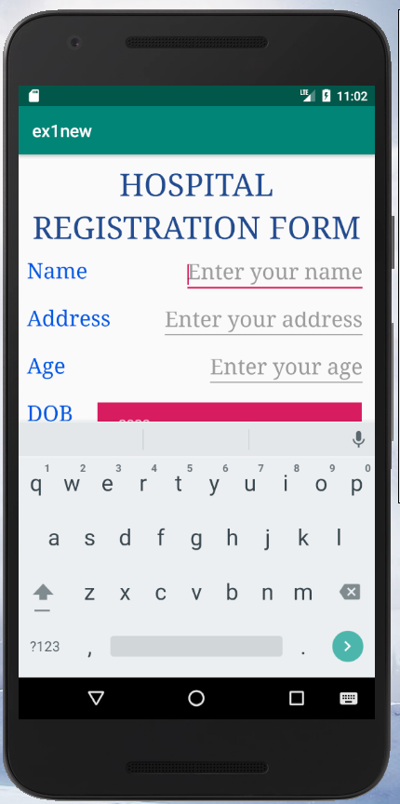 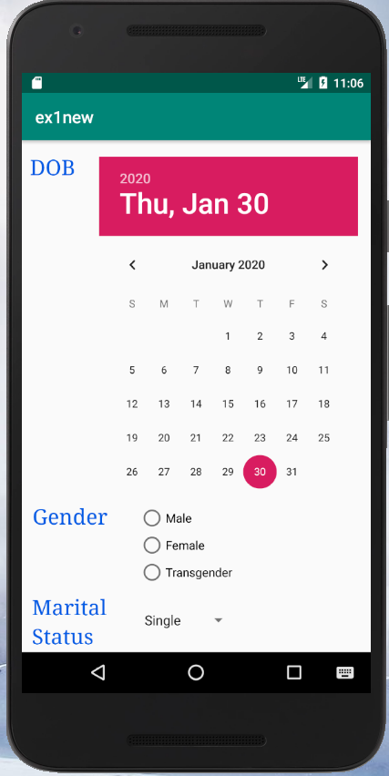

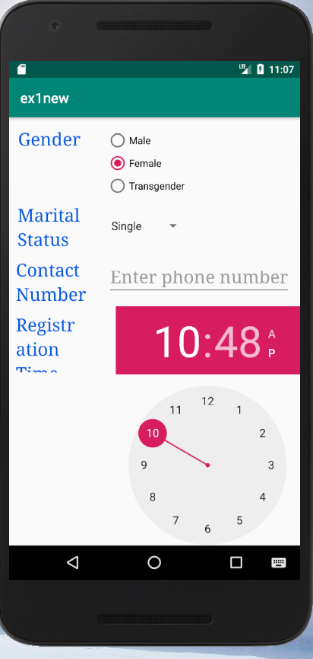

**CODE:**

**activity.xml:**

*<?*xml version="1.0" encoding="utf-8"*?>*<ScrollView  
 xmlns:android="http://schemas.android.com/apk/res/android"  
 xmlns:app="http://schemas.android.com/apk/res-auto"  
 xmlns:tools="http://schemas.android.com/tools"  
 tools:context=".MainActivity"  
 android:layout_width="match_parent"  
 android:layout_height="wrap_content"  
 android:fillViewport="true"  
 >  
 <RelativeLayout  
 android:layout_width="match_parent"  
 android:layout_height="match_parent"  
 tools:context=".MainActivity">  
  
 <TextView  
 android:id="@+id/tv1"  
 android:layout_width="match_parent"  
 android:layout_height="wrap_content"  
 android:text="HOSPITAL REGISTRATION FORM"  
 android:textColor="#214d90"  
 android:textSize="36sp"  
 android:textStyle="normal"  
 android:gravity="center"  
 android:typeface="serif"  
 android:layout_marginTop="10dp"  
 android:layout_marginLeft="10dp"  
 android:layout_marginRight="10dp"  
 />  
  
 <TextView  
 android:id="@+id/name_tv"  
 android:layout_width="125dp"  
 android:layout_height="45dp"  
 android:layout_below="@+id/tv1"  
 android:layout_alignParentLeft="true"  
 android:layout_marginLeft="10dp"  
 android:layout_marginTop="10dp"  
 android:text="Name"  
 android:textColor="#005ae4"  
 android:textSize="25sp"  
 android:typeface="serif" />  
  
 <EditText  
 android:id="@+id/name_et"  
 android:layout_width="wrap_content"  
 android:layout_height="45dp"  
 android:layout_below="@+id/tv1"  
 android:layout_alignParentRight="true"  
 android:layout_marginTop="10dp"  
 android:layout_marginRight="10dp"  
 android:hint="Enter your name"  
 android:inputType="text"  
 android:textColor="#005ae4"  
 android:textSize="25sp"  
 android:typeface="serif" />  
  
 <TextView  
 android:id="@+id/dob_tv"  
 android:layout_width="125dp"  
 android:layout_height="45dp"  
 android:layout_below="@+id/name_tv"  
 android:layout_alignParentLeft="true"  
 android:layout_marginLeft="10dp"  
 android:layout_marginTop="10dp"  
 android:text="DOB"  
 android:textColor="#005ae4"  
 android:textSize="25sp"  
 android:typeface="serif" />  
  
 <DatePicker  
 android:id="@+id/date_dp"  
 android:layout_width="305dp"  
 android:layout_height="400dp"  
 android:layout_below="@+id/name_et"  
 android:layout_alignParentRight="true"  
 android:layout_marginTop="15dp"  
 android:layout_marginRight="15dp"  
 android:inputType="date" />  
  
 <TextView  
 android:id="@+id/gender_tv"  
 android:layout_width="125dp"  
 android:layout_height="45dp"  
 android:layout_below="@+id/dob_tv"  
 android:layout_alignParentLeft="true"  
 android:layout_marginLeft="13dp"  
 android:layout_marginTop="367dp"  
 android:text="Gender"  
 android:textColor="#005ae4"  
 android:textSize="25sp"  
 android:typeface="serif" />  
  
 <RadioGroup  
 android:id="@+id/gd_rg"  
 android:layout_width="wrap_content"  
 android:layout_height="wrap_content"  
 android:layout_below="@+id/date_dp"  
 android:layout_toRightOf="@+id/gender_tv"  
 android:layout_marginTop="10dp"  
 android:layout_marginRight="10dp"  
 >  
  
 <RadioButton  
 android:layout_width="wrap_content"  
 android:layout_height="wrap_content"  
 android:text="Male">  
 </RadioButton>  
 <RadioButton  
 android:layout_width="wrap_content"  
 android:layout_height="wrap_content"  
 android:text="Female"  
 >  
 </RadioButton>  
 <RadioButton  
 android:layout_width="wrap_content"  
 android:layout_height="wrap_content"  
 android:text="Transgender">  
 </RadioButton>  
  
 </RadioGroup>  
  
 <TextView  
 android:id="@+id/ms_tv"  
 android:layout_width="125dp"  
 android:layout_height="wrap_content"  
 android:layout_below="@+id/gender_tv"  
 android:layout_alignParentLeft="true"  
 android:layout_marginLeft="12dp"  
 android:layout_marginTop="62dp"  
 android:text="Marital Status"  
 android:textColor="#005ae4"  
 android:textSize="25sp"  
 android:typeface="serif" />  
  
 <Spinner  
 android:id="@+id/ms_sp"  
 android:layout_width="wrap_content"  
 android:layout_height="wrap_content"  
 android:layout_below="@id/gd_rg"  
 android:layout_toRightOf="@+id/ms_tv"  
 android:layout_marginTop="28dp"  
 android:layout_marginRight="147dp"  
 android:layout_marginLeft="10dp"  
 android:entries="@array/marital">  
  
 </Spinner>  
  
 <TextView  
 android:id="@+id/contact_tv"  
 android:layout_width="125dp"  
 android:layout_height="wrap_content"  
 android:layout_below="@+id/ms_tv"  
 android:layout_alignParentLeft="true"  
 android:layout_marginLeft="10dp"  
 android:layout_marginTop="10dp"  
 android:text="Contact Number"  
 android:textColor="#005ae4"  
 android:textSize="25sp"  
 android:typeface="serif" />  
  
 <EditText  
 android:id="@+id/contact_et"  
 android:layout_width="wrap_content"  
 android:layout_height="45dp"  
 android:layout_below="@+id/ms_sp"  
 android:layout_alignParentRight="true"  
 android:layout_marginTop="42dp"  
 android:layout_marginRight="13dp"  
 android:hint="Enter phone number"  
 android:inputType="phone"  
 android:textColor="#005ae4"  
 android:textSize="25sp"  
 android:typeface="serif" />  
  
 <TextView  
 android:id="@+id/addict_tv"  
 android:layout_width="118dp"  
 android:layout_height="84dp"  
 android:layout_below="@+id/contact_tv"  
 android:layout_alignParentLeft="true"  
 android:layout_marginLeft="10dp"  
 android:layout_marginTop="10dp"  
 android:text="Addiction"  
 android:textColor="#005ae4"  
 android:textSize="25sp"  
 android:typeface="serif" />  
  
 <CheckBox  
 android:id="@+id/smoke_cb"  
 android:layout_width="wrap_content"  
 android:layout_height="wrap_content"  
 android:text="Smoking"  
 android:layout_below="@+id/contact_et"  
 android:layout_toRightOf="@+id/addict_tv"  
 android:layout_marginTop="10dp"  
 android:layout_marginRight="10dp"  
 android:layout_marginLeft="10dp"  
 />  
 <CheckBox  
 android:id="@+id/alcohol_cb"  
 android:layout_width="wrap_content"  
 android:layout_height="wrap_content"  
 android:text="Alcohol"  
 android:layout_below="@+id/smoke_cb"  
 android:layout_toRightOf="@+id/addict_tv"  
 android:layout_marginTop="10dp"  
 android:layout_marginRight="10dp"  
 android:layout_marginLeft="10dp"  
 />  
  
 <Button  
 android:id="@+id/submit_bt"  
 android:layout_width="wrap_content"  
 android:layout_height="wrap_content"  
 android:layout_below="@+id/alcohol_cb"  
 android:layout_centerInParent="false"  
 android:layout_marginLeft="40dp"  
 android:layout_marginTop="13dp"  
 android:layout_marginBottom="10dp"  
 android:text="SUBMIT"  
 android:textColor="#005ae4"  
 android:textSize="25sp"  
 android:typeface="serif" />  
  
 <Button  
 android:id="@+id/reset_bt"  
 android:layout_width="wrap_content"  
 android:layout_height="wrap_content"  
 android:layout_below="@+id/alcohol_cb"  
 android:layout_alignParentRight="true"  
 android:layout_marginTop="10dp"  
 android:layout_marginRight="40dp"  
 android:layout_marginBottom="10dp"  
 android:text="RESET"  
 android:textColor="#005ae4"  
 android:textSize="25sp"  
 android:typeface="serif"  
 android:onClick="resetFields"/>  
  
 </RelativeLayout>  
</ScrollView>

**activity_page2.xml:**

*<?*xml version="1.0" encoding="utf-8"*?>*<ScrollView  
 xmlns:android="http://schemas.android.com/apk/res/android"  
 xmlns:app="http://schemas.android.com/apk/res-auto"  
 xmlns:tools="http://schemas.android.com/tools"  
 tools:context=".MainActivity"  
 android:layout_width="match_parent"  
 android:layout_height="wrap_content"  
 android:fillViewport="true"  
 >  
  
 <LinearLayout  
 android:layout_width="match_parent"  
 android:layout_height="match_parent"  
 android:orientation="vertical"  
 >  
  
 <TextView  
 android:id="@+id/tv1"  
 android:layout_width="match_parent"  
 android:layout_height="wrap_content"  
 android:text="HOSPITAL REGISTRATION FORM"  
 android:textColor="#214d90"  
 android:textSize="36sp"  
 android:textStyle="normal"  
 android:gravity="center"  
 android:typeface="serif"  
 android:layout_marginTop="10dp"  
 android:layout_marginLeft="10dp"  
 android:layout_marginRight="10dp"  
 />  
  
 <TableLayout  
 android:layout_width="wrap_content"  
 android:layout_height="wrap_content"  
 >  
  
 <TableRow>  
 <TextView  
 android:layout_width="wrap_content"  
 android:layout_height="wrap_content"  
 android:text="Name"  
 android:textSize="30sp"  
 />  
 <TextView  
 android:id="@+id/name_tb"  
 android:layout_width="wrap_content"  
 android:layout_height="wrap_content"  
 android:textSize="30sp"  
 />  
 </TableRow>  
  
 <TableRow>  
 <TextView  
 android:layout_width="wrap_content"  
 android:layout_height="wrap_content"  
 android:text="DOB"  
 android:textSize="30sp"  
 />  
 <TextView  
 android:id="@+id/dob_tb"  
 android:layout_width="wrap_content"  
 android:layout_height="wrap_content"  
 android:textSize="30sp"  
 />  
 </TableRow>  
  
 <TableRow>  
 <TextView  
 android:layout_width="wrap_content"  
 android:layout_height="wrap_content"  
 android:text="Gender"  
 android:textSize="30sp"  
 />  
 <TextView  
 android:id="@+id/gender_tb"  
 android:layout_width="wrap_content"  
 android:layout_height="wrap_content"  
 android:textSize="30sp"  
 />  
 </TableRow>  
  
 <TableRow>  
 <TextView  
 android:layout_width="wrap_content"  
 android:layout_height="wrap_content"  
 android:text="Marital Status"  
 android:textSize="30sp"  
 />  
 <TextView  
 android:id="@+id/marital_tb"  
 android:layout_width="wrap_content"  
 android:layout_height="wrap_content"  
 android:textSize="30sp"  
 />  
 </TableRow>  
  
 <TableRow>  
 <TextView  
 android:layout_width="wrap_content"  
 android:layout_height="wrap_content"  
 android:text="Contact Number"  
 android:textSize="30sp"  
 />  
 <TextView  
 android:id="@+id/contact_tb"  
 android:layout_width="wrap_content"  
 android:layout_height="wrap_content"  
 android:textSize="30sp"  
 />  
 </TableRow>  
  
 <TableRow>  
 <TextView  
 android:layout_width="wrap_content"  
 android:layout_height="wrap_content"  
 android:text="Addiction"  
 android:textSize="30sp"  
 />  
 <TextView  
 android:id="@+id/addict_tb"  
 android:layout_width="wrap_content"  
 android:layout_height="wrap_content"  
 android:textSize="30sp"  
 />  
 </TableRow>  
  
  
 </TableLayout>  
  
  
 </LinearLayout>  
</ScrollView>

**MainActvity.java:**

package com.example.vaish.ex2new;  
  
import android.support.v7.app.AppCompatActivity;  
  
import android.content.Intent;  
import android.os.Bundle;  
import android.view.View;  
import android.widget.ArrayAdapter;  
import android.widget.Button;  
import android.widget.CheckBox;  
import android.widget.DatePicker;  
import android.widget.EditText;  
import android.widget.RadioButton;  
import android.widget.RadioGroup;  
import android.widget.Spinner;  
import android.widget.Toast;  
import java.util.Calendar;  
  
public class MainActivity extends AppCompatActivity {  
  
 Button submit,reset;  
 EditText name,contact_et;  
 DatePicker dob;  
 RadioGroup gd;  
 Spinner ms_sp;  
 CheckBox smoke_cb,alcohol_cb;  
 RadioButton check_rb;  
  
 @Override  
 protected void onCreate(Bundle savedInstanceState) {  
 super.onCreate(savedInstanceState);  
 setContentView(R.layout.*activity_main*);  
  
 submit = findViewById(R.id.*submit_bt*);  
 reset = findViewById(R.id.*reset_bt*);  
 name = findViewById(R.id.*name_et*);  
 dob = findViewById(R.id.*date_dp*);  
 gd = findViewById(R.id.*gd_rg*);  
 ms_sp = (Spinner) findViewById(R.id.*ms_sp*);  
 contact_et = findViewById(R.id.*contact_et*);  
 smoke_cb = findViewById(R.id.*smoke_cb*);  
 alcohol_cb = findViewById(R.id.*alcohol_cb*);  
  
 ArrayAdapter<CharSequence>  
 adapter=ArrayAdapter.*createFromResource*(this, R.array.*marital*,android.R.layout.*simple_spinner_item*);  
 adapter.setDropDownViewResource(android.R.layout.*simple_spinner_dropdown_item*);  
 ms_sp.setAdapter(adapter);  
  
  
 submit.setOnClickListener(new View.OnClickListener() {  
 @Override  
 public void onClick(View view) {  
 Intent myIntent = new Intent(getApplicationContext(), page2.class);  
  
 final String name_field = name.getText().toString();  
  
 String day=String.*valueOf*(dob.getDayOfMonth());  
 String month=String.*valueOf*(dob.getMonth()+1);  
 String year=String.*valueOf*(dob.getYear());  
  
 int selectedId = gd.getCheckedRadioButtonId();  
 check_rb = (RadioButton) findViewById(selectedId);  
 final String gender = check_rb.getText().toString();  
  
 long spin_id =ms_sp.getSelectedItemId();  
 System.*out*.println("id:"+spin_id);  
  
 final String contact = contact_et.getText().toString();  
  
 myIntent.putExtra("name", name_field);  
 myIntent.putExtra("day", day);  
 myIntent.putExtra("month", month);  
 myIntent.putExtra("year", year);  
 myIntent.putExtra("gender", gender);  
 if(spin_id==0)  
 myIntent.putExtra("marital", "Single");  
 if(spin_id==1)  
 myIntent.putExtra("marital", "Married");  
 myIntent.putExtra("contact", contact);  
 if (smoke_cb.isChecked())  
 myIntent.putExtra("addiction", "Smoking");  
 else  
 myIntent.putExtra("addiction", "Alcohol");  
  
 startActivity(myIntent);  
 }  
 });  
 }  
  
 public void resetFields(View v){  
 name.setText("");  
 gd.clearCheck();  
 ms_sp.setSelection(0);  
 contact_et.setText("");  
 smoke_cb.setChecked(false);  
 alcohol_cb.setChecked(false);  
 Calendar c = Calendar.*getInstance*();  
 int year = c.get(Calendar.*YEAR*);  
 int month = c.get(Calendar.*MONTH*);  
 int day = c.get(Calendar.*DAY_OF_MONTH*);  
 dob.init(year, month, day, null);  
 }  
  
}

**page2.java:**

package com.example.vaish.ex2new;  
  
import android.support.v7.app.AppCompatActivity;  
import android.os.Bundle;  
import android.widget.TextView;  
  
import java.text.SimpleDateFormat;  
import java.util.Date;  
import android.os.Bundle;  
import android.widget.RadioGroup;  
import android.widget.TextView;  
import android.widget.Toast;  
  
public class page2 extends AppCompatActivity {  
  
 TextView name,dob,gender,marital,contact,addict;  
  
 @Override  
 protected void onCreate(Bundle savedInstanceState) {  
 super.onCreate(savedInstanceState);  
 setContentView(R.layout.*activity_page2*);  
  
 name = findViewById(R.id.*name_tb*);  
 dob = findViewById(R.id.*dob_tb*);  
 gender = findViewById(R.id.*gender_tb*);  
 marital = findViewById(R.id.*marital_tb*);  
 contact = findViewById(R.id.*contact_tb*);  
 addict = findViewById(R.id.*addict_tb*);  
  
 Bundle extras = getIntent().getExtras();  
 if(extras == null) {  
 *//set all string to null* } else {  
 name.setText( extras.getString("name"));  
 gender.setText( extras.getString("gender"));  
 marital.setText( extras.getString("ms"));  
 contact.setText( extras.getString("contact"));  
 addict.setText( extras.getString("addiction"));  
 String date=extras.getString("day")+"-"+extras.getString("month")+"-"+extras.getString("year");  
 dob.setText(date);  
  
 }  
  
 }  
  
}

**OUTPUT:**

