**activity_main.xml:**

*<?*xml version="1.0" encoding="utf-8"*?>*<LinearLayout  
 xmlns:android="http://schemas.android.com/apk/res/android"  
 xmlns:app="http://schemas.android.com/apk/res-auto"  
 xmlns:tools="http://schemas.android.com/tools"  
 tools:context=".MainActivity"  
 android:layout_width="match_parent"  
 android:layout_height="match_parent"  
 android:orientation="vertical"  
 >  
  
 <EditText  
 android:layout_width="match_parent"  
 android:layout_height="200dp"  
 android:id="@+id/et_input"  
 android:background="#f3f2f2"  
 android:gravity="right|bottom"  
 android:textSize="40sp"  
 android:textStyle="bold"  
 />  
  
 <GridLayout  
 android:layout_width="match_parent"  
 android:layout_height="match_parent"  
  
 android:columnCount="5"  
 android:orientation="vertical"  
 android:rowCount="5">  
  
 <LinearLayout  
 android:layout_width="match_parent"  
 android:layout_height="wrap_content"  
 android:orientation="horizontal"  
 android:layout_rowWeight="1">  
  
 <Button  
 android:id="@+id/bt_sin"  
 android:layout_width="0dp"  
 android:layout_height="match_parent"  
 android:layout_weight="1"  
 android:background="#D3D3D3"  
 android:gravity="center"  
 android:padding="10dp"  
 android:text="sin"  
 android:textColor="#000000"  
 android:textSize="30sp" />  
  
 <Button  
 android:id="@+id/bt_cos"  
 android:layout_width="0dp"  
 android:layout_height="match_parent"  
 android:layout_weight="1"

android:background="#D3D3D3"  
 android:gravity="center"  
 android:padding="10dp"  
 android:text="cos"  
 android:textColor="#000000"  
 android:textSize="30sp" />  
  
 <Button  
 android:id="@+id/bt_log"  
 android:layout_width="0dp"  
 android:layout_height="match_parent"  
 android:layout_weight="1"  
 android:background="#D3D3D3"  
 android:gravity="center"  
 android:padding="10dp"  
 android:text="log"  
 android:textColor="#000000"  
 android:textSize="30sp" />  
  
 <Button  
 android:id="@+id/bt_del"  
 android:layout_width="0dp"  
 android:layout_height="match_parent"  
 android:layout_weight="1"  
 android:background="#D3D3D3"  
 android:gravity="center"  
 android:padding="10dp"  
 android:text="DEL"  
 android:textColor="#000000"  
 android:textSize="30sp" />  
  
 <Button  
 android:id="@+id/bt_c"  
 android:layout_width="0dp"  
 android:layout_height="match_parent"  
 android:layout_weight="1"  
 android:background="#D3D3D3"  
 android:gravity="center"  
 android:padding="10dp"  
 android:text="C"  
 android:textColor="#000000"  
 android:textSize="30sp" />  
  
 </LinearLayout>  
  
 <LinearLayout  
 android:layout_width="match_parent"  
 android:layout_height="wrap_content"  
 android:orientation="horizontal"  
 android:layout_rowWeight="1">  
  
 <Button  
 android:id="@+id/bt_7"  
 android:layout_width="0dp"  
 android:layout_height="match_parent"  
 android:layout_weight="1"

android:background="#D3D3D3"  
 android:gravity="center"  
 android:padding="10dp"  
 android:text="7"  
 android:textColor="#000000"  
 android:textSize="30sp" />  
  
 <Button  
 android:id="@+id/bt_8"  
 android:layout_width="0dp"  
 android:layout_height="match_parent"  
 android:layout_weight="1"  
 android:background="#D3D3D3"  
 android:gravity="center"  
 android:padding="10dp"  
 android:text="8"  
 android:textColor="#000000"  
 android:textSize="30sp" />  
  
 <Button  
 android:id="@+id/bt_9"  
 android:layout_width="0dp"  
 android:layout_height="match_parent"  
 android:layout_weight="1"  
 android:background="#D3D3D3"  
 android:gravity="center"  
 android:padding="10dp"  
 android:text="9"  
 android:textColor="#000000"  
 android:textSize="30sp" />  
  
 <Button  
 android:id="@+id/bt_open"  
 android:layout_width="0dp"  
 android:layout_height="match_parent"  
 android:layout_weight="1"  
 android:background="#D3D3D3"  
 android:gravity="center"  
 android:padding="10dp"  
 android:text="("  
 android:textColor="#000000"  
 android:textSize="30sp" />  
  
 <Button  
 android:id="@+id/bt_close"  
 android:layout_width="0dp"  
 android:layout_height="match_parent"  
 android:layout_weight="1"  
 android:background="#D3D3D3"  
 android:gravity="center"  
 android:padding="10dp"  
 android:text=")"  
 android:textColor="#000000"  
 android:textSize="30sp" />  
  
 </LinearLayout>  
  
 <LinearLayout  
 android:layout_width="match_parent"  
 android:layout_height="wrap_content"  
 android:orientation="horizontal"  
 android:layout_rowWeight="1">  
  
 <Button  
 android:id="@+id/bt_4"  
 android:layout_width="0dp"  
 android:layout_height="match_parent"  
 android:layout_weight="1"  
 android:background="#D3D3D3"  
 android:gravity="center"  
 android:padding="10dp"  
 android:text="4"  
 android:textColor="#000000"  
 android:textSize="30sp" />  
  
 <Button  
 android:id="@+id/bt_5"  
 android:layout_width="0dp"  
 android:layout_height="match_parent"  
 android:layout_weight="1"  
 android:background="#D3D3D3"  
 android:gravity="center"  
 android:padding="10dp"  
 android:text="5"  
 android:textColor="#000000"  
 android:textSize="30sp" />  
  
 <Button  
 android:id="@+id/bt_6"  
 android:layout_width="0dp"  
 android:layout_height="match_parent"  
 android:layout_weight="1"  
 android:background="#D3D3D3"  
 android:gravity="center"  
 android:padding="10dp"  
 android:text="6"  
 android:textColor="#000000"  
 android:textSize="30sp" />  
  
 <Button  
 android:id="@+id/bt_plus"  
 android:layout_width="0dp"  
 android:layout_height="match_parent"  
 android:layout_weight="1"  
 android:background="#D3D3D3"  
 android:gravity="center"  
 android:padding="10dp"  
 android:text="+"  
 android:textColor="#000000"  
 android:textSize="30sp" />  
  
 <Button  
 android:id="@+id/bt_minus"

android:layout_width="0dp"  
 android:layout_height="match_parent"  
 android:layout_weight="1"  
 android:background="#D3D3D3"  
 android:gravity="center"  
 android:padding="10dp"  
 android:text="-"  
 android:textColor="#000000"  
 android:textSize="30sp" />  
  
 </LinearLayout>  
  
 <LinearLayout  
 android:layout_width="match_parent"  
 android:layout_height="wrap_content"  
 android:orientation="horizontal"  
 android:layout_rowWeight="1">  
  
 <Button  
 android:id="@+id/bt_1"  
 android:layout_width="0dp"  
 android:layout_height="match_parent"  
 android:layout_weight="1"  
 android:background="#D3D3D3"  
 android:gravity="center"  
 android:padding="10dp"  
 android:text="1"  
 android:textColor="#000000"  
 android:textSize="30sp" />  
  
 <Button  
 android:id="@+id/bt_2"  
 android:layout_width="0dp"  
 android:layout_height="match_parent"  
 android:layout_weight="1"  
 android:background="#D3D3D3"  
 android:gravity="center"  
 android:padding="10dp"  
 android:text="2"  
 android:textColor="#000000"  
 android:textSize="30sp" />  
  
 <Button  
 android:id="@+id/bt_3"  
 android:layout_width="0dp"  
 android:layout_height="match_parent"  
 android:layout_weight="1"  
 android:background="#D3D3D3"  
 android:gravity="center"  
 android:padding="10dp"  
 android:text="3"  
 android:textColor="#000000"  
 android:textSize="30sp" />  
  
 <Button  
 android:id="@+id/bt_mul"  
 android:layout_width="0dp"  
 android:layout_height="match_parent"  
 android:layout_weight="1"  
 android:background="#D3D3D3"  
 android:gravity="center"  
 android:padding="10dp"  
 android:text="X"  
 android:textColor="#000000"  
 android:textSize="30sp" />  
  
 <Button  
 android:id="@+id/bt_div"  
 android:layout_width="0dp"  
 android:layout_height="match_parent"  
 android:layout_weight="1"  
 android:background="#D3D3D3"  
 android:gravity="center"  
 android:padding="10dp"  
 android:text="/"  
 android:textColor="#000000"  
 android:textSize="30sp" />  
  
 </LinearLayout>  
  
 <LinearLayout  
 android:layout_width="match_parent"  
 android:layout_height="wrap_content"  
 android:orientation="horizontal"  
 android:layout_rowWeight="1">  
  
 <Button  
 android:id="@+id/bt_0"  
 android:layout_width="0dp"  
 android:layout_height="match_parent"  
 android:layout_weight="2"  
 android:background="#D3D3D3"  
 android:gravity="center"  
 android:padding="10dp"  
 android:text="0"  
 android:textColor="#000000"  
 android:textSize="30sp" />  
  
 <Button  
 android:id="@+id/bt_dot"  
 android:layout_width="0dp"  
 android:layout_height="match_parent"  
 android:layout_weight="1"  
 android:background="#D3D3D3"  
 android:gravity="center"  
 android:padding="10dp"  
 android:text="."  
 android:textColor="#000000"  
 android:textSize="30sp" />  
  
 <Button  
 android:id="@+id/bt_percent"  
 android:layout_width="0dp"  
 android:layout_height="match_parent"  
 android:layout_weight="1"  
 android:background="#D3D3D3"  
 android:gravity="center"  
 android:padding="10dp"  
 android:text="%"  
 android:textColor="#000000"  
 android:textSize="30sp" />  
  
 <Button  
 android:id="@+id/bt_equal"  
 android:layout_width="0dp"  
 android:layout_height="match_parent"  
 android:layout_weight="1"  
 android:background="#D3D3D3"  
 android:gravity="center"  
 android:padding="10dp"  
 android:text="="  
 android:textColor="#000000"  
 android:textSize="30sp" />  
  
 </LinearLayout>  
  
 </GridLayout>  
  
</LinearLayout>  
  
**MainActivity.java**

**package** com.example.ex3;  
**import** androidx.appcompat.app.AppCompatActivity;  
  
**import** android.graphics.Color;  
**import** android.os.Bundle;  
**import** android.util.Log;  
**import** android.view.View;  
**import** android.widget.Button;  
**import** android.widget.EditText;  
**import** android.widget.TextView;  
**import** android.widget.Toast;  
  
**import** java.util.ArrayList;  
**import** java.util.EmptyStackException;  
**import** java.util.Stack;  
**import** java.lang.*;  
  
**public class** MainActivity **extends** AppCompatActivity **implements** View.OnClickListener{  
  
 EditText **et_input**;  
 Stack<String> **stack**;  
 ArrayList<String> **post_input**;  
  
 @Override  
 **protected void** onCreate(Bundle savedInstanceState) {  
 **super**.onCreate(savedInstanceState);  
 setContentView(R.layout.***activity_main***);  
  
 **et_input**=findViewById(R.id.***et_input***);  
 **stack**=**new** Stack<String>();  
 **post_input**=**new** ArrayList<String>();  
 String  
 ops[]={**"c"**,**"del"**,**"dot"**,**"plus"**,**"minus"**,**"mul"**,**"div"**,**"percent"**,**"open"**,**"close"**,**"equal"**,**"sin"**,**"cos"**,**"log"**};  
  
 **for**(**int** i=0;i<10;i++){  
 **int** id=getResources().getIdentifier(**"bt_"**+Integer.*toString*(i),**"id"**,getPackageName());  
 findViewById(id).setOnClickListener(**this**);  
 }  
 **for**(**int** i=0;i<14;i++){  
 **int** id=getResources().getIdentifier(**"bt_"**+ops[i],**"id"**,getPackageName());  
 findViewById(id).setOnClickListener(**this**);  
 }  
 }  
 @Override  
 **public void** onClick(View v) **throws** EmptyStackException{  
 **float** result;  
  
 **switch** (v.getId()){  
 **case** R.id.***bt_c***:  
 **et_input**.setText(**""**);  
 **break**;  
 **case** R.id.***bt_del***:  
 String val=**et_input**.getEditableText().toString();  
 **et_input**.setText(val.substring(0,val.length()-1));  
 **break**;  
 **case** R.id.***bt_equal***:  
 String ip=**et_input**.getEditableText().toString();  
 **if**(!ip.startsWith(**"sin"**) && !ip.startsWith(**"cos"**) && !ip.startsWith(**"log"**)) {  
 postFix(ip);  
 **try** {  
 result = calc();  
 **et_input**.setText(String.*valueOf*(result));  
 }**catch**(EmptyStackException ex){  
 Toast.*makeText*(**this**, **"INVALID. SYNTAX!"**, Toast.***LENGTH_SHORT***).show();  
 **et_input**.setText(**""**);  
 makeEmpty();  
 **post_input**.clear();  
 }  
 }  
 **else** trig_calc(ip);  
 **break**;  
 **default**:  
 Button bt_num=(Button)v;  
 **et_input**.setText(**et_input**.getEditableText().toString() + bt_num.getText());  
 **break**;  
 }  
 **et_input**.setSelection(**et_input**.getEditableText().length());  
 }  
  
 **static int** precedence(**char** c){  
 **switch** (c){  
 **case '+'**:  
 **case '-'**:  
 **return** 1;  
 **case 'X'**:  
 **case '/'**:  
 **case '%'**:  
 **return** 2;  
 }  
 **return** -1;  
 }  
  
 **private void** postFix(String ip){  
 makeEmpty();  
 **post_input**.clear();  
 String num_ip;  
 **int** prev=0; *//1 for op , 0 for other cases* **for** (**int** i = 0; i <ip.length() ; i++) {  
  
 **char** c = ip.charAt(i);  
 *//check if char is operator* **if**(*precedence*(c)>0) *//operator* {  
 **if**(i==0)  
 **post_input**.add(**"0"**); *//unary -6=0-6* **if**(prev!=1) *//not op* {  
 **while**(**stack**.isEmpty()==**false** && *precedence*(**stack**.peek().charAt(0))>=*precedence*(c))  
 **post_input**.add(**stack**.pop());  
 }  
 **else  
 post_input**.add(**"0"**);  
 **stack**.push(String.*valueOf*(c));  
 prev=1;  
 }  
 **else if**(c==**')'**)  
 {  
 **char** x = **stack**.pop().charAt(0);  
  
 **try** {  
 **while** (x != **'('**) {  
 **post_input**.add(String.*valueOf*(x));  
 *//result += x;* x = **stack**.pop().charAt(0);  
 }  
 }**catch**(EmptyStackException e)  
 {  
 Log.*i*(**"got"**, **"mmmmmm-------------brac excp"**);  
 *//stack.push("Error");* Log.*i*(**"got"**, **"kkkkkk---------------"**+**stack**.peek());  
 Log.*i*(**"got"**, **"kkkkkk---------------"**+**stack**.size());  
 Toast.*makeText*(**this**, **"INVALID. SYNTAX!"**, Toast.***LENGTH_SHORT***).show();  
 **et_input**.setText(**""**);  
 makeEmpty();  
 **post_input**.clear();  
 }  
 **finally** { prev=0; }  
 }  
 **else if**(c==**'('**)  
 { **stack**.push(String.*valueOf*(c)); prev=0; }  
  
 **else** {  
 *//character is neither operator nor (* num_ip = String.*valueOf*(c);  
 **while** ( (i + 1 != ip.length()) && ( Character.*isDigit*(ip.charAt(i + 1)) || ip.charAt(i + 1)==**'.'** )) {  
 num_ip = num_ip + ip.charAt(i + 1);  
 i++;  
 }  
  
 **post_input**.add(num_ip);  
 prev=0;  
 }  
 }  
 **while**(!**stack**.isEmpty())  
 **post_input**.add(**stack**.pop());  
 }  
  
 **private float** calc() **throws** EmptyStackException{  
 makeEmpty();  
 **float** res;  
 Stack<Float> float_stack=**new** Stack<>();  
  
**for**(**int** i=0;i<**post_input**.size();i++)  
 {  
 String post_str=**post_input**.get(i);  
  
 **try** {  
  
 **float** n = Float.*parseFloat*(post_str);  
 float_stack.push(n);  
 Log.*i*(**"err"**, **"no: "** + n);  
 } **catch** (NumberFormatException ex) {  
 Log.*i*(**"err"**, **"ty: "** + post_str);  
 **try** {  
 **float** val1 = float_stack.pop();  
 **float** val2 = float_stack.pop();  
  
 **switch** (post_str) {  
 **case "+"**:  
 float_stack.push(val2 + val1);  
 **break**;  
  
 **case "-"**:  
 **float** t = val2 - val1;  
 float_stack.push(val2 - val1);  
 Log.*i*(**"err"**, **"ty: "** + t);  
 **break**;  
  
 **case "/"**:  
 float_stack.push(val2 / val1);  
 **break**;  
  
 **case "X"**:  
 float_stack.push(val2 * val1);  
 **break**;  
  
 **case "%"**:  
 float_stack.push(val2 % val1);  
 **break**;  
 }  
 }**catch**(EmptyStackException exe){  
 */*Toast t = Toast.makeText(this, "INVALID - SYNTAX!", Toast.LENGTH_SHORT);  
 View v = t.getView();  
 v.setBackgroundColor(Color.WHITE);  
 t.show();*/* Toast.*makeText*(**this**, **"INVALID - SYNTAX!"**, Toast.***LENGTH_SHORT***).show();  
 **et_input**.setText(**""**);  
 makeEmpty();  
 **post_input**.clear();  
 }  
 }  
 **catch**(EmptyStackException ex){  
 Toast.*makeText*(**this**, **"INVALID .. SYNTAX!"**, Toast.***LENGTH_SHORT***).show();  
 **et_input**.setText(**""**);  
 makeEmpty();  
 **post_input**.clear();  
 }  
 }  
  
 res=float_stack.pop();  
 **return** res; *//change return value in fn call* }  
  
 **private void** trig_calc(String ip){  
  
 Double val = Double.*parseDouble*(ip.substring(3));  
 **if**(ip.startsWith(**"sin"**))  
 **et_input**.setText(Double.*toString*(Math.*sin*(Math.*toRadians*(val))));  
 **else if**(ip.startsWith(**"cos"**))  
 **et_input**.setText(Double.*toString*(Math.*cos*(Math.*toRadians*(val))));  
 **else if**(ip.startsWith(**"log"**))  
 **et_input**.setText(Double.*toString*(Math.*log*(val)));  
 }  
  
 **private void** makeEmpty(){  
 **while** (!**stack**.isEmpty())  
 **stack**.pop();  
 }  
}

**Output:**

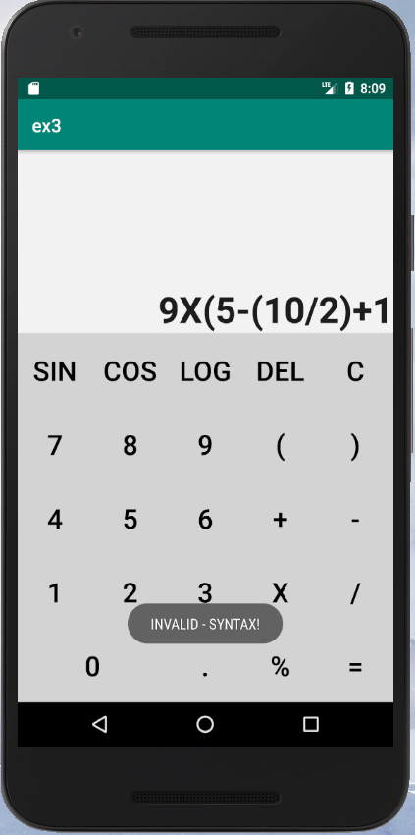

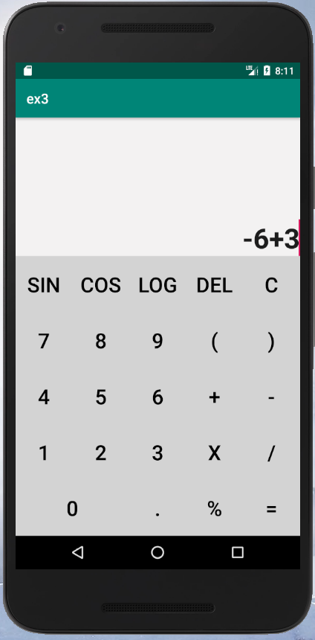 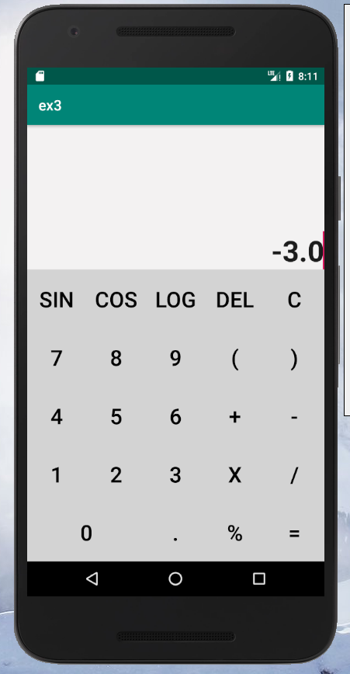

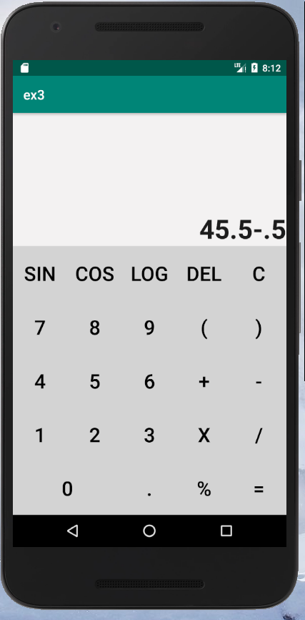 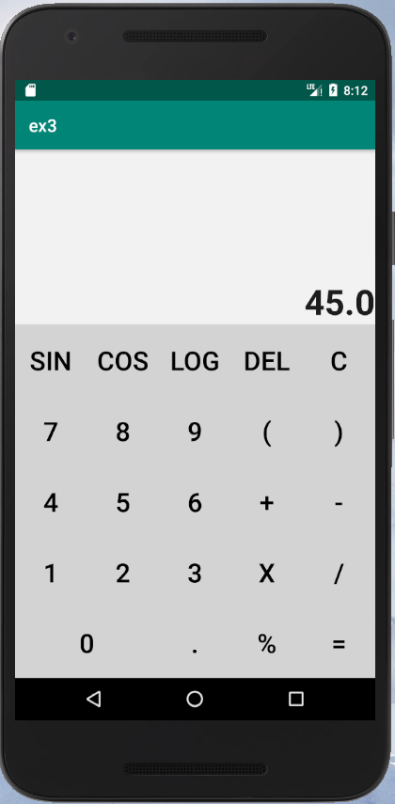

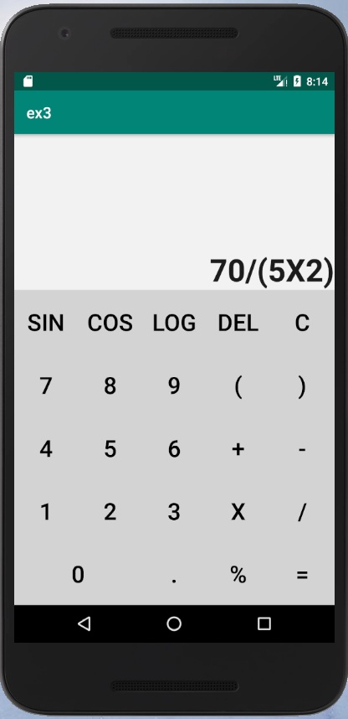 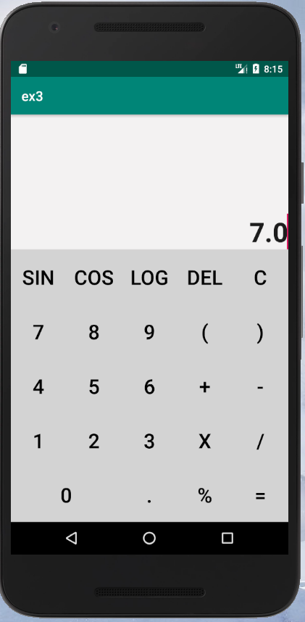

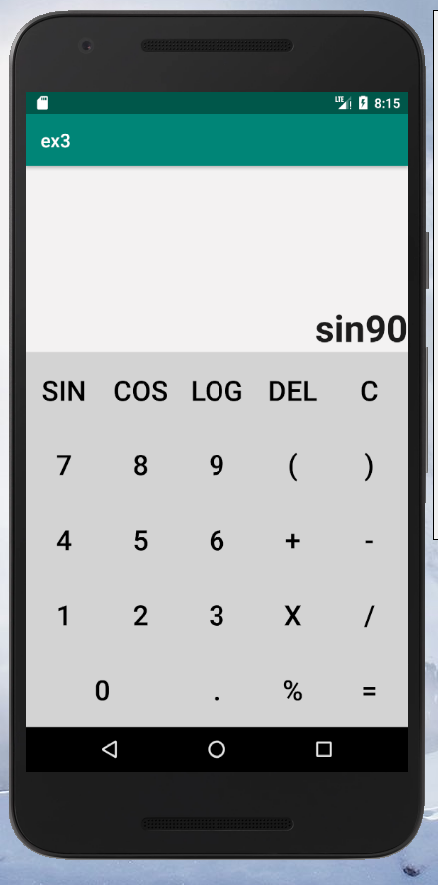 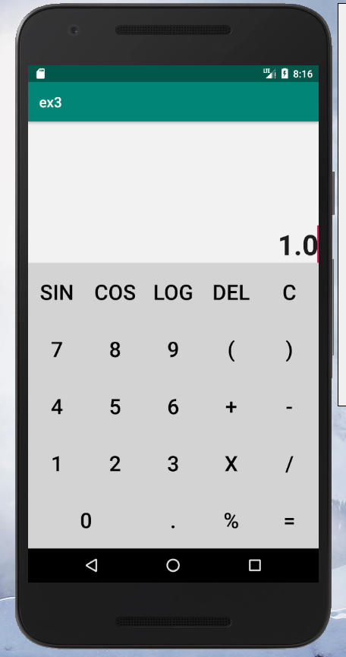

**activity_main.xml:**

**MainActivity.java**

**Output:**