**activity_main.xml**

*<?***xml version="1.0" encoding="utf-8"***?>*<**LinearLayout xmlns:android="http://schemas.android.com/apk/res/android"  
 xmlns:app="http://schemas.android.com/apk/res-auto"  
 xmlns:tools="http://schemas.android.com/tools"  
 android:layout_width="match_parent"  
 android:layout_height="match_parent"  
 android:orientation="vertical"  
 tools:context=".MainActivity"  
 android:layout_margin="10dp"**>  
  
 <**TextView  
 android:id="@+id/textView"  
 android:layout_width="match_parent"  
 android:layout_height="wrap_content"  
 android:textAllCaps="true"  
 android:textColor="@color/colorPrimaryDark"  
 android:textSize="30sp"  
 android:padding="10dp"  
 android:layout_margin="5dp"  
 android:text="Employee Database"  
 android:gravity="center"**/>  
  
 <**LinearLayout  
 android:layout_width="match_parent"  
 android:layout_height="match_parent"  
 android:orientation="vertical"  
 android:layout_margin="10dp"**>  
  
 <**Button  
 android:id="@+id/bt_cre"  
 android:layout_width="match_parent"  
 android:layout_height="wrap_content"  
 android:padding="10dp"  
 android:text="Create"  
 android:layout_margin="5dp"  
 android:layout_weight="1"**/>  
  
 <**Button  
 android:id="@+id/bt_ins"  
 android:layout_width="match_parent"  
 android:layout_height="wrap_content"  
 android:padding="10dp"  
 android:text="Insert"  
 android:layout_margin="5dp"  
 android:layout_weight="1"**/>  
  
 <**Button  
 android:id="@+id/bt_upd"  
 android:layout_width="match_parent"  
 android:layout_height="wrap_content"  
 android:padding="10dp"  
 android:text="Update"  
 android:layout_margin="5dp"  
 android:layout_weight="1"**/>  
  
 <**Button  
 android:id="@+id/bt_del"  
 android:layout_width="match_parent"  
 android:layout_height="wrap_content"  
 android:padding="10dp"  
 android:text="Delete"  
 android:layout_margin="5dp"  
 android:layout_weight="1"**/>  
  
 <**Button  
 android:id="@+id/bt_ret"  
 android:layout_width="match_parent"  
 android:layout_height="wrap_content"  
 android:padding="10dp"  
 android:text="Retrieve by employee code"  
 android:layout_margin="5dp"  
 android:layout_weight="1"**/>  
  
 <**Button  
 android:id="@+id/bt_ret_dt"  
 android:layout_width="match_parent"  
 android:layout_height="wrap_content"  
 android:padding="10dp"  
 android:text="Retrieve by department"  
 android:layout_margin="5dp"  
 android:layout_weight="1"**/>  
  
 </**LinearLayout**>  
</**LinearLayout**>

**MainActivity.java**

**package** com.example.ex5;  
  
**import** androidx.appcompat.app.AppCompatActivity;  
  
**import** android.content.Intent;  
**import** android.database.sqlite.SQLiteDatabase;  
**import** android.os.Bundle;  
**import** android.view.View;  
**import** android.widget.Button;  
**import** android.widget.Toast;  
  
**public class** MainActivity **extends** AppCompatActivity {  
 Button **bt_cre**,**bt_ins**,**bt_upd**,**bt_del**,**bt_ret**,**bt_ret_dt**;  
 SQLiteDatabase **db**;  
 @Override  
 **protected void** onCreate(Bundle savedInstanceState)  
 {  
 **super**.onCreate(savedInstanceState);  
 setContentView(R.layout.***activity_main***);  
 **bt_cre** = findViewById(R.id.***bt_cre***);  
 **bt_ins** = findViewById(R.id.***bt_ins***);  
 **bt_upd** = findViewById(R.id.***bt_upd***);  
 **bt_del** = findViewById(R.id.***bt_del***);  
 **bt_ret** = findViewById(R.id.***bt_ret***);  
 **bt_ret_dt**=findViewById(R.id.***bt_ret_dt***);  
   
 **bt_cre**.setOnClickListener(**new** View.OnClickListener() {  
 @Override  
 **public void** onClick(View v) {  
 **db** = openOrCreateDatabase(**"db"**, ***MODE_PRIVATE***, **null**);  
 *//db.execSQL("DROP TABLE IF EXISTS EMPLOYEES;");* **db**.execSQL(**"CREATE TABLE IF NOT EXISTS EMPLOYEES(NAME VARCHAR(20) NOT NULL, GENDER VARCHAR(20) NOT NULL, E_CODE VARCHAR(20) PRIMARY KEY NOT NULL, DEPT VARCHAR(20) NOT NULL, SALARY VARCHAR(20) NOT NULL);"**);  
 Toast.*makeText*(getApplicationContext(), **"Created table!"**, Toast.***LENGTH_SHORT***).show();  
 **if**(**db** != **null**) { **db**.close(); }  
 }  
 });  
 **bt_ins**.setOnClickListener(**new** View.OnClickListener() {  
 @Override  
 **public void** onClick(View v) {  
 Intent myIntent = **new** Intent(getApplicationContext(), InsertActivity.**class**);  
 MainActivity.**this**.startActivity(myIntent);  
 }  
 });  
 **bt_upd**.setOnClickListener(**new** View.OnClickListener() {  
 @Override  
 **public void** onClick(View v) {  
 Intent myIntent = **new** Intent(getApplicationContext(), UpdateActivity.**class**);  
 MainActivity.**this**.startActivity(myIntent);  
 }  
 });  
 **bt_del**.setOnClickListener(**new** View.OnClickListener() {  
 @Override  
 **public void** onClick(View v) {  
 Intent myIntent = **new** Intent(getApplicationContext(), DeleteActivity.**class**);  
 MainActivity.**this**.startActivity(myIntent);  
 }  
 });  
 **bt_ret**.setOnClickListener(**new** View.OnClickListener() {  
 @Override  
 **public void** onClick(View v) {  
 Intent myIntent = **new** Intent(getApplicationContext(), RetrieveActivity.**class**);  
 MainActivity.**this**.startActivity(myIntent);  
 }  
 });  
 **bt_ret_dt**.setOnClickListener(**new** View.OnClickListener() {  
 @Override  
 **public void** onClick(View view) {  
 Intent myIntent = **new** Intent(getApplicationContext(), Retrieve2Activity.**class**);  
 MainActivity.**this**.startActivity(myIntent);  
 }  
 });  
  
 }  
}

**activity_insert.xml**

*<?***xml version="1.0" encoding="utf-8"***?>*<**ScrollView xmlns:android="http://schemas.android.com/apk/res/android"  
 xmlns:tools="http://schemas.android.com/tools"  
 android:layout_width="match_parent"  
 android:layout_height="match_parent"  
 android:fillViewport="true"  
 tools:context=".InsertActivity"**>  
  
<**LinearLayout  
 android:layout_width="match_parent"  
 android:layout_height="match_parent"  
 android:orientation="vertical"**>  
  
 <**TextView  
 android:layout_width="match_parent"  
 android:layout_height="wrap_content"  
 android:layout_margin="5dp"  
 android:gravity="center"  
 android:padding="10dp"  
 android:text="Insert Data"  
 android:textAllCaps="true"  
 android:textColor="@color/colorPrimaryDark"  
 android:textSize="30sp"** />  
  
 <**EditText  
 android:id="@+id/et_name"  
 android:layout_width="match_parent"  
 android:layout_height="wrap_content"  
 android:layout_margin="10dp"  
 android:gravity="center"  
 android:hint="Name"  
 android:inputType="textPersonName"  
 android:textSize="30sp"** />  
  
 <**TextView  
 android:id="@+id/tv_gd"  
 android:layout_width="match_parent"  
 android:layout_height="wrap_content"  
 android:layout_margin="10dp"  
 android:gravity="center"  
 android:text="Gender"  
 android:textColor="#000000"  
 android:textSize="30sp"** />  
  
 <**RadioGroup  
 android:id="@+id/rg_gd"  
 android:layout_width="match_parent"  
 android:layout_height="wrap_content"  
 android:orientation="vertical"**>  
  
 <**RadioButton  
 android:id="@+id/rb_male"  
 android:layout_width="match_parent"  
 android:layout_height="wrap_content"  
 android:layout_marginLeft="150dp"  
 android:text="Male"** />  
  
 <**RadioButton  
 android:id="@+id/rb_female"  
 android:layout_width="match_parent"  
 android:layout_height="wrap_content"  
 android:layout_marginLeft="150dp"  
 android:text="Female"** />  
  
 <**RadioButton  
 android:id="@+id/rb_other"  
 android:layout_width="match_parent"  
 android:layout_height="wrap_content"  
 android:layout_marginLeft="150dp"  
 android:text="Other"** />  
  
 </**RadioGroup**>  
  
  
 <**EditText  
 android:id="@+id/et_ec"  
 android:layout_width="match_parent"  
 android:layout_height="wrap_content"  
 android:layout_margin="10dp"  
 android:gravity="center"  
 android:hint="Employee Code"  
 android:inputType="textVisiblePassword"  
 android:textSize="30sp"** />  
  
  
 <**TextView  
 android:id="@+id/tv_dt"  
 android:layout_width="match_parent"  
 android:layout_height="wrap_content"  
 android:layout_margin="10dp"  
 android:gravity="center"  
 android:text="Department"  
 android:textColor="#000000"  
 android:textSize="30sp"** />  
  
 <**Spinner  
 android:id="@+id/sp_dt"  
 android:layout_width="match_parent"  
 android:layout_height="wrap_content"  
 android:layout_margin="10dp"  
 android:entries="@array/dept"  
 android:textAlignment="center"** />  
  
 <**EditText  
 android:id="@+id/et_salary"  
 android:layout_width="match_parent"  
 android:layout_height="wrap_content"  
 android:layout_margin="10dp"  
 android:gravity="center"  
 android:hint="Salary"  
 android:inputType="number"  
 android:textSize="30sp"** />  
  
 <**Button  
 android:id="@+id/bt_insert"  
 android:layout_width="match_parent"  
 android:layout_height="wrap_content"  
 android:layout_gravity="center"  
 android:layout_margin="10pt"  
 android:text="Insert"** />  
  
</**LinearLayout**>  
</**ScrollView**>

**InsertActivity.java**

**package** com.example.ex5;  
  
**import** androidx.appcompat.app.AppCompatActivity;  
  
**import** android.database.sqlite.SQLiteDatabase;  
**import** android.os.Bundle;  
**import** android.view.View;  
**import** android.widget.Button;  
**import** android.widget.EditText;  
**import** android.widget.RadioButton;  
**import** android.widget.RadioGroup;  
**import** android.widget.Spinner;  
**import** android.widget.Toast;  
  
**public class** InsertActivity **extends** AppCompatActivity {  
 Button **bt_insert**;  
 EditText **et_ec**, **et_name**, **et_salary**;  
 RadioGroup **rg_gd**;  
 RadioButton **check_rb_gd**;  
 Spinner **sp_dt**;  
 SQLiteDatabase **db**;  
  
 @Override  
 **protected void** onCreate(Bundle savedInstanceState) {  
 **super**.onCreate(savedInstanceState);  
 setContentView(R.layout.***activity_insert***);  
  
 **bt_insert** = findViewById(R.id.***bt_insert***);  
 **et_ec** = findViewById(R.id.***et_ec***);  
 **et_name** = findViewById(R.id.***et_name***);  
 **et_salary** = findViewById(R.id.***et_salary***);  
 **rg_gd** = findViewById(R.id.***rg_gd***);  
 **sp_dt** = findViewById(R.id.***sp_dt***);  
  
 **bt_insert**.setOnClickListener(**new** View.OnClickListener() {  
 @Override  
 **public void** onClick(View view) {  
  
 **db** = openOrCreateDatabase(**"db"**, ***MODE_PRIVATE***, **null**);  
 String msg = **""**;  
  
 **if**(!**et_name**.getText().toString().matches(**"[A-Za-z.]+"**))  
 msg += **"Name error! "**;  
  
 **if**(**rg_gd**.getCheckedRadioButtonId() == -1)  
 msg += **"Gender not selected! "**;  
 **else  
 check_rb_gd** = findViewById(**rg_gd**.getCheckedRadioButtonId());  
  
 **if**(!**et_ec**.getText().toString().matches(**"[A-Za-z0-9]+"**))  
 msg += **"Invalid employee code! "**;  
  
 **if**(!**et_salary**.getText().toString().matches(**"[0-9]+"**))  
 msg += **"Salary error! "**;  
  
 **try** {  
 **if** (msg.equals(**""**)) {  
 **db**.execSQL(**"INSERT INTO EMPLOYEES VALUES(?, ?, ?, ?, ?);"**, **new** String[]{**et_name**.getText().toString(), **check_rb_gd**.getText().toString(), **et_ec**.getText().toString(), **sp_dt**.getSelectedItem().toString(), **et_salary**.getText().toString()});  
 msg = **"Inserted!"**;  
 }  
 }**catch**(Exception ex){  
 *//msg=ex.toString();* msg=**"Error inserting...Please enter correct details"**;  
 }  
 **finally** {  
 Toast.*makeText*(getApplicationContext(), msg, Toast.***LENGTH_LONG***).show();  
 **if**(**db** != **null**) { **db**.close(); }  
 }  
 }  
 });  
 }  
}

**activity_update.xml**

*<?***xml version="1.0" encoding="utf-8"***?>*<**ScrollView xmlns:android="http://schemas.android.com/apk/res/android"  
 xmlns:tools="http://schemas.android.com/tools"  
 android:layout_width="match_parent"  
 android:layout_height="match_parent"  
 android:fillViewport="true"  
 tools:context=".UpdateActivity"**>  
  
 <**LinearLayout  
 android:layout_width="match_parent"  
 android:layout_height="match_parent"  
 android:orientation="vertical"**>  
  
 <**TextView  
 android:layout_width="match_parent"  
 android:layout_height="wrap_content"  
 android:layout_margin="5dp"  
 android:gravity="center"  
 android:padding="10dp"  
 android:text="Update Data"  
 android:textAllCaps="true"  
 android:textColor="@color/colorPrimaryDark"  
 android:textSize="30sp"** />  
  
 <**EditText  
 android:id="@+id/et_name"  
 android:layout_width="match_parent"  
 android:layout_height="wrap_content"  
 android:layout_margin="10dp"  
 android:gravity="center"  
 android:hint="Name"  
 android:inputType="textPersonName"  
 android:textSize="30sp"** />  
  
 <**TextView  
 android:id="@+id/tv_gd"  
 android:layout_width="match_parent"  
 android:layout_height="wrap_content"  
 android:layout_margin="10dp"  
 android:gravity="center"  
 android:text="Gender"  
 android:textColor="#000000"  
 android:textSize="30sp"** />  
  
 <**RadioGroup  
 android:id="@+id/rg_gd"  
 android:layout_width="match_parent"  
 android:layout_height="wrap_content"  
 android:orientation="vertical"**>  
  
 <**RadioButton  
 android:id="@+id/rb_male"  
 android:layout_width="match_parent"  
 android:layout_height="wrap_content"  
 android:layout_marginLeft="150dp"  
 android:text="Male"** />  
  
 <**RadioButton  
 android:id="@+id/rb_female"  
 android:layout_width="match_parent"  
 android:layout_height="wrap_content"  
 android:layout_marginLeft="150dp"  
 android:text="Female"** />  
  
 <**RadioButton  
 android:id="@+id/rb_other"  
 android:layout_width="match_parent"  
 android:layout_height="wrap_content"  
 android:layout_marginLeft="150dp"  
 android:text="Other"** />  
  
 </**RadioGroup**>  
  
  
 <**EditText  
 android:id="@+id/et_ec"  
 android:layout_width="match_parent"  
 android:layout_height="wrap_content"  
 android:layout_margin="10dp"  
 android:gravity="center"  
 android:hint="Employee Code"  
 android:inputType="textVisiblePassword"  
 android:textSize="30sp"** />  
  
  
 <**TextView  
 android:id="@+id/tv_dt"  
 android:layout_width="match_parent"  
 android:layout_height="wrap_content"  
 android:layout_margin="10dp"  
 android:gravity="center"  
 android:text="Department"  
 android:textColor="#000000"  
 android:textSize="30sp"** />  
  
 <**Spinner  
 android:id="@+id/sp_dt"  
 android:layout_width="match_parent"  
 android:layout_height="wrap_content"  
 android:layout_margin="10dp"  
 android:entries="@array/dept"  
 android:textAlignment="center"** />  
  
 <**EditText  
 android:id="@+id/et_salary"  
 android:layout_width="match_parent"  
 android:layout_height="wrap_content"  
 android:layout_margin="10dp"  
 android:gravity="center"  
 android:hint="Salary"  
 android:inputType="number"  
 android:textSize="30sp"** />  
  
 <**Button  
 android:id="@+id/bt_update"  
 android:layout_width="match_parent"  
 android:layout_height="wrap_content"  
 android:layout_gravity="center"  
 android:layout_margin="10pt"  
 android:text="Update"** />  
  
 </**LinearLayout**>  
</**ScrollView**>

**UpdateActivity.java**

**package** com.example.ex5;  
  
**import** androidx.appcompat.app.AppCompatActivity;  
  
**import** android.database.Cursor;  
**import** android.database.sqlite.SQLiteDatabase;  
**import** android.os.Bundle;  
**import** android.view.View;  
**import** android.widget.Button;  
**import** android.widget.EditText;  
**import** android.widget.RadioButton;  
**import** android.widget.RadioGroup;  
**import** android.widget.Spinner;  
**import** android.widget.Toast;  
  
**public class** UpdateActivity **extends** AppCompatActivity {  
 Button **bt_update**;  
 EditText **et_ec**, **et_name**, **et_salary**;  
 RadioGroup **rg_gd**;  
 RadioButton **check_rb_gd**;  
 Spinner **sp_dt**;  
 SQLiteDatabase **db**;  
  
 @Override  
 **protected void** onCreate(Bundle savedInstanceState) {  
 **super**.onCreate(savedInstanceState);  
 setContentView(R.layout.***activity_update***);  
 *//db = openOrCreateDatabase("db", MODE_PRIVATE, null);* **bt_update** = findViewById(R.id.***bt_update***);  
 **et_ec** = findViewById(R.id.***et_ec***);  
 **et_name** = findViewById(R.id.***et_name***);  
 **et_salary** = findViewById(R.id.***et_salary***);  
 **rg_gd** = findViewById(R.id.***rg_gd***);  
 **sp_dt** = findViewById(R.id.***sp_dt***);  
  
 **bt_update**.setOnClickListener(**new** View.OnClickListener() {  
 @Override  
 **public void** onClick(View view) {  
  
 **db** = openOrCreateDatabase(**"db"**, ***MODE_PRIVATE***, **null**);  
 String msg = **""**;  
  
 **if**(!**et_name**.getText().toString().matches(**"[A-Za-z.]+"**))  
 msg += **"Name error! "**;  
  
 **if**(**rg_gd**.getCheckedRadioButtonId() == -1)  
 msg += **"Gender not selected! "**;  
 **else  
 check_rb_gd** = findViewById(**rg_gd**.getCheckedRadioButtonId());  
  
 **if**(!**et_ec**.getText().toString().matches(**"[A-Za-z0-9]+"**))  
 msg += **"Invalid employee code! "**;  
  
 **if**(!**et_salary**.getText().toString().matches(**"[0-9]+"**))  
 msg += **"et_salary error! "**;  
  
 Cursor c = **db**.rawQuery(**"SELECT * FROM EMPLOYEES WHERE E_CODE = ?;"**, **new** String[]{**et_ec**.getText().toString()});  
 **if**(!c.moveToNext()) {  
 msg = **"Employee code doesn't exist!"**;  
 }  
 **else if**(msg.equals(**""**)) {  
 msg = **"Updated!"**;  
 **db**.execSQL(**"UPDATE EMPLOYEES SET NAME = ?, GENDER = ?, DEPT = ?, SALARY = ? WHERE E_CODE = ?;"**, **new** String[]{**et_name**.getText().toString(), **check_rb_gd**.getText().toString(),**sp_dt**.getSelectedItem().toString(), **et_salary**.getText().toString(),**et_ec**.getText().toString()});  
 }  
 Toast.*makeText*(getApplicationContext(), msg, Toast.***LENGTH_SHORT***).show();  
 **if**(**db** != **null**) { **db**.close(); }  
 }  
 });  
  
 }  
}

**activity_delete.xml**

*<?***xml version="1.0" encoding="utf-8"***?>*<**LinearLayout xmlns:android="http://schemas.android.com/apk/res/android"  
 xmlns:tools="http://schemas.android.com/tools"  
 android:orientation="vertical"  
 android:layout_width="match_parent"  
 android:layout_height="match_parent"  
 tools:context=".DeleteActivity"**>  
  
 <**TextView  
 android:layout_width="match_parent"  
 android:layout_height="wrap_content"  
 android:layout_margin="20dp"  
 android:gravity="center"  
 android:text="Delete Employee Record"  
 android:textAllCaps="true"  
 android:textColor="@color/colorPrimaryDark"  
 android:textSize="30sp"** />  
  
 <**EditText  
 android:id="@+id/editTextd"  
 android:layout_width="match_parent"  
 android:layout_height="wrap_content"  
 android:layout_margin="15dp"  
 android:textSize="30sp"  
 android:gravity="center|center_horizontal|center_vertical"  
 android:hint="Employee ID"  
 android:inputType="textVisiblePassword"** />  
  
 <**Button  
 android:id="@+id/buttond"  
 android:layout_width="match_parent"  
 android:layout_height="wrap_content"  
 android:layout_margin="15dp"  
 android:text="Delete"  
 android:layout_gravity="center"**/>  
  
</**LinearLayout**>

**DeleteActivity.java**

**package** com.example.ex5;  
  
**import** androidx.appcompat.app.AppCompatActivity;  
  
**import** android.database.Cursor;  
**import** android.database.sqlite.SQLiteDatabase;  
**import** android.os.Bundle;  
**import** android.view.View;  
**import** android.widget.Button;  
**import** android.widget.EditText;  
**import** android.widget.Toast;  
  
**public class** DeleteActivity **extends** AppCompatActivity {  
 Button **d**;  
 EditText **e**;  
 SQLiteDatabase **db**;  
 Cursor **c**;  
 @Override  
 **protected void** onCreate(Bundle savedInstanceState) {  
 **super**.onCreate(savedInstanceState);  
 setContentView(R.layout.***activity_delete***);  
  
 **d** = findViewById(R.id.***buttond***);  
 **e** = findViewById(R.id.***editTextd***);  
 **d**.setOnClickListener(**new** View.OnClickListener() {  
 @Override  
 **public void** onClick(View view) {  
  
 **db** = openOrCreateDatabase(**"db"**, ***MODE_PRIVATE***, **null**);  
  
 String id = **e**.getText().toString();  
 **c** = **db**.rawQuery(**"SELECT * FROM EMPLOYEES WHERE E_CODE = ?;"**, **new** String[]{id});  
 **if** (!**c**.moveToNext())  
 Toast.*makeText*(getApplicationContext(), **"Doesn't exist!"**, Toast.***LENGTH_SHORT***).show();  
 **else** {  
 **db**.execSQL(**"DELETE FROM EMPLOYEES WHERE E_CODE = ?;"**, **new** String[]{id});  
 Toast.*makeText*(getApplicationContext(), **"Deleted "** + id, Toast.***LENGTH_SHORT***).show();  
 }  
  
 **if**(**db** != **null**) { **db**.close(); }  
 **if**(**c** != **null**) { **c**.close(); }  
 }  
 });  
 }  
}

**activity_retrieve.xml**

*<?***xml version="1.0" encoding="utf-8"***?>*<**ScrollView xmlns:android="http://schemas.android.com/apk/res/android"  
 xmlns:tools="http://schemas.android.com/tools"  
 android:layout_width="match_parent"  
 android:layout_height="match_parent"  
 android:fillViewport="true"  
 tools:context=".RetrieveActivity"**>  
  
<**LinearLayout  
 android:orientation="vertical"  
 android:layout_width="match_parent"  
 android:layout_height="match_parent"**>  
  
 <**LinearLayout  
 android:layout_width="match_parent"  
 android:layout_height="match_parent"  
 android:orientation="vertical"  
 android:layout_weight="1"**>  
  
 <**TextView  
 android:layout_width="match_parent"  
 android:layout_height="0dp"  
 android:layout_weight="1"  
 android:layout_margin="5dp"  
 android:gravity="center"  
 android:textAllCaps="true"  
 android:textColor="@color/colorPrimaryDark"  
 android:text="Retrieve by Employee Code"  
 android:textSize="30sp"**/>  
  
 <**EditText  
 android:id="@+id/et_ec"  
 android:layout_width="match_parent"  
 android:layout_height="0dp"  
 android:layout_weight="1"  
 android:layout_margin="5dp"  
 android:textSize="30sp"  
 android:gravity="center|center_horizontal"  
 android:hint="Enter Employee Code"  
 android:inputType="textVisiblePassword"** />  
  
 <**Button  
 android:id="@+id/bt_ec"  
 android:layout_width="match_parent"  
 android:layout_height="0dp"  
 android:layout_weight="1"  
 android:layout_margin="5dp"  
 android:text="Retrieve by employee code"**/>  
  
 </**LinearLayout**>  
  
 <**LinearLayout  
 android:id="@+id/ll2"  
 android:visibility="invisible"  
 android:layout_width="match_parent"  
 android:layout_height="match_parent"  
 android:orientation="vertical"  
 android:layout_weight="1"**>  
  
 <**TextView  
 android:layout_width="match_parent"  
 android:layout_height="wrap_content"  
 android:text="EMPLOYEE DETAILS"  
 android:textColor="@color/colorPrimaryDark"  
 android:textSize="30sp"  
 android:gravity="center"  
 android:layout_margin="10dp"  
 android:layout_weight="0"** />  
  
 <**TableLayout  
 android:layout_width="wrap_content"  
 android:layout_height="0dp"  
 android:layout_margin="5dp"  
 android:layout_weight="1"** >  
  
 <**TableRow  
 android:layout_height="0dp"  
 android:layout_weight="1"**>  
  
 <**TextView  
 android:layout_width="wrap_content"  
 android:layout_height="match_parent"  
 android:text="Name"  
 android:textSize="30sp"** />  
 <**TextView  
 android:id="@+id/name_tb"  
 android:layout_width="wrap_content"  
 android:layout_height="match_parent"  
 android:textSize="30sp"** />  
 </**TableRow**>  
  
 <**TableRow  
 android:layout_height="0dp"  
 android:layout_weight="1"**>  
  
 <**TextView  
 android:layout_width="wrap_content"  
 android:layout_height="match_parent"  
 android:text="Gender"  
 android:textSize="30sp"** />  
 <**TextView  
 android:id="@+id/gender_tb"  
 android:layout_width="wrap_content"  
 android:layout_height="match_parent"  
 android:textSize="30sp"** />  
 </**TableRow**>  
  
 <**TableRow  
 android:layout_height="0dp"  
 android:layout_weight="1"**>  
  
 <**TextView  
 android:layout_width="wrap_content"  
 android:layout_height="match_parent"  
 android:text="Employee Code"  
 android:textSize="30sp"** />  
 <**TextView  
 android:id="@+id/ec_tb"  
 android:layout_width="wrap_content"  
 android:layout_height="match_parent"  
 android:textSize="30sp"** />  
 </**TableRow**>  
  
 <**TableRow android:layout_height="0dp"  
 android:layout_weight="1"**>  
  
 <**TextView  
 android:layout_width="wrap_content"  
 android:layout_height="match_parent"  
 android:text="Department"  
 android:textSize="30sp"** />  
 <**TextView  
 android:id="@+id/dept_tb"  
 android:layout_width="wrap_content"  
 android:layout_height="match_parent"  
 android:textSize="30sp"** />  
 </**TableRow**>  
  
 <**TableRow android:layout_height="0dp"  
 android:layout_weight="1"** >  
  
 <**TextView  
 android:layout_width="wrap_content"  
 android:layout_height="match_parent"  
 android:text="Salary"  
 android:textSize="30sp"** />  
 <**TextView  
 android:id="@+id/sal_tb"  
 android:layout_width="wrap_content"  
 android:layout_height="match_parent"  
 android:textSize="30sp"** />  
 </**TableRow**>  
 </**TableLayout**>  
 </**LinearLayout**>  
  
  
</**LinearLayout**>  
  
</**ScrollView**>

**RetrieveActivity.java**

**package** com.example.ex5;  
  
**import** androidx.appcompat.app.AppCompatActivity;  
  
**import** android.content.Intent;  
**import** android.database.Cursor;  
**import** android.database.sqlite.SQLiteDatabase;  
**import** android.os.Bundle;  
**import** android.view.View;  
**import** android.widget.Button;  
**import** android.widget.EditText;  
**import** android.widget.LinearLayout;  
**import** android.widget.Spinner;  
**import** android.widget.TextView;  
**import** android.widget.Toast;  
  
**public class** RetrieveActivity **extends** AppCompatActivity {  
 Button **bt_ec**;  
 EditText **et_ec**;  
 TextView **name**,**gender**,**ecode**,**dept**,**sal**;  
 SQLiteDatabase **db**;  
 Cursor **rs**;  
 String **ec**;  
 LinearLayout **ll2**;  
  
 @Override  
 **protected void** onCreate(Bundle savedInstanceState) {  
 **super**.onCreate(savedInstanceState);  
 setContentView(R.layout.***activity_retrieve***);  
  
 **name** = findViewById(R.id.***name_tb***);  
 **gender** = findViewById(R.id.***gender_tb***);  
 **ecode** = findViewById(R.id.***ec_tb***);  
 **dept** = findViewById(R.id.***dept_tb***);  
 **sal** = findViewById(R.id.***sal_tb***);  
 **ll2**=findViewById(R.id.***ll2***);  
  
 **bt_ec** = findViewById(R.id.***bt_ec***);  
 **et_ec** = findViewById(R.id.***et_ec***);  
  
 **bt_ec**.setOnClickListener(**new** View.OnClickListener() {  
 @Override  
  
 **public void** onClick(View view) {  
  
 */*name.setText("");  
 gender.setText("");  
 ecode.setText("");  
 dept.setText("");  
 sal.setText("");*/* **ll2**.setVisibility(View.***INVISIBLE***);  
  
 **db** = openOrCreateDatabase(**"db"**, ***MODE_PRIVATE***, **null**);  
  
 **ec** = **et_ec**.getText().toString();  
 **rs** = **db**.rawQuery(**"SELECT * FROM EMPLOYEES WHERE E_CODE = ?;"**, **new** String[]{**ec**});  
  
 **try** {  
 **rs**.moveToFirst();  
 **name**.setText(**rs**.getString(0));  
 **gender**.setText(**rs**.getString(1));  
 **ecode**.setText(**rs**.getString(2));  
 **dept**.setText(**rs**.getString(3));  
 **sal**.setText(**rs**.getString(4));  
 **ll2**.setVisibility(View.***VISIBLE***);  
 }**catch** (Exception ex)  
 {  
 Toast.*makeText*(getApplicationContext(), **"No such Employee!"**, Toast.***LENGTH_LONG***).show();  
 }  
 **finally** {  
 **if**(**rs** != **null**) { **rs**.close(); }  
 **if**(**db** != **null**) { **db**.close(); }  
 }  
  
 }  
 });  
 }  
}

**activity_retrieve2.xml**

*<?***xml version="1.0" encoding="utf-8"***?>* <**LinearLayout xmlns:android="http://schemas.android.com/apk/res/android"  
 xmlns:tools="http://schemas.android.com/tools"  
 android:orientation="vertical"  
 android:layout_width="match_parent"  
 android:layout_height="match_parent"  
 tools:context=".Retrieve2Activity"**>  
  
 <**LinearLayout  
 android:layout_width="match_parent"  
 android:layout_height="0dp"  
 android:orientation="vertical"  
 android:layout_weight="1"**>  
  
 <**TextView  
 android:layout_width="match_parent"  
 android:layout_height="0dp"  
 android:layout_weight="1"  
 android:layout_margin="5dp"  
 android:padding="10dp"  
 android:gravity="center"  
 android:text="Retrieve By Department"  
 android:textAllCaps="true"  
 android:textColor="@color/colorPrimaryDark"  
 android:textSize="30sp"** />  
  
 <**Spinner  
 android:id="@+id/sp_dt"  
 android:layout_width="match_parent"  
 android:layout_height="0dp"  
 android:layout_margin="5dp"  
 android:layout_weight="1"  
 android:entries="@array/dept"** />  
  
 <**Button  
 android:id="@+id/bt_dt"  
 android:layout_width="match_parent"  
 android:layout_height="0dp"  
 android:layout_margin="5dp"  
 android:layout_weight="1"  
 android:text="Retrieve By Dept"** />  
  
 </**LinearLayout**>  
  
 <**LinearLayout  
 android:layout_width="match_parent"  
 android:layout_height="0dp"  
 android:orientation="vertical"  
 android:layout_weight="1"**>  
  
 <**TextView  
 android:id="@+id/tv1"  
 android:layout_width="match_parent"  
 android:layout_height="wrap_content"  
 android:text="EMPLOYEE DETAILS"  
 android:textColor="@color/colorPrimaryDark"  
 android:textSize="30sp"  
 android:gravity="center"  
 android:layout_margin="10dp"  
 android:layout_weight="0"  
 android:visibility="gone"** />  
  
 <**ScrollView  
 android:layout_width="match_parent"  
 android:layout_height="wrap_content"**>  
  
 <**TextView  
 android:id="@+id/resultr"  
 android:layout_width="match_parent"  
 android:layout_height="wrap_content"  
 android:layout_margin="10dp"  
 android:gravity="center|center_horizontal|center_vertical"  
 android:textColor="@android:color/black"  
 android:textSize="25sp"** />  
  
 </**ScrollView**>  
  
 </**LinearLayout**>  
  
 </**LinearLayout**>

**Retrieve2Activity.java**

**package** com.example.ex5;  
  
**import** androidx.appcompat.app.AppCompatActivity;  
  
**import** android.content.Intent;  
**import** android.database.Cursor;  
**import** android.database.sqlite.SQLiteDatabase;  
**import** android.os.Bundle;  
**import** android.view.View;  
**import** android.widget.Button;  
**import** android.widget.Spinner;  
**import** android.widget.TextView;  
**import** android.widget.Toast;  
  
**public class** Retrieve2Activity **extends** AppCompatActivity {  
  
 Button **bt_dt**;  
 Spinner **sp_dt**;  
 Cursor **rs**;  
 SQLiteDatabase **db**;  
 TextView **resultr**,**tv1**;  
 String **dept**,**msg**;  
  
 @Override  
 **protected void** onCreate(Bundle savedInstanceState) {  
 **super**.onCreate(savedInstanceState);  
 setContentView(R.layout.***activity_retrieve2***);  
  
 **bt_dt** = findViewById(R.id.***bt_dt***);  
 **sp_dt** = findViewById(R.id.***sp_dt***);  
 **resultr**=findViewById(R.id.***resultr***);  
 **tv1**=findViewById(R.id.***tv1***);  
  
 **bt_dt**.setOnClickListener(**new** View.OnClickListener() {  
 @Override  
 **public void** onClick(View view) {  
  
 **tv1**.setVisibility(View.***GONE***);  
 **db** = openOrCreateDatabase(**"db"**, ***MODE_PRIVATE***, **null**);  
 **dept** = **sp_dt**.getSelectedItem().toString();  
  
 **rs** = **db**.rawQuery(**"SELECT * FROM EMPLOYEES WHERE DEPT = ?;"**, **new** String[]{**dept**});  
 **msg** = **""**;  
  
 **while**(**rs**.moveToNext()) {  
 **msg** += **rs**.getString(0) + **" "** + **rs**.getString(1) + **" "** + **rs**.getString(2) + **" "** + **rs**.getString(3) + **" "** + **rs**.getString(4) + **"\n"**;  
 }  
 **if**(**msg**.equals(**""**)) {  
 **resultr**.setText(**"No employees in this department"**);  
 }  
 **else**{  
 **tv1**.setVisibility(View.***VISIBLE***);  
 **resultr**.setText(**msg**);  
 }  
  
 **if**(**rs** != **null**) { **rs**.close(); }  
 **if**(**db** != **null**) { **db**.close(); }  
 }  
 });  
 }  
}

**OUTPUT:**

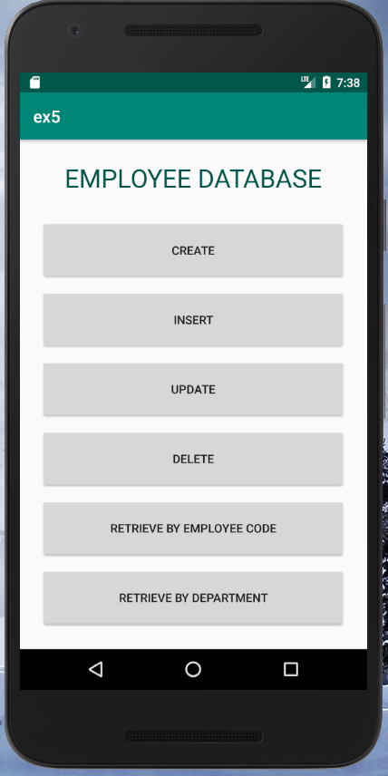 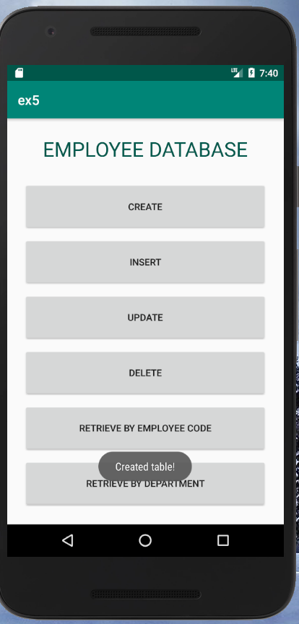

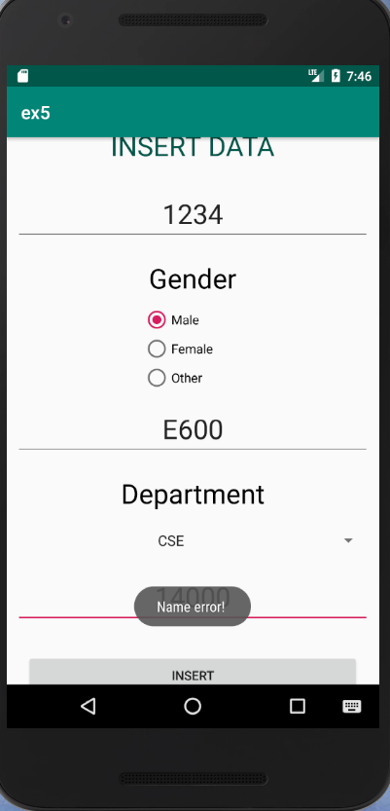 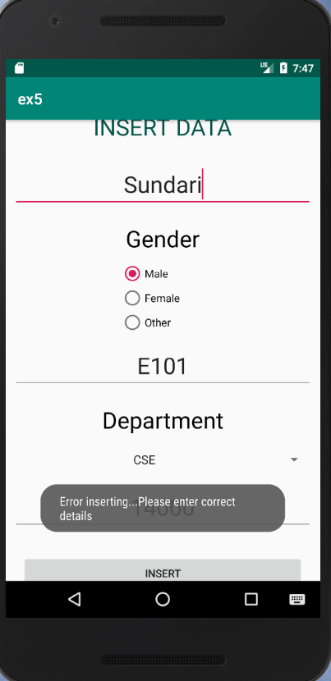 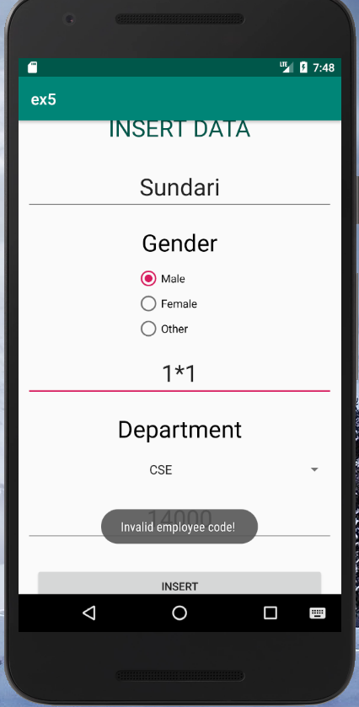

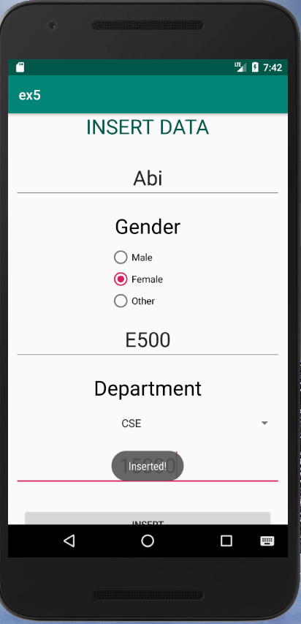 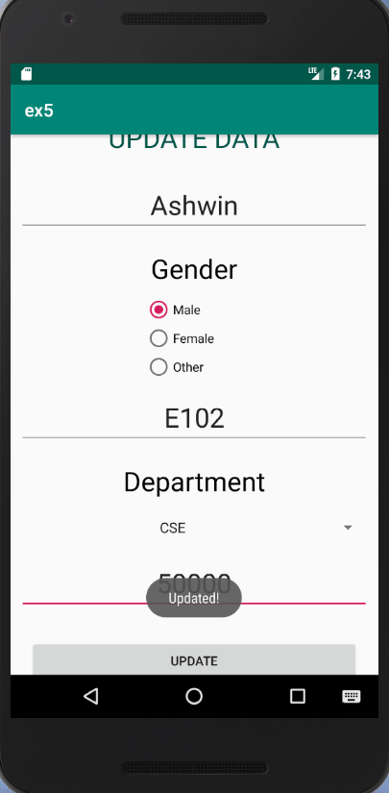

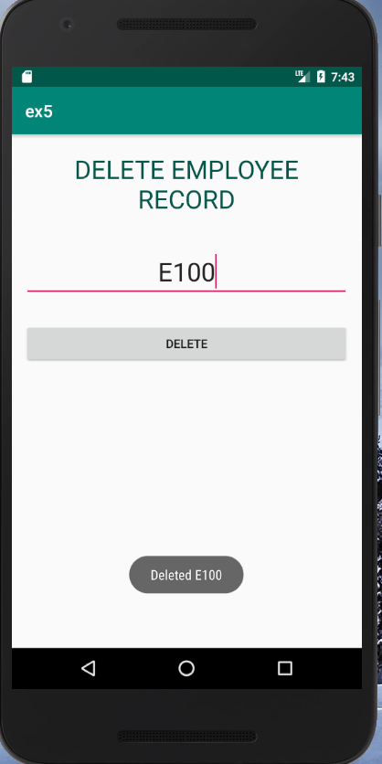 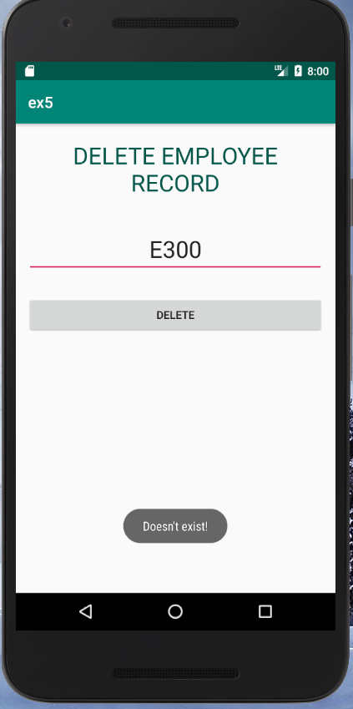

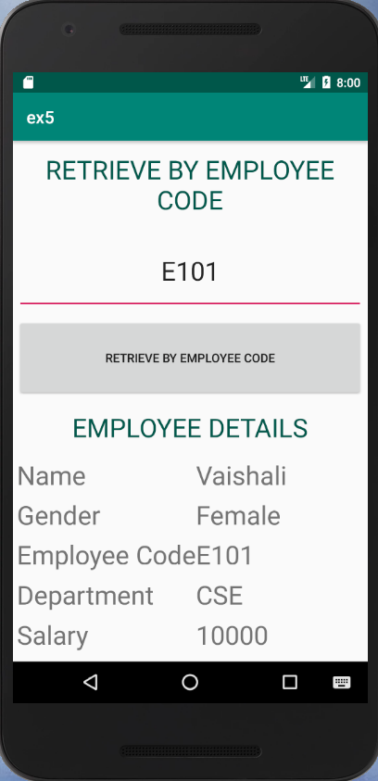 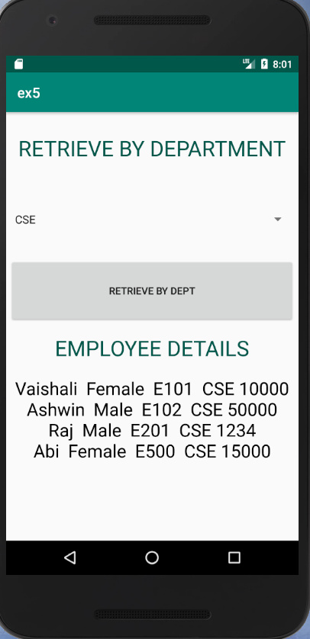 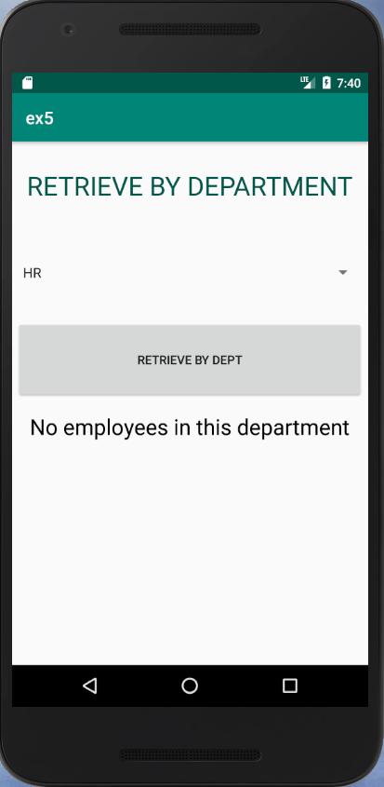

**activity_main.xml:**

*<?***xml version="1.0" encoding="utf-8"***?>* <**LinearLayout xmlns:android="http://schemas.android.com/apk/res/android"  
 xmlns:app="http://schemas.android.com/apk/res-auto"  
 xmlns:tools="http://schemas.android.com/tools"  
 android:layout_width="match_parent"  
 android:layout_height="match_parent"  
 android:layout_margin="10dp"  
 android:orientation="vertical"  
 tools:context=".MainActivity"**>  
  
 <**TextView  
 android:layout_width="wrap_content"  
 android:layout_height="wrap_content"  
 android:text="Enter your email-id"  
 android:textSize="30sp"  
 android:textColor="#000000"**/>  
  
 <**EditText  
 android:id="@+id/editText"  
 android:layout_width="match_parent"  
 android:layout_height="wrap_content"  
 android:singleLine="true"  
 android:textSize="30sp"** />  
  
 <**Button  
 android:id="@+id/button"  
 android:layout_width="wrap_content"  
 android:layout_height="wrap_content"  
 android:layout_margin="30dp"  
 android:layout_gravity="center"  
 android:text="Notify"  
 android:textSize="30sp"**/>  
  
  
 </**LinearLayout**>

**MainActivity.java:**

**package** com.example.ex6notif;  
  
**import** android.annotation.TargetApi;  
**import** android.app.NotificationChannel;  
**import** android.app.NotificationManager;  
**import** android.app.PendingIntent;  
**import** android.content.Context;  
**import** android.content.Intent;  
**import** android.os.Build;  
**import** android.os.Bundle;  
**import** android.view.View;  
**import** android.widget.Button;  
**import** android.widget.EditText;  
  
**import** androidx.appcompat.app.AppCompatActivity;  
**import** androidx.core.app.NotificationCompat;  
  
**import** java.util.Date;  
**import** java.util.Random;  
  
**public class** MainActivity **extends** AppCompatActivity {  
  
 Button **notify**;  
 EditText **e**;  
 String **channelId** = **"channelNotif"**;  
  
 @Override  
 @TargetApi(16)  
  
 **protected void** onCreate(Bundle savedInstanceState) {  
  
 **super**.onCreate(savedInstanceState);  
 setContentView(R.layout.***activity_main***);  
  
 **notify** = (Button) findViewById(R.id.***button***);  
 **e** = (EditText) findViewById(R.id.***editText***);  
  
 **notify**.setOnClickListener(**new** View.OnClickListener() {  
 @Override  
 **public void** onClick(View v) {  
  
 **int** m = (**int**) ((**new** Date().getTime() / 1000L) % Integer.***MAX_VALUE***);

m += **new** Random().nextInt(100) + 1; Intent intent = **new** Intent(MainActivity.**this**, SecondActivity.**class**);  
 intent.putExtra(**"msg"**, **e**.getText().toString());  
 PendingIntent pending = PendingIntent.*getActivity*(MainActivity.**this**, m, intent, 0);  
  
 NotificationCompat.Builder builder = **new** NotificationCompat.Builder(MainActivity.**this**, **channelId**);  
 builder.setSmallIcon(R.mipmap.***ic_launcher_round***);  
 builder.setContentTitle(**"Thanks for registering"**);  
 builder.setContentText(**"You've successfully registered. Tap for more...."**);  
 builder.setContentIntent(pending);  
 builder.setAutoCancel(**true**);  
 builder.setPriority(NotificationCompat.***PRIORITY_MAX***);NotificationManager manager = (NotificationManager) getSystemService(Context.***NOTIFICATION_SERVICE***);  
 **if** (Build.VERSION.***SDK_INT*** >= Build.VERSION_CODES.***O***) { NotificationChannel channel = **new** NotificationChannel(**channelId**, **"Notification channel"**, NotificationManager.***IMPORTANCE_HIGH***);  
 manager.createNotificationChannel(channel);  
 }  
 manager.notify(m, builder.build());  
  
 }  
 });  
 }  
}

**activity_second.xml:**

*<?***xml version="1.0" encoding="utf-8"***?>*<**LinearLayout xmlns:android="http://schemas.android.com/apk/res/android"  
 xmlns:app="http://schemas.android.com/apk/res-auto"  
 xmlns:tools="http://schemas.android.com/tools"  
 android:layout_width="match_parent"  
 android:layout_height="match_parent"  
 android:orientation="vertical"  
 tools:context=".SecondActivity"**>  
  
 <**TextView  
 android:layout_width="wrap_content"  
 android:layout_height="wrap_content"  
 android:text="DETAILS"  
 android:textSize="30sp"  
 android:textColor="@color/colorPrimaryDark"  
 android:layout_gravity="center"**/>  
  
 <**TextView  
 android:layout_width="wrap_content"  
 android:layout_height="wrap_content"  
 android:id="@+id/tv"  
 android:textSize="30sp"  
 android:layout_margin="10dp"  
 android:layout_gravity="center"**/>  
  
  
</**LinearLayout**>

**SecondActivity.java:**

**package** com.example.ex6notif;  
  
**import** androidx.appcompat.app.AppCompatActivity;  
  
**import** android.app.PendingIntent;  
**import** android.content.Intent;  
**import** android.os.Bundle;  
**import** android.widget.TextView;  
  
**public class** SecondActivity **extends** AppCompatActivity {  
  
 TextView **tv**;

**protected void** onPause() {  
 **super**.onPause();  
 finish();  
}

@Override  
 **protected void** onCreate(Bundle savedInstanceState) {  
 **super**.onCreate(savedInstanceState);  
 setContentView(R.layout.***activity_second***);  
  
 **tv**=findViewById(R.id.***tv***);  
  
 Intent myIntent = getIntent();  
 String str=myIntent.getStringExtra(**"msg"**);  
 **tv**.setText(**"Your email-id is:"**+str);  
 }  
}

**OUTPUT:**

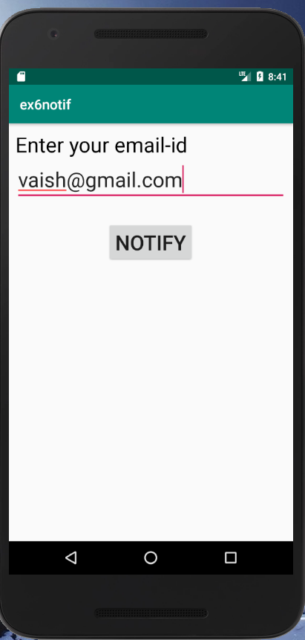 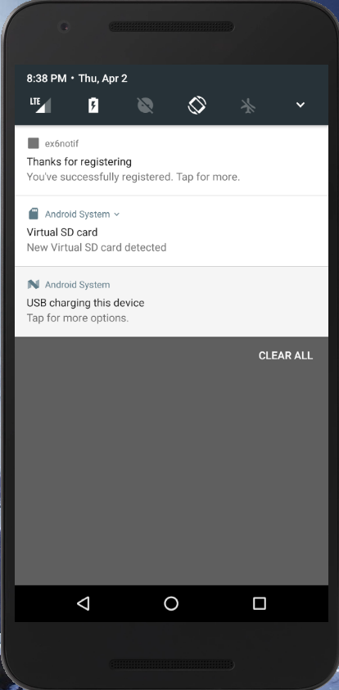 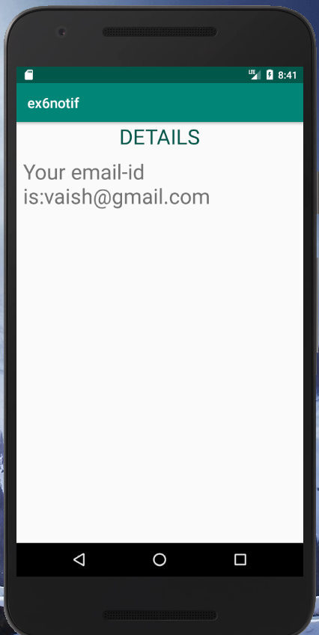

**activity_main.xml:**

*<?***xml version="1.0" encoding="utf-8"***?>*<**LinearLayout xmlns:android="http://schemas.android.com/apk/res/android"  
 xmlns:app="http://schemas.android.com/apk/res-auto"  
 xmlns:tools="http://schemas.android.com/tools"  
 android:layout_width="match_parent"  
 android:layout_height="match_parent"  
 android:orientation="vertical"  
 tools:context=".MainActivity"**>  
  
 <**TextView  
 android:id="@+id/textView"  
 android:layout_width="match_parent"  
 android:layout_height="wrap_content"  
 android:layout_margin="50px"  
 android:gravity="center"  
 android:text="Multithreading"  
 android:textColor="@android:color/black"  
 android:textSize="30sp"** />  
  
 <**TextView  
 android:id="@+id/tv2"  
 android:layout_width="match_parent"  
 android:layout_height="wrap_content"  
 android:gravity="center"  
 android:text="Press START to view!"** />  
  
 <**ProgressBar  
  
 android:id="@+id/pbar"  
 android:layout_width="match_parent"  
 android:layout_height="wrap_content"  
 android:layout_marginTop="10dp"  
 android:layout_marginLeft="50dp"  
 android:layout_marginRight="50dp"  
 style="@style/Widget.AppCompat.ProgressBar.Horizontal"** />  
  
 <**TextView  
 android:id="@+id/tv4"  
 android:layout_width="match_parent"  
 android:layout_height="wrap_content"  
 android:layout_marginBottom="20dp"  
 android:gravity="center"  
 android:textColor="@android:color/black"** />  
  
 <**Button  
 android:id="@+id/bt_start"  
 android:layout_width="wrap_content"  
 android:layout_height="wrap_content"  
 android:layout_gravity="center"  
 android:text="START"** />  
  
 <**TextView  
 android:id="@+id/textView3"  
 android:layout_width="match_parent"  
 android:layout_height="wrap_content"  
 android:layout_marginTop="50dp"  
 android:gravity="center"  
 android:text="Enter value and press SLEEP to view!"** />  
  
  
 <**EditText  
  
 android:id="@+id/et_time"  
 android:layout_width="match_parent"  
 android:layout_height="wrap_content"  
 android:layout_marginTop="10dp"  
 android:gravity="center"  
 android:hint="Enter duration (in secs)"  
 android:inputType="number"  
 android:backgroundTint="#000000"** />  
  
 <**Button  
  
 android:id="@+id/bt_sleep"  
 android:layout_width="wrap_content"  
 android:layout_height="wrap_content"  
 android:text="SLEEP"  
 android:layout_marginTop="20dp"  
 android:layout_gravity="center"**/>  
  
</**LinearLayout**>

**MainActivity.java:**

**package** com.example.multithread;  
  
**import** androidx.annotation.RequiresApi;  
**import** androidx.appcompat.app.AppCompatActivity;  
  
**import** android.annotation.TargetApi;  
**import** android.app.ProgressDialog;  
**import** android.content.res.ColorStateList;  
**import** android.graphics.Color;  
**import** android.os.Build;  
**import** android.os.Handler;  
**import** android.os.Bundle;  
**import** android.util.Log;  
**import** android.view.View;  
**import** android.widget.Button;  
**import** android.widget.EditText;  
**import** android.widget.ProgressBar;  
**import** android.widget.TextView;  
  
**public class** MainActivity **extends** AppCompatActivity {  
  
 ProgressBar **pbar**;  
 Handler **handler**;  
 TextView **tv4**;  
 Button **bt_sleep**, **bt_start**;  
 **int i**;  
 EditText **et_time**;  
  
 @Override  
 @TargetApi(21)  
 **protected void** onCreate(Bundle savedInstanceState) {  
 **super**.onCreate(savedInstanceState);  
 setContentView(R.layout.***activity_main***);  
  
 **bt_sleep** = findViewById(R.id.***bt_sleep***);  
 **bt_start** = findViewById(R.id.***bt_start***);  
 **pbar** = findViewById(R.id.***pbar***);  
 **tv4**=findViewById(R.id.***tv4***);  
 **et_time** = findViewById(R.id.***et_time***);  
  
 **handler** = **new** Handler();  
 **pbar**.setProgress(0);  
  
 **bt_sleep**.setOnClickListener(**new** View.OnClickListener() {  
 @Override  
 **public void** onClick(View v) {  
 **final int** count = Integer.*parseInt*(**et_time**.getText().toString());  
 **final** ProgressDialog pd = **new** ProgressDialog(MainActivity.**this**);  
 *//pd.setTitle("Sleep in Progress");  
 //pd.setMessage("Sleep in Progress");* pd.show();  
 */*handler.postDelayed(new Runnable() {  
 @Override  
 public void run() {  
 pd.dismiss();  
 }  
 }, count * 1000);*/* **new** Thread(**new** Runnable() {  
 @Override  
 **public void** run() {  
 **i**=0;  
 **while**(**i**<=count){  
 **handler**.post(**new** Runnable() {  
 @Override  
 **public void** run() {  
 pd.setMessage(**"Sleeping now for "** +(**i**)+**" seconds..."**);  
 **i**++;  
 }  
 });  
 **try** {  
 Thread.*sleep*(1000);  
 } **catch** (Exception e) {  
 e.printStackTrace();  
 }  
 }  
 pd.dismiss();  
 }  
 }).start();  
 }  
 });  
  
  
 **bt_start**.setOnClickListener(**new** View.OnClickListener() {  
 @Override  
 @RequiresApi(29)  
 **public void** onClick(View v) {  
 **pbar**.setProgressTintList(ColorStateList.*valueOf*(Color.***RED***));  
 **new** Thread(**new** Runnable() {  
 @Override  
 **public void** run() {  
 **i**=0;  
 **while**(**i**<=100){  
 **if** (**i** == 100) {  
 **pbar**.post(**new** Runnable() {  
 @Override  
 **public void** run() {  
 **pbar**.setProgressTintList(ColorStateList.*valueOf*(Color.***GREEN***));  
 }  
 });  
 }  
 **pbar**.setProgress(**i**);  
 **pbar**.post(**new** Runnable() {  
 @Override  
 **public void** run() {  
 **tv4**.setText(String.*valueOf*(**i**) + **"%"**);  
 **i**++;  
 }  
 });  
 **try** {  
 Thread.*sleep*(100);  
 } **catch** (Exception e) {  
 e.printStackTrace();  
 }  
 }  
 }  
 }).start();  
 }  
 });  
 }  
}

**OUTPUT:**

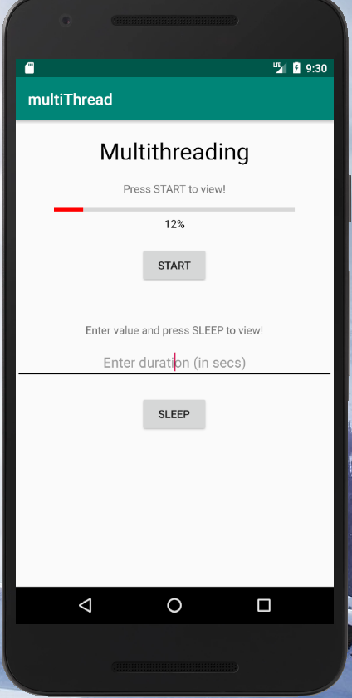 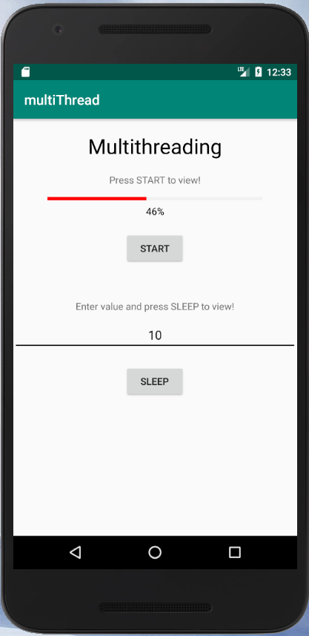 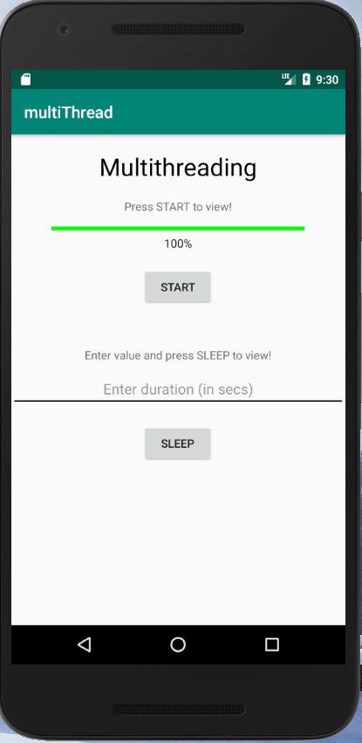

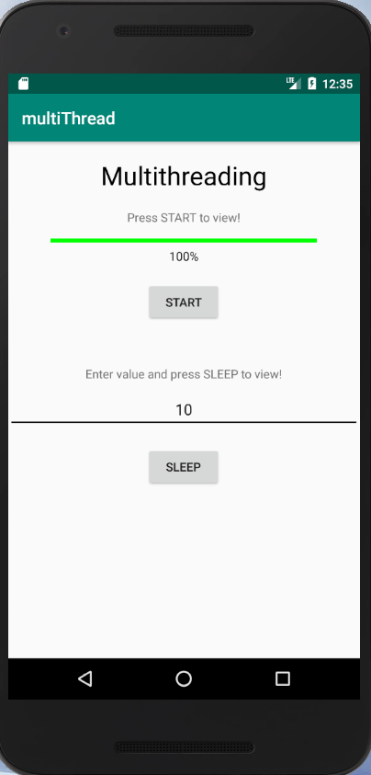 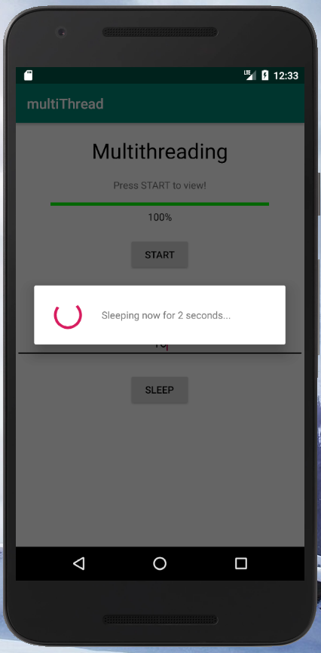 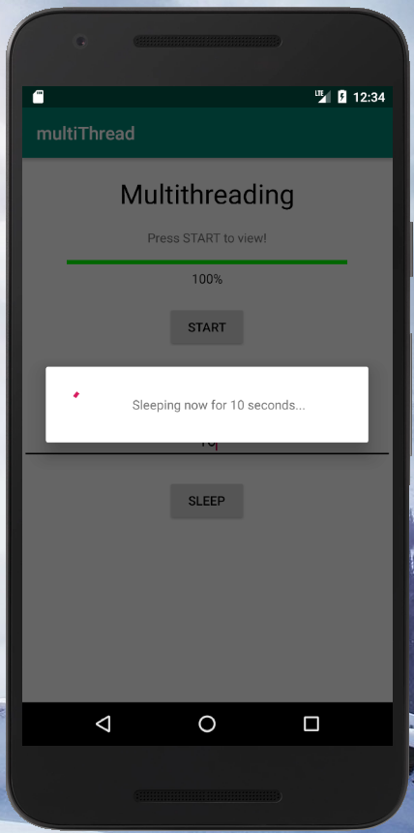

**activity_main.xml:**

*<?***xml version="1.0" encoding="utf-8"***?>*<**LinearLayout xmlns:android="http://schemas.android.com/apk/res/android"  
 xmlns:app="http://schemas.android.com/apk/res-auto"  
 xmlns:tools="http://schemas.android.com/tools"  
 android:layout_width="match_parent"  
 android:layout_height="match_parent"  
 android:orientation="vertical"  
 tools:context=".MainActivity"**>  
  
 <**TextView  
 android:layout_width="match_parent"  
 android:layout_height="wrap_content"  
 android:text="ALARM CLOCK"  
 android:textAllCaps="true"  
 android:textSize="36sp"  
 android:textColor="#000000"  
 android:gravity="center"**/>  
  
 <**EditText  
 android:id="@+id/et_time"  
 android:layout_width="match_parent"  
 android:layout_height="wrap_content"  
 android:hint="Click to select time"  
 android:layout_margin="5dp"**/>  
   
 <**Button  
 android:layout_width="wrap_content"  
 android:layout_height="wrap_content"  
 android:text="SET ALARM"  
 android:id="@+id/bt_set"**/>  
  
 <**Button  
 android:layout_width="wrap_content"  
 android:layout_height="wrap_content"  
 android:text="STOP ALARM"  
 android:id="@+id/bt_stop"**/>  
  
</**LinearLayout**>

**MainActivity.java:**

**package** com.example.alarmtrial;  
  
**import** androidx.annotation.RequiresApi;  
**import** androidx.appcompat.app.AppCompatActivity;  
  
**import** android.app.AlarmManager;  
**import** android.app.PendingIntent;  
**import** android.app.TimePickerDialog;  
**import** android.content.Intent;  
**import** android.os.Bundle;  
**import** android.util.Log;  
**import** android.view.View;  
**import** android.widget.Button;  
**import** android.widget.EditText;  
**import** android.widget.TimePicker;  
**import** android.widget.Toast;  
  
**import** java.util.Calendar;  
**import** java.util.Date;  
  
**public class** MainActivity **extends** AppCompatActivity {  
  
 Calendar **calObj**,**current**;  
 EditText **et_time**;  
 Button **bt_set**,**bt_stop**;  
 AlarmManager **alarmManager**;  
 PendingIntent **pending**;  
  
 @Override  
 **protected void** onCreate(Bundle savedInstanceState) {  
 **super**.onCreate(savedInstanceState);  
 setContentView(R.layout.***activity_main***);  
  
 **et_time**=findViewById(R.id.***et_time***);  
 **bt_set**=findViewById(R.id.***bt_set***);  
 **bt_stop**=findViewById(R.id.***bt_stop***);  
  
 **calObj** =Calendar.*getInstance*();  
  
 **bt_stop**.setOnClickListener(**new** View.OnClickListener() {  
 @Override  
 **public void** onClick(View v) {  
 **alarmManager**.cancel(**pending**);  
 **et_time**.setText(**""**);  
 **if**(alarmReceiver.*ringtone*!=**null**)  
 alarmReceiver.*ringtone*.stop();  
 }  
 });  
  
 **bt_set**.setOnClickListener(**new** View.OnClickListener() {  
 @Override  
 @RequiresApi(19)  
 **public void** onClick(View v) {  
  
 **if**(!**et_time**.getText().toString().equals(**""**))  
 {  
 *//Log.i("TIME", " val1: "+calObj.compareTo(Calendar.getInstance()));  
 //Log.i("TIME","set: "+calObj.getTime()+" cur: "+Calendar.getInstance().getTime());* **if** (**calObj**.compareTo(Calendar.*getInstance*()) <= 0)  
 Toast.*makeText*(getApplicationContext(), **"Invalid Time !!!"**, Toast.***LENGTH_LONG***).show();  
 **else** {  
 **alarmManager** = (AlarmManager) getSystemService(***ALARM_SERVICE***);  
 Intent myIntent = **new** Intent(MainActivity.**this**, alarmReceiver.**class**);  
 **pending** = PendingIntent.*getBroadcast*(MainActivity.**this**, 0, myIntent, 0);  
 **alarmManager**.setExact(AlarmManager.***RTC_WAKEUP***, **calObj**.getTimeInMillis(), **pending**);  
 **double** time=**calObj**.getTimeInMillis()-Calendar.*getInstance*().getTimeInMillis();  
 time=Math.*ceil*(time/(60*1000));  
 Toast.*makeText*(MainActivity.**this**, **"Alarm set for "**+(**int**)time+**" minutes from now!"**,  
 Toast.***LENGTH_LONG***).show();  
 }  
 }  
 **else** Toast.*makeText*(MainActivity.**this**, **"Please select the time"**,Toast.***LENGTH_LONG***).show();  
 }  
 });  
  
 **et_time**.setOnClickListener(**new** View.OnClickListener() {  
 @Override  
 **public void** onClick(View v) {  
  
 TimePickerDialog timePickerDialog = **new** TimePickerDialog(MainActivity.**this**,  
 **new** TimePickerDialog.OnTimeSetListener() {  
 @Override  
 **public void** onTimeSet(TimePicker view, **int** hourOfDay, **int** minute) {  
  
 **et_time**.setText(Integer.*toString*(hourOfDay) + **":"** + Integer.*toString*(minute));  
  
 **calObj**.set(Calendar.***HOUR_OF_DAY***, hourOfDay);  
 **calObj**.set(Calendar.***MINUTE***, minute);  
 **calObj**.set(Calendar.***SECOND***,0);  
  
 }  
 }, Calendar.*getInstance*().get(Calendar.***HOUR_OF_DAY***), Calendar.*getInstance*().get(Calendar.***MINUTE***), **false**);  
 timePickerDialog.show();  
 }  
 });  
 }  
}

**alarmReceiver.java**

**package** com.example.alarmtrial;  
  
**import** android.app.NotificationManager;  
**import** android.app.PendingIntent;  
  
**import** android.content.BroadcastReceiver;  
**import** android.content.Context;  
**import** android.content.Intent;  
**import** android.media.Ringtone;  
**import** android.media.RingtoneManager;  
**import** android.net.Uri;  
**import** java.util.Calendar;  
**import** androidx.annotation.RequiresApi;  
**import** androidx.core.app.NotificationCompat;  
  
**public class** alarmReceiver **extends** BroadcastReceiver {  
  
 Uri **uri**;  
 **static** Ringtone *ringtone*;  
  
 @RequiresApi(16)  
 **public void** onReceive(Context context, Intent intent) {  
  
 **uri** = RingtoneManager.*getDefaultUri*(RingtoneManager.***TYPE_ALARM***);  
 *ringtone* = RingtoneManager.*getRingtone*(context, **uri**);  
 *ringtone*.play();  
  
 Intent i1 = **new** Intent(context, MainActivity.**class**);  
 *// i1.setFlags(Intent.FLAG_ACTIVITY_REORDER_TO_FRONT);* PendingIntent pd = PendingIntent.*getActivity*(context, 0, i1, PendingIntent.***FLAG_UPDATE_CURRENT***);  
 NotificationCompat.Builder builder = **new** NotificationCompat.Builder(context);  
 builder.setSmallIcon(R.mipmap.***ic_launcher_round***);  
 builder.setContentIntent(pd);  
 builder.setContentTitle(**"Alarm"**);  
 builder.setContentText(**"Wake up!!It's "** +Calendar.*getInstance*().get(Calendar.***HOUR_OF_DAY***)+**":"**+Calendar.*getInstance*().get(Calendar.***MINUTE***));  
 builder.setAutoCancel(**true**);  
  
 NotificationManager manager = (NotificationManager) context.getSystemService(Context.***NOTIFICATION_SERVICE***);  
 manager.notify(1, builder.build());  
 }  
}

**AndroidManifest.xml:**

*<?***xml version="1.0" encoding="utf-8"***?>*<**manifest xmlns:android="http://schemas.android.com/apk/res/android"  
 package="com.example.alarmtrial"**>  
  
 <**application  
 android:allowBackup="true"  
 android:icon="@mipmap/ic_launcher"  
 android:label="@string/app_name"  
 android:roundIcon="@mipmap/ic_launcher_round"  
 android:supportsRtl="true"  
 android:theme="@style/AppTheme"**>  
 <**activity android:name=".MainActivity" android:launchMode="singleInstance"**>  
 <**intent-filter**>  
 <**action android:name="android.intent.action.MAIN"** />  
  
 <**category android:name="android.intent.category.LAUNCHER"** />  
 </**intent-filter**>  
 </**activity**>  
  
 <**receiver android:name=".alarmReceiver"** />  
 </**application**>  
  
</**manifest**>

**OUTPUT:**

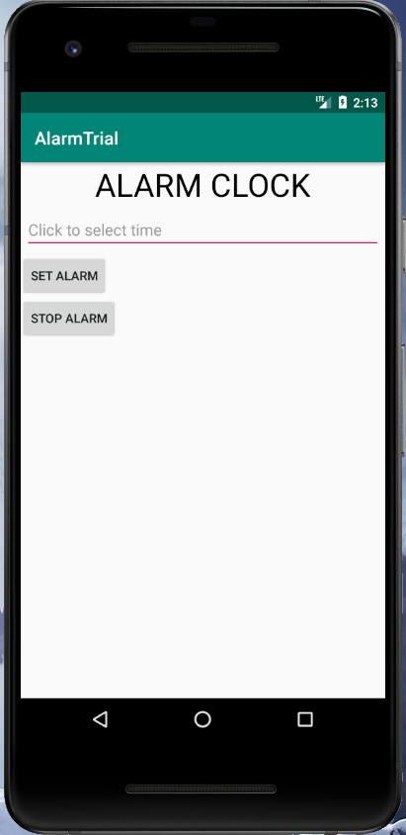 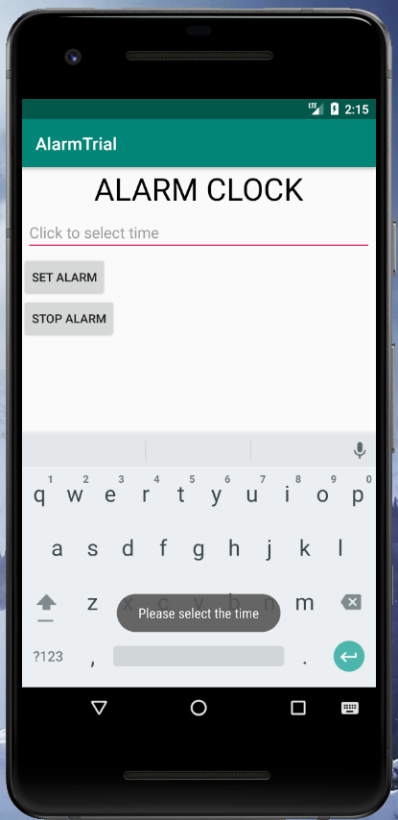

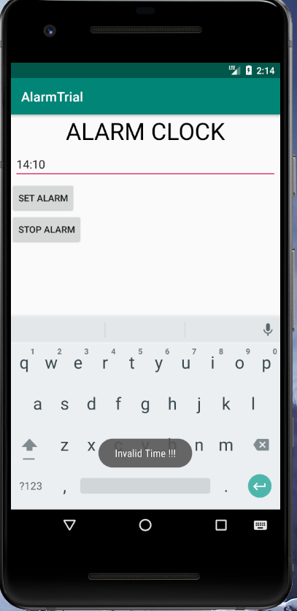 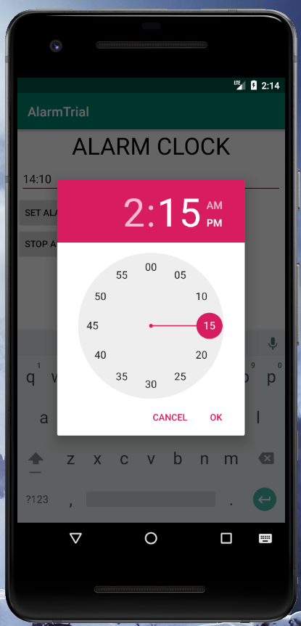

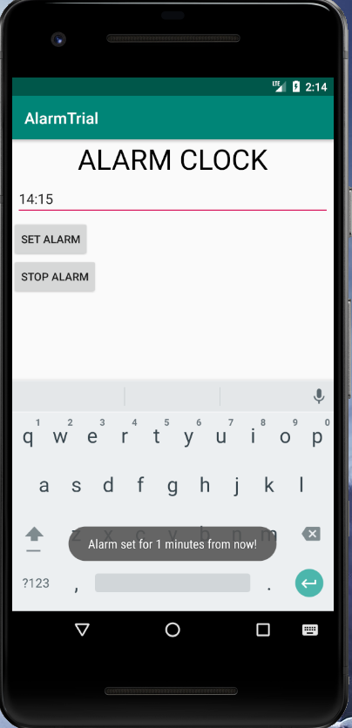 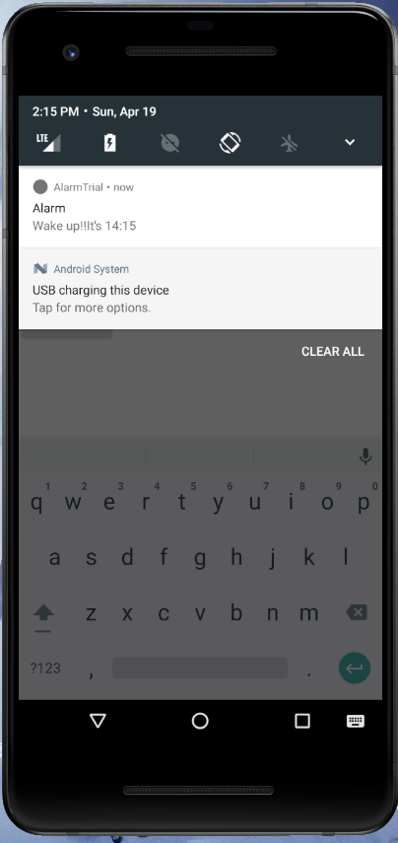

**activity_main.xml:**

*<?*xml version="1.0" encoding="utf-8"*?>*<LinearLayout xmlns:android="http://schemas.android.com/apk/res/android"  
 xmlns:app="http://schemas.android.com/apk/res-auto"  
 xmlns:tools="http://schemas.android.com/tools"  
 android:layout_width="match_parent"  
 android:layout_height="match_parent"  
 android:layout_margin="10dp"  
 android:orientation="vertical"  
 tools:context=".MainActivity">  
  
 <RelativeLayout  
 android:id="@+id/container"  
 android:layout_width="match_parent"  
 android:layout_height="wrap_content">  
  
 <TextView  
 android:id="@+id/title1"  
 android:layout_width="match_parent"  
 android:layout_height="wrap_content"  
 android:textSize="25sp"  
 android:textStyle="bold"  
 android:text="CURRENT COORDINATES"  
 android:gravity="center"/>  
  
 <TextView  
 android:id="@+id/tv_lat"  
 android:layout_below="@+id/title1"  
 android:layout_width="wrap_content"  
 android:layout_height="wrap_content"  
 android:layout_margin="10pt"  
 android:textSize="25sp"  
 android:text="Latitude:" />  
  
 <TextView  
 android:id="@+id/tv_latVal"  
 android:layout_width="wrap_content"  
 android:layout_height="wrap_content"  
 android:layout_below="@+id/title1"  
 android:layout_margin="10pt"  
 android:layout_toRightOf="@id/tv_lat"  
 android:text="00.00"  
 android:textSize="25sp"  
 android:textStyle="bold" />  
  
 <TextView  
 android:id="@+id/tv_long"  
 android:layout_below="@+id/tv_lat"  
 android:layout_width="wrap_content"  
 android:layout_height="wrap_content"  
 android:layout_marginBottom="10pt"  
 android:layout_marginLeft="10pt"  
 android:layout_marginRight="10pt"  
 android:textSize="25sp"  
 android:text="Longitude:" />  
  
 <TextView  
 android:id="@+id/tv_longVal"  
 android:layout_below="@+id/tv_latVal"  
 android:layout_toRightOf="@id/tv_long"  
 android:layout_width="wrap_content"  
 android:layout_height="wrap_content"  
 android:layout_marginBottom="10pt"  
 android:layout_marginLeft="10pt"  
 android:layout_marginRight="10pt"  
 android:text="00.00"  
 android:textSize="25sp"  
 android:textStyle="bold" />  
  
 <Button  
 android:id="@+id/getCurrent"  
 android:layout_width="wrap_content"  
 android:layout_height="wrap_content"  
 android:layout_below="@id/tv_long"  
 android:layout_marginBottom="10pt"  
 android:layout_marginLeft="10pt"  
 android:layout_marginRight="10pt"  
 android:text="Get Current coordinates"  
 android:layout_centerHorizontal="true"/>  
  
 </RelativeLayout>  
  
 <RelativeLayout  
 android:layout_width="match_parent"  
 android:layout_height="wrap_content">  
  
 <TextView  
 android:id="@+id/title2"  
 android:layout_width="match_parent"  
 android:layout_height="wrap_content"  
 android:textSize="25sp"  
 android:textStyle="bold"  
 android:text="COORDINATES OF A PLACE"  
 android:gravity="center"/>  
  
 <EditText  
 android:id="@+id/addressText"  
 android:layout_below="@+id/title2"  
 android:layout_width="match_parent"  
 android:layout_height="wrap_content"  
 android:layout_marginBottom="10pt"  
 android:layout_marginLeft="10pt"  
 android:layout_marginRight="10pt"  
 android:textSize="25sp"  
 android:hint="Enter location" />  
  
 <Button  
 android:id="@+id/getCoordinates"  
 android:layout_width="wrap_content"  
 android:layout_height="wrap_content"  
 android:layout_below="@id/addressText"  
 android:layout_marginBottom="10pt"  
 android:layout_centerHorizontal="true"  
 android:text="Get Coordinates" />  
  
 <TextView  
 android:id="@+id/tv_lat1"  
 android:layout_below="@+id/getCoordinates"  
 android:layout_width="wrap_content"  
 android:layout_height="wrap_content"  
 android:layout_marginBottom="10pt"  
 android:layout_marginLeft="10pt"  
 android:layout_marginRight="10pt"  
 android:textSize="25sp"  
 android:text="Latitude:" />  
  
 <TextView  
 android:id="@+id/tv_latVal1"  
 android:layout_below="@+id/getCoordinates"  
 android:layout_toRightOf="@id/tv_lat1"  
 android:layout_width="wrap_content"  
 android:layout_height="wrap_content"  
 android:layout_marginBottom="10pt"  
 android:layout_marginLeft="10pt"  
 android:layout_marginRight="10pt"  
 android:text="00.00"  
 android:textSize="25sp"  
 android:textStyle="bold" />  
  
 <TextView  
 android:id="@+id/tv_long1"  
 android:layout_below="@+id/tv_lat1"  
 android:layout_width="wrap_content"  
 android:layout_height="wrap_content"  
 android:layout_marginBottom="10pt"  
 android:layout_marginLeft="10pt"  
 android:layout_marginRight="10pt"  
 android:textSize="25sp"  
 android:text="Longitude:" />  
  
 <TextView  
 android:id="@+id/tv_longVal1"  
 android:layout_below="@+id/tv_latVal1"  
 android:layout_toRightOf="@id/tv_long1"  
 android:layout_width="wrap_content"  
 android:layout_height="wrap_content"  
 android:layout_marginBottom="10pt"  
 android:layout_marginLeft="10pt"  
 android:layout_marginRight="10pt"  
 android:text="00.00"  
 android:textSize="25sp"  
 android:textStyle="bold" />  
  
 </RelativeLayout>  
  
</LinearLayout>

**MainActivity.java:**

package com.example.gps;  
  
import androidx.appcompat.app.AppCompatActivity;  
import androidx.core.app.ActivityCompat;  
  
import android.Manifest;  
import android.location.Address;  
import android.location.Geocoder;  
import android.location.Location;  
import android.os.Bundle;  
import android.util.Log;  
import android.view.View;  
import android.widget.Button;  
import android.widget.EditText;  
import android.widget.TextView;  
import android.widget.Toast;  
  
import java.io.IOException;  
import java.util.ArrayList;  
  
public class MainActivity extends AppCompatActivity {  
  
 Button getCurrent,getCoordinates;  
 TextView latView,longView,lat2,long2;  
 EditText addressText;  
  
 @Override  
 protected void onCreate(Bundle savedInstanceState) {  
 super.onCreate(savedInstanceState);  
 setContentView(R.layout.activity_main);  
  
 getCurrent=findViewById(R.id.getCurrent);  
 latView=findViewById(R.id.tv_latVal);  
 longView=findViewById(R.id.tv_longVal);  
  
 getCoordinates=findViewById(R.id.getCoordinates);  
 addressText=findViewById(R.id.addressText);  
 lat2=findViewById(R.id.tv_latVal1);  
 long2=findViewById(R.id.tv_longVal1);  
  
 ActivityCompat.requestPermissions(MainActivity.this, new String[] {Manifest.permission.ACCESS_FINE_LOCATION}, 123);  
  
 getCurrent.setOnClickListener(new View.OnClickListener() {  
 @Override  
 public void onClick(View v) {  
  
 GPSTracker tracker=new GPSTracker(getApplicationContext());  
 Location l=tracker.getLocation();  
  
 if(l != null) {  
 Double lng = (double) Math.round(l.getLongitude() * 100) / 100;  
 Double lat = (double) Math.round(l.getLatitude() * 100) / 100;  
 latView.setText(lat.toString());  
 longView.setText(lng.toString());  
 }  
 else  
 {  
 latView.setText("00.00");  
 longView.setText("00.00");  
 }  
 }  
 });  
  
 getCoordinates.setOnClickListener(new View.OnClickListener() {  
 @Override  
 public void onClick(View v) {  
 Geocoder coder = new Geocoder(getApplicationContext());  
 ArrayList<Address> addresses = null;  
 try {  
 String address = addressText.getText().toString();  
 addresses = (ArrayList<Address>) coder.getFromLocationName(address, 1);  
 for(Address add: addresses){  
 Double lng = (double) Math.round(add.getLongitude() * 100) / 100;  
 Double lat = (double) Math.round(add.getLatitude() * 100) / 100;  
 lat2.setText(lat.toString());  
 long2.setText(lng.toString());  
 }  
 }  
 catch (IOException e) {  
 Toast.makeText(getApplicationContext(),"Can't get coordinates!\nNetwork problem",Toast.LENGTH_LONG);  
 }  
 }  
 });  
 }  
}

**GPSTracker.java:**

package com.example.gps;  
  
import android.Manifest;  
import android.content.Context;  
import android.content.pm.PackageManager;  
import android.location.Location;  
import android.location.LocationListener;  
import android.location.LocationManager;  
import android.os.Bundle;  
import android.util.Log;  
import android.widget.Toast;  
  
import androidx.core.content.ContextCompat;  
  
import static android.content.Context.*LOCATION_SERVICE*;  
  
public class GPSTracker implements LocationListener {  
  
 Context context;  
  
 public GPSTracker(Context context) {  
 this.context = context;  
 }  
  
 public Location getLocation(){  
 if (ContextCompat.*checkSelfPermission*( context, Manifest.permission.*ACCESS_FINE_LOCATION* ) != PackageManager.*PERMISSION_GRANTED*) {  
 Toast.*makeText*(context,"Location Permission not granted",Toast.*LENGTH_LONG*).show();  
 return null;  
 }  
  
 LocationManager lm = (LocationManager) context.getSystemService(*LOCATION_SERVICE*);  
 boolean isGPSEnabled = lm.isProviderEnabled(LocationManager.*GPS_PROVIDER*);  
 if(!isGPSEnabled){  
 Toast.*makeText*(context,"GPS not enabled!!!\nPlease enable it",Toast.*LENGTH_LONG*).show();  
 return null;  
 }  
  
 lm.requestLocationUpdates(LocationManager.*GPS_PROVIDER*, 5000,10,this);  
 Location loc = lm.getLastKnownLocation(LocationManager.*GPS_PROVIDER*);  
 return loc;  
 }  
  
 @Override  
 public void onLocationChanged(Location location) {  
 }  
  
 @Override  
 public void onStatusChanged(String provider, int status, Bundle extras) {  
 }  
  
 @Override  
 public void onProviderEnabled(String provider) {  
 }  
  
 @Override  
 public void onProviderDisabled(String provider) {  
 }  
}

**AndroidManifest.xml:**

*<?*xml version="1.0" encoding="utf-8"*?>*<manifest xmlns:android="http://schemas.android.com/apk/res/android"  
 package="com.example.gps">  
 <uses-permission android:name="android.permission.ACCESS_FINE_LOCATION" />  
 <application  
 android:allowBackup="true"  
 android:icon="@mipmap/ic_launcher"  
 android:label="@string/app_name"  
 android:roundIcon="@mipmap/ic_launcher_round"  
 android:supportsRtl="true"  
 android:theme="@style/AppTheme">  
 <activity android:name=".MainActivity">  
 <intent-filter>  
 <action android:name="android.intent.action.MAIN" />  
  
 <category android:name="android.intent.category.LAUNCHER" />  
 </intent-filter>  
 </activity>  
 </application>  
  
</**manifest**>

**OUTPUT:**

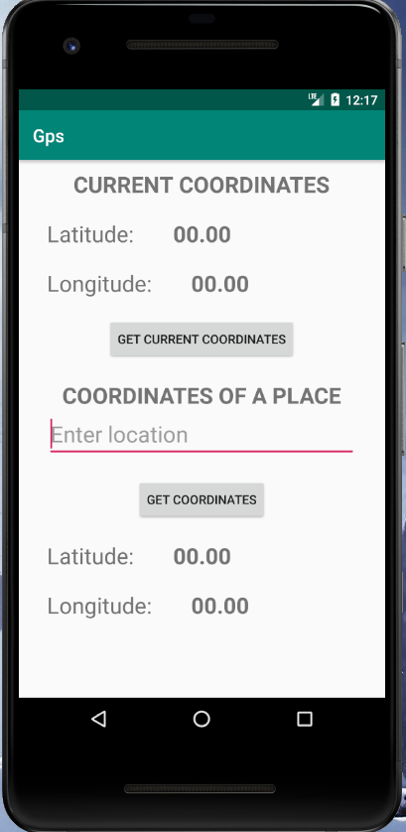 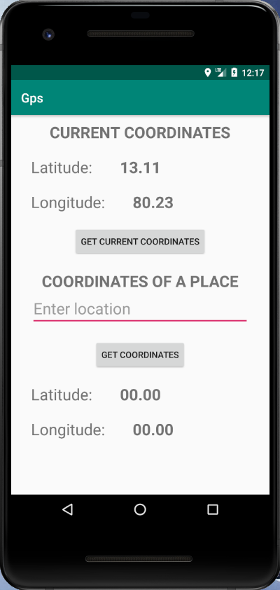 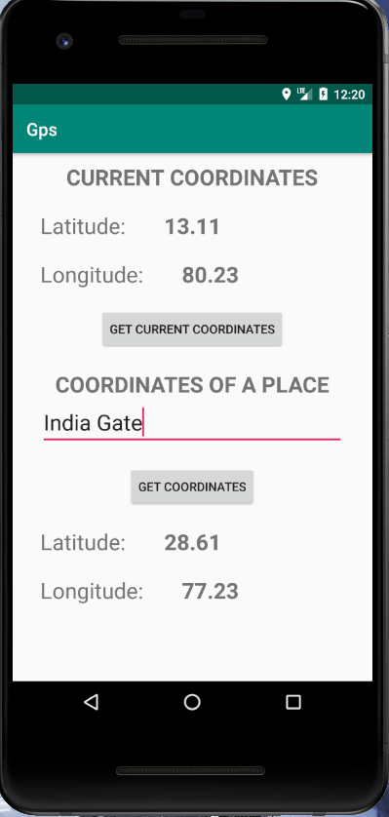

**activity_main.xml:**

*<?***xml version="1.0" encoding="utf-8"***?>*<**LinearLayout xmlns:android="http://schemas.android.com/apk/res/android"  
 xmlns:tools="http://schemas.android.com/tools"  
 android:layout_width="match_parent"  
 android:layout_height="match_parent"  
 android:layout_margin="10dp"  
 android:orientation="vertical"  
 tools:context=".MainActivity"**>  
  
 <**TextView  
 android:layout_width="fill_parent"  
 android:layout_height="wrap_content"  
 android:layout_margin="5dp"  
 android:text="Reading and Writing to External Storage"  
 android:textAlignment="center"  
 android:textAllCaps="true"  
 android:textSize="24sp"** />  
  
 <**EditText  
 android:id="@+id/et_name"  
 android:layout_width="match_parent"  
 android:layout_height="wrap_content"  
 android:layout_margin="5dp"  
 android:hint="Enter the file name"  
 android:textSize="20sp"**>  
 <**requestFocus** />  
 </**EditText**>  
  
 <**EditText  
 android:id="@+id/et_content"  
 android:layout_width="match_parent"  
 android:layout_height="wrap_content"  
 android:layout_margin="5dp"  
 android:hint="Enter content"  
 android:inputType="textMultiLine"  
 android:textSize="20sp"** />  
  
 <**LinearLayout  
 android:layout_width="match_parent"  
 android:layout_height="wrap_content"  
 android:orientation="horizontal"**>  
  
 <**Button  
 android:id="@+id/bt_read"  
 android:layout_width="0dp"  
 android:layout_height="wrap_content"  
 android:layout_margin="5dp"  
 android:layout_weight="1"  
 android:text="READ"** />  
  
 <**Button  
 android:id="@+id/bt_write"  
 android:layout_width="0dp"  
 android:layout_height="wrap_content"  
 android:layout_margin="5dp"  
 android:layout_weight="1"  
 android:text="WRITE"** />  
  
 </**LinearLayout**>  
  
 <**TextView  
 android:id="@+id/tv_info"  
 android:layout_width="match_parent"  
 android:layout_height="wrap_content"  
 android:layout_margin="10dp"  
 android:textSize="30sp"**/>  
  
</**LinearLayout**>

**MainActivity.java:**

**package** com.example.ex9_sdcard;  
  
**package** com.example.ex9_sdcard;  
  
**import** androidx.appcompat.app.AppCompatActivity;  
**import** androidx.core.app.ActivityCompat;  
**import** androidx.core.content.ContextCompat;  
  
**import** android.annotation.TargetApi;  
**import** android.os.Build;  
**import** android.os.Bundle;  
**import** android.os.Environment;  
**import** android.view.View;  
**import** android.widget.Button;  
**import** android.widget.EditText;  
**import** android.widget.TextView;  
**import** android.widget.Toast;  
  
**import** java.io.BufferedReader;  
**import** java.io.File;  
**import** java.io.FileOutputStream;  
**import** java.io.FileReader;

**public class** MainActivity **extends** AppCompatActivity **implements** ActivityCompat.OnRequestPermissionsResultCallback {  
 EditText **et_content**,**et_name**;  
 Button **bt_write**,**bt_read**;  
 TextView **tv_info**;  
 String **fileName**,**content**;  
 File **myFile**;  
  
 @Override  
 **protected void** onCreate(Bundle savedInstanceState) {  
 **super**.onCreate(savedInstanceState);  
 setContentView(R.layout.***activity_main***);  
  
 **tv_info**=findViewById(R.id.***tv_info***);  
 **et_name**=findViewById(R.id.***et_name***);  
 **et_content**=findViewById(R.id.***et_content***);  
  
 **bt_write**=findViewById(R.id.***bt_write***);  
 **bt_read**=findViewById(R.id.***bt_read***);  
  
 **if** (!isExternalStorageMounted()) {  
 **bt_read**.setEnabled(**false**);  
 **bt_write**.setEnabled(**false**);  
 **tv_info**.setText(**"External Strorage not mounted"**);  
 } **else if** (isExternalStorageReadOnly()) {  
 **bt_write**.setEnabled(**false**);  
 **tv_info**.setText(**"External Strorage is read-only! Can't write data to SD Card"**);  
 }  
 **bt_write**.setOnClickListener(**new** View.OnClickListener() {  
 @Override  
 @TargetApi(21)  
 **public void** onClick(View v) {  
 **fileName**=**et_name**.getText().toString().trim();  
 **content**=**et_content**.getText().toString().trim();  
 **tv_info**.setText(**""**);  
 **if**(**fileName**.equals(**""**))  
 {  
 Toast.*makeText*(MainActivity.**this**, **"Please enter file name"**, Toast.***LENGTH_SHORT***).show();  
 **return**;  
 }  
 **try** {

File[] farr = ContextCompat.*getExternalFilesDirs*(getApplicationContext(), **null**);  
 **if**(Build.VERSION.***SDK_INT***<=Build.VERSION_CODES.***KITKAT_WATCH***) {  
 **myFile** = **new** File(farr[0], **fileName**);  
 }  
 **else** {  
 **for**(File file:farr)  
 **if**(Environment.*isExternalStorageRemovable*(file)) {  
 **myFile** = **new** File(file, **fileName**);  
 **break**;  
 }  
 } FileOutputStream fos = **new** FileOutputStream(**myFile**);  
 fos.write(**content**.getBytes());  
 fos.close();  
 Toast.*makeText*(MainActivity.**this**, **"File "**+**fileName**+**" written to SD card"**, Toast.***LENGTH_LONG***).show();  
 } **catch** (Exception e) {  
 Toast.*makeText*(MainActivity.**this**, **"Error writing "**+**fileName**+**" to SD card"**, Toast.***LENGTH_LONG***).show();  
 }  
 **finally** {  
 **et_name**.setText(**""**);  
 **et_content**.setText(**""**);  
 }  
 }  
 });  
  
 **bt_read**.setOnClickListener(**new** View.OnClickListener() {  
 @Override  
 @TargetApi(21)  
 **public void** onClick(View v) {  
 **tv_info**.setText(**""**);  
 **et_content**.setText(**""**);  
 **fileName**=**et_name**.getText().toString().trim();  
 **if**(**fileName**.equals(**""**))  
 {  
 Toast.*makeText*(MainActivity.**this**, **"Please enter file name"**, Toast.***LENGTH_LONG***).show();  
 **return**;  
 }  
  
 **try** {  
 File[] farr = ContextCompat.*getExternalFilesDirs*(getApplicationContext(), **null**);  
 **if**(Build.VERSION.***SDK_INT***<=Build.VERSION_CODES.***KITKAT_WATCH***) { *//api 18* **myFile** = **new** File(farr[0], **fileName**);  
 }  
 **else** {  
 **for**(File file:farr)  
 **if**(Environment.*isExternalStorageRemovable*(file)) {  
 **myFile** = **new** File(file, **fileName**);  
 **break**;  
 }  
 }  
 BufferedReader br = **new** BufferedReader(**new** FileReader(**myFile**));  
 String input, text = **""**;  
 **while** ((input = br.readLine()) != **null**)  
 text = text+input+**"\n"**;  
 br.close();  
  
 **tv_info**.setText(**"Content read from file "**+**fileName**+**": \n"**+text);  
Toast.*makeText*(MainActivity.**this**, **"File "**+**fileName**+**" read"**, Toast.***LENGTH_LONG***).show();  
  
 }**catch** (Exception e){  
 Toast.*makeText*(MainActivity.**this**, **"Error reading "**+**fileName**+**" from SD card: No such file"**, Toast.***LENGTH_LONG***).show();  
 }  
 }  
 });  
 }  
  
  
 **private boolean** isExternalStorageMounted() {  
 **return** (Environment.*getExternalStorageState*().equals(Environment.***MEDIA_MOUNTED***) ) ||  
 (Environment.*getExternalStorageState*().equals(Environment.***MEDIA_MOUNTED_READ_ONLY*** ));  
 }  
  
 **private boolean** isExternalStorageReadOnly() {  
 **return** Environment.*getExternalStorageState*().equals(Environment.***MEDIA_MOUNTED_READ_ONLY***);  
 }  
  
}

**AndroidManifest.xml:**

*<?***xml version="1.0" encoding="utf-8"***?>*<**manifest xmlns:android="http://schemas.android.com/apk/res/android"  
 package="com.example.ex9_sdcard"**>  
  
 <**uses-permission  
 android:name="android.permission.WRITE_EXTERNAL_STORAGE"  
 android:maxSdkVersion="18"**/><**application  
 android:allowBackup="true"  
 android:icon="@mipmap/ic_launcher"  
 android:label="@string/app_name"  
 android:roundIcon="@mipmap/ic_launcher_round"  
 android:supportsRtl="true"  
 android:theme="@style/AppTheme"**>  
 <**activity android:name=".MainActivity"**>  
 <**intent-filter**>  
 <**action android:name="android.intent.action.MAIN"** />  
  
 <**category android:name="android.intent.category.LAUNCHER"** />  
 </**intent-filter**>  
 </**activity**>  
 </**application**>  
  
</**manifest**>

**OUTPUT:**

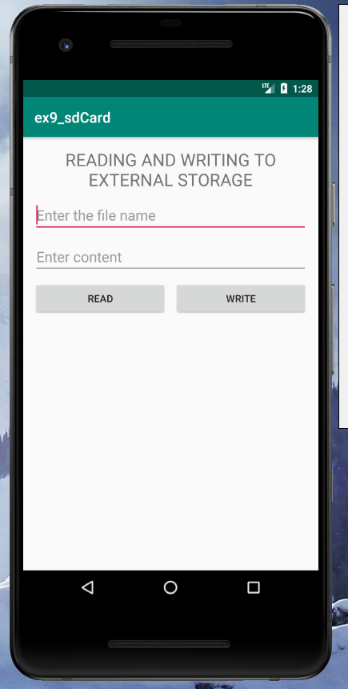 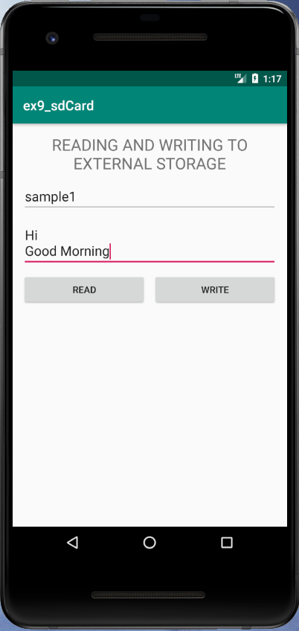

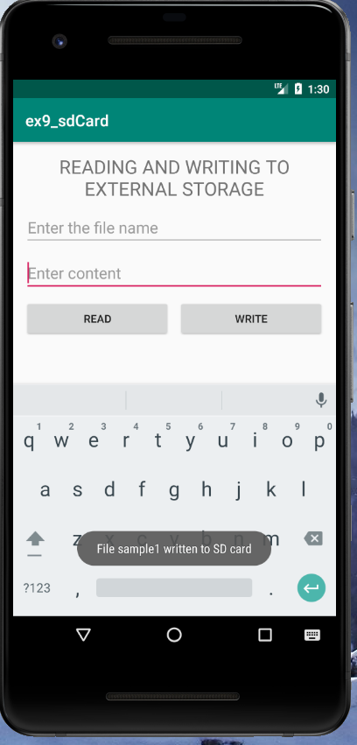 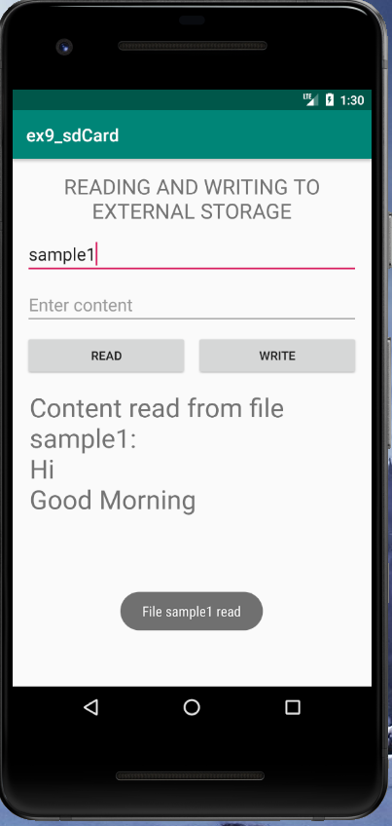

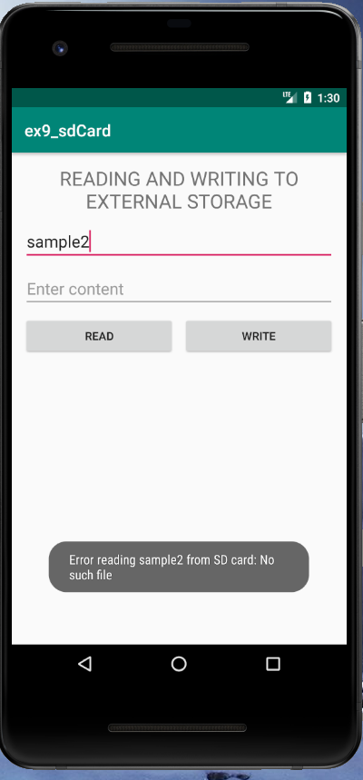

**activity_main.xml:**

*<?*xml version="1.0" encoding="utf-8"*?>*<LinearLayout xmlns:android="http://schemas.android.com/apk/res/android"  
 xmlns:app="http://schemas.android.com/apk/res-auto"  
 xmlns:tools="http://schemas.android.com/tools"  
 android:layout_width="match_parent"  
 android:layout_height="match_parent"  
 android:orientation="vertical"  
 android:layout_margin="10dp"  
 tools:context=".MainActivity">  
  
 <TextView  
 android:layout_width="match_parent"  
 android:layout_height="wrap_content"  
 android:text="SMS APP"  
 android:textSize="30sp"  
 android:gravity="center"  
 android:textStyle="bold"  
 android:layout_margin="20dp"/>  
  
 <Button  
 android:id="@+id/bt_send"  
 android:layout_width="wrap_content"  
 android:layout_height="wrap_content"  
 android:layout_margin="10dp"  
 android:text="SEND SMS"  
 android:layout_gravity="center"  
 android:onClick="launchSend"/>  
  
 <Button  
 android:id="@+id/bt_view"  
 android:layout_width="wrap_content"  
 android:layout_height="wrap_content"  
 android:layout_margin="10dp"  
 android:text="VIEW RECEIVED SMS"  
 android:layout_gravity="center"  
 android:onClick="launchInbox"/>  
  
 <TextView  
 android:id="@+id/tv_err"  
 android:layout_width="wrap_content"  
 android:layout_height="wrap_content"  
 android:layout_gravity="center"  
 android:layout_margin="25dp"/>  
</LinearLayout>

**activity_compose.xml:**

*<?*xml version="1.0" encoding="utf-8"*?>*<LinearLayout xmlns:android="http://schemas.android.com/apk/res/android"  
 xmlns:app="http://schemas.android.com/apk/res-auto"  
 xmlns:tools="http://schemas.android.com/tools"  
 android:layout_width="match_parent"  
 android:layout_height="match_parent"  
 android:orientation="vertical"  
 android:layout_margin="20dp"  
 tools:context=".MainActivity">  
  
 <TextView  
 android:layout_width="wrap_content"  
 android:layout_height="wrap_content"  
 android:text="SEND SMS"  
 android:textSize="30sp"  
 android:textStyle="bold"  
 android:layout_gravity="center"  
 android:layout_margin="10dp"/>  
  
 <EditText  
 android:id="@+id/et_ph"  
 android:layout_width="match_parent"  
 android:layout_height="wrap_content"  
 android:layout_margin="10dp"  
 android:textSize="20sp"  
 android:hint="Please enter the phone number"  
 android:inputType="phone" />  
  
 <EditText  
 android:id="@+id/et_msg"  
 android:layout_width="match_parent"  
 android:layout_height="wrap_content"  
 android:layout_margin="10dp"  
 android:textSize="20sp"  
 android:hint="Enter the message"  
 android:inputType="textMultiLine" />  
  
 <Button  
 android:id="@+id/bt_send"  
 android:layout_width="match_parent"  
 android:layout_height="wrap_content"  
 android:layout_marginTop="100px"  
 android:text="Send" />  
  
 </LinearLayout>

**activity_inbox.xml:**

*<?*xml version="1.0" encoding="utf-8"*?>*<LinearLayout xmlns:android="http://schemas.android.com/apk/res/android"  
 xmlns:app="http://schemas.android.com/apk/res-auto"  
 xmlns:tools="http://schemas.android.com/tools"  
 android:layout_width="match_parent"  
 android:layout_height="match_parent"  
 android:orientation="vertical"  
 tools:context=".InboxActivity">  
  
 <ScrollView  
 android:layout_width="match_parent"  
 android:layout_height="match_parent"  
 android:fillViewport="true">  
  
 <LinearLayout  
 android:layout_width="match_parent"  
 android:layout_height="wrap_content"  
 android:orientation="vertical">  
  
 <TextView  
 android:id="@+id/msgs"  
 android:layout_width="match_parent"  
 android:layout_height="wrap_content"  
 android:layout_margin="50px" />  
  
 </LinearLayout>  
  
 </ScrollView>  
</LinearLayout>

**MainActivty.java**

package com.example.ex10_smsalert;  
  
import android.Manifest;  
import android.content.Intent;  
import android.content.pm.PackageManager;  
import android.os.Bundle;  
import android.view.View;  
import android.widget.Button;  
import android.widget.TextView;  
  
import androidx.appcompat.app.AppCompatActivity;  
import androidx.core.app.ActivityCompat;  
  
public class MainActivity extends AppCompatActivity {  
  
 Button bt_send, bt_view;  
 TextView tv_err;  
  
 @Override  
 protected void onCreate(Bundle savedInstanceState) {  
 super.onCreate(savedInstanceState);  
 setContentView(R.layout.*activity_main*);  
  
 bt_send = findViewById(R.id.*bt_send*);  
 bt_view = findViewById(R.id.*bt_view*);  
 tv_err = findViewById(R.id.*tv_err*);  
  
 ActivityCompat.*requestPermissions*(MainActivity.this, new String[]{Manifest.permission.*SEND_SMS*, Manifest.permission.*READ_SMS*, Manifest.permission.*RECEIVE_SMS*}, 101);  
 }  
  
 @Override  
 public void onRequestPermissionsResult(int requestCode, String[] permissions, int[] grantResults) {  
 String info_text = "";  
 switch (requestCode) {  
 case 101: {  
 if (grantResults.length > 0) {  
 if (grantResults[0] == PackageManager.*PERMISSION_DENIED*) {  
 bt_send.setEnabled(false);  
 info_text = "Permission required to send sms\n";  
 }  
 if (grantResults[1] == PackageManager.*PERMISSION_DENIED*) {  
 bt_view.setEnabled(false);  
 info_text += "Permission required to read sms\n";  
 }  
 if (grantResults[2] == PackageManager.*PERMISSION_DENIED*) {  
 bt_view.setEnabled(false);  
 info_text += "Permission required to receive sms\n";  
 }  
 if (!info_text.equals(""))  
 info_text += "Please provide the required permissions!!\n";  
 tv_err.setText(info_text);  
 }  
 }  
 }  
 }  
  
 public void launchSend(View view) {  
 Intent intent = new Intent(MainActivity.this, ComposeActivity.class);  
 startActivity(intent);  
 }  
  
 public void launchInbox(View view) {  
 Intent intent = new Intent(MainActivity.this, InboxActivity.class);  
 intent.putExtra("from", "main");  
 startActivity(intent);  
 }  
}

**ComposeActivty.java:**

package com.example.ex10_smsalert;  
  
import android.os.Bundle;  
import android.telephony.SmsManager;  
import android.util.Log;  
import android.view.View;  
import android.widget.Button;  
import android.widget.EditText;  
import android.widget.Toast;  
  
import androidx.appcompat.app.AppCompatActivity;  
  
public class ComposeActivity extends AppCompatActivity {  
  
 public static boolean *active* = false;  
 Button bt_send;  
 EditText et_ph, et_msg;  
  
 protected void onStart() {  
 super.onStart();  
 *active* = true; *//active in background* }  
  
 @Override  
 protected void onDestroy() {  
 super.onDestroy();  
 *active* = false;  
 }  
  
 @Override  
 protected void onCreate(Bundle savedInstanceState) {  
 super.onCreate(savedInstanceState);  
 setContentView(R.layout.*activity_compose*);  
  
 bt_send = findViewById(R.id.*bt_send*);  
 et_ph = findViewById(R.id.*et_ph*);  
 et_msg = findViewById(R.id.*et_msg*);  
  
 bt_send.setOnClickListener(new View.OnClickListener() {  
 @Override  
 public void onClick(View view) {  
 SmsManager smsManager = SmsManager.*getDefault*();  
 *//smsManager.sendTextMessage(destinationAddress, scAddress, smsMessage,sentIntent, deliveryIntent);* smsManager.sendTextMessage(et_ph.getText().toString(), null, et_msg.getText().toString(), null, null);  
 Toast.*makeText*(getApplicationContext(), "Message Sent!", Toast.*LENGTH_SHORT*).show();  
 }  
 });  
 }  
}

**InboxActivity.java:**

package com.example.ex10_smsalert;  
  
import android.content.ContentResolver;  
import android.content.Intent;  
import android.database.Cursor;  
import android.net.Uri;  
import android.os.Bundle;  
import android.widget.TextView;  
  
import androidx.appcompat.app.AppCompatActivity;  
  
public class InboxActivity extends AppCompatActivity {  
  
 public static boolean *active* = false;  
 public static InboxActivity *inst*;  
 TextView msgs;  
  
 public static InboxActivity instance() {  
 return *inst*;  
 }  
  
 @Override  
 protected void onStart() {  
 super.onStart();  
 *active* = true;  
 *inst* = this;  
 }  
  
 @Override  
 protected void onStop() {  
 super.onStop();  
 *active* = false;  
 *inst* = null;  
 }  
  
 public void onBackPressed() {  
 Intent myIntent = getIntent();  
 String str = myIntent.getStringExtra("from");  
 if (str != null && str.equals("receiver")) {  
 if (ComposeActivity.*active*) {  
 finish();  
 this.startActivity(new Intent(InboxActivity.this, ComposeActivity.class));  
 } else {  
 finish();  
 this.startActivity(new Intent(InboxActivity.this, MainActivity.class));  
 }  
 } else  
 super.onBackPressed();  
 }  
  
 @Override  
 protected void onCreate(Bundle savedInstanceState) {  
 super.onCreate(savedInstanceState);  
 *//setContentView(R.layout.activity_inbox);  
 inst* = this;  
 refreshInbox();  
 }  
  
 void refreshInbox() {  
 this.runOnUiThread(new Runnable() {  
 @Override  
 public void run() {  
 setContentView(R.layout.*activity_inbox*);  
 msgs = findViewById(R.id.*msgs*);  
 String msg = "";  
 ContentResolver cr = getContentResolver();  
 Cursor i = cr.query(Uri.*parse*("content://sms/inbox"), new String[]{"address", "body"}, null, null, null);  
 if (!i.moveToFirst()) {  
 return;  
 } else {  
 do {  
 msg = msg + "From: " + i.getString(i.getColumnIndex("address")) + "\nMessage: " + i.getString(i.getColumnIndex("body")) + "\n\n";  
 } while (i.moveToNext());  
 msgs.setText(msg);  
 }  
 }  
 });  
 }  
}

**Receiver.java:**

package com.example.ex10_smsalert;  
  
import android.app.NotificationChannel;  
import android.app.NotificationManager;  
import android.app.PendingIntent;  
import android.content.BroadcastReceiver;  
import android.content.Context;  
import android.content.Intent;  
import android.os.Build;  
import android.os.Bundle;  
import android.provider.Telephony;  
import android.telephony.SmsMessage;  
import android.util.Log;  
  
import androidx.core.app.NotificationCompat;  
import androidx.core.app.Person;  
  
import java.util.Date;  
import java.util.Random;  
  
public class Receiver extends BroadcastReceiver {  
 String channelId = "channelAlarm";  
 SmsMessage smsMessage;  
  
 @Override  
  
 public void onReceive(Context context, Intent intent) {  
  
 String no = null, msg = null;  
 long time = 0;  
 Person p = new Person.Builder().setKey("123").setName("You").build(); *//receiver* Person sender = null;  
 Bundle b;  
  
 if (Build.VERSION.*SDK_INT* >= Build.VERSION_CODES.*KITKAT*) { *//KITKAT* SmsMessage[] msgs = Telephony.Sms.Intents.*getMessagesFromIntent*(intent);  
 smsMessage = msgs[0];  
 }  
 else { *//intent has extras: "pdus" - An Object[] of byte[]s containing the PDUs that make up the message.* b = intent.getExtras();  
 if (b != null) {  
 Object pdus[] = (Object[]) b.get("pdus");  
 smsMessage = SmsMessage.*createFromPdu*((byte[]) pdus[0]);  
  
 }  
 else  
 return;  
 }  
  
 no =smsMessage.getOriginatingAddress();  
 msg = smsMessage.getMessageBody();  
 time = smsMessage.getTimestampMillis();  
 *//sm.getUserData();* sender = new Person.Builder().setKey(no).setName(no).build();  
  
 if(InboxActivity.*active*) {  
 try {  
 Thread.*sleep*(1000);  
 } catch (InterruptedException e) {  
 e.printStackTrace();  
 }  
 InboxActivity.*instance*().refreshInbox();  
 }  
 sendNotification(context, p, msg, sender, time);  
 }  
  
 public void sendNotification(Context context,Person p, String msg, Person sender,long time) {  
  
 int m = (int) ((new Date().getTime() / 1000L) % Integer.*MAX_VALUE*); *//1000L -L denotes long //System.currentTimeMillis()%10000 can also be done  
 //The above line only works with diff seconds. So if you have multiple notifications at the same second, this will not work.* m += new Random().nextInt(100) + 1; *//hence add this line* Intent i1 = new Intent(context,InboxActivity.class); *//* i1.putExtra("from","receiver");  
 PendingIntent pd = PendingIntent.*getActivity*(context, m, i1, 0); *//* NotificationCompat.Builder builder = new NotificationCompat.Builder(context, channelId);  
 builder.setSmallIcon(R.mipmap.*ic_launcher_round*);  
 *//builder.setContentTitle("Message!!"); //from name // title and text will be ignored if style is messaging  
 //builder.setContentText("FROM: " + no + "\n" + msg); //subject \n won't work to display multi line text in notif use big style* builder.setContentIntent(pd);  
 builder.setAutoCancel(true);  
 builder.setStyle(new NotificationCompat.MessagingStyle(p).addMessage(msg, time, sender));  
 *//builder.setStyle(new NotificationCompat.BigTextStyle().bigText("Much longer text that cannot fit one line..."));* builder.setPriority(NotificationCompat.*PRIORITY_MAX*);  
  
 NotificationManager manager = (NotificationManager) context.getSystemService(Context.*NOTIFICATION_SERVICE*);  
  
 if (Build.VERSION.*SDK_INT* >= Build.VERSION_CODES.*O*) { *// Create the NotificationChannel, but only on API 26+ because  
 // the NotificationChannel class is new and not in the support library* NotificationChannel channel = new NotificationChannel(channelId, "Notification channel", NotificationManager.*IMPORTANCE_HIGH*);  
 manager.createNotificationChannel(channel);  
 *//setChannelid* }  
 manager.notify(m, builder.build()); *//NotificationCompat.Builder.build() returns a Notification* }  
  
}

**OUTPUT**

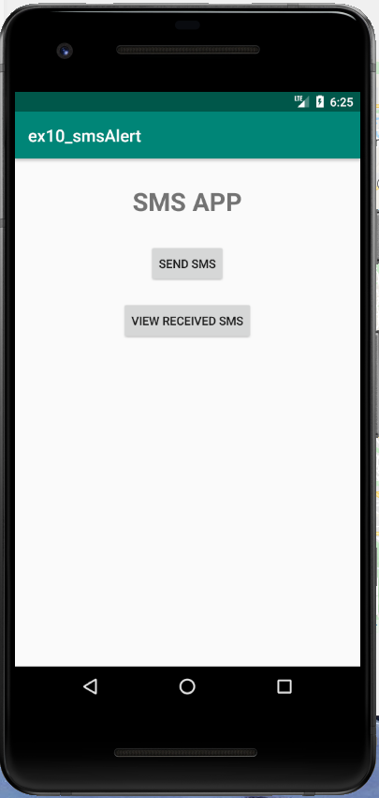 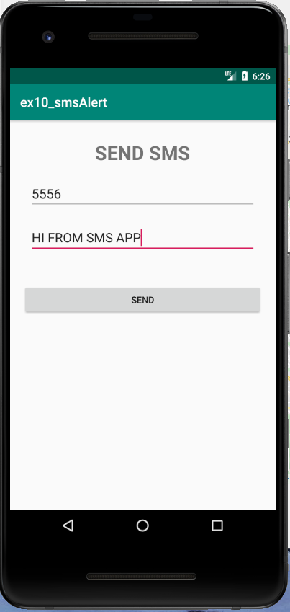

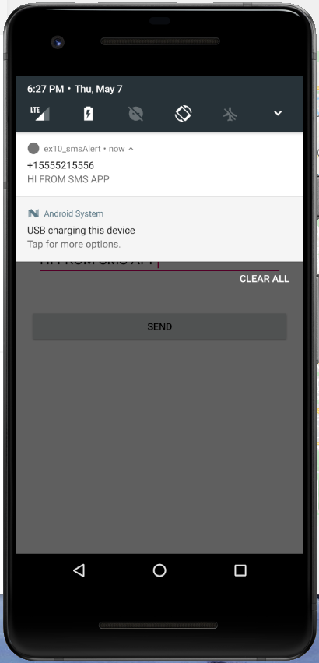 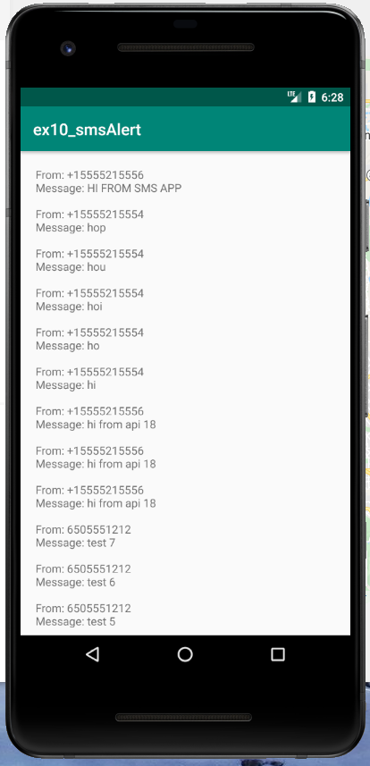

**activity_main.xml**

*<?*xml version="1.0" encoding="utf-8"*?>*<LinearLayout xmlns:android="http://schemas.android.com/apk/res/android"  
 xmlns:tools="http://schemas.android.com/tools"  
 android:layout_width="match_parent"  
 android:layout_height="match_parent"  
 android:layout_margin="20dp"  
 android:orientation="vertical"  
 tools:context=".MainActivity">  
  
 <TextView  
 android:layout_width="match_parent"  
 android:layout_height="wrap_content"  
 android:layout_margin="10dp"  
 android:gravity="center"  
 android:text="RSS Reader"  
 android:textColor="#000000"  
 android:textSize="30sp" />  
  
 <TextView  
 android:layout_width="match_parent"  
 android:layout_height="wrap_content"  
 android:layout_margin="10dp"  
 android:gravity="center"  
 android:text="Please enter the URL else default URL will be used"  
 android:textColor="#000000"  
 android:textSize="25sp"  
 android:textStyle="italic" />  
  
 <EditText  
 android:id="@+id/et_url"  
 android:layout_width="match_parent"  
 android:layout_height="wrap_content"  
 android:layout_margin="10dp"  
 android:hint="URL"  
 android:inputType="textMultiLine"  
 android:textSize="25sp" />  
  
 <Button  
 android:id="@+id/bt_fetch"  
 android:layout_width="match_parent"  
 android:layout_height="wrap_content"  
 android:layout_margin="10dp"  
 android:text="Fetch" />  
  
 <TextView  
 android:id="@+id/textview"  
 android:layout_width="match_parent"  
 android:layout_height="wrap_content"  
 android:layout_margin="20dp"  
 android:gravity="center" />  
  
</LinearLayout>

**activity_second.xml**

*<?*xml version="1.0" encoding="utf-8"*?>*<LinearLayout xmlns:android="http://schemas.android.com/apk/res/android"  
 xmlns:tools="http://schemas.android.com/tools"  
 android:id="@+id/relativeLayout"  
 android:layout_width="match_parent"  
 android:layout_height="match_parent"  
 android:layout_margin="20dp"  
 android:orientation="vertical"  
 tools:context=".SecondActivity">  
  
 <ListView  
 android:id="@+id/lv"  
 android:layout_width="match_parent"  
 android:layout_height="match_parent"  
 android:divider="#000000"  
 android:dividerHeight="1dp" />  
  
</LinearLayout>

**MainActivity.java**

package com.example.final_ex6;  
  
import android.app.Activity;  
import android.content.Context;  
import android.content.Intent;  
import android.net.ConnectivityManager;  
import android.net.NetworkInfo;  
import android.os.Bundle;  
import android.view.View;  
import android.widget.Button;  
import android.widget.EditText;  
import android.widget.TextView;  
import android.widget.Toast;  
  
import java.util.ArrayList;  
  
  
public class MainActivity extends Activity {  
 TextView tv;  
 EditText et_url;  
 Button bt_fetch;  
 String finalUrl = "https://www.thehindu.com/news/national/feeder/default.rss";  
 *//String finalUrl = "https://tutorialspoint.com/android/sampleXML.xml";* HandleXML obj;  
  
 @Override  
 protected void onCreate(Bundle savedInstanceState) {  
 super.onCreate(savedInstanceState);  
 setContentView(R.layout.*activity_main*);  
  
 tv = (TextView) findViewById(R.id.*textview*);  
 et_url = (EditText) findViewById(R.id.*et_url*);  
 bt_fetch = (Button) findViewById(R.id.*bt_fetch*);  
  
 *//Internet permission is a normal one not dangerous hence will be granted automatically during install time* bt_fetch.setOnClickListener(new View.OnClickListener() {  
 @Override  
 public void onClick(View v) {  
 if (!haveNetworkConnection()) {  
 Toast.*makeText*(MainActivity.this, "Internet connection not available\nPlease connect to internet!!", Toast.*LENGTH_LONG*).show();  
 return;  
 }  
 if (!et_url.getText().toString().equals(""))  
 finalUrl = et_url.getText().toString();  
 obj = new HandleXML(finalUrl, MainActivity.this);  
 obj.fetchXML();  
 while (!obj.parsingComplete) ;  
 ArrayList<RssItem> list = obj.getList();  
 Intent myIntent = new Intent(MainActivity.this, SecondActivity.class);  
 myIntent.putExtra("feed", list);  
 startActivity(myIntent);  
 }  
 });  
 }  
  
 private boolean haveNetworkConnection() {  
 boolean haveConnectedWifi = false;  
 boolean haveConnectedMobile = false;  
  
 ConnectivityManager cm = (ConnectivityManager) getSystemService(Context.*CONNECTIVITY_SERVICE*);  
 NetworkInfo[] netInfo = cm.getAllNetworkInfo();  
 for (NetworkInfo ni : netInfo) {  
 if (ni.getTypeName().equalsIgnoreCase("WIFI"))  
 if (ni.isConnected())  
 haveConnectedWifi = true;  
 if (ni.getTypeName().equalsIgnoreCase("MOBILE"))  
 if (ni.isConnected())  
 haveConnectedMobile = true;  
 }  
 return haveConnectedWifi || haveConnectedMobile;  
 }  
}

**SecondActivity.java**

package com.example.final_ex6;  
  
import android.content.Intent;  
import android.os.Bundle;  
import android.widget.ArrayAdapter;  
import android.widget.ListView;  
  
import androidx.appcompat.app.AppCompatActivity;  
  
import java.util.ArrayList;  
  
public class SecondActivity extends AppCompatActivity {  
  
 ArrayList<RssItem> list;  
 ListView lv;  
  
 @Override  
 protected void onCreate(Bundle savedInstanceState) {  
 super.onCreate(savedInstanceState);  
 setContentView(R.layout.*activity_second*);  
  
 lv = findViewById(R.id.*lv*);  
  
 Intent i1 = getIntent();  
 list = (ArrayList<RssItem>) i1.getSerializableExtra("feed");  
  
 ArrayAdapter adapter = new ArrayAdapter<RssItem>(this, R.layout.*list_view*, list);  
 lv.setAdapter(adapter);  
  
  
 }  
}

**HandleXML.java**

package com.example.final_ex6;  
  
import android.content.Context;  
  
import org.xmlpull.v1.XmlPullParser;  
import org.xmlpull.v1.XmlPullParserException;  
import org.xmlpull.v1.XmlPullParserFactory;  
  
import java.io.IOException;  
import java.net.HttpURLConnection;  
import java.net.MalformedURLException;  
import java.net.SocketTimeoutException;  
import java.net.URL;  
import java.util.ArrayList;  
  
public class HandleXML {  
 public volatile boolean parsingComplete = false;  
 Context context;  
 ArrayList<RssItem> list = new ArrayList<RssItem>();  
 private String urlString = null;  
  
 public HandleXML(String url, Context context) {  
 this.urlString = url;  
 this.context = context;  
 }  
  
 public ArrayList<RssItem> getList() {  
 return list;  
 }  
  
 public void parseXMLAndStoreIt(XmlPullParser myParser) {  
  
 String DESCRIPTION = "description";  
 String CHANNEL = "channel";  
 String LINK = "link";  
 String TITLE = "title";  
 String ITEM = "item";  
  
 String text = null;  
  
 int eventType, start = 0;  
 boolean done = false;  
 RssItem item = null;  
  
 try {  
 eventType = myParser.getEventType();  
 while (eventType != XmlPullParser.*END_DOCUMENT* && !done) {  
 String name = null;  
  
 switch (eventType) {  
  
 case XmlPullParser.*START_DOCUMENT*:  
 break;  
  
 case XmlPullParser.*START_TAG*:  
 name = myParser.getName();  
 if (name.equalsIgnoreCase(CHANNEL)) {  
 item = new RssItem();  
 start = 1;  
 }  
 if (name.equalsIgnoreCase(ITEM)) {  
 if (start == 1)  
 list.add(item);  
 item = new RssItem();  
 start = -1;  
 } else if (item != null && start == -1) {  
 if (name.equalsIgnoreCase(LINK))  
 item.setLink(myParser.nextText());  
 else if (name.equalsIgnoreCase(DESCRIPTION))  
 item.setDescription(myParser.nextText().trim());  
 else if (name.equalsIgnoreCase(TITLE))  
 item.setTitle(myParser.nextText().trim());  
 }  
 break;  
  
 case XmlPullParser.*TEXT*:  
 text = myParser.getText();  
 break;  
  
 case XmlPullParser.*END_TAG*:  
 name = myParser.getName();  
 if (name.equalsIgnoreCase(TITLE)) {  
 item.setTitle(text);  
 } else if (name.equalsIgnoreCase(LINK)) {  
 item.setLink(text);  
 } else if (name.equalsIgnoreCase(DESCRIPTION)) {  
 item.setDescription(text);  
 }  
  
 if (name.equalsIgnoreCase(ITEM) && item != null)  
 list.add(item);  
 else if (name.equalsIgnoreCase(CHANNEL)) {  
 if (start == 1) {  
 list.add(item);  
 }  
 done = true;  
 }  
 break;  
 }  
 eventType = myParser.next();  
 }  
 parsingComplete = true;  
 } catch (Exception e) {  
 e.printStackTrace();  
 }  
 }  
  
 public void fetchXML() {  
 Thread thread = new Thread(new Runnable() {  
 @Override  
 public void run() {  
 try {  
 URL url = new URL(urlString);  
 HttpURLConnection conn = (HttpURLConnection) url.openConnection();  
  
 XmlPullParser myparser = XmlPullParserFactory.*newInstance*().newPullParser();  
 myparser.setFeature(XmlPullParser.*FEATURE_PROCESS_NAMESPACES*, false);  
 myparser.setInput(conn.getInputStream(), null);  
 parseXMLAndStoreIt(myparser);  
  
 */*XmlPullParser myparser2 =context.getResources().getXml(R.xml.sample);  
 parseXMLAndStoreIt(myparser2);*/ //to obtain xml from file ---file is stored in r=xml directory of res folder.* } catch (SocketTimeoutException e) {  
 e.printStackTrace(); *//due to connectTimeout and readtimeout* } catch (XmlPullParserException e) {  
 e.printStackTrace();  
 } catch (MalformedURLException e) {  
 e.printStackTrace();  
 } catch (IOException e) {  
 e.printStackTrace();  
 }  
 }  
 });  
 thread.start();  
 }  
}

**RssItem.java**

package com.example.final_ex6;  
  
import java.io.Serializable;  
  
public class RssItem implements Serializable {  
 private String description;  
 private String link;  
 private String title;  
  
  
 public void setDescription(String description) {  
 this.description = description;  
 }  
  
 public void setLink(String link) {  
 this.link = link;  
 }  
  
 public void setTitle(String title) {  
 this.title = title;  
 }  
  
 @Override  
 public String toString() {  
 return title+"\n"+description;  
 }  
  
}

**AndroidManifest.xml**

*<?*xml version="1.0" encoding="utf-8"*?>*<manifest xmlns:android="http://schemas.android.com/apk/res/android"  
 package="com.example.final_ex6">  
 <uses-permission android:name="android.permission.INTERNET"/>  
 <uses-permission android:name="android.permission.ACCESS_NETWORK_STATE" />  
  
 <application  
 android:allowBackup="true"  
 android:icon="@mipmap/ic_launcher"  
 android:label="@string/app_name"  
 android:roundIcon="@mipmap/ic_launcher_round"  
 android:supportsRtl="true"  
 android:theme="@style/AppTheme">  
 <activity android:name=".SecondActivity"></activity>  
 <activity android:name=".MainActivity">  
 <intent-filter>  
 <action android:name="android.intent.action.MAIN" />  
  
 <category android:name="android.intent.category.LAUNCHER" />  
 </intent-filter>  
 </activity>  
 </application>  
  
</manifest>

**OUTPUT:**

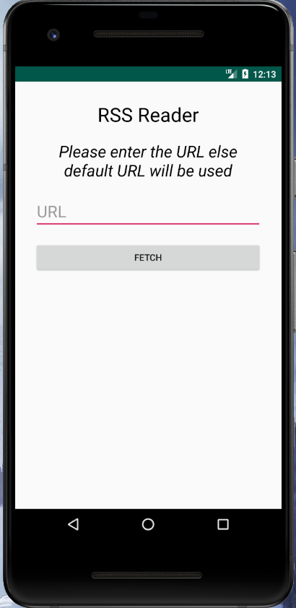 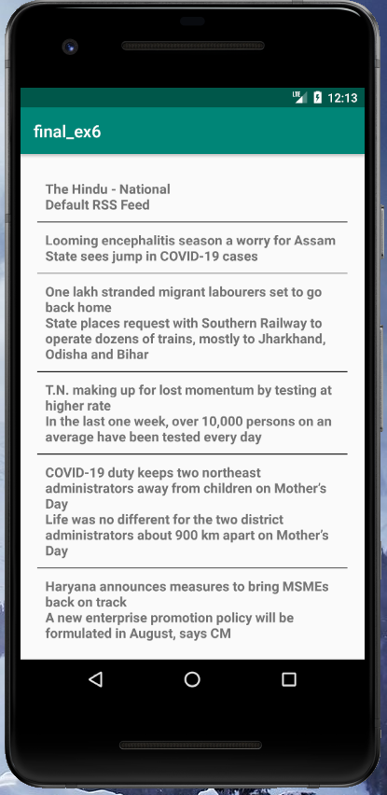

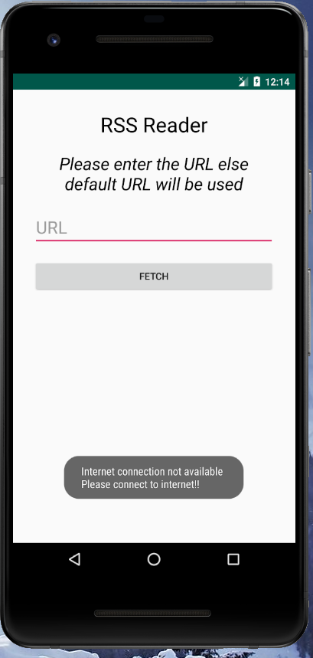

**activity_main.xml:**

*<?*xml version="1.0" encoding="utf-8"*?>*<LinearLayout xmlns:android="http://schemas.android.com/apk/res/android"  
 xmlns:app="http://schemas.android.com/apk/res-auto"  
 xmlns:tools="http://schemas.android.com/tools"  
 android:layout_width="match_parent"  
 android:layout_height="match_parent"  
 android:orientation="vertical"  
 android:layout_margin="20dp"  
 tools:context=".MainActivity">  
  
 <TextView  
 android:id="@+id/textView"  
 android:layout_width="match_parent"  
 android:layout_height="wrap_content"  
 android:gravity="center"  
 android:text="Email Application"  
 android:textAllCaps="true"  
 android:textColor="@android:color/black"  
 android:layout_margin="20dp"  
 android:textSize="24sp" />  
  
 <EditText  
 android:id="@+id/recipient"  
 android:layout_width="match_parent"  
 android:layout_height="wrap_content"  
 android:layout_margin="10dp"  
 android:textSize="20sp"  
 android:hint="Recipient Email"  
 android:inputType="textEmailAddress" />  
  
 <EditText  
 android:id="@+id/subject"  
 android:layout_width="match_parent"  
 android:layout_height="wrap_content"  
 android:layout_margin="10dp"  
 android:textSize="20sp"  
 android:hint="Subject"  
 android:inputType="textMultiLine" />  
  
 <EditText  
 android:id="@+id/body"  
 android:layout_width="match_parent"  
 android:layout_height="wrap_content"  
 android:layout_margin="10dp"  
 android:textSize="20sp"  
 android:hint="Compose email"  
 android:inputType="textMultiLine" />  
  
 <RelativeLayout  
 android:layout_width="match_parent"  
 android:layout_height="wrap_content"  
 android:layout_margin="10dp">  
  
 <TextView  
 android:id="@+id/tvAttachment"  
 android:layout_width="wrap_content"  
 android:layout_height="wrap_content"  
 android:drawableStart="@drawable/attach_symbol"  
 android:drawableLeft="@drawable/attach_symbol"  
 android:layout_alignParentLeft="true"  
 android:layout_margin="10dp"  
 android:visibility="gone" />  
  
 <Button  
 android:id="@+id/bt_attach"  
 android:layout_width="wrap_content"  
 android:layout_height="wrap_content"  
 android:layout_margin="10dp"  
 android:layout_alignParentRight="true"  
 android:text="Add Attachment"/>  
  
 </RelativeLayout>  
  
  
 <Button  
 android:id="@+id/b"  
 android:layout_width="wrap_content"  
 android:layout_height="wrap_content"  
 android:layout_margin="10dp"  
 android:text="Send Email"  
 android:layout_gravity="center"/>  
  
</LinearLayout>

**MainActivity.java:**

package com.example.ex12_email;  
  
import android.content.Intent;  
import android.net.Uri;  
import android.os.Bundle;  
import android.util.Log;  
import android.view.View;  
import android.widget.Button;  
import android.widget.EditText;  
import android.widget.TextView;  
import android.widget.Toast;  
  
import androidx.appcompat.app.AppCompatActivity;  
  
public class MainActivity extends AppCompatActivity {  
 Button b, bt_attach;  
 EditText recipient, subject, body;  
 TextView tvAttachment;  
 Uri URI = null;  
 private static final int *PICK_FROM_GALLERY* = 101;  
 int columnIndex;  
 String attachmentFile;  
  
 @Override  
 protected void onCreate(Bundle savedInstanceState) {  
 super.onCreate(savedInstanceState);  
 setContentView(R.layout.*activity_main*);  
  
 b = findViewById(R.id.*b*);  
 bt_attach = findViewById(R.id.*bt_attach*);  
 recipient = findViewById(R.id.*recipient*);  
 subject = findViewById(R.id.*subject*);  
 body = findViewById(R.id.*body*);  
 tvAttachment = findViewById(R.id.*tvAttachment*);  
  
 b.setOnClickListener(new View.OnClickListener() {  
 @Override  
 public void onClick(View view) {  
 Intent emailIntent = new Intent(Intent.*ACTION_SEND*); *//ACTION_SENDTO w/o setType can also be used* emailIntent.setData(Uri.*parse*("mailto:"));  
 emailIntent.setType("text/plain");  
 emailIntent.putExtra(Intent.*EXTRA_EMAIL*, new String[]{recipient.getText().toString()});  
 emailIntent.putExtra(Intent.*EXTRA_SUBJECT*, subject.getText().toString());  
 emailIntent.putExtra(Intent.*EXTRA_TEXT*, body.getText().toString());  
  
 if (URI != null) {  
 emailIntent.putExtra(Intent.*EXTRA_STREAM*, URI);  
 }  
  
 try {  
 startActivity(Intent.*createChooser*(emailIntent, "Send Email"));  
 } catch (android.content.ActivityNotFoundException ex) {  
 Toast.*makeText*(MainActivity.this, "There is no email client installed.", Toast.*LENGTH_LONG*).show();  
 }  
 }  
 });  
  
 bt_attach.setOnClickListener(new View.OnClickListener() {  
 @Override  
 public void onClick(View v) {  
 Intent intent = new Intent();  
 intent.setType("*/*");  
 intent.setAction(Intent.*ACTION_GET_CONTENT*);  
 intent.putExtra("return-data", true);  
 startActivityForResult(Intent.*createChooser*(intent, "Complete action using"), *PICK_FROM_GALLERY*);  
 }  
 });  
 }  
  
  
 protected void onActivityResult(int requestCode, int resultCode, Intent data) {  
 super.onActivityResult(requestCode, resultCode, data);  
 Log.*i*("mail", "" + requestCode);  
 if (requestCode == *PICK_FROM_GALLERY* && resultCode == *RESULT_OK*) {  
 URI = data.getData();  
 tvAttachment.setText(URI.getLastPathSegment());  
 tvAttachment.setVisibility(View.*VISIBLE*);  
 }  
 }  
  
}

**OUTPUT:**

