**CODE:**

**activity.xml:**

*<?*xml version="1.0" encoding="utf-8"*?>*<ScrollView  
 xmlns:android="http://schemas.android.com/apk/res/android"  
 xmlns:app="http://schemas.android.com/apk/res-auto"  
 xmlns:tools="http://schemas.android.com/tools"  
 tools:context=".MainActivity"  
 android:layout_width="match_parent"  
 android:layout_height="wrap_content"  
 android:fillViewport="true"  
 >  
 <RelativeLayout  
 android:layout_width="match_parent"  
 android:layout_height="match_parent"  
 tools:context=".MainActivity">  
  
 <TextView  
 android:id="@+id/tv1"  
 android:layout_width="match_parent"  
 android:layout_height="wrap_content"  
 android:text="HOSPITAL REGISTRATION FORM"  
 android:textColor="#214d90"  
 android:textSize="36sp"  
 android:textStyle="normal"  
 android:gravity="center"  
 android:typeface="serif"  
 android:layout_marginTop="10dp"  
 android:layout_marginLeft="10dp"  
 android:layout_marginRight="10dp"  
 />  
  
 <TextView  
 android:id="@+id/name_tv"  
 android:layout_width="125dp"  
 android:layout_height="45dp"  
 android:layout_below="@+id/tv1"  
 android:layout_alignParentLeft="true"  
 android:layout_marginLeft="10dp"  
 android:layout_marginTop="10dp"  
 android:text="Name"  
 android:textColor="#005ae4"  
 android:textSize="25sp"  
 android:typeface="serif" />  
  
 <EditText  
 android:id="@+id/name_et"  
 android:layout_width="wrap_content"  
 android:layout_height="45dp"  
 android:layout_below="@+id/tv1"  
 android:layout_alignParentRight="true"  
 android:layout_marginTop="10dp"  
 android:layout_marginRight="10dp"  
 android:hint="Enter your name"  
 android:inputType="text"  
 android:textColor="#005ae4"  
 android:textSize="25sp"  
 android:typeface="serif" />  
  
 <TextView  
 android:id="@+id/address_tv"  
 android:layout_width="125dp"  
 android:layout_height="45dp"  
 android:layout_below="@+id/name_tv"  
 android:layout_alignParentLeft="true"  
 android:layout_marginLeft="10dp"  
 android:layout_marginTop="10dp"  
 android:text="Address"  
 android:textColor="#005ae4"  
 android:textSize="25sp"  
 android:typeface="serif" />  
  
 <EditText  
 android:id="@+id/address_et"  
 android:layout_width="wrap_content"  
 android:layout_height="45dp"  
 android:layout_below="@+id/name_et"  
 android:layout_alignParentRight="true"  
 android:layout_marginTop="10dp"  
 android:layout_marginRight="10dp"  
 android:hint="Enter your address"  
 android:inputType="textMultiLine|textPostalAddress"  
 android:textColor="#005ae4"  
 android:textSize="25sp"  
 android:typeface="serif" />  
 <TextView  
 android:id="@+id/age_tv"  
 android:layout_width="125dp"  
 android:layout_height="45dp"  
 android:layout_below="@+id/address_tv"  
 android:layout_alignParentLeft="true"  
 android:layout_marginLeft="10dp"  
 android:layout_marginTop="10dp"  
 android:text="Age"  
 android:textColor="#005ae4"  
 android:textSize="25sp"  
 android:typeface="serif" />  
  
 <EditText  
 android:id="@+id/age_et"  
 android:layout_width="wrap_content"  
 android:layout_height="45dp"  
 android:layout_below="@+id/address_et"  
 android:layout_alignParentRight="true"  
 android:layout_marginTop="10dp"  
 android:layout_marginRight="10dp"  
 android:hint="Enter your age"  
 android:inputType="number"  
 android:textColor="#005ae4"  
 android:textSize="25sp"  
 android:typeface="serif" />  
  
 <TextView  
 android:id="@+id/dob_tv"  
 android:layout_width="125dp"  
 android:layout_height="45dp"  
 android:layout_below="@+id/age_tv"  
 android:layout_alignParentLeft="true"  
 android:layout_marginLeft="10dp"  
 android:layout_marginTop="10dp"  
 android:text="DOB"  
 android:textColor="#005ae4"  
 android:textSize="25sp"  
 android:typeface="serif" />  
  
 <DatePicker  
 android:id="@+id/date_dp"  
 android:layout_width="305dp"  
 android:layout_height="400dp"  
 android:layout_below="@+id/age_et"  
 android:layout_alignParentRight="true"  
 android:layout_marginTop="15dp"  
 android:layout_marginRight="15dp"  
 android:inputType="date" />  
  
 <TextView  
 android:id="@+id/gender_tv"  
 android:layout_width="125dp"  
 android:layout_height="45dp"  
 android:layout_below="@+id/dob_tv"  
 android:layout_alignParentLeft="true"  
 android:layout_marginLeft="13dp"  
 android:layout_marginTop="367dp"  
 android:text="Gender"  
 android:textColor="#005ae4"  
 android:textSize="25sp"  
 android:typeface="serif" />  
  
 <RadioGroup  
 android:id="@+id/gd_rg"  
 android:layout_width="wrap_content"  
 android:layout_height="wrap_content"  
 android:layout_below="@+id/date_dp"  
 android:layout_toRightOf="@+id/gender_tv"  
 android:layout_marginTop="10dp"  
 android:layout_marginRight="10dp"  
 >  
  
 <RadioButton  
 android:layout_width="wrap_content"  
 android:layout_height="wrap_content"  
 android:text="Male">  
 </RadioButton>  
 <RadioButton  
 android:layout_width="wrap_content"  
 android:layout_height="wrap_content"  
 android:text="Female"  
 >  
 </RadioButton>  
 <RadioButton  
 android:layout_width="wrap_content"  
 android:layout_height="wrap_content"  
 android:text="Transgender">  
 </RadioButton>  
  
 </RadioGroup>  
  
 <TextView  
 android:id="@+id/ms_tv"  
 android:layout_width="125dp"  
 android:layout_height="wrap_content"  
 android:layout_below="@+id/gender_tv"  
 android:layout_alignParentLeft="true"  
 android:layout_marginLeft="12dp"  
 android:layout_marginTop="62dp"  
 android:text="Marital Status"  
 android:textColor="#005ae4"  
 android:textSize="25sp"  
 android:typeface="serif" />  
  
 <Spinner  
 android:id="@+id/ms_sp"  
 android:layout_width="wrap_content"  
 android:layout_height="wrap_content"  
 android:layout_below="@id/gd_rg"  
 android:layout_toRightOf="@+id/ms_tv"  
 android:layout_marginTop="28dp"  
 android:layout_marginRight="147dp"  
 android:entries="@array/marital">  
  
 </Spinner>  
  
 <TextView  
 android:id="@+id/contact_tv"  
 android:layout_width="125dp"  
 android:layout_height="wrap_content"  
 android:layout_below="@+id/ms_tv"  
 android:layout_alignParentLeft="true"  
 android:layout_marginLeft="10dp"  
 android:layout_marginTop="10dp"  
 android:text="Contact Number"  
 android:textColor="#005ae4"  
 android:textSize="25sp"  
 android:typeface="serif" />  
  
 <EditText  
 android:id="@+id/contact_et"  
 android:layout_width="wrap_content"  
 android:layout_height="45dp"  
 android:layout_below="@+id/ms_sp"  
 android:layout_alignParentRight="true"  
 android:layout_marginTop="42dp"  
 android:layout_marginRight="13dp"  
 android:layout_marginLeft="5dp"  
 android:hint="Enter phone number"  
 android:inputType="phone"  
 android:textColor="#005ae4"  
 android:textSize="25sp"  
 android:typeface="serif" />  
  
 <TextView  
 android:id="@+id/time_tv"  
 android:layout_width="118dp"  
 android:layout_height="84dp"  
 android:layout_below="@+id/contact_tv"  
 android:layout_alignParentLeft="true"  
 android:layout_marginLeft="10dp"  
 android:layout_marginTop="10dp"  
 android:text="Registration Time"  
 android:textColor="#005ae4"  
 android:textSize="25sp"  
 android:typeface="serif" />  
  
 <TimePicker  
 android:id="@+id/time_tp"  
 android:layout_width="260dp"  
 android:layout_height="337dp"  
 android:layout_below="@+id/contact_et"  
 android:layout_alignParentRight="true"  
 android:layout_marginLeft="10dp"  
 android:layout_marginTop="15dp">  
  
 </TimePicker>  
  
  
 </RelativeLayout>  
</ScrollView>

**MainActivity.java:**

package com.example.ex1new;  
  
import androidx.appcompat.app.AppCompatActivity;  
  
import android.os.Bundle;  
  
public class MainActivity extends AppCompatActivity {  
  
 @Override  
 protected void onCreate(Bundle savedInstanceState) {  
 super.onCreate(savedInstanceState);  
 setContentView(R.layout.*activity_main*);  
 }  
}

**OUTPUT:**

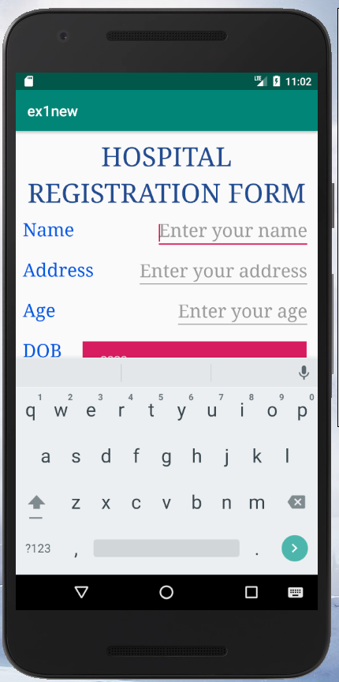 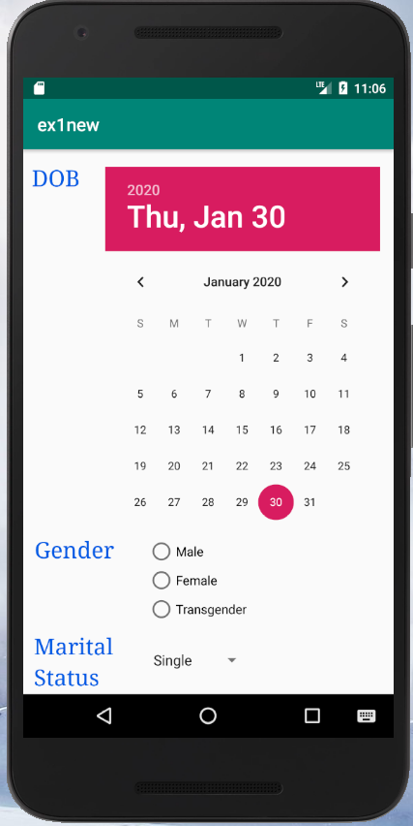

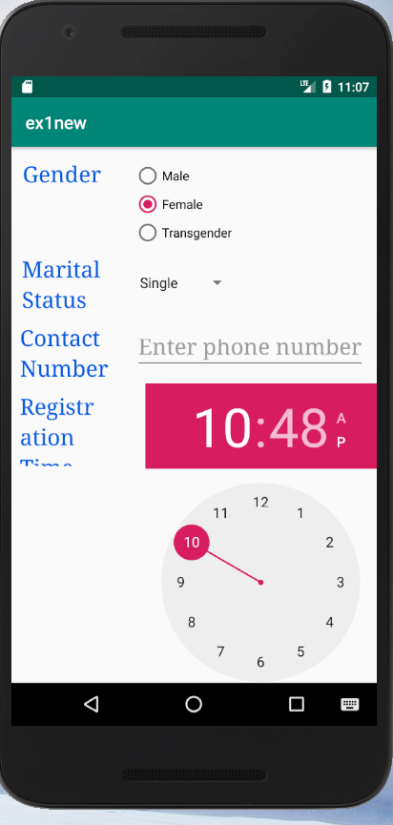

**CODE:**

**activity.xml:**

*<?*xml version="1.0" encoding="utf-8"*?>*<ScrollView  
 xmlns:android="http://schemas.android.com/apk/res/android"  
 xmlns:app="http://schemas.android.com/apk/res-auto"  
 xmlns:tools="http://schemas.android.com/tools"  
 tools:context=".MainActivity"  
 android:layout_width="match_parent"  
 android:layout_height="wrap_content"  
 android:fillViewport="true"  
 >  
 <RelativeLayout  
 android:layout_width="match_parent"  
 android:layout_height="match_parent"  
 tools:context=".MainActivity">  
  
 <TextView  
 android:id="@+id/tv1"  
 android:layout_width="match_parent"  
 android:layout_height="wrap_content"  
 android:text="HOSPITAL REGISTRATION FORM"  
 android:textColor="#214d90"  
 android:textSize="36sp"  
 android:textStyle="normal"  
 android:gravity="center"  
 android:typeface="serif"  
 android:layout_marginTop="10dp"  
 android:layout_marginLeft="10dp"  
 android:layout_marginRight="10dp"  
 />  
  
 <TextView  
 android:id="@+id/name_tv"  
 android:layout_width="125dp"  
 android:layout_height="45dp"  
 android:layout_below="@+id/tv1"  
 android:layout_alignParentLeft="true"  
 android:layout_marginLeft="10dp"  
 android:layout_marginTop="10dp"  
 android:text="Name"  
 android:textColor="#005ae4"  
 android:textSize="25sp"  
 android:typeface="serif" />  
  
 <EditText  
 android:id="@+id/name_et"  
 android:layout_width="wrap_content"  
 android:layout_height="45dp"  
 android:layout_below="@+id/tv1"  
 android:layout_alignParentRight="true"  
 android:layout_marginTop="10dp"  
 android:layout_marginRight="10dp"  
 android:hint="Enter your name"  
 android:inputType="text"  
 android:textColor="#005ae4"  
 android:textSize="25sp"  
 android:typeface="serif" />  
  
 <TextView  
 android:id="@+id/dob_tv"  
 android:layout_width="125dp"  
 android:layout_height="45dp"  
 android:layout_below="@+id/name_tv"  
 android:layout_alignParentLeft="true"  
 android:layout_marginLeft="10dp"  
 android:layout_marginTop="10dp"  
 android:text="DOB"  
 android:textColor="#005ae4"  
 android:textSize="25sp"  
 android:typeface="serif" />  
  
 <DatePicker  
 android:id="@+id/date_dp"  
 android:layout_width="305dp"  
 android:layout_height="400dp"  
 android:layout_below="@+id/name_et"  
 android:layout_alignParentRight="true"  
 android:layout_marginTop="15dp"  
 android:layout_marginRight="15dp"  
 android:inputType="date" />  
  
 <TextView  
 android:id="@+id/gender_tv"  
 android:layout_width="125dp"  
 android:layout_height="45dp"  
 android:layout_below="@+id/dob_tv"  
 android:layout_alignParentLeft="true"  
 android:layout_marginLeft="13dp"  
 android:layout_marginTop="367dp"  
 android:text="Gender"  
 android:textColor="#005ae4"  
 android:textSize="25sp"  
 android:typeface="serif" />  
  
 <RadioGroup  
 android:id="@+id/gd_rg"  
 android:layout_width="wrap_content"  
 android:layout_height="wrap_content"  
 android:layout_below="@+id/date_dp"  
 android:layout_toRightOf="@+id/gender_tv"  
 android:layout_marginTop="10dp"  
 android:layout_marginRight="10dp"  
 >  
  
 <RadioButton  
 android:layout_width="wrap_content"  
 android:layout_height="wrap_content"  
 android:text="Male">  
 </RadioButton>  
 <RadioButton  
 android:layout_width="wrap_content"  
 android:layout_height="wrap_content"  
 android:text="Female"  
 >  
 </RadioButton>  
 <RadioButton  
 android:layout_width="wrap_content"  
 android:layout_height="wrap_content"  
 android:text="Transgender">  
 </RadioButton>  
  
 </RadioGroup>  
  
 <TextView  
 android:id="@+id/ms_tv"  
 android:layout_width="125dp"  
 android:layout_height="wrap_content"  
 android:layout_below="@+id/gender_tv"  
 android:layout_alignParentLeft="true"  
 android:layout_marginLeft="12dp"  
 android:layout_marginTop="62dp"  
 android:text="Marital Status"  
 android:textColor="#005ae4"  
 android:textSize="25sp"  
 android:typeface="serif" />  
  
 <Spinner  
 android:id="@+id/ms_sp"  
 android:layout_width="wrap_content"  
 android:layout_height="wrap_content"  
 android:layout_below="@id/gd_rg"  
 android:layout_toRightOf="@+id/ms_tv"  
 android:layout_marginTop="28dp"  
 android:layout_marginRight="147dp"  
 android:layout_marginLeft="10dp"  
 android:entries="@array/marital">  
  
 </Spinner>  
  
 <TextView  
 android:id="@+id/contact_tv"  
 android:layout_width="125dp"  
 android:layout_height="wrap_content"  
 android:layout_below="@+id/ms_tv"  
 android:layout_alignParentLeft="true"  
 android:layout_marginLeft="10dp"  
 android:layout_marginTop="10dp"  
 android:text="Contact Number"  
 android:textColor="#005ae4"  
 android:textSize="25sp"  
 android:typeface="serif" />  
  
 <EditText  
 android:id="@+id/contact_et"  
 android:layout_width="wrap_content"  
 android:layout_height="45dp"  
 android:layout_below="@+id/ms_sp"  
 android:layout_alignParentRight="true"  
 android:layout_marginTop="42dp"  
 android:layout_marginRight="13dp"  
 android:hint="Enter phone number"  
 android:inputType="phone"  
 android:textColor="#005ae4"  
 android:textSize="25sp"  
 android:typeface="serif" />  
  
 <TextView  
 android:id="@+id/addict_tv"  
 android:layout_width="118dp"  
 android:layout_height="84dp"  
 android:layout_below="@+id/contact_tv"  
 android:layout_alignParentLeft="true"  
 android:layout_marginLeft="10dp"  
 android:layout_marginTop="10dp"  
 android:text="Addiction"  
 android:textColor="#005ae4"  
 android:textSize="25sp"  
 android:typeface="serif" />  
  
 <CheckBox  
 android:id="@+id/smoke_cb"  
 android:layout_width="wrap_content"  
 android:layout_height="wrap_content"  
 android:text="Smoking"  
 android:layout_below="@+id/contact_et"  
 android:layout_toRightOf="@+id/addict_tv"  
 android:layout_marginTop="10dp"  
 android:layout_marginRight="10dp"  
 android:layout_marginLeft="10dp"  
 />  
 <CheckBox  
 android:id="@+id/alcohol_cb"  
 android:layout_width="wrap_content"  
 android:layout_height="wrap_content"  
 android:text="Alcohol"  
 android:layout_below="@+id/smoke_cb"  
 android:layout_toRightOf="@+id/addict_tv"  
 android:layout_marginTop="10dp"  
 android:layout_marginRight="10dp"  
 android:layout_marginLeft="10dp"  
 />  
  
 <Button  
 android:id="@+id/submit_bt"  
 android:layout_width="wrap_content"  
 android:layout_height="wrap_content"  
 android:layout_below="@+id/alcohol_cb"  
 android:layout_centerInParent="false"  
 android:layout_marginLeft="40dp"  
 android:layout_marginTop="13dp"  
 android:layout_marginBottom="10dp"  
 android:text="SUBMIT"  
 android:textColor="#005ae4"  
 android:textSize="25sp"  
 android:typeface="serif" />  
  
 <Button  
 android:id="@+id/reset_bt"  
 android:layout_width="wrap_content"  
 android:layout_height="wrap_content"  
 android:layout_below="@+id/alcohol_cb"  
 android:layout_alignParentRight="true"  
 android:layout_marginTop="10dp"  
 android:layout_marginRight="40dp"  
 android:layout_marginBottom="10dp"  
 android:text="RESET"  
 android:textColor="#005ae4"  
 android:textSize="25sp"  
 android:typeface="serif"  
 android:onClick="resetFields"/>  
  
 </RelativeLayout>  
</ScrollView>

**activity_page2.xml:**

*<?*xml version="1.0" encoding="utf-8"*?>*<ScrollView  
 xmlns:android="http://schemas.android.com/apk/res/android"  
 xmlns:app="http://schemas.android.com/apk/res-auto"  
 xmlns:tools="http://schemas.android.com/tools"  
 tools:context=".MainActivity"  
 android:layout_width="match_parent"  
 android:layout_height="wrap_content"  
 android:fillViewport="true"  
 >  
  
 <LinearLayout  
 android:layout_width="match_parent"  
 android:layout_height="match_parent"  
 android:orientation="vertical"  
 >  
  
 <TextView  
 android:id="@+id/tv1"  
 android:layout_width="match_parent"  
 android:layout_height="wrap_content"  
 android:text="HOSPITAL REGISTRATION FORM"  
 android:textColor="#214d90"  
 android:textSize="36sp"  
 android:textStyle="normal"  
 android:gravity="center"  
 android:typeface="serif"  
 android:layout_marginTop="10dp"  
 android:layout_marginLeft="10dp"  
 android:layout_marginRight="10dp"  
 />  
  
 <TableLayout  
 android:layout_width="wrap_content"  
 android:layout_height="wrap_content"  
 >  
  
 <TableRow>  
 <TextView  
 android:layout_width="wrap_content"  
 android:layout_height="wrap_content"  
 android:text="Name"  
 android:textSize="30sp"  
 />  
 <TextView  
 android:id="@+id/name_tb"  
 android:layout_width="wrap_content"  
 android:layout_height="wrap_content"  
 android:textSize="30sp"  
 />  
 </TableRow>  
  
 <TableRow>  
 <TextView  
 android:layout_width="wrap_content"  
 android:layout_height="wrap_content"  
 android:text="DOB"  
 android:textSize="30sp"  
 />  
 <TextView  
 android:id="@+id/dob_tb"  
 android:layout_width="wrap_content"  
 android:layout_height="wrap_content"  
 android:textSize="30sp"  
 />  
 </TableRow>  
  
 <TableRow>  
 <TextView  
 android:layout_width="wrap_content"  
 android:layout_height="wrap_content"  
 android:text="Gender"  
 android:textSize="30sp"  
 />  
 <TextView  
 android:id="@+id/gender_tb"  
 android:layout_width="wrap_content"  
 android:layout_height="wrap_content"  
 android:textSize="30sp"  
 />  
 </TableRow>  
  
 <TableRow>  
 <TextView  
 android:layout_width="wrap_content"  
 android:layout_height="wrap_content"  
 android:text="Marital Status"  
 android:textSize="30sp"  
 />  
 <TextView  
 android:id="@+id/marital_tb"  
 android:layout_width="wrap_content"

android:layout_height="wrap_content"

android:textSize="30sp"

/>

</TableRow>

<TableRow>

<TextView

android:layout_width="wrap_content"

android:layout_height="wrap_content"

android:text="Contact Number"

android:textSize="30sp"

/>

<TextView

android:id="@+id/contact_tb"

android:layout_width="wrap_content"

android:layout_height="wrap_content"

android:textSize="30sp"

/>

</TableRow>

<TableRow

android:layout_height="wrap_content"

>

<TextView

android:layout_width="0dp"

android:layout_weight="1"

android:layout_height="match_parent"

android:text="Addiction"

android:textSize="30sp"

/>

<TextView

android:id="@+id/addict_tb"

android:layout_width="wrap_content"

android:layout_height="match_parent"

android:textSize="30sp"

/>

</TableRow>

</TableLayout>

</LinearLayout>

</ScrollView>

**MainActvity.java:**

package com.example.vaish.ex2new;  
  
import android.support.v7.app.AppCompatActivity;  
  
import android.content.Intent;  
import android.os.Bundle;  
import android.view.View;  
import android.widget.ArrayAdapter;  
import android.widget.Button;  
import android.widget.CheckBox;  
import android.widget.DatePicker;  
import android.widget.EditText;  
import android.widget.RadioButton;  
import android.widget.RadioGroup;  
import android.widget.Spinner;  
import android.widget.Toast;  
import java.util.Calendar;  
  
public class MainActivity extends AppCompatActivity {  
  
 Button submit,reset;  
 EditText name,contact_et;  
 DatePicker dob;  
 RadioGroup gd;  
 Spinner ms_sp;  
 CheckBox smoke_cb,alcohol_cb;  
 RadioButton check_rb;  
  
 @Override  
 protected void onCreate(Bundle savedInstanceState) {  
 super.onCreate(savedInstanceState);  
 setContentView(R.layout.*activity_main*);  
  
 submit = findViewById(R.id.*submit_bt*);  
 reset = findViewById(R.id.*reset_bt*);  
 name = findViewById(R.id.*name_et*);  
 dob = findViewById(R.id.*date_dp*);  
 gd = findViewById(R.id.*gd_rg*);  
 ms_sp = (Spinner) findViewById(R.id.*ms_sp*);  
 contact_et = findViewById(R.id.*contact_et*);  
 smoke_cb = findViewById(R.id.*smoke_cb*);  
 alcohol_cb = findViewById(R.id.*alcohol_cb*);  
  
 ArrayAdapter<CharSequence>  
 adapter.setDropDownViewResource(android.R.layout.simple_spinner_dropdown_item);

ms_sp.setAdapter(adapter);

submit.setOnClickListener(new View.OnClickListener() {

@Override

public void onClick(View view) {

Intent myIntent = new Intent(getApplicationContext(), page2.class);

String add="";

String name_field = name.getText().toString();

String day=String.valueOf(dob.getDayOfMonth());

String month=String.valueOf(dob.getMonth()+1);

String year=String.valueOf(dob.getYear());

int selectedId = gd.getCheckedRadioButtonId();

//Log.d("radio","rad bt id: "+selectedId);//i is 1,2,3 as it is not assigned

check_rb = (RadioButton) findViewById(selectedId);

String gender = check_rb.getText().toString(); //getTExt returns CharSequence

String marital_stat=ms_sp.getSelectedItem().toString();

//Log.d("sat","sat string : "+marital_stat);

//long spin_id =ms_sp.getSelectedItemId(); //id sarts with 0

//Log.d("sat","sat item id: "+spin_id);

//System.out.println("id:"+spin_id);

String contact = contact_et.getText().toString();

if (smoke_cb.isChecked())

add+="Smoking ";

if(alcohol_cb.isChecked())

add+="Alcohol";

Bundle b = new Bundle();

b.putString("name", name_field);

b.putString("day", day);

b.putString("month", month);

b.putString("year", year);

b.putString("gender", gender);

b.putString("marital", marital_stat);

b.putString("contact", contact);

b.putString("addiction", add);

myIntent.putExtras(b);

startActivity(myIntent);

}

});

}

public void resetFields(View v){

name.setText("");

gd.clearCheck();

ms_sp.setSelection(0);

contact_et.setText("");

smoke_cb.setChecked(false);

alcohol_cb.setChecked(false);

Calendar c = Calendar.getInstance();

int year = c.get(Calendar.YEAR);

int month = c.get(Calendar.MONTH);

int day = c.get(Calendar.DAY_OF_MONTH);

dob.init(year, month, day, null);

}

**page2.java:**

package com.example.vaish.ex2new;  
  
import android.support.v7.app.AppCompatActivity;  
import java.text.SimpleDateFormat;

import java.util.Date;

import android.os.Bundle;

import android.widget.RadioGroup;

import android.widget.TextView;

import android.widget.Toast;

public class page2 extends AppCompatActivity {

TextView name,dob,gender,marital,contact,addict;

@Override

protected void onCreate(Bundle savedInstanceState) {

super.onCreate(savedInstanceState);

setContentView(R.layout.activity_page2);

name = findViewById(R.id.name_tb);

dob = findViewById(R.id.dob_tb);

gender = findViewById(R.id.gender_tb);

marital = findViewById(R.id.marital_tb);

contact = findViewById(R.id.contact_tb);

addict = findViewById(R.id.addict_tb);

Bundle extras = getIntent().getExtras();

if(extras == null) {

//set all string to null

} else {

name.setText( extras.getString("name"));

gender.setText( extras.getString("gender"));

marital.setText( extras.getString("marital"));

contact.setText( extras.getString("contact"));

addict.setText( extras.getString("addiction"));

String date=extras.getString("day")+"-"+extras.getString("month")+"-"+extras.getString("year");

dob.setText(date);

}

}

}

**OUTPUT:**

