**IT 8761 NETWORK SECURITY LABORATORY**

**SEMESTER PRACTICAL EXAMINATION**

**QUESTION:**

Develop a java program to implement the Rail fence Cipher with depth 5 and reapply the same algorithm with depth 3 on the intermediate cipher and generate the final cipher text.

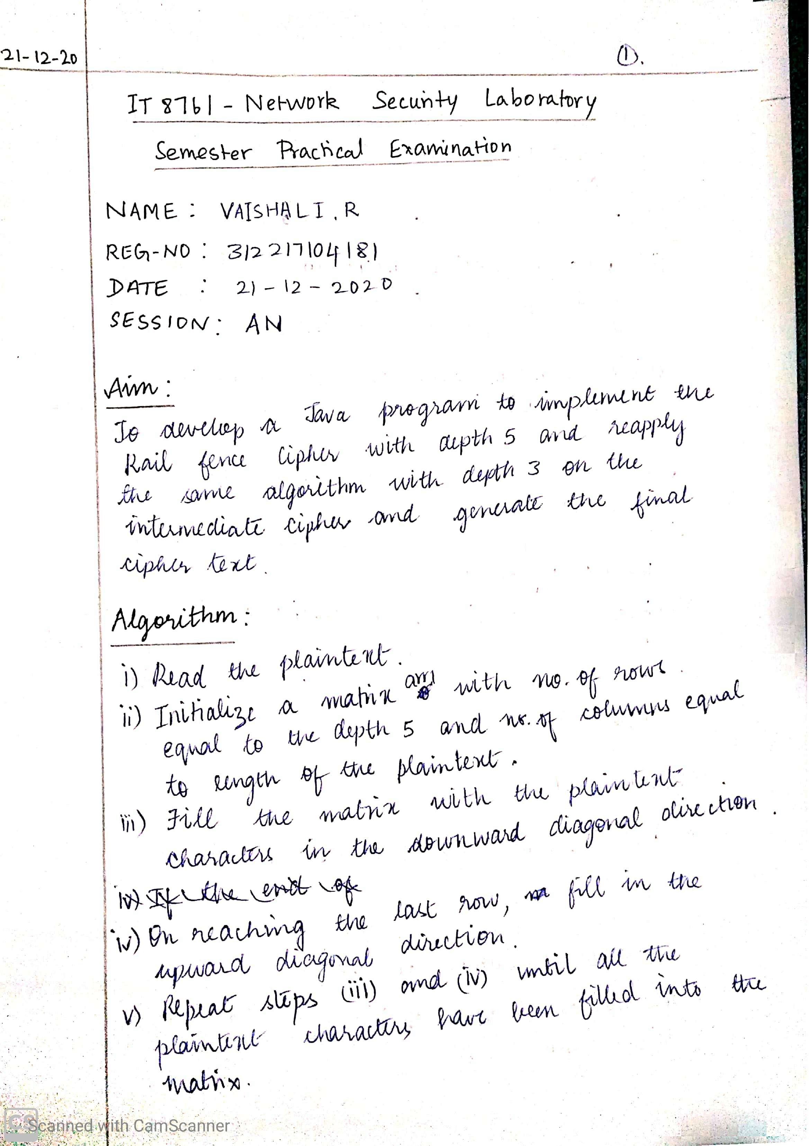

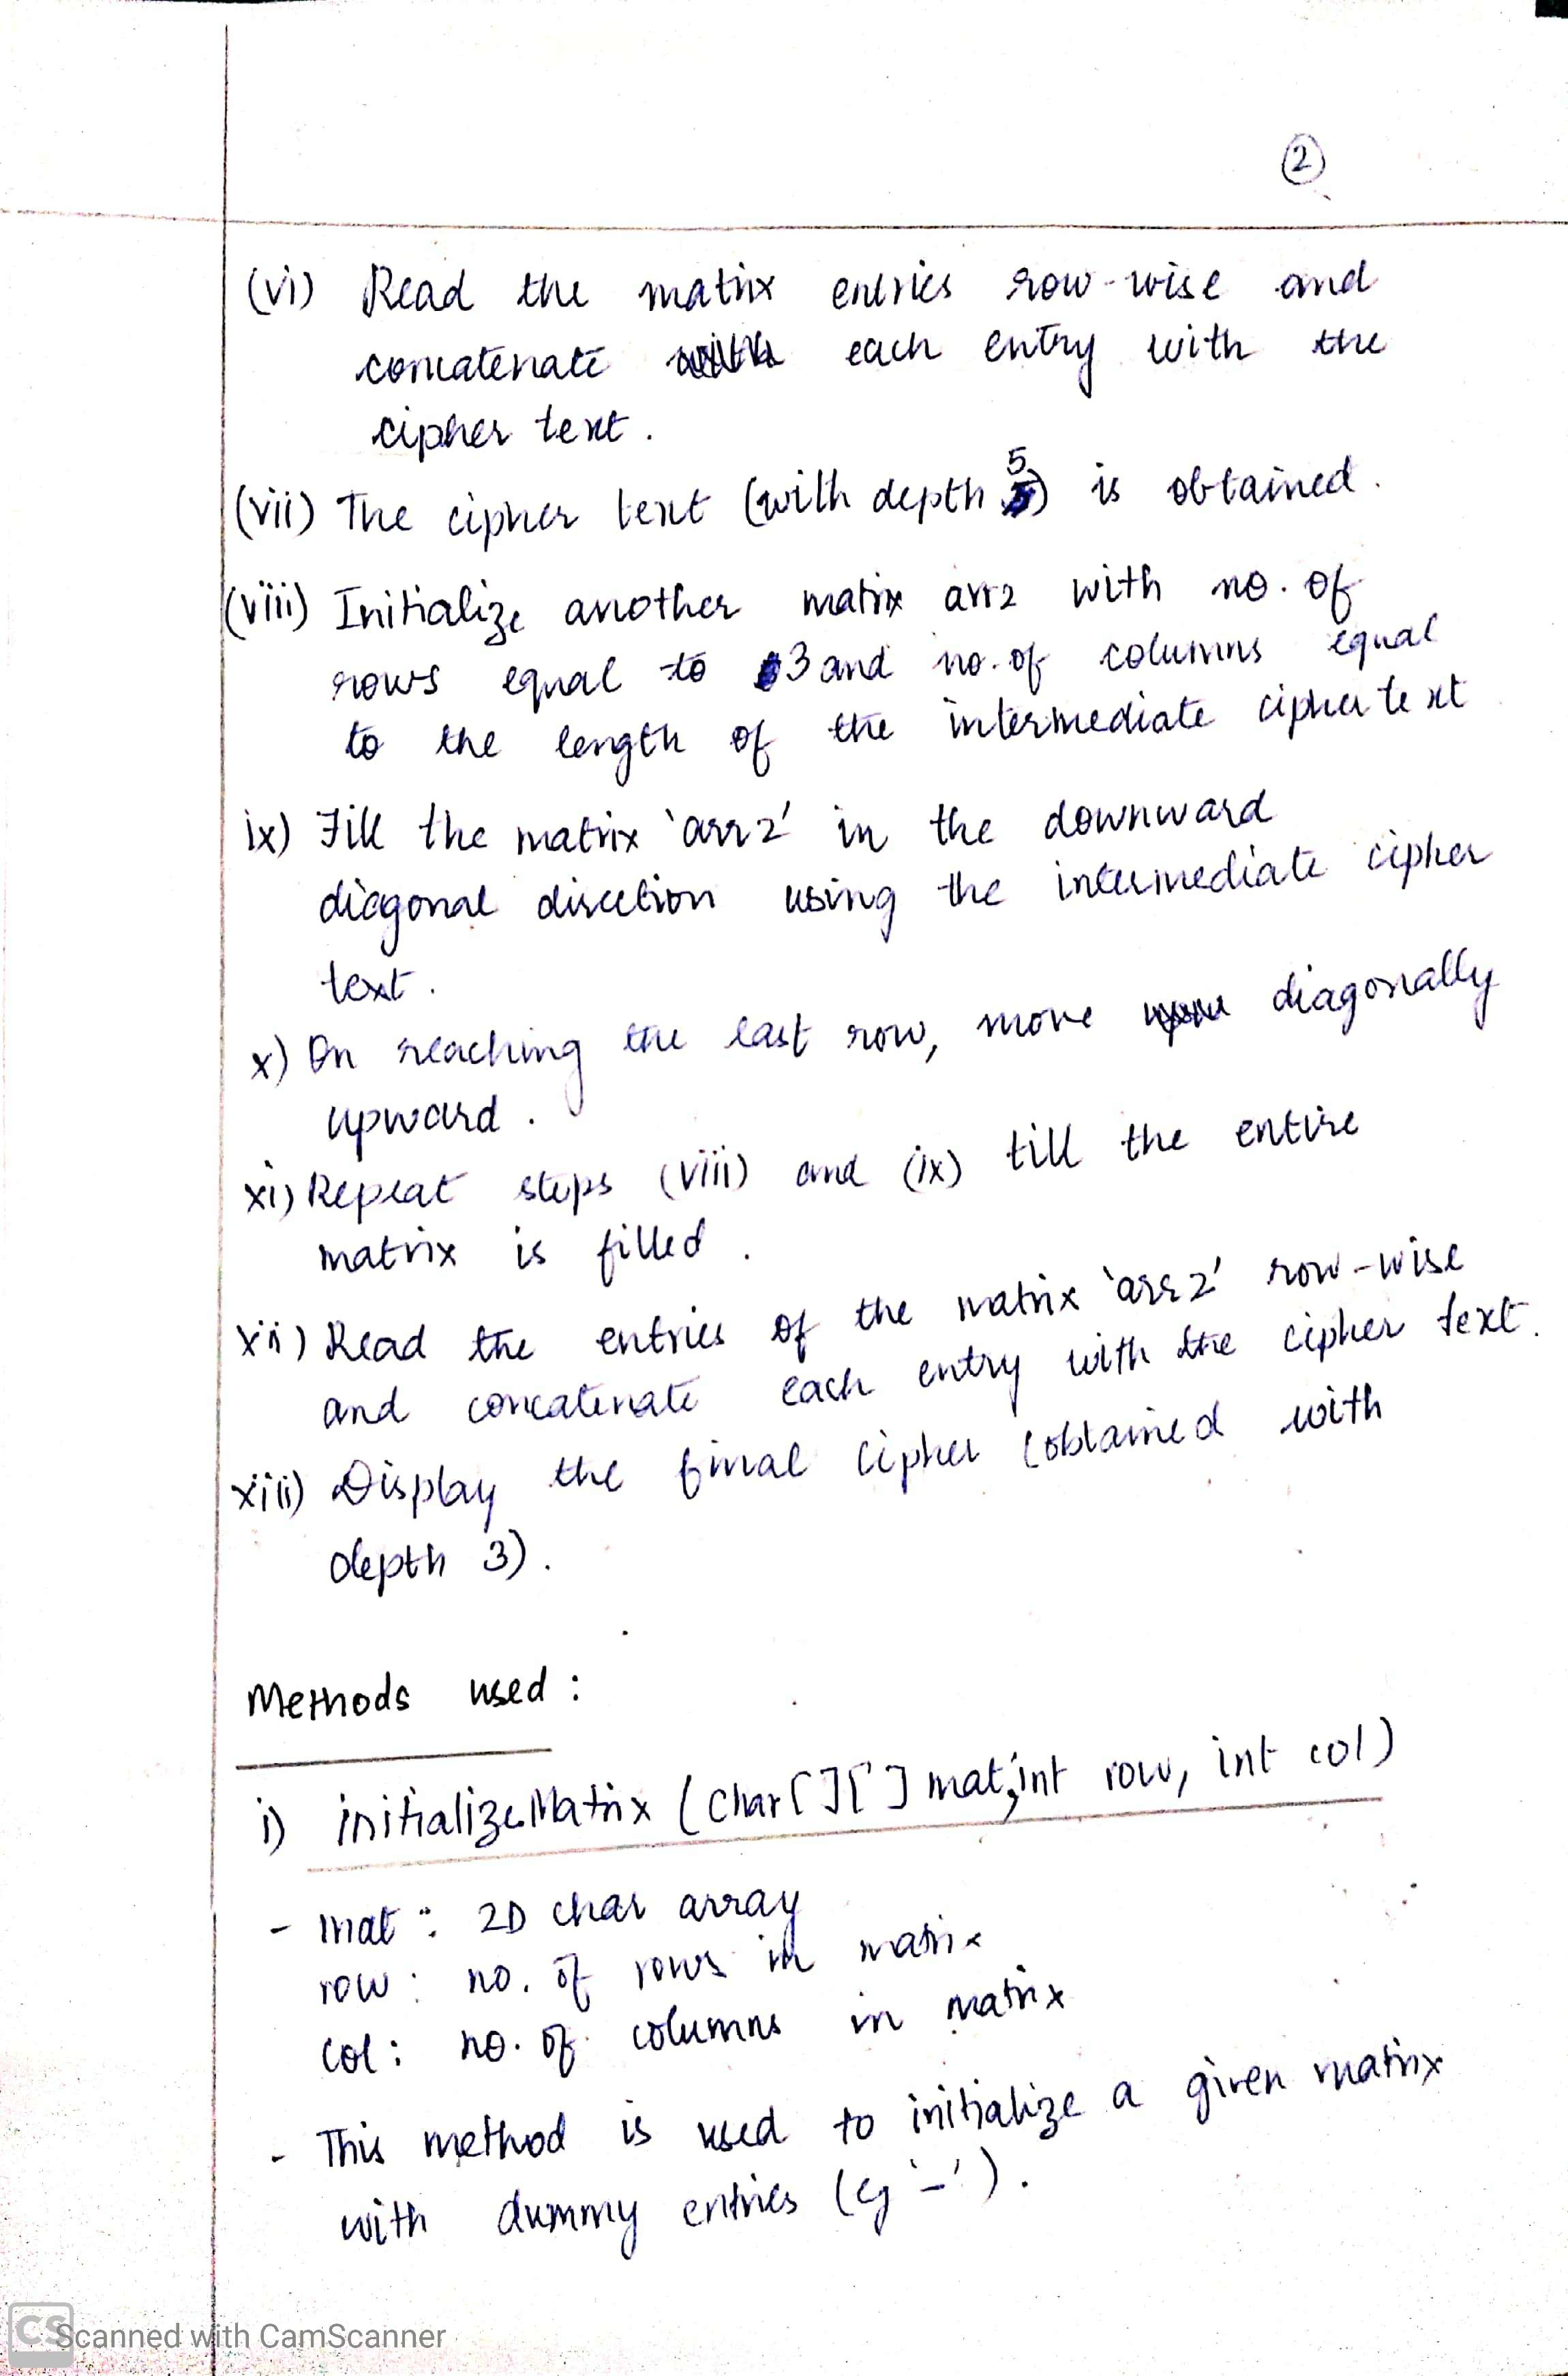

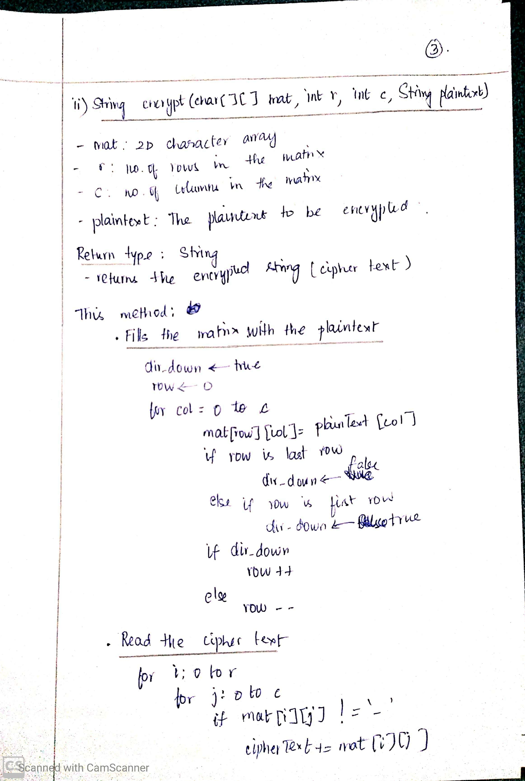

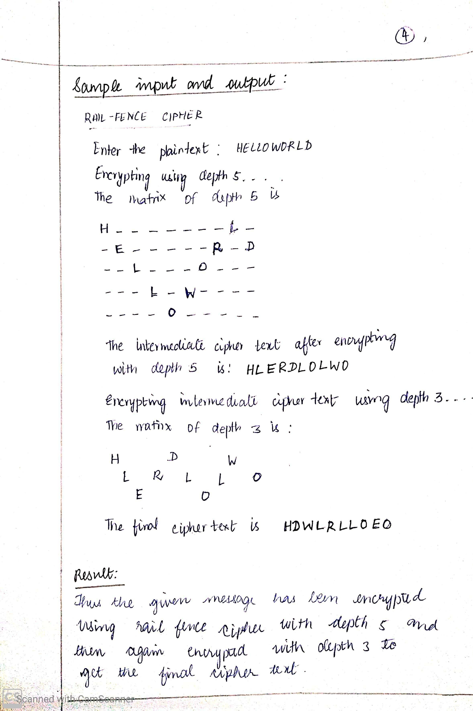

**CODE:**

import java.util.Scanner;

class Main {

public static void main(String[] args) {

String plainText;

String cipherText1,cipherText2;

Scanner sc = new Scanner(System.in);

System.out.println("\nRAIL-FENCE CIPHER");

System.out.println("-----------------");

System.out.print("\nEnter the plaintext: ");

plainText=sc.nextLine();

int len=plainText.length();

char arr1[][] = new char[5][len];

char arr2[][] = new char[3][len];

initializeMatrix(arr1,5,len);

initializeMatrix(arr2,3,len);

System.out.println("\nEncrypting using depth 5...");

cipherText1=encrypt(arr1,5,len,plainText);

System.out.println("\nThe intermediate cipher text after encrypting with depth 5 is: "+cipherText1);

System.out.println("\nEncrypting intermediate cipher text using depth 3...");

cipherText2=encrypt(arr2, 3, len, cipherText1);

System.out.println("\nThe final cipher text is: "+cipherText2);

}

static void initializeMatrix(char[][] mat,int row,int col){

for(int i=0;i<row;i++){

for(int j=0;j<col;j++){

mat[i][j]='-';

}

}

}

static String encrypt(char[][]mat,int r,int c,String plainText){

boolean dir_down=true;

int row=0;

for(int col=0;col<c;col++){

mat[row][col]=plainText.charAt(col);

if(row==r-1){

dir_down=false;

}

else if(row==0){

dir_down=true;

}

if(dir_down){

row++;

}

else{

row--;

}

}

String cipherText="";

System.out.println("The matrix of depth "+r+" is \n");

for(int i=0;i<r;i++){

for(int j=0;j<c;j++){

System.out.print(mat[i][j]+" ");

if(mat[i][j]!='-'){

cipherText+=mat[i][j];

}

}

System.out.println();

}

return cipherText;

}

}

**OUTPUT:**

**Example1:**

**PLAINTEXT: DECODE ZIGZAG**

**CIPHERTEXT: DGOGIZCZEDE A**

RAIL-FENCE CIPHER

-----------------

Enter the plaintext: DECODE ZIGZAG

Encrypting using depth 5...

The matrix of depth 5 is

D - - - - - - - I - - - -

- E - - - - - Z - G - - -

- - C - - - - - - Z - -

- - - O - E - - - - - A -

- - - - D - - - - - - - G

The intermediate cipher text after encrypting with depth 5 is: DIEZGC ZOEADG

Encrypting intermediate cipher text using depth 3...

The matrix of depth 3 is

D - - - G - - - O - - - G

- I - Z - C - Z - E - D -

- - E - - - - - - A - -

The final cipher text is: DGOGIZCZEDE A

**Example 2:**

**PLAINTEXT: HELLOWORLD**

**CIPHERTEXT: HDWLRLLOEO**

RAIL-FENCE CIPHER

-----------------

Enter the plaintext: HELLOWORLD

Encrypting using depth 5...

The matrix of depth 5 is

H - - - - - - - L -

- E - - - - - R - D

- - L - - - O - - -

- - - L - W - - - -

- - - - O - - - - -

The intermediate cipher text after encrypting with depth 5 is: HLERDLOLWO

Encrypting intermediate cipher text using depth 3...

The matrix of depth 3 is

H - - - D - - - W -

- L - R - L - L - O

- - E - - - O - - -

The final cipher text is: HDWLRLLOEO