**Exercise 12a:**

To build a Trojan and know the harmness of the trojan malwares in a computer system.

Trojan.bat:

@echo off

:x

start mspaint

start notepad

start cmd

start explorer

start control

start calc

When the above file is executed, it opens all the mentioned applications.

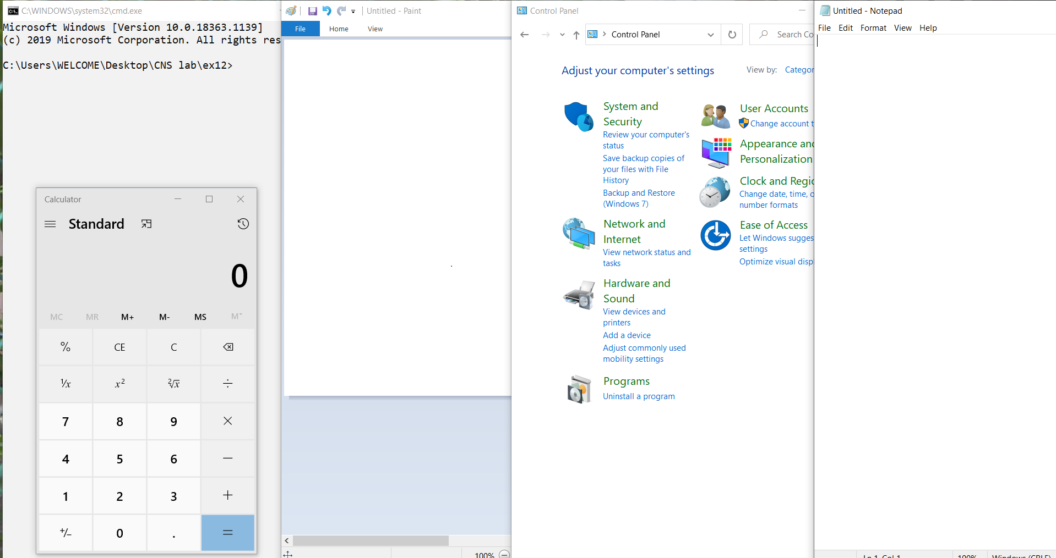

**Exercise 12b:**

To install rootkit and to study about the variety of options.

Rootkit screen :

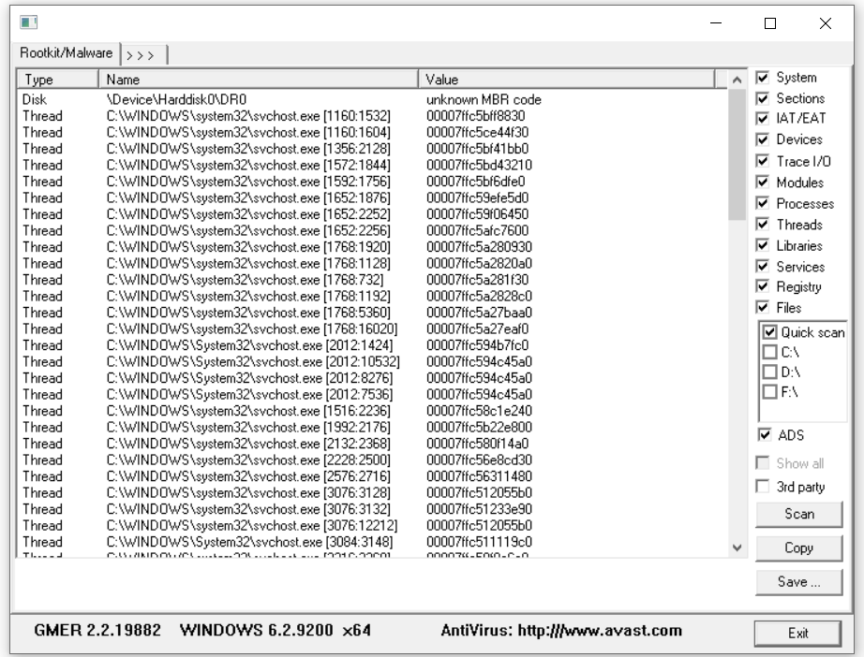

The C: drive is selected for scanning

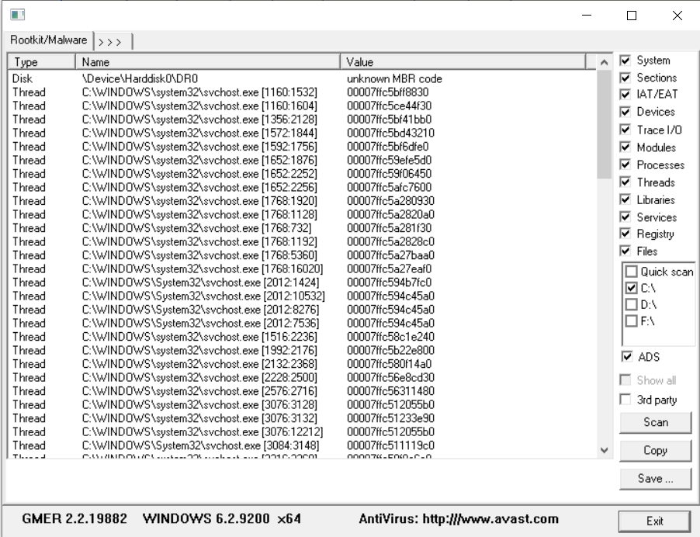

Processes tab:

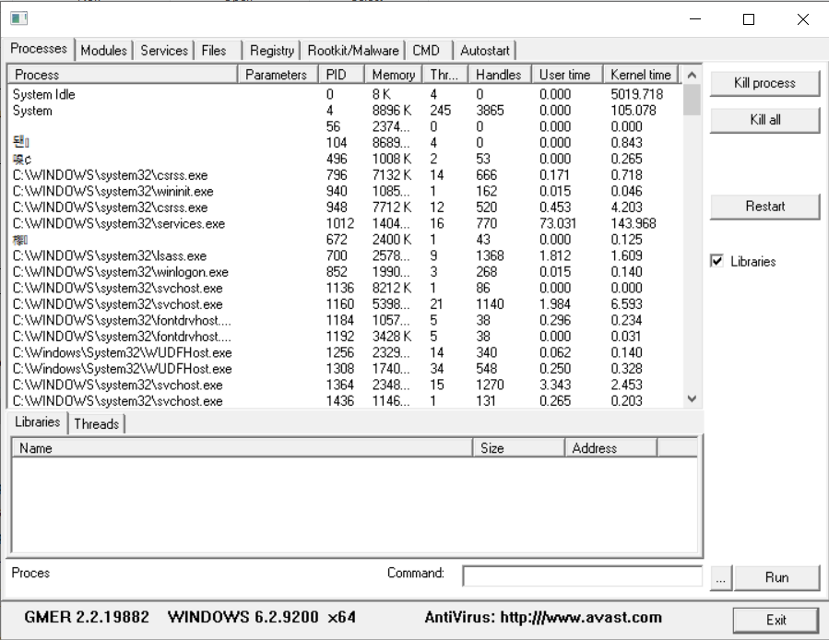

Modules tab:

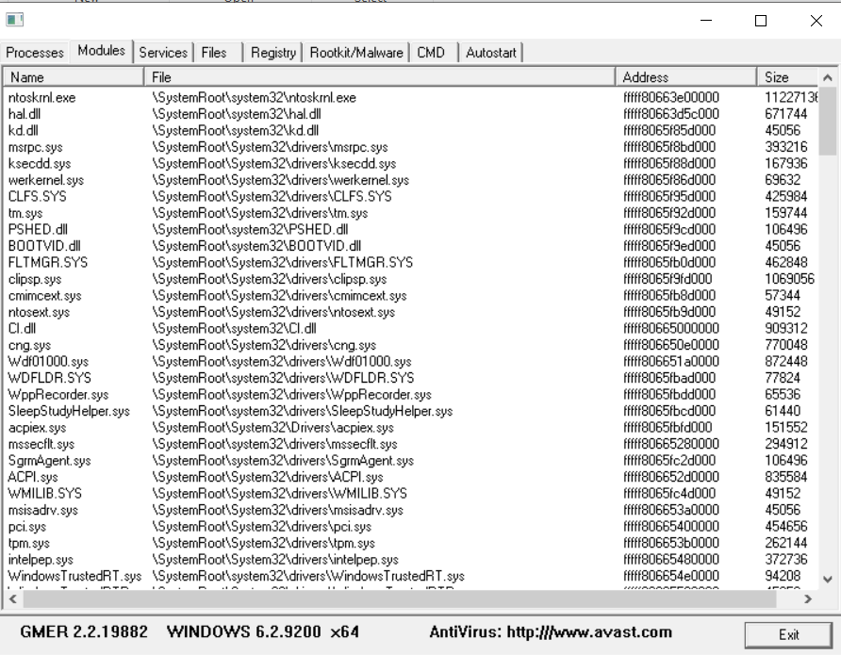

Services tab: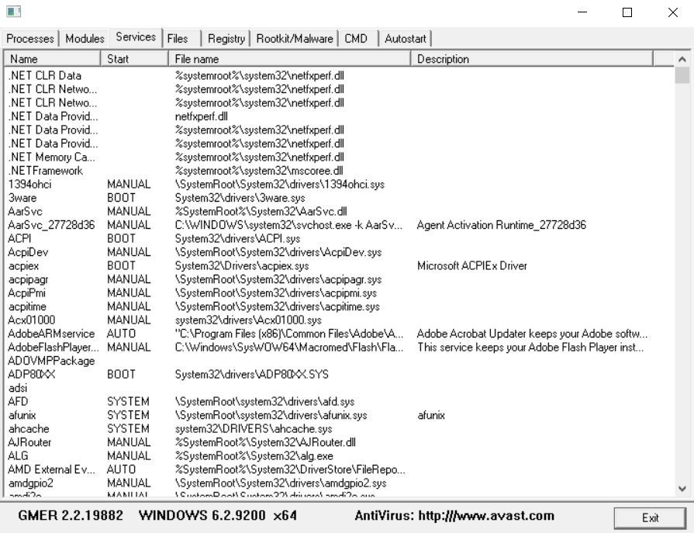

Files tab: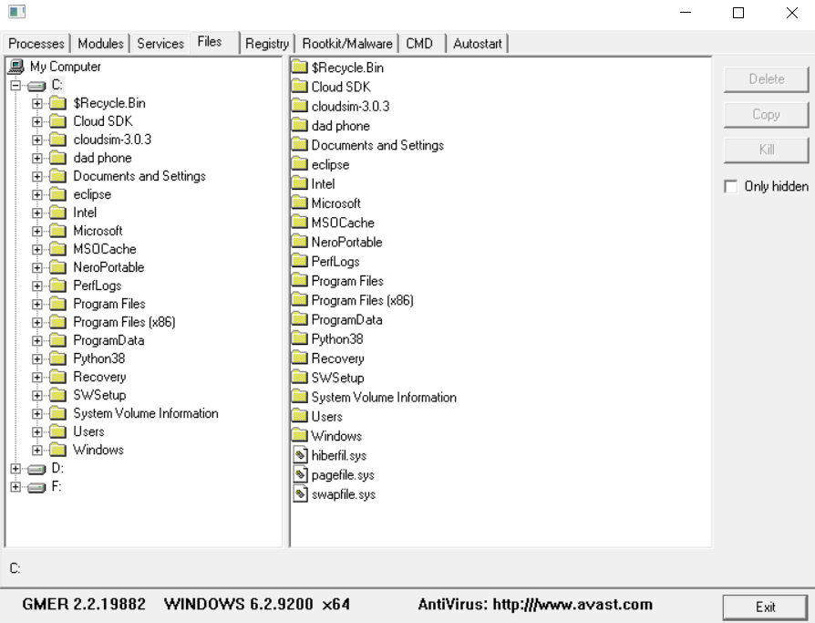

Registry tab:

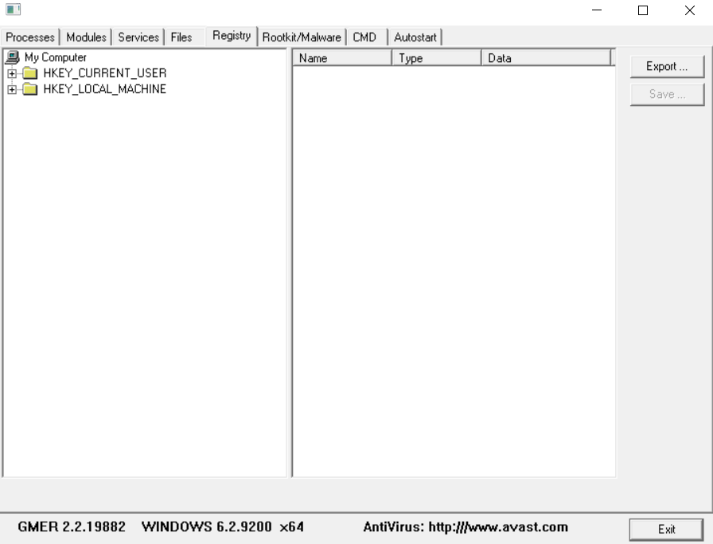

Rootkit/Malware tab: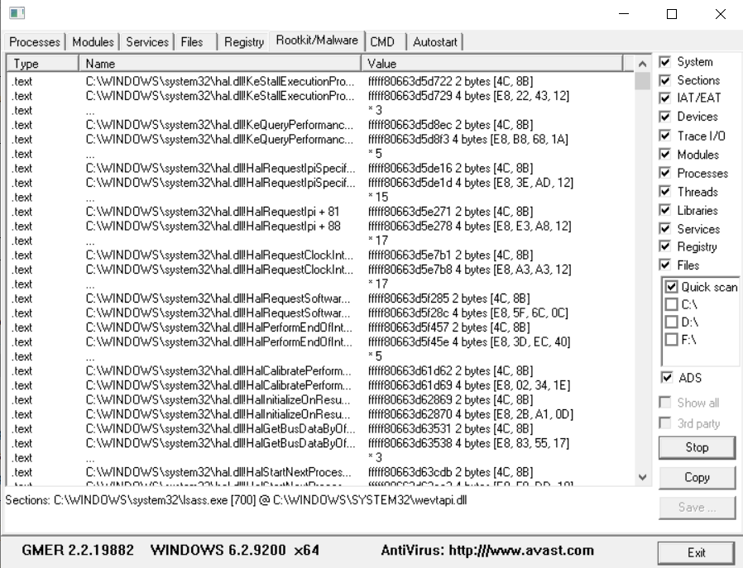

CMD tab:

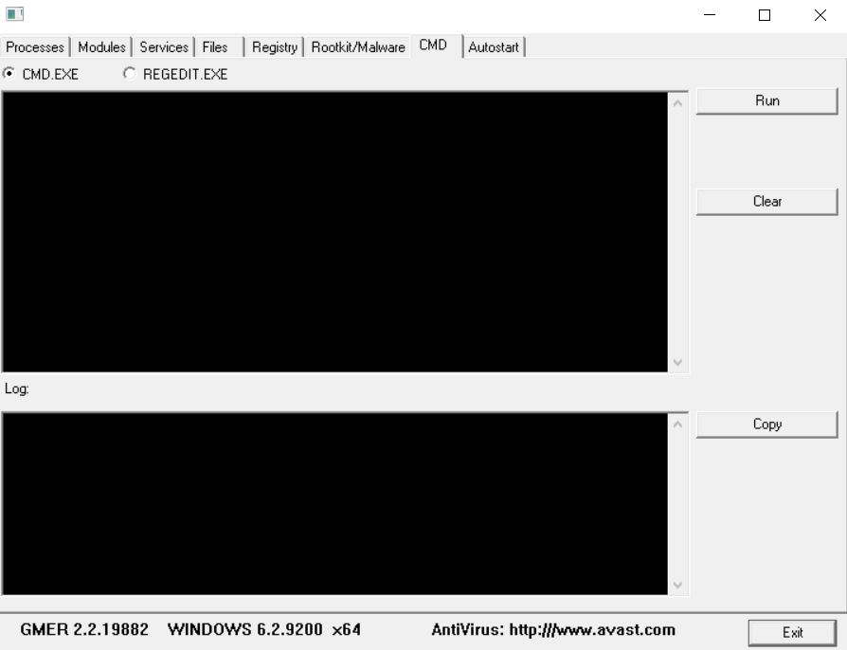

Killing the Adobe process:

