**EX.NO.1**

**CAESAR CIPHER – ENCRYPTION, DECRYPTION AND CRYPTANALYSIS**

**CODE:**

import java.util.Scanner;

import java.util.Arrays;

import java.util.HashSet;

public class CaesarCipher {

public static String encrypt(String plaintext, int key) {

String result = "";

for (int i = 0; i < plaintext.length(); i++) {

if (Character.isUpperCase(plaintext.charAt(i))) {

char ch = (char) (((int) plaintext.charAt(i) - 65 + key) % 26 + 65);

result += ch;

} else {

char ch = (char) (((int) plaintext.charAt(i) - 97 + key) % 26 + 97);

result += ch;

}

}

return result;

}

public static String decrypt(String ciphertext, int key) {

String result = "";

for (int i = 0; i < ciphertext.length(); i++) {

if (Character.isUpperCase(ciphertext.charAt(i))) {

char ch = (char) (((int) ciphertext.charAt(i) - 65 - key + 26) % 26 + 65);

result += ch;

} else {

char ch = (char) (((int) ciphertext.charAt(i) - 97 - key + 26) % 26 + 97);

result += ch;

}

}

return result;

}

public static boolean validateString(String str) {

str = str.toLowerCase();

char[] charArray = str.toCharArray();

for (int i = 0; i < charArray.length; i++) {

char ch = charArray[i];

if (!((ch >= 'a' && ch <= 'z') || (ch >= 'A' && ch <= 'Z'))) {

return false;

}

}

return true;

}

public static boolean validateKey(int key) {

return (key >= 0 && key <= 25);

}

public static void main(String[] args) {

Scanner sc = new Scanner(System.in);

String[] dictionary = { "hello", "zebra", "pen", "jug" };

HashSet<String> dict = new HashSet(Arrays.asList(dictionary));

boolean flag=false;

System.out.print("\nEnter the Plain Text: ");

String plaintext = sc.next();

while (!validateString(plaintext)) {

System.out.println("\nPlain text can contain only alphabets");

System.out.print("\nEnter the Plain Text: ");

plaintext = sc.next();

}

int key = -1;

System.out.print("\nEnter encryption key: ");

String k =sc.next();

while(!(k.length()<=2 && k.length()>=1 && k.matches("[0-9][0-9]") && validateKey(Integer.parseInt(k)))){

System.out.println("\nInvalid key");

System.out.print("\nEnter encryption key: ");

k =sc.next();

}

key=Integer.parseInt(k);

System.out.println("\nCipher text is : " + encrypt(plaintext, key));

System.out.print("\nEnter the Cipher Text: ");

String ciphertext = sc.next();

while (!validateString(ciphertext)) {

System.out.println("\nCipher text can only contain lower case alphabets");

System.out.print("\nEnter the Cipher Text: ");

ciphertext = sc.next();

}

key = -1;

System.out.print("\nEnter decryption key: ");

k =sc.next();

while(!(k.length()<=2 && k.length()>=1 && k.matches("[0-9][0-9]") && validateKey(Integer.parseInt(k)))){

System.out.println("\nInvalid key");

System.out.print("\nEnter decryption key: ");

k =sc.next();

}

key=Integer.parseInt(k);

System.out.println("\nPlain text is : " + decrypt(ciphertext, key));

System.out.print("\nEnter the Cipher Text for crypt analysis: ");

String crypt = sc.next();

while (!validateString(crypt)) {

System.out.println("\nCipher text can only contain lower case alphabets");

System.out.print("\nEnter the Cipher Text for crypt analysis: ");

crypt = sc.next();

}

System.out.print("Key PlainText");

System.out.print("\n*** *********");

String values = "";

for (int i = 0; i < 26; i++) {

String res = decrypt(crypt, i);

System.out.printf("\n%-3d %s", i, res);

if (dict.contains(res.toLowerCase())) {

values += "Key = " + i + " : " + res + "\n";

break;

}

}

System.out.println("\nThe possible plain text value is: " + values);

}

}

**OUTPUT:**

**Example 1:**

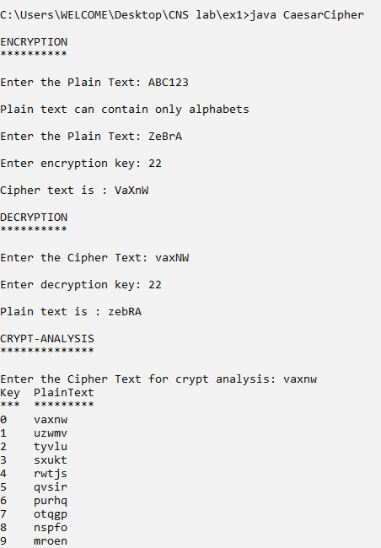

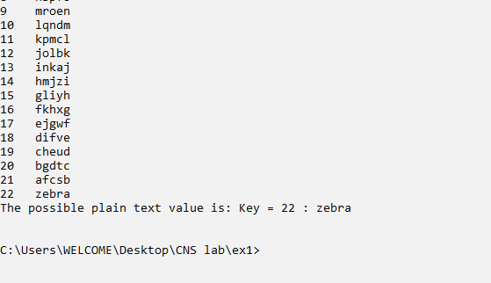

**Example 2:**

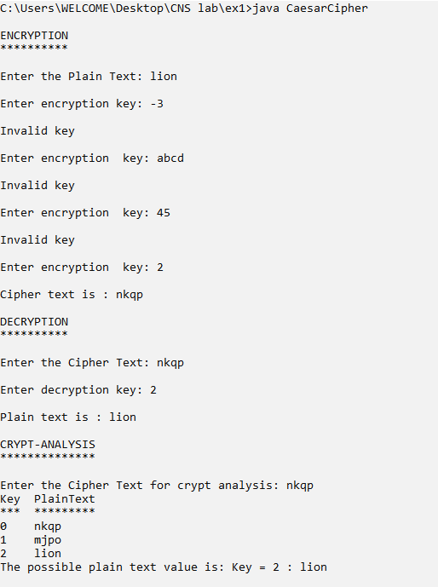

**PLAYFAIR CIPHER – ENCRYPTION AND DECRYPTION**

**CODE:**

import java.util.Scanner;

public class PlayFairCipher {

String keyword = new String();

String plainText = new String();

char key_mat[][] = new char[5][5];

String cipherText = new String();

public void validateKey() {

boolean isKeyValid = false;

if (keyword.contains("j")) {

isKeyValid = true;

keyword = keyword.replace('j', 'i');

}

// remove duplicates

String str = new String();

for (int i = 0; i < keyword.length(); i++) {

char c = keyword.charAt(i);

if (str.indexOf(c) < 0)

str += c;

}

if (isKeyValid || !keyword.equals(str)) {

keyword = str;

System.out.println("Modified key is ------ " + keyword);

}

// generating matrix entries as a string

boolean flag = true;

char current;

char drop_char = 'j';

for (int i = 0; i < 26; i++) {

current = (char) (i + 97);

if (current == drop_char)

continue;

for (int j = 0; j < keyword.length(); j++) {

if (current == keyword.charAt(j)) {

flag = false;

break;

}

}

if (flag)

keyword = keyword + current;

flag = true;

}

// System.out.println("key is " + keyword);

}

public void printKeyMatrix() {

System.out.println("\nThe key matrix is\n");

int idx = 0;

for (int i = 0; i < 5; i++) {

for (int j = 0; j < 5; j++) {

key_mat[i][j] = keyword.charAt(idx);

System.out.print(key_mat[i][j] + " ");

idx++;

}

System.out.println();

}

}

public void modifyPlainText() {

if (plainText.contains("j")) {

plainText = plainText.replace('j', 'i');

System.out.println("After replacing j with i in the plain text ---- " + plainText);

}

StringBuffer newString = new StringBuffer(plainText);

for (int i = 0; i < newString.length() - 1; i++) {

// check for reptition in a pair

if (i % 2 == 0) {

if (newString.charAt(i) == newString.charAt(i + 1)) {

if (newString.charAt(i) != 'z')

newString.insert(i + 1, "z");

else

newString.insert(i + 1, "q");

}

}

}

if (newString.length() % 2 != 0) {

if (newString.charAt(newString.length() - 1) != 'z')

newString.append("z");

else

newString.append("q");

}

if (!plainText.equals(newString.toString())) {

plainText = newString.toString();

System.out.println("Modified plain text is ---- " + plainText);

}

}

public int[] getDimensions(char letter) {

int[] dimen = new int[2];

for (int i = 0; i < 5; i++) {

for (int j = 0; j < 5; j++) {

if (key_mat[i][j] == letter) {

dimen[0] = i;

dimen[1] = j;

break;

}

}

}

return dimen;

}

public void encryptMessage() {

for (int i = 0; i < plainText.length(); i = i + 2) {

int p1[] = new int[2];

int p2[] = new int[2];

p1 = getDimensions(plainText.charAt(i));

p2 = getDimensions(plainText.charAt(i + 1));

if (p1[0] == p2[0]) {

int c1 = (p1[1] + 1) % 5;

int c2 = (p2[1] + 1) % 5;

cipherText = cipherText + key_mat[p1[0]][c1] + key_mat[p1[0]][c2];

} else if (p1[1] == p2[1]) {

int r1 = (p1[0] + 1) % 5;

int r2 = (p2[0] + 1) % 5;

cipherText = cipherText + key_mat[r1][p1[1]] + key_mat[r2][p1[1]];

} else {

cipherText = cipherText + key_mat[p1[0]][p2[1]] + key_mat[p2[0]][p1[1]];

}

}

}

public void decryptMessage() {

plainText = "";

for (int i = 0; i < cipherText.length(); i = i + 2) {

int p1[] = new int[2];

int p2[] = new int[2];

p1 = getDimensions(cipherText.charAt(i));

p2 = getDimensions(cipherText.charAt(i + 1));

if (p1[0] == p2[0]) {

int c1 = (p1[1] - 1 + 5) % 5;

int c2 = (p2[1] - 1 + 5) % 5;

plainText = plainText + key_mat[p1[0]][c1] + key_mat[p1[0]][c2];

} else if (p1[1] == p2[1]) {

int r1 = (p1[0] - 1 + 5) % 5;

int r2 = (p2[0] - 1 + 5) % 5;

plainText = plainText + key_mat[r1][p1[1]] + key_mat[r2][p1[1]];

} else {

plainText = plainText + key_mat[p1[0]][p2[1]] + key_mat[p2[0]][p1[1]];

}

}

}

public static void main(String[] args) {

Scanner sc = new Scanner(System.in);

PlayFairCipher pfc = new PlayFairCipher();

System.out.println("\nENCRYPTION");

System.out.print("\nEnter plain text: ");

pfc.plainText = sc.next();

pfc.modifyPlainText();

System.out.print("\nEnter the key: ");

pfc.keyword = sc.next();

pfc.validateKey();

pfc.printKeyMatrix();

pfc.encryptMessage();

System.out.println("\nCipher text is: " + pfc.cipherText);

System.out.println("\nDECRYPTION");

System.out.print("\nEnter cipher text: ");

pfc.cipherText = sc.next();

System.out.print("\nEnter the key: ");

pfc.keyword = sc.next();

pfc.validateKey();

pfc.printKeyMatrix();

pfc.decryptMessage();

System.out.println("\nPlain text is: " + pfc.plainText);

sc.close();

}

}

**OUTPUT:**

**Example 1:**

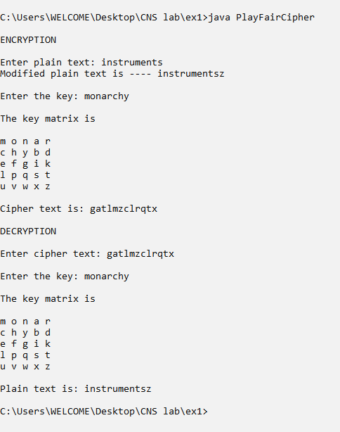

**Example 2:**

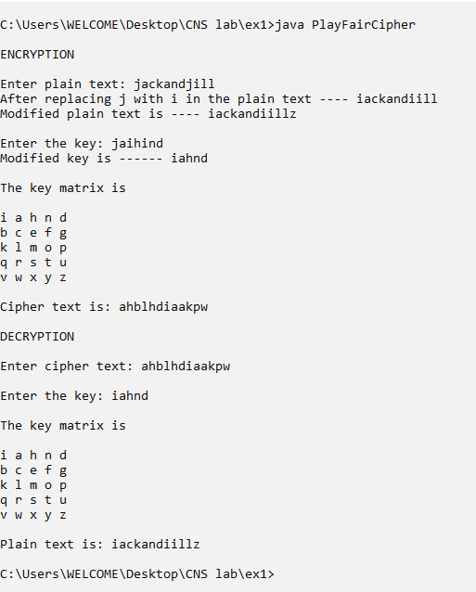

**Example 3:**

