**PROGRAM CODE:**

#Create a simulator object

set ns [new Simulator]

#Open the nam trace file

set nf [open outt.nam w]

$ns namtrace-all $nf

$ns color 1 Blue

#Define a 'finish' procedure

proc finish {} {

global ns nf

$ns flush-trace

#Close the trace file

close $nf

#Execute nam on the trace file

exec nam outt.nam &

exit 0

}

# Creating Nodes

set n0 [$ns node]

set n1 [$ns node]

set n2 [$ns node]

#Setting Links

$ns duplex-link $n0 $n1 10Mb 10ms DropTail

$ns duplex-link $n1 $n2 2Mb 10ms DropTail

#Setting Topology

$ns duplex-link-op $n0 $n1 orient right

$ns duplex-link-op $n1 $n2 orient right

#Setting Queue Limit

$ns queue-limit $n0 $n1 8

$ns queue-limit $n1 $n2 8

#Setup a TCP connection over 0 and 2 and its flow id, window size, packet size

set tcp [new Agent/TCP]

$ns attach-agent $n0 $tcp

set sink [new Agent/TCPSink]

$ns attach-agent $n2 $sink

$ns connect $tcp $sink

$tcp set fid_ 1

$tcp set window_ 16

$tcp set packetSize_ 552

#Setup a FTP over TCP connection

set ftp [new Application/FTP]

$ftp attach-agent $tcp

$ftp set type_ FTP

#Start and stop ftp

$ns at 0.1 "$ftp start"

$ns at 4.0 "$ftp stop"

#Call the finish procedure after 5 seconds of simulation time

$ns at 5.0 "finish"

#Run the simulation

$ns run

**OUTPUT:**

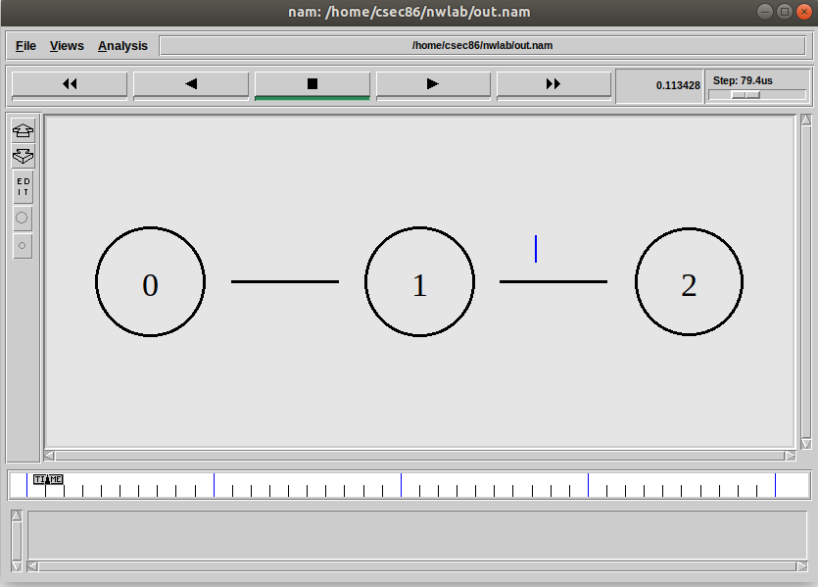

**PROGRAM CODE:**

#Create a simulator object

set ns [new Simulator]

#Open the nam trace file

set nf [open outr.nam w]

$ns namtrace-all $nf

$ns color 1 Red

#Define a 'finish' procedure

proc finish {} {

global ns nf

$ns flush-trace

#Close the trace file

close $nf

#Execute nam on the trace file

exec nam outr.nam &

exit 0

}

# Creating Nodes

set n0 [$ns node]

set n1 [$ns node]

set n2 [$ns node]

#Setting Links

$ns duplex-link $n0 $n1 10Mb 10ms DropTail

$ns duplex-link $n1 $n2 2Mb 10ms DropTail

#Setting Topology

$ns duplex-link-op $n0 $n1 orient right

$ns duplex-link-op $n1 $n2 orient right

#Setting Queue Limit

$ns queue-limit $n0 $n1 8

$ns queue-limit $n1 $n2 8

#Setup a TCP connection over 0 and 2 and its flow id, window size, packet size

set tcp [new Agent/TCP/Reno]

$ns attach-agent $n0 $tcp

set sink [new Agent/TCPSink]

$ns attach-agent $n2 $sink

$ns connect $tcp $sink

$tcp set fid_ 1

$tcp set window_ 16

$tcp set packetSize_ 552

#Setup a FTP over TCP connection

set ftp [new Application/FTP]

$ftp attach-agent $tcp

$ftp set type_ FTP

#Start and stop ftp

$ns at 0.1 "$ftp start"

$ns at 4.0 "$ftp stop"

#Call the finish procedure after 5 seconds of simulation time

$ns at 5.0 "finish"

#Run the simulation

$ns run

**OUTPUT:**

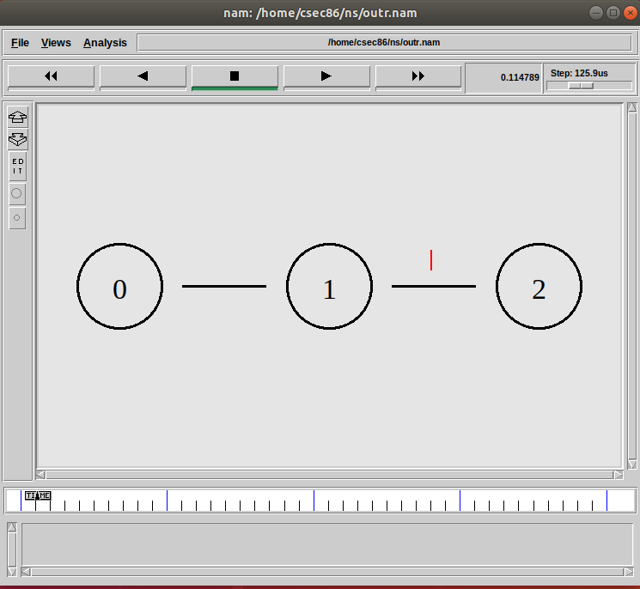

**PROGRAM CODE:**

#Create a simulator object

set ns [new Simulator]

#Open the nam trace file

set nf [open out3.nam w]

$ns namtrace-all $nf

$ns color 1 Blue

$ns color 2 Red

#Define a 'finish' procedure

proc finish {} {

global ns nf

$ns flush-trace

#Close the trace file

close $nf

#Execute nam on the trace file

exec nam out3.nam &

exit 0

}

# Creating Nodes

set n0 [$ns node]

set n1 [$ns node]

set n2 [$ns node]

set n3 [$ns node]

set n4 [$ns node]

set n5 [$ns node]

#Setting Links

$ns duplex-link $n0 $n2 2Mb 10ms DropTail

$ns duplex-link $n1 $n2 2Mb 10ms DropTail

$ns simplex-link $n2 $n3 0.3Mb 100ms DropTail

$ns simplex-link $n3 $n2 0.3Mb 100ms DropTail

$ns duplex-link $n3 $n4 0.5Mb 40ms DropTail

$ns duplex-link $n3 $n5 0.5Mb 40ms DropTail

#Setting Topology

$ns duplex-link-op $n0 $n2 orient right-down

$ns duplex-link-op $n1 $n2 orient right-up

$ns duplex-link-op $n2 $n3 orient left-up

$ns duplex-link-op $n3 $n2 orient right

$ns duplex-link-op $n3 $n4 orient up

$ns duplex-link-op $n3 $n5 orient right-up

#Setting Queue Limit

$ns queue-limit $n2 $n3 10

#Setup a TCP connection over 0 and 4 and its flow id, window size, packet size

set tcp [new Agent/TCP/Newreno]

$ns attach-agent $n0 $tcp

set sink [new Agent/TCPSink/DelAck]

$ns attach-agent $n4 $sink

$ns connect $tcp $sink

$tcp set fid_ 1

$tcp set window_ 8000

$tcp set packetSize_ 552

#Setup a FTP over TCP connection

set ftp [new Application/FTP]

$ftp attach-agent $tcp

$ftp set type_ FTP

#Create a UDP agent and attach it to node n0

set udp [new Agent/UDP]

$ns attach-agent $n0 $udp

# Create a CBR traffic source and attach it to udp0

set cbr [new Application/Traffic/CBR]

$cbr set type_ CBR

$cbr set packet_size_ 1000

$cbr set rate_ 0.01mb

$cbr set random_ false

$cbr attach-agent $udp

#Create a Null agent (a traffic sink) and attach it to node n1

set null [new Agent/Null]

$ns attach-agent $n5 $null

#Connect the traffic source with the traffic sink

$ns connect $udp $null

#Set Flow ID, Packet Size and Window Size

$udp set fid_ 2

$udp set window_ 8000

$udp set packetSize_ 552

#Start and stop the cbr and ftp

$ns at 0.1 "$cbr start"

$ns at 1.0 "$ftp start"

$ns at 4.5 "$ftp stop"

$ns at 5.0 "$cbr stop"

#Call the finish procedure after 5 seconds of simulation time

$ns at 5.0 "finish"

#Run the simulation

$ns run

**OUTPUT:**

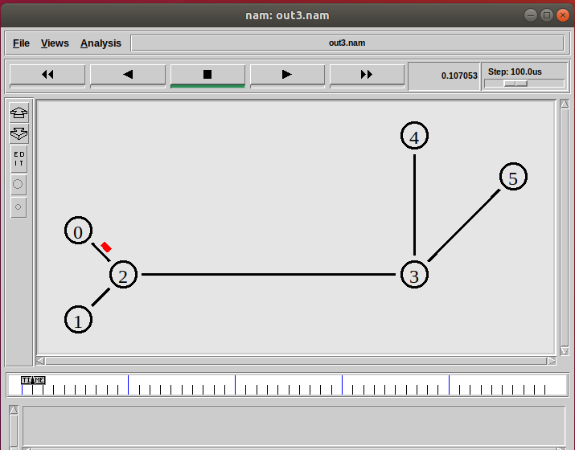

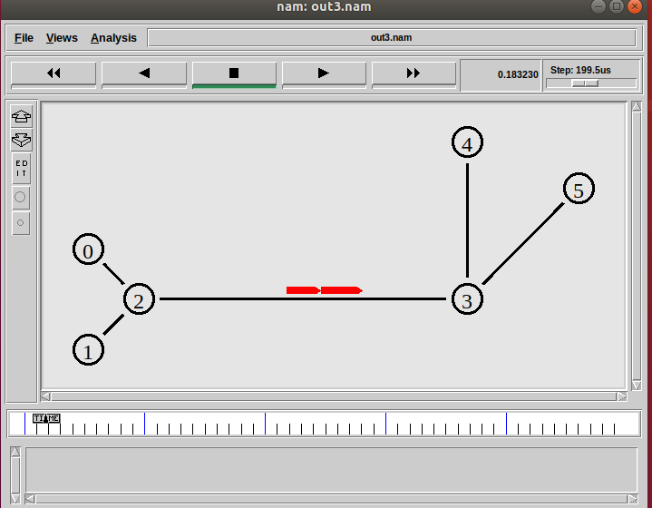

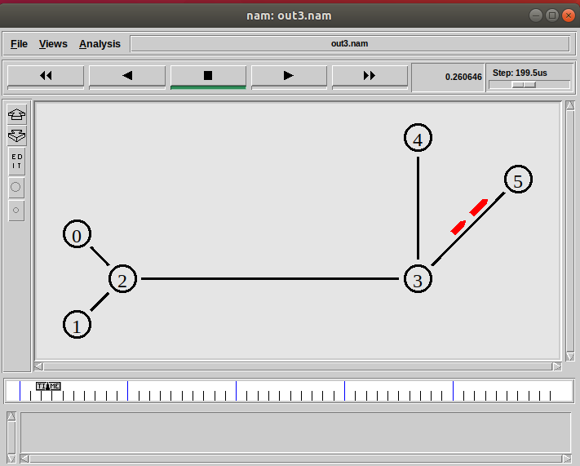

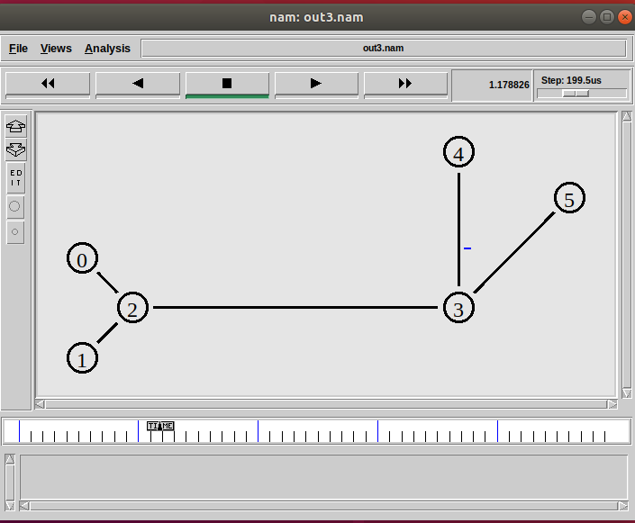

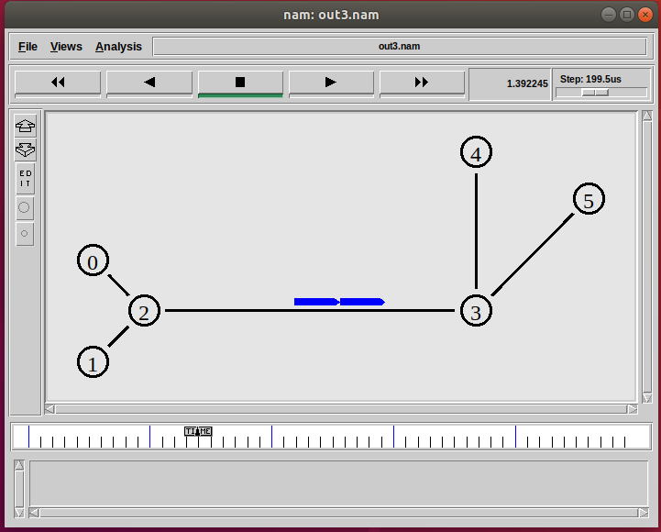

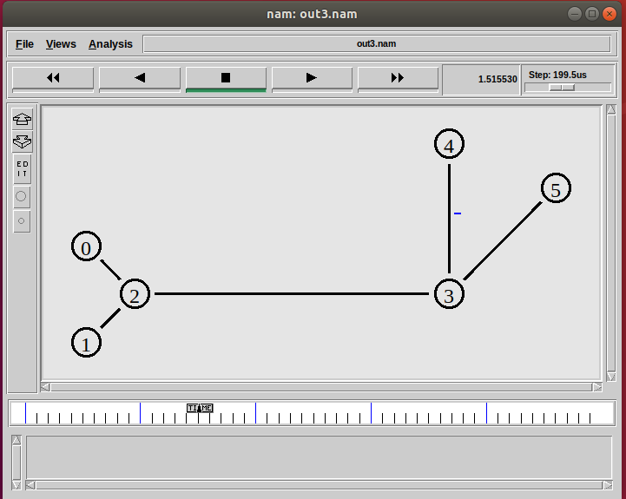

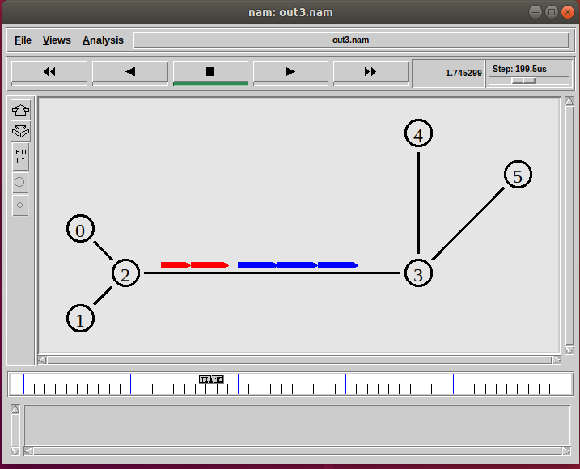



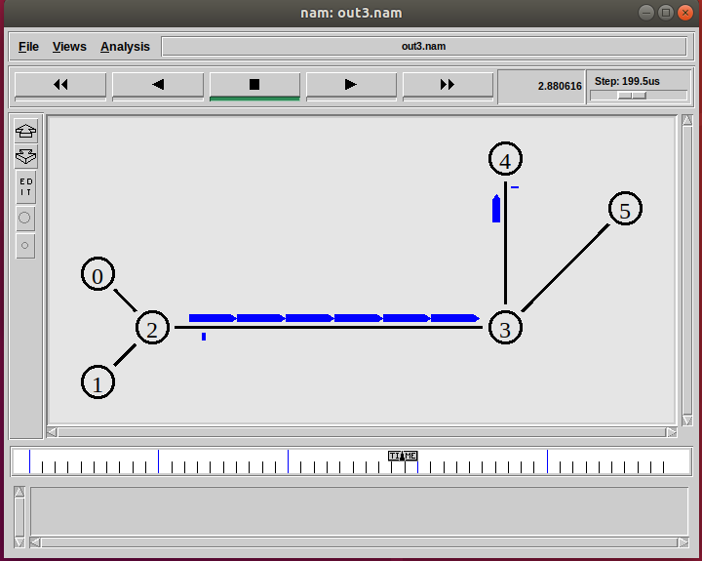

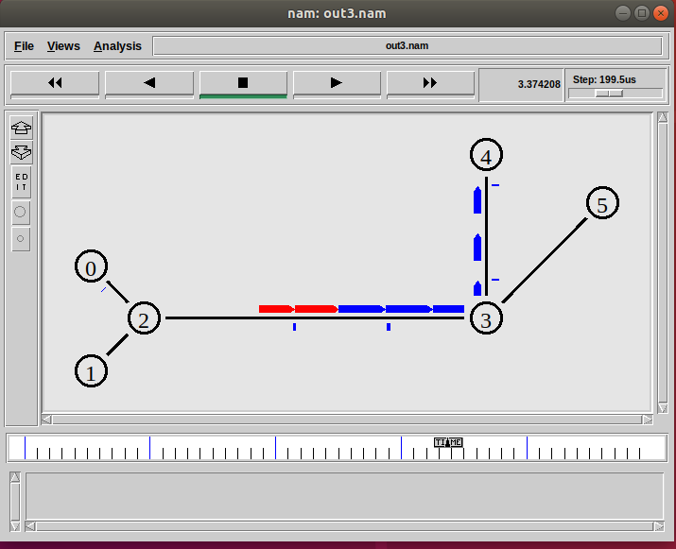

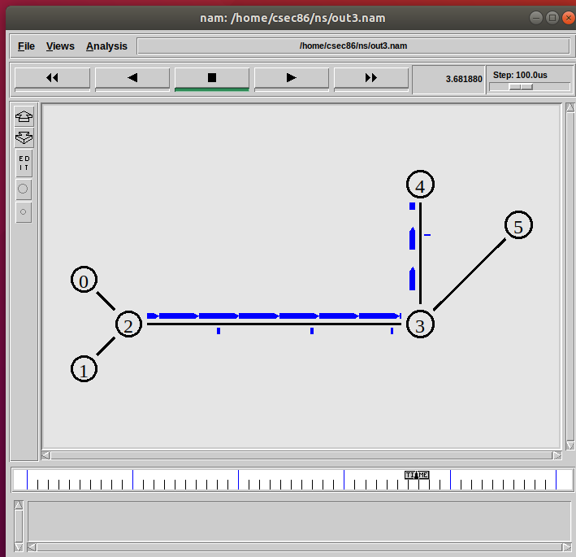

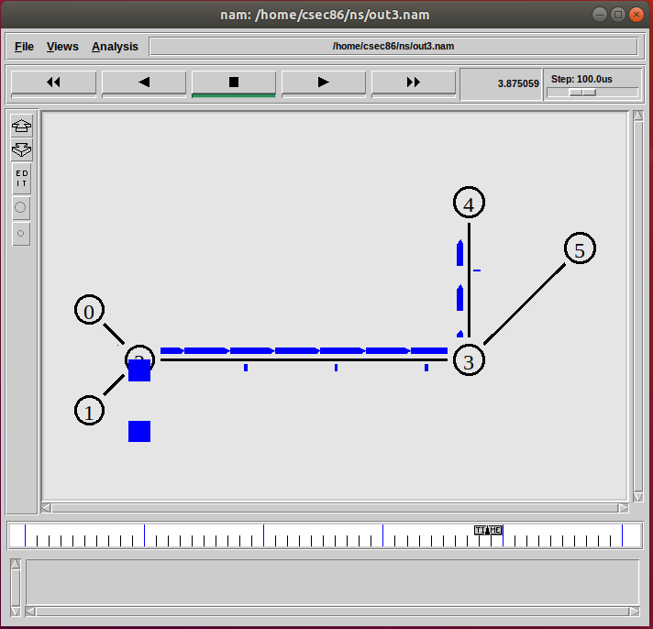

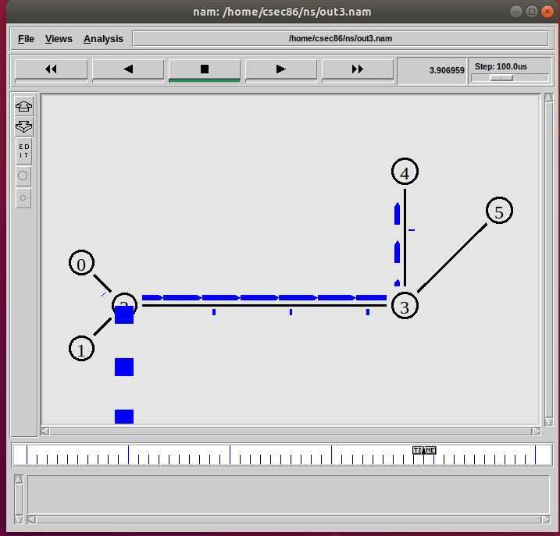

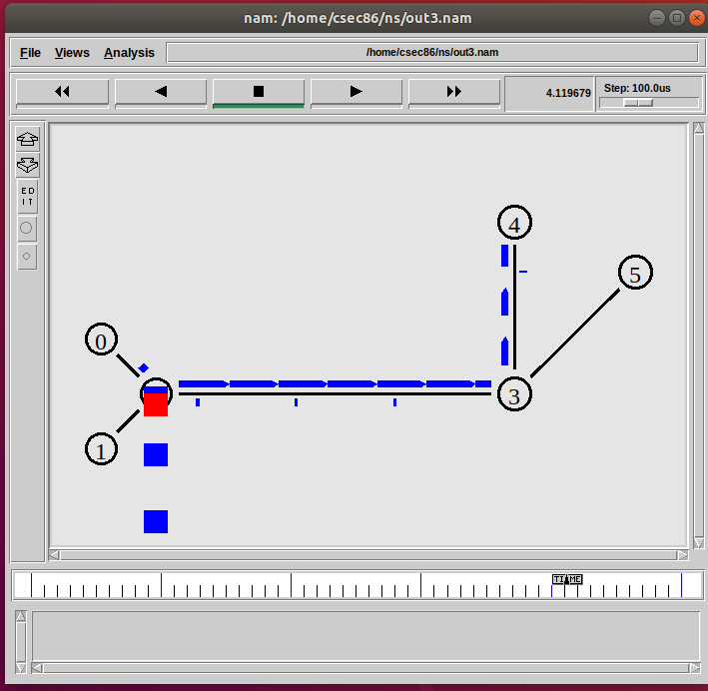

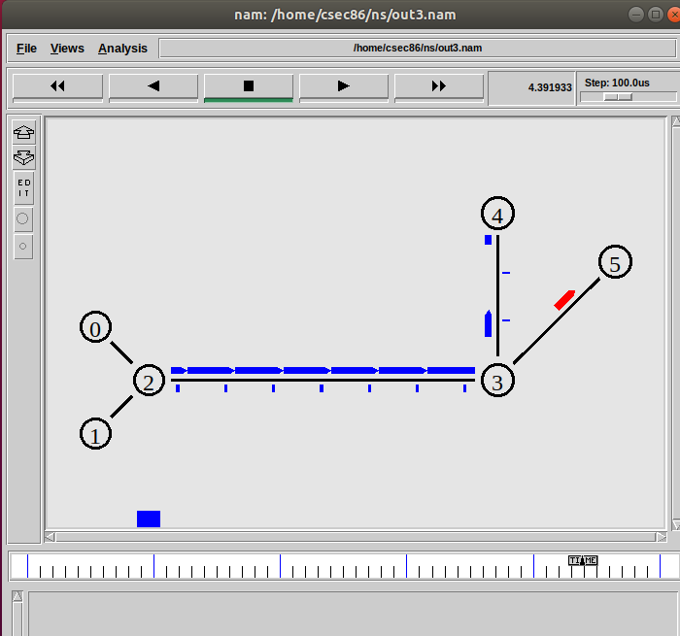

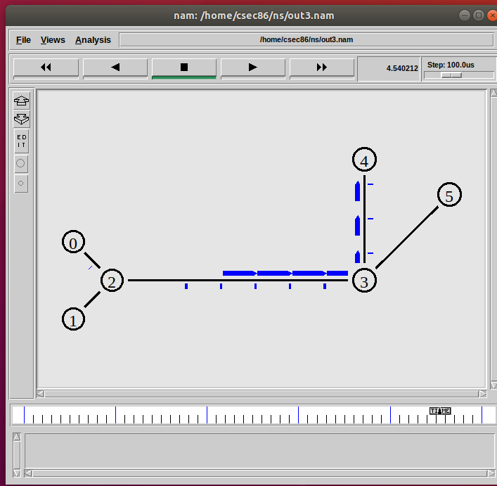

**PROGRAM CODE:**

set ns [new Simulator]

set nr [open dv.tr w]

$ns trace-all $nr

set nf [open dv.nam w]

$ns namtrace-all $nf

proc finish { } {

global ns nr nf

$ns flush-trace

close $nf

close $nr

exec nam dv.nam &

exit 0

}

for { set i 0 } { $i < 12} { incr i 1 } {

set n($i) [$ns node]}

for {set i 0} {$i < 8} {incr i} {

$ns duplex-link $n($i) $n([expr $i+1]) 1Mb 10ms DropTail }

$ns duplex-link $n(0) $n(8) 1Mb 10ms DropTail

$ns duplex-link $n(1) $n(10) 1Mb 10ms DropTail

$ns duplex-link $n(0) $n(9) 1Mb 10ms DropTail

$ns duplex-link $n(9) $n(11) 1Mb 10ms DropTail

$ns duplex-link $n(10) $n(11) 1Mb 10ms DropTail

$ns duplex-link $n(11) $n(5) 1Mb 10ms DropTail

set udp0 [new Agent/UDP]

$ns attach-agent $n(0) $udp0

set cbr0 [new Application/Traffic/CBR]

$cbr0 set packetSize_ 500

$cbr0 set interval_ 0.005

$cbr0 attach-agent $udp0

set null0 [new Agent/Null]

$ns attach-agent $n(5) $null0

$ns connect $udp0 $null0

set udp1 [new Agent/UDP]

$ns attach-agent $n(1) $udp1

set cbr1 [new Application/Traffic/CBR]

$cbr1 set packetSize_ 500

$cbr1 set interval_ 0.005

$cbr1 attach-agent $udp1

set null0 [new Agent/Null]

$ns attach-agent $n(5) $null0

$ns connect $udp1 $null0

$ns rtproto DV

$ns rtmodel-at 3.0 down $n(11) $n(5)

$ns rtmodel-at 3.0 down $n(7) $n(6)

$ns rtmodel-at 4.0 up $n(11) $n(5)

$ns rtmodel-at 4.0 up $n(7) $n(6)

$udp0 set fid_ 1

$udp1 set fid_ 2

$ns color 1 Red

$ns color 2 Green

$ns at 1.0 "$cbr0 start"

$ns at 2.0 "$cbr1 start"

$ns at 5 "finish"

$ns run

**OUTPUT:**

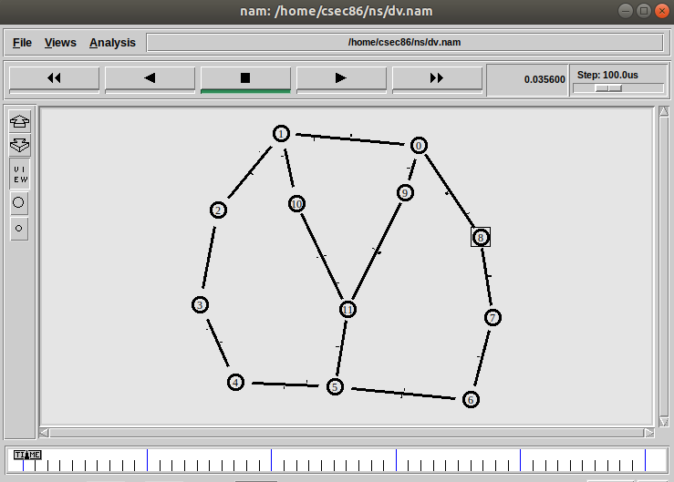

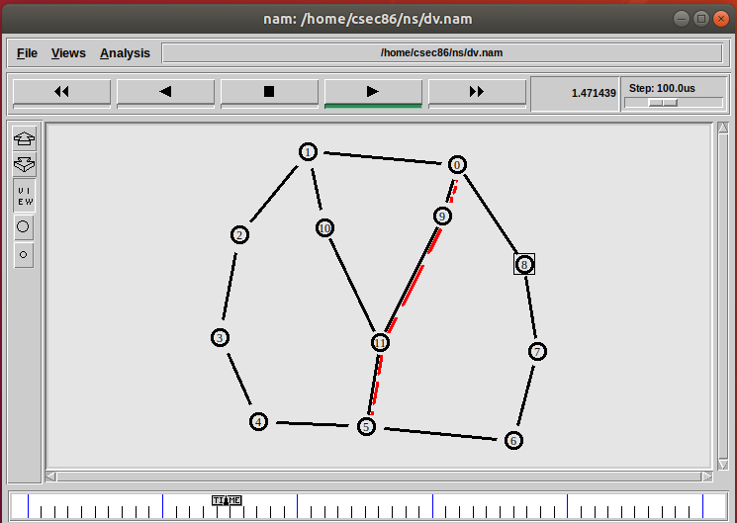

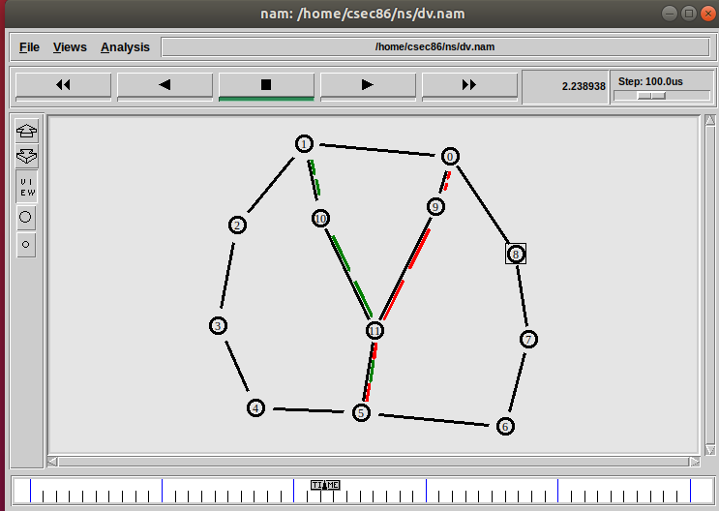

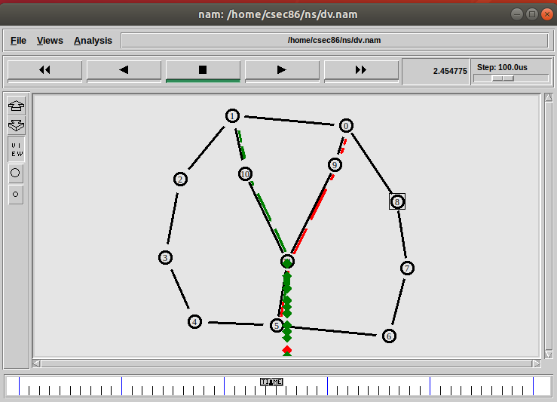

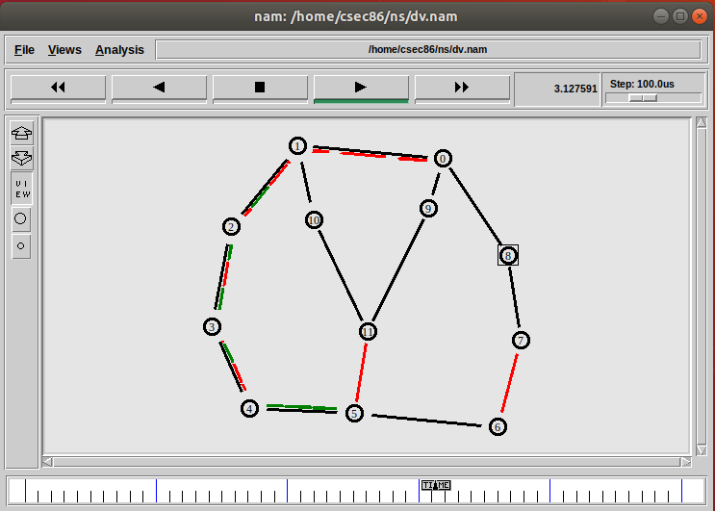

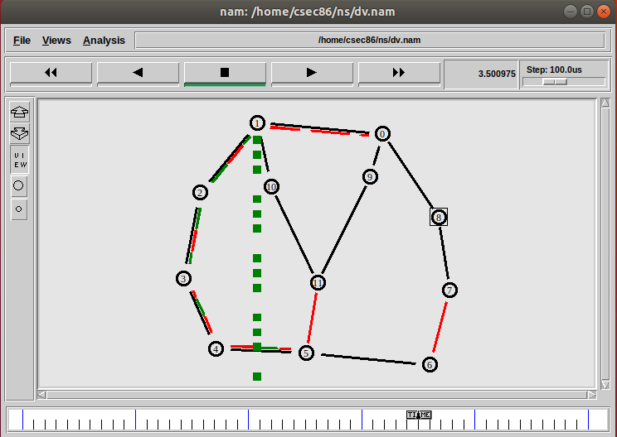

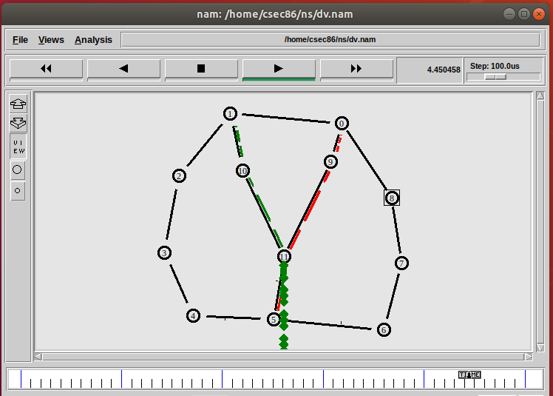

**PROGRAM CODE:**

set ns [new Simulator]

set nr [open ls.tr w]

$ns trace-all $nr

set nf [open ls.nam w]

$ns namtrace-all $nf

proc finish { } {

global ns nr nf

$ns flush-trace

close $nf

close $nr

exec nam ls.nam &

exit 0

}

for { set i 0 } { $i < 12} { incr i 1 } {

set n($i) [$ns node]}

for {set i 0} {$i < 8} {incr i} {

$ns duplex-link $n($i) $n([expr $i+1]) 1Mb 10ms DropTail }

$ns duplex-link $n(0) $n(8) 1Mb 10ms DropTail

$ns duplex-link $n(1) $n(10) 1Mb 10ms DropTail

$ns duplex-link $n(0) $n(9) 1Mb 10ms DropTail

$ns duplex-link $n(9) $n(11) 1Mb 10ms DropTail

$ns duplex-link $n(10) $n(11) 1Mb 10ms DropTail

$ns duplex-link $n(11) $n(5) 1Mb 10ms DropTail

set udp0 [new Agent/UDP]

$ns attach-agent $n(0) $udp0

set cbr0 [new Application/Traffic/CBR]

$cbr0 set packetSize_ 500

$cbr0 set interval_ 0.005

$cbr0 attach-agent $udp0

set null0 [new Agent/Null]

$ns attach-agent $n(5) $null0

$ns connect $udp0 $null0

set udp1 [new Agent/UDP]

$ns attach-agent $n(1) $udp1

set cbr1 [new Application/Traffic/CBR]

$cbr1 set packetSize_ 500

$cbr1 set interval_ 0.005

$cbr1 attach-agent $udp1

set null0 [new Agent/Null]

$ns attach-agent $n(5) $null0

$ns connect $udp1 $null0

$ns rtproto LS

$ns rtmodel-at 3.0 down $n(11) $n(5)

$ns rtmodel-at 3.0 down $n(7) $n(6)

$ns rtmodel-at 4.0 up $n(11) $n(5)

$ns rtmodel-at 4.0 up $n(7) $n(6)

$udp0 set fid_ 1

$udp1 set fid_ 2

$ns color 1 Red

$ns color 2 Green

$ns at 1.0 "$cbr0 start"

$ns at 2.0 "$cbr1 start"

$ns at 5 "finish"

$ns run

**OUTPUT:**

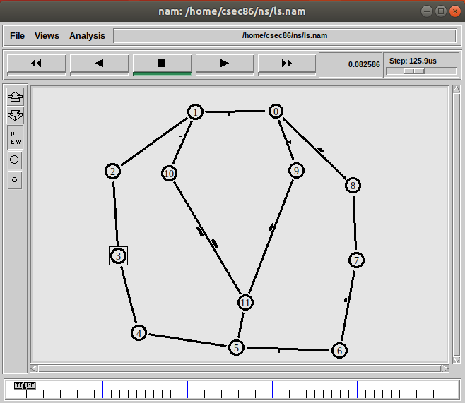

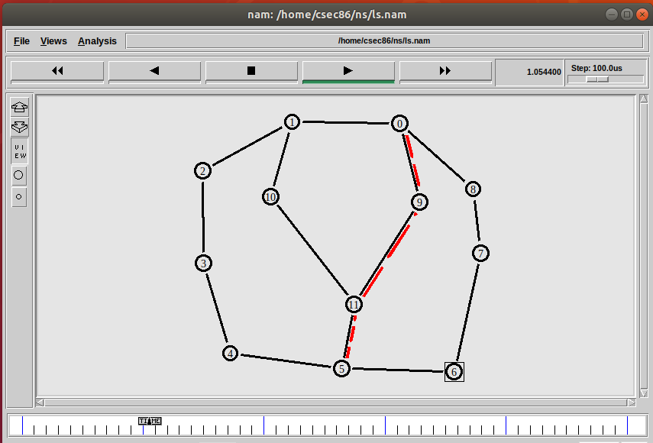

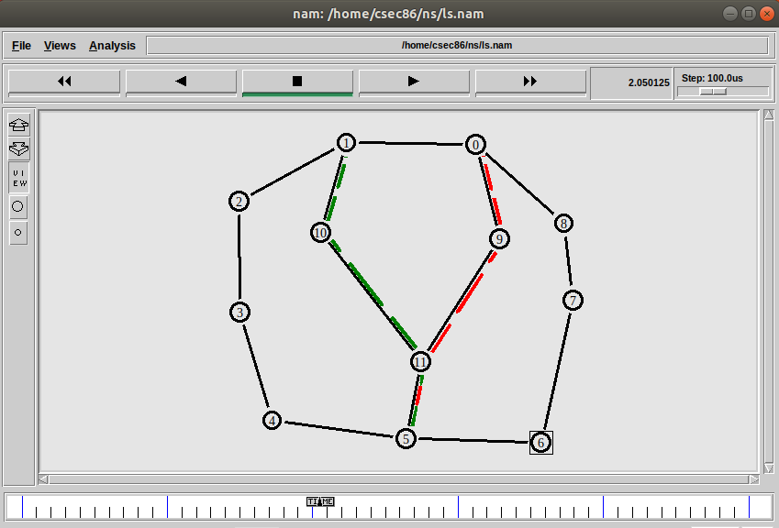

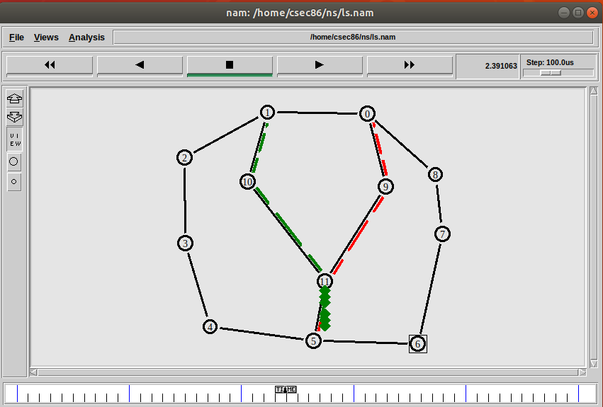

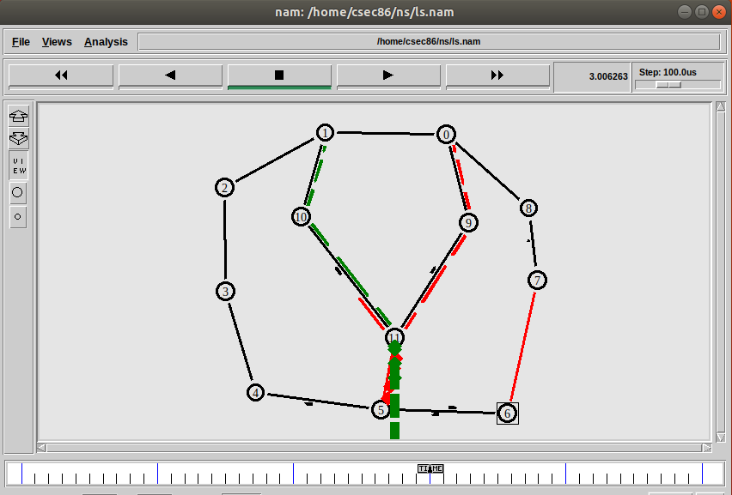

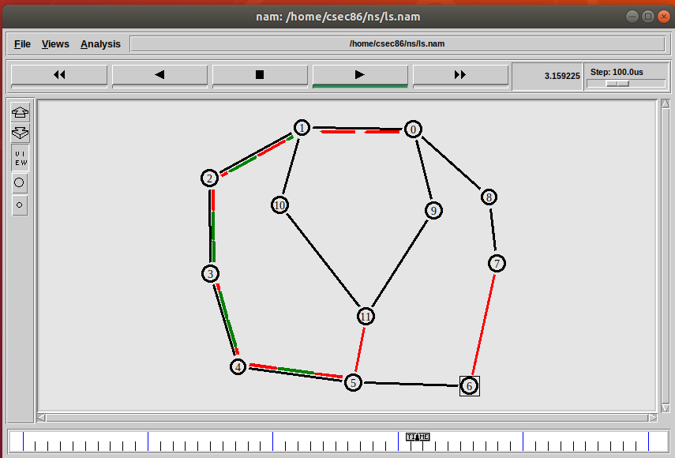

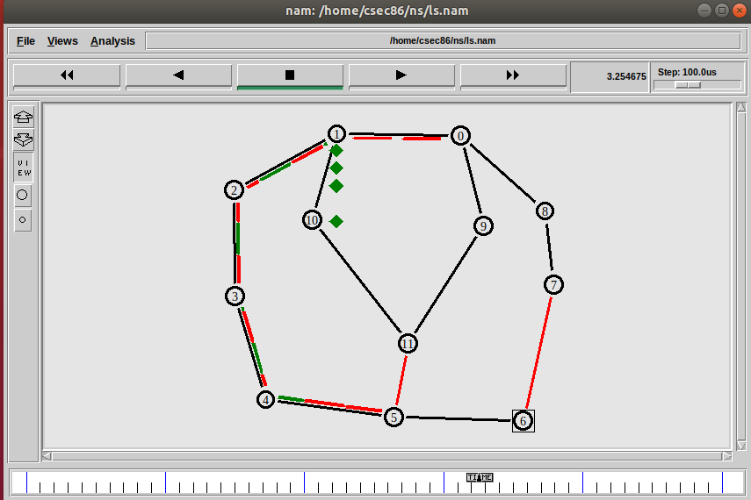

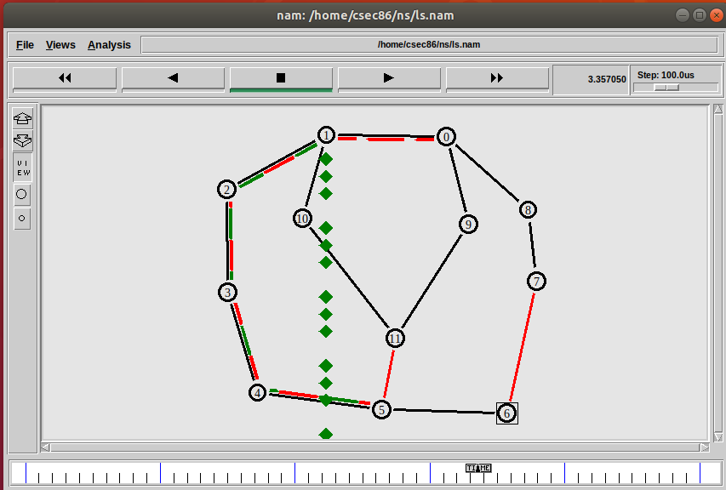

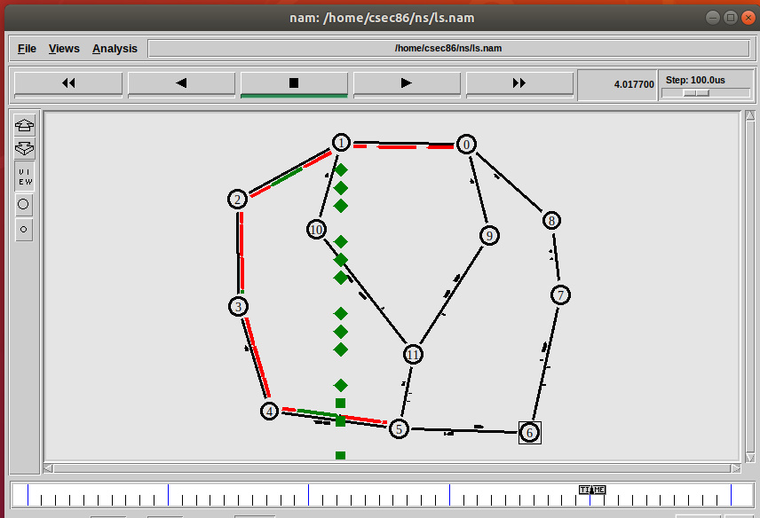

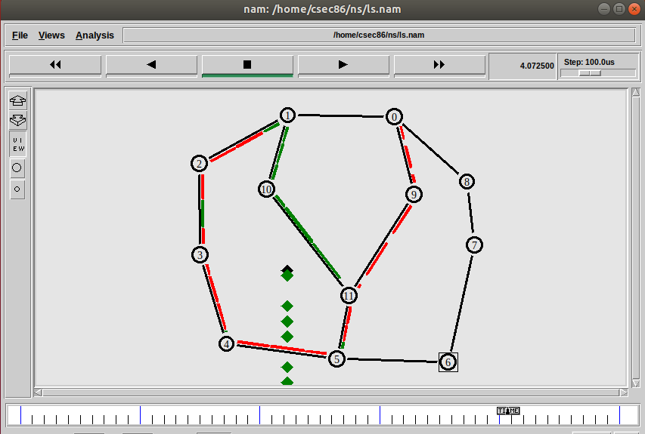



**PROGRAM CODE:**

BEGIN {

recvdSize = 0

txsize=0

drpSize=0

startTime = 0

stopTime = 0

thru=0

}

{

event = $1

time = $2

node_id = $3

pkt_size = $6

level = $5

# Store start time

if (level == "cbr" && (event == "+" || event == "s") )

{

if (time < startTime)

{

startTime = time

}

txsize++;}

# Update total received packetsâ€TM size and store packets arrival time

if (level == "cbr" && event == "r" )

{

if (time > stopTime)

{

stopTime = time

}

recvdSize++

}

if (level == "cbr" && event == "d" )

{

drpSize++

}

}

END {

printf("Average Throughput[kbps] = %.2f\ns=%.2f\nd=%.2f\nr=%.2f\nStartTime=%.2f\nStopTime=%.2f\n",(recvdSize/(stopTime-startTime)),txsize,drpSize,recvdSize,startTime,stopTime)

}

**OUTPUT:**

